**, SAFRAN**

**SAFRAN LANDING SYSTEMS UK Ltd**

CAGE: K0654

Cheltenham Road, Gloucester, GL2 9QH, England

Telephone: +44 (0) 1452 712424

[www.safran-landing-systems.com](http://www.safran-landing-systems.com)

**MAIN LANDING GEAR LEG**

PART NUMBER

**201587001, 201587002**

**201587003, 201587004**

**201587005, 201587006**

**201587007, 201587008**

**COMPONENT MAINTENANCE MANUAL  
WITH**

**ILLUSTRATED PARTS LIST**

STATEMENT OF INITIAL CERTIFICATION

This manual complies with British Civil Airworthiness Requirements, Section A, Chapter A5-3.

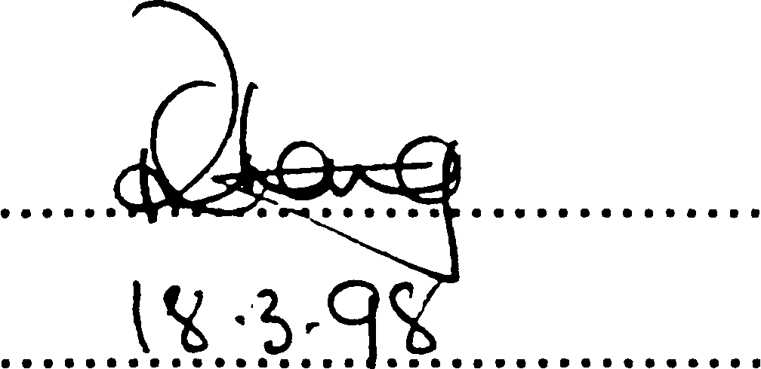

CAA Approval No. DAI/1018/39

NOTE: The above certification does not apply to revisions or amendments made after the date of initial certification by other Approved  
Organisations. Revisions or Amendments made by other Approved Organisations must each be separately certified and recorded  
on separate record sheets.

The technical data in this document (or file) may contain US data and be controlled for export under the Export Administration  
Regulations (EAR), 15 CFR Parts 730-774, ECCN: 9E991. Violations of these laws may be subject to fines and penalties under the Export  
Administration Act.

©

**SAFRAN LANDING SYSTEMS 2016 (AND SUBSEQUENT REVISION PAGE DATES)**

This document and all information contained herein is the sole property of Safran Landing Systems (and/or its affiliated companies).

No intellectual property rights are granted by the delivery of this document or the disclosure of its content. This document shall not be  
reproduced to a third party without the express written consent of Safran Landing Systems (and/or the appropriate affiliated company).

TITLE PAGE

32-12-22 Sep 16/2016

**SAFRAN LANDING SYSTEMS UK Ltd**

CAGE: K0654



PART No. 201587001 AND 201587002 COMPONENT MAINTENANCE MANUAL  
MAIN LANDING GEAR LEG

INTENTIONALLY BLANK

32-12-22

**SAFRAN LANDING SYSTEMS UK Ltd**



CAGE: K0654

Cheltenham Road, Gloucester, GL2 9QH, England

Telephone: +44 (0) 1452 712424

[www.safran-landing-systems.com](http://www.safran-landing-systems.com)

РУКОВОДСТВО ПО ТЕХНИЧЕСКОМУ ОБСЛУЖИВАНИЮ КОМПОНЕНТА 32-12-22  
ОСНОВНАЯ СТОЙКА ШАССИ

СОПРОВОДИТЕЛЬНОЕ ПИСЬМО К РЕВИЗИИ № 69

1. ПОСТОЯННЫЕ РЕВИЗИИ

A. Убедиться, что ревизия № 68 внесена в руководство и зарегистрирована как  
вставленная..

1. NEW/REVISED PAGES

|  |  |  |  |  |
| --- | --- | --- | --- | --- |
| Subject Reference | Remove and  Destroy Pages | Insert New/Revised | | Reason for Change |
| Pages | Dated |
| Record of Revisions | 1 | 1 | Mar 18/2025 | Updated revision status |
| Unit Identification Chart | 1 to 4 | 1 to 8 | Mar 18/2025 | Added Ref. Codes 2253 and 2255 details |
| List of Effective Pages | 1 to 14 | 1 to 16 | Mar 18/2025 | Updated pages |
| Table of Contents | 1 to 12 | 1 to 14 | Mar 18/2025 | Added content.  Updated page numbers.  Updated figure numbers |
| Disassembly | 314 to 316 | 314 to 316 | Mar 18/2025 | Added para 2.P.(31) |
| Check | 504, 507 to 512 | 504, 507 to 514 | Mar 18/2025 | Updated tables 501 and 502 |
| Repair | 606 to 684 | 606 to 698.2 | Mar 18/2025 | Updated table 601.  Updated caution at para 3.C. Updated figure titles. Deleted figures 626, 627, 649, 650, 653 and 654. Updated figure 626. Added figures 642 648. Updated table 602. Updated figure numbers |
| Repair No. 9-1 | 601 and 602 | 601 and 602 | Mar 18/2025 | Added fig-item (18-80A) in para 1. Updated Messier-Dowty Limited to Safran Landing Systems |
| Repair No. 9-2 | 601 to 603 | 601 to 603 | Mar 18/2025 | Added fig-item (18-80A) in para 1. Updated Messier-Dowty Limited to Safran Landing Systems |

Letter of Transmittal No. 69

Page 1 of 8

Mar 18/2025

**SAFRAN LANDING SYSTEMS UK Ltd**

CAGE: K0654



COMPONENT MAINTENANCE MANUAL 32-12-22  
MAIN LANDING GEAR LEG

|  |  |  |  |  |
| --- | --- | --- | --- | --- |
| Subject Reference | Remove and  Destroy Pages | Insert New/Revised | | Reason for Change |
| Pages | Dated |
| Repair No. 9-4 | 601 and 602 | 601 and 602 | Mar 18/2025 | Added fig-item (18-80A) in para 1. Updated Messier-Dowty Limited to Safran Landing Systems |
| Repair No. 9-5 | 601 | 601 | Mar 18/2025 | Added fig-item (18-80A) in paras 1. Updated Messier-Dowty Limited to Safran Landing Systems |
| Repair No. 9-6 | 601 and 602 | 601 and 602 | Mar 18/2025 | Added fig-item (18-80A) in para 1. Updated Messier-Dowty Limited to Safran Landing Systems |
| Repair No. 9-7 | 601 and 602 | 601 and 602 | Mar 18/2025 | Added fig-item (18-80A) in paras 1. and 1.A.(2) |
| Repair No. 9-8 | 601 to 603 and  605 | 601 to 603 and  605 | Mar 18/2025 | Added fig-item (18-80A) in para 1. Updated Messier-Dowty Limited to Safran Landing Systems. Updated conversion value in figure 602 |
| Repair No. 9-9 | 601 and 602 | 601 and 602 | Mar 18/2025 | Added fig-item (18-80A) in para 1. Updated Messier-Dowty Limited to Safran Landing Systems |
| Repair No. 9-10 | 601 to 606 | 601 to 608 | Mar 18/2025 | Added fig-item (18-80A) in para 1. Updated Messier-Dowty Limited to Safran Landing Systems |
| Repair No. 9-11 | 601, 602 and 605 | 601, 602 and 605 | Mar 18/2025 | Added fig-item (18-80A) in para 1. Updated material specification in para 1.D.(1). Updated Messier-Dowty Limited to Safran Landing System. Updated figure 603 |

Letter of Transmittal No. 69

Page 2 of 8

Mar 18/2025

**sSAFRAN SAFRAN LANDING SYSTEMS UK Ltd**

CAGE: K0654

COMPONENT MAINTENANCE MANUAL 32-12-22  
MAIN LANDING GEAR LEG

|  |  |  |  |  |
| --- | --- | --- | --- | --- |
| Subject Reference | Remove and  Destroy Pages | Insert New/Revised | | Reason for Change |
| Pages | Dated |
| Repair No. 11-1 | 601 and 602 | 601 and 602 | Mar 18/2025 | Updated fig-items in para 1. Updated Messier-Dowty Limited to Safran Landing Systems |
| Repair No. 11-2 | 601 and 602 | 601 and 602 | Mar 18/2025 | Updated fig-items in para 1. Updated Messier-Dowty Limited to Safran Landing Systems |
| Repair No. 11-3 | 601 to 603 | 601 to 603 | Mar 18/2025 | Updated fig-items in para 1. Updated Messier-Dowty Limited to Safran Landing Systems |
| Repair No. 11-4 | 601 and 602 | 601 and 602 | Mar 18/2025 | Updated fig-items in para 1. Updated Messier-Dowty Limited to Safran Landing Systems |
| Repair No. 11-5 | 601 and 602 | 601 and 602 | Mar 18/2025 | Updated fig-items in para 1. Updated Messier-Dowty Limited to Safran Landing Systems |
| Repair No. 11-6 | 601 and 602 | 601 and 602 | Mar 18/2025 | Updated fig-items in para 1. Updated Messier-Dowty Limited to Safran Landing Systems |
| Repair No. 11-7 | 601 and 602 | 601 and 602 | Mar 18/2025 | Updated fig-items in para 1. Updated Messier-Dowty Limited to Safran Landing Systems |
| Repair No. 11-8 | 601 and 602 | 601 and 602 | Mar 18/2025 | Updated fig-items in para 1. Updated Messier-Dowty Limited to Safran Landing Systems |

Mar 18/2025

Letter of Transmittal No. 69

Page 3 of 8

**SAFRAN LANDING SYSTEMS UK Ltd**

CAGE: K0654



COMPONENT MAINTENANCE MANUAL 32-12-22  
MAIN LANDING GEAR LEG

|  |  |  |  |  |
| --- | --- | --- | --- | --- |
| Subject Reference | Remove and  Destroy Pages | Insert New/Revised | | Reason for Change |
| Pages | Dated |
| Repair No. 11-9 | 601 to 603 | 601 to 603 | Mar 18/2025 | Updated fig-items in para 1. Updated Messier-Dowty Limited to Safran Landing Systems |
| Repair No. 11-11 | 601 and 602 | 601 and 602 | Mar 18/2025 | Updated fig-items in para 1. Updated Messier-Dowty Limited to Safran Landing Systems |
| Repair No. 11-12 | 601 and 602 | 601 and 602 | Mar 18/2025 | Updated fig-items in para 1. Updated Messier-Dowty Limited to Safran Landing Systems |
| Repair No. 11-13 | 601 to 603 | 601 to 603 | Mar 18/2025 | Updated fig-items in para 1. Updated Messier-Dowty Limited to Safran Landing Systems |
| Repair No. 11-14 | 601 and 602 | 601 and 602 | Mar 18/2025 | Updated fig-items in para 1. Updated Messier-Dowty Limited to Safran Landing Systems |
| Repair No. 11-17 | 601 | 601 | Mar 18/2025 | Updated fig-items in para 1. Updated Messier-Dowty Limited to Safran Landing Systems |
| Repair No. 11-18 | 601 and 602 | 601 and 602 | Mar 18/2025 | Updated fig-items in para 1 |
| Repair No. 11-19 | 601 and 602 | 601 and 602 | Mar 18/2025 | Updated fig-items in para 1 |
| Repair No. 11-20 | 601 | 601 | Mar 18/2025 | Updated Messier-Dowty  Limited to Safran Landing Systems |
| Repair No. 11-21 | 601 | 601 | Mar 18/2025 | Updated fig-items in para 1 |

Letter of Transmittal No. 69

Page 4 of 8

Mar 18/2025

**SAFRAN LANDING SYSTEMS UK Ltd**

CAGE: K0654



COMPONENT MAINTENANCE MANUAL 32-12-22  
MAIN LANDING GEAR LEG

|  |  |  |  |  |
| --- | --- | --- | --- | --- |
| Subject Reference | Remove and  Destroy Pages | Insert New/Revised | | Reason for Change |
| Pages | Dated |
| Repair No. 11-22 | 601 | 601 | Mar 18/2025 | Updated fig-items in para 1. Updated Messier-Dowty Limited to Safran Landing Systems |
| Repair No. 11-23 | 601 and 602 | 601 and 602 | Mar 18/2025 | Updated fig-items in para 1. Added caution at para 1.E. Updated Messier-Dowty Limited to Safran Landing Systems |
| Repair No. 11-24 | 601 and 602 | 601 and 602 | Mar 18/2025 | Updated fig-items in para 1. Updated Messier-Dowty Limited to Safran Landing Systems |
| Repair No. 11-25 | 601 and 602 | 601 and 602 | Mar 18/2025 | Updated fig-items in para 1. Updated Messier-Dowty Limited to Safran Landing Systems |
| Repair No. 11-27 | 601 and 602 | 601 and 602 | Mar 18/2025 | Updated fig-items in para 1. Updated Messier-Dowty Limited to Safran Landing Systems |
| Repair No. 11-28 | 601 and 602 | 601 and 602 | Mar 18/2025 | Updated fig-items in para 1. Updated Messier-Dowty Limited to Safran Landing Systems |
| Repair No. 11-31 | - | 601 to 604 | Mar 18/2025 | Added repair no. 11-31 |
| Repair No. 11-32 | - | 601 to 606 | Mar 18/2025 | Added repair no. 11-32 |
| Repair No. 11-33 | - | 601 to 606 | Mar 18/2025 | Added repair no. 11-33 |
| Repair No. 11-34 | - | 601 to 606 | Mar 18/2025 | Added repair no. 11-34 |
| Repair No. 11-35 | - | 601 to 606 | Mar 18/2025 | Added repair no. 11-35 |
| Repair No. 11-36 | - | 601 to 604 | Mar 18/2025 | Added repair no. 11-36 |
| Repair No. 11-37 | - | 601 to 606 | Mar 18/2025 | Added repair no. 11-37 |
| Repair No. 14-4 | - | 601 to 606 | Mar 18/2025 | Added repair no. 14-4 |

Mar 18/2025

Letter of Transmittal No. 69

Page 5 of 8

**SAFRAN LANDING SYSTEMS UK Ltd**

CAGE: K0654



COMPONENT MAINTENANCE MANUAL 32-12-22  
MAIN LANDING GEAR LEG

|  |  |  |  |  |
| --- | --- | --- | --- | --- |
| Subject Reference | Remove and  Destroy Pages | Insert New/Revised | | Reason for Change |
| Pages | Dated |
| Repair No. 17-1 | 601 and 602 | 601 and 602 | Mar 18/2025 | Updated Messier-Dowty  Limited to Safran Landing Systems.  Updated table 601 |
| Repair No. 18-8 | - | 601 to 604 | Mar 18/2025 | Added repair no. 18-8 |
| Repair No. 21-1 | 601 | 601 | Mar 18/2025 | Updated fig-item (2-340) only in para 1 |
| Repair No. 21-2 | 601 | 601 | Mar 18/2025 | Updated fig-item (2-340) only in para 1 |
| Repair No. 21-3 | 601 | 601 | Mar 18/2025 | Updated fig-item (2-340) only in para 1 |
| Repair No. 21-4 | 601 | 601 | Mar 18/2025 | Updated fig-item (2-350) only in para 1 |
| Repair No. 21-5 | 601 | 601 | Mar 18/2025 | Updated fig-item (2-350) only in para 1 |
| Repair No. 21-6 | 601 | 601 | Mar 18/2025 | Updated fig-item (2-350) only in para 1 |
| Assembly (Including Storage) | 701, 702, 704 to  709 and 729 to  798.6 | 701, 702, 704 to  709 and 729 to  798.12 | Mar 18/2025 | Updated paras 1.H.(1), 1.I.(1), 2.E, 2.F, 2.G, 2.H, 2.J, 2.K, 2.M, 2.N and 2.O. Added paras 2.I and 2.L. Added figure 713. Updated figures 705, 706, 707, 708 and 710. Updated figure numbers |
| Fits and Clearances | 836 to 868 | 836 to 872 | Mar 18/2025 | Updated figure 815.  Updated tables 813, 814, 818 and 823 |
| Special Tools, Fixtures and Equipment | 901 to 906 | 901 to 906 | Mar 18/2025 | Updated para 1.A |
| Illustrated Parts List | 1020 to 1098.36 | 1020 to 1098.48 | Mar 18/2025 | Updated IPL figs 13 to 18 to include Ref.  Codes: 2253 and 2255.  Updated IPL fig 15. |

Letter of Transmittal No. 69

Page 6 of 8

Mar 18/2025

**SAFRAN LANDING SYSTEMS UK Ltd**

CAGE: K0654



COMPONENT MAINTENANCE MANUAL 32-12-22

MAIN LANDING GEAR LEG

1. REVISION RECORD

A. Record the issue date and insertion date of this revision in the Record of Revisions and retain  
this Letter of Transmittal.

© **SAFRAN LANDING SYSTEMS 2025 (AND SUBSEQUENT REVISION PAGE DATES)**

This document and all information contained herein is the sole property of Safran Landing Systems (and/or its affiliated companies).

No intellectual property rights are granted by the delivery of this document or the disclosure of its content. This document shall not be  
reproduced to a third party without the express written consent of Safran Landing Systems (and/or the appropriate affiliated company).

Issued by

**Safran Landing Systems UK Ltd**

Cheltenham Road, Gloucester, GL2 9QH, England

Telephone: +44 (0) 1452 712424 Fax: +44 (0) 1452 713821

Mar 18/2025

Letter of Transmittal No. 69

Page 7 of 8

**SAFRAN LANDING SYSTEMS UK Ltd**

CAGE: K0654



COMPONENT MAINTENANCE MANUAL 32-12-22  
MAIN LANDING GEAR LEG

INTENTIONALLY BLANK

Letter of Transmittal No. 69

Page 8 of 8

Mar 18/2025

**SAFRAN LANDING SYSTEMS UK Ltd**

CAGE: K0654

PART No. 201587001 AND 201587002 COMPONENT MAINTENANCE MANUAL  
MAIN LANDING GEAR LEG

RECORD OF REVISIONS

|  |  |  |  |  |  |  |  |
| --- | --- | --- | --- | --- | --- | --- | --- |
| REV NO. | ISSUE DATE | INSERTION DATE | BY | REV NO. | ISSUE DATE | INSERTION DATE | BY |
| 1-15 | INCORPORATED | | M-D | 46 | Jun 17/2016 | Jun 17/2016 | M-D |
| 16 | Aug 1/2006 | Aug 1/2006 | M-D | 47 | Sep 16/2016 | Sep 16/2016 | SAFRAN |
| 17 | Apr 2/2007 | Apr 2/2007 | M-D | 48 | Dec 9/2016 | Dec 9/2016 | SAFRAN |
| 18 | Oct 1/2007 | Oct 1/2007 | M-D | 49 | Mar 24/2017 | Mar 24/2017 | SAFRAN |
| 19 | Jan 1/2008 | Jan 1/2008 | M-D | 50 | Jun 23/2017 | Jun 23/2017 | SAFRAN |
| 20 | Jul 1/2008 | Jul 1/2008 | M-D | 51 | Dec 8/2017 | Dec 8/2017 | SAFRAN |
| 21 | Jan 1/2009 | Jan 1/2009 | M-D | 52 | Mar 23/2018 | Mar 23/2018 | SAFRAN |
| 22 | Feb 1/2009 | Feb 1/2009 | M-D | 53 | Dec 21/2018 | Dec 21/2018 | SAFRAN |
| 23 | Jul 1/2009 | Jul 1/2009 | M-D | 54 | May 31/2019 | May 31/2019 | SAFRAN |
| 24 | Oct 1/2009 | Oct 1/2009 | M-D | 55 | Dec 6/2019 | Dec 6/2019 | SAFRAN |
| 25 | Jan 1/2010 | Jan 1/2010 | M-D | 56 | Mar 20/2020 | Mar 20/2020 | SAFRAN |
| 26 | Jul 1/2010 | Jul 1/2010 | M-D | 57 | Sep 18/2020 | Sep 18/2020 | SAFRAN |
| 27 | Oct 1/2010 | Oct 1/2010 | M-D | 58 | Dec 4/2020 | Dec 4/2020 | SAFRAN |
| 28 | Jan 1/2011 | Jan 1/2011 | M-D | 59 | Mar 19/2021 | Mar 19/2021 | SAFRAN |
| 29 | Mar 31/2011 | Mar 31/2011 | M-D | 60 | Jun 18/2021 | Jun 18/2021 | SAFRAN |
| 30 | Jul 1/2011 | Jul 1/2011 | M-D | 61 | Sep 17/2021 | Sep 17/2021 | SAFRAN |
| 31 | Jul 8/2011 | Jul 8/2011 | M-D | 62 | Mar 18/2022 | Mar 18/2022 | SAFRAN |
| 32 | Oct 1/2011 | Oct 1/2011 | M-D | 63 | Jun 17/2022 | Jun 17/2022 | SAFRAN |
| 33 | Apr 2/2012 | Apr 2/2012 | M-D | 64 | Dec 9/2022 | Dec 9/2022 | SAFRAN |
| 34 | Oct 1/2012 | Oct 1/2012 | M-D | 65 | Dec 23/2022 | Dec 23/2022 | SAFRAN |
| 35 | Jun 28/2013 | Jun 28/2013 | M-D | 66 | Jun 16/2023 | Jun 16/2023 | SAFRAN |
| 36 | Dec 24/2013 | Dec 24/2013 | M-D | 67 | Aug 11/2023 | Aug 11/2023 | SAFRAN |
| 37 | Mar 28/2014 | Mar 28/2014 | M-D | 68 | Mar 15/2024 | Mar 15/2024 | SAFRAN |
| 38 | May 14/2014 | May 14/2014 | M-D | 69 | Mar 18/2025 | Mar 18/2025 | SAFRAN |
| 39 | Sep 26/2014 | Sep 26/2014 | M-D |  |  |  |  |
| 40 | Oct 10/2014 | Oct 10/2014 | M-D |  |  |  |  |
| 41 | Oct 14/2014 | Oct 14/2014 | M-D |  |  |  |  |
| 42 | Mar 20/2015 | Mar 20/2015 | M-D |  |  |  |  |
| 43 | Jun 19/2015 | Jun 19/2015 | M-D |  |  |  |  |
| 44 | Sep 18/2015 | Sep 18/2015 | M-D |  |  |  |  |
| 45 | Dec 11/2015 | Dec 11/2015 | M-D |  |  |  |  |

RECORD OF REVISIONS

32-12-22

Page 1

Mar 18/2025

**SAFRAN LANDING SYSTEMS UK Ltd**

CAGE: K0654



PART No. 201587001 AND 201587002 COMPONENT MAINTENANCE MANUAL  
MAIN LANDING GEAR LEG

INTENTIONALLY BLANK

RECORD OF REVISIONS

32-12-22 Page 2

**SAFRAN LANDING SYSTEMS UK Ltd**

CAGE: K0654



PART No. 201587001 AND 201587002 COMPONENT MAINTENANCE MANUAL  
MAIN LANDING GEAR LEG

RECORD OF TEMPORARY REVISIONS

|  |  |  |  |  |  |  |
| --- | --- | --- | --- | --- | --- | --- |
| REV. No. | ISSUE DATE | DATE INSERTED | PAGE NUMBER | BY | DATE REMOVED | BY |
|  |  |  |  |  |  |  |
|  |  |  |  |  |  |  |
|  |  |  |  |  |  |  |
|  |  |  |  |  |  |  |
|  |  |  |  |  |  |  |
|  |  |  |  |  |  |  |
|  |  |  |  |  |  |  |
|  |  |  |  |  |  |  |
|  |  |  |  |  |  |  |
|  |  |  |  |  |  |  |
|  |  |  |  |  |  |  |
|  |  |  |  |  |  |  |
|  |  |  |  |  |  |  |
|  |  |  |  |  |  |  |
|  |  |  |  |  |  |  |
|  |  |  |  |  |  |  |
|  |  |  |  |  |  |  |
|  |  |  |  |  |  |  |
|  |  |  |  |  |  |  |
|  |  |  |  |  |  |  |
|  |  |  |  |  |  |  |
|  |  |  |  |  |  |  |
|  |  |  |  |  |  |  |
|  |  |  |  |  |  |  |
|  |  |  |  |  |  |  |
|  |  |  |  |  |  |  |
|  |  |  |  |  |  |  |
|  |  |  |  |  |  |  |
|  |  |  |  |  |  |  |
|  |  |  |  |  |  |  |
|  |  |  |  |  |  |  |

32-12-22

RECORD OF TEMPORARY REVISIONS

Page 1

Dec 6/2019

**SAFRAN LANDING SYSTEMS UK Ltd**

CAGE: K0654



PART No. 201587001 AND 201587002 COMPONENT MAINTENANCE MANUAL  
MAIN LANDING GEAR LEG

INTENTIONALLY BLANK

32-12-22

RECORD OF TEMPORARY REVISIONS

Page 2

**SAFRAN LANDING SYSTEMS UK Ltd**

CAGE: K0654



PART No. 201587001 AND 201587002 COMPONENT MAINTENANCE MANUAL  
MAIN LANDING GEAR LEG

LIST OF SERVICE BULLETINS

|  |  |  |  |  |
| --- | --- | --- | --- | --- |
| SB NUMBER | SB TITLE | SB REVISION NUMBER | DATE INCORPORATED INTO MANUAL | COVER SB NO. |
| 201-32-22 | MLG - Installation of stub bolt subassembly for the forward pintle pin in place of the cross bolt. | Initial Issue | Aug 1/2000 | A320-32-1213 |
| 1 | No effect |
| 201-32-24 | MLG - To allow an increase in aircraft maximum take-off weight to 93 tonne. | Initial Issue | Aug 1/2000 | - |
| 201-32-29 | MLG -To add tracking numbers to parts listed in Airbus Airworthiness Limitations Section (ALS). | Initial Issue | Apr 2/2007 | - |
| 1 | No effect |
| 201-32-31 | MLG - Installation of a 201585 series MLG Leg and Dressings where a 201387 MLG Leg and Dressings has been installed. | Initial Issue | Apr 2/2007 | - |
| 201-32-39 | MLG -To add tracking numbers to parts listed in Airbus Maintenance Planning Document, Section 9-1. (Torque link apex pin nut) | Initial Issue | Nov 1/2004 | A320-32-1265 |
| 1 | No effect |
| 201-32-49 | MLG - Introduction of a new lower bearing subassembly. | Initial Issue | Jan 1/2009 | A320-32-1340 |
| 1 | No effect |
| 201-32-53 | MLG - Introduction of new charging labels | Initial Issue | Apr 2/2012 | - |
| 201-32-54 | MLG - Introduction of new 1M and 2M Axle harnesses | Initial Issue | Mar 28/2014 | A320-32-1395 |
| 1 | No effect |
| 2 | No effect |
| 201-32-55 | MLG - Introduction of new 1M and 2M Leg Harness and of new 1M and 2M Axle Harnesses | Initial Issue | Jan 1/2011 | - |

32-12-22

LIST OF SERVICE BULLETINS

Page 1

Dec 6/2019

**SAFRAN LANDING SYSTEMS UK Ltd**

CAGE: K0654

PART No. 201587001 AND 201587002 COMPONENT MAINTENANCE MANUAL  
MAIN LANDING GEAR LEG

LIST OF SERVICE BULLETINS (Continued)

|  |  |  |  |  |
| --- | --- | --- | --- | --- |
| SB NUMBER | SB TITLE | SB REVISION NUMBER | DATE INCORPORATED INTO MANUAL | COVER SB NO. |
| 201-32-58 | MLG Leg-Introduction of new retaining pins and a new lower bearing subassembly with a new self lubricating liner | Initial Issue | Oct 1/2011 | A320-32-1374  A320-32-1386 |
| 201-32-59 | MLG Leg - Introduction of new retaining pins for the lower bearing subassembly | Initial Issue | Dec 24/2013 | - |
| 201-32-60 | MLG Leg - Introduction of a new lower bearing subassembly with a new low friction inner liner | Initial Issue | May 14/2014 | A320-32-1414 |
| 201-32-62 | MLG Leg - Barkhausen Noise Inspection of Main Landing Gear Sliding Tube Axles. | Initial Issue | No effect | - |
| 201-32-65 | MLG Leg - Introduction of a new Main Fitting | Initial Issue | Mar 20/2015 | A320-32-1428 |
| 201-32-70 | MLG Leg - Introduction of a new torque link damper unit | 1 | Dec 21/2018 | A320-32-1446 |
| 201-32-72 | MLG Leg - Introduction of a new main fitting subassembly and related parts | Initial Issue | Mar 20/2020 | A320-32-1488 |
| 201-32-76 | MLG - Introduction of a new upper pivot bracket | Initial Issue | Dec 4/2020 |  |
| 201-32-77 | MLG - Introduction of a new changeover valve stem and housing | Initial Issue | Dec 4/2020 | - |
| 201-32-80 | MLG Complete - Modification of the transfer block subassembly | Initial Issue | Dec 4/2020 | A320-32-1494  A320-32-1495 |

32-12-22

LIST OF SERVICE BULLETINS

Page 2

Dec 4/2020

**SAFRAN LANDING SYSTEMS UK Ltd**

CAGE: K0654



PART No. 201587001 AND 201587002 COMPONENT MAINTENANCE MANUAL  
MAIN LANDING GEAR LEG

LIST OF SERVICE BULLETINS (Continued)

|  |  |  |  |  |
| --- | --- | --- | --- | --- |
| SB NUMBER | SB TITLE | SB REVISION NUMBER | DATE INCORPORATED INTO MANUAL | COVER SB NO. |
| 201-32-78 | MLG - Conversion of low - friction lower - bearing MLG to standard lower - bearing MLG | Initial Issue | Mar 19/2021 | - |
| 201-32-81 | MLG complete - Introduction of a new transfer block subassembly | Initial Issue | Mar 19/2021 | A321-32-1502  A321-32-1503 |
|  |  |  |  |  |
|  |  |  |  |  |
|  |  |  |  |  |
|  |  |  |  |  |
|  |  |  |  |  |
|  |  |  |  |  |
|  |  |  |  |  |
|  |  |  |  |  |
|  |  |  |  |  |
|  |  |  |  |  |
|  |  |  |  |  |
|  |  |  |  |  |
|  |  |  |  |  |
|  |  |  |  |  |
|  |  |  |  |  |
|  |  |  |  |  |
|  |  |  |  |  |
|  |  |  |  |  |
|  |  |  |  |  |
|  |  |  |  |  |

32-12-22

LIST OF SERVICE BULLETINS

Page 3

Mar 19/2021

**SAFRAN LANDING SYSTEMS UK Ltd**

CAGE: K0654



PART No. 201587001 AND 201587002 COMPONENT MAINTENANCE MANUAL  
MAIN LANDING GEAR LEG

INTENTIONALLY BLANK

32-12-22

LIST OF SERVICE BULLETINS

Page 4

**sSAFRAN SAFRAN LANDING SYSTEMS UK Ltd**

CAGE: K0654

№ детали 201587001 и 201587002

РУКОВОДСТВО ПО ТЕХНИЧЕСКОМУ ОБСЛУЖИВАНИЮ КОМПОНЕНТА

ОСНОВНАЯ СТОЙКА ШАССИ

ТАБЛИЦА ИДЕНТИФИКАЦИИ АГРЕГАТА

|  |  |  |  |  |
| --- | --- | --- | --- | --- |
| PART NUMBER | DASH NO. | SAFRAN LANDING SYSTEMS MODIFICATION NUMBER | SAFRAN LANDING SYSTEMS SERVICE BULLETIN NUMBER | MOD.  STRIKE NO. |
| 201587001 | - | - | - | - |
| 201587002 | - |  |  | - |
| 201587001 | - | EDES2-0005-2542 | - | - |
| 201587002 | - |  |  | - |
| 201587001 | - | EDES2-0005-2253 | - | - |
| 201587002 | - |  |  | - |
| 201587001 | - | EDES2-0005-2255 | - | - |
| 201587002 | - |  |  | - |
| 201587001 | 010 | (c)AC12221 | 201-32-22 | - |
| 201587002 | 010 |  |  | - |
| 201587001 | 010 | EDES2-0005-2253 | - | - |
| 201587002 | 010 |  |  | - |
| 201587001 | 010 | EDES2-0005-2255 | - | - |
| 201587002 | 010 |  |  | - |
| 201587001 | 020 | (c)AC12454 | 201-32-29 | - |
| 201587002 | 020 |  |  | - |
| 201587001 | 020 | EDES2-0005-2253 | - | - |
| 201587002 | 020 |  |  | - |
| 201587001 | 020 | EDES2-0005-2255 | - | - |
| 201587002 | 020 |  |  | - |
| 201587001 | 030 | (c)AC12492 | 201-32-39 | - |
| 201587002 | 030 |  |  | - |
| 201587001 | 030 | (c)AC12636 | 201-32-49 | - |
| 201587002 | 030 |  |  | - |
| 201587001 | 030 | MAF1-0005-2157 | 201-32-55 | - |
| 201587002 | 030 |  |  | - |

32-12-22

UNIT IDENTIFICATION CHART

Page 1

Mar 18/2025

**sSAFRAN SAFRAN LANDING SYSTEMS UK Ltd**

CAGE: K0654

PART No. 201587001 AND 201587002 COMPONENT MAINTENANCE MANUAL

MAIN LANDING GEAR LEG

UNIT IDENTIFICATION CHART (Continued)

|  |  |  |  |  |
| --- | --- | --- | --- | --- |
| PART NUMBER | DASH NO. | SAFRAN LANDING SYSTEMS MODIFICATION NUMBER | SAFRAN LANDING SYSTEMS SERVICE BULLETIN NUMBER | MOD.  STRIKE NO. |
| 201587001 | 030 | MAF1-0005-2156 | 201-32-53 | - |
| 201587002 | 030 |  |  | - |
| 201587001 | 030 | MAF1-0005-2155 | 201-32-54 | - |
| 201587002 | 030 |  |  | - |
| 201587001 | 030 | MAF1-0005-2161 | 201-32-59 | - |
| 201587002 | 030 |  |  | - |
| 201587001 | 030 | MAF1-0005-2164 | 201-32-60 | - |
| 201587002 | 030 |  |  | - |
| 201587001 | 030 | MAF1-0005-2162 | - | - |
| 201587002 | 030 |  |  | - |
| 201587001 | 030 | MAF1-0005-2180 | 201-32-65 | - |
| 201587002 | 030 |  |  | - |
| 201587001 | 030 | MAF1-0005-2207 | 201-32-70 | - |
| 201587002 | 030 |  |  | - |
| 201587001 | 030 | EDES2-0005-2253 | - | - |
| 201587002 | 030 |  |  | - |
| 201587001 | 030 | EDES2-0005-2255 | - | - |
| 201587002 | 030 |  |  | - |
|  |  |  |  |  |
| 201587003 | - | (c)AC12229 | 201-32-24 | - |
| 201587004 | - |  |  | - |
| 201587003 | - | EDES2-0005-2542 | - | - |
| 201587004 | - |  |  | - |
| 201587003 | - | EDES2-0005-2253 | - | - |
| 201587004 | - |  |  | - |

32-12-22

UNIT IDENTIFICATION CHART

Page 2

Mar 18/2025

**sSAFRAN SAFRAN LANDING SYSTEMS UK Ltd**

CAGE: K0654

PART No. 201587001 AND 201587002 COMPONENT MAINTENANCE MANUAL

MAIN LANDING GEAR LEG

UNIT IDENTIFICATION CHART (Continued)

|  |  |  |  |  |  |
| --- | --- | --- | --- | --- | --- |
|  | PART NUMBER | DASH NO. | SAFRAN LANDING SYSTEMS MODIFICATION NUMBER | SAFRAN LANDING SYSTEMS SERVICE BULLETIN NUMBER | MOD.  STRIKE NO. |
| **1** | 201587003 | - | EDES2-0005-2255 | - | - |
| **1** | 201587004 | - |  |  | - |
|  | 201587003 | 010 | (c)AC12454 | 201-32-29 | - |
|  | 201587004 | 010 |  |  | - |
| **1** | 201587003 | 010 | EDES2-0005-2253 | - | - |
| **1** | 201587004 | 010 |  |  | - |
| **1** | 201587003 | 010 | EDES2-0005-2255 | - | - |
| **1** | 201587004 | 010 |  |  | - |
|  | 201587003 | 020 | (c)AC12492 | 201-32-39 | - |
|  | 201587004 | 020 |  |  | - |
| **1** | 201587003 | 020 | EDES2-0005-2253 | - | - |
| **1** | 201587004 | 020 |  |  | - |
| **1** | 201587003 | 020 | EDES2-0005-2255 | - | - |
| **1** | 201587004 | 020 |  |  | - |
|  | 201587003 | 030 | (c)AC12636 | 201-32-49 | - |
|  | 201587004 | 030 |  |  | - |
|  | 201587003 | 030 | MAF1-0005-2155 | 201-32-54 | - |
|  | 201587004 | 030 |  |  | - |
| **1** | 201587003 | 030 | EDES2-0005-2253 | - | - |
| **1** | 201587004 | 030 |  |  | - |
| **1** | 201587003 | 030 | EDES2-0005-2255 | - | - |
| **1** | 201587004 | 030 |  |  | - |
|  | 201587003 | 040 | MAF1-0005-2157 | 201-32-55 | - |
|  | 201587004 | 040 |  |  | - |
|  | 201587003 | 040 | MAF1-0005-2160 | 201-32-58 | - |
|  | 201587004 | 040 |  |  | - |

32-12-22

UNIT IDENTIFICATION CHART

Page 3

Mar 18/2025

**sSAFRAN SAFRAN LANDING SYSTEMS UK Ltd**

CAGE: K0654

PART No. 201587001 AND 201587002 COMPONENT MAINTENANCE MANUAL

MAIN LANDING GEAR LEG

UNIT IDENTIFICATION CHART (Continued)

|  |  |  |  |  |  |
| --- | --- | --- | --- | --- | --- |
|  | PART NUMBER | DASH NO. | SAFRAN LANDING SYSTEMS MODIFICATION NUMBER | SAFRAN LANDING SYSTEMS SERVICE BULLETIN NUMBER | MOD.  STRIKE NO. |
| **1** | 201587003 | 040 | EDES2-0005-2253 | - | - |
| **1** | 201587004 | 040 |  |  | - |
| **1** | 201587003 | 040 | EDES2-0005-2255 | - | - |
| **1** | 201587004 | 040 |  |  | - |
|  | 201587003 | 050 | MAF1-0005-2156 | 201-32-53 | - |
|  | 201587004 | 050 |  |  | - |
| **1** | 201587003 | 050 | EDES2-0005-2253 | - | - |
| **1** | 201587004 | 050 |  |  | - |
| **1** | 201587003 | 050 | EDES2-0005-2255 | - | - |
| **1** | 201587004 | 050 |  |  | - |
|  | 201587003 | 060 | MAF1-0005-2161 | 201-32-59 | - |
|  | 201587004 | 060 |  |  | - |
| **1** | 201587003 | 060 | EDES2-0005-2253 | - | - |
| **1** | 201587004 | 060 |  |  | - |
| **1** | 201587003 | 060 | EDES2-0005-2255 | - | - |
| **1** | 201587004 | 060 |  |  | - |
|  | 201587003 | 070 | MAF1-0005-2162 | - | - |
|  | 201587004 | 070 |  |  | - |
| **1** | 201587003 | 070 | EDES2-0005-2253 | - | - |
| **1** | 201587004 | 070 |  |  | - |
| **1** | 201587003 | 070 | EDES2-0005-2255 | - | - |
| **1** | 201587004 | 070 |  |  | - |
|  | 201587003 | 080 | MAF1-0005-2180 | 201-32-65 | - |
|  | 201587004 | 080 |  |  | - |
|  | 201587003 | 080 | MAF1-0005-2207 | 201-32-70 | - |
|  | 201587004 | 080 |  |  | - |

UNIT IDENTIFICATION CHART

32

Page 4

-12-22 Mar 18/2025

**SAFRAN LANDING SYSTEMS UK Ltd**

CAGE: K0654

**3» SAFRAN**

PART No. 201587001 AND 201587002 COMPONENT MAINTENANCE MANUAL

MAIN LANDING GEAR LEG

UNIT IDENTIFICATION CHART (Continued)

|  |  |  |  |  |  |
| --- | --- | --- | --- | --- | --- |
|  | PART NUMBER | DASH NO. | SAFRAN LANDING SYSTEMS MODIFICATION NUMBER | SAFRAN LANDING SYSTEMS SERVICE BULLETIN NUMBER | MOD.  STRIKE NO. |
| **1** | 201587003 | 080 | EDES2-0005-2253 | - | - |
| **1** | 201587004 | 080 |  |  | - |
| **1** | 201587003 | 080 | EDES2-0005-2255 | - | - |
| **1** | 201587004 | 080 |  |  | - |
|  |  |  |  |  |  |
|  | 201587005 | - | (c)AC12332 | 201-32-31 | - |
|  | 201587006 | - |  |  | - |
| **1** | 201587005 | - | EDES2-0005-2253 | - | - |
| **1** | 201587006 | - |  |  | - |
| **1** | 201587005 | - | EDES2-0005-2255 | - | - |
| **1** | 201587006 | - |  |  | - |
|  | 201587005 | 010 | (c)AC12454 | 201-32-29 | - |
|  | 201587006 | 010 |  |  | - |
| **1** | 201587005 | 010 | EDES2-0005-2253 | - | - |
| **1** | 201587006 | 010 |  |  | - |
| **1** | 201587005 | 010 | EDES2-0005-2255 | - | - |
| **1** | 201587006 | 010 |  |  | - |
|  | 201587005 | 020 | (c)AC12492 | 201-32-39 | - |
|  | 201587006 | 020 |  |  | - |
|  | 201587005 | 020 | (c)AC12636 | 201-32-49 | - |
|  | 201587006 | 020 |  |  | - |
|  | 201587005 | 020 | MAF1-0005-2157 | 201-32-55 | - |
|  | 201587006 | 020 |  |  | - |
|  | 201587005 | 020 | MAF1-0005-2156 | 201-32-53 | - |
|  | 201587006 | 020 |  |  | - |

32-12-22

UNIT IDENTIFICATION CHART

Page 5

Mar 18/2025

**sSAFRAN SAFRAN LANDING SYSTEMS UK Ltd**

CAGE: K0654

PART No. 201587001 AND 201587002 COMPONENT MAINTENANCE MANUAL

MAIN LANDING GEAR LEG

UNIT IDENTIFICATION CHART (Continued)

|  |  |  |  |  |
| --- | --- | --- | --- | --- |
| PART NUMBER | DASH NO. | SAFRAN LANDING SYSTEMS MODIFICATION NUMBER | SAFRAN LANDING SYSTEMS SERVICE BULLETIN NUMBER | MOD.  STRIKE NO. |
| 201587005 | 020 | MAF1-0005-2155 | 201-32-54 | - |
| 201587006 | 020 |  |  | - |
| 201587005 | 020 | MAF1-0005-2161 | 201-32-59 | - |
| 201587006 | 020 |  |  | - |
| 201587005 | 020 | MAF1-0005-2164 | 201-32-60 | - |
| 201587006 | 020 |  |  | - |
| 201587005 | 020 | MAF1-0005-2162 | - | - |
| 201587006 | 020 |  |  | - |
| 201587005 | 020 | MAF1-0005-2180 | 201-32-65 | - |
| 201587006 | 020 |  |  | - |
| 201587005 | 020 | MAF1-0005-2207 | 201-32-70 | - |
| 201587006 | 020 |  |  | - |
| 201587005 | 020 | EDES2-0005-2253 | - | - |
| 201587006 | 020 |  |  | - |
| 201587005 | 020 | EDES2-0005-2255 | - | - |
| 201587006 | 020 |  |  | - |
|  |  |  |  |  |
| 201587007 | - | MAF1-0005-2160 | 201-32-58 | - |
| 201587008 | - |  |  | - |
| 201587007 | - | EDES2-0005-2542 | - | - |
| 201587008 | - |  |  | - |
| 201587007 | - | EDES2-0005-2253 | - | - |
| 201587008 | - |  |  | - |
| 201587007 | - | EDES2-0005-2255 | - | - |
| 201587008 | - |  |  | - |

32-12-22

UNIT IDENTIFICATION CHART

Page 6

Mar 18/2025

**SAFRAN LANDING SYSTEMS UK Ltd**

CAGE: K0654

PART No. 201587001 AND 201587002 COMPONENT MAINTENANCE MANUAL  
MAIN LANDING GEAR LEG

UNIT IDENTIFICATION CHART (Continued)

|  |  |  |  |  |
| --- | --- | --- | --- | --- |
| PART NUMBER | DASH NO. | SAFRAN LANDING SYSTEMS MODIFICATION NUMBER | SAFRAN LANDING SYSTEMS SERVICE BULLETIN NUMBER | MOD.  STRIKE NO. |
| 201587007 | 010 | MAF1-0005-2156 | 201-32-53 | - |
| 201587008 | 010 |  |  | - |
| 201587007 | 010 | EDES2-0005-2253 | - | - |
| 201587008 | 010 |  |  | - |
| 201587007 | 010 | EDES2-0005-2255 | - | - |
| 201587008 | 010 |  |  | - |
| 201587007 | 020 | MAF1-0005-2162 | - | - |
| 201587008 | 020 |  |  | - |
| 201587007 | 020 | MAF1-0005-2180 | 201-32-65 | - |
| 201587008 | 020 |  |  | - |
| 201587007 | 020 | MAF1-0005-2207 | 201-32-70 | - |
| 201587008 | 020 |  |  | - |
| 201587007 | 020 | EDES2-0005-2253 | - | - |
| 201587008 | 020 |  |  | - |
| 201587007 | 020 | EDES2-0005-2255 | - | - |
| 201587008 | 020 |  |  | - |
| 201587007 | 030 | EDES2-0005-2253 | - | - |
| 201587008 | 030 |  |  | - |
| 201587007 | 030 | EDES2-0005-2255 | - | - |
| 201587008 | 030 |  |  | - |

32-12-22

UNIT IDENTIFICATION CHART

Page 7

Mar 18/2025

**SAFRAN LANDING SYSTEMS UK Ltd**

CAGE: K0654



PART No. 201587001 AND 201587002 COMPONENT MAINTENANCE MANUAL  
MAIN LANDING GEAR LEG

INTENTIONALLY BLANK

32-12-22

Page 8

UNIT IDENTIFICATION CHART

**SAFRAN LANDING SYSTEMS UK Ltd**

CAGE: K0654



PART No. 201587001 AND 201587002 COMPONENT MAINTENANCE MANUAL  
MAIN LANDING GEAR LEG

LIST OF EFFECTIVE PAGES

|  |  |  |  |  |  |
| --- | --- | --- | --- | --- | --- |
| Subject | Page | Date | Subject | Page | Date |
| Title Page | 1 | Sep 16/2016 | List of Effective | 13 | Mar 18/2025 |
|  | 2 | Blank | Pages (Continued) | 14 | Mar 18/2025 |
|  |  |  |  | 15 | Mar 18/2025 |
| Record of Revisions | 1 | Mar 18/2025 |  | 16 | Mar 18/2025 |
|  | 2 | Blank |  |  |  |
|  |  |  | Table of Contents | 1 | Mar 18/2025 |
| Record of Temporary | 1 | Dec 6/2019 |  | 2 | Mar 18/2025 |
| Revisions | 2 | Blank |  | 3 | Mar 18/2025 |
|  |  |  |  | 4 | Mar 18/2025 |
| List of Service Bulletins | 1 | Dec 6/2019 |  | 5 | Mar 18/2025 |
|  | 2 | Dec 4/2020 |  | 6 | Mar 18/2025 |
|  | 3 | Mar 19/2021 |  | 7 | Mar 18/2025 |
|  | 4 | Blank |  | 8 | Mar 18/2025 |
|  |  |  |  | 9 | Mar 18/2025 |
| Unit Identification | 1 | Mar 18/2025 |  | 10 | Mar 18/2025 |
|  |  |  |  | 11 | Mar 18/2025 |
| Chart | 2 | Mar 18/2025 |  |  |  |
|  | 3 | Mar 18/2025 |  | 12 | Mar 18/2025 |
|  |  |  |  | 13 | Mar 18/2025 |
|  | 4 | Mar 18/2025 |  |  |  |
|  |  |  |  | 14 | Blank |
|  | 5 | Mar 18/2025 |  |  |  |
|  | 6 | Mar 18/2025 |  |  |  |
|  | 7 | Mar 18/2025 | Introduction | 1 | Mar 18/2022 |
|  |  |  |  | 2 | Blank |
|  | 8 | Blank |  |  |  |
| List of Effective | 1 | Mar 18/2025 | Description and | 1 | Dec 6/2019 |
| Pages | 2 | Mar 18/2025 | Operation | 2 | Dec 6/2019 |
|  | 3 | Mar 18/2025 |  | 3 | Dec 6/2019 |
|  |  |  |  | 4 | Dec 6/2019 |
|  | 4 | Mar 18/2025 |  |  |  |
|  | 5 | Mar 18/2025 |  |  |  |
|  | 6 | Mar 18/2025 | Testing and Fault | 101 | Dec 6/2019 |
|  | 7 | Mar 18/2025 | Isolation | 102 | Dec 6/2019 |
|  |  |  |  | 103 | Dec 6/2019 |
|  | 8 | Mar 18/2025 |  |  |  |
|  | 9 | Mar 18/2025 |  | 104 | Dec 6/2019 |
|  |  |  |  | 105 | Dec 6/2019 |
|  | 10 | Mar 18/2025 |  |  |  |
|  |  |  |  | 106 | Dec 6/2019 |
|  | 11 | Mar 18/2025 |  |  |  |
|  |  |  |  | 107 | Dec 6/2019 |
|  | 12 | Mar 18/2025 |  |  |  |

32-12-22

LIST OF EFFECTIVE PAGES

Page 1

Mar 18/2025

**sSAFRAN SAFRAN LANDING SYSTEMS UK Ltd**

CAGE: K0654

PART No. 201587001 AND 201587002 COMPONENT MAINTENANCE MANUAL  
MAIN LANDING GEAR LEG

LIST OF EFFECTIVE PAGES (Continued)

|  |  |  |  |  |  |
| --- | --- | --- | --- | --- | --- |
| Subject | Page | Date | Subject | Page | Date |
| Testing and Fault | 108 | Dec 6/2019 | Check | 512 | Mar 18/2025 |
| Isolation (Continued) | 109 | Dec 6/2019 | (Continued) | 513 | Mar 18/2025 |
|  | 110 | Blank |  | 514 | Blank |
| Disassembly | 301 | Dec 6/2019 | Repair | 601 | Dec 6/2019 |
|  | 302 | Mar 15/2024 |  | 602 | Dec 6/2019 |
|  | 303 | Mar 15/2024 |  | 603 | Mar 19/2021 |
|  | 304 | Mar 20/2020 |  | 604 | Mar 15/2024 |
|  | 305 | Mar 20/2020 |  | 605 | Mar 15/2024 |
|  | 306 | Mar 20/2020 |  | 606 | Mar 18/2025 |
|  | 307 | Mar 19/2021 |  | 607 | Mar 18/2025 |
|  | 308 | Mar 19/2021 |  | 608 | Mar 18/2025 |
|  | 309 | Mar 20/2020 |  | 609 | Mar 18/2025 |
|  | 310 | Mar 20/2020 |  | 610 | Mar 18/2025 |
|  | 311 | Mar 20/2020 |  | 611 | Mar 18/2025 |
|  | 312 | Mar 20/2020 |  | 612 | Mar 18/2025 |
|  | 313 | Mar 15/2024 |  | 613 | Mar 18/2025 |
|  | 314 | Mar 18/2025 |  | 614 | Mar 18/2025 |
|  | 315 | Mar 18/2025 |  | 615 | Mar 18/2025 |
|  | 316 | Mar 18/2025 |  | 616 | Mar 18/2025 |
|  |  |  |  | 617 | Mar 18/2025 |
| Cleaning | 401 | Dec 6/2019 |  | 618 | Mar 18/2025 |
|  | 402 | Blank |  | 619 | Mar 18/2025 |
|  |  |  |  | 620 | Mar 18/2025 |
| Check | 501 | Sep 18/2020 |  | 621 | Mar 18/2025 |
|  | 502 | Mar 18/2022 |  | 622 | Mar 18/2025 |
|  | 503 | Mar 19/2021 |  | 623 | Mar 18/2025 |
|  | 504 | Mar 18/2025 |  | 624 | Mar 18/2025 |
|  | 505 | Mar 19/2021 |  | 625 | Mar 18/2025 |
|  | 506 | Mar 19/2021 |  | 626 | Mar 18/2025 |
|  | 507 | Mar 18/2025 |  | 627 | Mar 18/2025 |
|  | 508 | Mar 18/2025 |  | 628 | Mar 18/2025 |
|  | 509 | Mar 18/2025 |  | 629 | Mar 18/2025 |
|  | 510 | Mar 18/2025 |  | 630 | Mar 18/2025 |
|  | 511 | Mar 18/2025 |  | 631 | Mar 18/2025 |

32-12-22

LIST OF EFFECTIVE PAGES

Page 2

Mar 18/2025

**SAFRAN LANDING SYSTEMS UK Ltd**

CAGE: K0654



PART No. 201587001 AND 201587002 COMPONENT MAINTENANCE MANUAL  
MAIN LANDING GEAR LEG

LIST OF EFFECTIVE PAGES (Continued)

|  |  |  |  |  |  |
| --- | --- | --- | --- | --- | --- |
| Subject | Page | Date | Subject | Page | Date |
| Repair (Continued) | 632 | Mar 18/2025 | Repair (Continued) | 667 | Mar 18/2025 |
|  | 633 | Mar 18/2025 |  | 668 | Mar 18/2025 |
|  | 634 | Mar 18/2025 |  | 669 | Mar 18/2025 |
|  | 635 | Mar 18/2025 |  | 670 | Mar 18/2025 |
|  | 636 | Mar 18/2025 |  | 671 | Mar 18/2025 |
|  | 637 | Mar 18/2025 |  | 672 | Mar 18/2025 |
|  | 638 | Mar 18/2025 |  | 673 | Mar 18/2025 |
|  | 639 | Mar 18/2025 |  | 674 | Mar 18/2025 |
|  | 640 | Mar 18/2025 |  | 675 | Mar 18/2025 |
|  | 641 | Mar 18/2025 |  | 676 | Mar 18/2025 |
|  | 642 | Mar 18/2025 |  | 677 | Mar 18/2025 |
|  | 643 | Mar 18/2025 |  | 678 | Mar 18/2025 |
|  | 644 | Mar 18/2025 |  | 679 | Mar 18/2025 |
|  | 645 | Mar 18/2025 |  | 680 | Mar 18/2025 |
|  | 646 | Mar 18/2025 |  | 681 | Mar 18/2025 |
|  | 647 | Mar 18/2025 |  | 682 | Mar 18/2025 |
|  | 648 | Mar 18/2025 |  | 683 | Mar 18/2025 |
|  | 649 | Mar 18/2025 |  | 684 | Mar 18/2025 |
|  | 650 | Mar 18/2025 |  | 685 | Mar 18/2025 |
|  | 651 | Mar 18/2025 |  | 686 | Mar 18/2025 |
|  | 652 | Mar 18/2025 |  | 687 | Mar 18/2025 |
|  | 653 | Mar 18/2025 |  | 688 | Mar 18/2025 |
|  | 654 | Mar 18/2025 |  | 689 | Mar 18/2025 |
|  | 655 | Mar 18/2025 |  | 690 | Mar 18/2025 |
|  | 656 | Mar 18/2025 |  | 691 | Mar 18/2025 |
|  | 657 | Mar 18/2025 |  | 692 | Mar 18/2025 |
|  | 658 | Mar 18/2025 |  | 693 | Mar 18/2025 |
|  | 659 | Mar 18/2025 |  | 694 | Mar 18/2025 |
|  | 660 | Mar 18/2025 |  | 695 | Mar 18/2025 |
|  | 661 | Mar 18/2025 |  | 696 | Mar 18/2025 |
|  | 662 | Mar 18/2025 |  | 697 | Mar 18/2025 |
|  | 663 | Mar 18/2025 |  | 698 | Mar 18/2025 |
|  | 664 | Mar 18/2025 |  | 698.1 | Mar 18/2025 |
|  | 665 | Mar 18/2025 |  | 698.2 | Mar 18/2025 |
|  | 666 | Mar 18/2025 |  |  |  |

32-12-22

LIST OF EFFECTIVE PAGES

Page 3

Mar 18/2025

**sSAFRAN SAFRAN LANDING SYSTEMS UK Ltd**

CAGE: K0654

PART No. 201587001 AND 201587002 COMPONENT MAINTENANCE MANUAL  
MAIN LANDING GEAR LEG

LIST OF EFFECTIVE PAGES (Continued)

|  |  |  |  |  |  |
| --- | --- | --- | --- | --- | --- |
| Subject | Page | Date | Subject | Page | Date |
| Repair No. 1-1 | 601 | Dec 6/2019 | Repair No. 6-3 | 602 | Dec 6/2019 |
|  | 602 | Dec 6/2019 | (Continued) | 603 | Dec 6/2019 |
|  | 603 | Dec 6/2019 |  | 604 | Blank |
|  | 604 | Dec 6/2019 |  |  |  |
|  |  |  | Repair No. 7-1 | 601 | Dec 6/2019 |
| Repair No. 1-2 | 601 | Dec 6/2019 |  | 602 | Dec 6/2019 |
|  | 602 | Dec 6/2019 |  | 603 | Dec 6/2019 |
|  | 603 | Dec 6/2019 |  | 604 | Blank |
|  | 604 | Dec 6/2019 |  |  |  |
|  |  |  | Repair No. 7-2 | 601 | Dec 6/2019 |
| Repair No. 2-1 | 601 | Dec 6/2019 |  | 602 | Dec 6/2019 |
|  | 602 | Dec 6/2019 |  | 603 | Dec 6/2019 |
|  |  |  |  | 604 | Blank |
| Repair No. 3-1 | 601 | May 31/2019 |  |  |  |
|  | 602 | May 31/2019 | Repair No. 8-1 | 601 | Dec 6/2019 |
|  | 603 | Dec 8/2017 |  | 602 | Dec 6/2019 |
|  | 604 | Blank |  | 603 | Dec 6/2019 |
|  |  |  |  | 604 | Blank |
| Repair No. 4-1 | 601 | Dec 6/2019 |  |  |  |
|  | 602 | Dec 6/2019 | Repair No. 8-2 | 601 | Dec 6/2019 |
|  |  |  |  | 602 | Dec 6/2019 |
| Repair No. 5-1 | 601 | Dec 9/2016 |  | 603 | Dec 6/2019 |
|  | 602 | Dec 9/2016 |  | 604 | Blank |
| Repair No. 6-1 | 601 | Dec 6/2019 | Repair No. 9-1 | 601 | Mar 18/2025 |
|  | 602 | Dec 6/2019 |  | 602 | Mar 18/2025 |
|  | 603 | Dec 6/2019 |  | 603 | Dec 6/2019 |
|  | 604 | Blank |  | 604 | Dec 6/2019 |
| Repair No. 6-2 | 601 | Dec 6/2019 | Repair No. 9-2 | 601 | Mar 18/2025 |
|  | 602 | Dec 6/2019 |  | 602 | Mar 18/2025 |
|  | 603 | Dec 6/2019 |  | 603 | Mar 18/2025 |
|  | 604 | Blank |  | 604 | Dec 9/2016 |
| Repair No. 6-3 | 601 | Dec 6/2019 | Repair No. 9-3 | 601 | Dec 6/2019 |

32-12-22

LIST OF EFFECTIVE PAGES

Page 4

Mar 18/2025

**sSAFRAN SAFRAN LANDING SYSTEMS UK Ltd**

CAGE: K0654

PART No. 201587001 AND 201587002 COMPONENT MAINTENANCE MANUAL  
MAIN LANDING GEAR LEG

LIST OF EFFECTIVE PAGES (Continued)

|  |  |  |  |  |  |
| --- | --- | --- | --- | --- | --- |
| Subject | Page | Date | Subject | Page | Date |
| Repair No. 9-3 | 602 | Blank | Repair No. 9-10 | 603 | Mar 18/2025 |
| (Continued) |  |  | (Continued) | 604 | Mar 18/2025 |
|  |  |  |  | 605 | Mar 18/2025 |
| Repair No. 9-4 | 601 | Mar 18/2025 |  | 606 | Mar 18/2025 |
|  | 602 | Mar 18/2025 |  | 607 | Mar 18/2025 |
|  | 603 | Aug 11/2023 |  | 608 | Blank |
|  | 604 | Aug 11/2023 |  |  |  |
|  |  |  | Repair No. 9-11 | 601 | Mar 18/2025 |
| Repair No. 9-5 | 601 | Mar 18/2025 |  | 602 | Mar 18/2025 |
|  | 602 | Dec 6/2019 |  | 603 | Dec 6/2019 |
|  |  |  |  | 604 | Aug 11/2023 |
| Repair No. 9-6 | 601 | Mar 18/2025 |  | 605 | Mar 18/2025 |
|  | 602 | Mar 18/2025 |  | 606 | Blank |
|  | 603 | Dec 6/2019 |  |  |  |
|  | 604 | Blank | Repair No. 10-1 | 601 | Dec 6/2019 |
|  |  |  |  | 602 | Dec 6/2019 |
| Repair No. 9-7 | 601 | Mar 18/2025 |  | 603 | Dec 6/2019 |
|  | 602 | Mar 18/2025 |  | 604 | Blank |
|  | 603 | Dec 6/2019 |  |  |  |
|  | 604 | Dec 6/2019 | Repair No. 11-1 | 601 | Mar 18/2025 |
|  |  |  |  | 602 | Mar 18/2025 |
| Repair No. 9-8 | 601 | Mar 18/2025 |  | 603 | Dec 6/2019 |
|  | 602 | Mar 18/2025 |  | 604 | Dec 6/2019 |
|  | 603 | Mar 18/2025 |  |  |  |
|  | 604 | Aug 11/2023 | Repair No. 11-2 | 601 | Mar 18/2025 |
|  | 605 | Mar 18/2025 |  | 602 | Mar 18/2025 |
|  | 606 | Blank |  | 603 | Dec 6/2019 |
|  |  |  |  | 604 | Dec 6/2019 |
| Repair No. 9-9 | 601 | Mar 18/2025 |  |  |  |
|  | 602 | Mar 18/2025 | Repair No. 11-3 | 601 | Mar 18/2025 |
|  | 603 | Dec 6/2019 |  | 602 | Mar 18/2025 |
|  | 604 | Dec 6/2019 |  | 603 | Mar 18/2025 |
|  |  |  |  | 604 | Dec 6/2019 |
| Repair No. 9-10 | 601 | Mar 18/2025 |  | 605 | Dec 6/2019 |
|  | 602 | Mar 18/2025 |  | 606 | Dec 6/2019 |

32-12-22

LIST OF EFFECTIVE PAGES

Page 5

Mar 18/2025

|  |  |  |  |  |  |
| --- | --- | --- | --- | --- | --- |
| **3» SAFRAN** |  |  | **SAFRAN LANDING SYSTEMS UK Ltd** | | |
|  |  |  |  | CAGE: K0654 |
| PART No. 201587001 AND 201587002 COMPONENT MAINTENANCE MANUAL | | | | | |
|  |  | MAIN LANDING GEAR LEG | |  |  |
|  | LIST OF EFFECTIVE PAGES (Continued) | | |  |  |
| Subject | Page | Date | Subject | Page | Date |
| Repair No. 11-4 | 601 | Mar 18/2025 | Repair No. 11-10 | 602 | Blank |
|  | 602 | Mar 18/2025 | (Continued) |  |  |
|  | 603 | Dec 6/2019 |  |  |  |
|  | 604 | Dec 6/2019 | Repair No. 11-11 | 601 | Mar 18/2025 |
|  |  |  |  | 602 | Mar 18/2025 |
| Repair No. 11-5 | 601 | Mar 18/2025 |  | 603 | Dec 6/2019 |
|  | 602 | Mar 18/2025 |  | 604 | Dec 6/2019 |
|  | 603 | Dec 6/2019 |  |  |  |
|  | 604 | Dec 6/2019 | Repair No. 11-12 | 601 | Mar 18/2025 |
|  |  |  |  | 602 | Mar 18/2025 |
| Repair No. 11-6 | 601 | Mar 18/2025 |  | 603 | Dec 6/2019 |
|  | 602 | Mar 18/2025 |  | 604 | Dec 6/2019 |
|  | 603 | Dec 6/2019 |  |  |  |
|  | 604 | Dec 6/2019 | Repair No. 11-13 | 601 | Mar 18/2025 |
|  |  |  |  | 602 | Mar 18/2025 |
| Repair No. 11-7 | 601 | Mar 18/2025 |  | 603 | Mar 18/2025 |
|  | 602 | Mar 18/2025 |  | 604 | Dec 8/2017 |
|  | 603 | Dec 6/2019 |  | 605 | Dec 8/2017 |
|  | 604 | Dec 6/2019 |  | 606 | Blank |
|  | 605 | Dec 6/2019 |  |  |  |
|  | 606 | Blank | Repair No. 11-14 | 601 | Mar 18/2025 |
|  |  |  |  | 602 | Mar 18/2025 |
| Repair No. 11-8 | 601 | Mar 18/2025 |  | 603 | Dec 6/2019 |
|  | 602 | Mar 18/2025 |  | 604 | Blank |
|  | 603 | May 31/2019 |  |  |  |
|  | 604 | May 31/2019 | Repair No. 11-15 | 601 | Dec 4/2020 |
|  |  |  |  | 602 | Dec 6/2019 |
| Repair No. 11-9 | 601 | Mar 18/2025 |  | 603 | Dec 6/2019 |
|  | 602 | Mar 18/2025 |  | 604 | Dec 6/2019 |
|  | 603 | Mar 18/2025 |  | 605 | Dec 6/2019 |
|  | 604 | Dec 6/2019 |  | 606 | Blank |
|  | 605 | Dec 6/2019 |  |  |  |
|  | 606 | Dec 6/2019 | Repair No. 11-16 | 601 | Dec 4/2020 |
|  |  |  |  | 602 | Dec 6/2019 |
| Repair No. 11-10 | 601 | Dec 4/2020 |  |  |  |
|  |  |  | LIST OF EFFECTIVE PAGES | | |
|  |  |  | 32-12-22 | | Page 6 Mar 18/2025 |

|  |  |  |  |  |  |
| --- | --- | --- | --- | --- | --- |
| **^ SAFRAN** | | | **SAFRAN LANDING SYSTEMS UK Ltd**  CAGE: K0654 | | |
| PART No. 201587001 AND 201587002 COMPONENT MAINTENANCE MANUAL MAIN LANDING GEAR LEG | | | | | |
|  |  | LIST OF EFFECTIVE PAGES (Continued) | |  |  |
| Subject | Page | Date | Subject | Page | Date |
| Repair No. 11-17 | 601 | Mar 18/2025 | Repair No. 11-25 | 601 | Mar 18/2025 |
|  | 602 | May 31/2019 |  | 602 | Mar 18/2025 |
|  |  |  |  | 603 | Dec 6/2019 |
| Repair No. 11-18 | 601 | Mar 18/2025 |  | 604 | Blank |
|  | 602 | Mar 18/2025 |  |  |  |
|  | 603 | Dec 6/2019 | Repair No. 11-26 | 601 | Dec 4/2020 |
|  | 604 | Dec 6/2019 |  | 602 | Mar 15/2024 |
|  |  |  |  | 603 | Mar 15/2024 |
| Repair No. 11-19 | 601 | Mar 18/2025 |  | 604 | Dec 6/2019 |
|  | 602 | Mar 18/2025 |  | 605 | Mar 15/2024 |
|  | 603 | Dec 6/2019 |  | 606 | Mar 15/2024 |
|  | 604 | Dec 6/2019 | Repair No. 11-27 | 601 | Mar 18/2025 |
| Repair No. 11-20 | 601 | Mar 18/2025 |  | 602 | Mar 18/2025 |
|  | 602 | Blank |  | 603 | Mar 24/2017 |
|  |  |  |  | 604 | Mar 24/2017 |
| Repair No. 11-21 | 601 | Mar 18/2025 |  |  |  |
|  | 602 | Dec 6/2019 | Repair No. 11-28 | 601 | Mar 18/2025 |
|  | 603 | Dec 6/2019 |  | 602 | Mar 18/2025 |
|  | 604 | Dec 6/2019 |  | 603 | Dec 6/2019 |
|  |  |  |  | 604 | Dec 6/2019 |
| Repair No. 11-22 | 601 | Mar 18/2025 |  | 605 | Dec 6/2019 |
|  | 602 | Mar 24/2017 |  | 606 | Dec 6/2019 |
| Repair No. 11-23 | 601 | Mar 18/2025 | Repair No. 11-29 | 601 | Dec 23/2022 |
|  | 602 | Mar 18/2025 |  | 602 | Dec 23/2022 |
|  | 603 | Dec 6/2019 |  | 603 | Dec 6/2019 |
|  | 604 | Dec 6/2019 |  | 604 | Dec 23/2022 |
|  | 605 | Dec 6/2019 |  | 605 | Dec 23/2022 |
|  | 606 | Blank |  | 606 | Dec 23/2022 |
|  |  |  |  | 607 | Dec 23/2022 |
| Repair No. 11-24 | 601 | Mar 18/2025 |  | 608 | Dec 9/2022 |
|  | 602 | Mar 18/2025 |  |  |  |
|  | 603 | Dec 6/2019 | Repair No. 11-30 | 601 | Dec 4/2020 |
|  | 604 | Dec 6/2019 |  | 602 | Dec 6/2019 |
|  |  |  | LIST OF EFFECTIVE PAGES  Page 7  3-- Mar 18/2025 | | |

**sSAFRAN SAFRAN LANDING SYSTEMS UK Ltd**

CAGE: K0654

PART No. 201587001 AND 201587002 COMPONENT MAINTENANCE MANUAL  
MAIN LANDING GEAR LEG

LIST OF EFFECTIVE PAGES (Continued)

|  |  |  |  |  |  |
| --- | --- | --- | --- | --- | --- |
| Subject | Page | Date | Subject | Page | Date |
| Repair No. 11-30 | 603 | Dec 6/2019 | Repair No. 11-35 | 603 | Mar 18/2025 |
| (Continued) | 604 | Dec 6/2019 | (Continued) | 604 | Mar 18/2025 |
|  | 605 | Dec 6/2019 |  | 605 | Mar 18/2025 |
|  | 606 | Dec 6/2019 |  | 606 | Blank |
|  | 607 | Dec 6/2019 |  |  |  |
|  | 608 | Dec 6/2019 | Repair No. 11-36 | 601 | Mar 18/2025 |
|  |  |  |  | 602 | Mar 18/2025 |
| Repair No. 11-31 | 601 | Mar 18/2025 |  | 603 | Mar 18/2025 |
|  | 602 | Mar 18/2025 |  | 604 | Mar 18/2025 |
|  | 603 | Mar 18/2025 |  |  |  |
|  | 604 | Mar 18/2025 | Repair No. 11-37 | 601 | Mar 18/2025 |
|  |  |  |  | 602 | Mar 18/2025 |
| Repair No. 11-32 | 601 | Mar 18/2025 |  | 603 | Mar 18/2025 |
|  | 602 | Mar 18/2025 |  |  |  |
|  |  |  |  | 604 | Mar 18/2025 |
|  | 603 | Mar 18/2025 |  |  |  |
|  |  |  |  | 605 | Mar 18/2025 |
|  | 604 | Mar 18/2025 |  |  |  |
|  |  |  |  | 606 | Mar 18/2025 |
|  | 605 | Mar 18/2025 |  |  |  |
|  | 606 | Mar 18/2025 |  |  |  |
|  |  |  | Repair No. 12-1 | 601 | Dec 6/2019 |
|  |  |  |  | 602 | Dec 6/2019 |
| Repair No. 11-33 | 601 | Mar 18/2025 |  |  |  |
|  |  |  |  | 603 | Dec 6/2019 |
|  | 602 | Mar 18/2025 |  |  |  |
|  |  |  |  | 604 | Dec 6/2019 |
|  | 603 | Mar 18/2025 |  |  |  |
|  | 604 | Mar 18/2025 |  |  |  |
|  | 605 | Mar 18/2025 | Repair No. 12-2 | 601 | Dec 6/2019 |
|  | 606 | Mar 18/2025 |  | 602 | Dec 6/2019 |
|  |  |  |  | 603 | Dec 6/2019 |
| Repair No. 11-34 | 601 | Mar 18/2025 |  | 604 | Dec 6/2019 |
|  | 602 | Mar 18/2025 |  | 605 | Dec 6/2019 |
|  | 603 | Mar 18/2025 |  | 606 | Dec 6/2019 |
|  | 604 | Mar 18/2025 |  |  |  |
|  | 605 | Mar 18/2025 | Repair No. 12-3 | 601 | Dec 6/2019 |
|  | 606 | Blank |  | 602 | Dec 6/2019 |
|  |  |  |  | 603 | Dec 6/2019 |
| Repair No. 11-35 | 601 | Mar 18/2025 |  | 604 | Dec 6/2019 |
|  | 602 | Mar 18/2025 |  |  |  |

32-12-22

LIST OF EFFECTIVE PAGES

Page 8

Mar 18/2025

**SAFRAN LANDING SYSTEMS UK Ltd**

CAGE: K0654



PART No. 201587001 AND 201587002 COMPONENT MAINTENANCE MANUAL  
MAIN LANDING GEAR LEG

LIST OF EFFECTIVE PAGES (Continued)

|  |  |  |  |  |  |
| --- | --- | --- | --- | --- | --- |
| Subject | Page | Date | Subject | Page | Date |
| Repair No. 12-4 | 601 | Dec 6/2019 | Repair No. 14-3 | 602 | Dec 6/2019 |
|  | 602 | Dec 6/2019 | (Continued) | 603 | Dec 6/2019 |
|  | 603 | Dec 6/2019 |  | 604 | Dec 6/2019 |
|  | 604 | Dec 6/2019 |  | 605 | Dec 6/2019 |
|  |  |  |  | 606 | Blank |
| Repair No. 12-5 | 601 | Dec 6/2019 |  |  |  |
|  | 602 | Dec 6/2019 | Repair No. 14-4 | 601 | Mar 18/2025 |
|  | 603 | Dec 6/2019 |  | 602 | Mar 18/2025 |
|  | 604 | Dec 6/2019 |  | 603 | Mar 18/2025 |
|  |  |  |  | 604 | Mar 18/2025 |
| Repair No. 13-1 | 601  602 | Dec 6/2019  Dec 6/2019 |  | 605 | Mar 18/2025  Mar 18/2025 |
|  |  | 606 |
|  | 603 | Dec 6/2019 |  |  |  |
|  | 604 | Dec 6/2019 | Repair No. 15-1 | 601 | Dec 6/2019 |
|  | 605 | Dec 6/2019 | 602 | Dec 6/2019 |
|  |
|  | 606 | Dec 9/2022 |  |  |
|  |  |  |  | 603 | Dec 6/2019 |
|  |  |  |  | 604 | Dec 6/2019 |
| Repair No. 13-2 | 601 | Dec 6/2019 |  |  |
|  | 602 | Dec 6/2019  Dec 6/2019 | Repair No. 15-2 | 601 | Dec 6/2019 |
|  | 603 | 602 | Dec 6/2019 |
|  |  |
|  | 604 | Dec 6/2019 |  |  |
|  |  |  |  | 603 | Dec 6/2019 |
|  |  |  |  | 604 | Dec 6/2019 |
| Repair No. 14-1 | 601 | May 31/2019 |  |  |  |
|  | 602 | Jun 23/2017 | Repair No. 16-1 | 601 | Dec 6/2019 |
|  | 603 | Jun 23/2017 | 602 | Mar 20/2020 |
|  |
|  | 604 | Jun 23/2017 |  |  |
|  |  |  |  | 603 | Dec 6/2019 |
|  |  |  |  | 604 | Mar 20/2020 |
| Repair No. 14-2 | 601 | May 31/2019 |  |  |  |
|  | 602 | May 31/2019 | Repair No. 17-1 | 601 | Mar 18/2025 |
|  | 603 | May 31/2019 |  | 602 | Mar 18/2025 |
|  | 604 | May 31/2019 |  | 603 | Dec 6/2019 |
|  |  |  |  | 604 | Blank |
| Repair No. 14-3 | 601 | Dec 6/2019 |  |  |  |
|  |  |  |  | LIST OF EFFECTIVE PAGES | |
|  |  |  | 32-12-22 | | Page 9  Mar 18/2025 |

**SAFRAN LANDING SYSTEMS UK Ltd**

CAGE: K0654



PART No. 201587001 AND 201587002 COMPONENT MAINTENANCE MANUAL  
MAIN LANDING GEAR LEG

LIST OF EFFECTIVE PAGES (Continued)

|  |  |  |  |  |  |
| --- | --- | --- | --- | --- | --- |
| Subject | Page | Date | Subject | Page | Date |
| Repair No. 18-1 | 601 | Dec 6/2019 | Repair No. 19-1 | 602 | May 31/2019 |
|  | 602 | Dec 6/2019 | (Continued) | 603 | May 31/2019 |
|  |  |  |  | 604 | May 31/2019 |
| Repair No. 18-2 | 601 | Dec 6/2019 |  | 605 | May 31/2019 |
|  | 602 | Dec 6/2019 |  | 606 | Blank |
|  | 603 | Dec 6/2019 |  |  |  |
|  | 604 | Dec 6/2019 | Repair No. 19-2 | 601 | Dec 6/2019 |
|  |  |  |  | 602 | Dec 6/2019 |
| Repair No. 18-3 | 601 | Dec 6/2019 |  | 603 | Dec 6/2019 |
|  | 602 | Blank |  | 604 | Dec 6/2019 |
| Repair No. 18-4 | 601 | Dec 6/2019 | Repair No. 20-1 | 601 | Dec 6/2019 |
|  | 602 | Dec 6/2019 |  | 602 | Dec 6/2019 |
|  |  |  |  | 603 | Dec 6/2019 |
| Repair No. 18-5 | 601 | Dec 6/2019 |  | 604 | Blank |
|  | 602 | Dec 6/2019 |  |  |  |
|  | 603 | Dec 6/2019 | Repair No. 21-1 | 601 | Mar 18/2025 |
|  | 604 | Blank |  | 602 | Dec 6/2019 |
|  |  |  |  | 603 | Dec 6/2019 |
| Repair No. 18-6 | 601 | Dec 6/2019 |  | 604 | Dec 6/2019 |
|  | 602 | Dec 6/2019 |  |  |  |
|  | 603 | Dec 6/2019 | Repair No. 21-2 | 601 | Mar 18/2025 |
|  | 604 | Blank  Dec 6/2019 |  | 602  603  604 | Mar 20/2020  Mar 20/2020  Dec 6/2019 |
| Repair No. 18-7 | 601 |  |
|  | 602 | Dec 6/2019 | Repair No. 21-3 | 601  602 | Mar 18/2025  Sep 16/2016 |
| Repair No. 18-8 | 601 | Mar 18/2025 |  |
| 602 | Mar 18/2025 |  | 603 | Sep 16/2016 |
|  |
|  | 603  604 | Mar 18/2025  Mar 18/2025 |  | 604 | Sep 16/2016 |
| Mar 18/2025 |
|  | Repair No. 21-4 | 601 |
|  |  |  |  | 602 | Dec 6/2019 |
| Repair No. 19-1 | 601 | May 31/2019 |  | 603 | Dec 6/2019 |
|  |  |  |  | 604 | Dec 6/2019 |
|  |  |  |  | LIST OF EFFECTIVE PAGES | |
|  |  |  | 32-12-22 | | Page 10 Mar 18/2025 |

**SAFRAN LANDING SYSTEMS UK Ltd**

CAGE: K0654



|  |  |  |  |  |  |
| --- | --- | --- | --- | --- | --- |
| PART No. 201587001 AND 201587002 COMPONENT MAINTENANCE MANUAL MAIN LANDING GEAR LEG | | | | | |
| Subject | Page | LIST OF EFFECTIVE PAGES (Continued) | | | |
| Date | Subject | Page | Date |
| Repair No. 21-5 | 601 | Mar 18/2025 | Repair No. 25-2 | 604 | Blank |
|  | 602 | Dec 6/2019 | (Continued) |  |  |
|  | 603 | Dec 6/2019 |  |  |  |
|  | 604 | Dec 6/2019 | Repair No. 26-1 | 601 | Dec 6/2019 |
|  |  |  |  | 602 | Dec 6/2019 |
| Repair No. 21-6 | 601 | Mar 18/2025 |  | 603 | Dec 6/2019 |
|  | 602 | Dec 6/2019 |  | 604 | Dec 6/2019 |
|  | 603 | Dec 6/2019 |  |  |  |
|  | 604 | Dec 6/2019 | Assembly (Including | 701 | Mar 18/2025 |
|  |  |  | Storage) | 702 | Mar 18/2025 |
| Repair No. 22-1 | 601 | Dec 6/2019 |  | 703 | Mar 20/2020 |
|  | 602 | Dec 6/2019 |  | 704 | Mar 18/2025 |
|  |  |  |  | 705 | Mar 18/2025 |
| Repair No. 23-1 | 601 | Dec 9/2016 |  | 706 | Mar 18/2025 |
|  | 602 | Dec 9/2016 |  | 707 | Mar 18/2025 |
|  | 603 | Dec 9/2016 |  | 708 | Mar 18/2025 |
|  | 604 | Blank |  | 709 | Mar 18/2025 |
| Repair No. 23-2 | 601 | Dec 6/2019 |  | 710 | Mar 15/2024 |
|  | 602 | Dec 6/2019 |  | 711 | Mar 20/2020 |
|  | 603 | Dec 6/2019 |  | 712 | Mar 20/2020 |
|  | 604 | Dec 6/2019 |  | 713 | Mar 20/2020 |
|  |  |  |  | 714 | Sep 17/2021 |
| Repair No. 24-1 | 601 | Dec 6/2019 |  | 715 | Sep 17/2021 |
|  | 602 | Dec 6/2019 |  | 716 | Sep 17/2021 |
|  | 603 | Dec 6/2019 |  | 717 | Sep 17/2021 |
|  | 604 | Dec 6/2019 |  | 718 | Sep 17/2021 |
|  |  |  |  | 719 | Sep 17/2021 |
| Repair No. 25-1 | 601 | Dec 6/2019 |  | 720 | Mar 15/2024 |
|  | 602 | Dec 6/2019 |  | 721 | Mar 15/2024 |
|  | 603 | Dec 6/2019 |  | 722 | Sep 17/2021 |
|  | 604 | Blank |  | 723 | Sep 17/2021 |
|  |  |  |  | 724 | Sep 17/2021 |
| Repair No. 25-2 | 601 | Dec 6/2019 |  | 725 | Sep 17/2021 |
|  | 602 | Dec 6/2019 |  | 726 | Sep 17/2021 |
|  | 603 | Dec 6/2019 |  | 727 | Sep 17/2021 |
|  |  |  | LIST OF EFFECTIVE PAGES Page 11 3-- Mar 18/2025 | | |

**sSAFRAN SAFRAN LANDING SYSTEMS UK Ltd**

CAGE: K0654

PART No. 201587001 AND 201587002 COMPONENT MAINTENANCE MANUAL

MAIN LANDING GEAR LEG

LIST OF EFFECTIVE PAGES (Continued)

|  |  |  |  |  |  |
| --- | --- | --- | --- | --- | --- |
| Subject | Page | Date | Subject | Page | Date |
| Assembly (Including | 728 | Sep 17/2021 | Assembly (Including | 763 | Mar 18/2025 |
| Storage) (Continued) | 729 | Mar 18/2025 | Storage) (Continued) | 764 | Mar 18/2025 |
|  | 730 | Mar 18/2025 |  | 765 | Mar 18/2025 |
|  | 731 | Mar 18/2025 |  | 766 | Mar 18/2025 |
|  | 732 | Mar 18/2025 |  | 767 | Mar 18/2025 |
|  | 733 | Mar 18/2025 |  | 768 | Mar 18/2025 |
|  | 734 | Mar 18/2025 |  | 769 | Mar 18/2025 |
|  | 735 | Mar 18/2025 |  | 770 | Mar 18/2025 |
|  | 736 | Mar 18/2025 |  | 771 | Mar 18/2025 |
|  | 737 | Mar 18/2025 |  | 772 | Mar 18/2025 |
|  | 738 | Mar 18/2025 |  | 773 | Mar 18/2025 |
|  | 739 | Mar 18/2025 |  | 774 | Mar 18/2025 |
|  | 740 | Mar 18/2025 |  | 775 | Mar 18/2025 |
|  | 741 | Mar 18/2025 |  | 776 | Mar 18/2025 |
|  | 742 | Mar 18/2025 |  | 777 | Mar 18/2025 |
|  | 743 | Mar 18/2025 |  | 778 | Mar 18/2025 |
|  | 744 | Mar 18/2025 |  | 779 | Mar 18/2025 |
|  | 745 | Mar 18/2025 |  | 780 | Mar 18/2025 |
|  | 746 | Mar 18/2025 |  | 781 | Mar 18/2025 |
|  | 747 | Mar 18/2025 |  | 782 | Mar 18/2025 |
|  | 748 | Mar 18/2025 |  | 783 | Mar 18/2025 |
|  | 749 | Mar 18/2025 |  | 784 | Mar 18/2025 |
|  | 750 | Mar 18/2025 |  | 785 | Mar 18/2025 |
|  | 751 | Mar 18/2025 |  | 786 | Mar 18/2025 |
|  | 752 | Mar 18/2025 |  | 787 | Mar 18/2025 |
|  | 753 | Mar 18/2025 |  | 788 | Mar 18/2025 |
|  | 754 | Mar 18/2025 |  | 789 | Mar 18/2025 |
|  | 755 | Mar 18/2025 |  | 790 | Mar 18/2025 |
|  | 756 | Mar 18/2025 |  | 791 | Mar 18/2025 |
|  | 757 | Mar 18/2025 |  | 792 | Mar 18/2025 |
|  | 758 | Mar 18/2025 |  | 793 | Mar 18/2025 |
|  | 759 | Mar 18/2025 |  | 794 | Mar 18/2025 |
|  | 760 | Mar 18/2025 |  | 795 | Mar 18/2025 |
|  | 761 | Mar 18/2025 |  | 796 | Mar 18/2025 |
|  | 762 | Mar 18/2025 |  | 797 | Mar 18/2025 |

32-12-22

LIST OF EFFECTIVE PAGES

Page 12

Mar 18/2025

**SAFRAN LANDING SYSTEMS UK Ltd**

CAGE: K0654

PART No. 201587001 AND 201587002 COMPONENT MAINTENANCE MANUAL  
MAIN LANDING GEAR LEG

LIST OF EFFECTIVE PAGES (Continued)

|  |  |  |  |  |  |
| --- | --- | --- | --- | --- | --- |
| Subject | Page | Date | Subject | Page | Date |
| Assembly (Including | 798 | Mar 18/2025 | Fits and Clearances | 822 | Dec 6/2019 |
| Storage) (Continued) | 798.1 | Mar 18/2025 | (Continued) | 823 | Dec 6/2019 |
|  | 798.2 | Mar 18/2025 |  | 824 | Dec 6/2019 |
|  | 798.3 | Mar 18/2025 |  | 825 | Dec 6/2019 |
|  | 798.4 | Mar 18/2025 |  | 826 | Dec 6/2019 |
|  | 798.5 | Mar 18/2025 |  | 827 | Dec 6/2019 |
|  | 798.6 | Mar 18/2025 |  | 828 | Dec 6/2019 |
|  | 798.7 | Mar 18/2025 |  | 829 | Dec 6/2019 |
|  | 798.8 | Mar 18/2025 |  | 830 | Dec 6/2019 |
|  | 798.9 | Mar 18/2025 |  | 831 | Dec 6/2019 |
|  | 798.10 | Mar 18/2025 |  | 832 | Dec 6/2019 |
|  | 798.11 | Mar 18/2025 |  | 833 | Dec 6/2019 |
|  | 798.12 | Mar 18/2025 |  | 834 | Dec 6/2019 |
|  |  |  |  | 835 | Dec 6/2019 |
| Fits and Clearances | 801 | Dec 6/2019 |  | 836 | Mar 18/2025 |
|  | 802 | Dec 6/2019 |  | 837 | Mar 18/2025 |
|  | 803 | Dec 6/2019 |  | 838 | Mar 18/2025 |
|  | 804 | Dec 6/2019 |  | 839 | Mar 18/2025 |
|  | 805 | Dec 6/2019 |  | 840 | Mar 18/2025 |
|  | 806 | Dec 6/2019 |  | 841 | Mar 18/2025 |
|  | 807 | Dec 6/2019 |  | 842 | Mar 18/2025 |
|  | 808 | Dec 6/2019 |  | 843 | Mar 18/2025 |
|  | 809 | Dec 6/2019 |  | 844 | Mar 18/2025 |
|  | 810 | Dec 6/2019 |  | 845 | Mar 18/2025 |
|  | 811 | Dec 6/2019 |  | 846 | Mar 18/2025 |
|  | 812 | Dec 6/2019 |  | 847 | Mar 18/2025 |
|  | 813 | Dec 6/2019 |  | 848 | Mar 18/2025 |
|  | 814 | Dec 6/2019 |  | 849 | Mar 18/2025 |
|  | 815 | Dec 6/2019 |  | 850 | Mar 18/2025 |
|  | 816 | Dec 6/2019 |  | 851 | Mar 18/2025 |
|  | 817 | Dec 6/2019 |  | 852 | Mar 18/2025 |
|  | 818 | Dec 6/2019 |  | 853 | Mar 18/2025 |
|  | 819 | Dec 6/2019 |  | 854 | Mar 18/2025 |
|  | 820 | Dec 6/2019 |  | 855 | Mar 18/2025 |
|  | 821 | Dec 6/2019 |  | 856 | Mar 18/2025 |

LIST OF EFFECTIVE PAGES

32-12-22

Page 13

Mar 18/2025

**sSAFRAN SAFRAN LANDING SYSTEMS UK Ltd**

CAGE: K0654

PART No. 201587001 AND 201587002 COMPONENT MAINTENANCE MANUAL  
MAIN LANDING GEAR LEG

LIST OF EFFECTIVE PAGES (Continued)

|  |  |  |  |  |  |
| --- | --- | --- | --- | --- | --- |
| Subject | Page | Date | Subject | Page | Date |
| Fits and Clearances | 857 | Mar 18/2025 | Illustrated Parts List | 1010 | Mar 19/2021 |
| (Continued) | 858 | Mar 18/2025 | (Continued) | 1011 | Mar 19/2021 |
|  | 859 | Mar 18/2025 |  | 1012 | Mar 19/2021 |
|  | 860 | Mar 18/2025 |  | 1013 | Dec 4/2020 |
|  | 861 | Mar 18/2025 |  | 1014 | Mar 19/2021 |
|  | 862 | Mar 18/2025 |  | 1015 | Mar 19/2021 |
|  | 863 | Mar 18/2025 |  | 1016 | Mar 19/2021 |
|  | 864 | Mar 18/2025 |  | 1017 | Mar 19/2021 |
|  | 865 | Mar 18/2025 |  | 1018 | Mar 19/2021 |
|  | 866 | Mar 18/2025 |  | 1019 | Mar 19/2021 |
|  | 867 | Mar 18/2025 |  | 1020 | Mar 18/2025 |
|  | 868 | Mar 18/2025 |  | 1021 | Mar 18/2025 |
|  | 869 | Mar 18/2025 |  | 1022 | Mar 18/2025 |
|  | 870 | Mar 18/2025 |  | 1023 | Mar 18/2025 |
|  | 871 | Mar 18/2025 |  | 1024 | Mar 18/2025 |
|  | 872 | Mar 18/2025 |  | 1025 | Mar 18/2025 |
|  |  |  |  | 1026 | Mar 18/2025 |
| Special Tools, Fixtures | 901 | Mar 18/2025 |  | 1027 | Mar 18/2025 |
| and Equipment | 902 | Mar 18/2025 |  | 1028 | Mar 18/2025 |
|  | 903 | Mar 18/2025 |  | 1029 | Mar 18/2025 |
|  | 904 | Mar 18/2025 |  | 1030 | Mar 18/2025 |
|  | 905 | Mar 18/2025 |  | 1031 | Mar 18/2025 |
|  | 906 | Mar 18/2025 |  | 1032 | Mar 18/2025 |
|  | 907 | Mar 20/2020 |  | 1033 | Mar 18/2025 |
|  | 908 | Blank |  | 1034 | Mar 18/2025 |
|  |  |  |  | 1035 | Mar 18/2025 |
| Illustrated Parts List | 1001 | Dec 9/2016 |  | 1036 | Mar 18/2025 |
|  | 1002 | Dec 9/2016 |  | 1037 | Blank |
|  | 1003 | Dec 6/2019 |  | 1038 | Mar 18/2025 |
|  | 1004 | Dec 6/2019 |  | 1039 | Mar 18/2025 |
|  | 1005 | Dec 6/2019 |  | 1040 | Mar 18/2025 |
|  | 1006 | May 31/2019 |  | 1041 | Mar 18/2025 |
|  | 1007 | Mar 20/2020 |  | 1042 | Mar 18/2025 |
|  | 1008 | Mar 19/2021 |  | 1043 | Blank |
|  | 1009 | Mar 19/2021 |  | 1044 | Mar 18/2025 |

32-12-22

LIST OF EFFECTIVE PAGES

Page 14

Mar 18/2025

**sSAFRAN SAFRAN LANDING SYSTEMS UK Ltd**

CAGE: K0654

PART No. 201587001 AND 201587002 COMPONENT MAINTENANCE MANUAL  
MAIN LANDING GEAR LEG

LIST OF EFFECTIVE PAGES (Continued)

|  |  |  |  |  |  |
| --- | --- | --- | --- | --- | --- |
| Subject | Page | Date | Subject | Page | Date |
| Illustrated Parts List | 1045 | Mar 18/2025 | Illustrated Parts List | 1080 | Mar 18/2025 |
| (Continued) | 1046 | Mar 18/2025 | (Continued) | 1081 | Mar 18/2025 |
|  | 1047 | Blank |  | 1082 | Mar 18/2025 |
|  | 1048 | Mar 18/2025 |  | 1083 | Mar 18/2025 |
|  | 1049 | Mar 18/2025 |  | 1084 | Mar 18/2025 |
|  | 1050 | Mar 18/2025 |  | 1085 | Mar 18/2025 |
|  | 1051 | Mar 18/2025 |  | 1086 | Mar 18/2025 |
|  | 1052 | Mar 18/2025 |  | 1087 | Mar 18/2025 |
|  | 1053 | Blank |  | 1088 | Mar 18/2025 |
|  | 1054 | Mar 18/2025 |  | 1089 | Blank |
|  | 1055 | Mar 18/2025 |  | 1090 | Mar 18/2025 |
|  | 1056 | Mar 18/2025 |  | 1091 | Mar 18/2025 |
|  | 1057 | Mar 18/2025 |  | 1092 | Mar 18/2025 |
|  | 1058 | Mar 18/2025 |  | 1093 | Mar 18/2025 |
|  | 1059 | Mar 18/2025 |  | 1094 | Mar 18/2025 |
|  | 1060 | Mar 18/2025 |  | 1095 | Mar 18/2025 |
|  | 1061 | Mar 18/2025 |  | 1096 | Mar 18/2025 |
|  | 1062 | Mar 18/2025 |  | 1097 | Blank |
|  | 1063 | Mar 18/2025 |  | 1098 | Mar 18/2025 |
|  | 1064 | Mar 18/2025 |  | 1098.1 | Mar 18/2025 |
|  | 1065 | Mar 18/2025 |  | 1098.2 | Mar 18/2025 |
|  | 1066 | Mar 18/2025 |  | 1098.3 | Mar 18/2025 |
|  | 1067 | Mar 18/2025 |  | 1098.4 | Mar 18/2025 |
|  | 1068 | Mar 18/2025 |  | 1098.5 | Mar 18/2025 |
|  | 1069 | Blank |  | 1098.6 | Mar 18/2025 |
|  | 1070 | Mar 18/2025 |  | 1098.7 | Mar 18/2025 |
|  | 1071 | Mar 18/2025 |  | 1098.8 | Mar 18/2025 |
|  | 1072 | Mar 18/2025 |  | 1098.9 | Mar 18/2025 |
|  | 1073 | Blank |  | 1098.10 | Mar 18/2025 |
|  | 1074 | Mar 18/2025 |  | 1098.11 | Mar 18/2025 |
|  | 1075 | Mar 18/2025 |  | 1098.12 | Mar 18/2025 |
|  | 1076 | Mar 18/2025 |  | 1098.13 | Mar 18/2025 |
|  | 1077 | Mar 18/2025 |  | 1098.14 | Mar 18/2025 |
|  | 1078 | Mar 18/2025 |  | 1098.15 | Mar 18/2025 |
|  | 1079 | Mar 18/2025 |  | 1098.16 | Mar 18/2025 |

LIST OF EFFECTIVE PAGES

32-12-22

Page 15

Mar 18/2025

**SAFRAN LANDING SYSTEMS UK Ltd**

CAGE: K0654



PART No. 201587001 AND 201587002 COMPONENT MAINTENANCE MANUAL  
MAIN LANDING GEAR LEG

LIST OF EFFECTIVE PAGES (Continued)

|  |  |  |
| --- | --- | --- |
| Subject | Page | Date |
| Illustrated Parts List | 1098.17 | Mar 18/2025 |
| (Continued) | 1098.18 | Mar 18/2025 |

1098.19 Mar 18/2025

1098.20 Mar 18/2025

1098.21 Mar 18/2025

1098.22 Mar 18/2025

1098.23 Mar 18/2025

1098.24 Mar 18/2025

1098.25 Mar 18/2025

1098.26 Mar 18/2025

1098.27 Mar 18/2025

1098.28 Mar 18/2025

1098.29 Mar 18/2025

1098.30 Mar 18/2025

1098.31 Mar 18/2025

1098.32 Mar 18/2025

1098.33 Mar 18/2025

1098.34 Mar 18/2025

1098.35 Mar 18/2025

1098.36 Mar 18/2025

1098.37 Blank

1098.38 Mar 18/2025

1098.39 Mar 18/2025

1098.40 Mar 18/2025

1098.41 Blank

1098.42 Mar 18/2025

1098.43 Mar 18/2025

1098.44 Mar 18/2025

1098.45 Mar 18/2025

1098.46 Mar 18/2025

1098.47 Mar 18/2025

1098.48 Mar 18/2025

32-12-22

LIST OF EFFECTIVE PAGES

Page 16

Mar 18/2025

**SAFRAN LANDING SYSTEMS UK Ltd**

CAGE: K0654

**>SAFRAN**

PART No. 201587001 AND 201587002 COMPONENT MAINTENANCE MANUAL

MAIN LANDING GEAR LEG

TABLE OF CONTENTS

Page

Description and Operation 1

General 1

Description 1

Operation 1

Data 2

Testing and Fault Isolation 101

Equipment and Materials 101

Test Conditions 102

Procedure 102

Fault Isolation 109

Disassembly 301

General 301

Procedure 307

Cleaning 401

General 401

Procedure 401

Check 501

General 501

Detailed Inspection 501

Special Detailed Inspection 501

Repair 601

General 601

Repair Procedure Conditions 602

Protective Treatment 602

Approved Repairs 689

Repair No. 1-1 Lower Bearing Subassembly Repair No. 1-1 601

Repair No. 1-2 Lower Bearing Subassembly Repair No. 1-2 601

Repair No. 2-1 Pin Repair No. 2-1 601

Repair No. 3-1 Pivot Pin Repair No. 3-1 601

Repair No. 4-1 Uplock Pin Repair No. 4-1 601

Repair No. 5-1 Pin Repair No. 5-1 601

Repair No. 6-1 Pin Repair No. 6-1 601

Repair No. 6-2 Pin Repair No. 6-2 601

Repair No. 6-3 Pin Repair No. 6-3 601

Repair No. 7-1 Pin Repair No. 7-1 601

Repair No. 7-2 Pin Repair No. 7-2 601

Repair No. 8-1 Bracket Repair No. 8-1 601

Repair No. 8-2 Bracket Repair No. 8-2 601

Repair No. 9-1 Sliding Tube Repair No. 9-1 601

Repair No. 9-2 Sliding Tube Repair No. 9-2 601

Repair No. 9-3 Sliding Tube (Superseded) Repair No. 9-3 601

Repair No. 9-4 Sliding Tube Repair No. 9-4 601

Repair No. 9-5 Sliding Tube Repair No. 9-5 601

TABLE OF CONTENTS

32

Page 1

-- Mar 18/2025

**SAFRAN LANDING SYSTEMS UK Ltd**

CAGE: K0654



PART No. 201587001 AND 201587002 COMPONENT MAINTENANCE MANUAL  
MAIN LANDING GEAR LEG  
TABLE OF CONTENTS (Continued)

Page

Repair No. 9-6 Sliding Tube Repair No. 9-6 601

Repair No. 9-7 Sliding Tube Repair No. 9-7 601

Repair No. 9-8 Sliding Tube Repair No. 9-8 601

Repair No. 9-9 Sliding Tube Repair No. 9-9 601

Repair No. 9-10 Sliding Tube Repair No. 9-10 601

Repair No. 9-11 Sliding Tube Repair No. 9-11 601

Repair No. 10-1 Pin Repair No. 10-1 601

Repair No. 11-1 Main Fitting Repair No. 11-1 601

Repair No. 11-2 Main Fitting Repair No. 11-2 601

Repair No. 11-3 Main Fitting Repair No. 11-3 601

Repair No. 11-4 Main Fitting Repair No. 11-4 601

Repair No. 11-5 Main Fitting Repair No. 11-5 601

Repair No. 11-6 Main Fitting Repair No. 11-6 601

Repair No. 11-7 Main Fitting Repair No. 11-7 601

Repair No. 11-8 Main Fitting Repair No. 11-8 601

Repair No. 11-9 Main Fitting Repair No. 11-9 601

Repair No. 11-10 Main Fitting (Withdrawn) Repair No. 11-10 601

Repair No. 11-11 Main Fitting Repair No. 11-11 601

Repair No. 11-12 Main Fitting Repair No. 11-12 601

Repair No. 11-13 Main Fitting Repair No. 11-13 601

Repair No. 11-14 Main Fitting Repair No. 11-14 601

Repair No. 11-15 Main Fitting Repair No. 11-15 601

Repair No. 11-16 Main Fitting Repair No. 11-16 601

Repair No. 11-17 Main Fitting Repair No. 11-17 601

Repair No. 11-18 Main Fitting Repair No. 11-18 601

Repair No. 11-19 Main Fitting Repair No. 11-19 601

Repair No. 11-20 Main Fitting (Withdrawn) Repair No. 11-20 601

Repair No. 11-21 Main Fitting Repair No. 11-21 601

Repair No. 11-22 Main Fitting Repair No. 11-22 601

Repair No. 11-23 Main Fitting Repair No. 11-23 601

Repair No. 11-24 Main Fitting Repair No. 11-24 601

Repair No. 11-25 Main Fitting Repair No. 11-25 601

Repair No. 11-26 Main Fitting Repair No. 11-26 601

Repair No. 11-27 Main Fitting Repair No. 11-27 601

Repair No. 11-28 Main Fitting Repair No. 11-28 601

Repair No. 11-29 Main Fitting Repair No. 11-29 601

Repair No. 11-30 Main Fitting Repair No. 11-30 601

Repair No. 11-31 Main Fitting Repair No. 11-31 601

Repair No. 11-32 Main Fitting Repair No. 11-32 601

Repair No. 11-33 Main Fitting Repair No. 11-33 601

Repair No. 11-34 Main Fitting Repair No. 11-34 601

Repair No. 11-35 Main Fitting Repair No. 11-35 601

Repair No. 11-36 Main Fitting Repair No. 11-36 601

32-12-22

TABLE OF CONTENTS

Page 2

Mar 18/2025

**SAFRAN LANDING SYSTEMS UK Ltd**

CAGE: K0654



PART No. 201587001 AND 201587002 COMPONENT MAINTENANCE MANUAL

MAIN LANDING GEAR LEG

TABLE OF CONTENTS (Continued)

Page

I Repair No. 11-37 Main Fitting Repair No. 11-37 601

Repair No. 12-1 Lower Torque Link Repair No. 12-1 601

Repair No. 12-2 Upper Torque Link Repair No. 12-2 601

Repair No. 12-3 Upper Torque Link Repair No. 12-3 601

Repair No. 12-4 Lower Torque Link Repair No. 12-4 601

Repair No. 12-5 Upper Torque Link Repair No. 12-5 601

Repair No. 13-1 Upper Slave Link Repair No. 13-1 601

Repair No. 13-2 Upper Slave Link Repair No. 13-2 601

Repair No. 14-1 Upper Diaphragm Tube Repair No. 14-1 601

Repair No. 14-2 Upper Diaphragm Tube Repair No. 14-2 601

Repair No. 14-3 Upper Diaphragm Tube Repair No. 14-3 601

I Repair No. 14-4 Upper Diaphragm Tube Repair No. 14-4 601

Repair No. 15-1 Bracket Repair No. 15-1 601

Repair No. 15-2 Bracket Repair No. 15-2 601

Repair No. 16-1 Bracket Repair No. 16-1 601

Repair No. 17-1 Pivot Bracket Repair No. 17-1 601

Repair No. 18-1 Cylinder Repair No. 18-1 601

Repair No. 18-2 Cylinder Repair No. 18-2 601

Repair No. 18-3 Cylinder (Withdrawn) Repair No. 18-3 601

Repair No. 18-4 Cylinder Repair No. 18-4 601

Repair No. 18-5 Cylinder Repair No. 18-5 601

Repair No. 18-6 Cylinder Repair No. 18-6 601

Repair No. 18-7 Cylinder Repair No. 18-7 601

I Repair No. 18-8 Cylinder Repair No. 18-8 601

Repair No. 19-1 Lock Stay Cardan Repair No. 19-1 601

Repair No. 19-2 Lock Stay Cardan Repair No. 19-2 601

Repair No. 20-1 Lower Slave Link Repair No. 19-2 601

Repair No. 21-1 Transfer Block Repair No. 21-1 601

Repair No. 21-2 Transfer Block Repair No. 21-2 601

Repair No. 21-3 Transfer Block Repair No. 21-3 601

Repair No. 21-4 Transfer Block Repair No. 21-4 601

Repair No. 21-5 Transfer Block Repair No. 21-5 601

Repair No. 21-6 Transfer Block Repair No. 21-6 601

Repair No. 22-1 Spherical Bearing Repair No. 22-1 601

Repair No. 23-1 Pintle pin Repair No. 23-1 601

Repair No. 23-2 Pintle Pin Repair No. 23-2 601

Repair No. 24-1 Harness Support Bracket Repair No. 24-1 601

Repair No. 25-1 Retaining Pin Repair No. 25-1 601

Repair No. 25-2 Retaining Pin Repair No. 25-2 601

Repair No. 26-1 Upper Pivot Bracket Repair No. 26-1 601

Assembly (Including Storage) 701

General 701

Procedure 706

TABLE OF CONTENTS

32-12-22

Page 3

Mar 18/2025

**SAFRAN LANDING SYSTEMS UK Ltd**

CAGE: K0654



PART No. 201587001 AND 201587002 COMPONENT MAINTENANCE MANUAL

MAIN LANDING GEAR LEG

TABLE OF CONTENTS (Continued)

Page

Storage 798.12

Fits and Clearances 801

Fits and Clearances Definitions 801

Remarks 869

Torque Data 869

Special Tools, Fixtures and Equipment 901

General 901

Illustrated Parts List 1001

Introduction 1002

How To Use This Illustrated Parts List 1003

Vendor Codes, Names and Addresses 1004

Numerical Index 1005

Detailed Parts List 1031

ILLUSTRATIONS

Fig. Page

1. Main Landing Gear Leg 3
2. Diagram of Operation 4

101 Main Landing Gear Leg (1-1) 105

102 Electrical Bonding Resistance Test Points (Tables 101 and 102) 108

601 Bracket (2-120 and 2-130) - Protective Treatment 622

602 Transfer Block (2-340, 2-340A, 2-350 and 2-350A) - Protective Treatment 623

603 Bracket (4-140 and 4-150) - Protective Treatment 624

604 Bracket (5-160) - Protective Treatment 625

605 Bracket (6-170 and 6-180) - Protective Treatment 626

606 Slave Link (6-230) - Protective Treatment 627

607 Slave Link (6-230A) - Protective Treatment 628

608 Pin (10-80) - Protective Treatment 629

609 630

610 Pin (11-130) - Protective Treatment 631

611 632

612 Valve Stem (12-90) - Protective Treatment 633

613 Retaining Pin (13-10) - Protective Treatment 633

614 Inflation Valve (13-110A) - Protective Treatment 634

615 Pin (13-190 and 13-190A) - Protective Treatment 635

616 Upper Diaphragm Tube (15-390) - Protective Treatment 636

617 Cylinder (17-230) - Protective Treatment 637

618 Sliding Tube (18-80) or (18-80A) - Protective Treatment (Sheet 1) 638

618 Sliding Tube (18-80) or (18-80A) - Protective Treatment (Sheet 2) 639

619 Main Fitting Subassembly (20-90, 20-90A, 20-100 and 20-100A)

* Protective Treatment (Sheet 1) 640

619 Main Fitting Subassembly (20-90, 20-90A, 20-100 and 20-100A)

* Protective Treatment (Sheet 2) 641

620 Main Fitting (20-410) and (20-420) - Protective Treatment 642

32-12-22

TABLE OF CONTENTS

Page 4

Mar 18/2025

**SAFRAN LANDING SYSTEMS UK Ltd**

CAGE: K0654



PART No. 201587001 AND 201587002 COMPONENT MAINTENANCE MANUAL  
MAIN LANDING GEAR LEG  
TABLE OF CONTENTS (Continued)

ILLUSTRATIONS (Continued)

Fig.

Page

621 Main Fitting (20-410) and (20-420) - Protective Treatment 643

622 Main Fitting (20-410A) and (20-420A) - Protective Treatment (Sheet 1) 644

622 Main Fitting (20-410A) and (20-420A) - Protective Treatment (Sheet 2) 645

623 Upper Diaphragm Tube (15-390A) - Protective Treatment 646

624 Cylinder (17-230A) - Protective Treatment 647

625 Sliding Tube (18-80B) - Protective Treatment (Sheet 1) 648

625 Sliding Tube (18-80B) - Protective Treatment (Sheet 2) 649

625 Sliding Tube (18-80B) - Protective Treatment (Sheet 3) 650

625 Sliding Tube (18-80B) - Protective Treatment (Sheet 4) 651

626 Upper Pivot Bracket (10-160) Only - Protective Treatment 652

627 Upper Pivot Bracket (10-160A) - Protective Treatment 653

628 Valve Stem (12-90A) - Protective Treatment 654

629 Upper Diaphragm Tube Subassembly (15-360) - Protective Treatment 655

630 Upper Diaphragm Tube Subassembly (15-360A) - Protective Treatment 656

631 Bracket (2-80 and 2-90) - Protective Treatment 657

632 Harness Support Bracket (7-100, 7-100A, 7-110 and 7-110A) - Protective Treatment 658

633 Bracket (8-170) - Protective Treatment 659

634 Harness Support Bracket (11-140) - Protective Treatment 660

635 Transfer block (2-310B and 2-320B) - Protective Treatment - Sheet 1 661

635 Transfer block (2-310B and 2-320B) - Protective Treatment - Sheet 2 662

636 Main Fitting (20-410B, 20-420B, 20-410C, 20-420C, 20-410D and 20-420D) -

Protective Treatment - Sheet 1 663

636 Main Fitting (20-410B, 20-420B, 20-410C, 20-420C, 20-410D and 20-420D) -

Protective Treatment - Sheet 2 664

636 Main Fitting (20-410B, 20-420B, 20-410C, 20-420C, 20-410D and 20-420D) -

Protective Treatment - Sheet 3 665

636 Main Fitting (20-410B, 20-420B, 20-410C, 20-420C, 20-410D and 20-420D) -

Protective Treatment - Sheet 4 666

636 Main Fitting (20-410B, 20-420B, 20-410C, 20-420C, 20-410D and 20-420D) -

Protective Treatment - Sheet 5 667

636 Main Fitting (20-410B, 20-420B, 20-410D and 20-420D) -   
Protective Treatment - Sheet 6 668

636

637

638

638

639

640

641

642

643

644

645

Main Fitting (20-410B, 20-420B, 20-410D and 20-420D) -

Protective Treatment - Sheet 7 669

Uplock Pin ain Fitting (5-400A) - Protective Treatment 670

Main Fitting (20-90B) and (20-100B) - Protective Treatment - Sheet 1 671

Main Fitting (20-90B) and (20-100B) - Protective Treatment - Sheet 2 672

Forward Pintle Pin (1-60A) - Protective Treatment 673

Spacer (4-180) Only - Protective Treatment 674

Drag-arm Spacer (4-180A) - Protective Treatment 674

Bracket (4-210) - Protective Treatment 675

Bracket (9-150) - Protective Treatment 676

Bracket (9-150A) - Protective Treatment 677

Spacer (9-190) - Protective Treatment 678

TABLE OF CONTENTS

32-12-22

Page 5

Mar 18/2025

**SAFRAN LANDING SYSTEMS UK Ltd**

CAGE: K0654

PART No. 201587001 AND 201587002 COMPONENT MAINTENANCE MANUAL  
MAIN LANDING GEAR LEG  
TABLE OF CONTENTS (Continued)

ILLUSTRATIONS (Continued)

Fig.

Page

646

647

648

648

648

648

648

648

648

648

649

650

651

652

653

654

655

656

657

601

601

601

601

601

601

601

601

601

601

601

601

Spacer (9-190A) - Protective Treatment 679

Spacer (11-30) - Protective Treatment 680

Sliding tube (18-80D, 18-80E, 18-80F and 18-80G) -

Protective Treatment - Sheet 1 681

Sliding tube (18-80D, 18-80E, 18-80F and 18-80G) -

Protective Treatment - Sheet 2 682

Sliding tube (18-80D, 18-80E, 18-80F and 18-80G) -

Protective Treatment - Sheet 3 683

Sliding tube (18-80D, 18-80E, 18-80F and 18-80G) -

Protective Treatment - Sheet 4 684

Sliding tube (18-80D, 18-80E, 18-80F and 18-80G) -

Protective Treatment - Sheet 5 685

Sliding tube (18-80D, 18-80E, 18-80F and 18-80G) -

Protective Treatment - Sheet 6 686

Sliding tube (18-80D, 18-80E, 18-80F and 18-80G) -

Protective Treatment - Sheet 7 687

Sliding tube (18-80D, 18-80E, 18-80F and 18-80G) -

Protective Treatment - Sheet 8 688

Approved Repairs - Key Diagram 693

Main Fitting Repairs - Key Diagram 694

Torque Link Repairs - Key Diagram 695

Sliding Tube Repairs - Key Diagram 696

Upper Diaphragm Tube Repairs - Key Diagram 697

Cylinder Repairs - Key Diagram 698

Transfer Block Repairs - Key Diagram 698.1

Harness Support Bracket Repairs - Key Diagram 698.2

Upper Pivot Bracket Repairs - Key Diagram 698.2

Repair to Lower Bearing Subassembly Repair No. 1-1 604

Repair to Lower Bearing Subassembly Repair No. 1-2 604

Repair to Pin Repair No. 2-1 602

Repair to Pivot Pin Repair No. 3-1 603

Repair to Uplock Pin Repair No. 4-1 602

Repair to Pin Repair No. 5-1 602

Repair to Pin Repair No. 6-1 603

Repair to Pin Repair No. 6-2 603

Repair to Pin Repair No. 6-3 603

Repair to Pin Repair No. 7-1 603

Repair to Pin Repair No. 7-2 603

Repair to Bracket Repair No. 8-1 603

32-12-22

TABLE OF CONTENTS

Page 6

Mar 18/2025

**^SAFRAN**

**SAFRAN LANDING SYSTEMS UK Ltd**

CAGE: K0654

PART No. 201587001 AND 201587002 COMPONENT MAINTENANCE MANUAL  
MAIN LANDING GEAR LEG

TABLE OF CONTENTS (Continued)  
ILLUSTRATIONS (Continued)

Fig. Page

601 Repair to Bracket Repair No. 8-2 603

601 Repair to Sliding Tube Repair No. 9-1 603

602 Repair to Sliding Tube Repair No. 9-1 604

601 Repair to Sliding Tube Repair No. 9-2 604

601 Repair to Sliding Tube - Machining Repair No. 9-4 603

602 Repair Bush - Machining and Installation Repair No. 9-4 604

601 Repair to Sliding Tube Repair No. 9-5 602

601 Repair to Sliding Tube Repair No. 9-6 603

601 Repair to Sliding Tube - Machining Repair No. 9-7 603

602 Repair Bushes - Machining and Installation Repair No. 9-7 604

601 Repair to Sliding Tube - Machining Repair No. 9-8 604

602 Repair Bushes - Machining and Installation Repair No. 9-8 605

601 Repair to Sliding Tube - Machining Repair No. 9-9 603

602 Repair Bushes - Machining and Installation Repair No. 9-9 604

601 Repair to Sliding Tube Repair No. 9-10 605

602 Repair to Sliding Tube Repair No. 9-10 606

601 Repair to Sliding Tube Repair No. 9-11 603

602 Repair to Sliding Tube - Machining Repair No. 9-11 604

603 Repair Bushes - Machining and Installation Repair No. 9-11 605

601 Repair to Pin Repair No. 10-1 603

601 Repair to Main Fitting Repair No. 11-1 603

602 Oversize Bushes - Machining and Installation Repair No. 11-1 604

601 Repair to Main Fitting Repair No. 11-2 603

602 Oversize Bush(es) - Machining and Installation Repair No. 11-2 604

601 Repair to Main Fitting Repair No. 11-3 604

602 Repair to Main Fitting Repair No. 11-3 605

603 Repair to Main Fitting - Repair Bush Machining and Installation Repair No. 11-3 606

601 Repair to Main Fitting Repair No. 11-4 603

602 Repair Bush - Machining and Installation Repair No. 11-4 604

601 Repair to Main Fitting Repair No. 11-5 603

602 Repair Bush - Machining and Installation Repair No. 11-5 604

601 Repair to Main Fitting Repair No. 11-6 603

602 Repair Bush - Machining and Installation Repair No. 11-6 604

601 Repair to Main Fitting Repair No. 11-7 603

602 Repair to Main Fitting Repair No. 11-7 604

603 Repair to Main Fitting - Repair Bush Machining and Installation Repair No. 11-7 605

601 Repair to Main Fitting Repair No. 11-8 603

602 Repair to Main Fitting - Repair Bush Machining and Installation Repair No. 11-8 604

601 Repair to Main Fitting Repair No. 11-9 604

602 Repair to Main Fitting - Machining Repair No. 11-9 605

603 Repair to Main Fitting - Repair Bush Installation Repair No. 11-9 606

601 Repair to Main Fitting - Machining Repair No. 11-11 603

602 Repair Bearing - Machining and Installation Repair No. 11-11 604

601 Repair to Main Fitting - Machining Repair No. 11-12 603

602 Repair Bush - Machining and Installation Repair No. 11-12 604

601 Repair to Main Fitting - Machining Repair No. 11-13 604

TABLE OF CONTENTS

32

Page 7

-- Mar 18/2025

**^SAFRAN**

**SAFRAN LANDING SYSTEMS UK Ltd**

CAGE: K0654

PART No. 201587001 AND 201587002 COMPONENT MAINTENANCE MANUAL  
MAIN LANDING GEAR LEG

TABLE OF CONTENTS (Continued)  
ILLUSTRATIONS (Continued)

Fig. Page

602 Repair to Bushes - Machining and Installation Repair No. 11-13 605

601 Repair to Main Fitting - Machining Repair No. 11-14 603

601 Repair to Main Fitting Repair No. 11-15 603

602 Repair to Main Fitting - Machining Repair No. 11-15 604

603 Repair Bush - Machining and installation Repair No. 11-15 605

601 Repair to Main Fitting Repair No. 11-16 602

601 Repair to Main Fitting Repair No. 11-17 602

601 Repair to Main Fitting - Machining Repair No. 11-18 603

602 Repair Bearing - Machining and Installation Repair No. 11-18 604

601 Repair to Main Fitting - Machining Repair No. 11-19 603

602 Repair Bushes - Machining and Installation Repair No. 11-19 604

601 Repair to Main Fitting - Machining Repair No. 11-21 603

602 Repair Bush - Machining and Installation Repair No. 11-21 604

601 Repair to Main Fitting Repair No. 11-22 602

601 Repair to Main Fitting Repair No. 11-23 603

602 Repair to Main Fitting - Machining Repair No. 11-23 604

603 Oversize Lubrication adapter - Installation Repair No. 11-23 605

601 Repair to Main Fitting Repair No. 11-24 603

602 Repair to Main Fitting Repair No. 11-24 604

601 Repair to Main Fitting Repair No. 11-25 603

601 Repair to Main Fitting Repair No. 11-26 604

602 Repair to Main Fitting - Machining Repair No. 11-26 605

603 Lower Bearing Subassembly Machining and Liner Installation Repair No. 11-26 606

601 Repair to Main Fitting Repair No. 11-27 603

602 Repair Bearing - Machining and Installation Repair No. 11-27 604

601 Repair to Main Fitting Repair No. 11-28 604

602 Repair to Main Fitting Repair No. 11-28 605

603 Oversize Transfer Dowel - Installation Repair No. 11-28 606

601 Repair to Main Fitting - Machining Repair No. 11-29 606

602 Repair to Main Fitting Repair No. 11-29 607

603 Repair to Main Fitting - Chromium Plate Termination Repair No. 11-29 608

601 Repair to Main Fitting - Machining Repair No. 11-30 605

602 Repair to Main Fitting Repair No. 11-30 606

603 Repair to Main Fitting - Chromium Plate Termination Repair No. 11-30 607

604 Lower Bearing Subassembly - Machining and Inner Liner InstallationRepair No. 11-30 608

601 Repair to Main Fitting Repair No. 11-31 604

601 Repair to Main Fitting - Sheet 1 Repair No. 11-32 604

601 Repair to Main Fitting - Sheet 2 Repair No. 11-32 605

601 Repair to Main Fitting - Sheet 3 Repair No. 11-32 606

601 Repair to Main Fitting - Sheet 1 Repair No. 11-33 604

601 Repair to Main Fitting - Sheet 2 Repair No. 11-33 605

601 Repair to Main Fitting - Sheet 3 Repair No. 11-33 606

TABLE OF CONTENTS

32

Page 8

-- Mar 18/2025

**♦ SAFRAN**

**SAFRAN LANDING SYSTEMS UK Ltd**

CAGE: K0654

PART No. 201587001 AND 201587002 COMPONENT MAINTENANCE MANUAL  
MAIN LANDING GEAR LEG

TABLE OF CONTENTS (Continued)  
ILLUSTRATIONS (Continued)

Fig. Page

601 Repair to Main Fitting - Sheet 1 Repair No. 11-34 603

601 Repair to Main Fitting - Sheet 2 Repair No. 11-34 604

602 Repair to Main Fitting - Bush Repair No. 11-34 605

601 Repair to Main Fitting - Sheet 1 Repair No. 11-35 603

601 Repair to Main Fitting - Sheet 2 Repair No. 11-35 604

602 Repair to Main Fitting - Bush Repair No. 11-35 605

601 Repair to Main Fitting - Sheet 1 Repair No. 11-36 603

601 Repair to Main Fitting - Sheet 2 Repair No. 11-36 604

601 Repair to Main Fitting - Sheet 1 Repair No. 11-37 603

601 Repair to Main Fitting - Sheet 2 Repair No. 11-37 604

601 Repair to Main Fitting - Sheet 3 Repair No. 11-37 605

602 Repair sleeve Repair No. 11-37 606

601 Repair to Lower Torque Link - Machining Repair No. 12-1 603

602 Repair Bushes - Machining and Installation Repair No. 12-1 604

601 Repair to Upper Torque Link - Machining Repair No. 12-2 604

602 Repair Bushes - Machining and Installation Repair No. 12-2 605

603 Repair Sleeves - Machining and Installation Repair No. 12-2 606

601 Repair to Upper Torque Link - Machining Repair No. 12-3 603

602 Repair Bushes - Machining and Installation Repair No. 12-3 604

601 Repair to Lower Torque Link - Machining Repair No. 12-4 603

602 Repair Bushes - Machining and Installation Repair No. 12-4 604

601 Repair to Upper Torque Link - Machining Repair No. 12-5 603

602 Repair Sleeves - Machining and Installation Repair No. 12-5 604

601 Repair to Upper Slave Link - Machining Repair No. 13-1 604

602 Repair to Upper Slave Link - Machining Repair No. 13-1 605

603 Repair Bushes - Machining and Installation Repair No. 13-1 606

601 Repair to Upper Slave Link - Machining Repair No. 13-2 603

602 Repair Bushes - Installation Repair No. 13-2 604

601 Repair to Upper Diaphragm Tube - Machining Repair No. 14-1 603

602 Repair Bush - Machining and Installation Repair No. 14-1 604

601 Repair to Upper Diaphragm Tube - Machining Repair No. 14-2 603

602 Repair Bush - Machining and Installation Repair No. 14-2 604

601 Repair to Upper Diaphragm Tube Repair No. 14-3 604

602 Repair to Upper Diaphragm Tube Repair No. 14-3 605

601 Repair to Upper Diaphragm Tube - Sheet 1 Repair No. 14-4 605

601 Repair to Upper Diaphragm Tube - Sheet 2 Repair No. 14-4 606

601 Repair to Bracket - Machining Repair No. 15-1 603

602 Repair Bearing - Machining and Installation Repair No. 15-1 604

601 Repair to Bracket - Machining Repair No. 15-2 603

602 Repair Bearing - Machining and Installation Repair No. 15-2 604

601 Repair to Bracket - Machining Repair No. 16-1 603

602 Repair Bushes - Machining and Installation Repair No. 16-1 604

TABLE OF CONTENTS

32

Page 9

-- Mar 18/2025

**^SAFRAN**

**SAFRAN LANDING SYSTEMS UK Ltd**

CAGE: K0654

PART No. 201587001 AND 201587002 COMPONENT MAINTENANCE MANUAL  
MAIN LANDING GEAR LEG

TABLE OF CONTENTS (Continued)  
ILLUSTRATIONS (Continued)

Fig. Page

601 Repair to Pivot Bracket Repair No. 17-1 603

601 Repair to Cylinder Repair No. 18-1 602

601 Repair to Cylinder - Machining Repair No. 18-2 603

602 Oversize Thread Insert - Installation Repair No. 18-2 604

601 Repair to Cylinder Repair No. 18-4 602

601 Repair to Cylinder Repair No. 18-5 603

601 Repair to Cylinder Repair No. 18-6 603

601 Repair to Cylinder Repair No. 18-7 602

601 Repair to Cylinder Repair No. 18-8 603

602 Repair to Cylinder Repair No. 18-8 604

601 Repair to Lock Stay Cardan Repair No. 19-1 603

602 Repair to Lock Stay Cardan - Machining Repair No. 19-1 604

603 Repair Bushes - Machining and Installation Repair No. 19-1 605

601 Repair to Lock Stay Cardan - Machining Repair No. 19-2 603

602 Repair Bushes - Machining and Installation Repair No. 19-2 604

601 Repair to Lower Slave Link Repair No. 20-1 603

601 Repair to Transfer Block - Machining Repair No. 21-1 603

602 Repair Bush - Machining and Installation Repair No. 21-1 604

601 Repair to Transfer Block - Machining Repair No. 21-2 603

602 Repair Bush - Machining and Installation Repair No. 21-2 604

601 Repair to Transfer Block - Machining Repair No. 21-3 603

602 Repair Threaded Insert - Machining and Installation Repair No. 21-3 604

601 Repair to Transfer Block - Machining Repair No. 21-4 603

602 Repair Bush - Machining and Installation Repair No. 21-4 604

601 Repair to Transfer Block - Machining Repair No. 21-5 603

602 Repair Bush - Machining and Installation Repair No. 21-5 604

601 Repair to Transfer Block - Machining Repair No. 21-6 603

602 Repair Threaded Insert - Machining and Installation Repair No. 21-6 604

601 Repair to Spherical Bearing Repair No. 22-1 602

601 Repair to Pintle Pin Repair No. 23-1 603

601 Repair to Pintle Pin Repair No. 23-2 603

602 Repair Bushes - Machining and Installation Repair No. 23-2 604

601 Repair to Harness Support Bracket Repair No. 24-1 603

602 Repair Bushes - Machining and Installation Repair No. 24-1 604

601 Repair to Retaining Pin Repair No. 25-1 603

601 Repair to Retaining Pin Repair No. 25-2 603

601 Repair to Upper Pivot Bracket - Machining Repair No. 26-1 603

602 Repair Sleeve - Machining and Installation Repair No. 26-1 604

701 Main Fitting Subassembly (20-90) - Bearing (20-300) - Installation (Sheet 1 of 2) 711

701 Main Fitting Subassembly (20-90) - Ardrox Application (Sheet 2 of 2) 712

702 Labels (20-10, 20-30, 20-40, 20-60 and 20-80) and wiring diagram plate (1-110)

* Installation 713

TABLE OF CONTENTS

32

Page 10

-- Mar 18/2025

**^SAFRAN**

**SAFRAN LANDING SYSTEMS UK Ltd**

CAGE: K0654

PART No. 201587001 AND 201587002 COMPONENT MAINTENANCE MANUAL  
MAIN LANDING GEAR LEG  
TABLE OF CONTENTS (Continued)

ILLUSTRATIONS (Continued)

Fig. Page

703 Main Fitting Subassembly (20-90B) or (20-90C) - Installation (Sheet 1 of 6) 722

703 Main Fitting Subassembly (20-90B) or (20-90C) - Installation (Sheet 2 of 6) 723

703 Main Fitting Subassembly (20-90B) or (20-90C) - Installation (Sheet 3 of 6) 724

703 Main Fitting Subassembly (20-90B) or (20-90C) - Installation (Sheet 4 of 6) 725

703 Main Fitting Subassembly (20-90B) or (20-90C) - Installation (Sheet 5 of 6) 726

703 Main Fitting Subassembly (20-90B) or (20-90C) - Installation (Sheet 6 of 6) 727

704 Installation of Labels 728

705 Label (18-70) - Installation 731

706 Label (17-290) Only and Bush (18-50) Only - Installation 732

707 Sliding Tube Subassembly (17-240B or 17-240G) - Installation of Bushes (Sheet 1 of 5) 737

707 Sliding Tube Subassembly (17-240B or 17-240G) - Installation of Bushes (Sheet 2 of 5) 738

707 Sliding Tube Subassembly (17-240B or 17-240C or 17-240F) -  
Installation of Bushes (Sheet 3 of 5) 739

707 Sliding Tube Subassembly (17-240C or 17-240F) - Installation of Bushes (Sheet 4 of 5) 740

707 Sliding Tube Subassembly (17-240C or 17-240F) - Installation of Bushes (Sheet 5 of 5) 741

708 Bushes (18-20 and 18-30) - Installation 743

709 Label (17-250) - Installation 743

710 Application of Jointing Compound 751

711 Pre SB 201-32-49 or Pre SB 201-32-58 or Pre SB 201-32-60 Lower Bearing (16-150)

or (16A-150) Grease Groove Dimensions After Installation in the Gland Housing (16-140)

or (16A-140) or (16A-140A) 752

712 Post SB-201-32-58 - Lower Bearing Subassembly Machining and Liner Installation .  
(Sheet 1 of 2) 757

712 Assembly of Lower Bearing Subassembly (16A-110C) (Sheet 2 of 2) 758

713 Assembly of Lower Bearing Subassembly (16-110D or 16A-110E) 759

714 Seal Configuration (Sheet 1 of 2) 760

714 Seal Configuration (Sheet 2 of 2) 761

715 Upper Diaphragm Tube Subassembly (15-360 only) 768

716 Crimping of the Pin (15-120) 769

717 Upper Diaphragm Tube Subassembly (15-360A) 776

718 Locking Plate (15-80) - Hole Locations 777

719 Application of Ardrox AV100D to the Upper Diaphragm Tube (15-390) (Sheet 1 of 3) 778

719 Application of Ardrox AV100D to the Upper Diaphragm Tube (15-390A) (Sheet 2 of 3) 779

719 Application of Ardrox AV100D to the Pin (13-190) (Sheet 3 of 3) 780

720 Bushes (10-240, 10-250, 11-220 and 11-230) - Installation 785

[721 1M Electrical Axle Harness (11-40) and 2M Electrical Axle Harness (11-50)-   
Installation 787](#bookmark83)

722 Assembly of Damper (9-160) 789

723 Bracket Subassembly (5-270) - Installation 797

724 Bracket Subassembly (5-90) - Installation 798

725 Bushes (3-150 and 3-160) - Installation 798.3

726 Bolt Subassembly (1-40A) - Assembly 798.7

TABLE OF CONTENTS

32

Page 11

-- Mar 18/2025

**SAFRAN LANDING SYSTEMS UK Ltd**

CAGE: K0654



PART No. 201587001 AND 201587002 COMPONENT MAINTENANCE MANUAL  
MAIN LANDING GEAR LEG  
TABLE OF CONTENTS (Continued)

ILLUSTRATIONS (Continued)

Fig.

Page

727

728

801

802

803

804

805

806

807

808

809

810

811

812

813

814

815

816

817

818

819

820

821

822

823

824

IPL 1

IPL 2

IPL 2

IPL 3

IPL 4

IPL 5

IPL 6

IPL 7

IPL 8

IPL 9

PL 10

IPL 11

IPL 12

IPL 13

IPL 14

IPL 15

IPL 16

Proximity Switch (7-230) and Target (7-180) - Adjustment 798.11

Proximity Switch (7-40) and Target (6-130) - Adjustment 798.11

Fits and Clearances - Key Diagram 802

Fits and Clearances - Key Diagram 803

Fits and Clearances (Table 801) 804

Fits and Clearances (Table 802) 807

Fits and Clearances (Table 803) 810

Fits and Clearances (Table 804) 814

Fits and Clearances (Table 805) 817

Fits and Clearances (Table 806) 819

Fits and Clearances (Table 807) 821

Fits and Clearances (Table 808) 823

Fits and Clearances (Table 809) 826

Fits and Clearances (Table 810) 828

Fits and Clearances (Table 811) 830

Fits and Clearances (Table 812) 832

Fits and Clearances (Table 813) 836

Fits and Clearances (Table 814) 840

Fits and Clearances (Table 815) 845

Fits and Clearances (Table 816) 849

Fits and Clearances (Table 817) 852

Fits and Clearances (Table 818) 855

Fits and Clearances (Table 819) 858

Fits and Clearances (Table 820) 860

Fits and Clearances (Table 821) 864

Fits and Clearances (Table 822) 867

Main Landing Gear Leg 1032

Main Landing Gear Leg (Sheet 1) 1036

Main Landing Gear Leg (Sheet 2) 1038

Main Landing Gear Leg 1044

Main Landing Gear Leg 1048

Main Landing Gear Leg 1054

Main Landing Gear Leg 1060

Main Landing Gear Leg 1064

Main Landing Gear Leg 1070

Main Landing Gear Leg 1074

Main Landing Gear Leg 1078

Main Landing Gear Leg 1082

Main Landing Gear Leg 1086

Main Landing Gear Leg 1090

Main Landing Gear Leg 1098

Main Landing Gear Leg 1098.4

Main Landing Gear Leg (Pre SB-201-32-58) (Post SB-201-32-78) 1098.12

32-12-22

TABLE OF CONTENTS

Page 12

Mar 18/2025

**SAFRAN LANDING SYSTEMS UK Ltd**

CAGE: K0654



PART No. 201587001 AND 201587002 COMPONENT MAINTENANCE MANUAL  
MAIN LANDING GEAR LEG  
TABLE OF CONTENTS (Continued)

ILLUSTRATIONS (Continued)

Fig.

Page

IPL 16AMain Landing Gear Leg (Post SB-201-32-58) (Pre SB-201-32-78) 1098.18

IPL 17 Main Landing Gear Leg 1098.26

IPL 18 Sliding Tube Subassembly 1098.34

IPL 19 Main Landing Gear Leg 1098.38

IPL 20 Main Landing Gear Leg 1098.42

TABLE OF CONTENTS

32-12-22

Page 13

Mar 18/2025

**SAFRAN LANDING SYSTEMS UK Ltd**

CAGE: K0654



PART No. 201587001 AND 201587002 COMPONENT MAINTENANCE MANUAL  
MAIN LANDING GEAR LEG

INTENTIONALLY BLANK

32-12-22

Page 14

TABLE OF CONTENTS

**^SAFRAN SAFRAN LANDING SYSTEMS UK Ltd**

CAGE: K0654

PART No. 201587001 AND 201587002 COMPONENT MAINTENANCE MANUAL  
MAIN LANDING GEAR LEG

INTRODUCTION

1. General
2. AECMA Simplified English to PSC-85-16598 is used in this manual.
3. This manual contains Description, Operation, Maintenance procedures and an Illustrated  
   Parts List (IPL). IPL Figure and Item numbers in parentheses follow the part name to identify  
   them.
4. A Unit Identification Chart is included to show the modification status of the unit. The  
   modification status is related to the unit part number by the dash number: the dash number is  
   marked on the unit name plate adjacent to the part number.
5. All references in this manual are to the left configuration of the unit unless the instructions tell  
   you differently.
6. All dimensions and quantities in this manual are in SI units with Imperial units in parentheses.  
   A comma shows a decimal part of an SI unit. A full point shows a decimal part of an Imperial  
   unit.
7. This manual refers to Process Specifications (M-DLPS and PCS) and Non-destructive Tests  
   (M-DLNDT). These are available within the Safran Landing Systems Technical Publications  
   on-line service.
8. All the materials in this manual have a Ref. Item identification. This is the reference item  
   number of the material in the Aircraft Manufacturer’s Consumable Materials List.
9. Use approved persons and good aircraft engineering practice for all procedures in this  
   manual.
10. The repairs in this CMM have been approved under Airbus’ EASA Design Organisation  
    Approval No. EASA.21J.031.
11. On occasion a REF. CODE can be identified in the NOMENCLATURE column in the  
    DETAILED PARTS LIST. This is a Safran Landing Systems reference code and is used for  
    cross-reference purposes only.
12. The accuracy and the adequacy of the instructions in this CMM have been technically verified  
    by shop verification (performed or simulated) or by similarity with manufacturing instructions  
    or with component maintenance manuals instructions from other programs that have been  
    verified in shop.
13. Reference Publications
14. Safran Landing Systems UK Ltd Component Maintenance Manual, Main Landing Gear Leg  
    and Dressings, 32-12-21.
15. Safran Landing Systems UK Ltd Component Maintenance Manual, Axle Harness 1M and 2M,  
    32-12-29.
16. Safran Landing Systems UK Ltd Component Maintenance Manual, Damper, 32-11-93.
17. Safran Landing Systems UK Ltd Component Maintenance Manual, Damper, 32-12-85.

INTRODUCTION

Page 1

Mar 18/2022

32-12-22

**SAFRAN LANDING SYSTEMS UK Ltd**

CAGE: K0654



PART No. 201587001 AND 201587002 COMPONENT MAINTENANCE MANUAL  
MAIN LANDING GEAR LEG

INTENTIONALLY BLANK

32-12-22

INTRODUCTION

Page 2

**^SAFRAN SAFRAN LANDING SYSTEMS UK Ltd**

CAGE: K0654

PART No. 201587001 AND 201587002 COMPONENT MAINTENANCE MANUAL  
MAIN LANDING GEAR LEG

DESCRIPTION AND OPERATION

1. General

A. The main landing gear leg is a two stage, telescopic shock absorber.

1. Description (Refer to Figures 1 and 2)
2. The main landing gear leg has a sliding tube subassembly that operates in a main fitting  
   subassembly. The sliding tube subassembly operates through a lower bearing subassembly.  
   The lower bearing subassembly also seals the sliding tube subassembly in the main fitting  
   subassembly.
3. An upper torque link subassembly attaches to the main fitting subassembly. A lower torque  
   link subassembly attaches to the sliding tube subassembly. A damper attaches to the upper  
   torque link subassembly. A pin installs through the damper and connects the upper and lower  
   torque link subassemblies.
4. A slave link subassembly and a lower slave link subassembly attach opposite the upper and  
   lower torque link subassemblies.
5. A rod and a cylinder install in the sliding tube subassembly. A piston installs in the cylinder.  
   An upper diaphragm tube subassembly installs in the main fitting subassembly. A baffle, a  
   compression orifice plate and a diaphragm subassembly install in the upper diaphragm tube  
   subassembly. The rod goes through the baffle.
6. An upper bearing housing installs between the top of the sliding tube subassembly and the  
   main fitting subassembly. A recoil orifice plate operates in the upper bearing housing.
7. Operation (Refer to Figure 2)
8. Compression
9. The sliding tube subassembly moves into the main fitting subassembly. The subsequent  
   decrease in volume causes hydraulic fluid to flow through the upper bearing housing:  
   the recoil orifice plate moves and slows the flow of hydraulic fluid. The decrease in  
   volume also causes hydraulic fluid to move through the diaphragm and lift the  
   compression orifice plate: the hydraulic fluid flows through the baffle and into the upper  
   diaphragm tube subassembly. This slows the speed of the compression.
10. Hydraulic fluid that moves into the upper diaphragm tube compresses the nitrogen in the  
    main fitting subassembly and the upper diaphragm tube subassembly. As the pressure  
    of the nitrogen increases, the hydraulic fluid in the rod moves against the piston. The  
    piston is pushed into the cylinder and compresses the nitrogen in it. This slows the  
    speed of the compression more.
11. Recoil
12. After compression, the nitrogen pressure in the cylinder pushes the piston to the end of  
    the cylinder: hydraulic fluid moves out of the cylinder and into the rod. The nitrogen  
    pressure in the main fitting subassembly and the upper diaphragm subassembly pushes  
    the hydraulic fluid through the baffle: the compression orifice plate is pushed against the  
    diaphragm subassembly and limits the flow of hydraulic fluid through it. This slows the  
    speed of the recoil. The sliding tube subassembly moves out of the main fitting  
    subassembly.

32-12-22

Page 1

Dec 6/2019

**SAFRAN LANDING SYSTEMS UK Ltd**

CAGE: K0654



PART No. 201587001 AND 201587002 COMPONENT MAINTENANCE MANUAL

MAIN LANDING GEAR LEG

1. The Upper and Lower Torque Link Subassemblies
2. The upper and lower torque link subassemblies prevent the sliding tube subassembly  
   from turning in the main fitting subassembly.
3. The damper controls the movement of the upper and lower torque link subassemblies.
4. Data

522 kg (1151 lb) approximately

505 kg (1113 lb) approximately  
 Material Ref. Item 02-501

Weight with hydraulic fluid

Weight without hydraulic fluid

Hydraulic fluid

32-12-22

Page 2

Dec 6/2019

**SAFRAN LANDING SYSTEMS UK Ltd**

CAGE: K0654



PART No. 201587001 AND 201587002 COMPONENT MAINTENANCE MANUAL  
MAIN LANDING GEAR LEG

SLIDING TUBE  
SUBASSEMBLY

MAIN FITTING  
SUBASSEMBLY

SLAVE LINK  
SUBASSEMBLY

UPPER TORQUE LINK  
SUBASSEMBLY

DAMPER

LOWER TORQUE LINK  
SUBASSEMBLY

LOWER SLAVE LINK  
SUBASSEMBLY

A3219168-1

Main Landing Gear Leg  
Figure 1

32-12-22

Page 3

Dec 6/2019

**SAFRAN LANDING SYSTEMS UK Ltd**

CAGE: K0654



PART No. 201587001 AND 201587002 COMPONENT MAINTENANCE MANUAL  
MAIN LANDING GEAR LEG

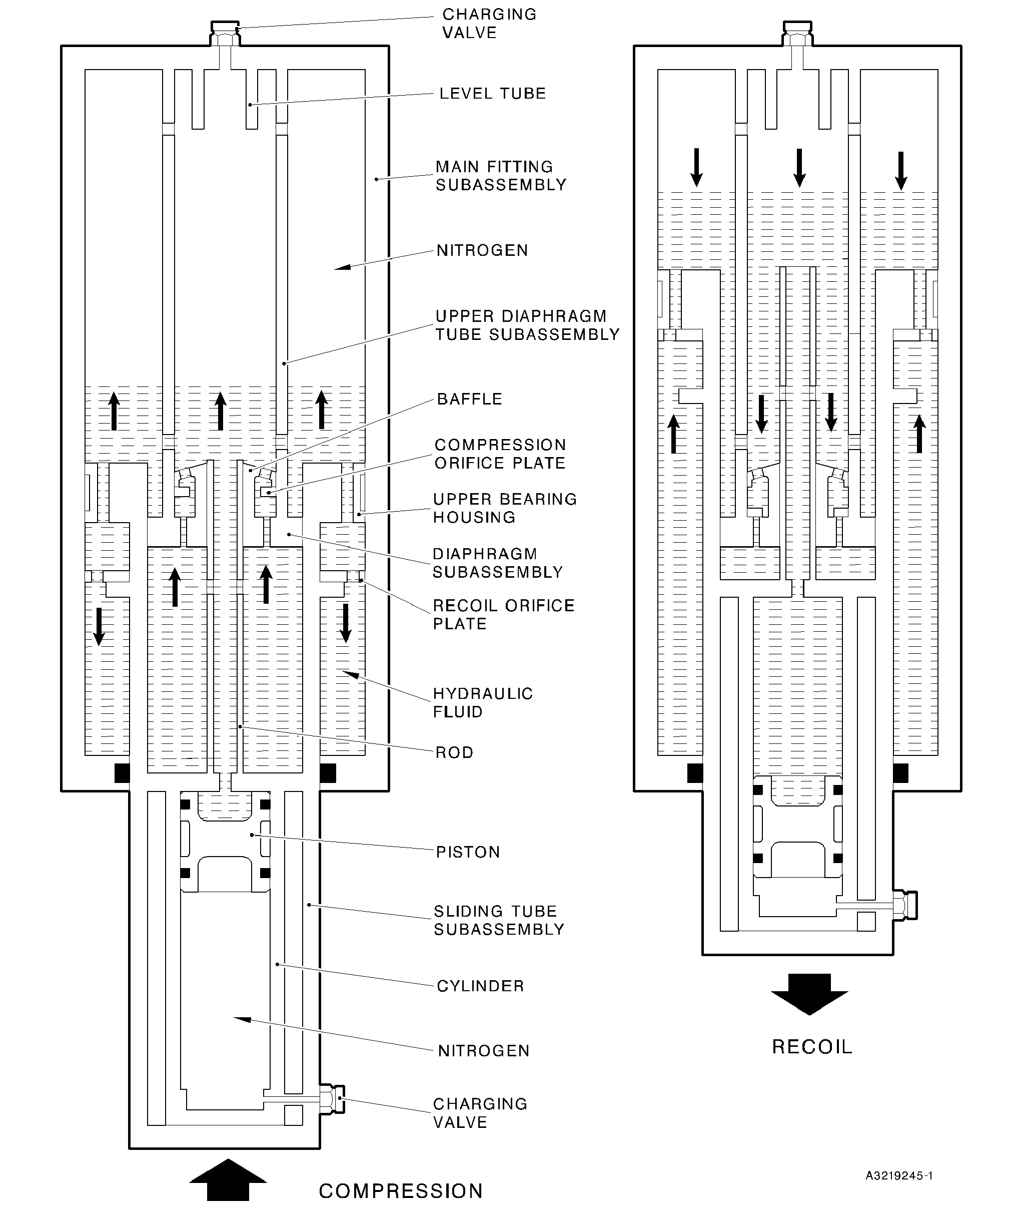

Diagram of Operation  
Figure 2

32-12-22

Page 4

Dec 6/2019

**sSAFRAN SAFRAN LANDING SYSTEMS UK Ltd**

CAGE: K0654

PART No. 201587001 AND 201587002 COMPONENT MAINTENANCE MANUAL  
MAIN LANDING GEAR LEG  
TESTING AND FAULT ISOLATION

1. Equipment and Materials
2. Equipment
3. This equipment is necessary:

**NOTE: Alternative equivalents are permitted.**

|  |  |  |
| --- | --- | --- |
| Part No. | Equipment | Function |
| - | Hydraulic Test Rig |  |
| - | Nitrogen Supply | Main landing gear leg (1-1) tests |
| - | Loading Press |  |
|  | Milliohmmeter Megger, | Electrical bonding resistance |
|  | Type BT51 | tests |
| - | 28 VDC Power Supply | Proximity switch and target tests |
| T14218 | Turner Inflation Equipment | Main landing gear leg (1-1) tests |
| T14500 | Crowfoot Wrench | Close the charging valves (13-60 and 17-20) |
| 460002502 | Charging Adapter | Main landing gear leg (1-1) tests |
| 460005842 | Lampbox | Proximity switch and target tests |
| 460006231 | Holding Fixture |  |
| 460006232 | Load Cell and Adapter |  |
| 460006233 | Press Adapter | Main landing gear leg (1-1) tests |
| 460006234 | Offset Adapter |  |
| 460007260 | Bottom Press Adapter |  |

1. Materials
2. These materials are necessary:

**NOTE: Alternative equivalents are permitted.**

|  |  |
| --- | --- |
| Ref. Item | Material |
| TBA | Nitrogen |
| 02-501 | Hydraulic fluid |

32-12-22

Page 101

Dec 6/2019

**SAFRAN LANDING SYSTEMS UK Ltd**

CAGE: K0654

PART No. 201587001 AND 201587002 COMPONENT MAINTENANCE MANUAL  
MAIN LANDING GEAR LEG

1. Test Conditions

**WARNING: DO NOT GET HYDRAULIC FLUID ON YOUR SKIN OR IN YOUR EYES. DO NOT  
BREATHE THE FUMES. ONLY USE IN A LOCATION THAT HAS A CONTINUOUS  
FLOW OF CLEAN AIR. HYDRAULIC FLUID IS POISONOUS AND DANGEROUS.**

A. General

1. The hydraulic test rig must have a hand pump and a power pump. The power pump  
   must have a controlled flow of not less than 4,5 l/min (4.62 in3/sec).
2. The inflation equipment must be to MIL-G-8348.
3. The temperature of the test fluid must be between 20 and 40 °C (68 and 104 °F).
4. The test fluid must be clean: refer to M-DLPS910-1.
5. During all hydraulic tests, the unit and the test circuit must be hydraulically full.
6. Examine the unit for damage before you start the tests.
7. During the proximity switch tests the ambient temperature must be between 15 and  
   25 °C (59 and 77 °F).
8. Procedure
9. Piston (17-200) Leakage Tests
10. Use the Charging Adapter 460002502 and the Turner Inflation Equipment T14218:  
    connect the charging valve (17-20) to the nitrogen supply. Open the charging valve  
    (17-20).
11. Slowly increase the nitrogen pressure to between 9,32 and 10,68 bar (135 and  
    155 lbf/in2). Make a record of the pressure. Close the charging valve (17-20) and hold  
    the nitrogen pressure for 15 minutes.
12. Open the charging valve (17-20) and measure the nitrogen pressure: it must be the  
    same as the record in para (2). Leakage must not occur.
13. Release the nitrogen pressure.
14. Disconnect the nitrogen supply and remove the Turner Inflation Equipment T14218 and  
    the Charging Adapter 460002502.
15. Make sure that all of the nitrogen pressure has been released: remove the charging  
    valve (17-20).
16. Refer to ASSEMBLY: install the charging valve (17-20) and complete the assembly  
    procedure.
17. Main Landing Gear Leg (1-1) Tests
18. Initial Operations
19. Use these special tools to install the main landing gear leg (1-1) vertically in the  
    loading press:

1 The Holding Fixture 460006231.

2 The Press Adapter 460006233.

32-12-22

Page 102

Dec 6/2019

**sSAFRAN SAFRAN LANDING SYSTEMS UK Ltd**

CAGE: K0654

PART No. 201587001 AND 201587002 COMPONENT MAINTENANCE MANUAL  
MAIN LANDING GEAR LEG

3 The Bottom Press Adapter 460007260.

1. Assemble the Load Cell and Adapter 460006232 and the Offset Adapter  
   460006234 to the main landing gear leg (1-1).
2. Procedure to Fill and Pressurize the Main Landing Gear Leg (1-1)

**CAUTION: DO NOT PUT AN END LOAD OF MORE THAN 5,08 TONNES (5 TONS)  
ON THE MAIN LANDING GEAR LEG (1-1).**

1. Make sure that there is no pressure in the main landing gear leg (1-1): open the  
   charging valves (13-60 and 17-20).
2. Use the Charging Adapter 460002502 to connect the hydraulic test rig to the  
   charging valve (13-60).
3. Slowly increase the hydraulic pressure to between 13,11 and 14,48 bar (190 and  
   210 lbf/in2) and let the unit extend fully.
4. Release the hydraulic pressure and fully close the unit.
5. Do para (c) and (d) until the hydraulic fluid that comes out of the unit does not have  
   air in it.
6. Fully close the unit and disconnect the hydraulic test rig.
7. Use the Charging Adapter 460002502 and the Turner Inflation Equipment T14218  
   to connect the nitrogen supply to the charging valve (13-60).

**CAUTION: DO NOT USE A PRESSURE OF MORE THAN 7,58 BAR (110 LBF/IN2).**

1. Slowly increase the nitrogen pressure until the unit starts to extend. Hold the  
   pressure and fully extend the unit. The pressure must not be more than 7,58 bar  
   (110 lbf/in2).

**NOTE: The charging valve (17-20) must be open to let the unit extend fully.**

1. Refer to Figure 101 and measure the dimension X: it must be between 483,05 and  
   487,85 mm (19.017 and 19.207 in).
2. Disconnect the nitrogen supply and remove the Turner Inflation Equipment T14218  
   and the Charging Adapter 460002502.
3. Open the charging valve (13-60) and release the nitrogen pressure. Do not close  
   the charging valve (13-60).
4. Use the Charging Adapter 460002502 and the Turner Inflation Equipment T14218  
   to connect the charging valve (17-20) to the nitrogen supply.
5. Slowly increase the nitrogen pressure to between 13,11 and 14,48 bar (190 and  
   210 lbf/in2).

**NOTE: Nitrogen will be released through the charging valve (13-60) as the  
piston (17-200) moves.**

1. Slowly increase the nitrogen pressure to between 67,59 and 70,34 bar (980  
   and1020 lbf/in2).

32-12-22

Page 103

Dec 6/2019

**SAFRAN LANDING SYSTEMS UK Ltd**

CAGE: K0654

PART No. 201587001 AND 201587002 COMPONENT MAINTENANCE MANUAL  
MAIN LANDING GEAR LEG

1. Close the charging valve (17-20); use the Crowfoot Wrench T14500 to torque it to  
   between 5,7 and 7,9 N m (50 and 70 lbf in).
2. Disconnect the nitrogen supply and remove the Turner Inflation Equipment T14218  
   and the Charging Adapter 460002502.
3. Use the Turner Inflation Equipment T14218 and the Charging Adapter 460002502  
   to connect the nitrogen supply to the charging valve (13-60).
4. Slowly increase the nitrogen pressure to between 6,90 and 8,27 bar (100 and  
   120 lbf/in2).
5. Close the charging valve (13-60); use the Crowfoot Wrench T14500 to torque it to  
   between 5,7 and 7,9 N m (50 and 70 lbf in).
6. Disconnect the nitrogen supply and remove the Turner Inflation Equipment T14218  
   and the Charging Adapter 460002502.
7. Leakage Tests
8. Make a record of the nitrogen pressure at the charging valve (13-60), (P1A) and  
   the charging valve (17-20), (P1B).
9. Make a record of the ambient temperature, (T1).
10. Keep the unit in this condition for a minimum of six hours.
11. Measure the nitrogen pressure at the charging valve (13-60), (P2A) and the  
    charging valve (17-20), (P2B).
12. Measure the ambient temperature, (T2).
13. Compare the pressures P1A and P2A and compare the pressures P1B and P2B.  
    The pressures P1A and P2A must be the same and the pressures P1B and P2B  
    must be the same, unless:
14. There is a difference between the temperatures T1 and T2
15. There is an error because of the pressure gauge capacity.
16. If there is a difference between the temperatures T1 and T2, calculate the correct  
    value for the nitrogen pressures (these will be P3A and P3B) and adjust the  
    pressures to the corrected values. Use the formula:

P3A = (P2A + Z) x (T1 + K) - Z

(T2 + K)  
OR  
(P2B + Z) x (T1 + K)  
P3B = - Z

(T2 + K)

Where K = 273 for temperatures in °C

(459 for temperatures in °F)

Z = 1 for pressures in bar

(15 for pressures in lbf/in2)

32-12-22

Page 104

Dec 6/2019

**SAFRAN LANDING SYSTEMS UK Ltd**

CAGE: K0654



PART No. 201587001 AND 201587002 COMPONENT MAINTENANCE MANUAL  
MAIN LANDING GEAR LEG

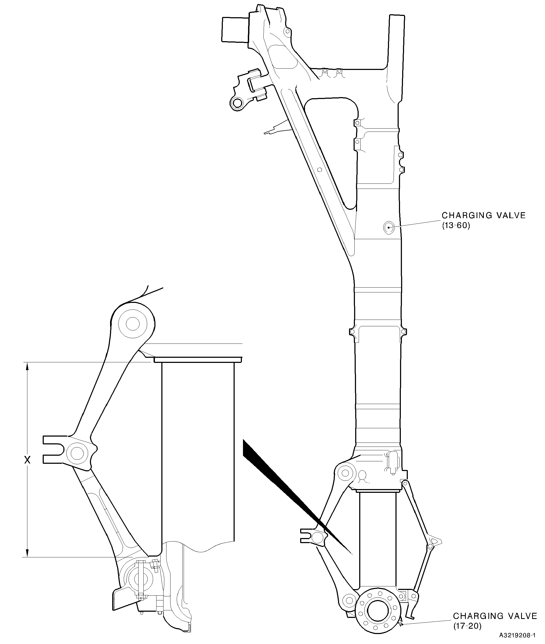

Main Landing Gear Leg (1-1)  
Figure 101

32-12-22

Page 105

Dec 6/2019

**sSAFRAN SAFRAN LANDING SYSTEMS UK Ltd**

CAGE: K0654

PART No. 201587001 AND 201587002 COMPONENT MAINTENANCE MANUAL  
MAIN LANDING GEAR LEG

1. If there is an error because of the gauge capacity:
2. Close the charging valve (13-60).
3. Release the pressure in the gauge.

3 Open the charging valve (13-60) and measure the nitrogen pressure, (P4A).

1. Close the charging valve (13-60).
2. Close the charging valve (17-20).
3. Release the pressure in the gauge.

7 Open the charging valve (17-20) and measure the nitrogen pressure, (P4B).

1. Calculate the correct values for the nitrogen pressures (these will be P5A and  
   P5B) and adjust the pressures to the corrected values. Use the formula:

P5A = P1A + (P2A - P4A)

OR

P5B = P1B + (P2B - P4B)

1. Prepare for Transport and Storage
2. Open the charging valve (13-60) and reduce the nitrogen pressure to between 3,45  
   and 4,82 bar (50 and 70 lbf/in2).
3. Close the charging valve (13-60); use the Crowfoot Wrench T14500 to torque it to  
   between 5,7 and 7,9 N m (50 and 70 lbf in).
4. Open the charging valve (17-20) and reduce the nitrogen pressure to between 3,45  
   and 4,82 bar (50 and 70 lbf/in2).
5. Close the charging valve (17-20); use the Crowfoot Wrench T14500 to torque it to  
   between 5,7 and 7,9 N m (50 and 70 lbf in).
6. Write this data on a label and attach it to the unit: THE GEAR MUST BE INFLATED  
   TO THE APPROPRIATE PRESSURES BEFORE BEING PLACED IN SERVICE.
7. Complete the torque procedure for the retaining pins (13-10): refer to ASSEMBL .
8. Proximity Switches (7-40 and 7-230) Adjustments and Tests
9. Use the loading press: set the dimension between the pins (10-80 and 11-130) to  
   between 632,80 and 636,95 mm (24.9134 and 25.0767 in).
10. Adjust the spacers (6-140, 7-50, 7-190 and 7-240) or laminated shims (6-140A, 7-50A,  
    7-90A and 7-240A): refer to ASSEMBLY.

**NOTE: If the calculated gap is in the tolerance, the spacers (6-140, 7-50, 7-190  
and 7-240) or laminated shims (6-140A, 7-50A, 7-90A and 7-240A) are not  
necessary.**

1. Connect the 28 VDC power supply, the Lampbox 460005842 and the main landing gear  
   leg (1-1).

32-12-22

Page 106

Dec 6/2019

**sSAFRAN SAFRAN LANDING SYSTEMS UK Ltd**

CAGE: K0654

PART No. 201587001 AND 201587002 COMPONENT MAINTENANCE MANUAL  
MAIN LANDING GEAR LEG

1. Use the loading press to fully extend the main landing gear leg (1-1).
2. Use the loading press to slowly close the main landing gear leg (1-1):
3. The proximity switch (7-230) must operate before the main landing gear leg (1-1)  
   has closed by 26,00 mm (1.0236 in).
4. The proximity switch (7-40) must operate before the main landing gear leg (1-1)  
   has closed by 29,30 mm (1.1535 in).
5. Do para (4) and (5) again.
6. Disconnect the 28 VDC supply and the Lampbox 460005842.
7. Remove the main landing gear leg (1-1) from the loading press.
8. Electrical Bonding Resistance Tests (Refer to Figure 102)

**CAUTION: DO NOT CAUSE DAMAGE TO THE PAINT FINISH.**

**NOTE: Make sure that the main landing gear leg (1-1) is electrically isolated from the  
equipment that is used to hold it.**

1. Use the Milliohmmeter Megger, Type BT51, to measure the electrical bonding  
   resistance.
2. Measure between the bearing (20-250) and the test points given in Table 101. The  
   electrical bonding resistance must not be more than the limit given in Table 101.
3. Measure between the axle of the sliding tube subassembly (17-240) and the test  
   points given in Table 102. The electrical bonding resistance must not be more than  
   the limit given in Table 102.

32-12-22

Page 107

Dec 6/2019

**SAFRAN LANDING SYSTEMS UK Ltd**

CAGE: K0654

PART No. 201587001 AND 201587002 COMPONENT MAINTENANCE MANUAL  
MAIN LANDING GEAR LEG

BEARING (20-250)

3

8

AXLE OF SLIDING TUBE  
SUBASSEMBLY (17-240)

A3219209-2

Electrical Bonding Resistance Test Points (Tables 101 and 102)  
Figure 102

32-12-22

Page 108

Dec 6/2019

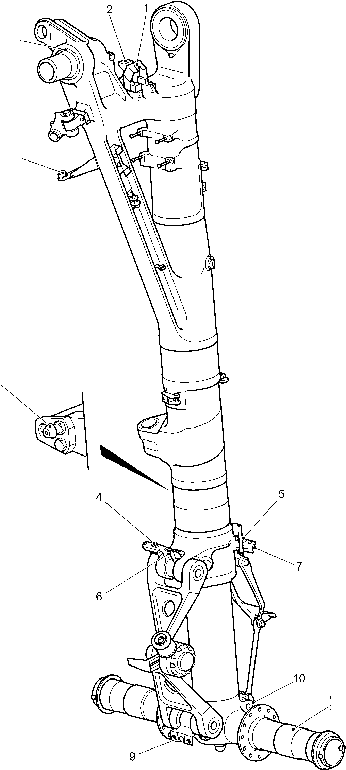

**sSAFRAN SAFRAN LANDING SYSTEMS UK Ltd**

CAGE: K0654

PART No. 201587001 AND 201587002 COMPONENT MAINTENANCE MANUAL

MAIN LANDING GEAR LEG

Electrical Bonding Resistance Tests

Table 101 (Refer to Figure 102)

|  |  |  |  |
| --- | --- | --- | --- |
| TEST POINT | IPL FIGURE AND ITEM No. | NAME | LIMIT VALUE MILLIOHMS |
| 1 | 2-80 | Bracket | 10 |
| 2 | 2-120 | Bracket | 10 |
| 3 | 4-100 | Proximity switch connector shell | 20 |
| 4 | 7-230 | Proximity switch connector shell | 20 |
| 5 | 7-100 | Harness support bracket | 20 |
| 6 | 10-160 | Upper pivot bracket | 20 |
| 7 | 7-40 | Proximity switch connector shell | 20 |
| 8 | 5-390 | Static discharge connector | 10 |

Electrical Bonding Resistance Tests  
Table 102 (Refer to Figure 102)

|  |  |  |  |
| --- | --- | --- | --- |
| TEST POINT | IPL FIGURE AND ITEM No. | NAME | LIMIT VALUE MILLIOHMS |
| 9 | 11-140 | Harness support bracket | 20 |
| 10 | 8-170 | Bracket | 20 |

1. Fault Isolation

A. To be given subsequently.

32-12-22

Page 109

Dec 6/2019

**SAFRAN LANDING SYSTEMS UK Ltd**

CAGE: K0654



PART No. 201587001 AND 201587002 COMPONENT MAINTENANCE MANUAL  
MAIN LANDING GEAR LEG

INTENTIONALLY BLANK

32-12-22

Page 110

**sSAFRAN SAFRAN LANDING SYSTEMS UK Ltd**

CAGE: K0654

PART No. 201587001 AND 201587002 COMPONENT MAINTENANCE MANUAL  
MAIN LANDING GEAR LEG  
DISASSEMBLY

1. General

**WARNING: DO NOT GET HYDRAULIC FLUID ON YOUR SKIN OR IN YOUR EYES. DO NOT  
BREATHE THE FUMES. ONLY USE IN A LOCATION THAT HAS A CONTINUOUS  
FLOW OF CLEAN AIR. HYDRAULIC FLUID IS POISONOUS AND DANGEROUS.**

**NOTE:** **Refer to TESTING AND FAULT ISOLATION** **to find the necessary level of  
disassembly. This will give the condition of the component or the possible cause of  
its malfunction.**

1. Make sure that the work area, the tools and the equipment are clean.
2. Discard parts that you must not use again. These include:

|  |  |
| --- | --- |
| IPL Fig/Item No. | Part Name |
| 1-10 | Split pin |
| 1-41 | Heat shrink sleeve |
| 1-43 | Ferrule |
| 1-45 | Bowden cable |
| 1-80 | Tab washers |
| 2-70 | Tab washers |
| 2-150 | Tab washer |
| 2-180 | Tab washers |
| 2-200 | Tab washer |
| 2-230 | Split pins |
| 3-20 | Split pin |
| 3-180 | Split pin |
| 4-20 | Split pin |
| 4-110 | Split pins |
| 4-170 | Tab washers |
| 4-200 | Tab washers |
| 4-220 | Split pin |
| 4-270 | Split pins |
| 5-170 | Split pin |
| 5-320 | Split pins |
| 5-360 | Split pin |
| 6-60 | Split pin |
| 6-240 | Split pin |
| 7-60 | Split pins |
| 8-40 | Split pins |

32-12-22

Page 301

Dec 6/2019

**SAFRAN LANDING SYSTEMS UK Ltd**

CAGE: K0654



PART No. 201587001 AND 201587002 COMPONENT MAINTENANCE MANUAL  
MAIN LANDING GEAR LEG

|  |  |
| --- | --- |
| IPL Fig/Item No. | Part Name |
| 8-100 | Split pins |
| 9-10 | Split pin |
| 10-20 | Tab washers |
| 10-40 | Split pin |
| 10-100 | Tab washers |
| 10-150 | O-ring seals |
| 11-70 | Tab washers |
| 11-90 | Split pin |
| 12-10 | Split pins |
| 12-50 | Split pins |
| 12-100 | O-ring seal |
| 12-110 | Backing ring |
| 12-130 | O-ring seals |
| 12-140 | Backing rings |
| 12-150 | O-ring seals |
| 12-160 | Backing rings |
| 13-67 | O-ring seal |
| 13-120 | O-ring seal |
| 13-140 | Split pin |
| 14-20 | Split pins |
| 15-80 | Locking plate |
| 15-90 | Screws |
| 15-100 | Tab washers |
| 15-120 | Pin |
| 15-170 | Tab washers |
| 15-250 | O-ring seal |
| 15-260 | Backing rings |
| 15-280 | Seal |
| 15-290 | Seal |
| 15-310 | O-ring seal |
| 15-320 | Split pin |
| 16-20 | O-ring seal |
| 16-30 | Backing rings |
| 16-40 | O-ring seal |
| 16-50 | Backing rings |
| 16-60 | Seal |

32-12-22

Page 302

Mar 15/2024

**sSAFRAN SAFRAN LANDING SYSTEMS UK Ltd**

CAGE: K0654

PART No. 201587001 AND 201587002 COMPONENT MAINTENANCE MANUAL  
MAIN LANDING GEAR LEG

|  |  |
| --- | --- |
| IPL Fig/Item No. | Part Name |
| 16-70 | Seal |
| 16-80 | Joint seal |
| 16-90 | Sealing ring |
| 16-100 | Wiper ring |
| 16A-117 | Inner liner |
| 17-27 | O-ring seal |
| 17-60 | O-ring seal |
| 17-70 | Backing ring |
| 17-90 | Lock washer |
| 17-110 | Tab washers |
| 17-190 | Seal |
| 17-210 | O-ring seal |
| 17-220 | Backing ring |
| 19-10 | Split pin |

1. Wire Thread Inserts
2. If necessary, remove the wire thread inserts:
3. Bend the outer coil of the wire thread insert to the centre of the hole.
4. Remove the wire thread insert. Make sure that broken pieces do not stay in the  
   hole.
5. Special Tools
6. These special tools are necessary:

**NOTE: Alternative equivalents are permitted.**

|  |  |  |
| --- | --- | --- |
| Part No. | Special Tool | Function |
| MT1025 | Bench Clamp | Use with MT1026/63 and 460006406 |
| MT1026/63 | Holding Blocks | Hold the cylinder (17-230) |
| T14500 | Crowfoot Wrench | Remove the charging valves (13-60 and 17-20) |
| T14544 | Torque Adapter | Remove the nut (9-50) |
| 460001355 | Extractor | Remove the lubrication adapters (18-60), (20-130), (20-160), (20-190) and (20-220) |
| 460004331/1 | Drift | Use with 460006151/47 |
| 460004331/7 | Drift | Use with 460006151/24, 460006151/25, 460006151/26 and 460006151/51 |

32-12-22

Page 303

Mar 15/2024

**SAFRAN LANDING SYSTEMS UK Ltd**

CAGE: K0654



PART No. 201587001 AND 201587002 COMPONENT MAINTENANCE MANUAL  
MAIN LANDING GEAR LEG

|  |  |  |
| --- | --- | --- |
| Part No. | Special Tool | Function |
| 460004331/8 | Drift | Use with 460006151/7, 460006151/20, 460006151/30 and 460006151/31 |
| 460004331/9 | Drift | Use with 460006151/47, 460006151/87 and 460006151/88 |
| 460004331/20 | Drift | Use with 460006151/21 and 460006151/22 |
| 460004331/21 | Drift | Use with 460006151/9, 460006151/10 and 460007259 |
| 460004680 | Extraction Tube | Remove the forward pintle bush (20-250A) |
| 460006151/7 | Extractor | Remove the bushes (18-30) |
| 460006151/9 | Extractor | Remove the bushes (20-340) and (20-350) |
| 460006151/10 | Extractor | Remove the bushes (10-250, 11-230, 18-40 and 20-330) |
| 460006151/20 | Extractor | Remove the bushes (18-20) |
| 460006151/21 | Extractor | Remove the bush (15-370) |
| 460006151/22 | Extractor | Remove the bush (15-380) |
| 460006151/24 | Extractor | Remove the bearings (5-280 and 5-290) and the bushes (20-380) |
| 460006151/25 | Extractor | Remove the bearing (4-340) and the bush (20-360) |
| 460006151/26 | Extractor | Remove the bearing (4-350) |
| 460006151/30 | Extractor | Remove the bush (6-210 and 8-160) |
| 460006151/31 | Extractor | Remove the bush (6-220 and 8-150) |
| 460006151/47 | Extractor | Remove the bearings (20-230, 20-240 and 20-290) |
| 460006151/48 | Extractor | Remove the bearing (20-290) |
| 460006151/51 | Extractor | Remove the bushes (20-390) |
| 460006151/86 | Extractor | Remove the bushes (20-320) |
| 460006151/87 | Extractor | Remove the bearing (20-270) |
| 460006151/88 | Extractor | Remove the bearing (20-260) |
| 460006208 | Lifting Bar Assembly | Hold the main landing gear leg (1-1), use with 460007281 and 460007282 |
| 460006211 | Lifting Tackle | Lift the sliding tube subassembly (17-240) and related parts |

32-12-22

Page 304

Mar 20/2020

**sSAFRAN SAFRAN LANDING SYSTEMS UK Ltd**

CAGE: K0654

PART No. 201587001 AND 201587002 COMPONENT MAINTENANCE MANUAL  
MAIN LANDING GEAR LEG

|  |  |  |
| --- | --- | --- |
| Part No. | Special Tool | Function |
| 460006213 | Transport and Build Trolley |  |
| 460006215 | Support Arms |  |
| 460006216 | Towing Frame | Hold the main landing gear leg (1-1) |
| 460006223 | Jacking Dome Adapter |  |
| 460006237 | Adapter |  |
| 460006232 | Extraction Pad | Remove the bearing (20-300) |
| 460006253 | Extractor | Remove the bearing (20-280) |
| 460006261 | Extraction Pad | Remove the bearing (20-310) |
| 460006262 | Extraction Bar | Use with 460006232, 460006263 and 460006261 |
| 460006263 | Extraction Pad | Remove the bearing (20-300) |
| 460006267 | Press Pad Assembly | Remove drag arm sleeve (20-370A) |
| 460006404 | Torque Adapter | Remove the jacking dome (17-80) |
| 460006406 | Holding Blocks | Hold the upper diaphragm tube (15-390) |
| 460006410 | Assembly/Extraction Tool | Remove the level tube (15-300) |
| 460006413 | Extractor | Remove the bushes (7-130) |
| 460006415 | Extractor Pad and Drawbolt | Remove the bush (2-310) |
| 460006416 | Extractor | Remove the bush (2-320) |
| 460006497 | Hydraulic-Pneumatic  Pump Set | To remove the forward pintle bush |
| 460006498/7 | Bolt | (2-250A) |
| 460006499/25 | Press Pad |  |
| 460007230 | Torque Adapter | Remove the nuts (14-60) |
| 460007231 | Spacer | Use with 460007282 |
| 460007232 | Torque Adapter | Remove the locking nut (19-52) |
| 460007234 | Location Frame | Hold the main landing gear leg (1-1) (left configuration) |
| OR 460007235 | Location Frame | Hold the main landing gear leg (1-2) (right configuration) |
| 460007240 | Build Trolley | Hold the sliding tube subassembly (17-240) and related parts |

32-12-22

Page 305

Mar 20/2020

**sSAFRAN SAFRAN LANDING SYSTEMS UK Ltd**

CAGE: K0654

PART No. 201587001 AND 201587002 COMPONENT MAINTENANCE MANUAL

MAIN LANDING GEAR LEG

|  |  |  |
| --- | --- | --- |
| Part No. | Special Tool | Function |
| 460007242 | Torque Reaction Adapter | Hold the pin (9-70) |
| 460007254 | Extractor | Remove the bush (18-50) |
| 460007259 | Extractor Plate | Remove the bushes (20-340 and 20-350) |
| 460007278 | Torque Reactor | Use with 460006406 |
| 460007279 | Pin Spanner | Remove the upper bearing housing (15-40) |
| 460007281 | Pintle Location  Assembly | Hold the main landing gear leg (1-1), |
| 460007282 | Spherical Bearing Locator | use with 460006208 |
| 460007283 | Torque Adapter | Remove the diaphragm subassembly (15-190) |
| 460007284 | Pin Spanner | Remove the nut subassembly (17-130) |

32-12-22

Page 306

Mar 20/2020

**^SAFRAN SAFRAN LANDING SYSTEMS UK Ltd**

CAGE: K0654

PART No. 201587001 AND 201587002 COMPONENT MAINTENANCE MANUAL  
MAIN LANDING GEAR LEG

1. Procedure (Refer to IPL Figures 1 to 20)
2. Initial Operations
3. Use these special tools as necessary during the procedure to lift and to hold the unit:
4. The Lifting Bar Assembly 460006208
5. The Spherical Bearing Locator 460007282
6. The Pintle Location Assembly 460007281
7. The Transport and Build Trolley 460006213
8. The Support Arms 460006215
9. The Towing Frame 460006216
10. The Jacking Dome Adapter 460006223
11. The Adapter 460006237
12. The Spacer 460007231
13. The Location Frame 460007234 (for left configuration units)
14. The Location Frame 460007235 (for right configuration units).
15. Pintle Pin (1-60)
16. Pre SB 201-32-22: remove the split pin (1-10), the nut (1-20), the washer (1-30), the bolt  
    (1-40) and the washer (1-50).
17. Post SB 201-32-22: remove the split pins (1-10A), the nuts (1-20A), the spacers (1-25),  
    the washers (1-30A), the shims (1-35), the bolt subassembly (1-40A) and the washers  
    (1-50A).
18. Post SB 201-32-22: cut the Bowden cable (1-45) and remove the cross bolts (1-47 and  
    1-49).
19. Remove the pintle pin (1-60).
20. Remove the bolts (1-70), tab washers (1-80), nuts (1-90) and retainers (1-100).
21. Remove the wiring diagram plate (1-110).
22. PRE SB 201-32-81: Transfer Block Subassembly (2-290 and 2-290A)
23. Remove the bolt (2-10), the washer (2-20), the pin (2-30), the spacer (2-40) and the  
    threaded insert (2-50).
24. Release the tab washers (2-70). Remove the bolts (2-60), the tab washers (2-70) and  
    the bracket (2-80).
25. Remove the bolts (2-100), the washers (2-110) and the bracket (2-120).
26. Release the tab washer (2-150). Remove the bolt (2-140), the tab washer (2-150) and  
    the bonding cable (2-160).
27. Release the tab washers (2-180 and 2-200). Remove the bolts (2-170 and 2-190) and  
    the tab washers (2-180 and 2-200).

32-12-22

Page 307

Mar 19/2021

**sSAFRAN SAFRAN LANDING SYSTEMS UK Ltd**

CAGE: K0654

PART No. 201587001 AND 201587002 COMPONENT MAINTENANCE MANUAL  
MAIN LANDING GEAR LEG

1. Remove the nuts (2-210) and retainers (2-220).
2. Remove the split pins (2-230), the nuts (2-240), the washers (2-250), the bolts (2-260)  
   and the bracket (2-270).
3. Remove the transfer block subassembly (2-290 and 2-290A).
4. Use the Extractor Pad and Drawbolt 460006415 to remove the bush (2-310) and the  
   Extractor 460006416 to remove the bush (2-320) from the transfer block (2-340 and  
   2-340A).
5. POST SB 201-32-81: Transfer Block Subassembly (2-290B)
6. Remove the bolt (2-10), the washer (2-20), the pin (2-30), the spacer (2-40) and the  
   threaded insert (2-50).
7. Release the tab washer (2-150). Remove the bolt (2-140), the tab washer (2-150) and  
   the bonding cable (2-160).
8. Release the tab washers (2-180 and 2-200). Remove the bolts (2-170 and 2-190A) and  
   the tab washers (2-180 and 2-200).
9. Remove the nuts (2-210) and retainers (2-220).
10. Remove the transfer block subassembly (2-290B).
11. Use the Extractor Pad and Drawbolt 460006415 to remove the bush (2-310) and the  
    Extractor 460006416 to remove the bush (2-320) from the transfer block (2-340B).
12. Cardan Assembly (3-10)
13. Remove the split pin (3-20), the nut (3-30), the washer (3-40), the pin (3-50), the spacers  
    (3-60 and 3-70) and the cardan assembly (3-10).
14. Remove the lubrication fittings (3-80, 3-100 and 3-120) and the identification washers  
    (3-90, 3-110 and 3-130) from the lock stay cardan subassembly (3-140).
15. Remove the bushes (3-150 and 3-160) from the lock stay cardan (3-170).
16. Remove the split pin (3-180), the nut (3-190), the washer (3-200), the bolt (3-210) and  
    the bracket (3-220).
17. Rod End Assembly (4-10), Proximity Switch (4-100) and Bracket Subassembly (4-330)
18. Remove the split pin (4-20), the nut (4-30), the washer (4-40) and the rod end assembly  
    (4-10).
19. Remove the spherical bearing (4-50) from the rod end (4-60).
20. Remove the nuts (4-70), the washers (4-80), the cap screws (4-90) and the proximity  
    switch (4-100).
21. Remove the split pins (4-110), the nuts (4-120), the washers (4-130) and the bracket  
    (4-140).
22. Release the tab washers (4-170 and 4-200). Remove the nuts (4-160), the tab washers  
    (4-170), the spacer (4-180), the bolts (4-190), the tab washers (4-200) and the bracket  
    (4-210).
23. Remove the split pin (4-220), the nut (4-230), the washer (4-240), the bolt (4-250) and  
    the sleeve (4-260).

32-12-22

Page 308

Mar 19/2021

**sSAFRAN SAFRAN LANDING SYSTEMS UK Ltd**

CAGE: K0654

PART No. 201587001 AND 201587002 COMPONENT MAINTENANCE MANUAL  
MAIN LANDING GEAR LEG

1. Remove the split pins (4-270), the nuts (4-280), the washers (4-290) and the bolts  
   (4-300).
2. Remove the bonding cable (4-310) and the washer (4-320).
3. Remove the bracket subassembly (4-330).
4. Use the Drift 460004331/7 and the Extractor 460006151/25 to remove the bearing  
   (4-340) from the bracket (4-360).
5. Use the Drift 460004331/7 and the Extractor 460006151/26 to remove the bearing  
   (4-350) from the bracket (4-360).
6. Bracket Assembly (5-10), Bracket Subassemblies (5-90 and 5-270) and Uplock Pin (5-400)
7. Remove the bolts (5-20 and 5-40), the washers (5-30 and 5-50), the nut (5-60) and the  
   bracket assembly (5-10).
8. Remove the spherical bearing (5-70) from the bracket (5-80): refer to M-DLPS1014-2.
9. Remove the bolts (5-100 and 5-120), the washers (5-110 and 5-130), the nut (5-140)  
   and the bracket subassembly (5-90).
10. Remove the spherical bearing (5-150) from the bracket (5-160): refer to M-DLPS1014-2.
11. Remove the split pin (5-170), the nut (5-180), the washer (5-190), the bolt (5-200) and  
    the sleeve (5-210).
12. Remove the bolt (5-220), the washer (5-230) and the bonding cable (5-240).
13. Remove the bolt (5-250), the washer (5-260), the bracket subassembly (5-270) and the  
    nut (5-310).
14. Use the Drift 460004331/7 and the Extractor 460006151/24 to remove the bearings  
    (5-280 and 5-290) from the bracket (5-300).
15. PRE SB 201-32-72:
16. Remove the split pins (5-320), the nuts (5-330), the washers (5-340) and the bolts  
    (5-350).
17. Remove the split pin (5-360), the nut (5-370), the washer (5-380), the static  
    discharge connector (5-390) and the uplock pin (5-400).
18. POST SB 201-32-72:
19. Remove the split pins (5-320A), the nuts (5-330A), the washers (5-340B) and the  
    bolts (5-350A).
20. Remove the ground stud subassembly (5-390A), the washer (5-380B), the  
    bolt (5-395) and the uplock pin (5-400A).
21. Slave Link Subassembly (6-190) and Lower Slave Link Subassembly (6-290)
22. Remove the split pin (6-10), the nut (6-20), the washer (6-30), the bolt (6-40) and the  
    spacer (6-50).
23. Remove the split pin (6-60), the slotted nut (6-70), the washer (6-80) and the pivot pin  
    (6-90).
24. Remove the slave link subassembly (6-190) and its attached parts.

32-12-22

Page 309

Mar 20/2020

**sSAFRAN SAFRAN LANDING SYSTEMS UK Ltd**

CAGE: K0654

PART No. 201587001 AND 201587002 COMPONENT MAINTENANCE MANUAL  
MAIN LANDING GEAR LEG

1. Remove the nuts (6-100), the washers (6-110), the cap screws (6-120), the  
   target (6-130) and the spacers (6-140) or the laminated shim (6-140A).

**NOTE: If the calculated gap is in the tolerance, the spacers (6-140) or the  
laminated shim (6-140A) is not installed.**

1. Remove the bolts (6-150), the washers (6-160) and the bracket (6-170).
2. Remove the bushes (6-200) from the slave link (6-230).
3. Use the Drift 460004331/8 and the Extractor 460006151/30 to remove the bush (6-210)  
   from the slave link (6-230).
4. Use the Drift 460004331/8 and the Extractor 460006151/31 to remove the bush (6-220)  
   from the slave link (6-230).
5. Remove the split pin (6-240), the nut (6-250), the washer (6-260), the bolt (6-270) and  
   the spacer (6-280): remove the lower slave link subassembly (6-290).
6. Remove the grooved spherical bearing (6-300) or the self lubricating bearing (6-300A)  
   from the lower slave link (6-310).
7. Proximity Switches (7-40 and 7-230) and Harness Support Bracket (7-100)
8. Remove the nuts (7-10), the washers (7-20), the cap screws (7-30), the proximity switch  
   (7-40) and the spacer (7-50) or the laminated shim (7-50A).

**NOTE: If the calculated gap is in the tolerance, the spacer (7-50) or the laminated  
shim (7-50A) is not installed.**

1. Remove the split pins (7-60), the nuts (7-70), the washers (7-80), the bolts (7-90) and  
   the harness support bracket (7-100).
2. Remove the pivot bracket subassembly (7-120).
3. Use the Extractor 460006413 to remove the bushes (7-130) from the pivot bracket  
   (7-140).
4. Remove the nuts (7-150), the washers (7-160), the cap screws (7-170), the target  
   (7-180) and the spacer (7-190) or the laminated shim (7-190A).

**NOTE: If the calculated gap is in the tolerance, the spacer (7-190) or the  
laminated shim (7-190A) is not installed.**

1. Remove the nuts (7-200), the washers (7-210), the cap screws (7-220), the proximity  
   switch (7-230) and the spacer (7-240) or the laminated shim (7-240A).
2. Bracket Subassembly (8-90)
3. Remove the nuts (8-10), the washers (8-20) and the bolts (8-30).
4. Remove the split pins (8-40), the nuts (8-50), the washers (8-60), the bolts (8-70) and  
   the bracket (8-80).
5. Remove the split pin (8-100), the nut (8-110), the washer (8-120), the sleeves (8-130)  
   and the bolt (8-140). Remove the bracket subassembly (8-90).
6. Use the Extractor 460006151/31 and the Drift 460004331/8 to remove the bush (8-150).
7. Use the Extractor 460006151/30 and the Drift 460004331/8 to remove the bush (8-160).

32-12-22

Page 310

Mar 20/2020

**sSAFRAN SAFRAN LANDING SYSTEMS UK Ltd**

CAGE: K0654

PART No. 201587001 AND 201587002 COMPONENT MAINTENANCE MANUAL  
MAIN LANDING GEAR LEG

K. Damper (9-160)

1. Remove the split pin (9-10), the nut (9-20), the washer(s) (9-30) and the bolt (9-40).
2. Remove the clamp (9-165) and the dust cap (9-170).
3. Use the Torque Reaction Adapter 460007242 to hold the pin (9-70) and use the Torque  
   Adapter T14544 to remove the nut (9-50). Remove the spacer (9-60), the pin (9-70), the  
   spacer (9-80) and the sleeve (9-90).
4. Remove the bolts (9-100), the washers (9-110), the bolts (9-120), the washers (9-130),  
   the bolts (9-140), the washers (9-145) and the bracket (9-150).
5. Remove the damper (9-160), the spacers (9-180 and 9-190) and the sleeve (9-200).
6. Upper Torque Link Subassembly (10-170)
7. Release the tab washers (10-20). Remove the bolts (10-10), the tab washers (10-20)  
   and the wedge (10-30).
8. Remove the split pin (10-40), the nut (10-50), the washers (10-60), the bolt (10-70) and  
   the pin (10-80).
9. Remove the upper torque link subassembly (10-170), the upper pivot bracket (10-160)  
   and the spacers (10-270).
10. Remove the lubrication shaft subassembly (10-90) from the pin (10-80).
11. Remove the O-ring seals (10-150) from the lubrication shaft subassembly (10-90).
12. Remove the lubrication fittings (10-120) and the identification washers (10-130).
13. Release the tab washers (10-100). Remove the lubrication adapters (10-110) and the  
    tab washers (10-100).
14. Remove the lubrication fittings (10-180 and 10-210) and the identification washers  
    (10-190 and 10-220). Remove the lubrication adapters (10-200 and 10-230).
15. Remove the bushes (10-240).
16. Use the Extractor 460006151/10 to remove the bushes (10-250) from the upper torque  
    link (10-260).
17. 1M Electrical Axle Harness (11-40) and 2M Electrical Axle Harness (11-50)
18. Remove the cap screws (11-10), the washers (11-20) and the harness support (11-30).
19. Remove the 2M electrical axle harness (11-50).
20. Remove the 1M electrical axle harness (11-40).
21. Lower Torque Link Subassembly (11-150)
22. Release the tab washers (11-70).
23. Remove the bolts (11-60), the tab washers (11-70) and the wedge (11-80).
24. Remove the split pin (11-90), the nut (11-100), the washer (11-110) and the bolt (11-120).
25. Remove the pin (11-130), the harness support bracket (11-140), the lower torque link  
    subassembly (11-150) and the spacers (11-250).

32-12-22

Page 311

Mar 20/2020

**sSAFRAN SAFRAN LANDING SYSTEMS UK Ltd**

CAGE: K0654

PART No. 201587001 AND 201587002 COMPONENT MAINTENANCE MANUAL  
MAIN LANDING GEAR LEG

1. Remove the lubrication fittings (11-160 and 11-190) and the identification washers  
   (11-170 and 11-200). Remove the lubrication adapters (11-180 and 11-210).
2. Remove the bushes (11-220).
3. Use the Extractor 460006151/10 to remove the bushes (11-230) from the lower torque  
   link (11-240).

O. Housing (12-170)

1. Remove the split pins (12-10), the nuts (12-20), the washers (12-30) and the bolts  
   (12-40).
2. Remove the housing (12-170) and its related parts.
3. Remove the split pins (12-50), the washers (12-60), the pin (12-70) and the cap screw  
   (1).
4. Remove the valve stem (12-90).
5. Remove the O-ring seal (12-100) and the backing ring (12-110).
6. Remove the transfer dowels (12-120).
7. Remove the O-ring seals (12-130 and 12-150) and the backing rings (12-140 and  
   12-160).

P. Shock Absorber Subassembly (13-50) and Related Parts

1. Remove the split pins (14-20), the nuts (14-30), the washers (14-40) and the bolts  
   (14-50).
2. Use the Torque Adapter 460007230 to remove the nuts (14-60).
3. Remove the stop rings (14-70).

**WARNING: RELEASE ALL NITROGEN PRESSURE BEFORE YOU REMOVE THE  
CHARGING VALVES (13-60 AND 17-20).**

1. Slowly open the charging valve (17-20) and release all of the second stage nitrogen  
   pressure.
2. Slowly open the charging valve (13-60) and release all of the first stage nitrogen  
   pressure.
3. Release the cup washers (13-20).
4. Remove the retaining pins (13-10) and the cup washers (13-20).
5. Remove the lubrication fittings (13-30) and the identification washers (13-40).
6. Use the Crowfoot Wrench T14500 to remove the charging valve (13-60). Remove the  
   O-ring seal (13-67) from the charging valve (13-60).
7. Remove the bolts (13-70), the spacers (13-80) and the inflation valve subassembly  
   (13-90).
8. Remove the plate (13-100) from the inflation valve (13-110).
9. Remove the O-ring seal (13-120) and the backing rings (13-130).
10. Remove the split pin (13-140), the nut (13-150), the washers (13-160), the bolt (13-170)  
    and the stop ring (13-180).
11. Remove the pin (13-190), the washer subassembly (13-200) and the bush (13-230).

32-12-22

Page 312

Mar 20/2020

**sSAFRAN SAFRAN LANDING SYSTEMS UK Ltd**

CAGE: K0654

PART No. 201587001 AND 201587002 COMPONENT MAINTENANCE MANUAL  
MAIN LANDING GEAR LEG

1. Remove the shock absorber subassembly (13-50) and its related parts from the main  
   fitting subassembly (20-90).
2. Use the Lifting Tackle 460006211 and install the sliding tube subassembly (17-240) in  
   the Build Trolley 460007240.
3. Remove the bearings (15-20 and 15-30).
4. Remove the upper bearing housing (15-40) and related parts as follows:
5. Release the tab washers (15-100).

**CAUTION: DISCARD THE SCREWS (15-90) AND THE LOCKING PLATES (15-80)  
WHEN REMOVED.**

1. Remove the screws (15-90) and the tab washers (15-100).
2. Remove the locking plate (15-80).
3. Use Pin Spanner 460007279 to remove the upper bearing housing (15-40).
4. Remove and discard the pins (15-120).
5. Remove the two piece stop with inserts (15-130).
6. Remove the locking pins (15-50), the retaining ring (15-60) and the recoil orifice plate  
   (15-70).
7. Remove the upper diaphragm tube subassembly (15-360) and its related parts.
8. Release the tab washers (15-170). Remove the bolts (15-160), the tab washers (15-170)  
   and the lock plate (15-180).
9. Use the Torque Adapter 460007283, the Torque Reactor 460007278, the Holding Blocks  
   460006406 and the Bench Clamp MT1025 to remove the diaphragm subassembly  
   (15-190), the compression orifice plate (15-220), the clapper seat (15-230) and the  
   baffle (15-240).
10. Remove the O-ring seal (15-250) and the backing rings (15-260).
11. Remove the bearing (15-270) and the seals (15-280 and 15-290).
12. Use the Assembly/Extraction Tool 460006410 to remove the level tube (15-300) and  
    remove the O-ring seal (15-310).
13. Remove the split pin (15-320), the nut (15-330), the washer (15-340) and the bolt  
    (15-350).
14. Use the Extractor 460006151/21 and the Drift 460004331/20 to remove the bush  
    (15-370).
15. Use the Extractor 460006151/22 and the Drift 460004331/20 to remove the bush  
    (15-380) from the upper diaphragm tube (15-390).
16. Lower Bearing Subassembly (16-110) Pre SB 201-32-58
17. Remove the lower bearing subassembly (16-110) and its related parts from the  
    sliding tube subassembly (17-240).
18. Remove the O-ring seal (16-20), the backing rings (16-30), the O-ring seal (16-40)  
    and the backing rings (16-50).
19. Remove the seals (16-60 and 16-70).

32-12-22

Page 313

Mar 15/2024

**sSAFRAN SAFRAN LANDING SYSTEMS UK Ltd**

CAGE: K0654

PART No. 201587001 AND 201587002 COMPONENT MAINTENANCE MANUAL  
MAIN LANDING GEAR LEG

1. Remove the joint seal (16-80), the sealing ring (16-90) and the wiper ring (16-100).
2. Remove the lower bearing (16-150) from the lower bearing housing subassembly  
   (16-120).
3. Remove the bushes (16-130) from the gland housing (16-140).
4. Lower Bearing Subassembly (16A-110D) Post SB 201-32-58
5. Remove the lower bearing subassembly (16A-110D) and its related parts from the  
   sliding tube subassembly (17-240).
6. Remove the O-ring seal (16A-20), the backing rings (16A-30), the O-ring seal  
   (16A-40) and the backing rings (16A-50).
7. Remove the seals (16A-60 and 16A-70).
8. Remove the joint seal (16A-80), the sealing ring (16A-90) and the wiper ring  
   (16A-100).
9. Remove the inner liner (16A-117) from the lower bearing subassembly (16A-110D)  
   and discard it.
10. Remove the lower bearing (16A-150A) from the lower bearing housing  
    subassembly (16A-120B). Discard the machined lower bearing (16A-150A).
11. Remove the bushes (16A-130A) from the gland housing (16A-140B).
12. Lower Bearing Subassembly (16-110D or 16A-110E) Post Ref. Code: 2253
13. Remove the lower bearing subassembly (16-110D or 16A-110E) and its related  
    parts from the sliding tube subassembly (17-240).
14. Remove the O-ring seal (16-20A or 16A-20A), the backing rings (16-30  
    or 16A-30), the O-ring seal (16-40A or 16A-40A) and the backing  
    rings (16-50 or 16A-50).
15. Remove the seals (16-60 or 16A-60) and (16-70 or 16A-70).
16. Remove the joint seal (16-80 or 16A-80), the sealing ring (16-90 or 16A-90) and  
    the wiper ring (16-100 or 16A-100).
17. Remove the common lower bearing bushes (16-130A or 16A-130B) from the lower  
    bearing housing (16-140B or 16A-140C).
18. Use the Crowfoot Wrench T14500 to remove the charging valve (17-20). Remove the  
    O-ring seal (17-27) from the charging valve (17-20).
19. Remove the cap screws (17-30), the washers (17-40) and the valve support (17-50).
20. Remove the O-ring seal (17-60) and the backing ring (17-70).
21. Release the lock washer (17-90) and use the Torque Adapter 460006404 to remove the  
    jacking dome (17-80). Remove the lock washer (17-90).
22. Remove the cylinder (17-230) and its related parts from the sliding tube subassembly  
    (17-240).
23. Hold the cylinder (17-230) in the Bench Clamp MT1025 and Holding Blocks MT1026/63.
24. Release the tab washer (17-110) and remove the bolts (17-100). Remove the tab  
    washers (17-110).

32-12-22

Page 314

Mar 18/2025

**sSAFRAN SAFRAN LANDING SYSTEMS UK Ltd**

CAGE: K0654

PART No. 201587001 AND 201587002 COMPONENT MAINTENANCE MANUAL  
MAIN LANDING GEAR LEG

1. Remove the lock plate (17-120) and use the Pin Spanner 460007284 to remove the nut  
   subassembly (17-130). Remove the rod (17-160) and the washer (17-170).
2. Remove the piston (17-200) and remove the bearing (17-180) and the seal (17-190).
3. Remove the O-ring seal (17-210) and the backing ring (17-220) from the cylinder  
   (17-230).
4. Remove the cylinder (17-230) from the Bench Clamp MT1025 and Holding Blocks  
   MT1026/63.
5. Remove the labels (17-250 and 17-290).
6. Remove the lubrication fittings (17-270) and the identification washers (17-280) from the  
   sliding tube subassembly (17-240).
7. Remove the sliding tube subassembly (17-240) from the Build Trolley 460007240.
8. Sliding Tube Subassembly (17-240)
9. Remove the bushes (18-10).
10. Use the Extractor 460006151/20 and the Drift 460004331/8 to remove the bushes  
    (18-20).
11. Use the Extractor 460006151/7 and the Drift 460004331/8 to remove the bushes  
    (18-30).
12. Use the Extractor 460006151/10 and the Drift 460004331/21 to remove the bushes  
    (18-40).
13. Use the Extractor 460007254 to remove the bush (18-50).
14. Remove the lubrication fittings (18-52) and identification washers (18-54).
15. Remove the label (18-70) from the sliding tube (18-80).

Q. Spherical Bearing (19-50) and Bung (19-60)

1. Remove the split pin (19-10), the nut (19-20), the washers (19-30) and the bolt (19-40).
2. Release the lock indentations of the locking washer (19-54).
3. Use the Torque Adapter 460007232 to remove the locking nut (19-52). Remove the  
   locking washer (19-54) and the outer race and the ball of the spherical bearing (19-50).

**NOTE: The outer race and the ball are parts of the spherical bearing (19-550).  
They are a set: keep them together.**

1. Remove the bung (19-60).

R. Main Fitting Subassembly (20-90)

1. Remove the labels (20-10, 20-30, 20-40, 20-60 and 20-80).
2. Remove the lubrication fitting (20-110) and the identification washer (20-120). Remove  
   the lubrication adapter (20-130).
3. Remove the lubrication fitting (20-140) and the identification washer (20-150). Remove  
   the lubrication adapter (20-160).
4. Remove the lubrication fitting (20-170) and the identification washer (20-180). Remove  
   the lubrication adapter (20-190).

32-12-22

Page 315

Mar 18/2025

**sSAFRAN SAFRAN LANDING SYSTEMS UK Ltd**

CAGE: K0654

PART No. 201587001 AND 201587002 COMPONENT MAINTENANCE MANUAL  
MAIN LANDING GEAR LEG

1. Remove the lubrication fittings (20-200) and identification washers (20-210). Remove  
   the lubrication adapters (20-220).
2. Use the Extractor 460001355 and remove the lubrication adapters (20-130), (20-160)  
   (20-190) and (20-220).
3. Use the Extractor 460006151/47 and the Drift 460004331/1 to remove the bearings  
   (20-230 and 20-240).
4. Remove the bearing (20-250 only).
5. Use the Hydraulic-Pneumatic Pump Set 460006497, the Bolt 460006498/7, the Press  
   Pad 460006499/25 and the Extraction Tube 460004680 and remove the forward pintle  
   bush (20-250A).
6. Use the Extractor 460006151/88 and the Drift 460004331/9 to remove the bearing  
   (20-260).
7. Use the Extractor 460006151/87 and the Drift 460004331/9 to remove the  
   bearing (20-260 and 20-270).
8. Use the Extractor 460006253 to remove the bearing (20-280).
9. Use the Extractor 460006151/47/48 and the Drift 460004331/9 to remove the  
   bearing (20-290).
10. Use the Extraction Pad 460006263/460006232 and the Extraction Bar 460006262 to  
    remove the bearing (20-300).
11. Use the Extraction Pad 460006261 and the Extraction Bar 460006262 to remove the  
    bearing (20-310).
12. Use the Extractor 460006151/86 to remove the bushes (20-320).
13. Use the Extractor 460006151/10 and the Drift 460004331/21 to remove the bushes  
    (20-330).
14. Use the Extractor Plate 460007259/460006151/9 and the Drift 460004331/21 to remove  
    the bushes (20-340 and 20-350).
15. Use the Extractor 460006151/25 and the Drift 460004331/7 to remove the bush  
    (20-360).
16. Remove the bearing (20-370 only).
17. Use the Press Pad Assembly 460006267 and remove the drag arm sleeve (20-370A  
    only).
18. Use the Extractor 460006151/24 and the Drift 460004331/7 to remove the bushes  
    (20-380).
19. Use the Extractor 460006151/51 and the Drift 460004331/7 to remove the bushes  
    (20-390).
20. Remove the bearings (20-400).

32-12-22

Page 316

Mar 18/2025

**SAFRAN LANDING SYSTEMS UK Ltd**

CAGE: K0654



PART No. 201587001 AND 201587002 COMPONENT MAINTENANCE MANUAL  
MAIN LANDING GEAR LEG

CLEANING

1. General

A. Materials

1. These materials are necessary:

**NOTE: Alternative equivalents are permitted.**

|  |  |
| --- | --- |
| Ref. Item | Material |
| 11-524 | White spirit |

1. Procedure
2. Cleaning

**WARNING: DO NOT GET CLEANING AGENTS ON YOUR SKIN, IN YOUR EYES OR  
NEAR A FLAME. DO NOT BREATHE THE FUMES. ONLY USE IN A  
LOCATION THAT HAS A CONTINUOUS FLOW OF CLEAN AIR. CLEANING  
AGENTS ARE POISONOUS AND FLAMMABLE.**

**CAUTION: DO NOT USE CHLORINATED SOLVENTS. CHLORINATED SOLVENTS CAN  
MIX WITH VERY SMALL QUANTITIES OF WATER IN HYDRAULIC SYSTEMS  
TO MAKE HYDROCHLORIC ACID. HYDROCHLORIC ACID WILL CAUSE  
CORROSION ON METAL SURFACES.**

1. Clean all the metal parts with white spirit, Material Ref. Item 11-524. Make sure that you  
   fully remove all sealants, adhesives and jointing compounds.
2. Dry all the metal parts.
3. Use clean PVC or polythene gloves to prevent corrosion of metal parts.
4. Prevent corrosion of the metal parts that you do not immediately use for assembly  
   procedures: refer to PCS-2800.
5. Paint Removal

**WARNING: DO NOT GET PAINT STRIPPER ON YOUR SKIN, IN YOUR EYES OR NEAR  
A FLAME. DO NOT BREATHE THE FUMES. ONLY USE IN A LOCATION  
THAT HAS A CONTINUOUS FLOW OF CLEAN AIR. PAINT STRIPPER IS  
POISONOUS AND FLAMMABLE.**

1. Remove the damaged paint: refer to PCS-2700.
2. Clean the part: refer to para 2.A.
3. Paint the part: refer to REPAIR.

32-12-22

Page 401

Dec 6/2019

**SAFRAN LANDING SYSTEMS UK Ltd**

CAGE: K0654



PART No. 201587001 AND 201587002 COMPONENT MAINTENANCE MANUAL  
MAIN LANDING GEAR LEG

INTENTIONALLY BLANK

32-12-22

Page 402

**^SAFRAN SAFRAN LANDING SYSTEMS UK Ltd**

CAGE: K0654

PART No. 201587001 AND 201587002 COMPONENT MAINTENANCE MANUAL  
MAIN LANDING GEAR LEG  
CHECK

1. General

A. The procedure to examine the parts is in two levels:

1. Detailed Inspection.
2. Special Detailed Inspection.
3. Detailed Inspection
4. Examine Parts Visually
5. Visually examine each part. Carefully examine changes of section and areas which  
   contact sealing rings.
6. Examine each part for these types of damage:
7. Corrosion.
8. Deterioration of protective treatment.
9. Distortion and/or cracks.
10. Wear or fretting.
11. Scores, dents or burrs.
12. Unserviceable screw threads.
13. Parts of permanent assemblies that are not correctly attached.
14. Examine Dimensions
15. Measure all the parts that are in FITS AND CLEARANCES and compare with the  
    dimensions in the table.
16. Spring Data

(a) Not applicable.

1. Special Detailed Inspection
2. Special Dimension Check:
3. Examine the rod (17-160) for the diameter of radial damping holes. The diameter of  
   each hole must be between 5,40 and 5,60 mm (0.213 and 0.220 in).
4. Examine the thread form of the diaphragm subassembly (15-190) and  
   diaphragm (15-210A) with shadow graph projection.

**NOTE: The thread size is M142 x 1.5 pitch - 5h6h to BS3643.**

1. Examine the 4 holes in the sliding tube (18-80) where the bracket (8-170) installs, for  
   burrs. If you find burrs contact Safran Landing Systems who will supply an applicable  
   repair.

**NOTE: Use a good light source and 10x magnification to view the area, to look  
for burrs.**

1. Unless instructions are different:
2. Examine all parts shown in Tables 501 and 502 to the applicable NDT and information  
   given.

32-12-22

Page 501

Sep 18/2020

**sSAFRAN SAFRAN LANDING SYSTEMS UK Ltd**

CAGE: K0654

PART No. 201587001 AND 201587002 COMPONENT MAINTENANCE MANUAL  
MAIN LANDING GEAR LEG

**CAUTION: YOU MUST DISASSEMBLE ALL PARTS, THIS WILL INCLUDE THE  
BUSHES, THEY MUST BE REMOVED AND DISCARDED. YOU MUST  
APPLY THE NDT INSPECTION TO THE DETAIL LEVEL PART ONLY AS  
IDENTIFIED IN TABLES** **501** **AND** **502****. IF THE BUSHES ARE NOT  
REMOVED THE INSPECTION IS NOT COMPLETE FOR THE DETAIL PART  
AND DAMAGE CAN OCCUR.**

1. Parts that are included in Tables 501 and 502 must be fully disassembled to the lowest  
   detail level for NDT inspection. This includes the removal of all of the bushes.

Examination of Magnetic Steel Parts by Non-destructive Testing

Table 501

|  |  |  |  |  |
| --- | --- | --- | --- | --- |
| Fig Item No. | Name | Material Type | M-D Spec | Remarks |
| 1-40 | Bolt | Steel, S99 | PCS-3100 and  M-DLNDT3  Parts 1 and 2 | - Inclusion class 4 on areas without chromium plate - Chromium plated areas |
| 1-47, 1-47A, 1-49, and 1-49A, | Cross Bolt | Steel, S99 | PCS-3100 and  M-DLNDT3  Parts 1 and 2 | - Inclusion class 4 on areas without chromium plate - Chromium plated areas |
| 1-60 | Pintle pin | Steel, S155 or 300M to MTL1201 | PCS-3100 and  M-DLNDT3  Parts 1 and 2 | - Inclusion class 4 on areas without chromium plate - Chromium plated areas |
| 1-60A | Pintle pin | Steel, 300M to MTL1201 | PCS-3100 and  PCS-3002 | - Inclusion class 4 on areas without chromium plate - Chromium plated areas |
| 2-30 | Pin | Stainless Steel, 17-4PH to AMS5643 | PCS-3100 | Inclusion class 4 |
| 2-40 | Spacer | Stainless Steel, S80 | PCS-3100 | Inclusion class 3 |
| 2-50 | Threaded insert | Steel, S154 | PCS-3100 | Inclusion class 3 |

32-12-22

Page 502

Mar 18/2022

**SAFRAN LANDING SYSTEMS UK Ltd**

CAGE: K0654



PART No. 201587001 AND 201587002 COMPONENT MAINTENANCE MANUAL  
MAIN LANDING GEAR LEG

|  |  |  |  |  |
| --- | --- | --- | --- | --- |
| Fig Item No. | Name | Material Type | M-D Spec | Remarks |
| 3-50 | Pin | Steel, S99 | PCS-3100 and  M-DLNDT3  Parts 1 and 2 | - Inclusion class 3 on areas without chromium plate - Chromium plated areas |
| 3-60 | Spacer | Stainless Steel, S80 | PCS-3100 | Inclusion class 3 |
| 3-70 | Spacer | Stainless Steel, S80 | PCS-3100 | Inclusion class 3 |
| 4-60 | Rod end | Steel, S154 | PCS-3100 | Inclusion class 3 |
| 4-190 | Bolt | Steel, S154 | PCS-3100 | Inclusion class 3 |
| 4-190A | Special Bolt | Steel 4340 to  MTL-1101 | PCS-3100 | Inclusion class 3 |
| 5-160 | Bracket | Steel, S99 | PCS-3100 | Inclusion class 4 |
| 5-200 | Bolt | Steel, S154 | PCS-3100 | Inclusion class 3 |
| 5-390 | Static dis- charge con- nector | Stainless Steel, MAT130 or AMS5659 Cond H1025 | PCS-3100 | Inclusion class 4 |
| 5-400 | Uplock pin | Steel, S99 | PCS-3100 and  M-DLNDT3  Parts 1 and 2 | - Inclusion class 4 on areas without chromium plate - Chromium plated areas |
| 5-400A | Uplock pin | Steel, 4340 to MTL-1101 | PCS-3100 and PCS-3002 | * Inclusion class 3 * Chromium plated areas |
| 6-90 | Pin | Steel, S99 | PCS-3100 and  M-DLNDT3  Parts 1 and 2 | - Inclusion class 4 on areas without chromium plate - Chromium plated areas |
| 9-50 | Nut | Steel, S99 to  MAT123 | PCS-3100 | Inclusion class 3 |

32-12-22

Page 503

Mar 19/2021

**SAFRAN LANDING SYSTEMS UK Ltd**

CAGE: K0654



PART No. 201587001 AND 201587002 COMPONENT MAINTENANCE MANUAL  
MAIN LANDING GEAR LEG

|  |  |  |  |  |
| --- | --- | --- | --- | --- |
| Fig Item No. | Name | Material Type | M-D Spec | Remarks |
| 9-70 | Pin | Steel, S155 or MTL1201 | PCS-3100 and  M-DLNDT3  Parts 1 and 2 | - Inclusion class 4 on areas without chromium plate - Chromium plated areas |
| 9-90 | Spacer | Steel, S99 | PCS-3100 and  M-DLNDT3  Parts 1 and 2 | - Inclusion class 4 on areas without chromium plate - Chromium plated areas |
| 9-180 | Spacer | Stainless Steel, S145 | PCS-3100 | Inclusion class 3 |
| 9-200 | Sleeve | Stainless Steel, S145 | PCS-3100 | Inclusion class 3 |
| 10-80 | Pin | Steel, S155 or MTL1201 | PCS-3100 and  M-DLNDT3  Parts 1 and 2 | - Inclusion class 4 on areas without chromium plate - Chromium plated areas |
| 10-260 and  10-260A | Upper torque link | Steel, MAT125 | PCS-3100 | Inclusion class 3 |
| 10-270 | Spacer | Stainless Steel, S80 | PCS-3100 | Inclusion class 2 |
| 11-130 | Pin | Steel, S155 or MTL1201 | PCS-3100 and  M-DLNDT3  Parts 1 and 2 | - Inclusion class 4 on areas without chromium plate - Chromium plated areas |
| 11-240 and  11-240A | Lower torque link | Steel, MAT125 | PCS-3100 | Inclusion class 3 |
| 12-70 | Pin | Steel, S154 | PCS-3100 | Inclusion class 3 |
| 12-90 | Valve stem | Steel, S99 | PCS-3100 | Inclusion class 3 |
| 12-90A | Valve stem | Steel, S99 or 4340 to AMS 6414 | PCS-3100 | Inclusion class 3 |

32-12-22

Page 504

Mar 18/2025

**SAFRAN LANDING SYSTEMS UK Ltd**

CAGE: K0654



PART No. 201587001 AND 201587002 COMPONENT MAINTENANCE MANUAL  
MAIN LANDING GEAR LEG

|  |  |  |  |  |
| --- | --- | --- | --- | --- |
| Fig Item No. | Name | Material Type | M-D Spec | Remarks |
| 13-10  13-10A | Retaining pin | Steel S99 | PCS-3100 and  M-DLNDT3  Parts 1 and 2 | - Inclusion class 2 on areas without chromium plate - Chromium plated areas |
| 13-10B | Retaining pin | Steel, 4340 to MTL-1101 | PCS-3100 and  PCS-3002 | - Inclusion class 3 on areas without chromium plate - Chromium plated areas |
| 13-70 | Bolt | Steel | PCS-3100 | Inclusion class 2 |
| 13-110 | Inflation valve | Stainless Steel, Z8CND17-04 | PCS-3100 | Inclusion class 3 |
| 13-110A | Inflation valve | Stainless Steel, Z8CND17-04T1 | PCS-3100 | Inclusion class 3 |
| 13-190  13-190A | Pin | Steel, 35NCD16 | PCS-3100 and  M-DLNDT3  Parts 1 and 2 | - Inclusion class 4 on areas without chromium plate - Chromium plated areas |
| 14-60 | Nut | Steel, 35CD4 | PCS-3100 | Inclusion class 4 |
| 15-50 | Locking pin | Steel, 35CD4 or 4340 to  AMS6414 or 35NCD16 to NCT 10-123-11 MD | PCS-3100 | Inclusion class 3 |
| 15-60 | Retaining ring | Steel, 35CD4 or 4340 to  AMS6414 or 35NCD16 to NCT 10-123-11 MD | PCS-3100 | Inclusion class 3 |
| 15-70 | Recoil orifice plate | Steel, 35CD4 or 4340 to  AMS6414 or 35NCD16 to NCT 10-123-11 MD | PCS-3100 | Inclusion class 2 |
| 15-180 | Lock plate | Steel, 25CD4S | PCS-3100 | Inclusion class 2 |

32-12-22

Page 505

Mar 19/2021

**sSAFRAN SAFRAN LANDING SYSTEMS UK Ltd**

CAGE: K0654

PART No. 201587001 AND 201587002 COMPONENT MAINTENANCE MANUAL

MAIN LANDING GEAR LEG

|  |  |  |  |  |
| --- | --- | --- | --- | --- |
| Fig Item No. | Name | Material Type | M-D Spec | Remarks |
| 15-220 | Compression orifice plate | Steel, 35CD4 or 4340 to  AMS6414 or 35NCD16 to NCT 10-123-11 MD | PCS-3100 | Inclusion class 2 |
| 15-230 | Clapper seat | Steel, 35CD4 or 4340 to  AMS6414 or 35NCD16 to NCT 10-123-11 MD | PCS-3100 | Inclusion class 2 |
| 15-300 | Level tube | Stainless Steel, Z15CN17-03 Type 1 or 17-4PH to  AMS 5604/5643 | PCS-3100 | Inclusion class 2 |
| 15-350 | Bolt | Stainless Steel, Z6CNU17-04 | PCS-3100 | Inclusion class 3 |
| 15-390 | Upper dia- phragm tube | Steel, 4340 | PCS-3100 | Inclusion class 4 |
| 15-390A | Upper dia- phragm tube | Steel, 4340 to MTL-1101 | PCS-3100 | Inclusion class 3 |
| 17-80 | Jacking dome | Steel, 35NCD16 | PCS-3100 | Inclusion class 4 |
| 17-120 | Lock plate | Steel, 25CD4S or MTL1101 | PCS-3100 | Inclusion class 2 |
| 17-170 | Washer | Steel, 35NCD16 | PCS-3100 | Inclusion class 3 |
| 17-230 | Cylinder | Steel, 35NCD16 | PCS-3100 and  M-DLNDT3  Parts 1 and 2 | - Inclusion class 4 on areas without chromium plate - Chromium plated areas |
| 17-230A | Cylinder | Steel, 35NCD16 to NCT 10-123-11MD or Steel, 4340 to AMS6414 | PCS-3100 | - Inclusion class 3 |

32-12-22

Page 506

Mar 19/2021

**SAFRAN LANDING SYSTEMS UK Ltd**

CAGE: K0654



PART No. 201587001 AND 201587002 COMPONENT MAINTENANCE MANUAL  
MAIN LANDING GEAR LEG

|  |  |  |  |  |
| --- | --- | --- | --- | --- |
| Fig Item No. | Name | Material Type | M-D Spec | Remarks |
| 18-80 and 18-80A | Sliding tube | Steel, 300M | PCS-3100 and  M-DLNDT3  Parts 1 and 2 | - Inclusion class 4 on areas without chromium plate - Chromium plated areas |
| 18-80B | Sliding tube | Steel, 300M to MTL1201 | PCS-3100 and  PCS-3002 | - Inclusion class 4 on areas without chromium plate - Chromium plated areas |
| 18-80D,  18-80E, 18-80F and  18-80G | Sliding tube | Steel, 300M to MTL-1201 | PCS-3100 | - Inclusion class 4 |
| 19-40 | Bolt | Steel, S154 | PCS-3100 | - Inclusion class 3 |
| 20-410  20-410A | Main fitting | Steel, MAT135 (35NCD16THQ) | PCS-3100 | - Inclusion class 4 |
| 20-420  20-420A | Main fitting | Steel, MAT135 (35NCD16THQ) | PCS-3100 | - Inclusion class 4 |
| 20-410B  20-420B | Main fitting | Steel, 35NCD16THQ to MTL1203 | PCS-3100 | - Inclusion class 4 |
| 20-410C,  20-410D, 20-420C and 20-420D | Main fitting | Steel, 300M to MTL1201 | PCS-3100 | - Inclusion class 4 |

Examination of Non-Magnetic Parts by Non-destructive Testing  
Table 502

|  |  |  |  |  |
| --- | --- | --- | --- | --- |
| Fig Item No. | Name | Material Type | M-D Spec | Remarks |
| 2-80 | Bracket | Aluminium Alloy, L113 or L168-T6511 | PCS-3200 | - |
| 2-90 | Bracket | Aluminium Alloy, L113 or L168-T6511 | PCS-3200 | - |
| 2-120 | Bracket | Aluminium Alloy, L113 | PCS-3200 | - |
| 2-130 | Bracket | Aluminium Alloy, L113 | PCS-3200 | - |

32-12-22

Page 507

Mar 18/2025

**SAFRAN LANDING SYSTEMS UK Ltd**

CAGE: K0654



PART No. 201587001 AND 201587002 COMPONENT MAINTENANCE MANUAL  
MAIN LANDING GEAR LEG

|  |  |  |  |  |
| --- | --- | --- | --- | --- |
| Fig Item No. | Name | Material Type | M-D Spec | Remarks |
| 2-270 | Bracket | Aluminium Alloy, L113 | PCS-3200 | - |
| 2-280 | Bracket | Aluminium Alloy, L113 | PCS-3200 | - |
| 2-340 Only, 2-340A | Transfer block | Aluminium Alloy, L168T6511 | PCS-3200 | - |
| 2-340B | Transfer block | Aluminium Alloy, BS L168-T6511 or BS 2L93 or 7075-T73 T7351, T7310 or T73511 to MTL-2701 or 7050 T7451 to MTL-2712 | PCS-3200 | - |
| 2-350 Only, 2-350A | Transfer block | Aluminium Alloy, L168T6511 | PCS-3200 | - |
| 2-350B | Transfer block | Aluminium Alloy, BS L168-T6511 or BS 2L93 or 7075-T73 T7351, T7310 or T73511 to MTL-2701 or 7050 T7451 to MTL-2712 | PCS-3200 | - |
| 3-170 | Lock stay cardan | Aluminium Alloy, 7010T736 | PCS-3200 | - |
|  |  |  |  |  |
| 4-140 | Bracket | Aluminium Alloy, BS L168-T6511 or BS 2L93 or 7075-T73, T7351, T73510 or T73511 to MTL-2701 | PCS-3200 | - |

32-12-22

Page 508

Mar 18/2025

**sSAFRAN SAFRAN LANDING SYSTEMS UK Ltd**

CAGE: K0654

PART No. 201587001 AND 201587002 COMPONENT MAINTENANCE MANUAL  
MAIN LANDING GEAR LEG

|  |  |  |  |  |
| --- | --- | --- | --- | --- |
| Fig Item No. | Name | Material Type | M-D Spec | Remarks |
| 4-150 | Bracket | Aluminium Alloy, BS L168-T6511 or BS 2L93 or 7075-T73, T7351, T73510 or T73511 to MTL-2701 | PCS-3200 | - |
| 4-180A | Drag-arm Spacer | Aluminium Alloy, 7075-T73 to AMS  QQ-A-250/12 or to MTL-2701 | PCS-3200 | - |
| 4-210 | Bracket | Aluminium Alloy, 6082 to  BS EN 4007 (MAT206) or  Aluminium Alloy, 2014A to BS L168 or 6082 to BS EN 2326 or BS 2L93 or 7075-T73, T7351, T73510 or T73511 to MTL-2701 | PCS-3200 | - |
| 4-360 | Bracket | Aluminium Alloy, L168T6511 | PCS-3200 | - |
| 5-80 | Bracket | Aluminium Alloy, L168T6511 | PCS-3200 | - |
| 5-300 | Bracket | Aluminium Alloy, L168T6511 or L93T651 | PCS-3200 | - |
| 6-50 | Spacer | Stainless Steel, S130 | PCS-3200 | - |
| 6-170 | Bracket | Aluminium Alloy, BS L168-T6511 or BS 2L93 or 7075-T73, T7351, T73510 or T73511 to MTL-2701 | PCS-3200 | - |

32-12-22

Page 509

Mar 18/2025

**SAFRAN LANDING SYSTEMS UK Ltd**

CAGE: K0654



PART No. 201587001 AND 201587002 COMPONENT MAINTENANCE MANUAL  
MAIN LANDING GEAR LEG

|  |  |  |  |  |
| --- | --- | --- | --- | --- |
| Fig Item No. | Name | Material Type | M-D Spec | Remarks |
| 6-180 | Bracket | Aluminium Alloy, BS L168-T6511 or BS 2L93 or 7075-T73, T7351, T73510 or T73511 to MTL-2701 | PCS-3200 | - |
| 6-230 Only | Slave link | Aluminium Alloy, L99 | PCS-3200 | - |
| 6-280 | Spacer | Stainless Steel, S130 | PCS-3200 | - |
| 6-310 | Lower slave link | Aluminium Alloy, BS L168 or  BS 2L93 or 7075-T73, T7351, T73510 or T73511 to MTL-2701 | PCS-3200 | - |
| 7-50 | Spacer | Aluminium Alloy, L70 | PCS-3200 | - |
| 7-100 | Harness support bracket | Aluminium Alloy, L99 | PCS-3200 | - |
| 7-100A | Harness support bracket | Aluminium Alloy, L168 or L93 | PCS-3200 | - |
| 7-110 | Harness support bracket | Aluminium Alloy, L99 | PCS-3200 | - |
| 7-110A | Harness support bracket | Aluminium Alloy, L168 or L93 | PCS-3200 | - |
| 7-140 | Pivot bracket | Aluminium Alloy, BS L168-T6511 or BS 2L93 or 7075-T73, T7351, T73510 or T73511 to MTL-2701 | PCS-3200 | - |
|  |  |  |  |  |
| 8-170 | Bracket | Aluminium Alloy, L168 or L93 | PCS-3200 | - |

32-12-22

Page 510

Mar 18/2025

**sSAFRAN SAFRAN LANDING SYSTEMS UK Ltd**

CAGE: K0654

PART No. 201587001 AND 201587002 COMPONENT MAINTENANCE MANUAL  
MAIN LANDING GEAR LEG

|  |  |  |  |  |
| --- | --- | --- | --- | --- |
| Fig Item No. | Name | Material Type | M-D Spec | Remarks |
| 9-150 Only | Bracket | Aluminium Alloy, L113 or  Aluminium Alloy, BS L168-T6511 or BS 2L93 or 7075-T73, T7351, T73510 or T73511 to MTL-2701 | PCS-3200 | - |
| 9-150A | Bracket | Aluminium Alloy, L168-T6511 7075-T73, T7351, T73510 or T73511 to MTL-2701 | PCS-3200 | - |
| 9-190 Only | Spacer | Aluminium Alloy, BS L168-T6511 or BS 2L93 or 7075-T73, T7351, T73510 or T73511 to MTL-2701 | PCS-3200 | - |
| 9-190A | Spacer | Aluminium Alloy, L168-T6511 or 7075-T73, T7351, T73510 or T73511 to MTL-2701 | PCS-3200 | - |
| 10-30 | Wedge | Aluminium Alloy, BS L168-T6 or BS 2L93 or 7075-T73, T7351, T73510 or T73511 to MTL-2701 | PCS-3200 | - |
| 11-30 | Harness support | Aluminium Alloy, BS L168-T6 or BS 2L93 or 7075-T73, T7351, T73510 or T73511 to MTL-2701 | PCS-3200 | - |

32-12-22

Page 511

Mar 18/2025

**sSAFRAN SAFRAN LANDING SYSTEMS UK Ltd**

CAGE: K0654

PART No. 201587001 AND 201587002 COMPONENT MAINTENANCE MANUAL

MAIN LANDING GEAR LEG

|  |  |  |  |  |
| --- | --- | --- | --- | --- |
| Fig Item No. | Name | Material Type | M-D Spec | Remarks |
| 11-80 | Wedge | Aluminium Alloy, BS L168-T6 or BS 2L93 or 7075-T73, T7351, T73510 or T73511 to MTL-2701 | PCS-3200 | - |
| 11-140 | Harness support bracket | Aluminium Alloy, L168 or L93 | PCS-3200 | - |
| 12-120 | Transfer dowel | Aluminium Alloy, L168-T6511 | M-DLNDT8 | - |
| 12-170 Only | Housing | Aluminium Alloy, L168T6511 | PCS-3200 | - |
| 12-170A | Housing | Aluminium Alloy, L168-T6511 or 7075-T73, T7351, T73510 or T73511 to MTL-2701 | PCS-3200 | - |
|  |  |  |  |  |
| 13-220 | Washer | Aluminium Alloy, 2024T4 or T351 | PCS-3200 | - |
| 14-70 | Stop ring | Stainless Steel, Z12CN18-10 | PCS-3200 | - |
| 15-40 | Upper bearing housing | Aluminium Alloy, 2024T3511 | PCS-3200 | - |
| 15-140 | Two piece stop | Aluminium Alloy, 2024T4 or T351 | PCS-3200 | - |
| 15-210 | Diaphragm | Aluminium Alloy, 2024T3511 | PCS-3200 | - |
| 15-210A | Diaphragm | Aluminium Alloy, 7050-T7451 to AMS 4050 | PCS-3200 | - |
| 15-240 | Baffle | Aluminium Alloy, 2024T4 or T351 | PCS-3200 | - |
| 16-140 | Gland housing | Aluminium Alloy, 2024T3 | PCS-3200 | - |
| 17-50 | Valve support | Aluminium Alloy, 2024T4 or T452 | PCS-3200 | - |
| 17-50A | Valve support | Aluminium Alloy, 2024T351 or T3 | PCS-3200 | - |

32-12-22

Page 512

Mar 18/2025

**sSAFRAN SAFRAN LANDING SYSTEMS UK Ltd**

CAGE: K0654

PART No. 201587001 AND 201587002 COMPONENT MAINTENANCE MANUAL  
MAIN LANDING GEAR LEG

|  |  |  |  |  |
| --- | --- | --- | --- | --- |
| Fig Item No. | Name | Material Type | M-D Spec | Remarks |
| 17-150 | Nut | Aluminium Alloy, 2024T3511 | PCS-3200 | - |
| 17-160 | Rod | Aluminium Alloy, 2024T3 or T351 | PCS-3200 | - |
| 17-200 | Piston | Aluminium Alloy, 7175T7351 | PCS-3200 | - |

32-12-22

Page 513

Mar 18/2025

**SAFRAN LANDING SYSTEMS UK Ltd**

CAGE: K0654



PART No. 201587001 AND 201587002 COMPONENT MAINTENANCE MANUAL  
MAIN LANDING GEAR LEG

INTENTIONALLY BLANK

32-12-22

Page 514

**sSAFRAN SAFRAN LANDING SYSTEMS UK Ltd**

CAGE: K0654

PART No. 201587001 AND 201587002 COMPONENT MAINTENANCE MANUAL  
MAIN LANDING GEAR LEG

REPAIR

1. General
2. Repair Levels
3. There are two levels of repair procedure for parts that are found to be unserviceable  
   after inspection: refer to CHECK.
4. Repair of surface damage.
5. Repair of wear or damage with an approved Messier-Dowty Limited or Safran  
   Landing Systems repair.
6. Surface Damage
7. Repair isolated external scores, smooth dents and abrasions, that have no cracks and  
   no effect on internal dimensions: refer to para (2). Such damage must not be:
8. More than 19,00 mm (0.750 in) in length
9. More than 0,76 mm (0.030 in) in depth
10. Less than one diameter from a hole and less than 6,35 mm (0.250 in) from a  
    bearing surface
11. On a radius.
12. Remove burrs, corrosion and sharp edges: the area of damage must not be more than  
    645 mm2 (1.0 in2) for each 6450 mm2 (10.0 in2). Subsequently, remove 0,127 mm  
    (0.0050 in) more of the material and repair the protective treatment.
13. In a bore that will not seal, ignore abrasions and small scores that have no burrs. If there  
    are burrs, remove them plus 0,127 mm (0.0050 in) of material from the area. Repair the  
    protective treatment.
14. In a bore that will seal, polish scores to remove them. Make sure that the surface finish,  
    concentricity and fits and clearances do not change.
15. Remove burrs from external screw threads.
16. Approved Repairs

**CAUTION: DO NOT REPAIR A PART WITH A PROCEDURE THAT IS NOT APPROVED.**

1. Approved repairs are in para 4. The repairs in this CMM have been approved under  
   Airbus’ EASA Design Organisation Approval No. EASA.21J.031.
2. Unless instructions are different in the approved repair, the applicable tolerances are:
3. General tolerance: + or - 0,25 mm (0.010 in)
4. Holes that are drilled or machined: + 0,25 to - 0,05 mm (+ 0.010 to - 0.002 in)
5. Angular tolerance: + or - 0,5 degree.
6. Before you repair a part that is identified with a concession, salvage or repair number,  
   write to Safran Landing Systems for approval. Such numbers are adjacent to the part  
   number, for example:
7. Concession - CON 14235
8. Salvage - 440015644
9. Repair - 450213024.

32-12-22

Page 601

Dec 6/2019

**SAFRAN LANDING SYSTEMS UK Ltd**

CAGE: K0654



PART No. 201587001 AND 201587002 COMPONENT MAINTENANCE MANUAL  
MAIN LANDING GEAR LEG

1. If the repairs in this manual cannot correct the wear or damage to the part, write to  
   Safran Landing Systems: refer to M-DLPS3002.
2. Repair Procedure Conditions
3. Cleaning
4. Clean the parts after repair: refer to CLEANING.
5. Identification
6. Identify the parts after repair with the Messier-Dowty Limited or Safran Landing Systems  
   Repair Number: refer to the applicable repair for instructions.
7. Protective Treatment
8. Protective Treatment Repair
9. Cadmium Plated Surfaces

(a) Repair damage to small areas of cadmium plated surfaces: refer to PCS-2141.

1. Anodized Surfaces

(a) Repair damage to small areas of anodized surfaces: refer to PCS-2220.

1. Paint Finish

(a) Repair damage to small areas of paint finish: refer to M-DLPS1003-1, use paint to  
PCS-2500.

1. Sermetel W

(a) Chip damage of less than 10,0 mm2 (0.015 in2) can be restored with Sermetel 249  
with Sermetel 273 catalyst: refer to M-DLPS637 (cold rework only).

1. Protective Treatment Replacement
2. Protective treatment replacement procedures and the applicable parts are given in  
   Table 601.

Protective Treatment

Table 601

|  |  |  |  |
| --- | --- | --- | --- |
| IPL Figure and Item No. | Name | Material  Specification | Protective Treatment |
| 1-40 | Bolt | Steel, S99 | Apply cadmium plate: refer to M-DLPS100-2. Do not include areas that have chromium plate. Paint: refer to M-DLPS1003-1 and PCS-2500. Do not paint:   * areas that have chromium plate - the thread and undercut * the split pin hole. |

32-12-22

Page 602

Dec 6/2019

**SAFRAN LANDING SYSTEMS UK Ltd**

CAGE: K0654



PART No. 201587001 AND 201587002 COMPONENT MAINTENANCE MANUAL  
MAIN LANDING GEAR LEG

|  |  |  |  |
| --- | --- | --- | --- |
| IPL Figure and Item No. | Name | Material  Specification | Protective Treatment |
| 1-47, 1-47A, 1-49 and 1-49A | Cross bolt | Steel, S99 | Apply cadmium plate, but not to the chromium plated areas: refer to M-DLPS100-2.  Apply paint: refer to M-DLPS1003-1 and PCS-2500. Do not paint: - the thread   * chromium plated areas * the 1,5 mm (0.060 in) hole for the Bowden cable(1-45). |
| 1-60 | Pintle pin | Steel, S155 or 300M to MTL1201 | Apply cadmium plate: refer to PCS-2100. Do not include areas that have chromium plate. Paint: refer to M-DLPS1003-1 and PCS-2500. Do not paint:  - areas that have chromium plate - the two holes through the end. Apply a thin coat of primer paint to the holes through the end: refer to PCS-2500. |
| 1-60A | Pintle pin | Steel, 300M or MTL1201 | Refer to Figure 639. Apply cadmium plate: refer to PCS-2100. Do not include areas that have chromium plate. Make the cadmium plate thickness between 0,010 and 0,020 mm (0.0004 and 0.00078 in). The cadmium plate must overlap the chromium plate run out. Bare metal not permitted.  Apply primer paint to the areas A: refer to PCS-2500. Apply paint all over: refer to PCS-2500. Do not apply paint to:  - areas that have chromium plate - the areas A. |
| 2-30 | Pin | Stainless steel, 17- 4PH to AMS5643 | Passivate: refer to AMS2700 |
| 2-40 | Spacer | Stainless steel, S80 | Passivate: refer to AMS2700 |
| 2-50 | Threaded insert | Steel, S154 | Apply cadmium plate all over: refer to M-DLPS100-1. The cadmium plate must be 0,010 to 0,015 mm (0.0004 to 0.0006 in) thick. Apply paint all over: refer to PCS-2500. Do not apply paint to the thread or to the surfaces that enter the transfer block (2-340 and 2-350) |

32-12-22

Page 603

Mar 19/2021

**SAFRAN LANDING SYSTEMS UK Ltd**

CAGE: K0654



PART No. 201587001 AND 201587002 COMPONENT MAINTENANCE MANUAL  
MAIN LANDING GEAR LEG

|  |  |  |  |
| --- | --- | --- | --- |
| IPL Figure and Item No. | Name | Material  Specification | Protective Treatment |
| 2-80 and 2-90 | Bracket | Aluminium Alloy, L113 or L168-T6511 | Refer to Figure 631. Chromic acid anodise all over, but not the spotface A and area B: refer to M-DLPS102-1. Apply Alocrom 1200 to the spotface A and area B: refer to M-DLPS114. Apply paint all over but not to the spotface A, areas B and holes C. Apply only primer paint to the holes C: refer to PCS-2500. |
| 2-120 and 2-130 | Bracket | Aluminium Alloy, L113 | Refer to Figure 601. Anodise all over, but not areas A. Apply Alocrom 1200 to areas A: refer to PCS-2220. Paint all over but do not include on areas A and bores B. Apply primer to bores B: refer to PCS-2500. |
| 2-340 Only and  2-350 Only | Transfer block | Aluminium alloy, L168 - T6511 | Chromic acid anodize: refer to M-DLPS102-1. Do not include areas A. Alocrom areas A: refer to M-DLPS114. Paint: refer to M-DLPS1003-1 and PCS-2500. Do not paint the holes and areas A, B and C. Apply primer to areas C: refer to PCS-2500. Refer to Figure 602. |
| 2-340A and  2-350A | Transfer block | Aluminium alloy, L168 - T6511 | Refer to Figure 602. Chromic acid anodize: refer to MIL-A-8625 Type 1B, Class 1, do not include areas A.  Apply Alocrom to areas A: refer to PCS-2220, Type 2.  Paint: refer to M-DLPS1003-1 and  PCS-2500. Do not paint:   * the holes * areas A * areas B * areas C.   Apply primer to areas C: refer to PCS-2500. |

32-12-22

Page 604

Mar 15/2024

**SAFRAN LANDING SYSTEMS UK Ltd**

CAGE: K0654



PART No. 201587001 AND 201587002 COMPONENT MAINTENANCE MANUAL  
MAIN LANDING GEAR LEG

|  |  |  |  |
| --- | --- | --- | --- |
| IPL Figure and Item No. | Name | Material  Specification | Protective Treatment |
| 2-340B and  2-350B | Transfer block | Aluminium Alloy, BS L168-T6511 or BS 2L93 or 7075- T73 T7351, T7310 or T73511 to MTL-2701 or 7050 T7451 to MTL-2712 | Refer to Figure 635. Chromic acid anodize all over, but not the spotfaces A: refer to MIL-A-8625 Type 1B, Class 1. Apply Alocrom to spotfaces A: refer to PCS-2220, Type 2. Paint all over: refer to PCS-2500. Do not paint:   * The threads * areas A * areas B * areas C.   Apply primer to areas C: refer to PCS-2500. |
| 3-50 | Pin | Steel, S99 | Apply cadmium plate: refer to M-DLPS100-2. Do not include areas that have chromium plate. Paint: refer to M-DLPS1003-1 and PCS-2500. Do not paint:   * areas that have chromium plate * the threads * the thread undercut * the hole through the threads. |
| 3-60 | Spacer | Stainless steel, S80 | Passivate: refer to AMS2700 |
| 3-70 | Spacer | Stainless steel, S80 | Passivate: refer to AMS2700 |
| 3-140 | Lock stay cardan subassembly | - | Paint: refer to M-DLPS1003-1 and PCS-2500. Apply primer only to the flanges of the bushes. Do not paint: - the bushes  - the holes for the lubrication fittings. |
| 3-170 | Lock stay cardan | Aluminium alloy, 7010T736 | Chromic acid anodize: refer to M-DLPS102-1. Apply primer: refer to PCS-2500. Do not include the holes for lubrication |
| 4-60 | Rod end | Steel, S154 | Apply cadmium plate: refer to M-DLPS100-1. The cadmium plate must be 0,004 to 0,005 mm (0.00015 to 0.0002 in) thick. Paint to PCS-2500 but not on the threaded diameter, shank and the adjacent flange face. Apply a light coat of primer paint only to the bore for the spherical bearing (4-50). |

32-12-22

Page 605

Mar 15/2024

**SAFRAN LANDING SYSTEMS UK Ltd**

CAGE: K0654



PART No. 201587001 AND 201587002 COMPONENT MAINTENANCE MANUAL  
MAIN LANDING GEAR LEG

|  |  |  |  |
| --- | --- | --- | --- |
| IPL Figure and Item No. | Name | Material  Specification | Protective Treatment |
| 4-140 and 4-150 | Bracket | Aluminium Alloy, BS L168-T6511 or BS 2L93 or 7075-T73, T7351, T73510 or T73511 to MTL-2701 | Refer to Figure 603. Chromic acid anodise all over but not to the areas A: refer to M-DLPS102-1. Apply Alocrom 1200 to the areas A: refer to M-DLPS114. Apply a light coat of primer paint only to the holes B: refer to PCS-2500. Paint all over but not to the areas A and holes B: refer to PCS-2500. |
| 4-180 Only | Spacer | Aluminium Alloy, L156 | Refer to Figure 640. Chromic acid anodise all over: refer to M-DLPS102-1. Paint all over but not to the areas A: refer to PCS-2500. Apply primer to areas A: refer to PCS-2500. |
| 4-180A | Drag-arm Spacer | Aluminium Alloy, 7075-T73 to AMS QQ-A-250/12 or to MTL-2701 | Refer to Figure 641. chromic acid anodise all over: refer to MIL-A-8625, Type IB class 1. Paint all over but not to the areas A: refer to PCS-2500. Apply primer to areas A: refer to PCS-2500. |
| 4-190 | Bolt | Steel, S154 | Apply cadmium plate all over: refer to M-DLPS100-1. |
| 4-190A | Special Bolt | Steel, 4340 to MTL-1101 | Apply cadmium plate all over: refer to PCS-2101. Make the cadmium plate thickness between 0,010 and 0,015 mm (0.0004 and 0.00059 in). |
| 4-210 | Bracket | Aluminium Alloy, 6082 to BS EN 4007 (MAT206) or  Aluminium Alloy, 2014A to BS L168 or  6082 to BS EN 2326 or  BS 2L93 OR 7075-T73, T7351, T73510 or T73511 to MTL-2701 | Refer to Figure 642. Anodise all over: refer to MIL-A-8625 Type 1B, Class 1. Apply Alocrom 1200 to the spotfaces A: refer to PCS-2220.  Apply paint all over but not to the spotfaces A and areas B: refer to PCS-2500. Apply primer paint only to areas B. Do not paint spotfaces A. |

32-12-22

Page 606

Mar 18/2025

**SAFRAN LANDING SYSTEMS UK Ltd**

CAGE: K0654



PART No. 201587001 AND 201587002 COMPONENT MAINTENANCE MANUAL  
MAIN LANDING GEAR LEG

|  |  |  |  |
| --- | --- | --- | --- |
| IPL Figure and Item No. | Name | Material  Specification | Protective Treatment |
| 5-160 | Bracket | Steel, S99 | Apply cadmium plate: refer to M-DLPS100-2. The cadmium plate must be 0,010 to 0,015 mm (0.0004 to 0.0006 in) thick. Paint: refer to M-DLPS1003-1 and PCS-2500. Do not paint areas A and B. Apply primer to area A: refer to Figure 604. |
| 5-200 | Bolt | Steel, S154 | Apply cadmium plate all over: refer to M-DLPS100-1. |
| 5-390 | Static discharge connector | Stainless steel, MAT130 or  AMS5659 condition  H1025 | Apply cadmium plate all over: refer to M-DLPS100-2S. The cadmium plate must be 0,010 to 0,015 mm (0.0004 to 0.0006 in) thick. |
| 5-400 | Uplock pin | Steel, S99 | Apply cadmium plate: refer to M-DLPS100-2. Do not include the area that has chromium plate. Paint: refer to M-DLPS1003-1 and PCS-2500. Apply primer paint only to the contact faces of the flanges. Do not paint:  - the area that has chromium plate - 15,00 mm (0.591 in) diameter areas around the holes on the inside face of one flange. |
| 5-400A | Uplock pin | Steel, 4340 to MTL-1101 | Refer to Figure 637.  Apply cadmium plate all over but not to the chromium plated areas: refer to PCS-2101. Make the cadmium plate thickness between 0,010 and 0,015 mm (0.0004 and 0.00059 in). The cadmium plate must overlap the chromium plate run out. Bare metal not permitted.  Apply one layer of primer paint only to the areas A: refer to PCS-2500.  Apply paint all over as per PCS-2500 but not to:  - Chromium plated areas, - Areas A and B. |
| 6-50 | Spacer | Stainless steel, S130 | Passivate: refer to AMS2700. |

32-12-22

Page 607

Mar 18/2025

**SAFRAN LANDING SYSTEMS UK Ltd**

CAGE: K0654



PART No. 201587001 AND 201587002 COMPONENT MAINTENANCE MANUAL  
MAIN LANDING GEAR LEG

|  |  |  |  |
| --- | --- | --- | --- |
| IPL Figure and Item No. | Name | Material  Specification | Protective Treatment |
| 6-90 | Pivot pin | Steel, S99 | Apply cadmium plate: refer to M-DLPS100-2. Do not include areas that have chromium plate and the 9,00 mm (0.354 in) bore. Paint: refer to PCS-2500. Do not include areas that have chromium plate, the thread and the thread undercut. |
| 6-170 and 6-180 | Bracket | Aluminium Alloy, BS L168-T6511 or BS 2L93 or 7075- T73, T7351, T73510 or T73511 to MTL-2701 | Refer to Figure 605. Anodise all over, but not the spotfaces A: refer to M-DLPS102-1. Apply Alocrom 1200 to the spotfaces A: refer to PCS-2220. Apply paint all over, but not to spotfaces A and bores B.  Apply primer paint to bores B: refer to PCS-2500. |
| 6-230 Only | Slave link | Aluminium Alloy, L99 | Refer to Figure 606. Anodise all over: refer to M-DLPS102-1. Apply paint all over but not on areas A and B. Apply a thin coat of primer paint to areas A: refer to PCS-2500. |
| 6-230A | Slave link | Aluminium Alloy, L168 or L93 | Refer to Figure 607. Anodise all over: refer to M-DLPS102-1. Apply paint all over but not on areas A and B. Apply a thin coat of primer paint to areas A: refer to PCS-2500. |
| 6-280 | Spacer | Stainless steel, S130 | Passivate: refer to AMS2700. |
| 7-100 and 7-110 | Harness support bracket | Aluminium Alloy, L99 | Refer to Figure 632. Chromic acid anodise all over but not the spotfaces A, B, C and F: refer to M-DLPS102-1. Apply Alocrom 1200 to the spotfaces A, B, C and F: refer to M-DLPS114. Apply paint all over but not to the spotfaces A, B, C, F and holes E, D. Apply a coat of primer to the holes D: refer to PCS-2500. |
| 7-100A and  7-110A | Harness support bracket | Aluminium Alloy, L168 or L93 | Refer to Figure 632. Chromic acid anodise all over but not the spotfaces A, B, C and F: refer to M-DLPS102-1. Apply Alocrom 1200 to the spotfaces A, B, C and F: refer to M-DLPS114. Apply paint all over but not to the spotfaces A, B, C, F and holes E, D. Apply a coat of primer to the holes D: refer to PCS-2500. |

32-12-22

Page 608

Mar 18/2025

**SAFRAN LANDING SYSTEMS UK Ltd**

CAGE: K0654



PART No. 201587001 AND 201587002 COMPONENT MAINTENANCE MANUAL  
MAIN LANDING GEAR LEG

|  |  |  |  |
| --- | --- | --- | --- |
| IPL Figure and Item No. | Name | Material  Specification | Protective Treatment |
| 8-170 | Bracket | Aluminium Alloy, L168 or L93 | Refer to Figure 633. Chromic acid anodise all over but not the spotfaces A: refer to M-DLPS102-1. Apply Alocrom 1200 to the spotfaces A: refer to M-DLPS114.  Apply paint all over but not to the areas A, B and C: refer to PCS-2500. Apply only primer to areas B: refer to PCS-2500. |
| 9-50 | Nut | Steel, S99 MAT123 | Apply cadmium plate: refer to M-DLPS100-2. Paint: refer to M-DLPS1003-1 and PCS-2500. Do not include the load bearing face and the thread. |
| 9-70 | Pin | Steel, S155 or MTL1201 | Apply cadmium plate: refer to M-DLPS131. Do not include areas that have chromium plate. Paint the head of the pin only: refer to M-DLPS1003-1 and PCS-2500. Do not paint the undercut below the head. |
| 9-90 | Sleeve | Steel, S99 Mat123 | Apply cadmium plate: refer to M-DLPS100-2. The cadmium plate must be 0,0035 to 0,005 mm (0.00014 to 0.00020 in) thick. Do not include areas that have chromium plate. |
| 9-150 Only | Bracket | Aluminium Alloy, L113  or  Aluminium Alloy, BS L168-T6511 or BS 2L93 or 7075-T73, T7351, T73510 or T73511 to MTL-2701 | Refer to Figure 643. Chromic acid anodise all over: refer to M-DLPS102-1. Apply Alocrom 1200 to the spotfaces A: refer to M-DLPS114.  Apply paint all over but not to the spotfaces A and areas B: refer to PCS-2500. Apply primer paint only to areas B. Do not paint spotfaces A. |
| 9-150A | Bracket | Aluminium Alloy, L168-T6511 7075-T73, T7351, T73510 OR T73511 to MTL-2701 | Refer to Figure 644. Chromic acid anodise all over: refer to MIL-A-8625 Type IB, Class 1. Apply  Alocrom 1200 to the spotfaces A: refer to PCS-2220 Type 2.  Apply paint all over but not to the spotface A and areas B: refer to PCS-2500. Apply primer paint only to areas B. Do not paint spotface A. |

32-12-22

Page 609

Mar 18/2025

**SAFRAN LANDING SYSTEMS UK Ltd**

CAGE: K0654



PART No. 201587001 AND 201587002 COMPONENT MAINTENANCE MANUAL  
MAIN LANDING GEAR LEG

|  |  |  |  |
| --- | --- | --- | --- |
| IPL Figure and Item No. | Name | Material  Specification | Protective Treatment |
| 9-180 | Spacer | Stainless steel, S145 | Passivate: refer to AMS2700 |
| 9-190 Only | Spacer | Aluminium Alloy, BS L168-T6511 or  BS 2L93 or 7075-T73, T7351, T73510 or T73511 to MTL-2701 | Refer to Figure 645. Chromic acid anodise all over: refer to M-DLPS102-1. Apply paint all over but not to the areas A: refer to PCS-2500. Apply primer paint only to the areas A. |
| 9-190A | Spacer | Aluminium Alloy, L168-T6511 or 7075-T73, T7351, T73510 or T73511 to MTL-2701 | Refer to Figure 646. Chromic acid anodise all over: refer to MIL-A-8625 Type IB, Class 1.  Apply paint all over but not to the areas A and B: refer to PCS-2500. Apply primer paint only to areas A. Do not paint areas B. |
| 9-200 | Sleeve | Stainless steel, S145 | Passivate: refer to AMS2700 |
| 10-80 | Pin | Steel, S155 or MTL1201 | Apply cadmium plate: refer to M-DLPS131. Do not include areas that have chromium plate. Paint: refer to M-DLPS1003-1 and PCS-2500. Do not paint areas A and areas that have chromium plate: refer to Figure 608. |
| 10-160 Only | Upper Pivot Bracket | Aluminium Alloy, L168 or L93 | Refer to Figure 626. Chromic acid anodise all over but not the spotfaces A: refer to M-DLPS102-1. Apply Alocrom 1200 to the areas A: refer to M-DLPS114. Apply paint all over but not to the areas A, B, C and D: refer to PCS-2500. Primer paint only on faces D. Apply light coat of primer to area B. |
| 10-160A | Upper Pivot Bracket | Aluminium Alloy, L168, L93 or 7075-T73, T7351, T73510 or T73511 to MTL-2701 | Refer to Figure 627. Chromic acid anodise all over but not the spotfaces A: refer to MIL-A-8625 Type 1B, Class 1. Apply Alocrom 1200 to the areas A: refer to PCS-2220 Type 2. Apply one coat of primer to the areas B: refer to PCS-2500. Apply primer only to the areas D: refer to PCS-2500.  Apply paint all over but not to the areas A, C and D: refer to PCS-2500. |

32-12-22

Page 610

Mar 18/2025

**SAFRAN LANDING SYSTEMS UK Ltd**

CAGE: K0654



PART No. 201587001 AND 201587002 COMPONENT MAINTENANCE MANUAL  
MAIN LANDING GEAR LEG

|  |  |  |  |
| --- | --- | --- | --- |
| IPL Figure and Item No. | Name | Material  Specification | Protective Treatment |
| 10-170 and  10-170A | Upper torque link subassembly | - | Paint: refer to M-DLPS1003-1 and PCS-2500. Do not paint: - the bushes   * the lubrication fittings * the identification washers. |
| 10-170B | Upper torque link subassembly | - | Paint: refer to PCS-2500. Do not paint:   * the bushes * the lubrication fittings * the identification washers * lubrication adapters. |
| 10-260 and  10-260A | Upper torque link | Steel, MAT125 | Apply cadmium plate all over: refer to M-DLPS100-2. Make the cadmium plate thickness between 0,010 and 0,015 mm (0.0004 and 0.0005 in). |
| 10-270 | Spacer | Stainless steel, S80 | Passivate: refer to AMS2700 |
| 11-30 | Harness support | Aluminium Alloy, BS L168-T6 or BS 2L93 or 7075-T73, T7351, T73510 or T73511 to MTL-2701 | Refer to Figure 647. Chromic acid anodise all over: refer to M-DLPS102-1.  Apply paint all over but not to the areas A: refer to PCS-2500. Do not paint areas A. |
| 11-130 | Pin | Steel, S155 or MTL1201 | Refer to Figure 610. Apply cadmium plate: refer to M-DLPS131. Do not include areas that have chromium plate. Paint: refer to M-DLPS1003-1 and PCS-2500. Do not paint areas A and areas that have chromium plate. |
| 11-140 | Harness support bracket | Aluminium Alloy, L168 or L93 | Refer to Figure 634. Chromic acid anodise all over but not the spotface A: refer to M-DLPS102-1. Apply Alocrom 1200 to the areas A: refer to M-DLPS114. Apply paint all over but not to the areas A, B, C and D: refer to PCS-2500. Apply a light coat of primer to the hole B: refer to PCS-2500. Apply only primer to face D: refer to PCS-2500. |
| 11-150 and  11-150A | Lower torque link subassembly | - | Paint: refer to M-DLPS1003-1 and PCS-2500. Do not paint: - the bushes   * the lubrication fittings * the identification washers. |

32-12-22

Page 611

Mar 18/2025

**SAFRAN LANDING SYSTEMS UK Ltd**

CAGE: K0654



PART No. 201587001 AND 201587002 COMPONENT MAINTENANCE MANUAL  
MAIN LANDING GEAR LEG

|  |  |  |  |
| --- | --- | --- | --- |
| IPL Figure and Item No. | Name | Material  Specification | Protective Treatment |
| 11-150B | Lower torque link subassembly | - | Paint: refer to PCS-2500. Do not paint:   * the bushes * the lubrication fittings * the identification washers * lubrication adapters. |
| 11-240 and  11-240A | Lower torque link | Steel, MAT125 | Apply cadmium plate all over: refer to M-DLPS100-2. Make the cadmium plate thickness between 0,010 and 0,015 mm (0.0004 and 0.0005 in). |
| 12-70 | Pin | Steel, S154 | Apply cadmium plate all over: refer to M-DLPS100-1. |
| 12-90 | Valve stem | Steel, S99 | Refer to Figure 612. Apply cadmium plate to where shown: refer to PCS-2101. The cadmium plate must be 0,010 to 0,015 mm (0.0004 to 0.0006 in) thick. |
| 12-90A | Valve stem | Steel, S99 or 4340 to AMS 6414 | Refer to Figure 628. Apply cadmium plate to the area A: refer to PCS-2101. Make the cadmium plate thickness between 0,010 and 0,015 mm (0.0004 and 0.0005 in).  Apply paint all over but not to the areas B, C and D: refer to PCS-2500. Use three coat process to apply red paint to the area B as given below: (refer to PCS-2500) - Apply primer 463-12-8.   * Apply top coat with Aerodur SGL ALUM. * Apply over layer with red color paint AVIOX 77702   Make sure that the outer diameter is not more than 12,540 mm (0.493 in) after the paint.  Apply green color paint FED-STD- 595-14062 only to the area C: refer to PCS-2500. |
| 12-120 | Transfer dowel | Aluminium Alloy, L168-T6511 | Chromic acid anodise all over: refer to M-DLPS102-1. |
| 12-170 Only | Housing | Aluminium alloy, L168T6511 | Paint external areas only: refer to M-DLPS1003-1 and PCS-2500.  Apply primer paint only to the contact face. Paint must not go in the bores. |

32-12-22

Page 612

Mar 18/2025

**SAFRAN LANDING SYSTEMS UK Ltd**

CAGE: K0654



PART No. 201587001 AND 201587002 COMPONENT MAINTENANCE MANUAL  
MAIN LANDING GEAR LEG

|  |  |  |  |
| --- | --- | --- | --- |
| IPL Figure and Item No. | Name | Material  Specification | Protective Treatment |
| 12-170A | Housing | Aluminium alloy, L168-T6511 or 7075-T73, T7351, T73510 or T73511 to MTL-2701 | Paint external areas only: refer to M-DLPS1003-1 and PCS-2500.  Apply primer paint only to the contact face. Paint must not go in the bores. |
| 13-10 and  13-10A | Retaining pin | Steel, S99 | Refer to Figure 613. Apply cadmium plate: refer to M-DLPS100-2. Do not include areas that have chromium plate. Paint area A: refer to M-DLPS1003-1 and PCS-2500. |
| 13-10B | Retaining pin | Steel, 4340 to MTL-1101 | Refer to Figure 613. Apply cadmium plate: refer to PCS-2101. Make the cadmium plate thickness between 0,010 and 0,015 mm (0.0004 and 0.0005 in). Do not include areas that have chromium plate. Paint area A: refer to PCS-2500. |
| 13-110 | Inflation valve | Stainless steel, Z8CND17-04 | Refer to Figure 614. Passivate all over: refer to AMS 2700. Apply paint all over externally but not on areas A. Apply primer paint to areas B: refer to PCS-2500. |
| 13-110A | Inflation valve | Stainless steel, Z8CND17-04T1 | Refer to Figure 614. Passivate all over: refer to AMS 2700. Apply paint all over externally but not on areas A. Apply primer paint to areas B: refer to PCS-2500 |
| 13-190 and  13-190A | Pin | Steel, 35NCD16 | Refer to Figure 615. Apply cadmium plate: refer to M-DLPS100-2. Do not include areas that have chromium plate. Paint: refer to M-DLPS1003-1 and PCS-2500. Do not paint areas that have chromium plate and areas A and B. Apply primer to areas B. |
| 14-60 | Nut | Steel, 35CD4 | Apply cadmium plate: refer to M-DLPS100-2. Paint: refer to M-DLPS1003-1 and PCS-2500. Do not paint the screw threads and the face that touches the wheel bearings. |
| 14-70 | Stop ring | Stainless steel, Z12CN18-10 | Passivate: refer to AMS2700 |

32-12-22

Page 613

Mar 18/2025

**SAFRAN LANDING SYSTEMS UK Ltd**

CAGE: K0654



PART No. 201587001 AND 201587002 COMPONENT MAINTENANCE MANUAL  
MAIN LANDING GEAR LEG

|  |  |  |  |
| --- | --- | --- | --- |
| IPL Figure and Item No. | Name | Material  Specification | Protective Treatment |
| 15-50 | Locking pin | Steel, 35CD4 or 4340 to AMS6414 or 35NCD16 to  NCT 10-123-11MD | Protective treatment is not necessary |
| 15-60 | Retaining ring | Steel, 35CD4 or 4340 to AMS6414 or 35NCD16 to  NCT 10-123-11MD | Protective treatment is not necessary |
| 15-180 | Lock plate | Steel, 25CD4S | Protective treatment is not necessary |
| 15-220 | Compression orifice plate | Steel, 35CD4 or 4340 to AMS6414 or 35NCD16 to  NCT 10-123-11MD | Protective treatment is not necessary |
| 15-230 | Clapper seat | Steel, 35CD4 or 4340 to AMS6414 or 35NCD16 to  NCT 10-123-11MD | Protective treatment is not necessary |
| 15-300 | Level tube | Stainless Steel, Z15CN17-03 Type1 or 17-4PH to AMS 5604/5643 | Passivate: refer to AMS2700 |
| 15-350 | Bolt | Stainless steel, Z6CNU17-04 | Protective treatment is not necessary |
| 15-360 | Upper diaphragm tube sub-assembly | - | Refer to Figure 629. Before installation of bushes: Apply primer paint to the areas A: refer to IFC 30-117-05.  After installation of bushes: Apply paint to the areas B but not to the bushes: refer to IFC 30-117-05. |
| 15-360A | Upper diaphragm tube sub-assembly | - | Refer to Figure 630. Before installation of bushes: Apply primer paint to areas A but not to the areas B: refer to PCS-2500.  After installation of bushes: Apply paint to the areas C but not to the areas D: refer to PCS-2500. |
| 15-390 | Upper diaphragm tube | Steel, NCT10-123- 21MD | Refer to Figure 616. Apply cadmium plate internally and externally on area A: refer to M-DLPS100-2. Do not apply cadmium plate to bores B and C |

32-12-22

Page 614

Mar 18/2025

**SAFRAN LANDING SYSTEMS UK Ltd**

CAGE: K0654



PART No. 201587001 AND 201587002 COMPONENT MAINTENANCE MANUAL  
MAIN LANDING GEAR LEG

|  |  |  |  |
| --- | --- | --- | --- |
| IPL Figure and Item No. | Name | Material  Specification | Protective Treatment |
| 15-390A | Upper diaphragm tube | Steel, 4340 to MTL-1101 | Refer to Figure 623. Apply cadmium plate internally and externally over area A: refer to PCS-2101. Make the cadmium plate thickness between 0,010 and 0,015 mm (0.0004 and 0.0006 in). |
| 17-80 | Jacking dome | Steel, 35NCD16 | Apply cadmium plate: refer to PCS-2100. Make the cadmium plate thickness 0,010 to 0,015 mm (0.0004 to 0.0006 in).  Paint: refer to M-DLPS1003-1 and  PCS-2500. Do not paint:   * the threads * the axial hole and chamfers * the two radial holes. |
| 17-120 | Lock plate | Steel, 25CD4S or MTL011 | Protective treatment is not necessary |
| 17-170 | Washer | Steel, 35NCD16 | Protective treatment is not necessary |
| 17-230 | Cylinder | Steel, 35NCD16 | Refer to Figure 617. Cadmium plate all over to M-DLPS100-2. Make cadmium plate thickness 0,010 to 0,015 mm (0.0004 to 0.0006 in). Do not cadmium plate:   * the area B * chromium plated area C * the 3 holes in face D   Paint areas A: refer to PCS-2500. Primer paint only on face D and areas E and F including the chamfer. Do not paint:   * chromium plated area C * the 3 holes in face D. |
| 17-230A | Cylinder | Steel, 35NCD16 to NCT 10-123-11MD or Steel, 4340 to AMS6414 | Refer to Figure 624. Apply cadmium plate all over but not to the areas A: refer to PCS-2101. Cadmium plate is optional on radii and chamfer B. Make the cadmium plate thickness between 0,010 and 0,015 mm (0.0004 and 0.0006 in).  Apply only primer paint to areas C including chamfer: refer to PCS-2500. Apply paint to areas D: refer to PCS-2500. No bare cadmium permitted. |

32-12-22

Page 615

Mar 18/2025

**SAFRAN LANDING SYSTEMS UK Ltd**

CAGE: K0654



PART No. 201587001 AND 201587002 COMPONENT MAINTENANCE MANUAL  
MAIN LANDING GEAR LEG

|  |  |  |  |
| --- | --- | --- | --- |
| IPL Figure and Item No. | Name | Material  Specification | Protective Treatment |
| 18-80 and 18-80A | Sliding tube | Steel, 300M | Refer to para 3.C. and Figure 618. Apply cadmium plate to PCS-2100. The cadmium plate thickness should be between 0,010 and 0,015 mm (0.0004 and 0.0006 in). Do not apply cadmium plate:   * to the areas where Sermetel W is applied * to the chromium plated areas - where identified on Figure 618. Apply Sermetel W where shown: refer to IFC 40-860-03MD. Apply primer as shown and finish paint to PCS-2500. Do not apply paint: * where identified on Figure 618 - to the chromium plated areas. - to the threaded surfaces. |
| 18-80B | Sliding tube | Steel, 300M to MTL-1201 | Refer to Figure 625. Apply cadmium plate all over but not to the chromium plated areas A and areas B and C: refer to PCS-2100. Make the cadmium plate thickness between 0,010 and 0,020 mm (0.0004 and 0.0008 in).  Apply sermetel W only to the areas C: refer to IFC 40-860-03MD.  Sermetel is optional in areas D. If sermetel is not applied in areas D, apply cadmium plate to areas D. Make the sermetel W coating thickness between 0,025 and 0,050 mm (0.001 and 0.002 in). The Sermetel W coating must overlap the chromium plated areas and cadmium plated areas.  Apply primer paint only to the areas E. Apply paint all over but not to the chromium plated areas A, areas E and F: refer to PCS-2500.  Do not paint areas F. |

32-12-22

Page 616

Mar 18/2025

**SAFRAN LANDING SYSTEMS UK Ltd**

CAGE: K0654



PART No. 201587001 AND 201587002 COMPONENT MAINTENANCE MANUAL  
MAIN LANDING GEAR LEG

|  |  |  |  |
| --- | --- | --- | --- |
| IPL Figure and Item No. | Name | Material  Specification | Protective Treatment |
| 18-80D, 18-80E, 18-80F and 18-80G | Sliding tube | Steel, 300M to MTL-1201 | Refer to Figure 648. Apply zinc-nickel plate all over but not to the chromium plated areas A and areas B, C, D, E and F: refer to PCS-2133.  Make the zinc-nickel plate thickness between 0,010 and 0,030 mm (0.0004 and 0.0011 in). Zinc-nickel plate must extend onto the chrome surfaces completely covering the base material. Apply zinc-nickel plate to the areas B, C and D: refer to PCS-2133. Make the zinc-nickel plate thickness in areas B, C and D as below:   * In areas B between 0,0250 and 0,0375 mm (0.00100 and 0.00147 in). Zinc-nickel plate must extend onto the chrome surfaces completely covering the base material * In areas C between 0,010 and 0,020 mm (0.0004 and 0.0008 in) - In areas D between 0,025 and 0,050 mm (0.0010 and 0.0020 in). Zinc-nickel plate must extend onto the chrome surfaces completely covering the base material.   Zinc-nickel plate is optional on areas E. Do not apply zinc-nickel plate in areas F.  Apply two coat of paint all over but not to the areas G, H and J. Paint must extend onto the chrome surfaces completely covering the zinc-nickel plate areas. Apply primer paint only to the areas G. Primer paint is optional on areas H: refer to PCS-2500. Do not paint areas J. |
| 19-40 | Bolt | Steel, S154 | Apply cadmium plate all over: refer to M-DLPS100-1 |
| 19-50 | Spherical bearing | Steel, S99 | Apply cadmium plate to the split housing (cadmium plate is not per- mitted inside the housing or the outer race split line): refer to PCS-2101, PCS-2141 or DEF STAN 03-19. |

32-12-22

Page 617

Mar 18/2025

**SAFRAN LANDING SYSTEMS UK Ltd**

CAGE: K0654



PART No. 201587001 AND 201587002 COMPONENT MAINTENANCE MANUAL  
MAIN LANDING GEAR LEG

|  |  |  |  |
| --- | --- | --- | --- |
| IPL Figure and Item No. | Name | Material  Specification | Protective Treatment |
| 19-52 | Locking nut | Steel,S99 | Apply cadmium plate: refer to M-DLPS100-2, M-DLPS137 or DEF STAN 03-19. |
| 19-54 | Locking washer | Stainless steel, S526/S527 | Apply cadmium plate: refer to M-DLPS100-2, M-DLPS137 or DEF STAN 03-19. |
| 20-90, 20-90A  20-100, 20-100A | Main fitting subassembly | - | Refer to Figure 619. Apply primer paint only to the areas D: refer to Figure 619 and PCS-2500.  Refer to PCS-2500 and apply paint all over externally, but not to: - the bearings, bush bores and flanges   * the lubrication fittings and their identification washers * the holes (with or without threads) - the areas A and D.   Refer to PCS-2500 and apply paint internally along surface B, but not along surface C. |
| 20-90B and 20-100B | Main fitting subassembly |  | Refer to Figure 638. Apply paint all over externally, but not to areas A: refer to PCS-2500. |
| 20-410 and  20-420 | Main fitting | Steel, MAT135 | Refer to Figures 620 and 621. Apply cadmium plate to M-DLPS131, do not apply cadmium plate to areas A. Primer paint all over but not in holes and on areas identified B and the 22,0 mm (0.87 in) diameters C: refer to PCS-2500. |
| 20-410A and  20-420A | Main fitting | Steel, MAT135 or 35NCD16THQ | Refer to Figure 622. Apply cadmium plate all over but not to the chromium plated areas and areas A: refer to M-DLPS131. Apply brush cadmium plate to the areas D: refer to M-DLPS137. Paint all over externally and internally to areas B but not to the chromium plated areas, the bush and bearing bores, the chamfers, the lubrication fitting bores and areas C and D: refer to PCS-2500. |

32-12-22

Page 618

Mar 18/2025

**SAFRAN LANDING SYSTEMS UK Ltd**

CAGE: K0654



PART No. 201587001 AND 201587002 COMPONENT MAINTENANCE MANUAL  
MAIN LANDING GEAR LEG

|  |  |  |  |
| --- | --- | --- | --- |
| IPL Figure and Item No. | Name | Material  Specification | Protective Treatment |
| 20-410B and  20-420B only | Main fitting | Steel, E35NCD16THQ to MTL-1203 | Refer to Figure 636. Apply cadmium plate all over including the holes less than diameter 10 mm (0.393 in) but not to the chromium plated areas and areas A: refer to PCS-2100. Make the cadmium plate thickness between 0,010 and 0,020 mm (0.0004 and 0.0008 in). The cadmium plate must overlap the chromium plate run out. The cadmium plate is optional on the lubrication fitting bores where the lubrication adaptors (20-130), (20-160), (20-190) and (20-220) will install.  Apply primer paint only to areas B: refer to PCS-2500.  Apply wet primer to PCS-2804 or apply resin to PCS-2802 to the area D.  Apply paint all over but not on the chromium plated areas, the areas A, B, C and on the lubrication fitting bores where the lubrication adaptors (20-130), (20-160), (20-190) and (20-220) will install: refer to PCS-2500. Paint finish is optional in areas E. |

32-12-22

Page 619

Mar 18/2025

**SAFRAN LANDING SYSTEMS UK Ltd**

CAGE: K0654



PART No. 201587001 AND 201587002 COMPONENT MAINTENANCE MANUAL  
MAIN LANDING GEAR LEG

|  |  |  |  |
| --- | --- | --- | --- |
| IPL Figure and Item No. | Name | Material  Specification | Protective Treatment |
| 20-410C and  20-420C | Main fitting | Steel, 300M to MTL-1201 | Refer to Figure 636. Apply cadmium plate all over including the holes less than diameter 10 mm (0.393 in) but not to the chromium plated areas and areas A: refer to PCS-2100. Make the cadmium plate thickness between 0,010 and 0,020 mm (0.0004 and 0.0008 in). The cadmium plate must overlap the chromium plate run out. The cadmium plate is optional on the lubrication fitting bores where the lubrication adaptors (20-130), (20-160), (20-190) and (20-220) will install.  Apply primer paint only to areas B: refer to PCS-2500.  Apply wet primer to PCS-2804 or apply resin to PCS-2802 to the area D.  Apply paint all over but not on the chromium plated areas, the areas A, B, C and on the lubrication fitting bores where the lubrication adaptors (20-130), (20-160), (20- 190) and (20-220) will install: refer to PCS-2500. |

32-12-22

Page 620

Mar 18/2025

**SAFRAN LANDING SYSTEMS UK Ltd**

CAGE: K0654



PART No. 201587001 AND 201587002 COMPONENT MAINTENANCE MANUAL  
MAIN LANDING GEAR LEG

|  |  |  |  |
| --- | --- | --- | --- |
| IPL Figure and Item No. | Name | Material  Specification | Protective Treatment |
| 20-410D and  20-420D only | Main fitting | Steel, 300M to MTL-1201 | Refer to Figure 636. Apply cadmium plate all over including the holes less than diameter 10 mm (0.393 in) but not to the chromium plated areas and areas A: refer to PCS-2100. Make the cadmium plate thickness between 0,010 and 0,020 mm (0.0004 and 0.0008 in). The cadmium plate must overlap the chromium plate run out. The cadmium plate is optional on the lubrication fitting bores where the lubrication adaptors (20-130), (20-160), (20-190) and (20-220) will install.  Apply primer paint only to areas B: refer to PCS-2500.  Apply wet primer to PCS-2804 or apply resin to PCS-2802 to the area D.  Apply paint all over but not on the chromium plated areas, the areas A, B, C and on the lubrication fitting bores where the lubrication adaptors (20-130), (20-160), (20- 190) and (20-220) will install: refer to PCS-2500. Paint finish is optional in areas E. |

1. Protective Treatment - Sequence of Application

**CAUTION: YOU MUST COMPLETE THE PROCESSES THAT FOLLOW IN THE  
SEQUENCE SHOWN. FAILURE TO DO THE PROCESSES IN THE CORRECT  
SEQUENCE CAN DAMAGE THE SLIDING TUBE (18-80) OR (18-80A) OR  
(18-80B) OR REDUCE THE EFFECT OF THE PROTECTIVE TREATMENTS.**

1. If you apply protective treatment processes that include Sermetel W to any ultra high  
   tensile (UHT) steel part, the sequence of the processes is important. The sequence of  
   the protective treatment processes must be as follows:
2. Chromium plate processes.
3. Cadmium plate processes.
4. Sermetel W processes.
5. Paint processes.

32-12-22

Page 621

Mar 18/2025

**SAFRAN LANDING SYSTEMS UK Ltd**

CAGE: K0654



PART No. 201587001 AND 201587002 COMPONENT MAINTENANCE MANUAL  
MAIN LANDING GEAR LEG

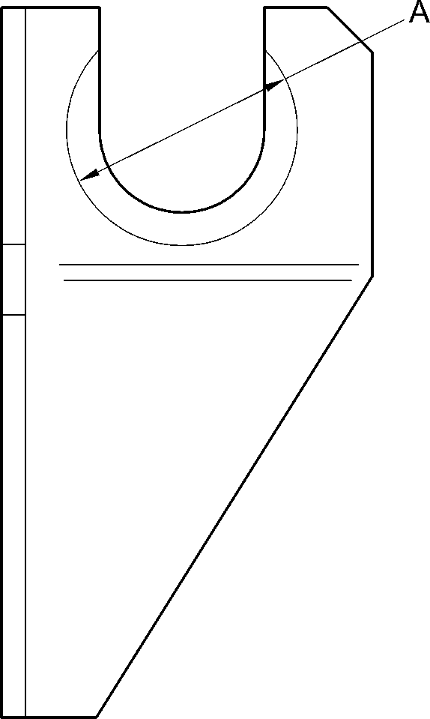

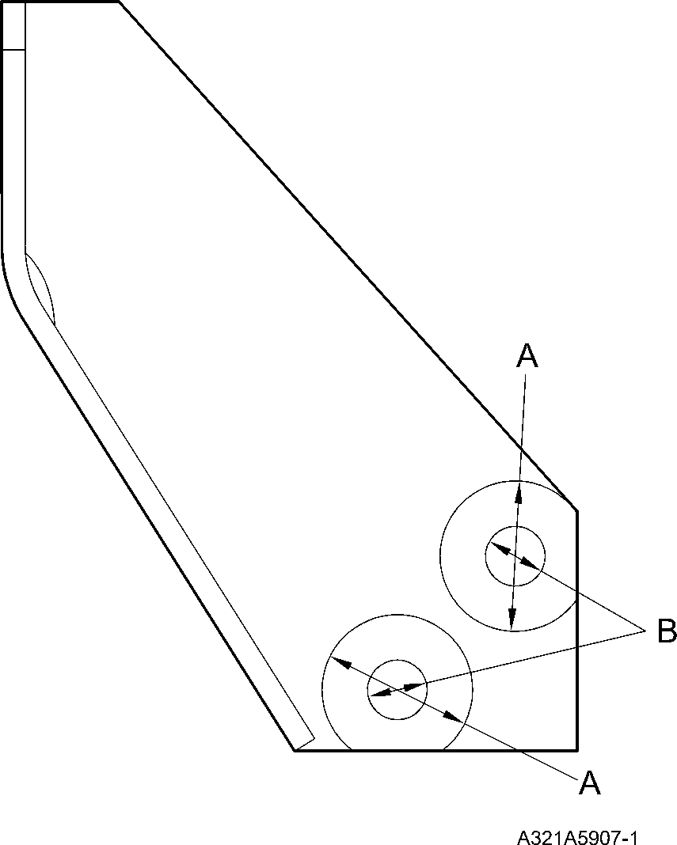

Bracket (2-120 and 2-130) - Protective Treatment  
Figure 601

32-12-22

Page 622

Mar 18/2025

**SAFRAN LANDING SYSTEMS UK Ltd**

CAGE: K0654



PART No. 201587001 AND 201587002 COMPONENT MAINTENANCE MANUAL  
MAIN LANDING GEAR LEG

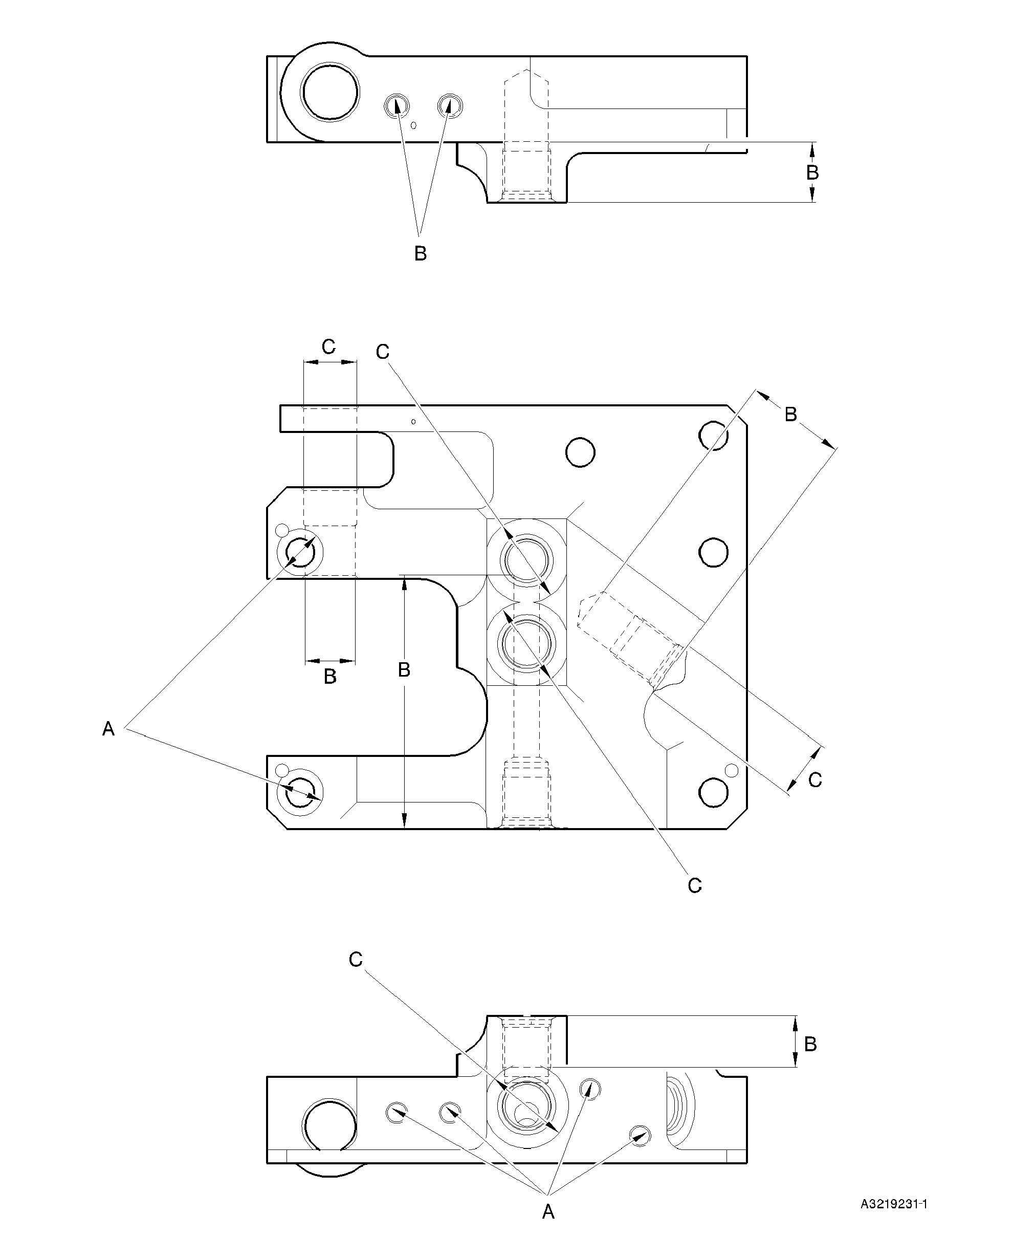

Transfer Block (2-340, 2-340A, 2-350 and 2-350A) - Protective Treatment

Figure 602

32-12-22

Page 623

Mar 18/2025

**SAFRAN LANDING SYSTEMS UK Ltd**

CAGE: K0654



PART No. 201587001 AND 201587002 COMPONENT MAINTENANCE MANUAL  
MAIN LANDING GEAR LEG

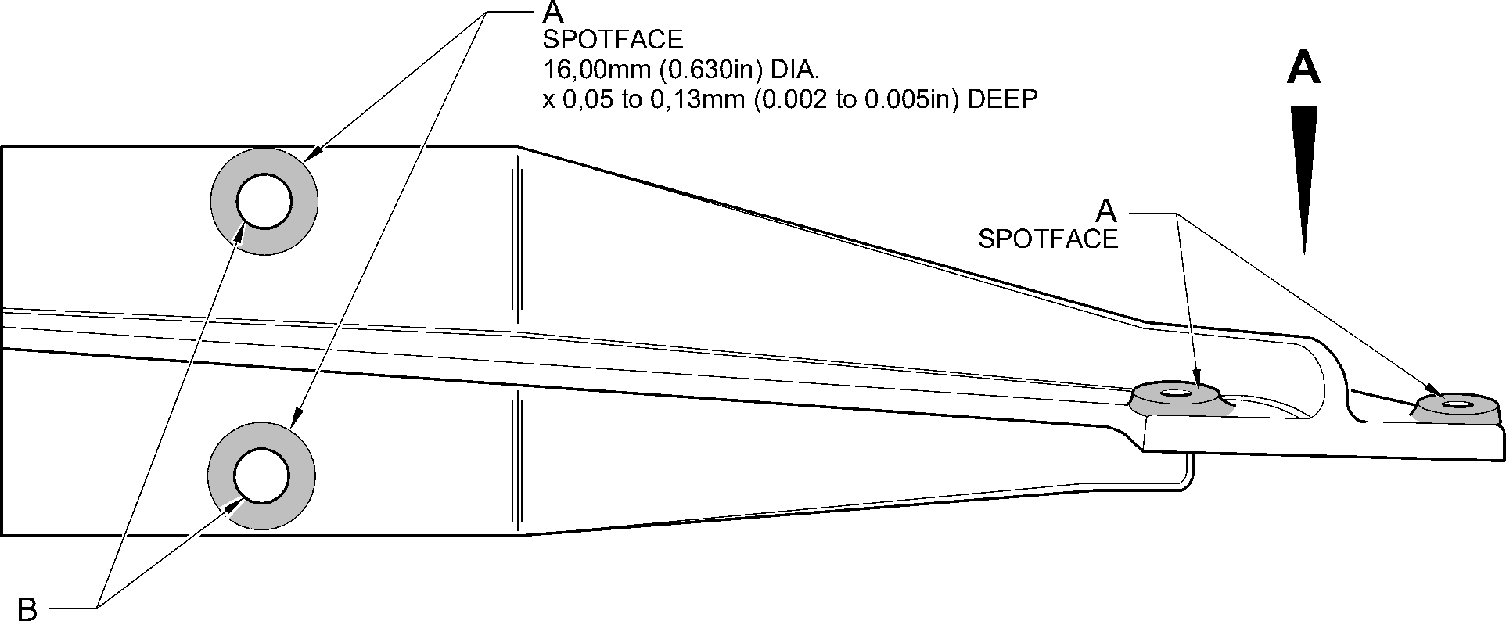

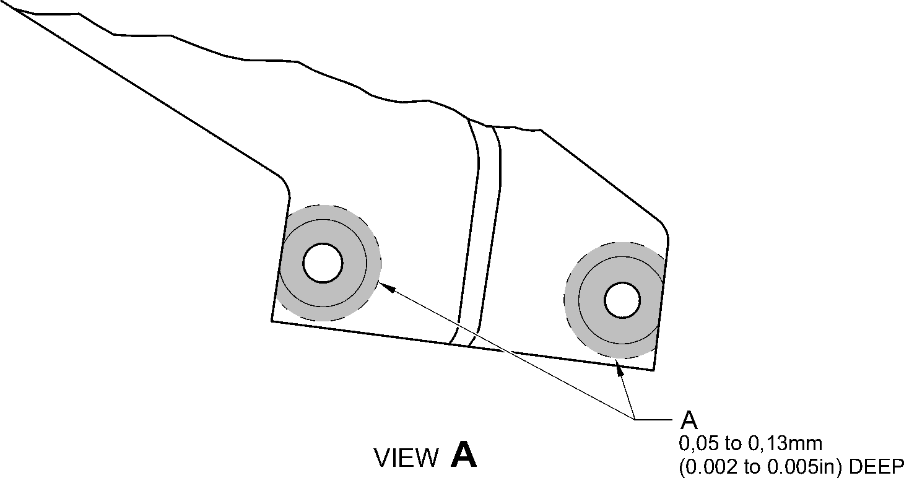

A321-S-32-12-22-096-0

Bracket (4-140 and 4-150) - Protective Treatment  
Figure 603

32-12-22

Page 624

Mar 18/2025

**SAFRAN LANDING SYSTEMS UK Ltd**

CAGE: K0654



PART No. 201587001 AND 201587002 COMPONENT MAINTENANCE MANUAL  
MAIN LANDING GEAR LEG

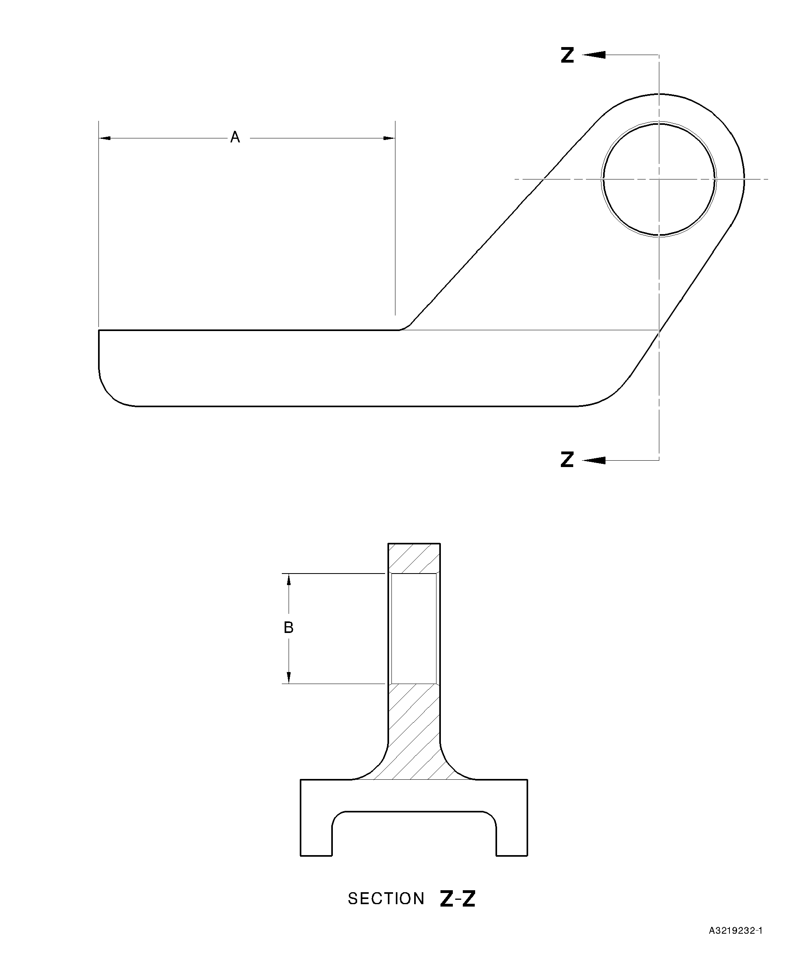

Bracket (5-160) - Protective Treatment  
Figure 604

32-12-22

Page 625

Mar 18/2025

**SAFRAN LANDING SYSTEMS UK Ltd**

CAGE: K0654



PART No. 201587001 AND 201587002 COMPONENT MAINTENANCE MANUAL  
MAIN LANDING GEAR LEG

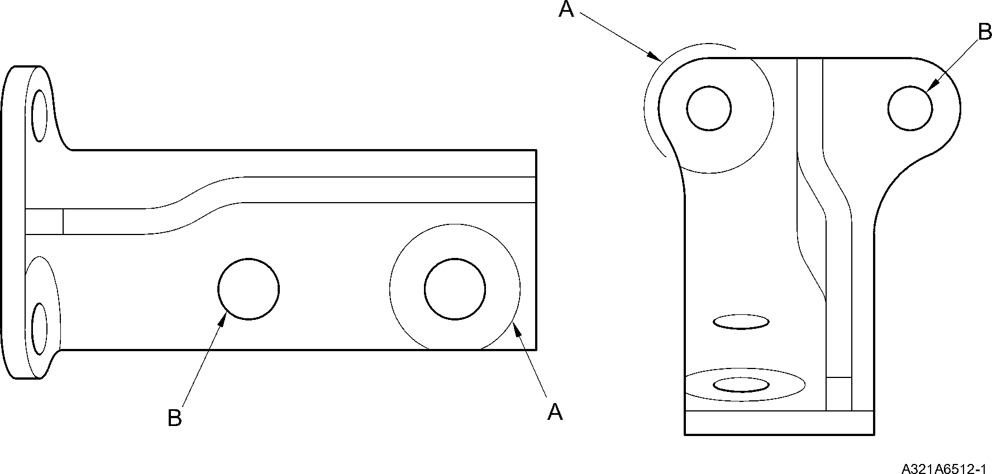

Bracket (6-170 and 6-180) - Protective Treatment  
Figure 605

32-12-22

Page 626

Mar 18/2025

**SAFRAN LANDING SYSTEMS UK Ltd**

CAGE: K0654

PART No. 201587001 AND 201587002 COMPONENT MAINTENANCE MANUAL  
MAIN LANDING GEAR LEG

section Z-Z

A

B

B

Z

Z

(BOTH HOLES) 27,00mm  
(1.062in)  
DIA

27,00mm (1.062in) DIA  
(4 PLACES)

(BOTH HOLES)

A321A6405-1

Slave Link (6-230) Only - Protective Treatment  
Figure 606

32-12-22

Page 627

Mar 18/2025

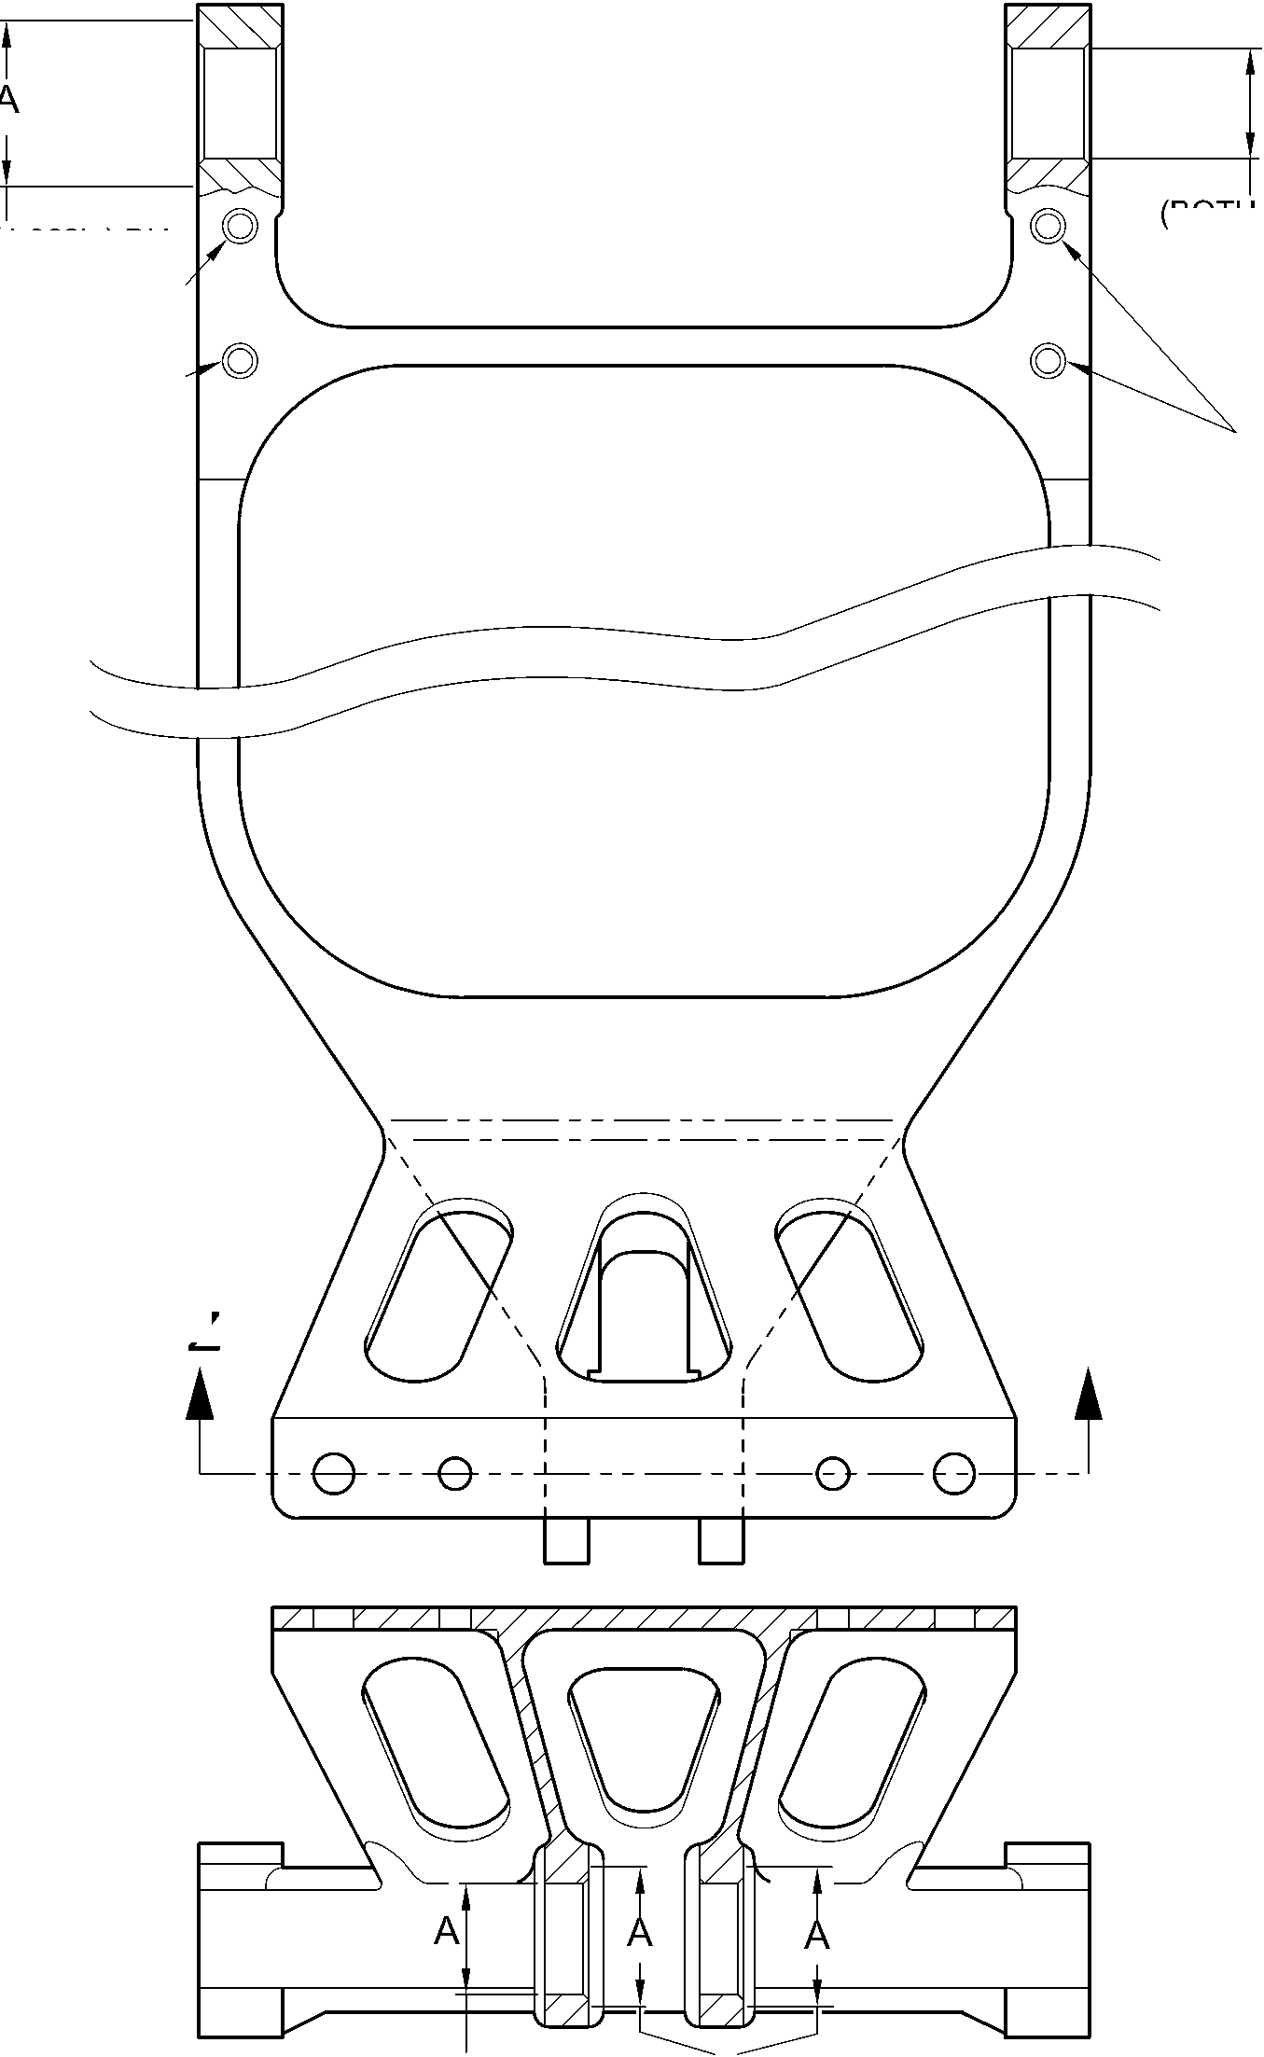

**SAFRAN LANDING SYSTEMS UK Ltd**

CAGE: K0654



PART No. 201587001 AND 201587002 COMPONENT MAINTENANCE MANUAL  
MAIN LANDING GEAR LEG

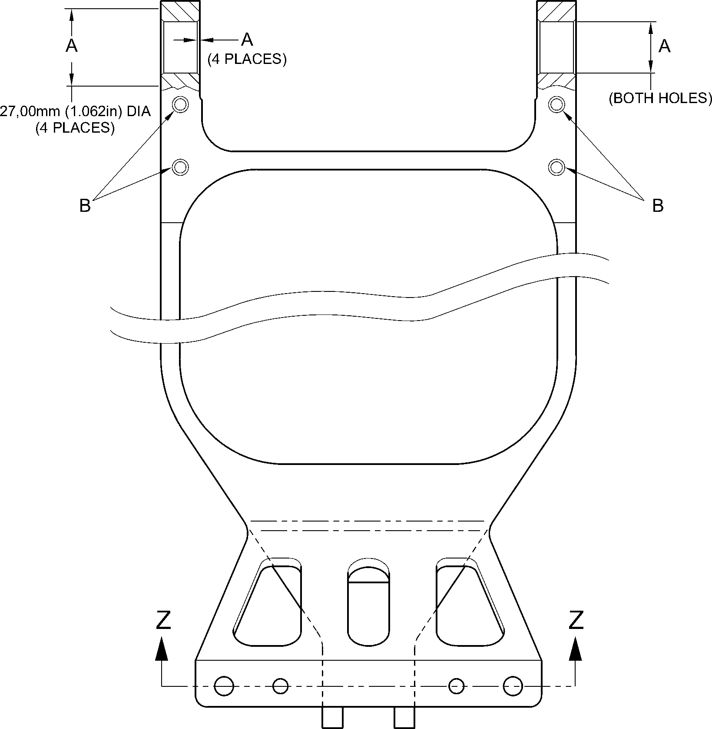

section Z-Z

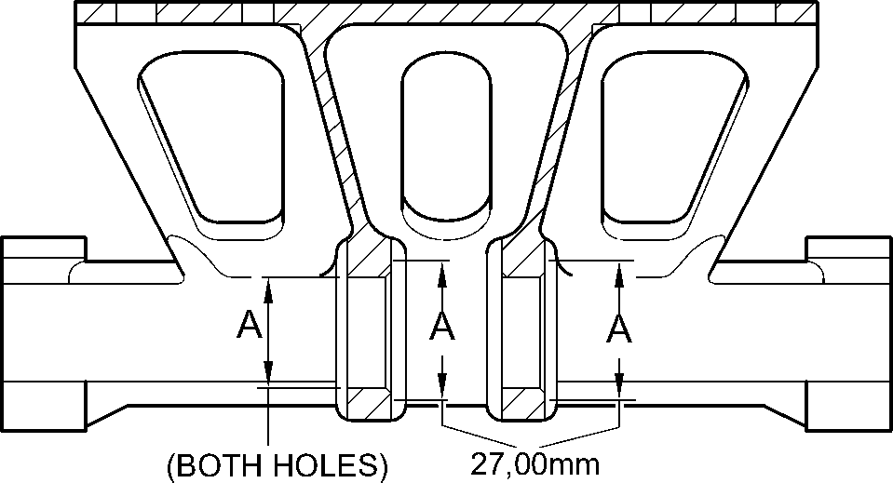

(1.062in)  
DIA

A321A6406-1

Slave Link (6-230A) - Protective Treatment  
Figure 607

32-12-22

Page 628

Mar 18/2025

**SAFRAN LANDING SYSTEMS UK Ltd**

CAGE: K0654

PART No. 201587001 AND 201587002 COMPONENT MAINTENANCE MANUAL  
MAIN LANDING GEAR LEG

Pin (10-80) - Protective Treatment  
Figure 608

32-12-22

Page 629

Mar 18/2025

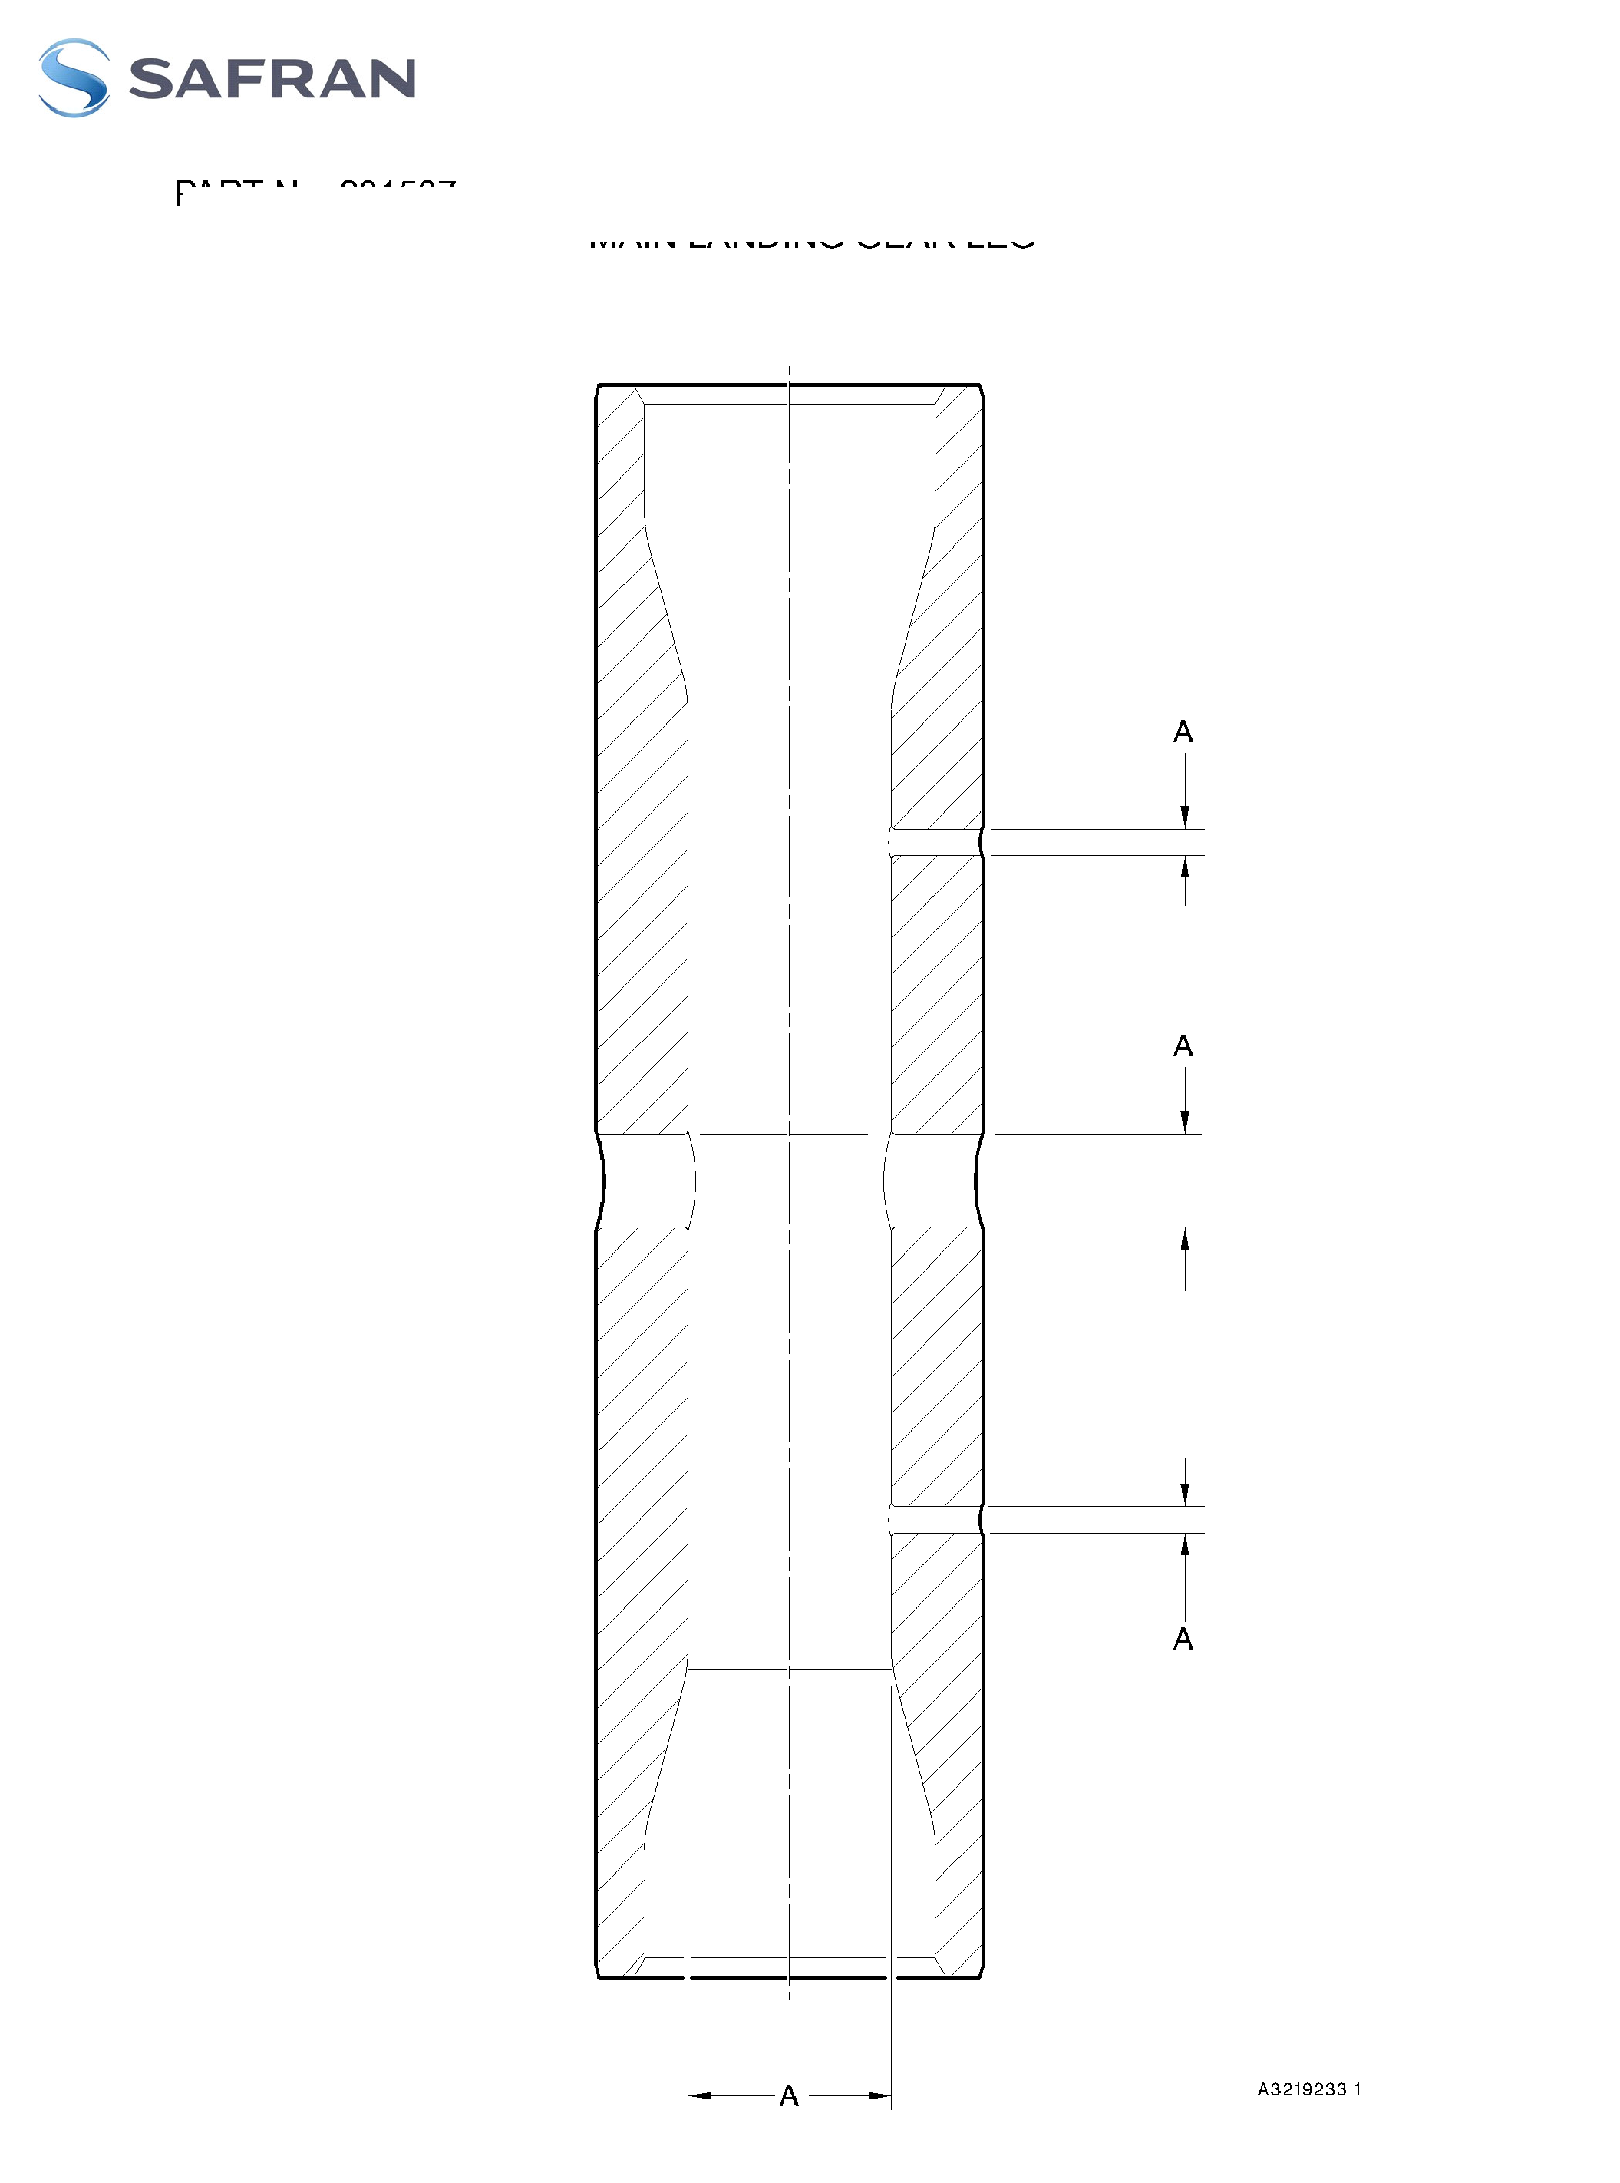

**SAFRAN LANDING SYSTEMS UK Ltd**

CAGE: K0654



PART No. 201587001 AND 201587002 COMPONENT MAINTENANCE MANUAL  
MAIN LANDING GEAR LEG

Figure Deleted

Figure 609

32-12-22

Page 630

Mar 18/2025

**SAFRAN LANDING SYSTEMS UK Ltd**

CAGE: K0654



PART No. 201587001 AND 201587002 COMPONENT MAINTENANCE MANUAL  
MAIN LANDING GEAR LEG

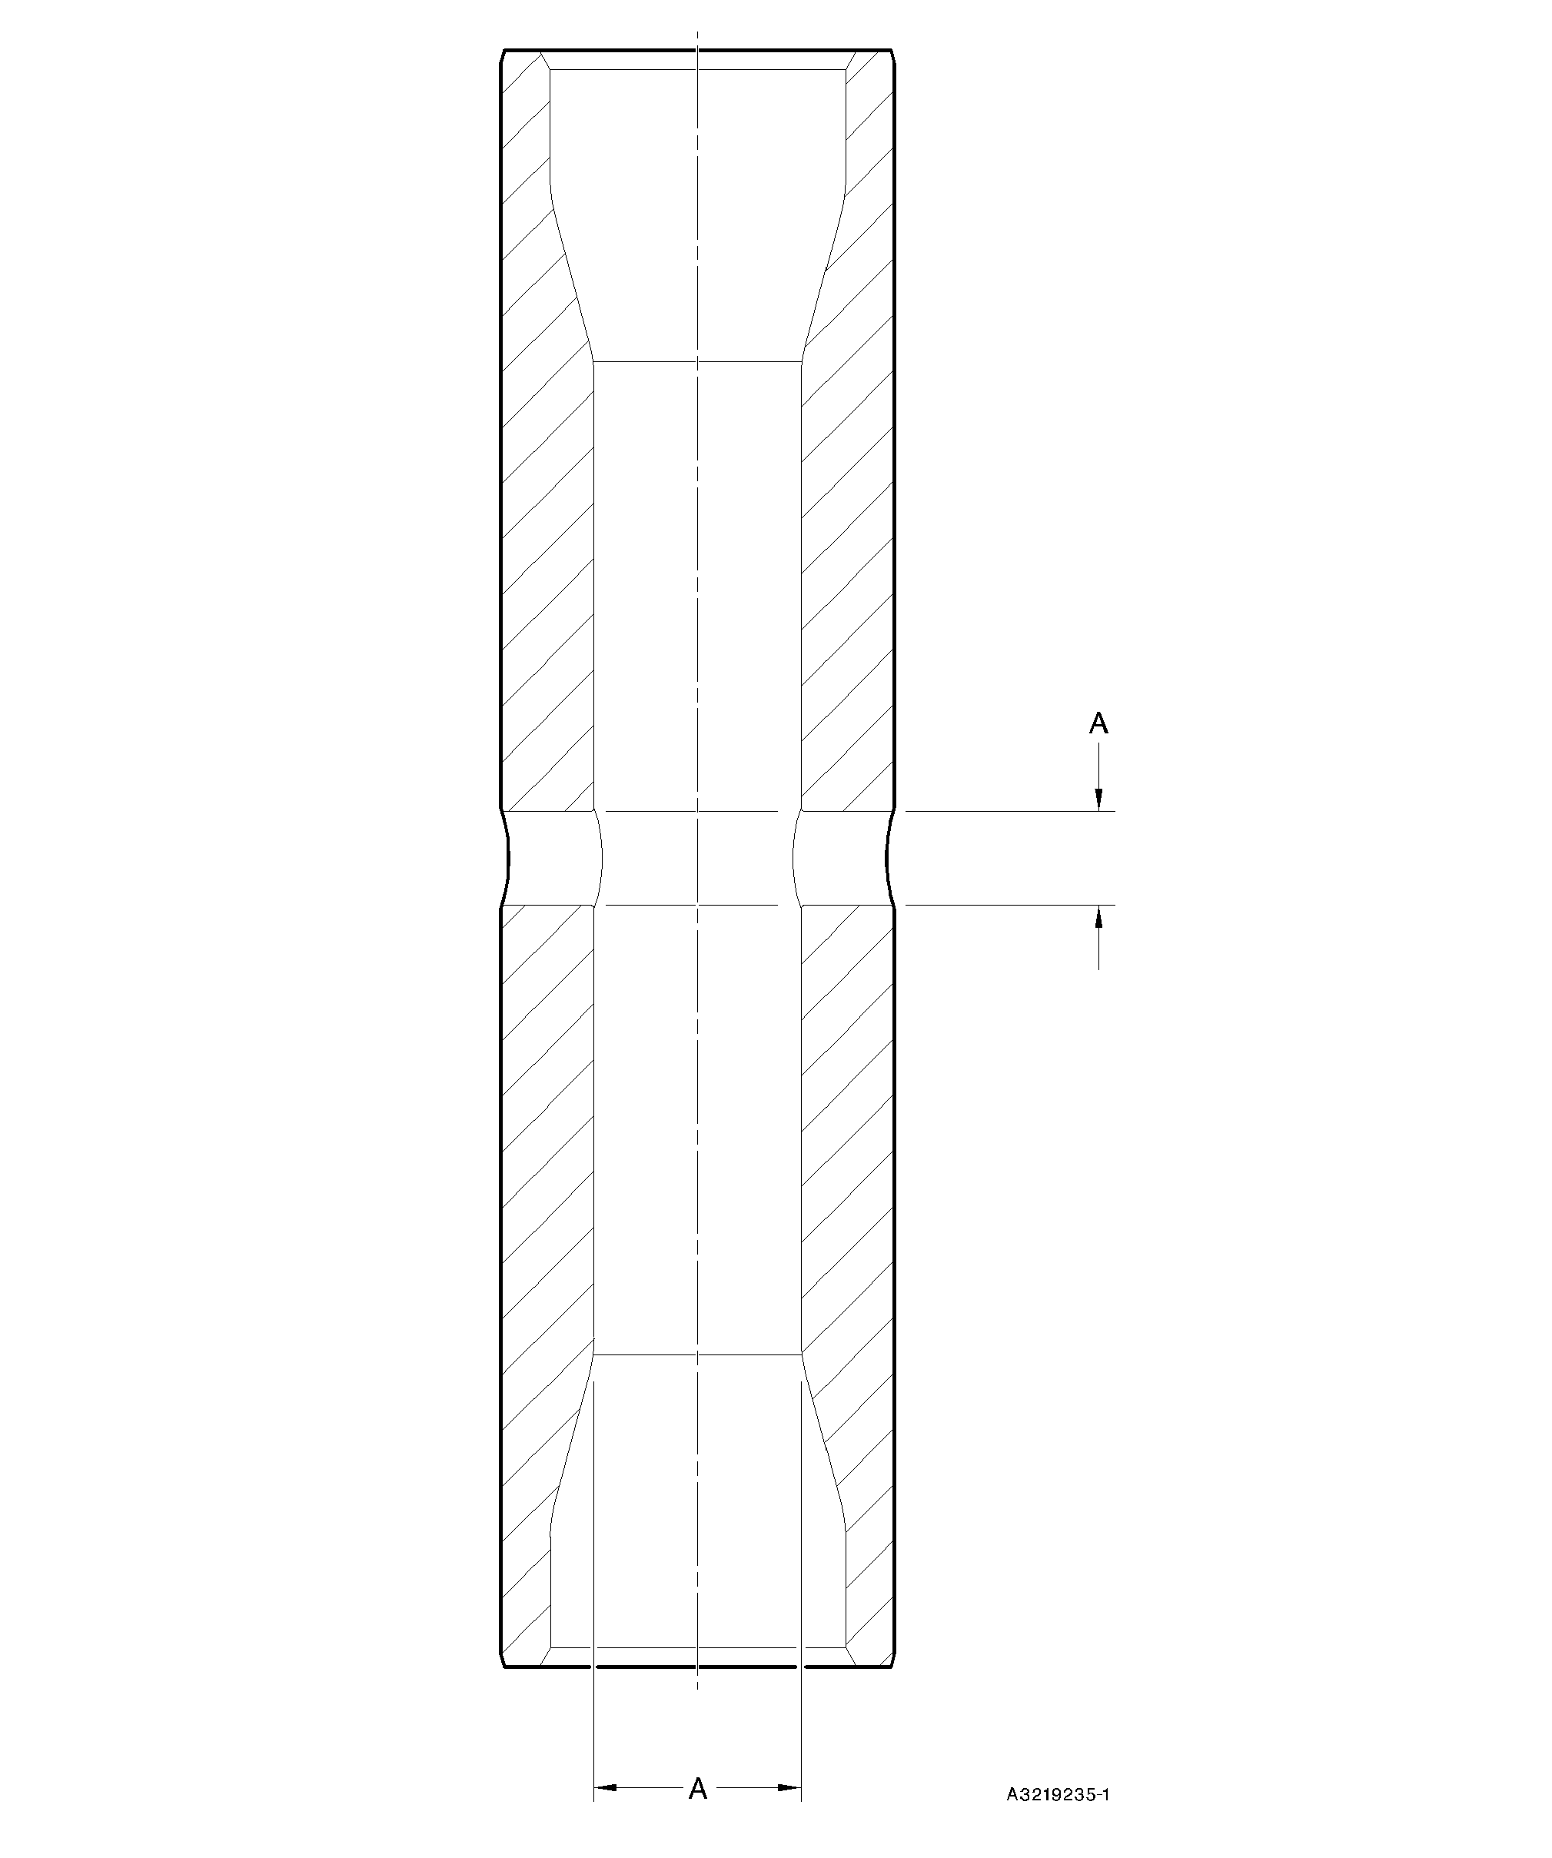

Pin (11-130) - Protective Treatment  
Figure 610

32-12-22

Page 631

Mar 18/2025

**SAFRAN LANDING SYSTEMS UK Ltd**

CAGE: K0654



PART No. 201587001 AND 201587002 COMPONENT MAINTENANCE MANUAL  
MAIN LANDING GEAR LEG

Figure Deleted

Figure 611

32-12-22

Page 632

Mar 18/2025

**SAFRAN LANDING SYSTEMS UK Ltd**

CAGE: K0654



PART No. 201587001 AND 201587002 COMPONENT MAINTENANCE MANUAL  
MAIN LANDING GEAR LEG

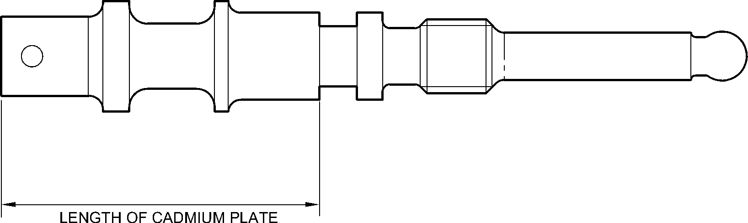

A321A4849-1

Valve Stem (12-90) - Protective Treatment  
Figure 612

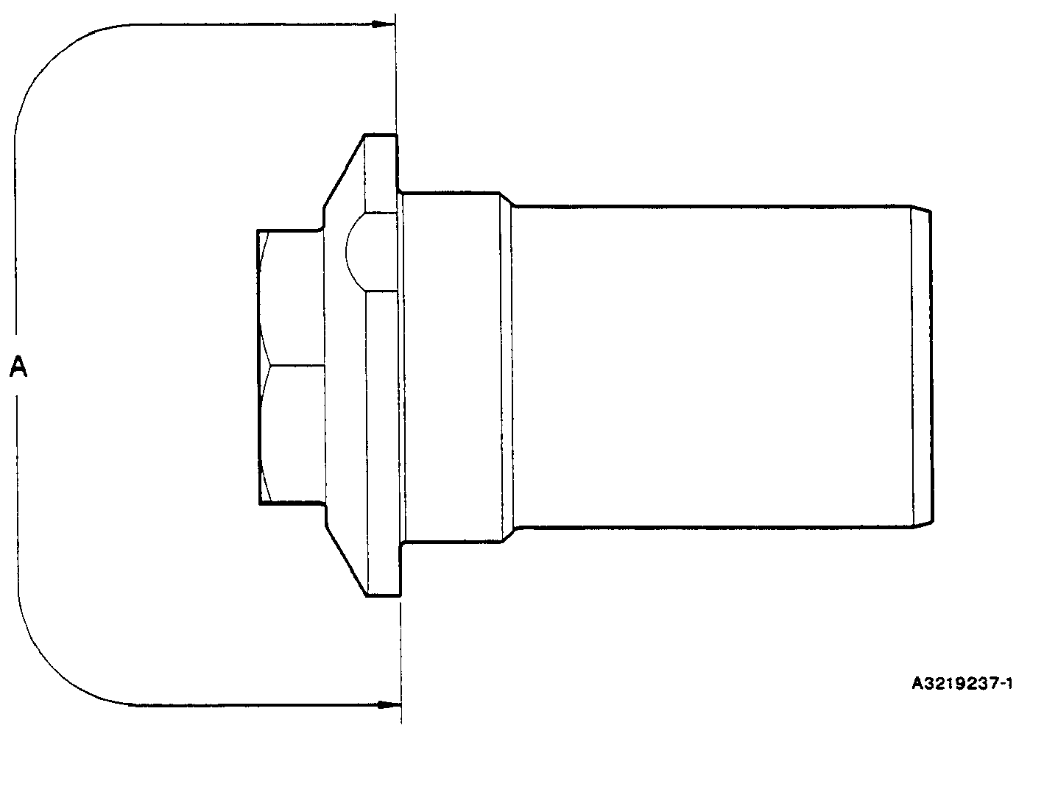

Retaining Pin (13-10) - Protective Treatment  
Figure 613

32-12-22

Page 633

Mar 18/2025

**SAFRAN LANDING SYSTEMS UK Ltd**

CAGE: K0654



PART No. 201587001 AND 201587002 COMPONENT MAINTENANCE MANUAL  
MAIN LANDING GEAR LEG

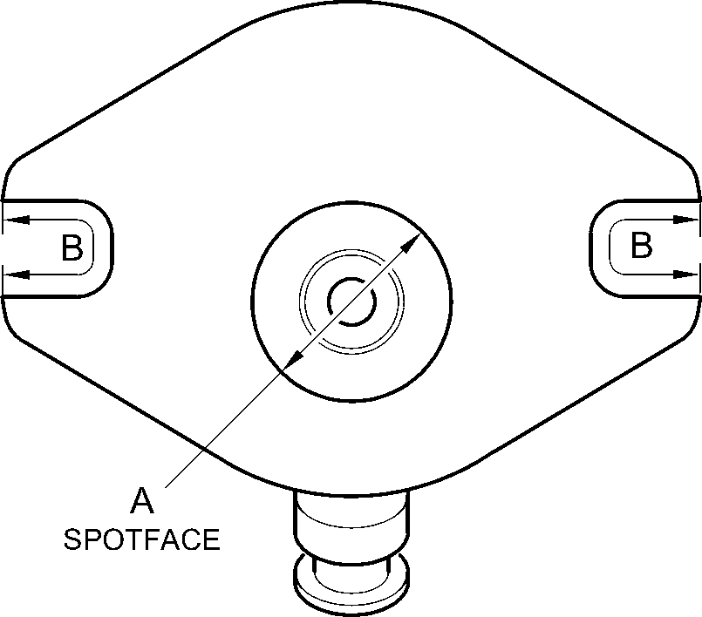

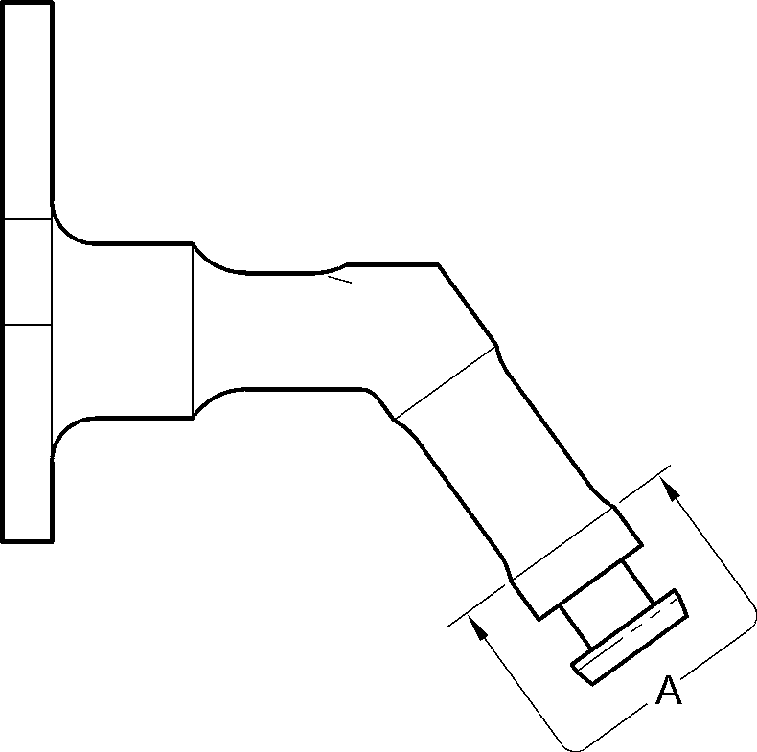

A321A4850-2

Inflation Valve (13-110 and 13-110A) - Protective Treatment  
Figure 614

32-12-22

Page 634

Mar 18/2025

**SAFRAN LANDING SYSTEMS UK Ltd**

CAGE: K0654



PART No. 201587001 AND 201587002 COMPONENT MAINTENANCE MANUAL  
MAIN LANDING GEAR LEG

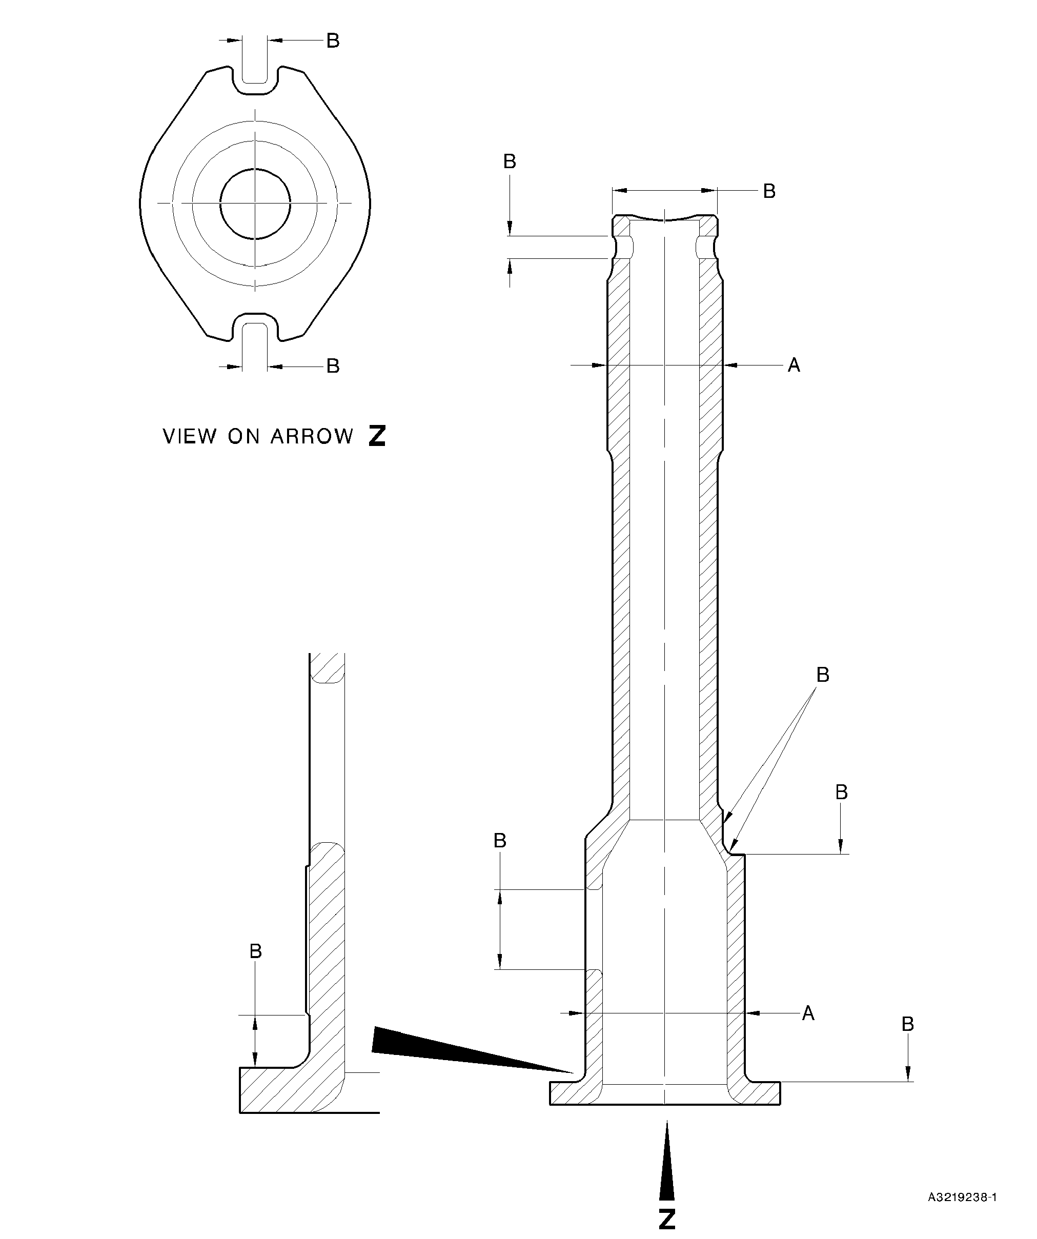

Pin (13-190 and 13-190A) - Protective Treatment  
Figure 615

32-12-22

Page 635

Mar 18/2025

**SAFRAN LANDING SYSTEMS UK Ltd**

CAGE: K0654



PART No. 201587001 AND 201587002 COMPONENT MAINTENANCE MANUAL  
MAIN LANDING GEAR LEG

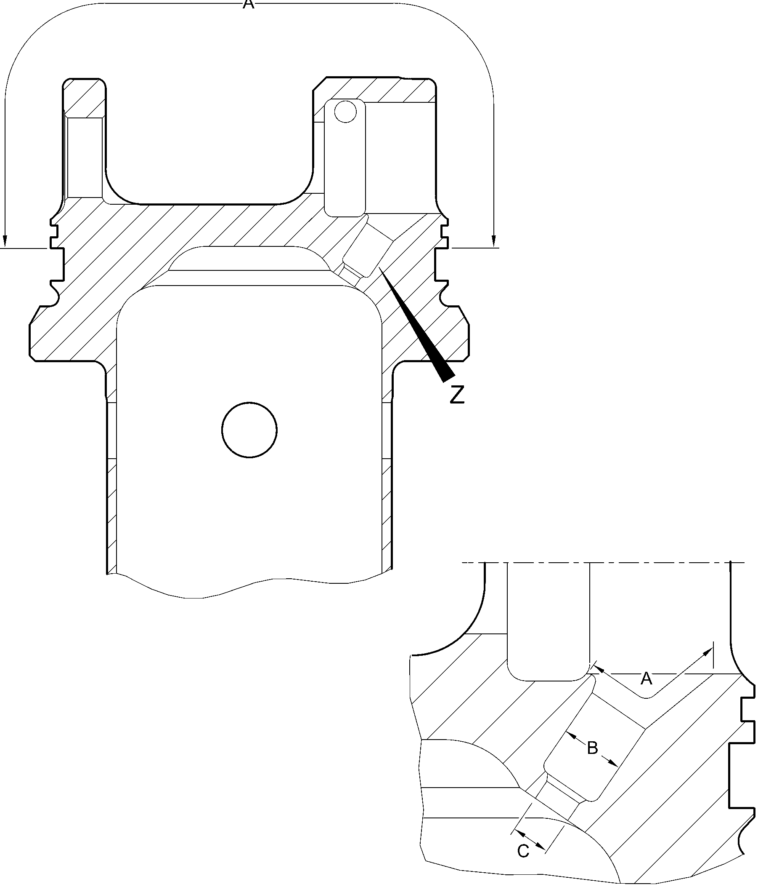

detail Z

A321A3758-1

Upper Diaphragm Tube (15-390) - Protective Treatment

Figure 616

32-12-22

Page 636

Mar 18/2025

**SAFRAN LANDING SYSTEMS UK Ltd**

CAGE: K0654



PART No. 201587001 AND 201587002 COMPONENT MAINTENANCE MANUAL  
MAIN LANDING GEAR LEG

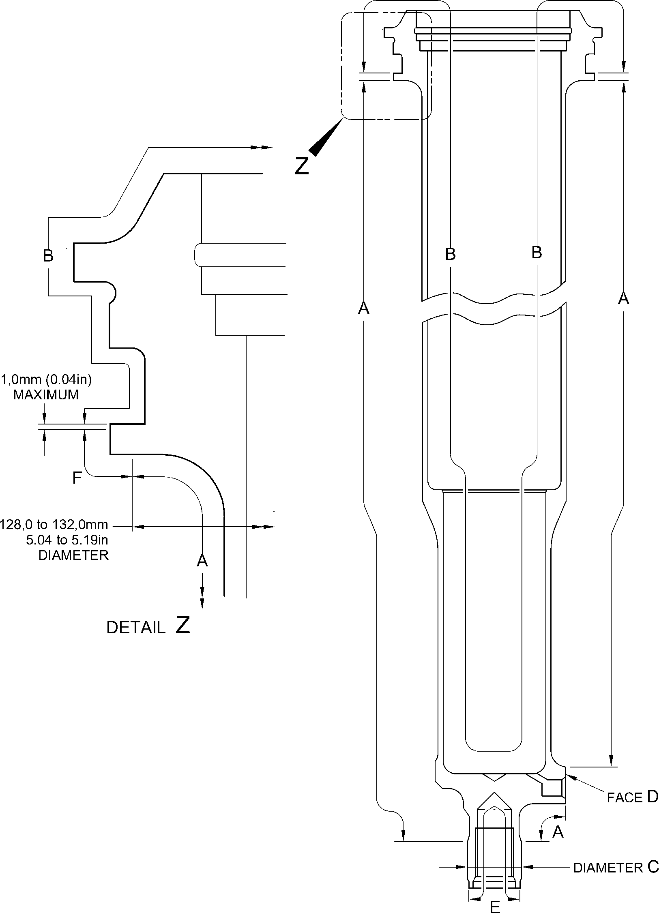

A321A5553-1

Cylinder (17-230) - Protective Treatment  
Figure 617

32-12-22

Page 637

Mar 18/2025

**SAFRAN LANDING SYSTEMS UK Ltd**

CAGE: K0654



PART No. 201587001 AND 201587002 COMPONENT MAINTENANCE MANUAL  
MAIN LANDING GEAR LEG

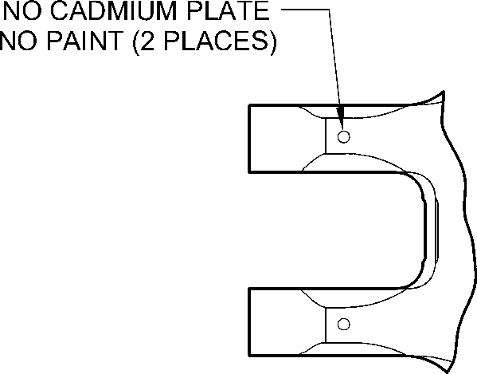

NO CADMIUM PLATE

NO PAINT

IN HOLES (Qty 6)

NO CADMIUM PLATE

NO PAINT

(2 PLACES)

VIEW **W**

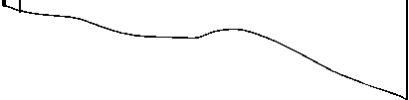

**Z-Z**

**Z**

NO CADMIUM PLATE  
NO PAINT

NO PAINT  
39,00 to 40,00mm  
(1.535 to 1.575in) DIA.

NO PAINT  
80,00 to 81,00mm  
(3.150 to 3.188in) DIA.

NO PAINT

NO PAINT

SECTION

**Z**

VIEW **V**

**W**

PAINT TO  
PCS-2500  
UP TO BUSH

FLANGES

NO PAINT  
(Qty 24)

PRIMER PAINT TO PCS-2500

6,50 to 6,70mm (0.256 to 0.263in) DIA. for (18-80)

6,60 to 6,80mm (0.259 to 0.268in) DIA. for (18-80A)  
(4 PLACES)

NO PAINT

80,00 to 81,00mm  
(3.150 to 3.188in) DIA.

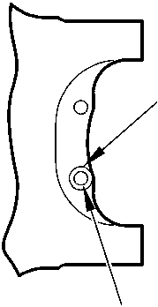

NO PAINT  
13,00mm  
(0.512in) DIA.

NO PAINT  
39,00 to 40,00mm

(1.535 to 1.575in) DIA.

A321-S-32-12-22-088-0

Sliding Tube (18-80) or (18-80A) - Protective Treatment  
Figure 618 - Sheet 1

32-12-22

Page 638

Mar 18/2025

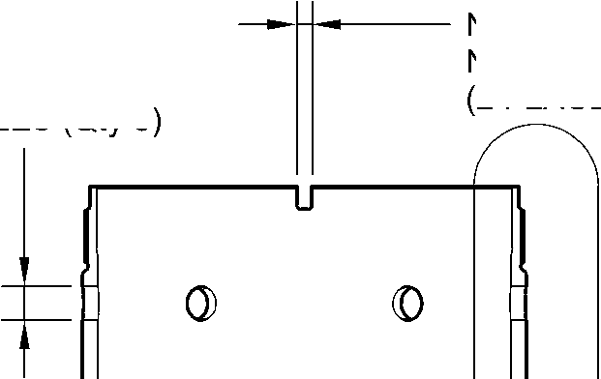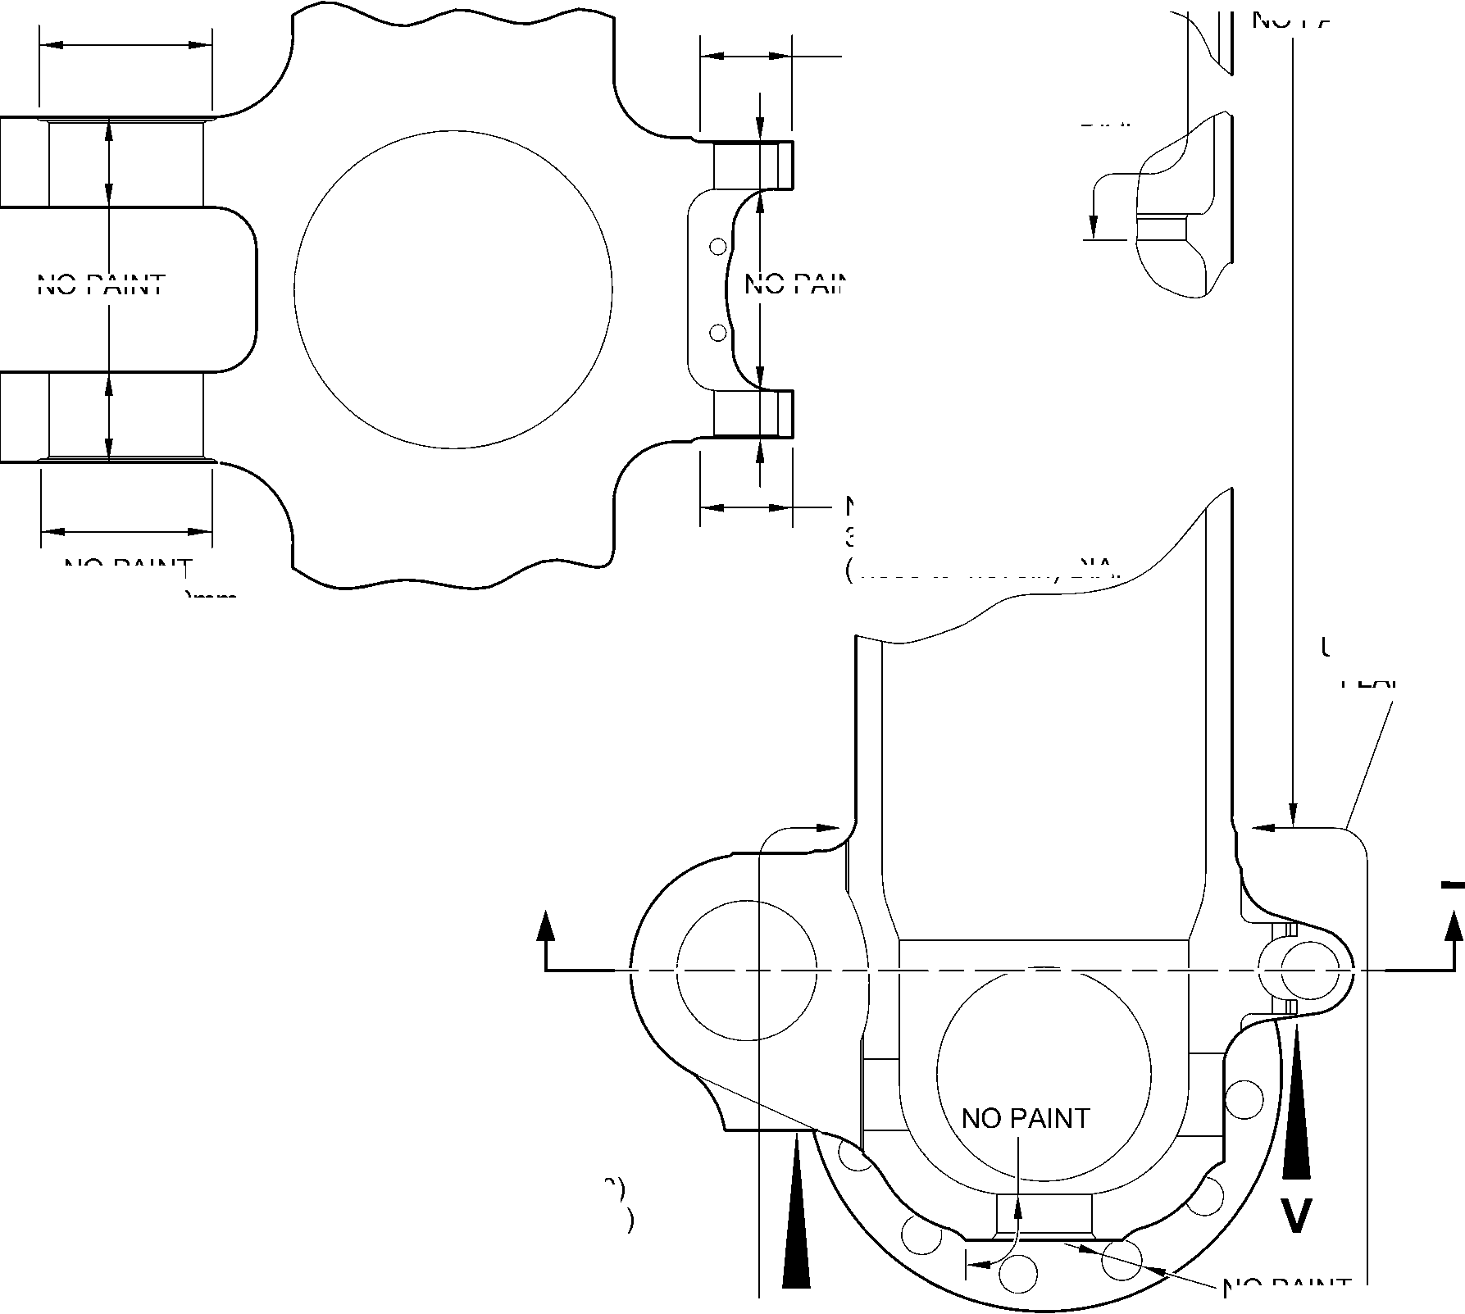

**SAFRAN LANDING SYSTEMS UK Ltd**

CAGE: K0654



PART No. 201587001 AND 201587002 COMPONENT MAINTENANCE MANUAL  
MAIN LANDING GEAR LEG

PRIMER PAINT TO PCS-2500  
OVER SERMETEL W TO LENGTH  
305,00mm (12.000in) for (18-80)  
220,00mm (8.661in) for (18-80A)

SERMETEL W  
TO

IFC 40-860-03MD

0

©

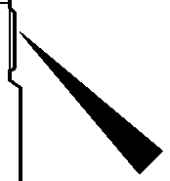

**B**

SERMETEL W

TO

IFC 40-860-03MD

PAINT TO  
PCS-2500

DETAIL **B**

NOTE:-

SERMETEL W ON INTERNAL  
DIAMETER OVER LENGTH A  
TO IFC 40-860-03MD

A

SERMETEL W  
TO  
IFC 40-860-03MD

PRIMER PAINT TO  
PCS-2500  
29,50 to 30,50mm  
(1.161 to 1.200in) DIA.

SPOTFACE (Qty. 24)

SERMETEL W

TO

IFC 40-860-03MD

CHROMIUM  
PLATE

0 to 2,00mm  
(0 to 0.078in)  
RUNOUT  
(BOTH SIDES)

SERMETEL W

TO  
IFC 40-860-03MD

149,90mm (5.901in)  
DIAMETER

SERMETEL W  
TO IFC 40-860-03MD

160,00mm (6.299in)  
DIAMETER

0 to 2,00mm  
(0 to 0.078in)

RUNOUT  
(BOTH SIDES)

LIMIT OF SERMETEL W  
TERMINATION FROM CENTER  
84,00 to 96,00mm  
(3.307 to 3.779in)

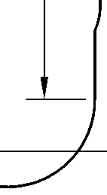

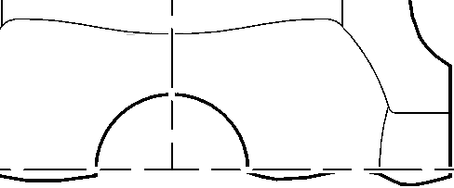

CENTERLINE OF  
SLIDING TUBE

SERMETEL W

TO IFC 40-860-03MD

LIMIT OF SERMETEL W  
TERMINATION FROM CENTER  
95,50 TO 107,50MM

(3.759 TO 4.232IN)

A321-S-32-12-22-089-0

Sliding Tube (18-80) or (18-80A) - Protective Treatment  
Figure 618 - Sheet 2

32-12-22

Page 639

Mar 18/2025

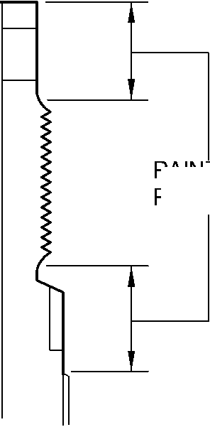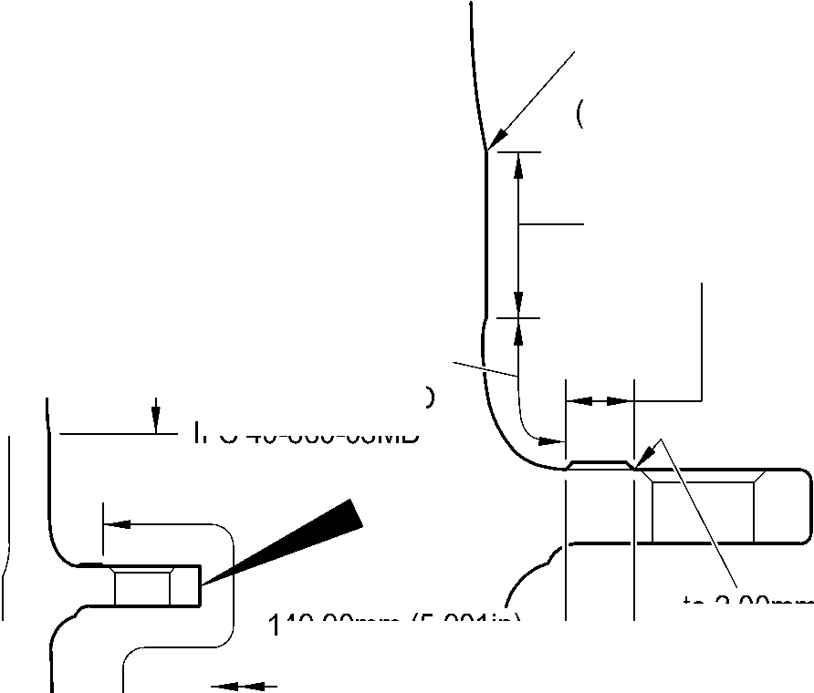

**SAFRAN LANDING SYSTEMS UK Ltd**

CAGE: K0654

PART No. 201587001 AND 201587002 COMPONENT MAINTENANCE MANUAL  
MAIN LANDING GEAR LEG

**M**

**N**

**W**

**W**

**W**

**X**

**Z**

B

INTERNALLY

**W**

**U**

DETAIL **U**

**Q**

**W**

**S**

**Y**

VIEW **Y**

A  
PLACES

**W**

**V**

2 PLACES

22,00mm (0.866in) DIA.

THIS FACE ONLY

**W**

**W**

**W**

**W**

DETAIL **W**14 PLACES

**W**

C

INTERNALLY

DETAIL **V**

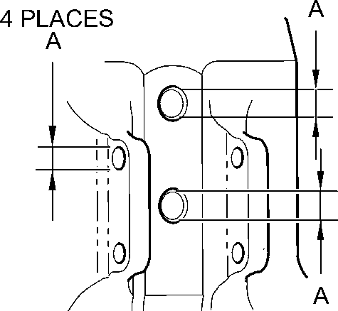

A DETAIL **X**

4 PLACES

16,0mm  
(0,63in) DIA.  
THIS FACE

ONLY

FOR ALL SECTION VIEWS SEE SHEET 2

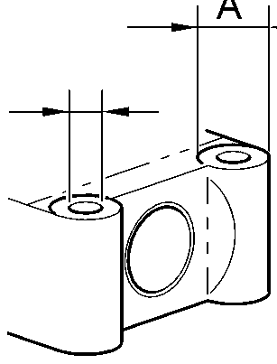

DETAIL **Z**

**T**

A321-S-32-12-22-033-1

Main Fitting Subassembly (20-90, 20-90A, 20-100 and 20-100A) - Protective Treatment

Figure 619 - Sheet 1

32

Page 640

-12-22 Mar 18/2025

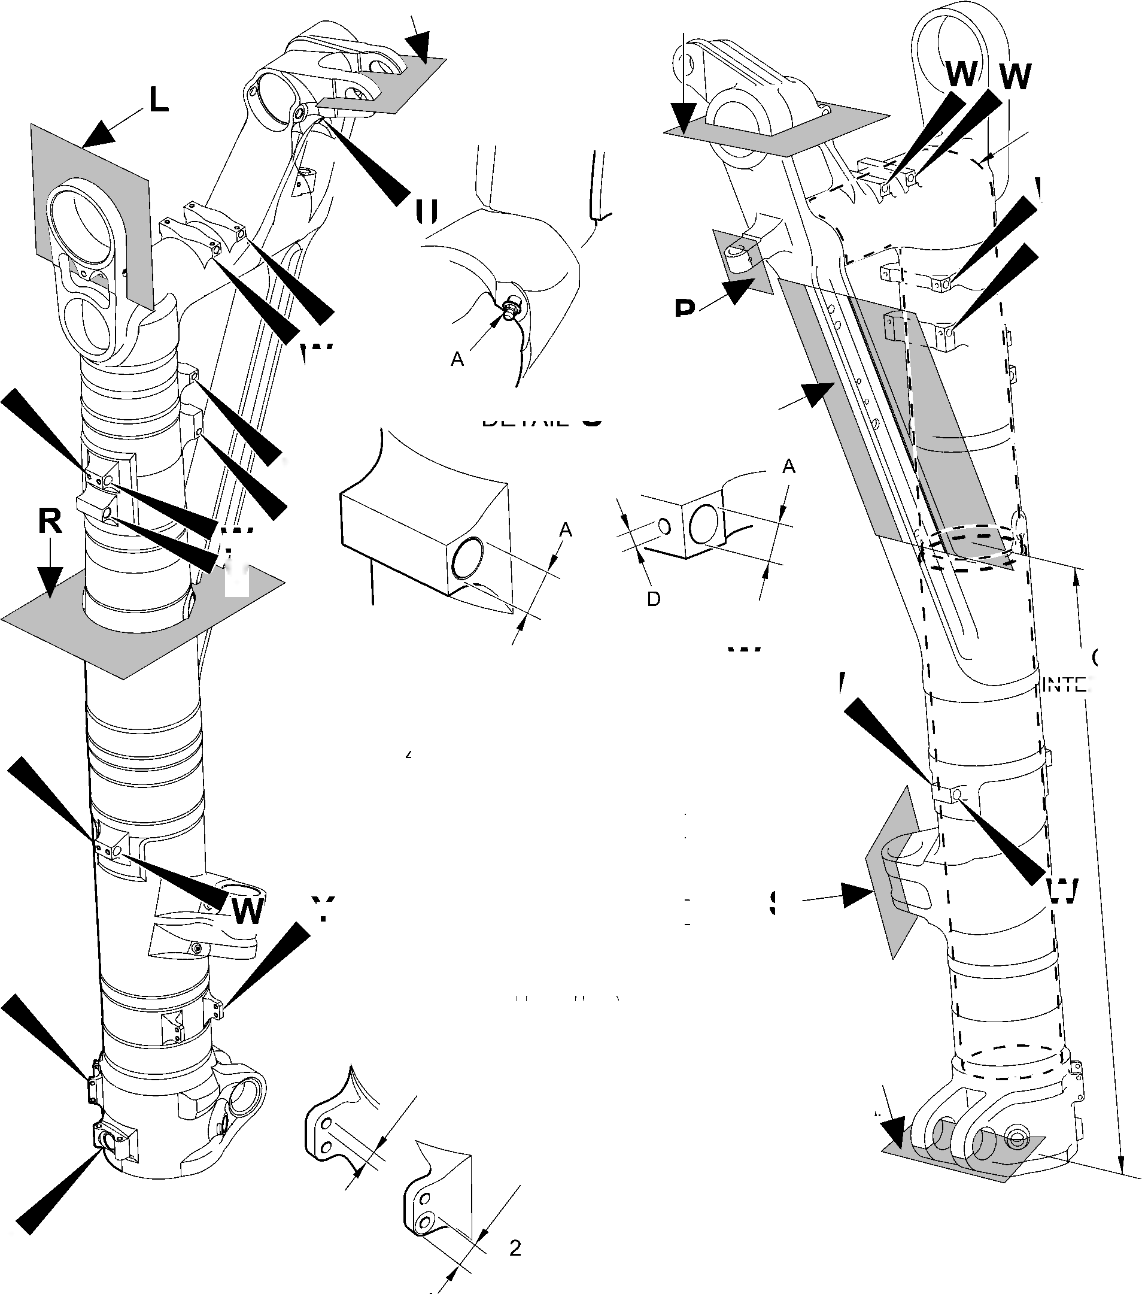

**SAFRAN LANDING SYSTEMS UK Ltd**

CAGE: K0654

PART No. 201587001 AND 201587002 COMPONENT MAINTENANCE MANUAL  
MAIN LANDING GEAR LEG

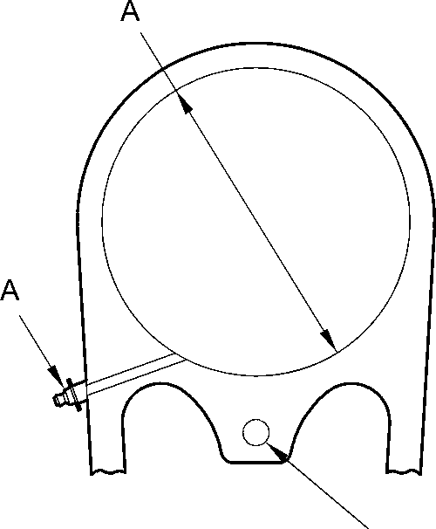

SECTION **L**

**M**

A

3 PLACES

A

SECTION

SECTION **N**

**P**

SECTION

SECTION **R**

SECTION **Q**

SECTION **S**

SECTION **T**

A321-S-32-12-22-087-0

A

Main Fitting Subassembly (20-90, 20-90A, 20-100 and 20-100A) - Protective Treatment

Figure 619 - Sheet 2

32-12-22

Page 641

Mar 18/2025

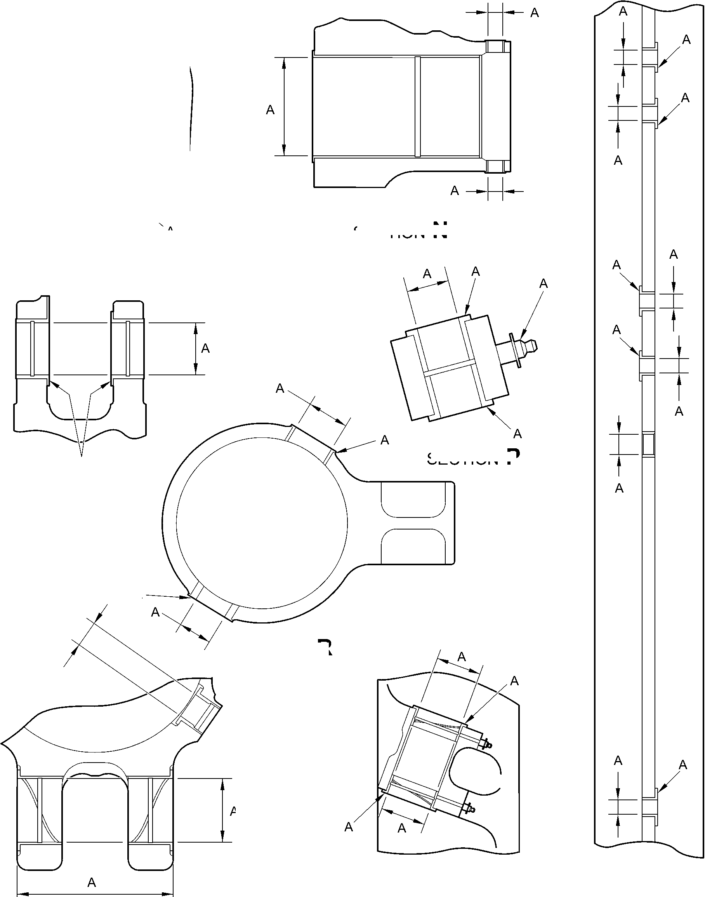

**SAFRAN LANDING SYSTEMS UK Ltd**

CAGE: K0654



PART No. 201587001 AND 201587002 COMPONENT MAINTENANCE MANUAL  
MAIN LANDING GEAR LEG

Z

B (2 hOleS)

B (4 holes)

VIEW ON ARROW  
Z

A and B

(INNER DIAMETER)

B (2 hOleS)

C (2 diameters)

A3219241-4

Main Fitting (20-410) and (20-420) - Protective Treatment  
Figure 620

32-12-22

Page 642

Mar 18/2025

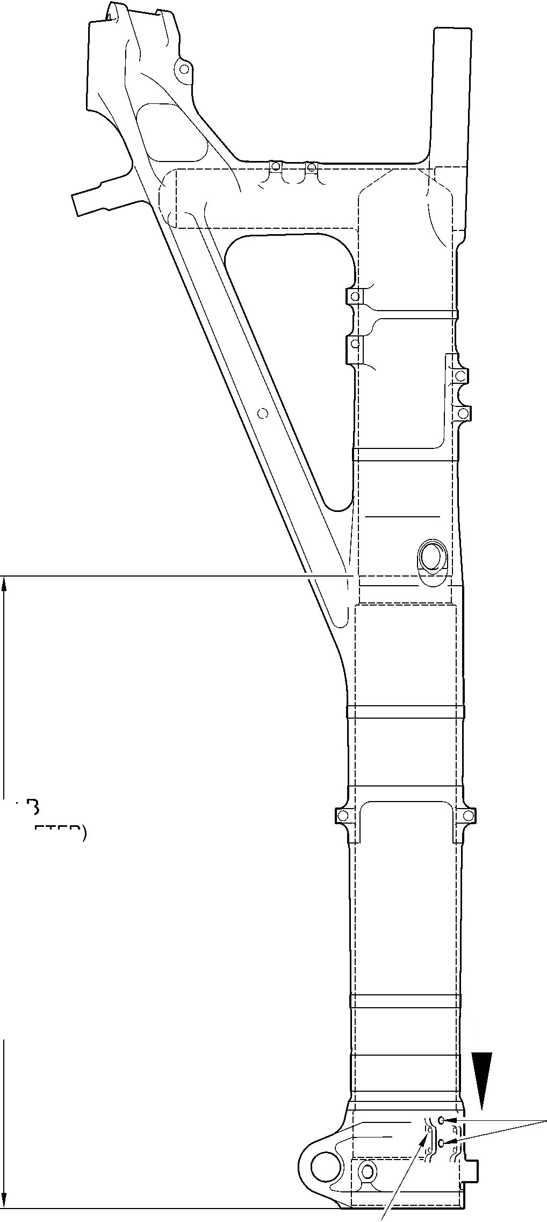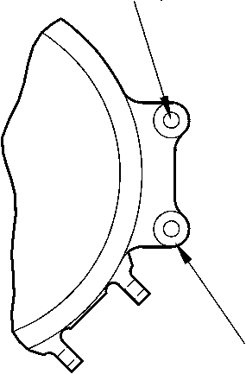

**SAFRAN LANDING SYSTEMS UK Ltd**

CAGE: K0654

PART No. 201587001 AND 201587002 COMPONENT MAINTENANCE MANUAL  
MAIN LANDING GEAR LEG

B

B  
(DIAMETER)

B

(HOLE TO DEPTH OF  
16,0mm (0.63in)  
FROM THIS SURFACE)

B (DIAMETER)

Z

B

B  
(CHAMFER)

B (DIAMETER)

B  
(DIAMETER)

B

(DIAMETER)

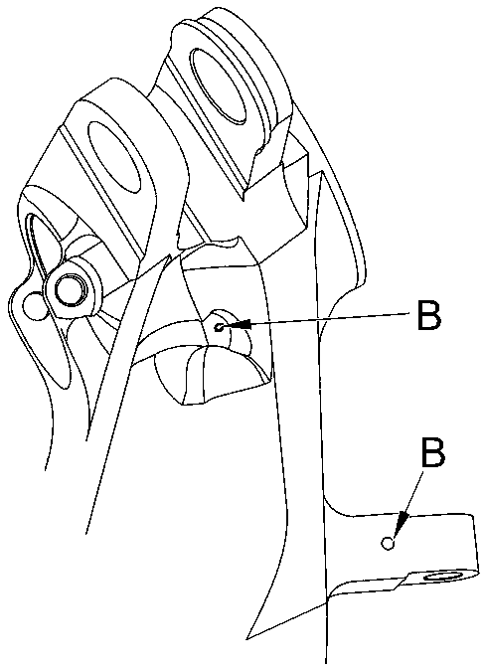

view on arrow Z

B (DIAMETER)

B  
(DIAMETER)

B (DIAMETER)

B  
(DIAMETER)

B

(DIAMETER)

A321A3506-1

Main Fitting (20-410) and (20-420)- Protective Treatment

Figure 621

32-12-22

Page 643

Mar 18/2025

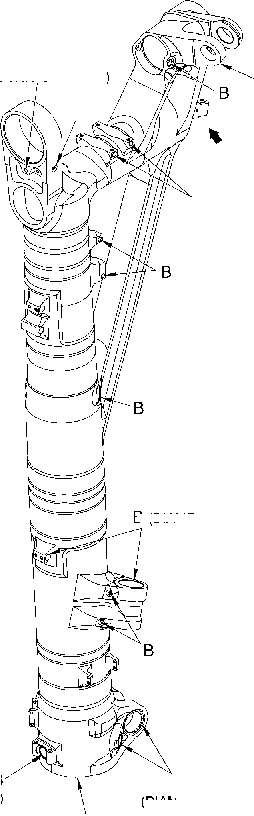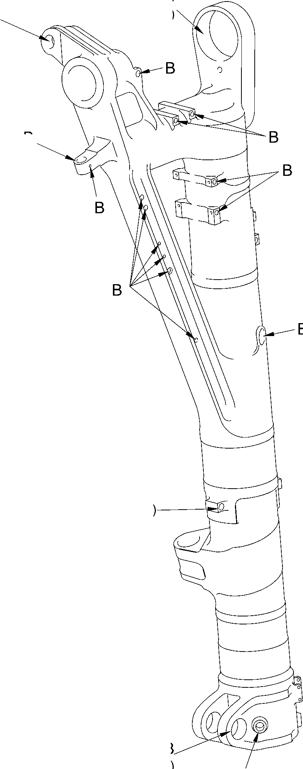

**SAFRAN LANDING SYSTEMS UK Ltd**

CAGE: K0654

PART No. 201587001 AND 201587002 COMPONENT MAINTENANCE MANUAL  
MAIN LANDING GEAR LEG

B INTERNALLY

W

X

U

B

INTERNALLY

C

INTERNALLY

C  
16,000mm  
(0.6299in)  
1 POSITION ONLY

C

19,800 to 20,000mm

0.7795 to 0.7873in) DIA.

SECTION Y-Y

X

A

U

Z

3 BORES

C

section X-X

section U-U

A321-S-32-12-22-085-0

52,000mm

(2.0472in) C

THROUGH DIA.

detail W

TYPICAL 2 PLACES

section Z-Z

C  
2 HOLES  
9,700 to 10,000mm  
(0.3818 to 0.3936in) DIA.

Main Fitting (20-410A) and (20-420A) - Protective Treatment  
Figure 622 - Sheet 1

32-12-22

Page 644

Mar 18/2025

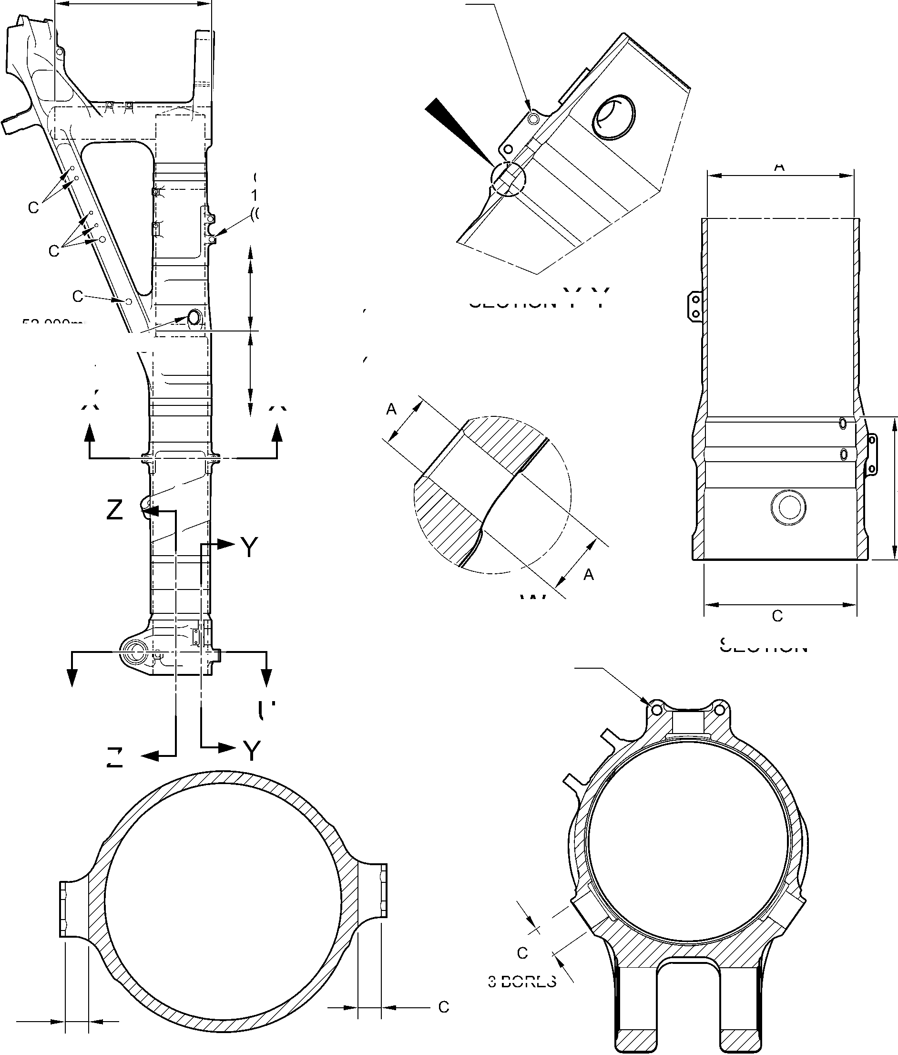

**SAFRAN LANDING SYSTEMS UK Ltd**

CAGE: K0654

C

22,000mm

(0.8661in) DIA.

2 POSITIONS

IN THIS FACE ONLY

**W**

SECTION **V-V**

C

**V**

SECTION **W-W**

SECTION **Z-Z**

**U**

**U**

SECTION **Y-Y**

A321-S-32-12-22-086-0

C  
RAD.

4 PLACES

D

4 PLACES

C

TO A DEPTH

OF 16,000mm  
(0.6299in)

FROM OUTSIDE  
FACE

D  
RAD.

4 PLACES

C

4 HOLES

PART No. 201587001 AND 201587002 COMPONENT MAINTENANCE MANUAL

MAIN LANDING GEAR LEG

SECTION **U-U**

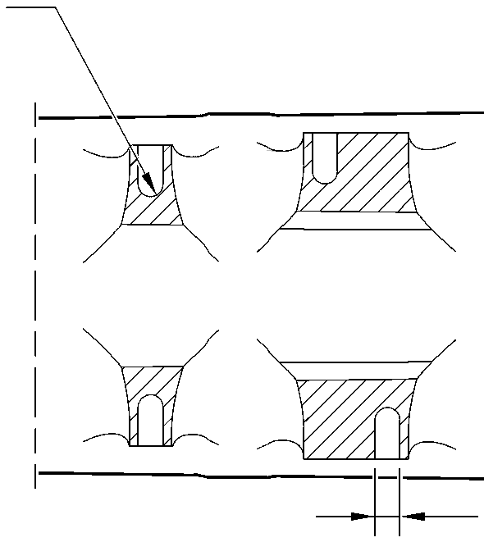

SECTION **X-X**

Main Fitting (20-410A) and (20-420A) - Protective Treatment  
Figure 622 - Sheet 2

32-12-22

Page 645

Mar 18/2025

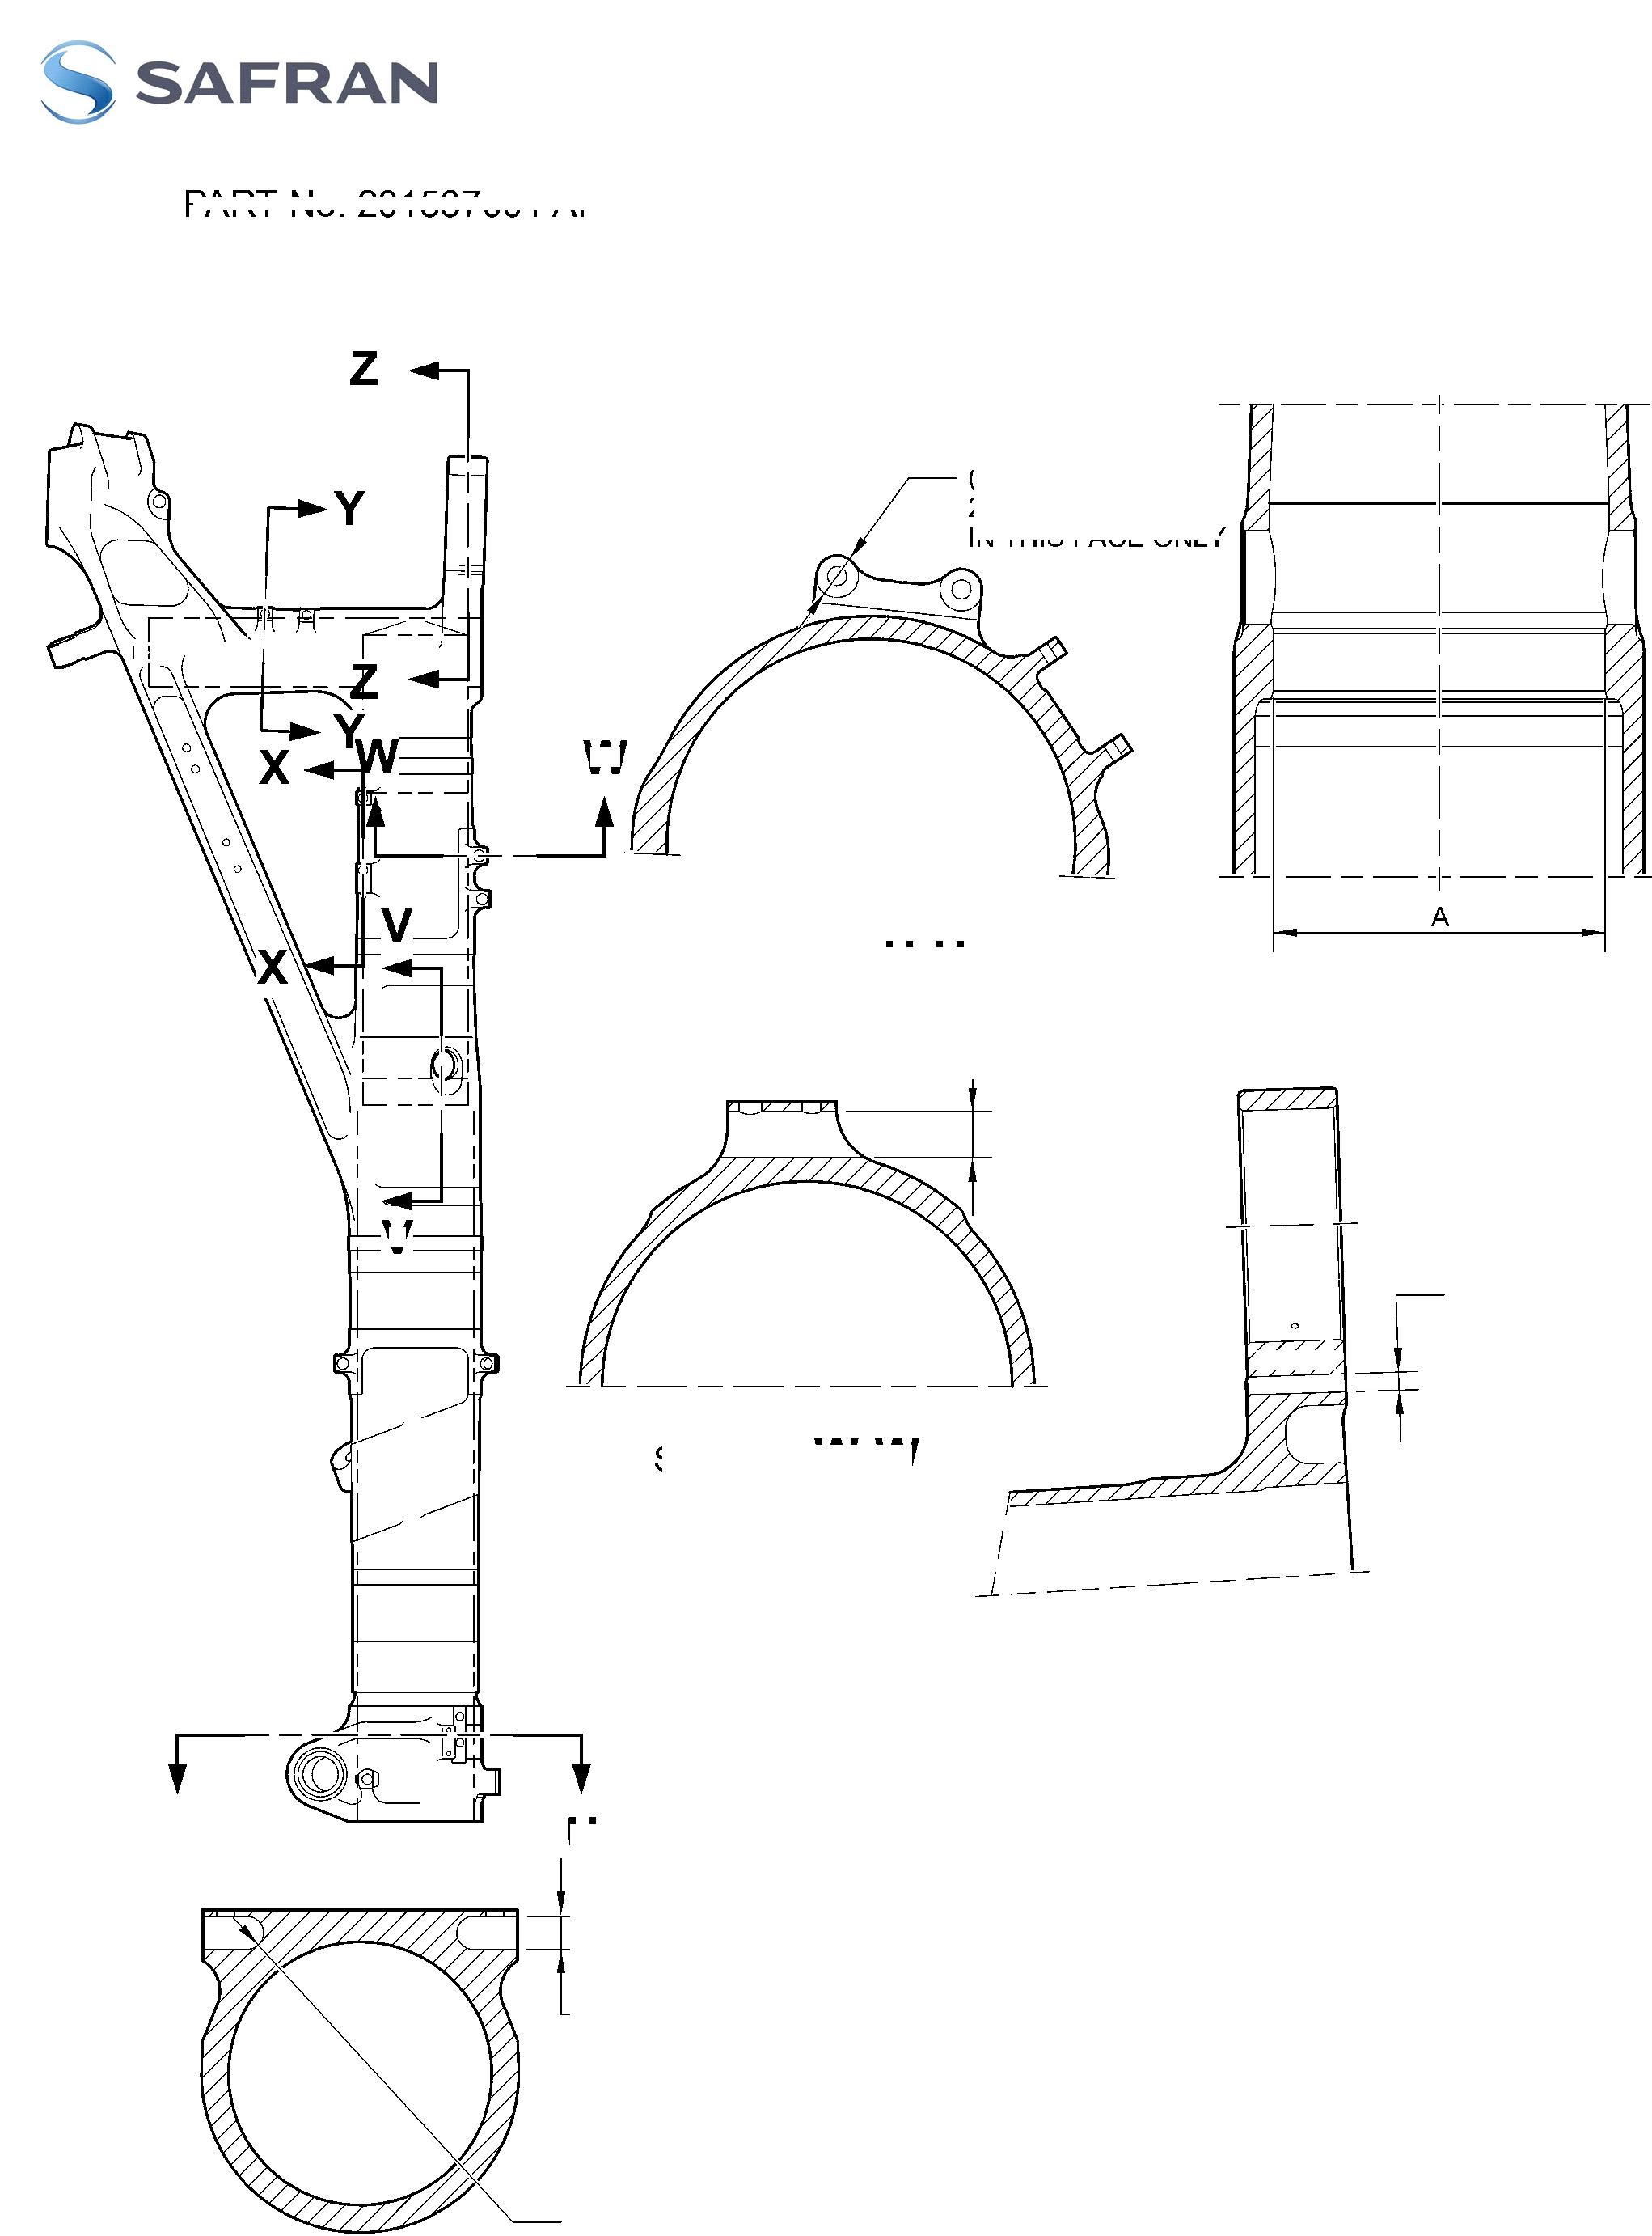

**SAFRAN LANDING SYSTEMS UK Ltd**

CAGE: K0654



PART No. 201587001 AND 201587002 COMPONENT MAINTENANCE MANUAL  
MAIN LANDING GEAR LEG

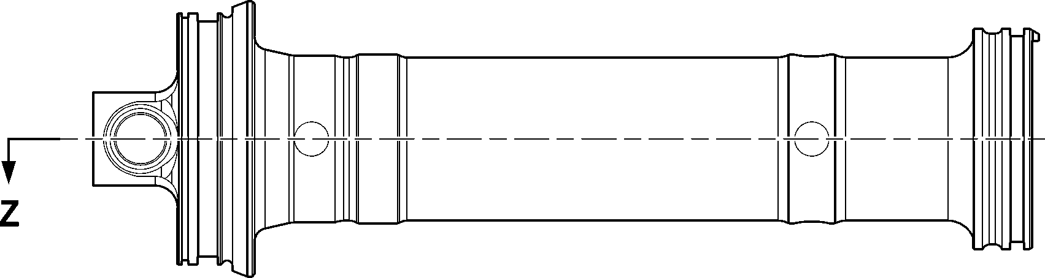

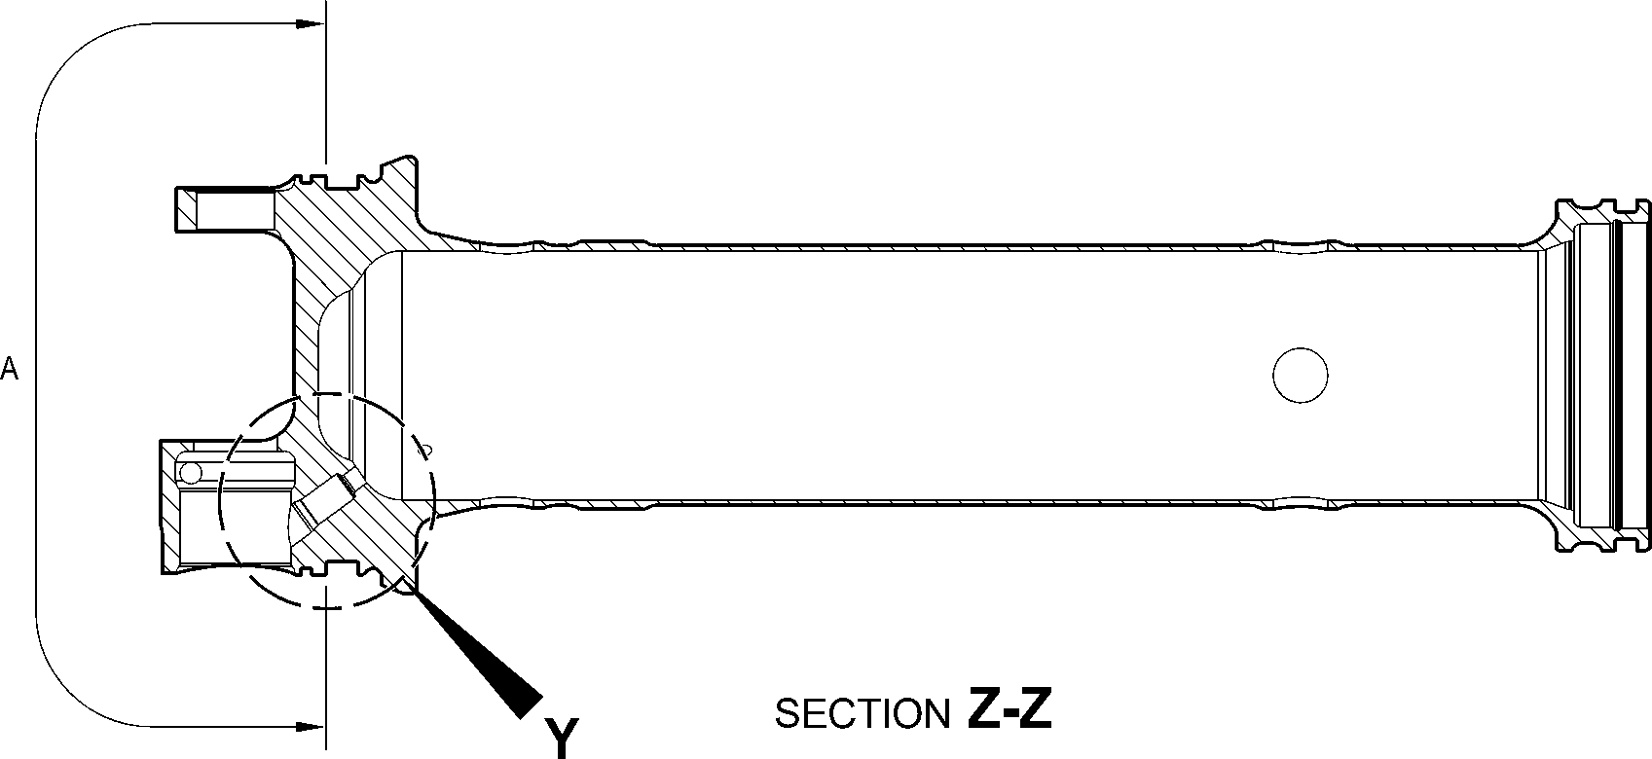

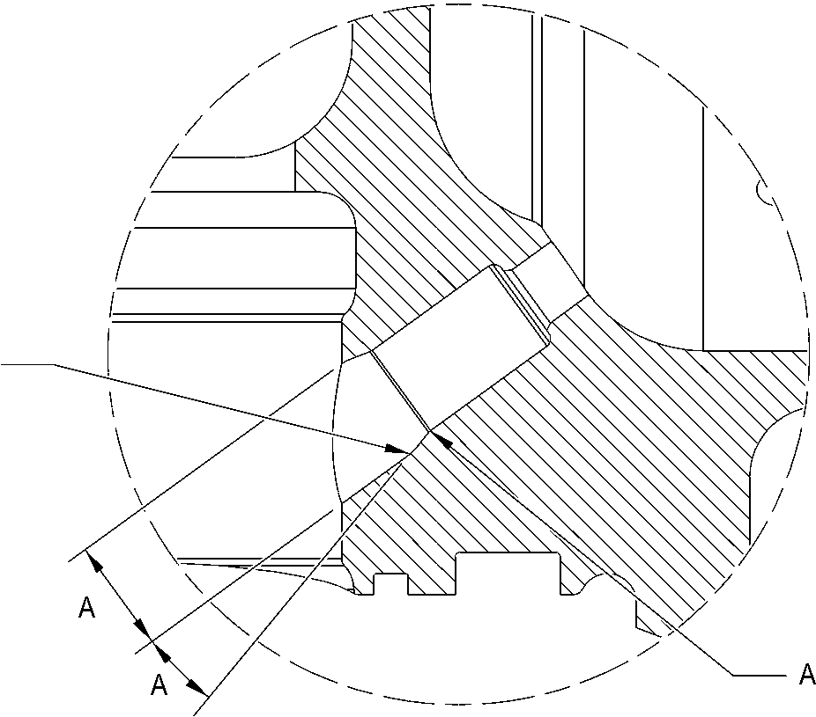

DETAIL **Y**

A321-T-32-12-22-109-0

Upper Diaphragm Tube (15-390A) - Protective Treatment

Figure 623

32-12-22

Page 646

Mar 18/2025

**SAFRAN LANDING SYSTEMS UK Ltd**

CAGE: K0654



PART No. 201587001 AND 201587002 COMPONENT MAINTENANCE MANUAL  
MAIN LANDING GEAR LEG

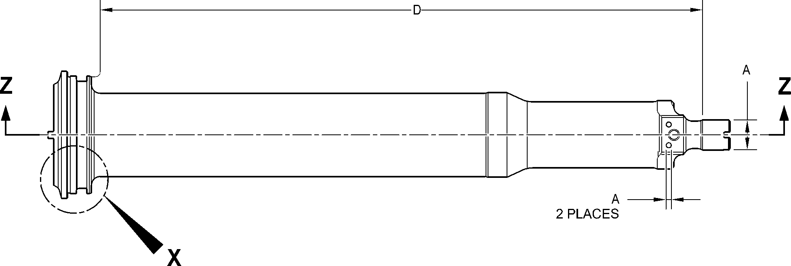

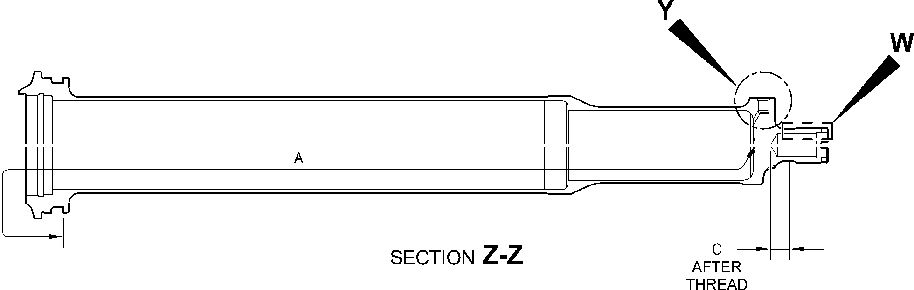

D

128,00 to 132,00mm

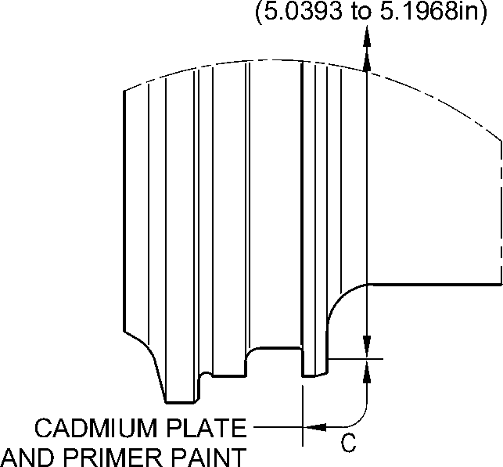

DETAIL **X**

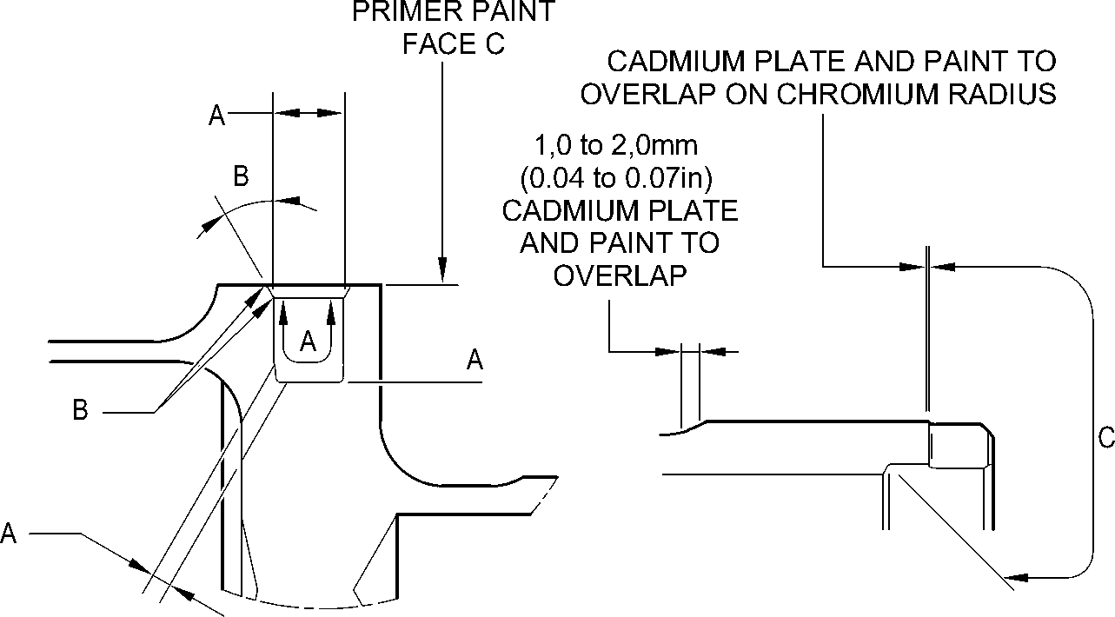

DETAIL **Y**

DETAIL **W**

A321-T-32-12-22-110-0

Cylinder (17-230A) - Protective Treatment  
Figure 624

32-12-22

Page 647

Mar 18/2025

**SAFRAN LANDING SYSTEMS UK Ltd**

CAGE: K0654



PART No. 201587001 AND 201587002 COMPONENT MAINTENANCE MANUAL  
MAIN LANDING GEAR LEG

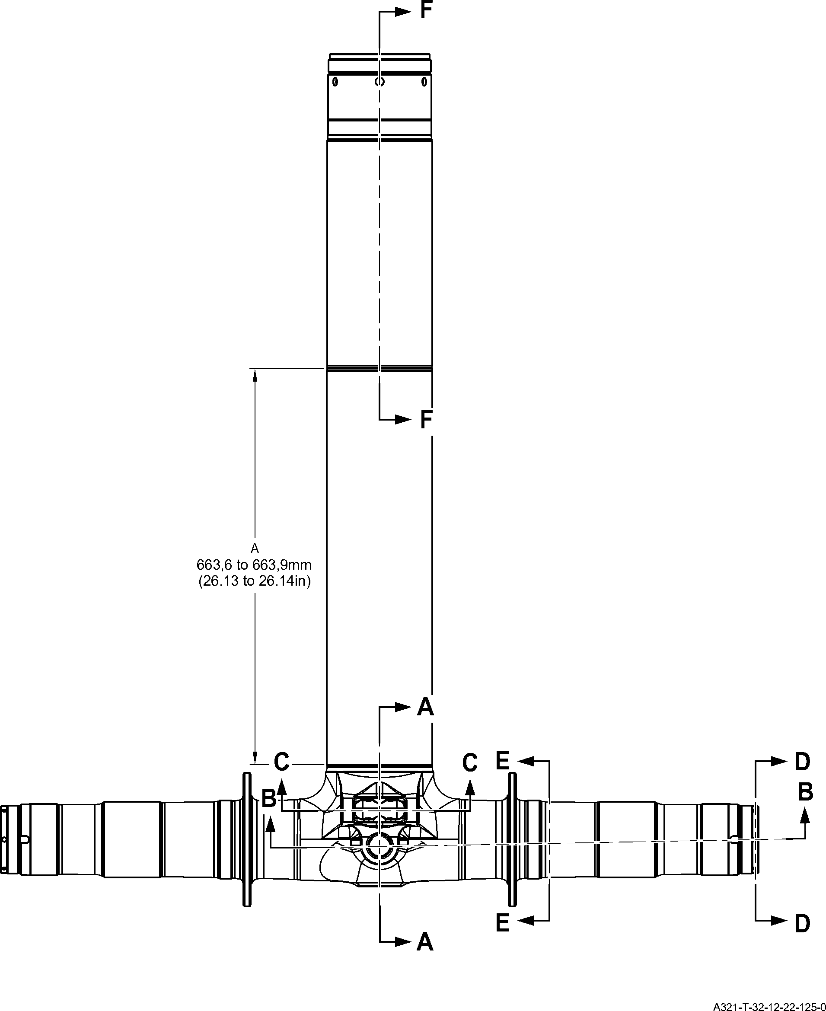

Sliding Tube (18-80B) - Protective Treatment

Figure 625 - Sheet 1

32-12-22

Page 648

Mar 18/2025

**SAFRAN LANDING SYSTEMS UK Ltd**

CAGE: K0654



PART No. 201587001 AND 201587002 COMPONENT MAINTENANCE MANUAL  
MAIN LANDING GEAR LEG

**F**

SECTION **A-A**KNUCKLE BORES

16,75 to 17,25mm  
(0.6594 to 0.6791in)

SECTION **G-G**

KNUCKLE TOOLING LUG  
GREASE HOLES

**E**

17,750 to 18,250mm

(0.6988 to 0.7185in)

**E**

71,750 to 72,250mm

(2.8248 to 2.8445in) DIA.

**A**

119,929 to 119,964mm

(4.7216 to 4.7230in) DIA.

220.00mm

(8.6614in) MIN.

**G**

**G**

**A**

126,917 to 126,957mm  
(4.9967 to 4.9983in) DIA.

**A**

131,294 to 131,357mm  
(5.1690 to 5.1715in) DIA.

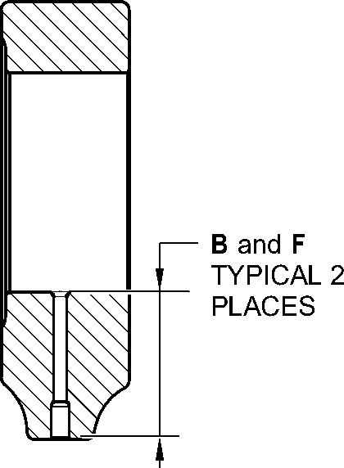

**C**

19,500 to 20,500mm  
(0.7677 to 0.8071in)

95,500 to 107,500mm  
(3.7598 to 4.2323in)  
EXTERNAL

SERMETEL LIMIT

SECTION **B-B**(BOTH SIDES)  
AXLE BORE

84,000 to 96,000mm  
(3.3071 to 3.7795in)  
INTERNAL  
SERMETEL LIMIT

A321-T-32-12-22-126-0

Sliding Tube (18-80B)- Protective Treatment

Figure 625 - Sheet 2

32-12-22

Page 649

Mar 18/2025

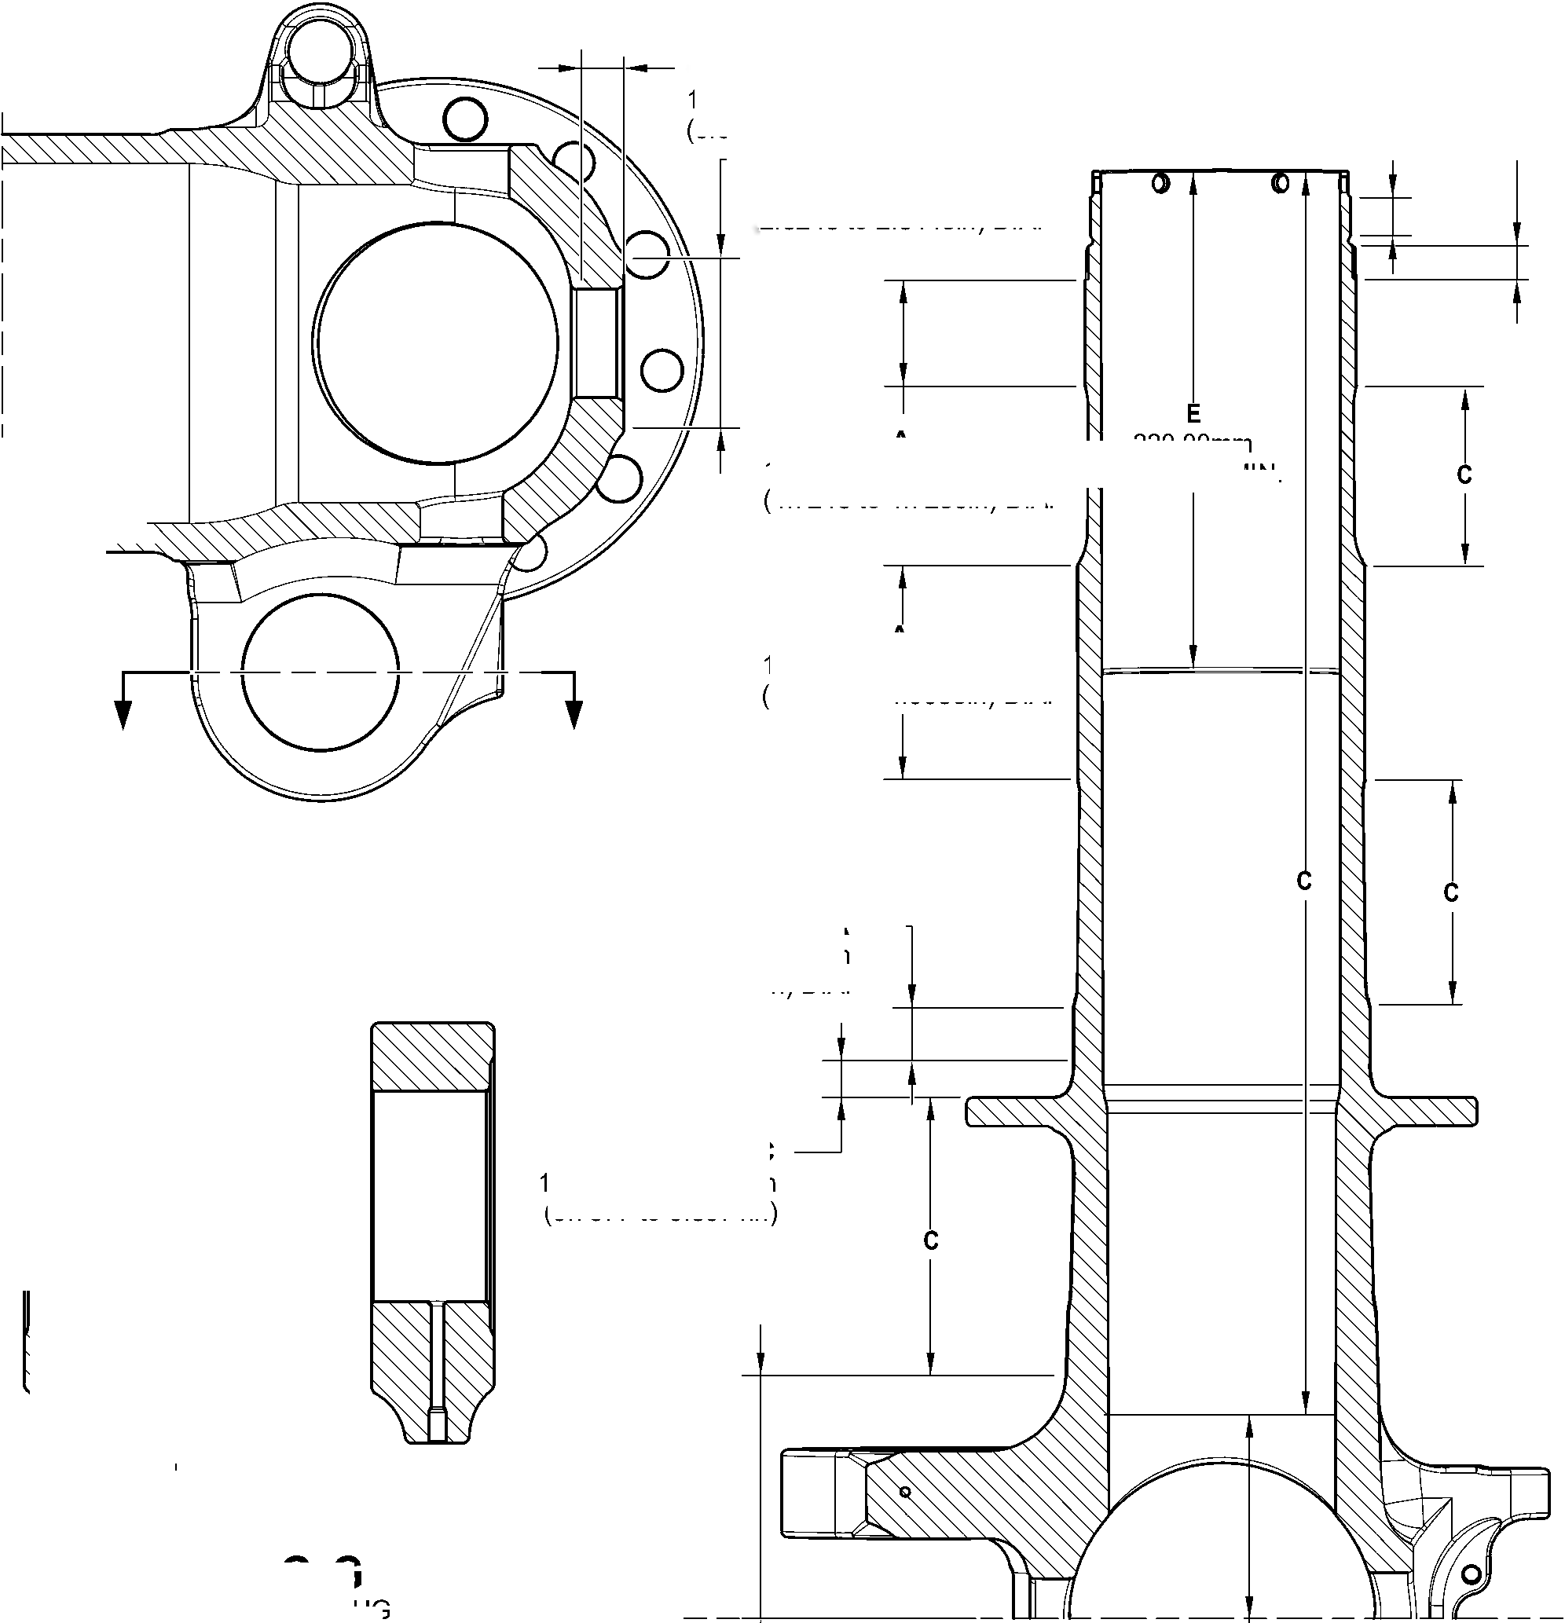

**SAFRAN LANDING SYSTEMS UK Ltd**

CAGE: K0654

PART No. 201587001 AND 201587002 COMPONENT MAINTENANCE MANUAL  
MAIN LANDING GEAR LEG

**E**

69,750 to 70,250mm  
(2.7461 to 2.7657in) DIA.  
SPOTFACE TYPICAL  
2 PLACES

**F**

5,000 to 7,000mm  
(0.1968 to 0.2755in)

TYPICAL 2 PLACES

**E**

23,400mm  
(0.9213in) MIN.

TYPICAL 2  
PLACES

**E**

6,50 to 6,70mm  
(0.256 to 0.264in) DIA.  
TYPICAL 4 PLACES

19,000 to 21,000mm  
(0.7481 to 0.8268in)  
TYPICAL 2 PLACES

**E**

81,750 to 82,250mm  
(3.2185 to 3.2382in) DIA.  
SPOTFACE TYPICAL

2 PLACES

SECTION **D-D**(BOTH SIDES)  
AXLE NUT CROSS  
BOLT HOLES

**D**

6,70 to 6,90mm  
(0.2638 to 0.2717in) DIA.  
TYPICAL 6 PLACES

**E**

38,750 to 39,250mm  
(1.5256 to 1.5453in) DIA.  
SPOTFACE TYPICAL  
2 PLACES INCLUDING  
CHAMFER

**F**

13,000mm

(0.5118in) DIA.

SPOTFACE TYPICAL 4 PLACES

INCLUDING CHAMFER

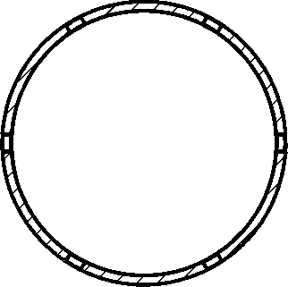

SECTION

LUG BORES

**C-C**

SECTION **E-E**(BOTH SIDES)  
BRAKE FLANGE

**E**

30,750 to 31,250mm  
(1.2106 to 1.2303in) DIA.

SPOTFACE TYPICAL  
12 PLACES INCLUDING  
CHAMFER

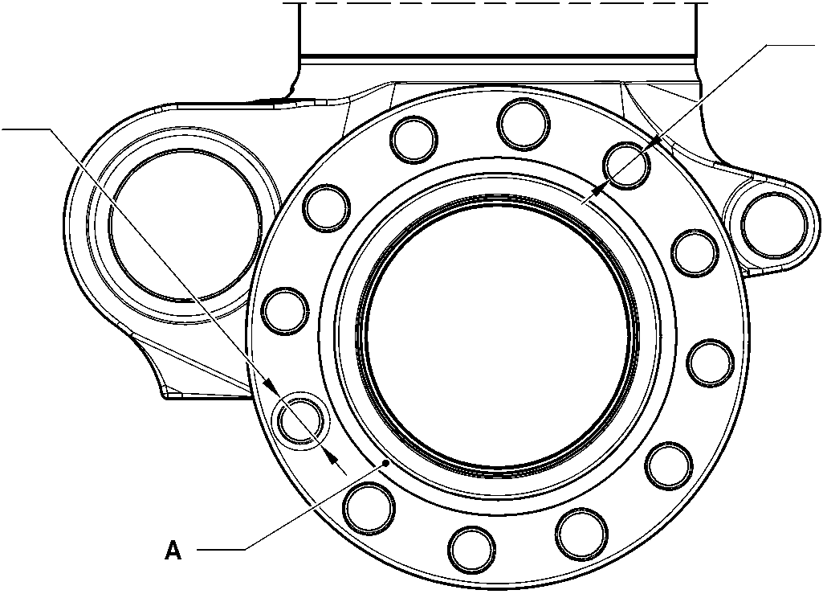

**A**

TYPICAL 12 PLACES

A321-T-32-12-22-127-0

Sliding Tube (18-80B)- Protective Treatment

Figure 625 - Sheet 3

32-12-22

Page 650

Mar 18/2025

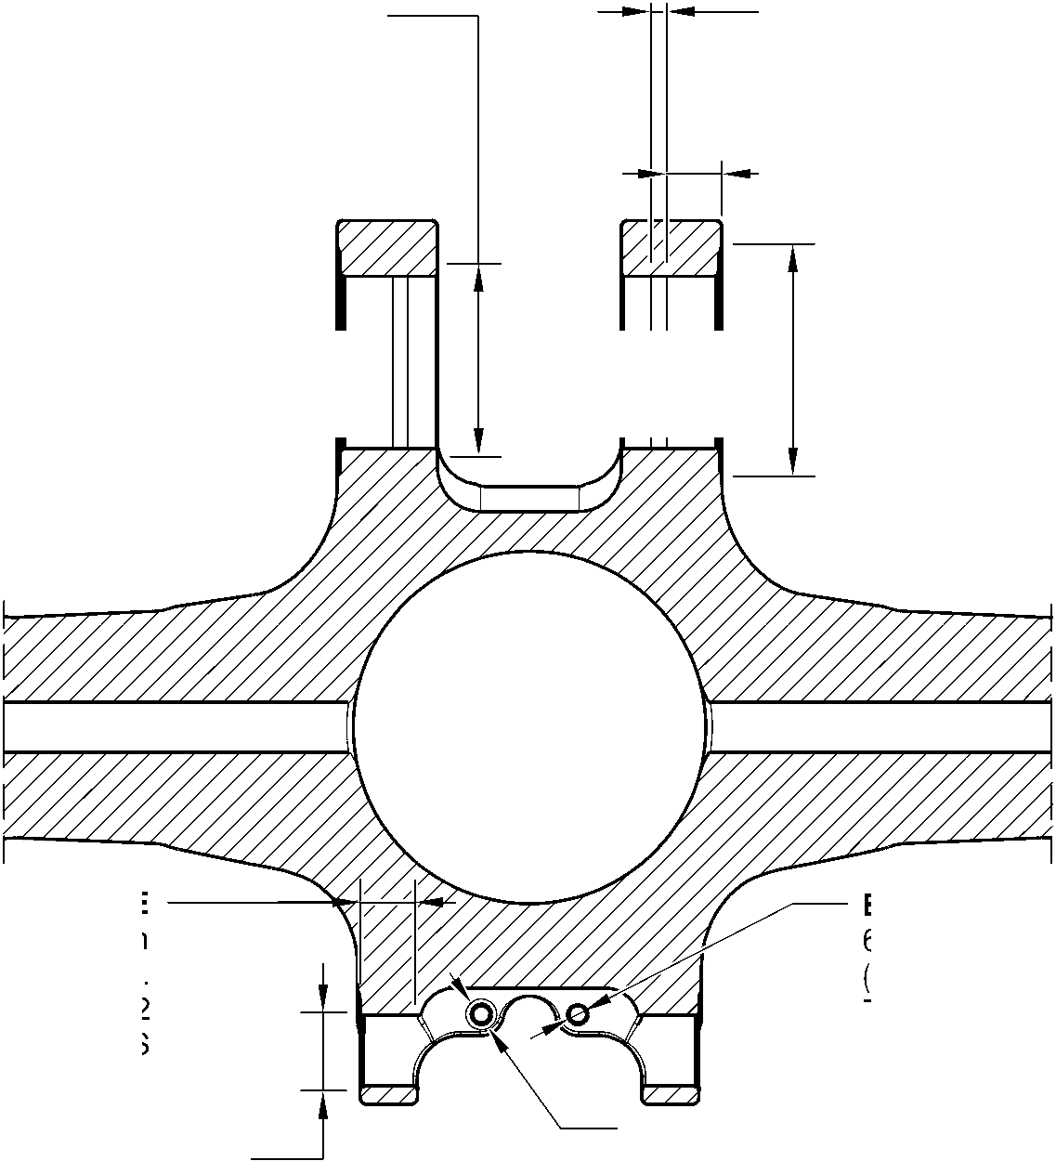

**SAFRAN LANDING SYSTEMS UK Ltd**

CAGE: K0654



PART No. 201587001 AND 201587002 COMPONENT MAINTENANCE MANUAL  
MAIN LANDING GEAR LEG

**B** and **F**

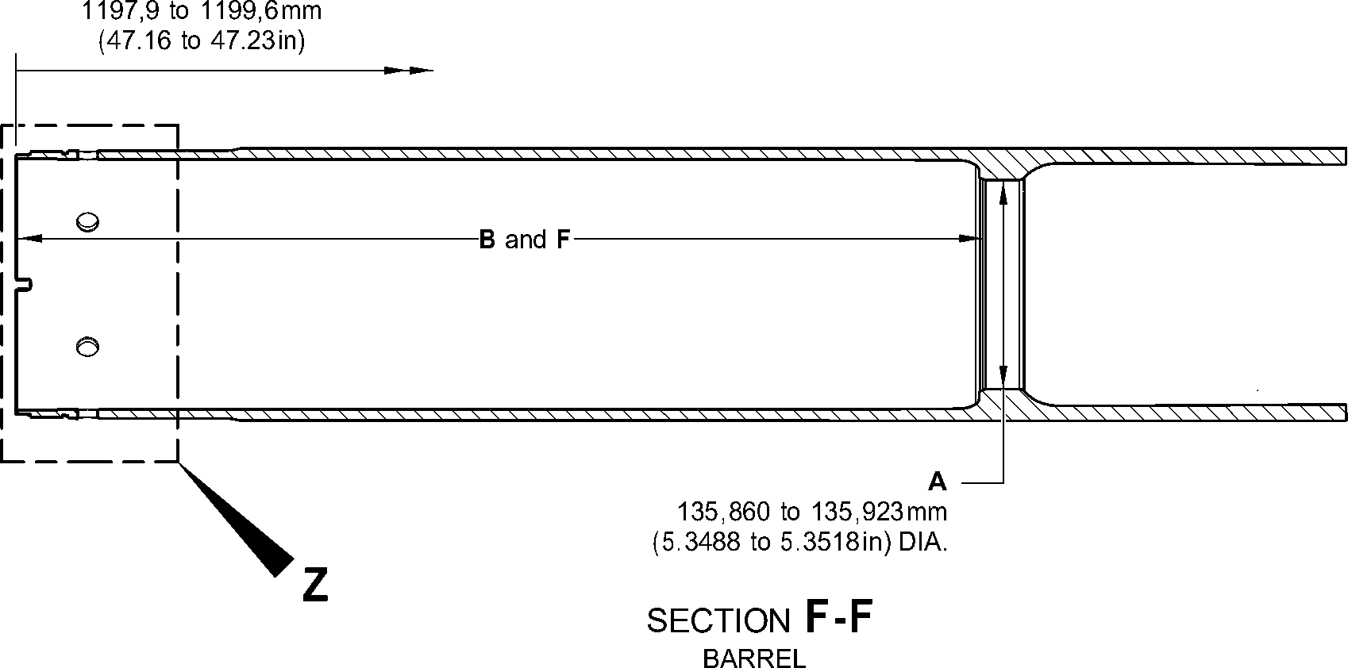

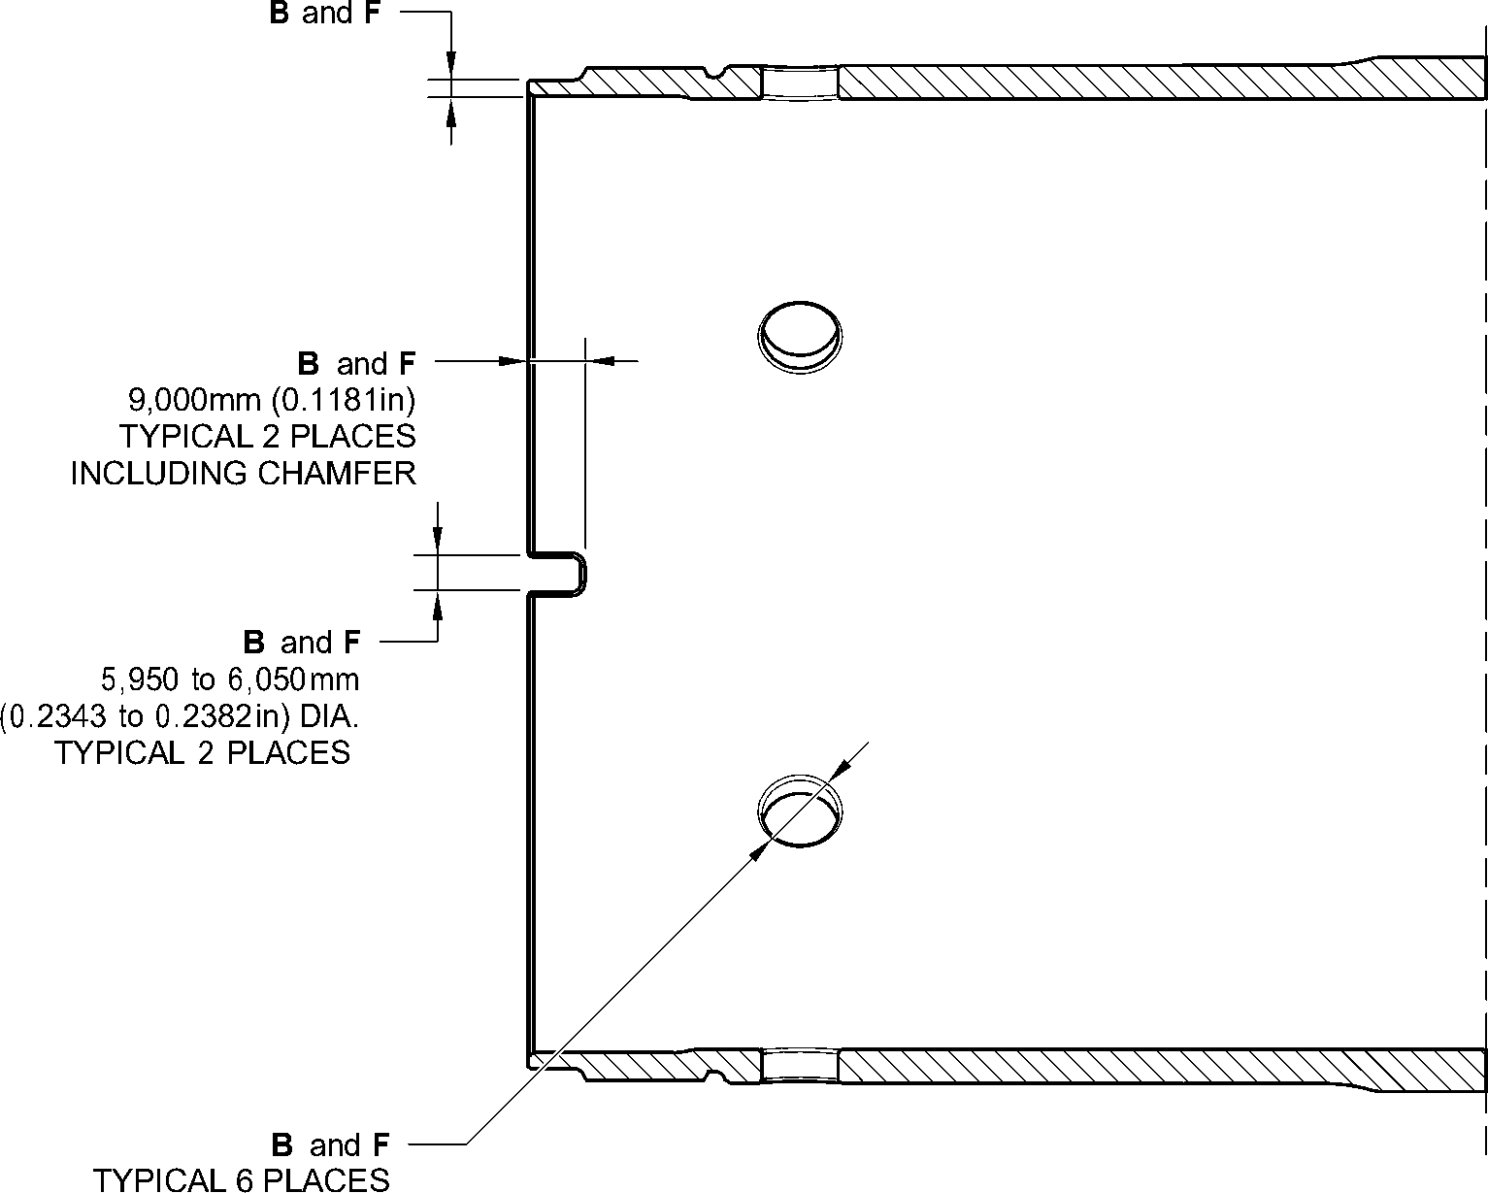

INCLUDING CHAMFER

DETAIL **Z**

A321-T-32-12-22-128-0

Sliding Tube (18-80B)- Protective Treatment

Figure 625 - Sheet 4

32-12-22

Page 651

Mar 18/2025

**SAFRAN LANDING SYSTEMS UK Ltd**

CAGE: K0654



PART No. 201587001 AND 201587002 COMPONENT MAINTENANCE MANUAL  
MAIN LANDING GEAR LEG

A

SPOTFACE

(BOTH SIDES)

A

SPOTFACE  
(BOTH SIDES)

D

A

SPOTFACE  
(BOTH SIDES)

A

SPOTFACE

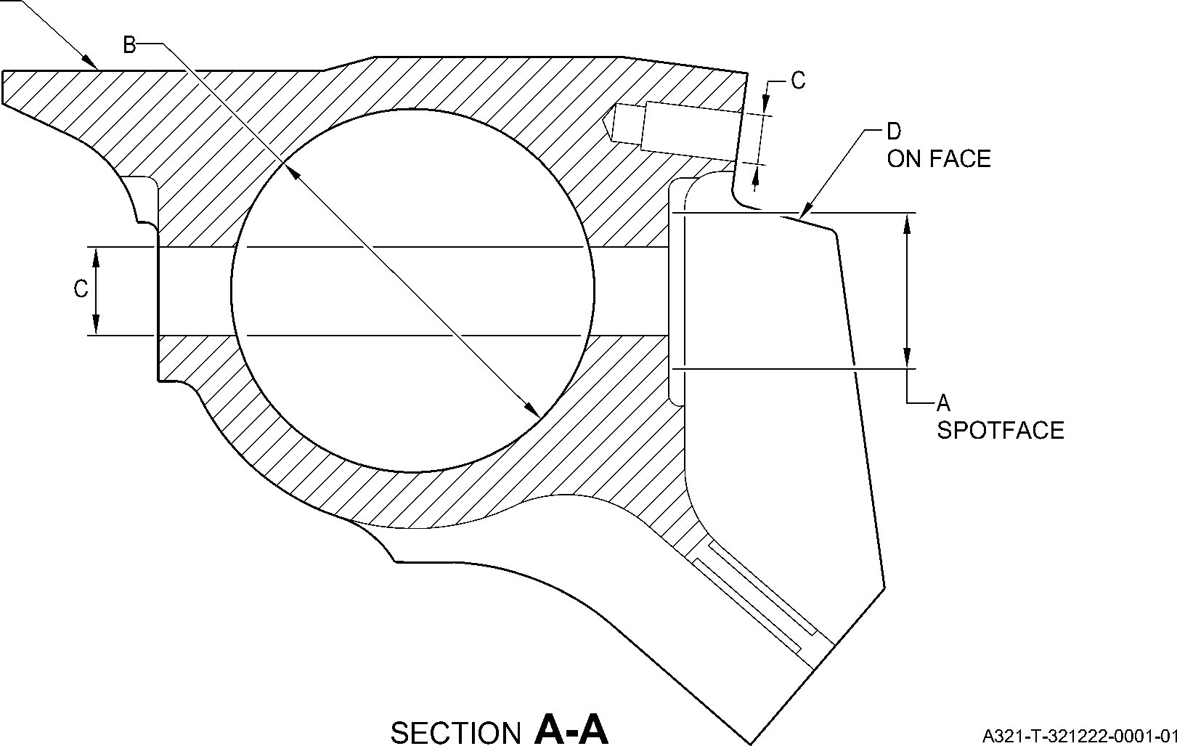

Upper Pivot Bracket (10-160) Only - Protective Treatment

Figure 626

32-12-22

Page 652

Mar 18/2025

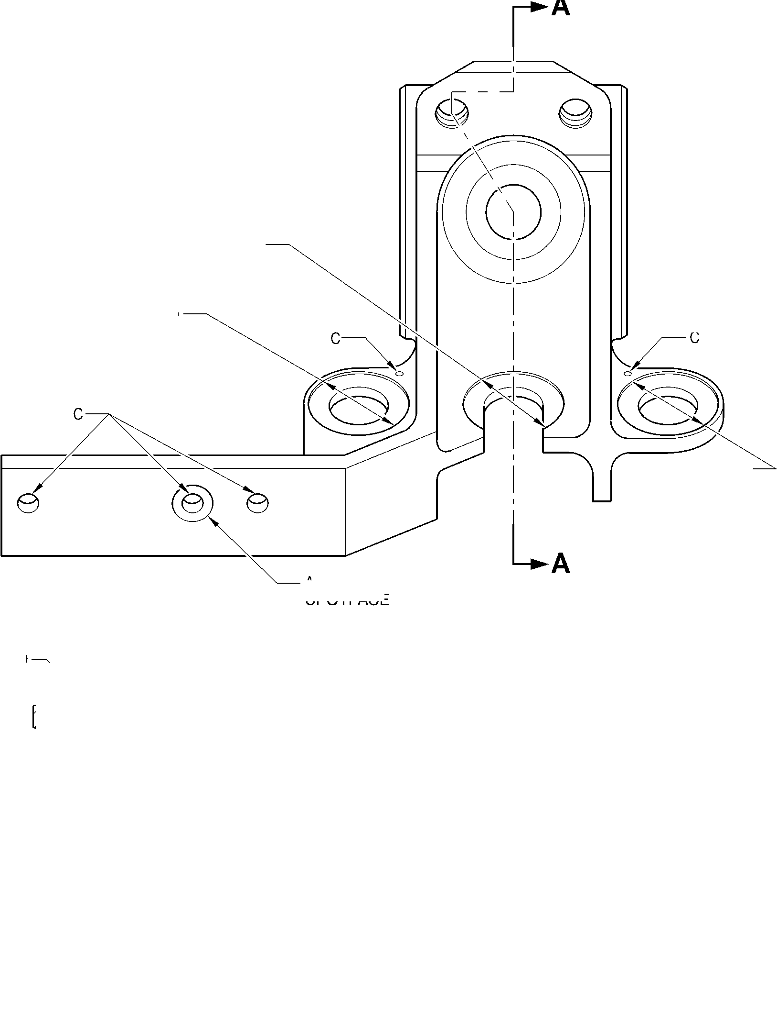

**SAFRAN LANDING SYSTEMS UK Ltd**

CAGE: K0654



PART No. 201587001 AND 201587002 COMPONENT MAINTENANCE MANUAL  
MAIN LANDING GEAR LEG

A

SPOTFACE  
(BOTH SIDES)

A

A

SPOTFACE  
(BOTH SIDES)

A

SPOTFACE

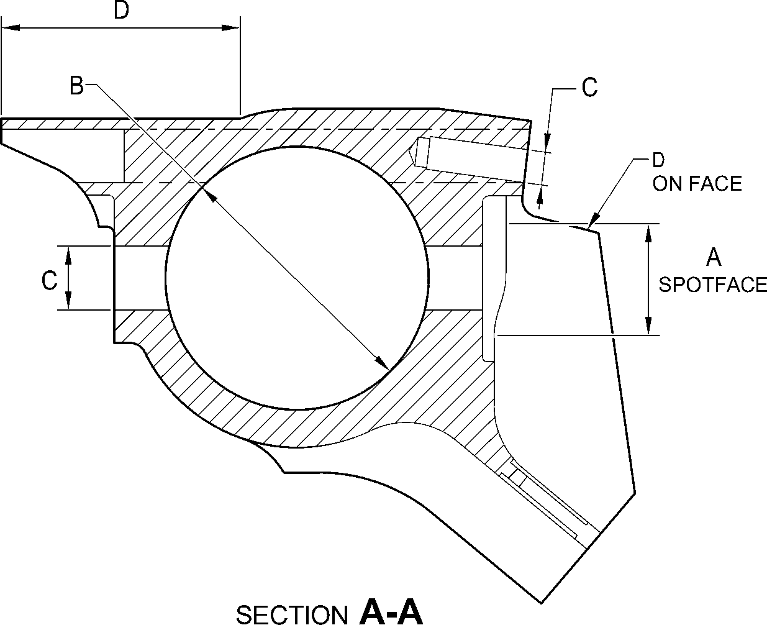

A321-T-321222-0002-01

Upper Pivot Bracket (10-160A) - Protective Treatment

Figure 627

32-12-22

Page 653

Mar 18/2025

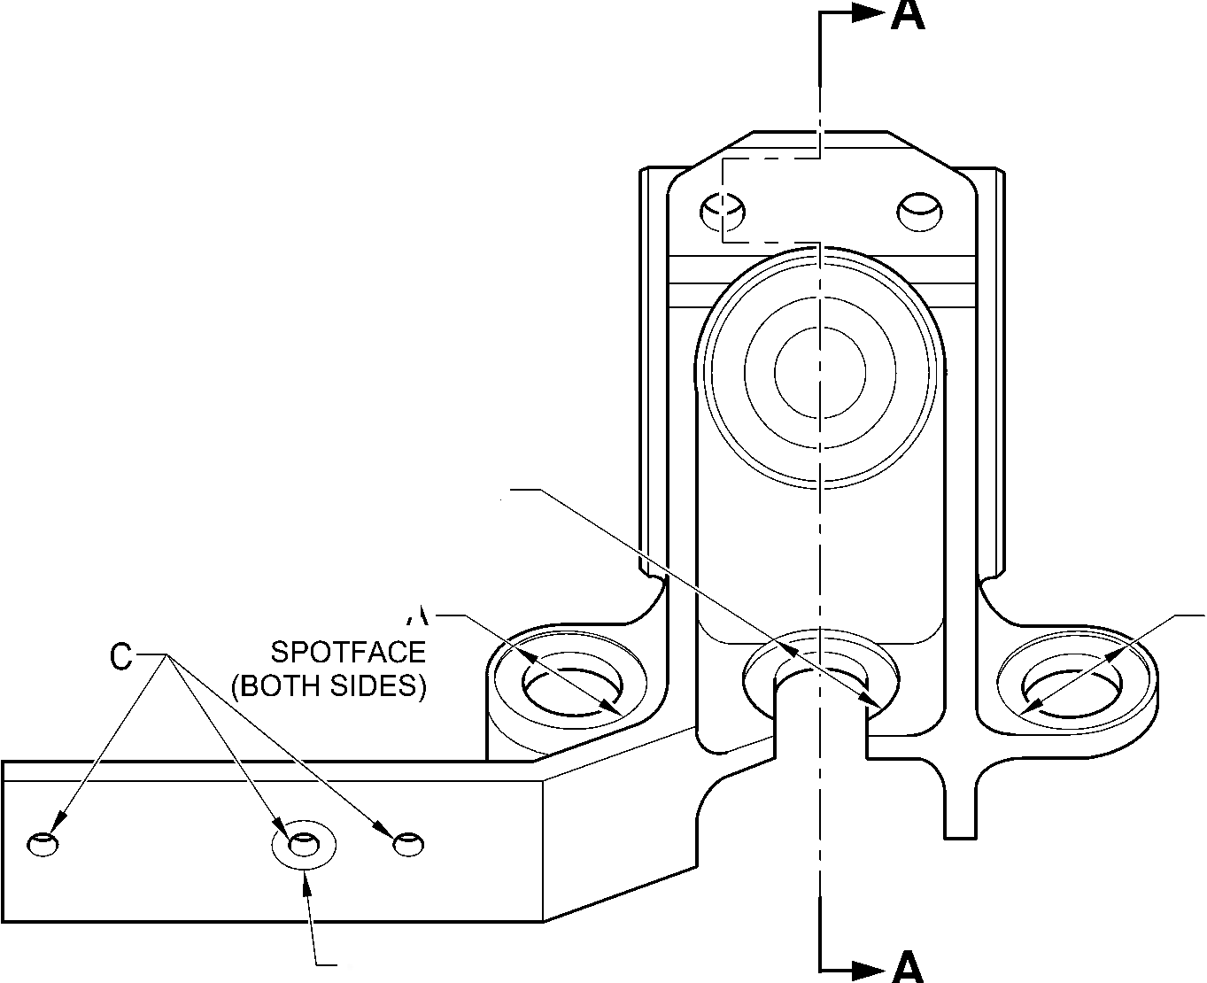

**SAFRAN LANDING SYSTEMS UK Ltd**

CAGE: K0654



PART No. 201587001 AND 201587002 COMPONENT MAINTENANCE MANUAL  
MAIN LANDING GEAR LEG

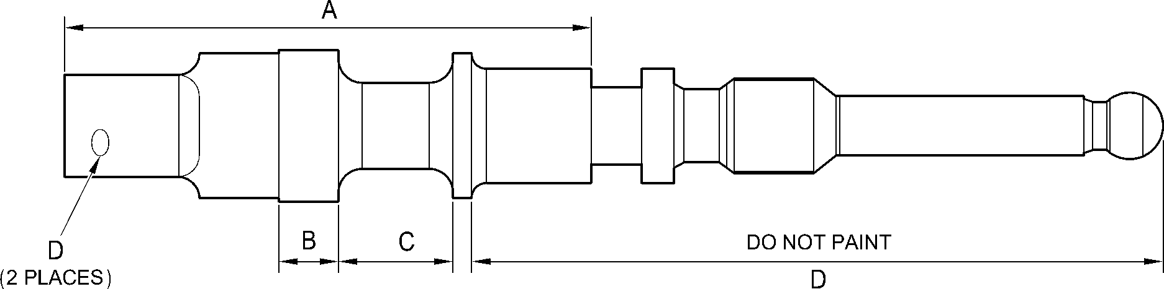

A321-T-321222-0003-00

Valve Stem (12-90A) - Protective Treatment

Figure 628

32-12-22

Page 654

Mar 18/2025

**SAFRAN LANDING SYSTEMS UK Ltd**

CAGE: K0654



PART No. 201587001 AND 201587002 COMPONENT MAINTENANCE MANUAL  
MAIN LANDING GEAR LEG

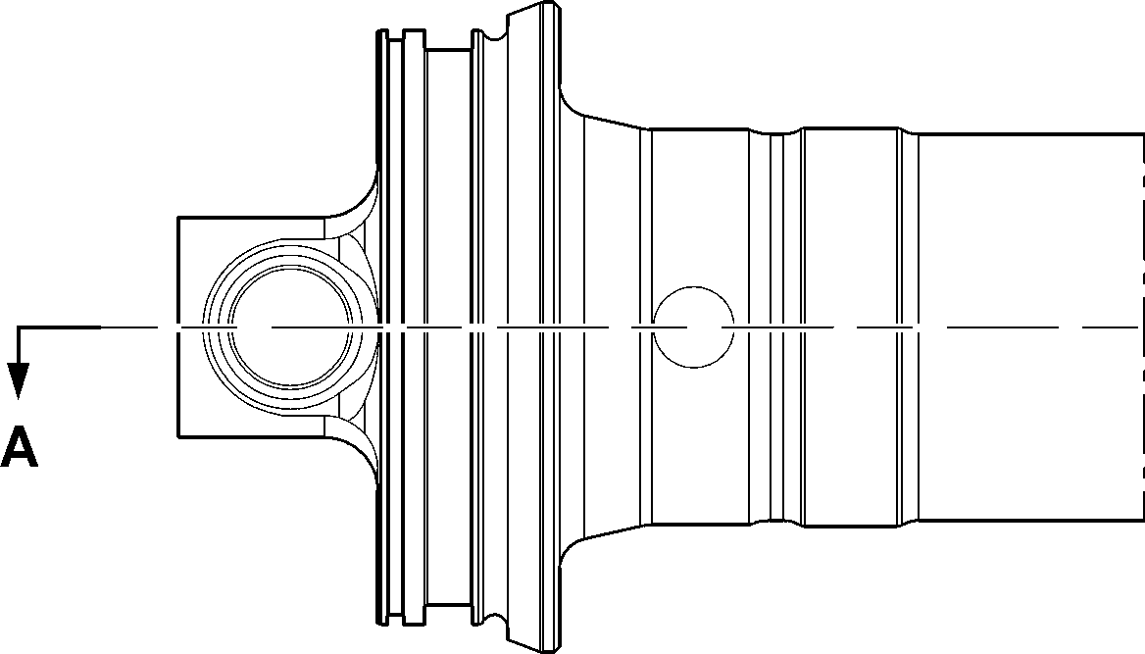

B

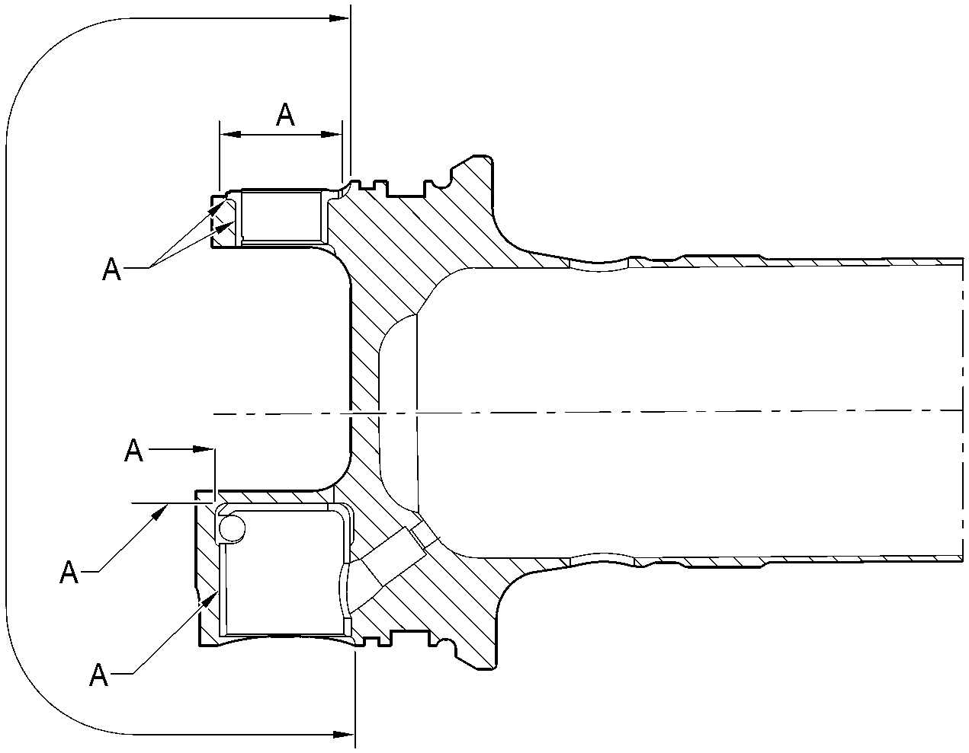

SECTION **A-A**

A321-T-321222-0004-00

Upper Diaphragm Tube Subassembly (15-360) - Protective Treatment

Figure 629

32-12-22

Page 655

Mar 18/2025

**SAFRAN LANDING SYSTEMS UK Ltd**

CAGE: K0654

PART No. 201587001 AND 201587002 COMPONENT MAINTENANCE MANUAL  
MAIN LANDING GEAR LEG

**A**

**A**

A and C

**A**

B and D

SECTION **A-A**

**Z**

C

B and D

B and D

D

DETAIL **A**

DETAIL **B**

SECTION **Z-Z**

A321-T-321222-0005-00

Upper Diaphragm Tube Subassembly (15-360A) - Protective Treatment

Figure 630

32-12-22

Page 656

Mar 18/2025

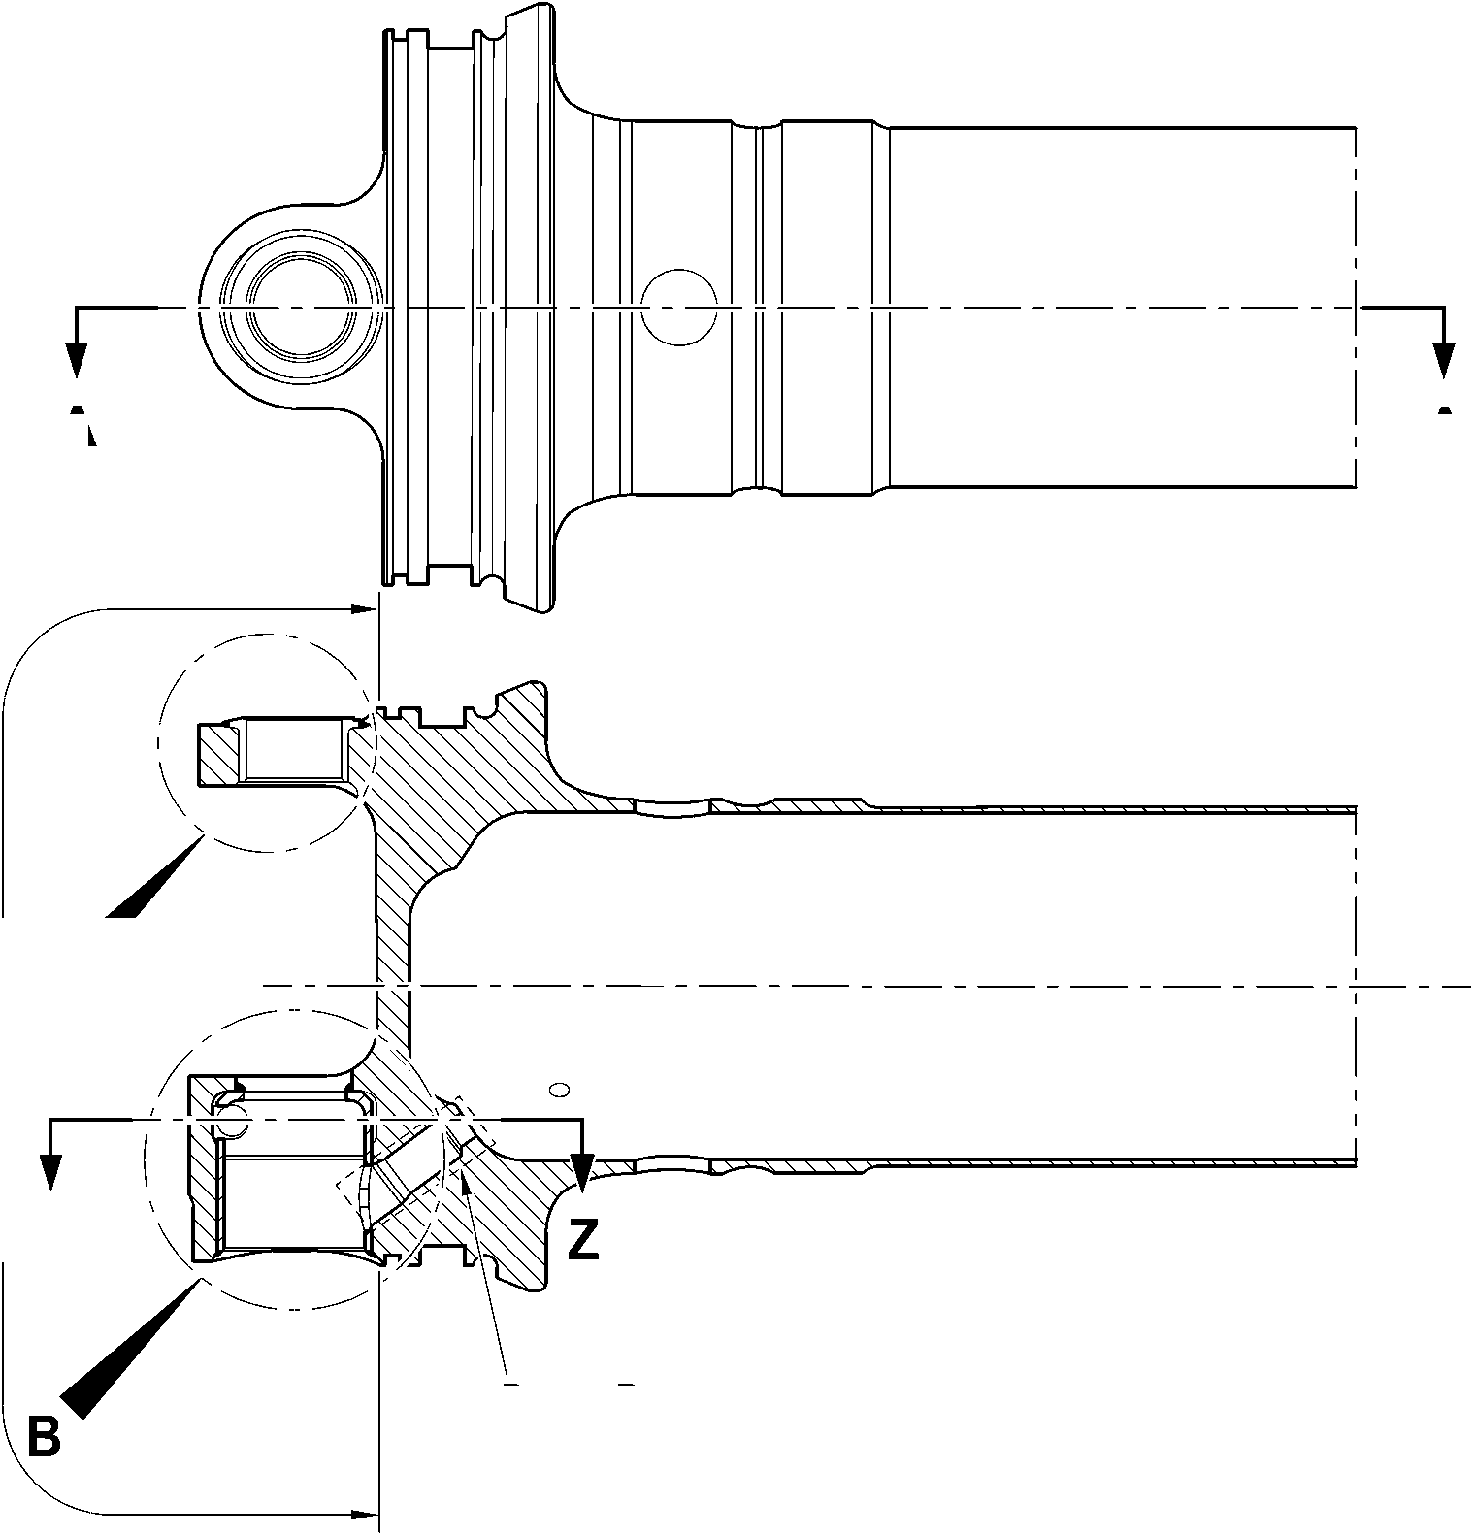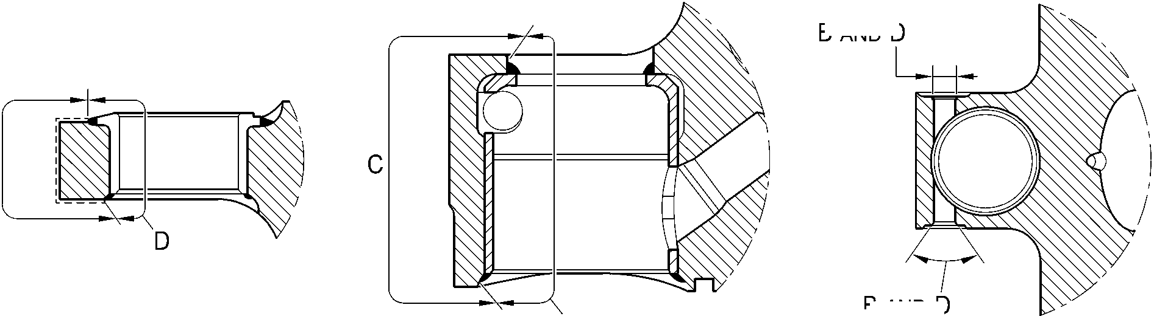

**SAFRAN LANDING SYSTEMS UK Ltd**

CAGE: K0654



PART No. 201587001 AND 201587002 COMPONENT MAINTENANCE MANUAL  
MAIN LANDING GEAR LEG

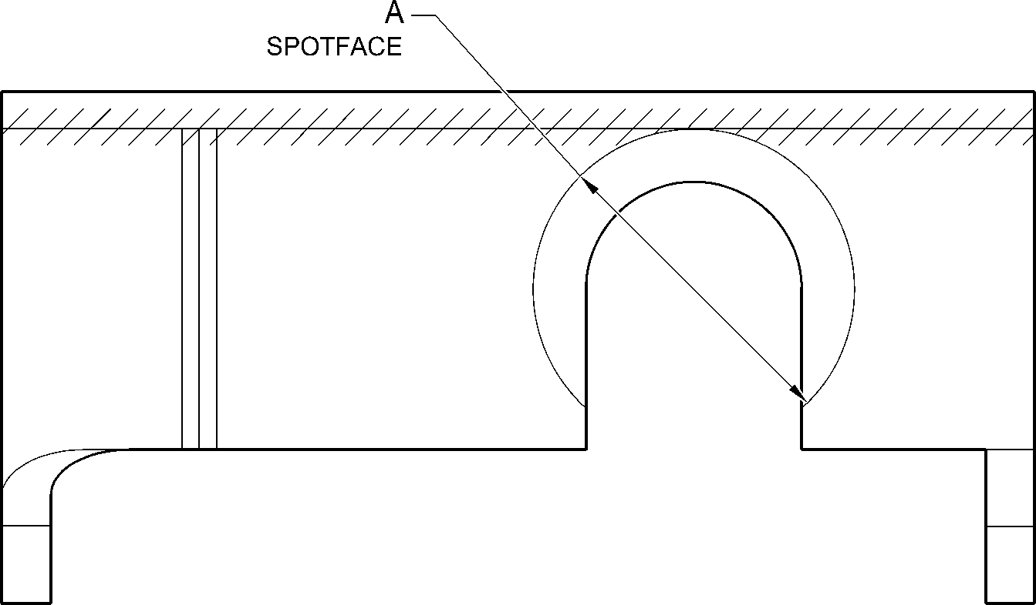

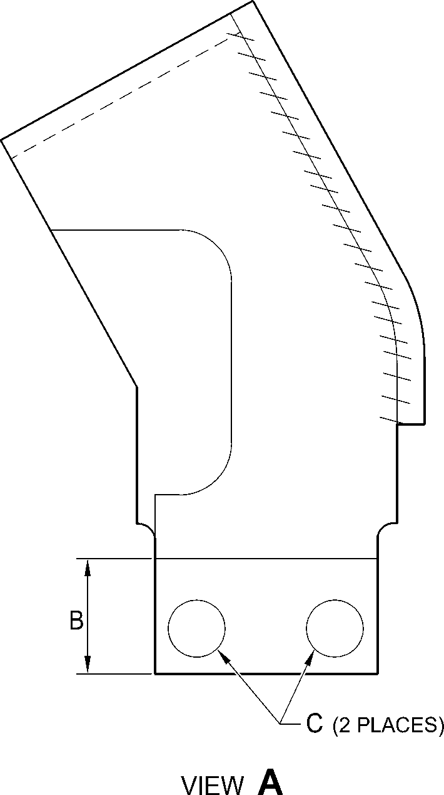

A321-T-321222-0006-00

Bracket (2-80 and 2-90) - Protective Treatment

Figure 631

32-12-22

Page 657

Mar 18/2025

**SAFRAN LANDING SYSTEMS UK Ltd**

CAGE: K0654



PART No. 201587001 AND 201587002 COMPONENT MAINTENANCE MANUAL  
MAIN LANDING GEAR LEG

**A**

F  
SPOTFACE  
(BOTH SIDES)

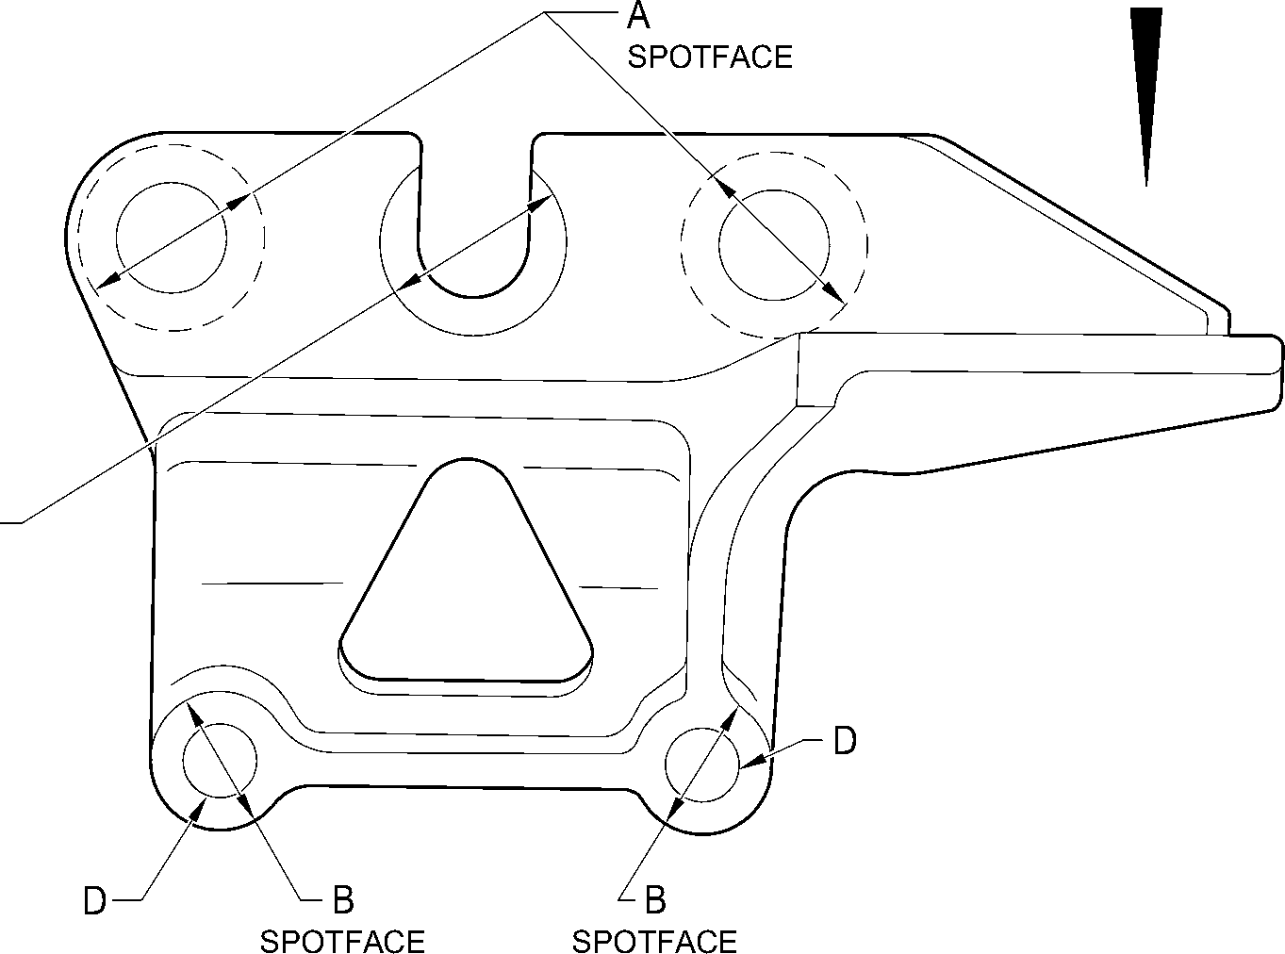

(BOTH SIDES)

(BOTH SIDES)

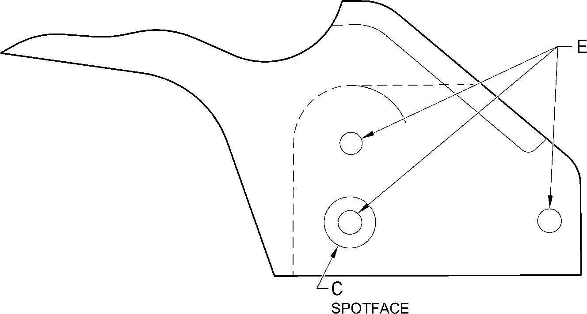

VIEW **A**

A321-T-321222-0007-00

Harness Support Bracket (7-100, 7-100A, 7-110 and 7-110A) - Protective Treatment

Figure 632

32-12-22

Page 658

Mar 18/2025

**SAFRAN LANDING SYSTEMS UK Ltd**

CAGE: K0654



PART No. 201587001 AND 201587002 COMPONENT MAINTENANCE MANUAL  
MAIN LANDING GEAR LEG

**Y**

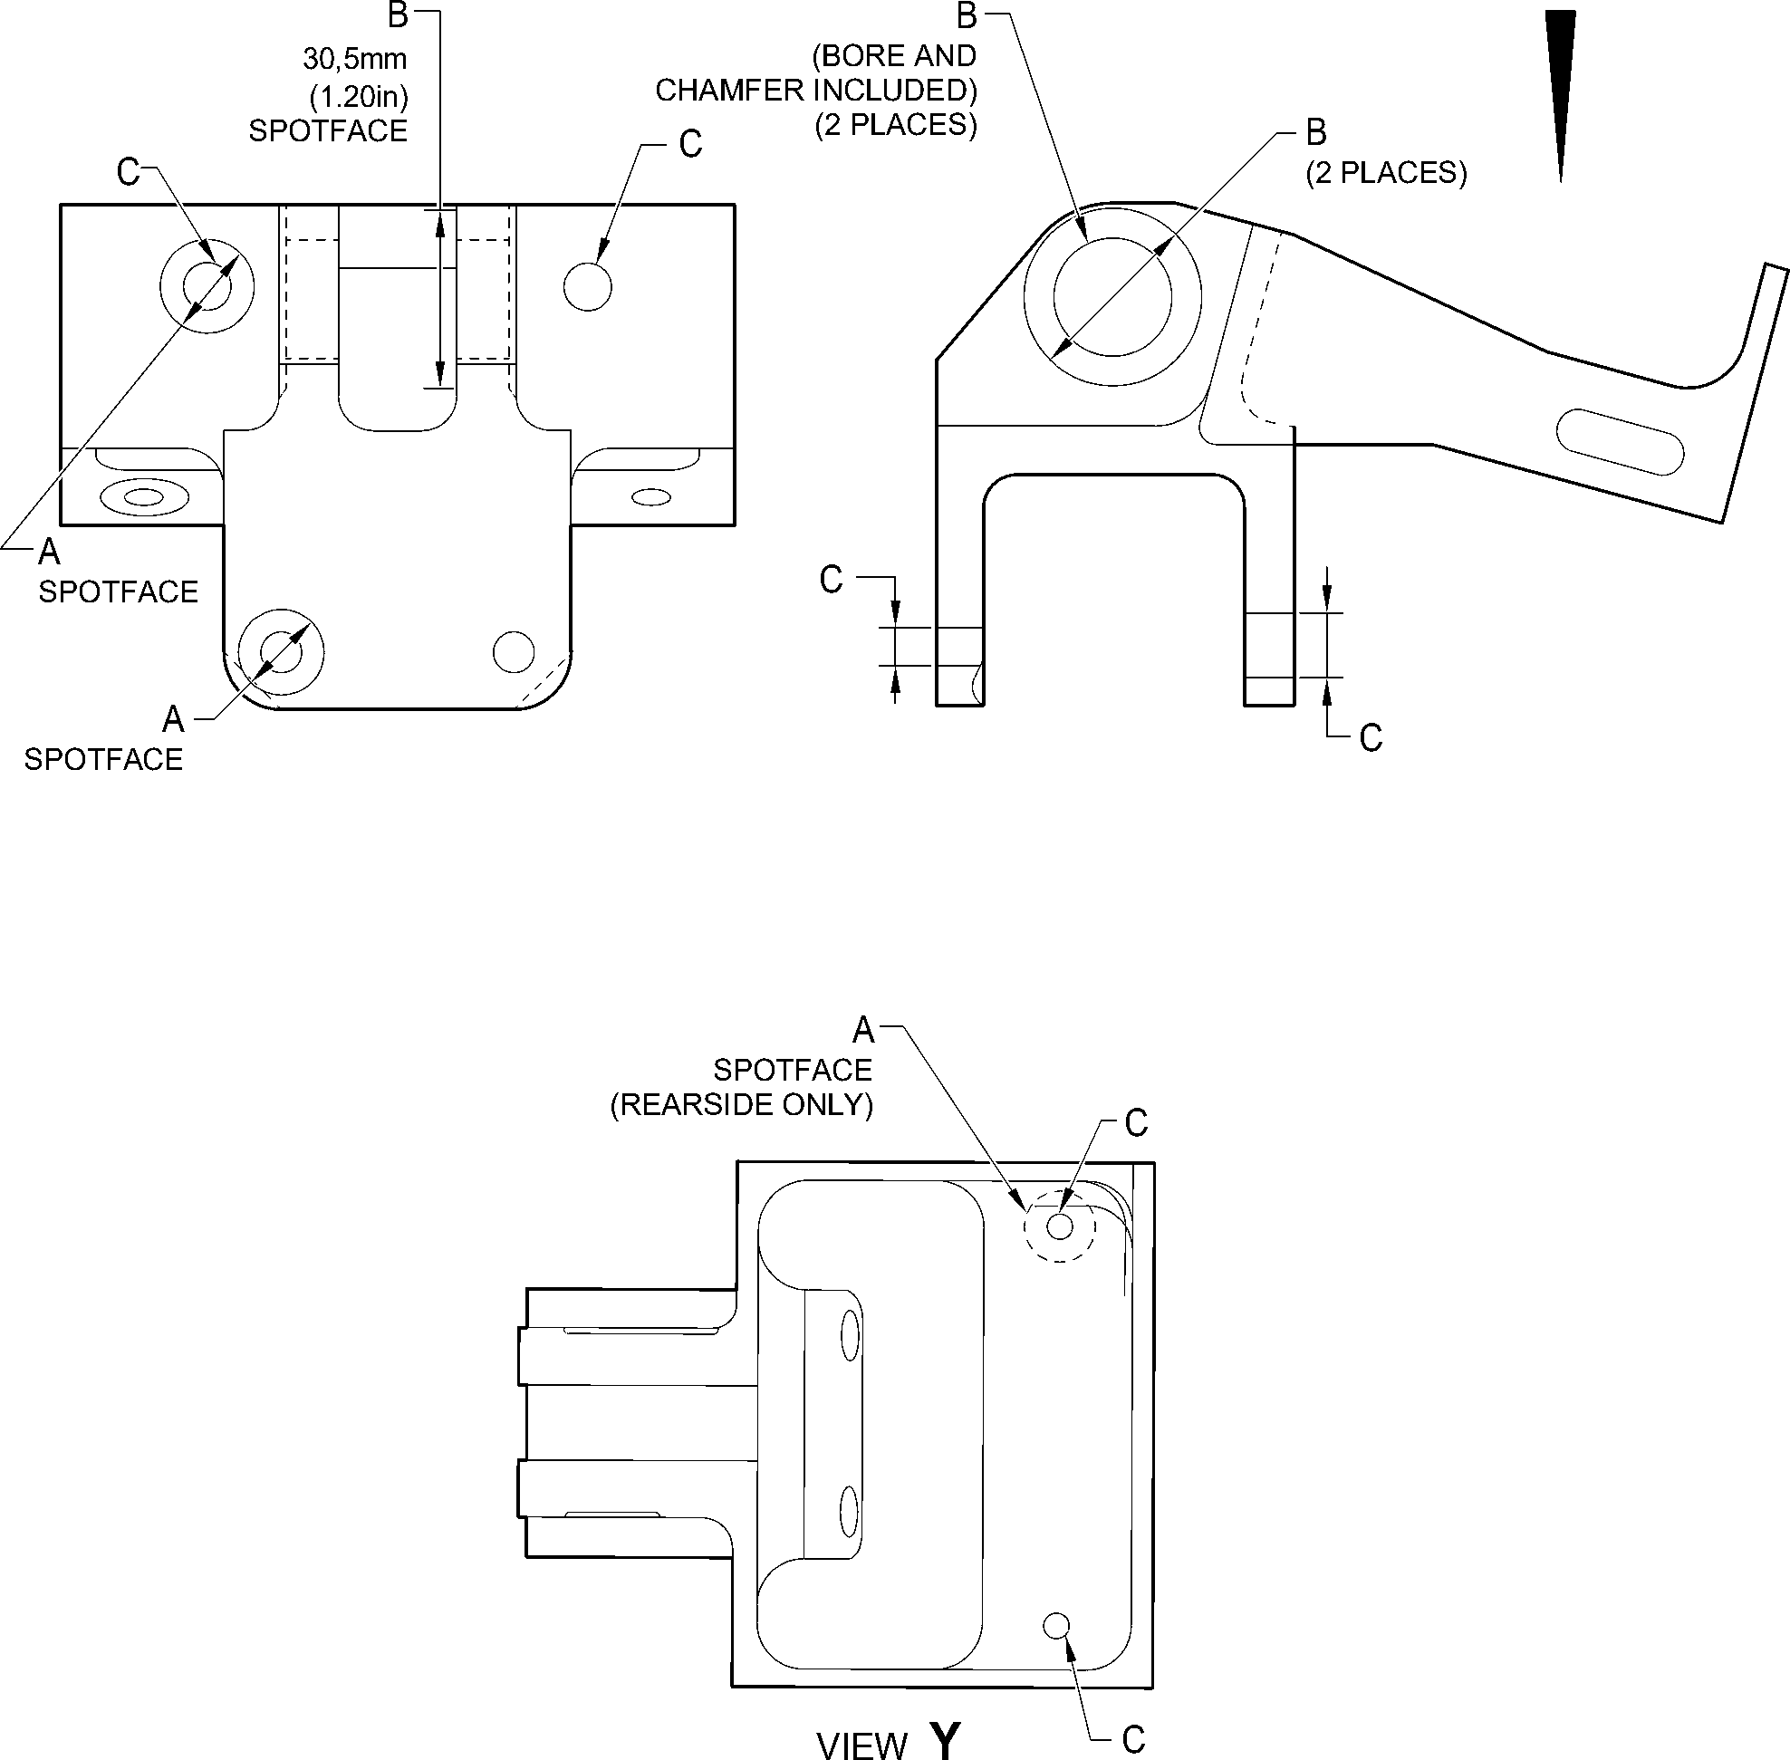

A321-T-321222-0009-00

Bracket (8-170) - Protective Treatment

Figure 633

32-12-22

Page 659

Mar 18/2025

**SAFRAN LANDING SYSTEMS UK Ltd**

CAGE: K0654



PART No. 201587001 AND 201587002 COMPONENT MAINTENANCE MANUAL  
MAIN LANDING GEAR LEG

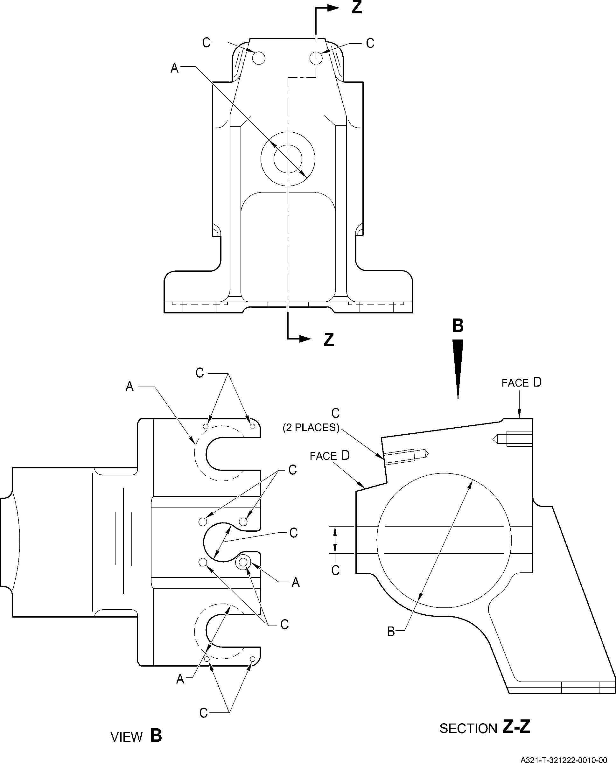

Harness Support Bracket (11-140) - Protective Treatment  
Figure 634

32-12-22

Page 660

Mar 18/2025

**SAFRAN LANDING SYSTEMS UK Ltd**

CAGE: K0654



PART No. 201587001 AND 201587002 COMPONENT MAINTENANCE MANUAL  
MAIN LANDING GEAR LEG

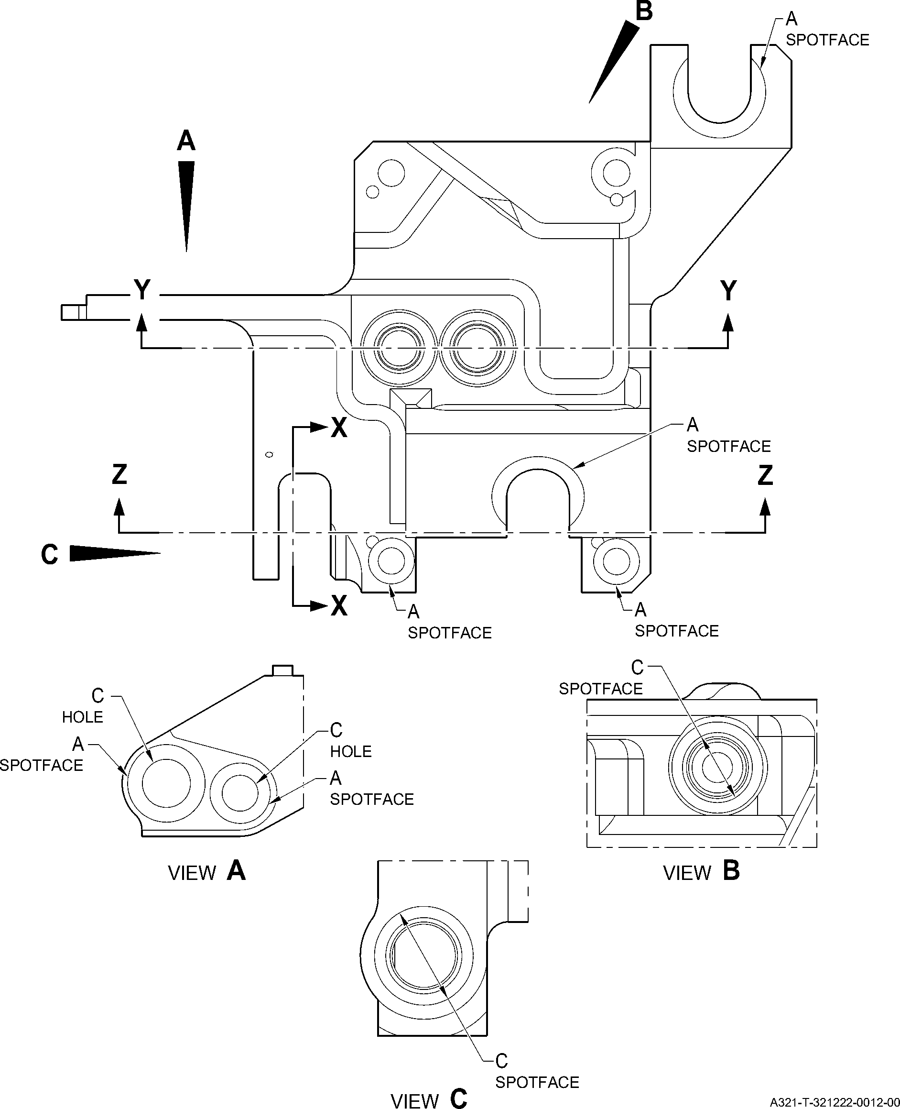

Transfer Block (2-340B and 2-350B) - Protective Treatment  
Figure 635 - Sheet 1

32-12-22

Page 661

Mar 18/2025

**SAFRAN LANDING SYSTEMS UK Ltd**

CAGE: K0654



PART No. 201587001 AND 201587002 COMPONENT MAINTENANCE MANUAL  
MAIN LANDING GEAR LEG

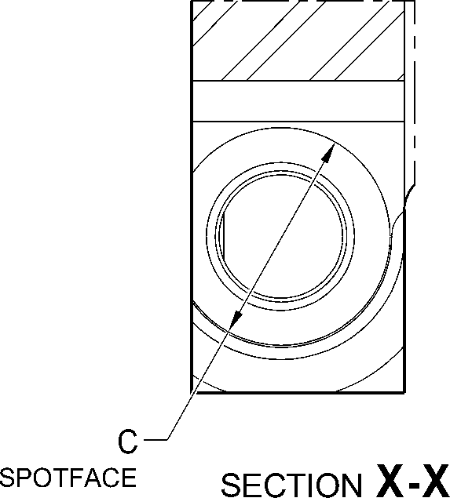

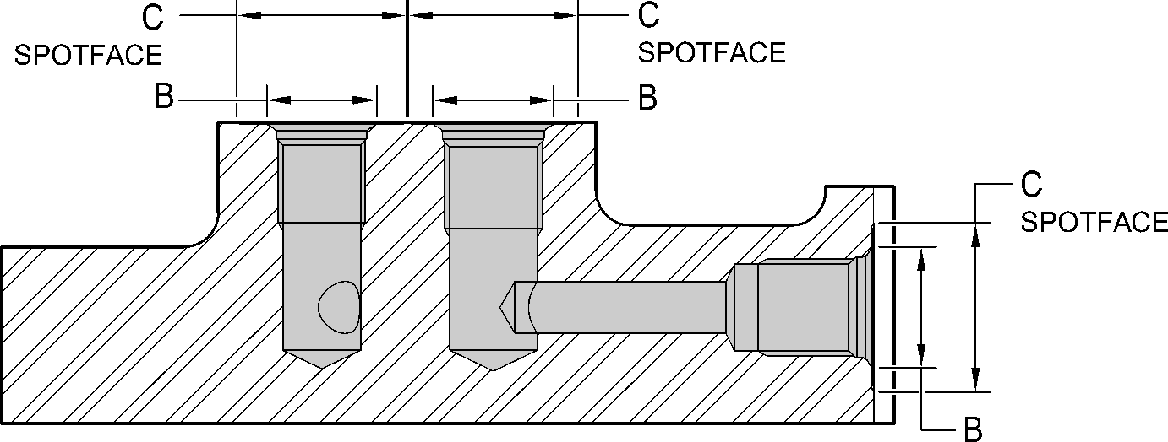

SECTION **Y-Y**

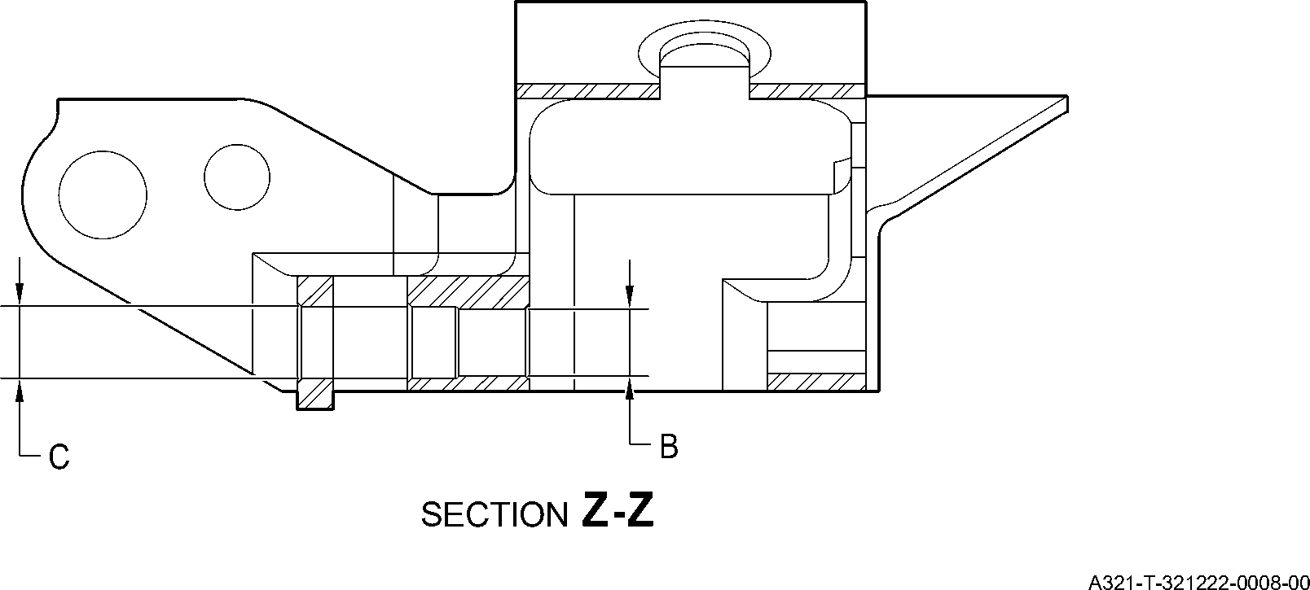

Transfer Block (2-340B and 2-350B) - Protective Treatment  
Figure 635 - Sheet 2

32-12-22

Page 662

Mar 18/2025

**SAFRAN LANDING SYSTEMS UK Ltd**

CAGE: K0654



PART No. 201587001 AND 201587002 COMPONENT MAINTENANCE MANUAL  
MAIN LANDING GEAR LEG

**A**

**H**

**N**

**D**

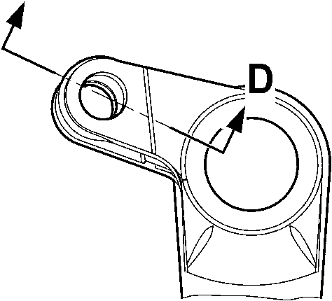

VIEW **A**

**M**

**M**

VIEW **B**

A321-T-321222-0020-00

Main Fitting (20-410B, 20-420B, 20-410C, 20-420C, 20-410D and 20-420D) - Protective Treatment

Figure 636 - Sheet 1

32-12-22

Page 663

Mar 18/2025

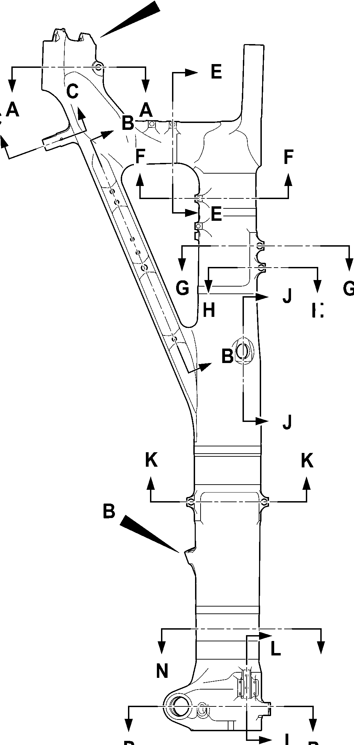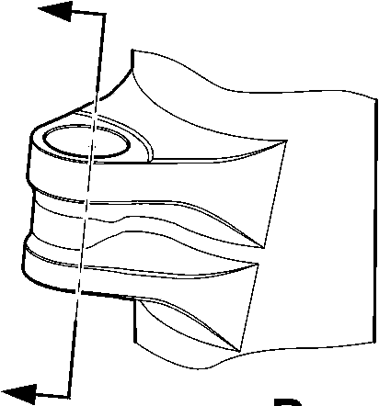

**SAFRAN LANDING SYSTEMS UK Ltd**

CAGE: K0654

PART No. 201587001 AND 201587002 COMPONENT MAINTENANCE MANUAL  
MAIN LANDING GEAR LEG

**C**

**C**

5,000 to 7,000mm

0.1968 to 0.2755in)

40,000 to 50,000mm  
(1.5747 to 1.9684in)

REF.

**B**

INCLUDING  
CHAMFERS

**B**

INCLUDING  
CHAMFERS

70,000 to 80,000mm  
(2.7558 to 3.1495in)  
REF.

**C**

5,000 to 7,000mm  
(0.1968 to 0.2755in)

2 PLACES

**B**

**B**

RADIUS  
TYPICAL

**C**

DIAMETER

THRU BORE

(0.7086 to 0.7480in) RAD.  
INCLUDING CHAMFERS  
TYPICAL 2 PLACES

**B**

SPOTFACE 18,000 to 19,000mm

**B**

SPOTFACE 14,000 to 15,000mm  
(0.5511 to 0.5905in) RAD.

INCLUDING CHAMFERS

TYPICAL 2 PLACES

PINTLE BORES

FOR MAIN FITTING (20-410C  
AND 20-420C) ONLY

**B**

RADIUS

SECTION **A-A**

PINTLE CROSS BORES

SECTION **C-C**LOCK LINK BORE

**C**

**B**

11,500 to 12,500mm  
(0.4527 to 0.4921in) RAD.  
TYPICAL 2 PLACES

**B**

11,750 to 12,750mm  
(0.4626 to 0.5019in) RAD.

**B**

10,750 to 11,750mm  
(0.4232 to 0.462in) RAD.

TYPICAL 2 PLACES

**C**

TYPICAL  
2 HOLES

**C**TYPICAL

2 HOLES

SECTION **B-B**DRAG ARM HOLES  
FOR MAIN FITTING (20-410C, 20-420C) ONLY

A321-T-321222-0021-02

Main Fitting (20-410B, 20-420B, 20-410C, 20-420C, 20-410D and 20-420D) - Protective Treatment

Figure 636 - Sheet 2

32-12-22

Page 664

Mar 18/2025

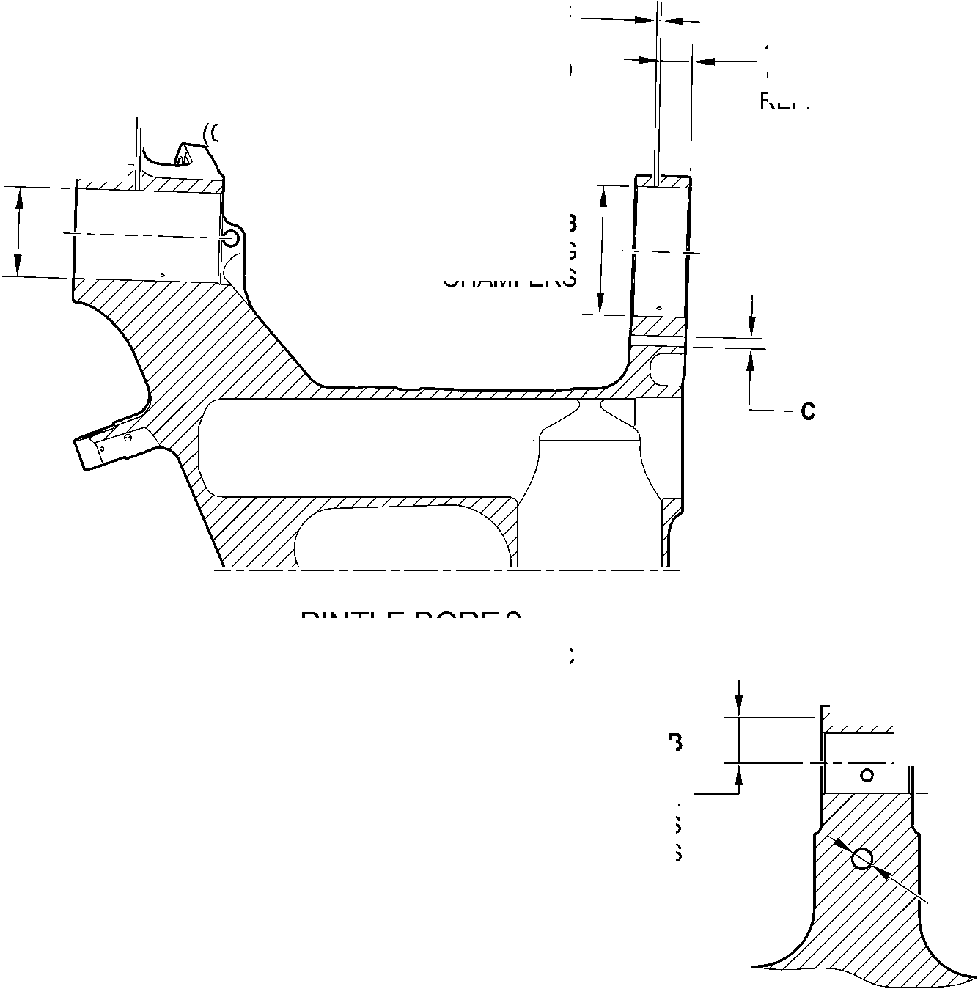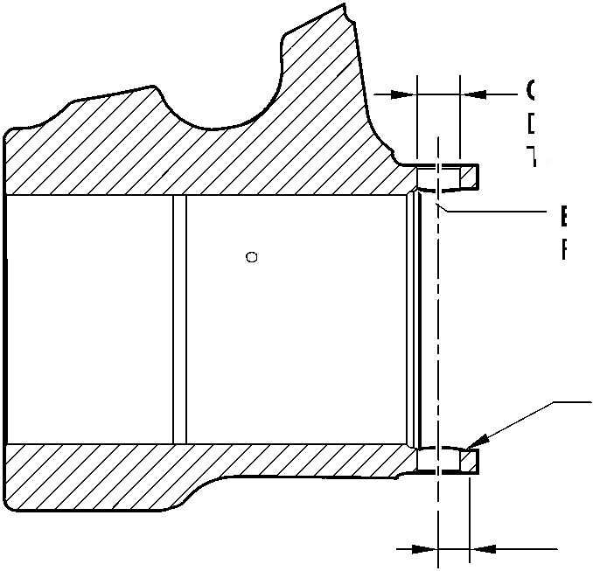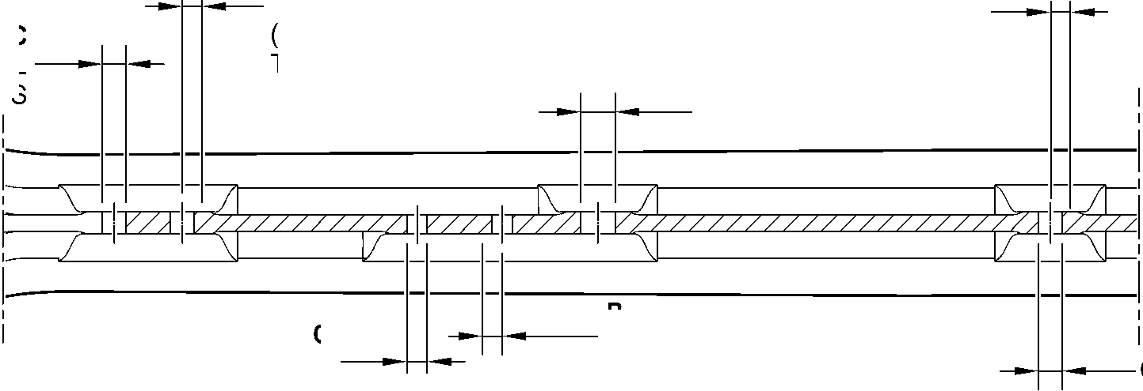

**SAFRAN LANDING SYSTEMS UK Ltd**

CAGE: K0654



PART No. 201587001 AND 201587002 COMPONENT MAINTENANCE MANUAL  
MAIN LANDING GEAR LEG

14,000 to 16,000mm  
(0.5511 to 0.6299in) REF.

**B**

30,000 to 31,000mm  
(1.1810 to 1.2204in)

SPOTFACE RAD.

**C**

5,000 to 7,000mm  
(0.1968 to 0.2755in)

TYPICAL 2 PLACES

**B**

35,500 to 36,500mm  
(1.3976 to 1.4370in)  
SPOTFACE RAD.

**B**

DIAMETERS THRU BORES

INCLUDING CHAMFERS

**B**

29,500 to 30,500mm  
(1.1614 to 1.2007in)  
SPOTFACE RAD.

**B**

51,500 to 52,500mm  
(2.0275 to 2.0669in)

SPOTFACE RAD.

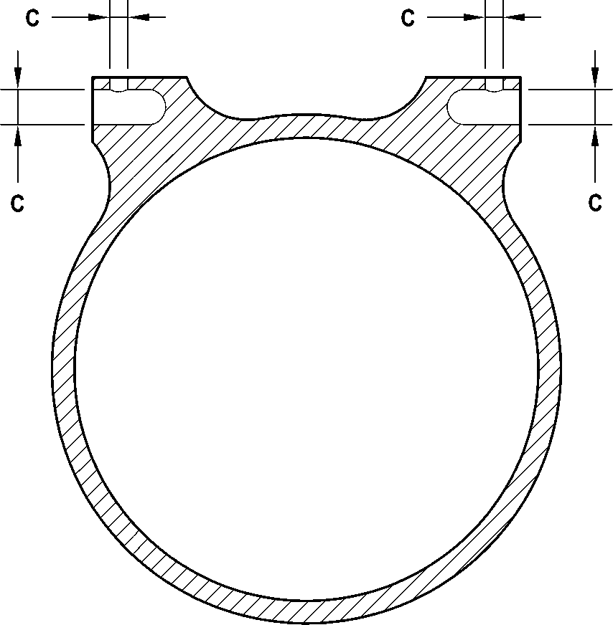

**C**

SECTION **D-D**RETRACTION BORES

FOR MAIN FITTING (20-410C

AND 20-420C) ONLY

**C**

SECTION **E-E**

TYPICAL 2 TRANSFER BLOCK LUGS

SECTION **F-F**

TYPICAL 2 BRAKE MANIFOLD LUGS

**C**

**B**

CHAMFERS ONLY

TYPICAL 2 PLACES

SECTION **G-G**UPPER DOOR LUGS

SECTION **H-H**TOOLING LUG

FOR MAIN FITTING (20-410C

AND 20-420C) ONLY

A321-T-321222-0022-01

Main Fitting (20-410B, 20-420B, 20-410C, 20-420C, 20-410D and 20-420D) - Protective Treatment

Figure 636 - Sheet 3

32-12-22

Page 665

Mar 18/2025

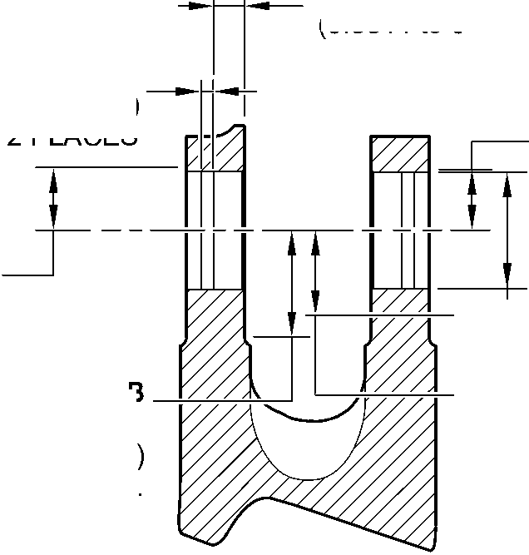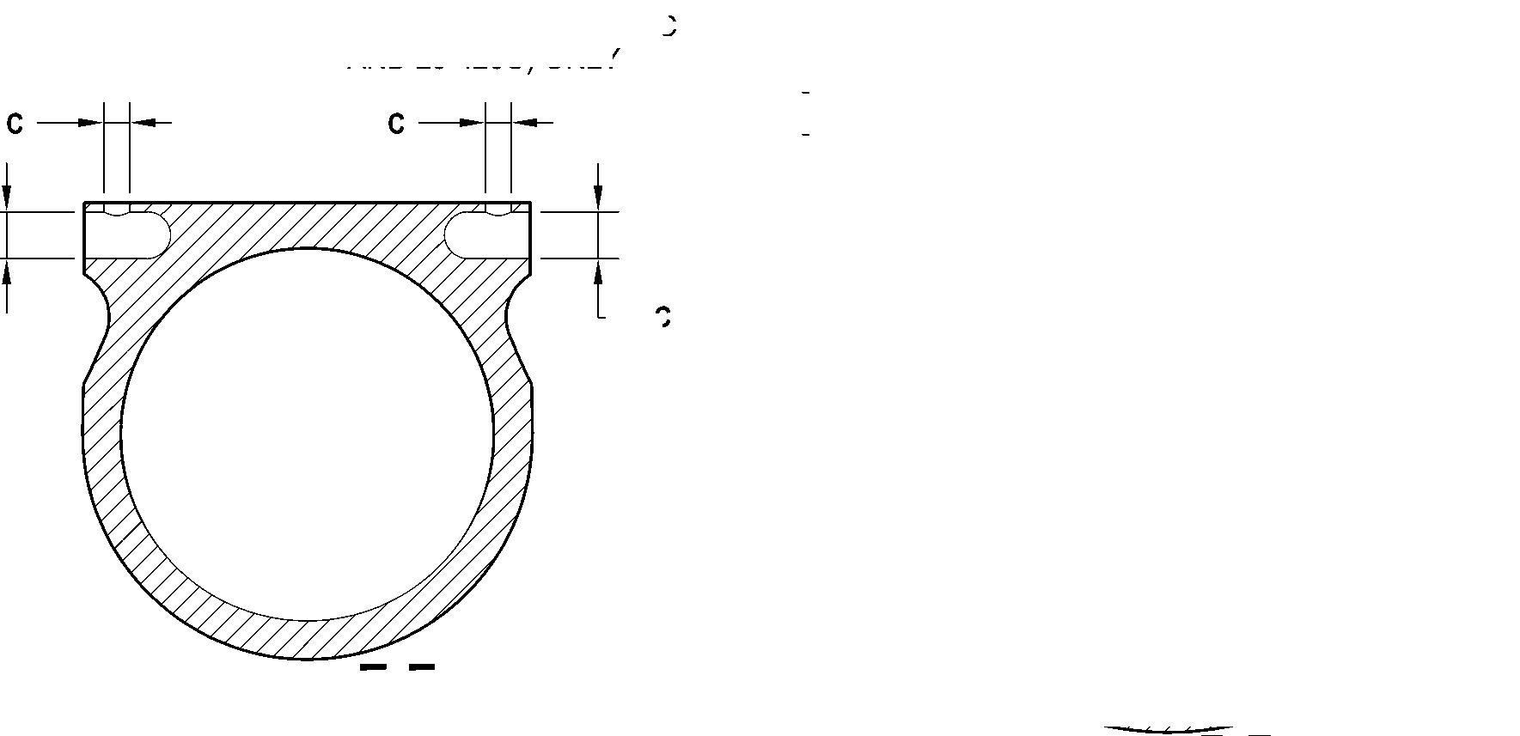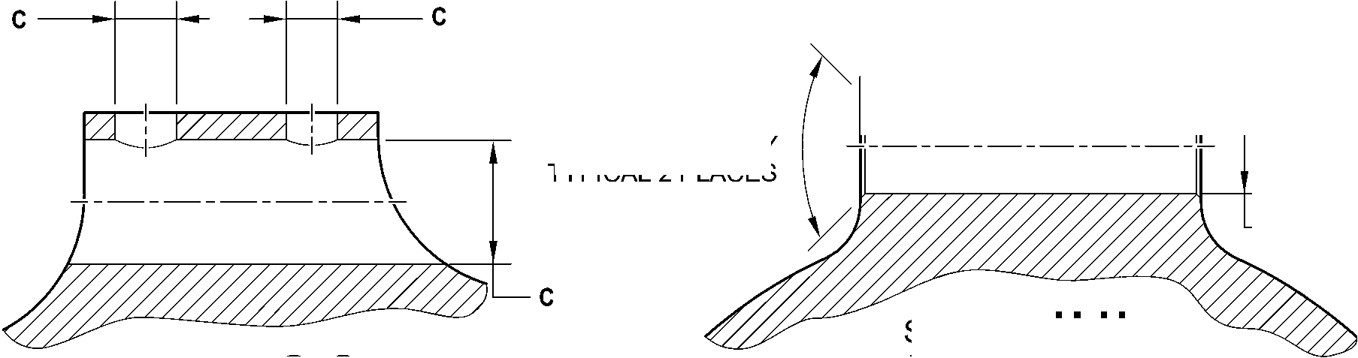

**SAFRAN LANDING SYSTEMS UK Ltd**

CAGE: K0654

PART No. 201587001 AND 201587002 COMPONENT MAINTENANCE MANUAL  
MAIN LANDING GEAR LEG

**B**

51,500 to 52,500mm  
(2.0275 to 2.0669in)  
EXTENT  
OF FINE LIMIT DIA.

**C**

5,000 to 7,000mm  
(0.1968 to 0.2755in)

**B**

25,000 to 26,000mm  
(0.9842 to 1.0236in)  
EXTENT

OF FINE LIMIT DIA.

**C**

5,000 to 7,000mm  
(0.1968 to 0.2755in)

**C**

2 LUGS

**C**

2 LUGS

**C**

2 LUGS

27,000 to 29,000  
(1.0629 to 1.1417in)  
REF.

**B**

52,500 to 53,500mm  
(2.0669 to 2.1063in)  
SPOTFACE RADIUS

INCLUDING CHAMFERS

NO CADMIUM  
PLATE OR PAINT  
BEYOND THIS LINE

**B**

DIAMETER THRU BORE  
INCLUDING CHAMFERS

**B**

47,000 to 48,000mm  
(1.8503 to 1.8897in)  
SPOTFACE RADIUS  
INCLUDING CHAMFERS

**B**

30,500 to 31,500mm  
(1.2007 to 1.2401in)  
SPOTFACE RADIUS  
TYPICAL 2 PLACES

SECTION **K-K**LOWER DOOR LUGS

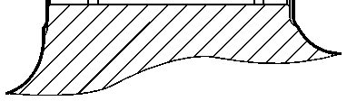

14,000 to 16,000mm  
(0.5511 to 0.6299in)

REF.

SECTION **M-M**LOWER CARDAN BORE

SECTION **J-J**

UPPER DIAPHRAGM TUBE

CROSS BORE

FOR MAIN FITTING (20-410C  
AND 20-420C) ONLY

A321-T-321222-0023-01

Main Fitting (20-410B, 20-420B, 20-410C, 20-420C, 20-410D and 20-420D) - Protective Treatment

Figure 636 - Sheet 4

32-12-22

Page 666

Mar 18/2025

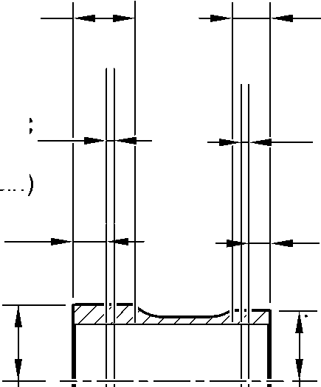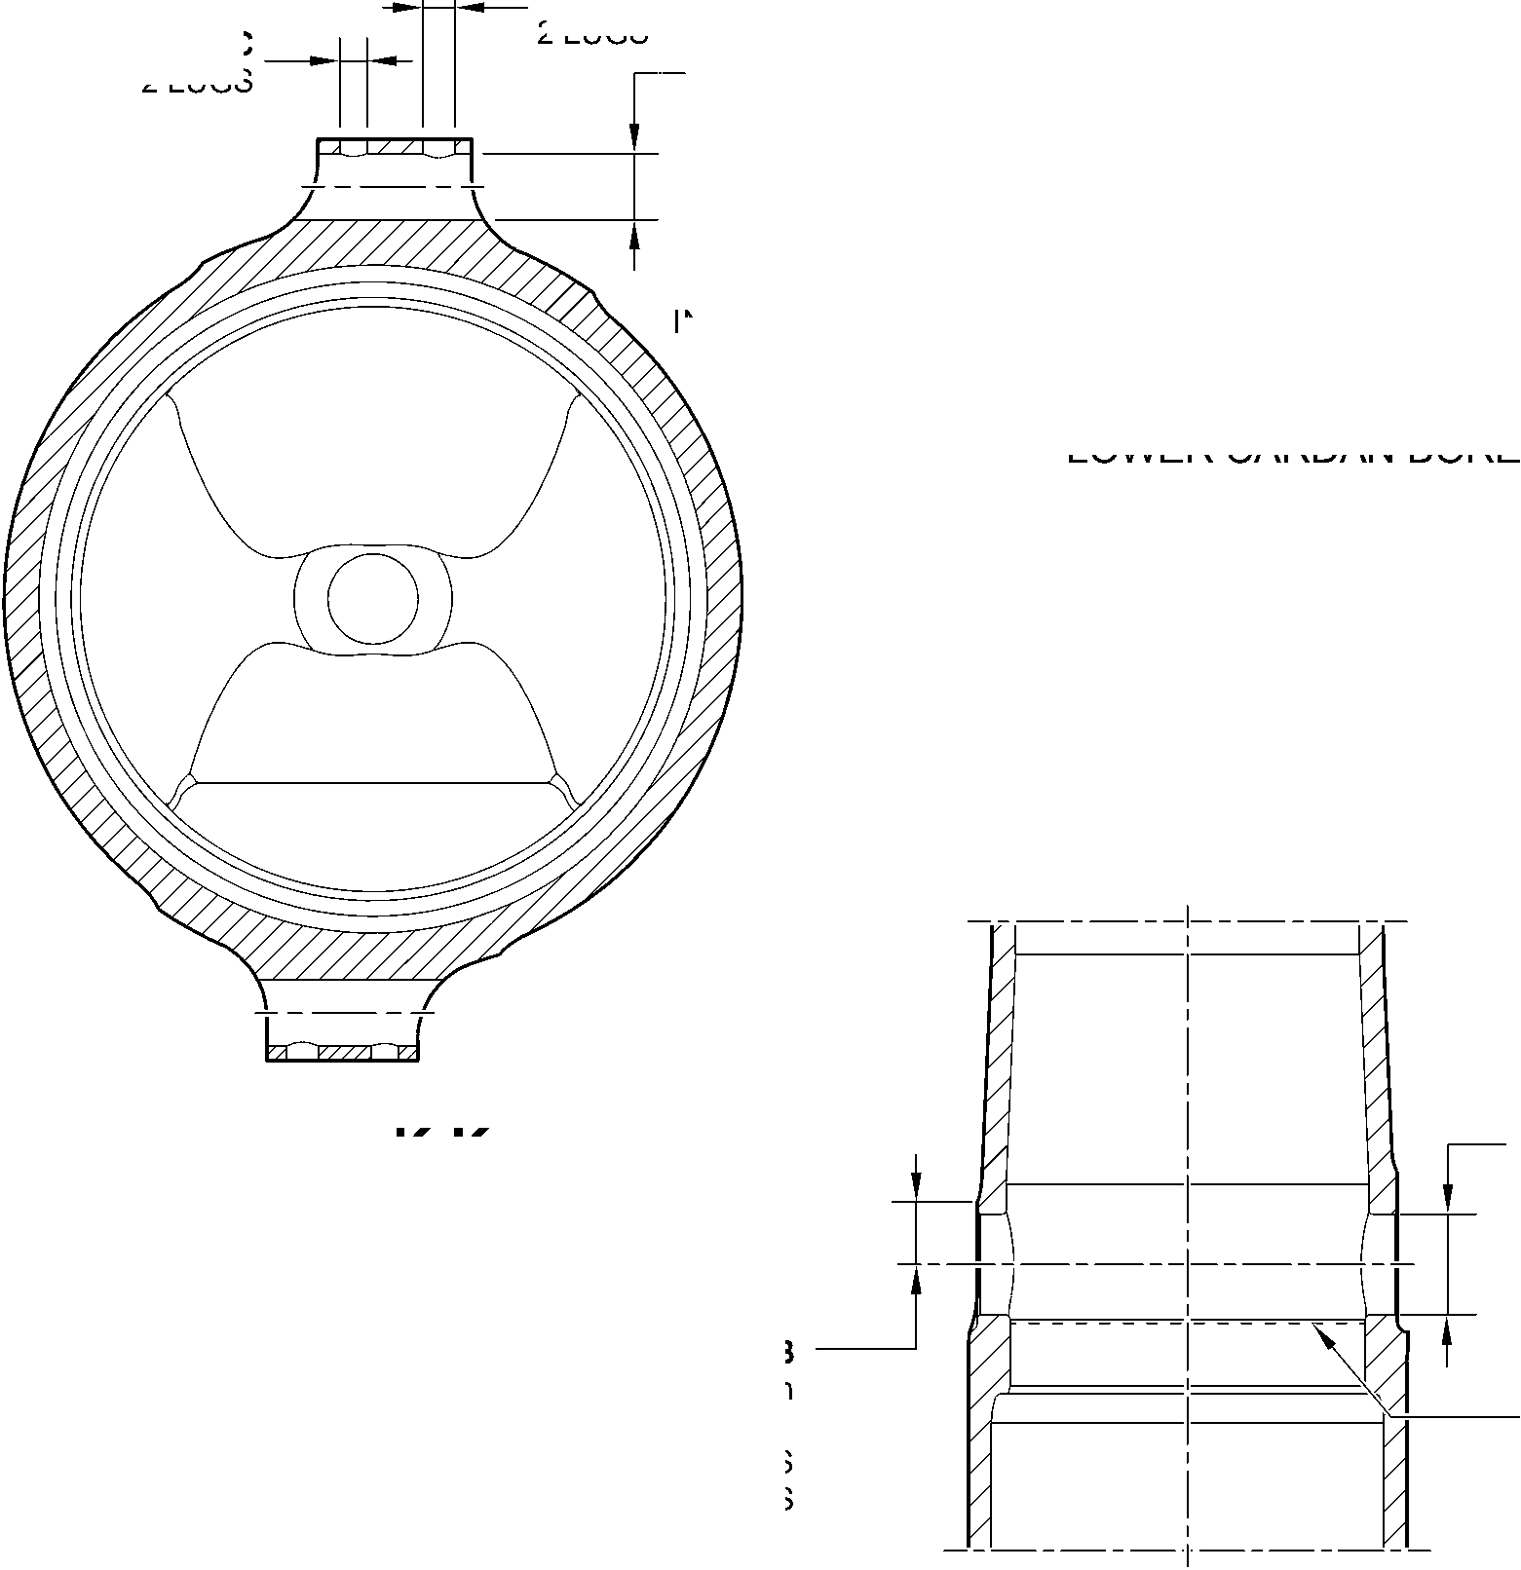

**SAFRAN LANDING SYSTEMS UK Ltd**

CAGE: K0654



PART No. 201587001 AND 201587002 COMPONENT MAINTENANCE MANUAL  
MAIN LANDING GEAR LEG

**B**

4 HOLES

C

9,000 to 10,000mm  
(0.3543 to 0.3936in)

SPOTFACE RAD IUS

**C**

**C**

10,500 to 11,500mm

(0.4133 to 0.4527in)

RADIUS TYPICAL 2 PLACES

SECTION **N-N**

UPLOCK LUGS

22,000 to 24,000mm  
(0.8661 to 0.9448in) REF.

**C**

5,000 to 7,000mm  
(0.1968 to 0.2755in)

TYPICAL 2 PLACES

**B**

INCLUDING CHAMFER

TYPICAL 2 LUGS

**B**

DIAMETER

INCLUDING CHAMFER

3 BORES

**D**

**B**

34,500 to 35,500mm  
(1.3583 to 1.3976in)  
RADIUS

TYPICAL 2 PLACES

**A** and **C**

2 HOLES

**B**

TYPICAL

4 HOLES

SECTION **L-L**

CHANGE OVER VALVE

SECTION **P-P**

TORQUE LINK AND RETAINING PIN BORES

HOLES AND LUGS

A321-T-321222-0024-01

Main Fitting (20-410B, 20-420B, 20-410C, 20-420C, 20-410D and 20-420D) - Protective Treatment

Figure 636 - Sheet 5

32-12-22

Page 667

Mar 18/2025

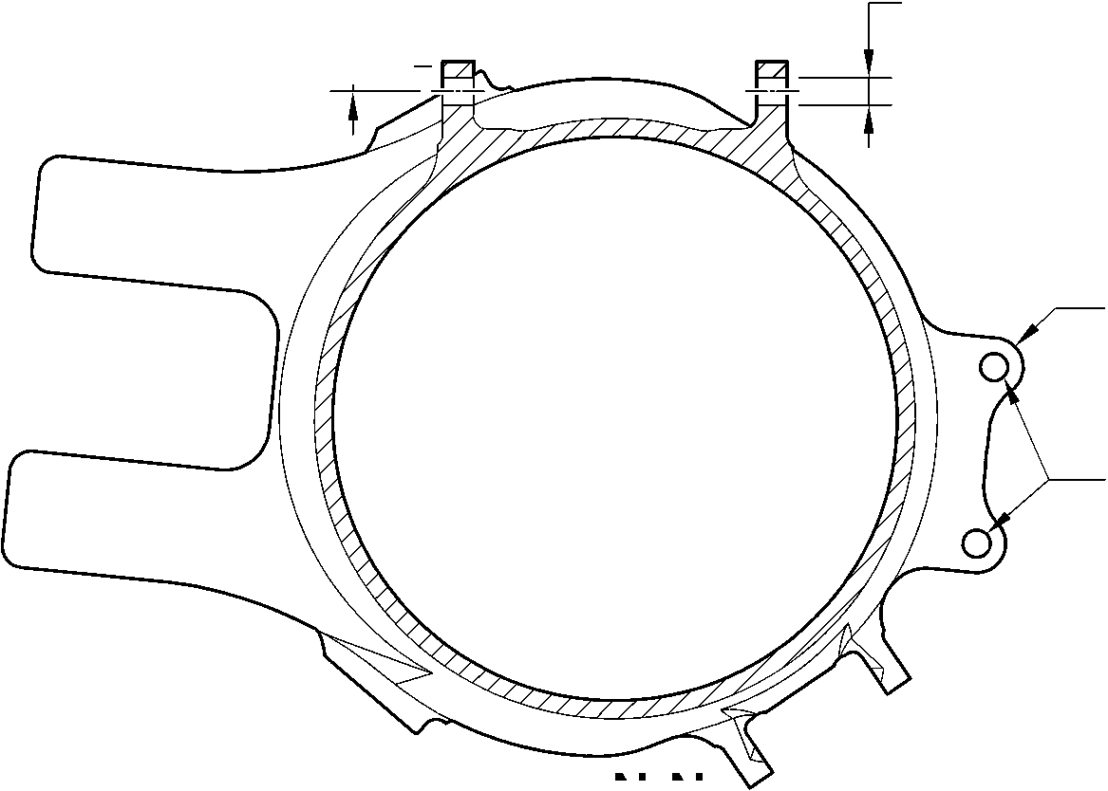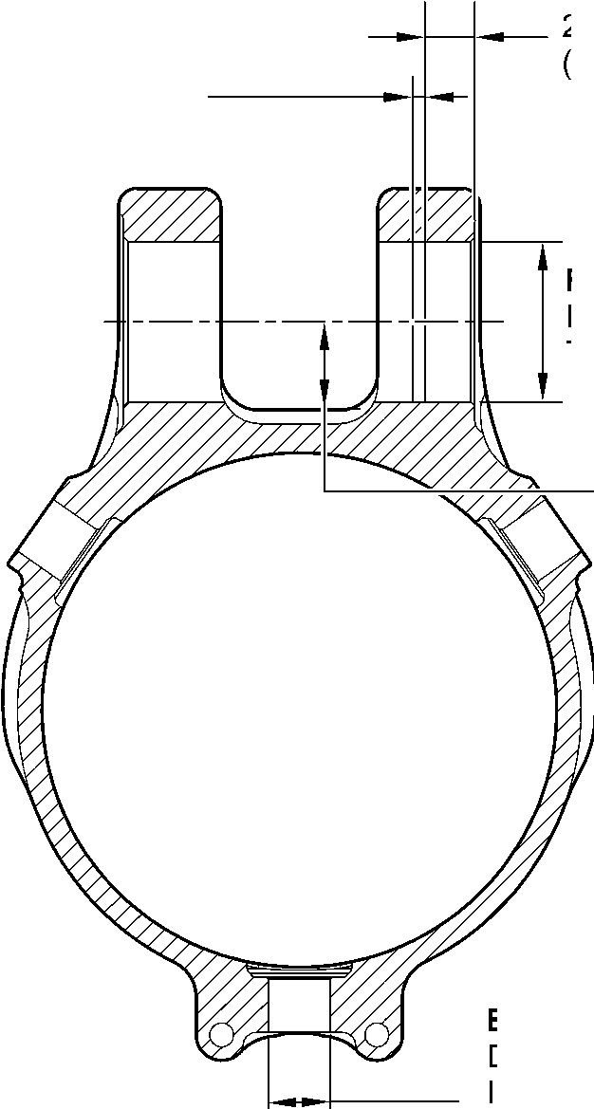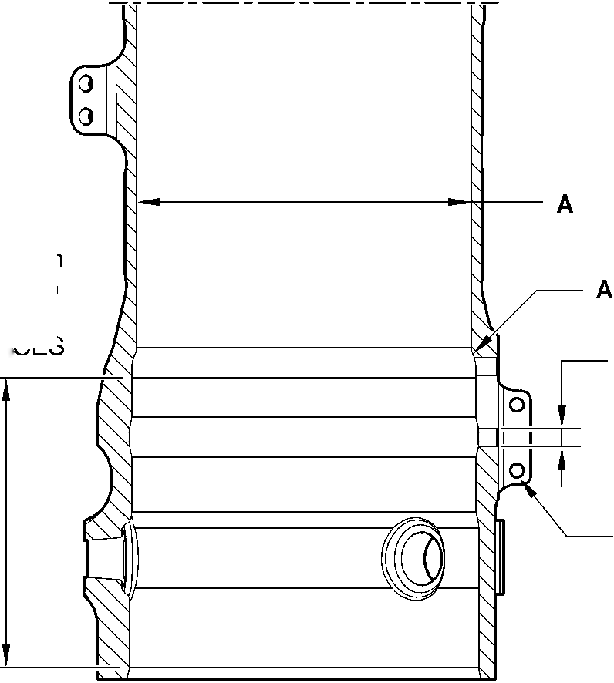

**SAFRAN LANDING SYSTEMS UK Ltd**

CAGE: K0654

PART No. 201587001 AND 201587002 COMPONENT MAINTENANCE MANUAL  
MAIN LANDING GEAR LEG

C

E

5,000 to 7,000mm

(0.1968 to 0.2755in)

B  
INCLUDING  
CHAMFERS

C

5,000 to 7,000mm  
(0.1968 to 0.2755in)

70,000 to 80,000mm  
(2.7558 to 3.1495in)  
REF.

B1

INCLUDING  
CHAMFERS

C

40,000 to 50,000mm  
(1.5747 to 1.9684in)

REF.

**C**

B

11,750 to 12,750mm  
(0.4626 to 0.5019in) RAD.

PINTLE BORES

FOR MAIN FITTING (20-410B, 20-420B,  
20-410D AND 20-420D) ONLY

C

B

10,750 to 11,750mm  
(0.4232 to 0.462in) RAD.

TYPICAL 2 PLACES

C

TYPICAL  
2 HOLES

14,000 to 16,000mm  
(0.5511 to 0.6299in) REF.

C

5,000 to 7,000mm  
(0.1968 to 0.2755in)

TYPICAL 2 PLACES

B

30,000 to 31,000mm  
(1.1810 to 1.2204in)

SPOTFACE RAD.

B

DIAMETERS THRU BORES

INCLUDING CHAMFERS

B

35,500 to 36,500mm  
(1.3976 to 1.4370in)  
SPOTFACE RAD.

B

29,500 to 30,500mm  
(1.1614 to 1.2007in)  
SPOTFACE RAD.

section B-B

DRAG ARM HOLES  
FOR MAIN FITTING (20-410B, 20-420B,  
20-410D AND 20-420D) ONLY

B

50,500 to 51,500mm  
(1.9881 to 2.0275in)

SPOTFACE RAD.

section D-D  
RETRACTION BORES  
FOR MAIN FITTING (20-410B, 20-420B,  
20-410D AND 20-420D) ONLY

A321-T-32-12-22-125-1

Main Fitting (20-410B, 20-420B, 20-410D and 20-420D) - Protective Treatment

Figure 636 - Sheet 6

32-12-22

Page 668

Mar 18/2025

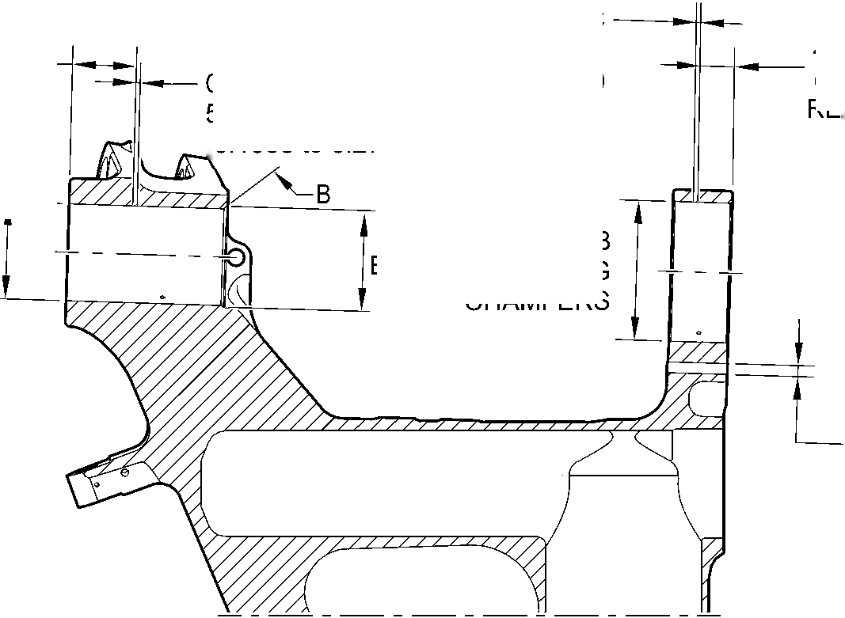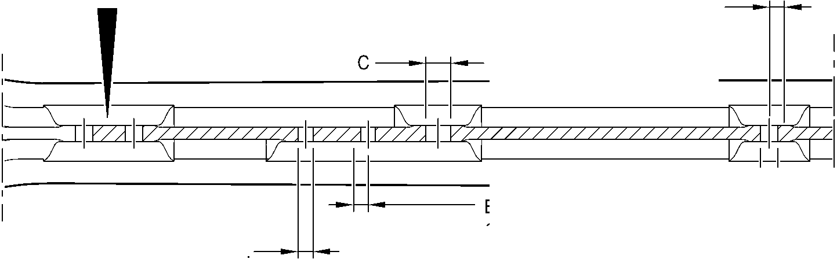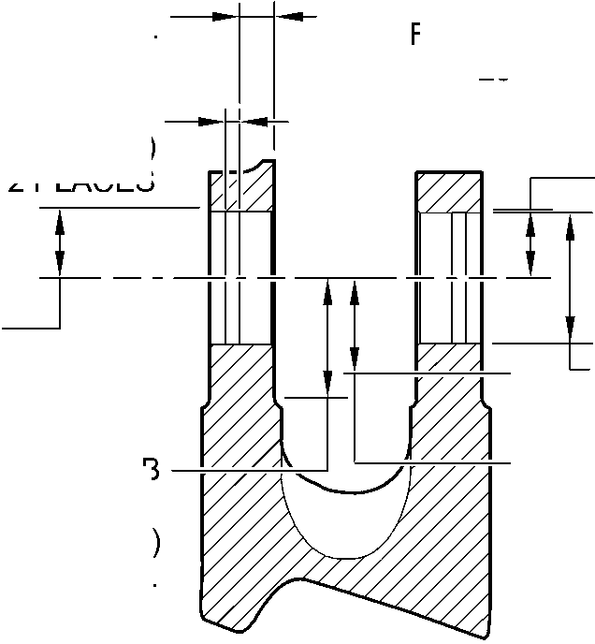

**SAFRAN LANDING SYSTEMS UK Ltd**

CAGE: K0654



PART No. 201587001 AND 201587002 COMPONENT MAINTENANCE MANUAL  
MAIN LANDING GEAR LEG

*’7ZZ777777ZZ777777ZA*

C

B AND E  
CHAMFERS ONLY

TYPICAL 2 PLACES

section H-H

TOOLING LUG

FOR MAIN FITTING (20-410B, 20-420B,  
20-410D AND 20-420D) ONLY

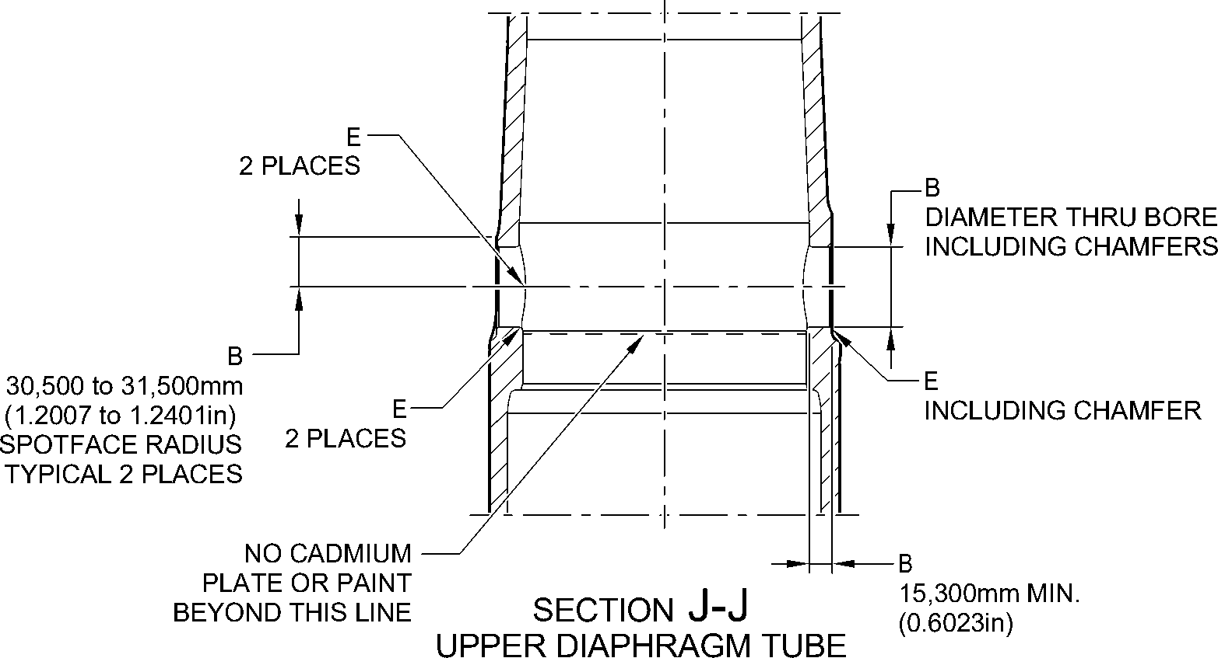

CROSS BORE

FOR MAIN FITTING (20-410B, 20-420B,  
20-410D AND 20-420D) ONLY

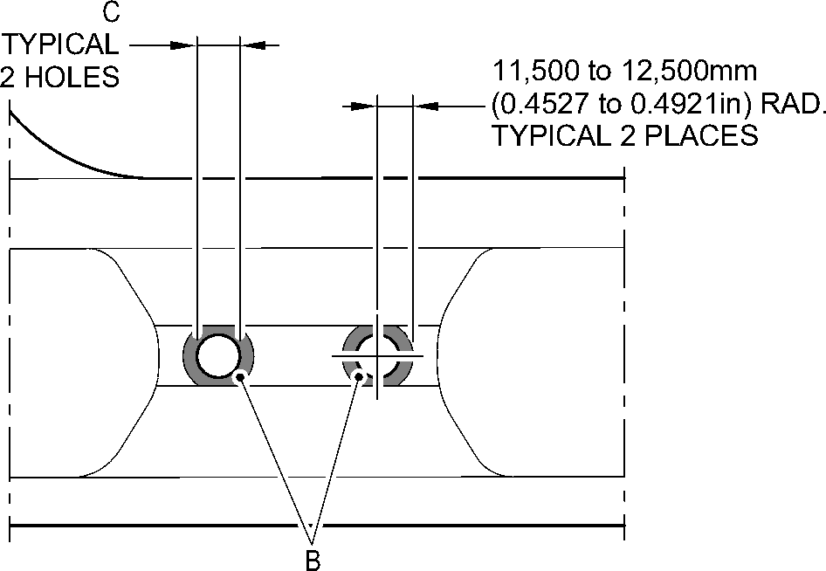

VIEW **C**

FOR MAIN FITTING (20-410B, 20-420B,  
20-410D AND 20-420D) ONLY

A321-T-32-12-22-126-1

Main Fitting (20-410B, 20-420B, 20-410D and 20-420D) - Protective Treatment

Figure 636 - Sheet 7

32-12-22

Page 669

Mar 18/2025

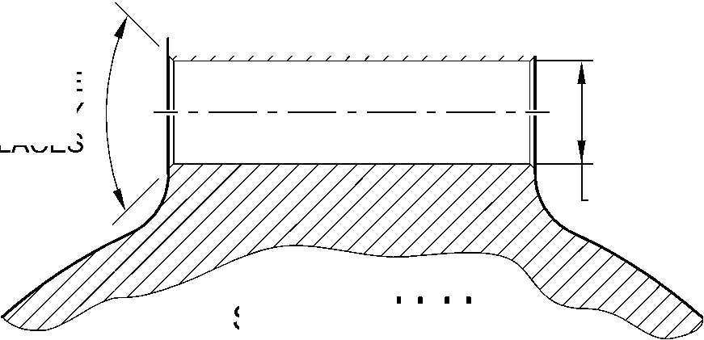

**SAFRAN LANDING SYSTEMS UK Ltd**

CAGE: K0654



PART No. 201587001 AND 201587002 COMPONENT MAINTENANCE MANUAL  
MAIN LANDING GEAR LEG

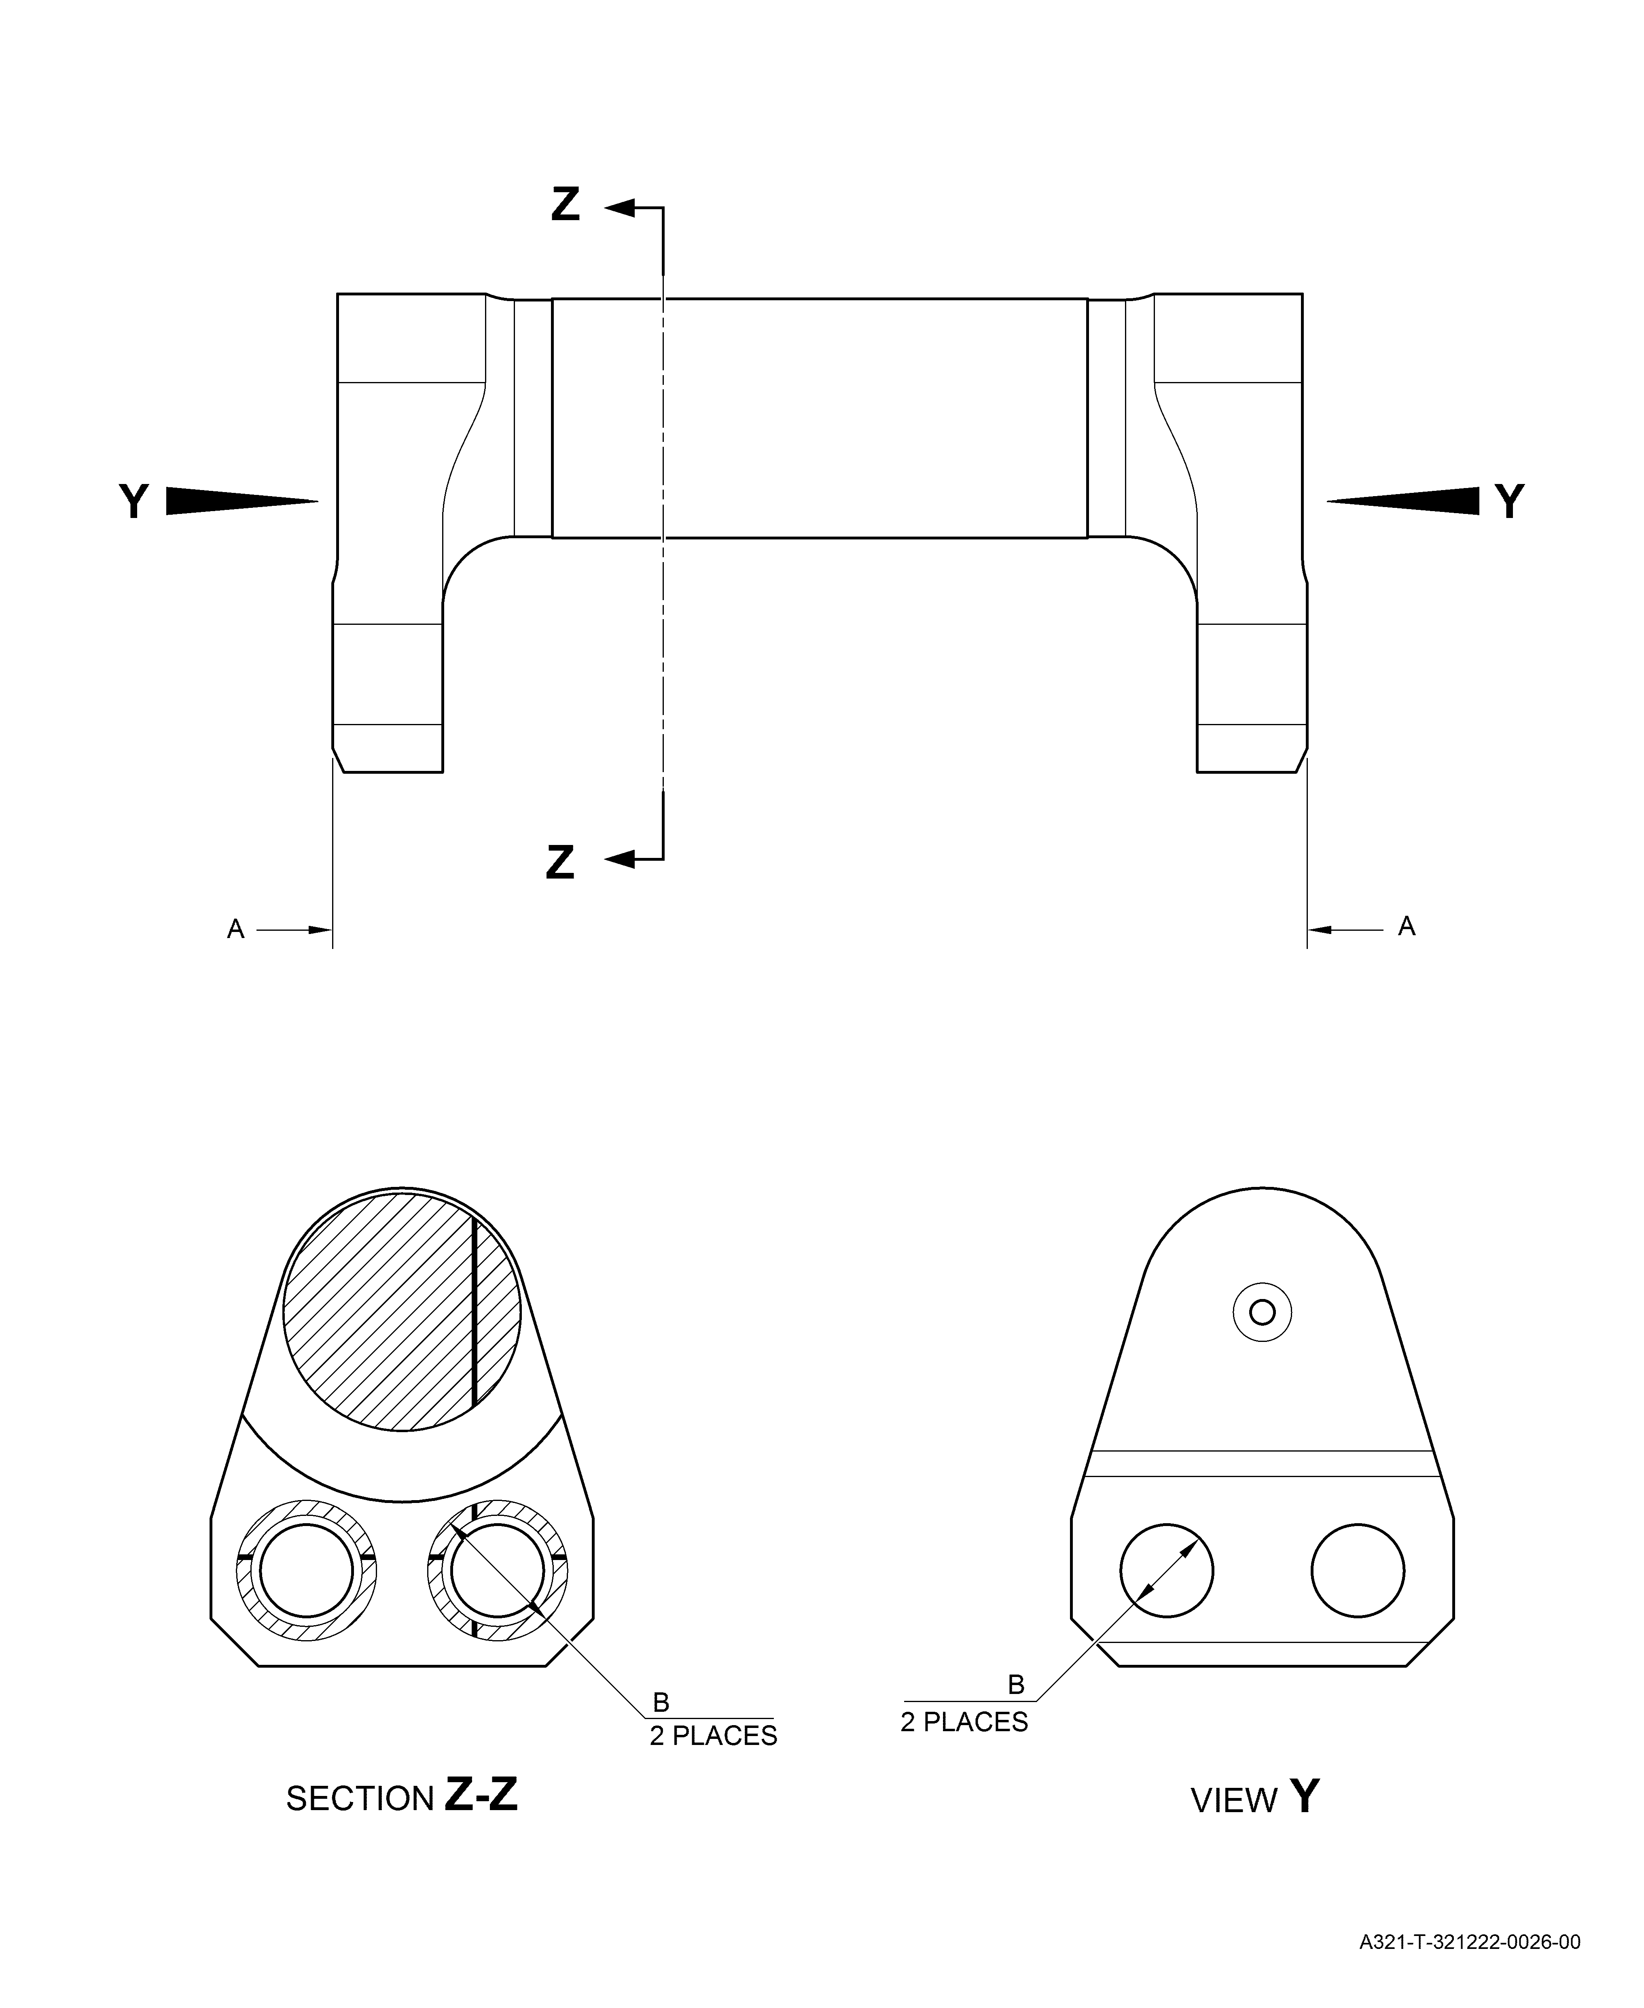

Uplock Pin (5-400A) - Protective Treatment  
Figure 637

Page 670

3-- Mar 18/2025

**SAFRAN LANDING SYSTEMS UK Ltd**

CAGE: K0654

Main Fitting Subassembly (20-90B and 20-100B) - Protective Treatment  
Figure 638 - Sheet 1

PART No. 201587001 AND 201587002 COMPONENT MAINTENANCE MANUAL  
MAIN LANDING GEAR LEG

32-12-22

Page 671

Mar 18/2025

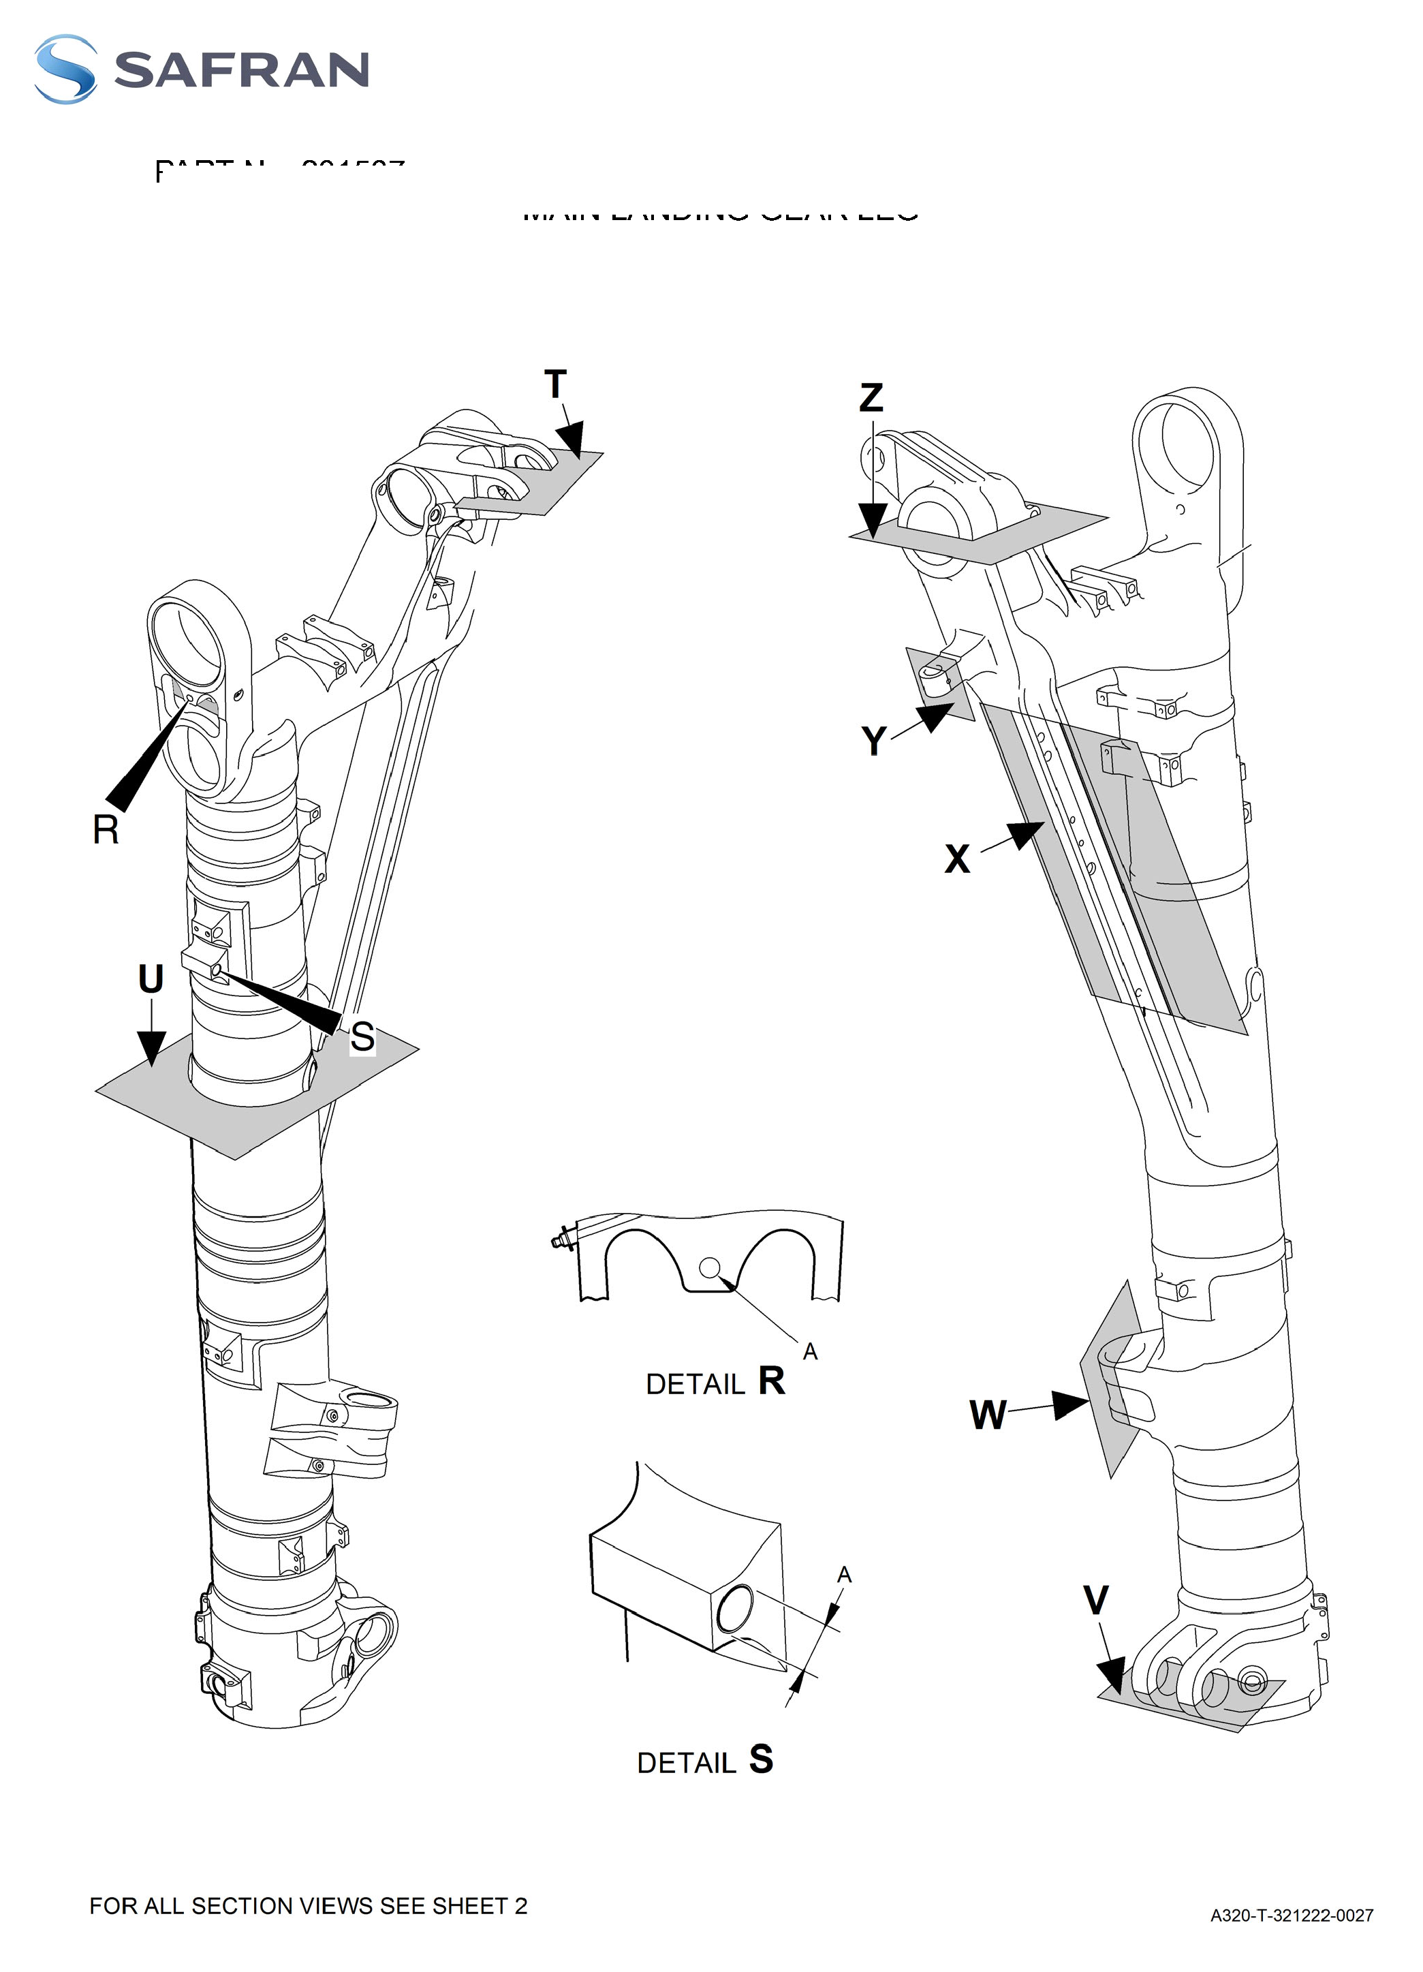

**SAFRAN LANDING SYSTEMS UK Ltd**

CAGE: K0654



PART No. 201587001 AND 201587002 COMPONENT MAINTENANCE MANUAL  
MAIN LANDING GEAR LEG

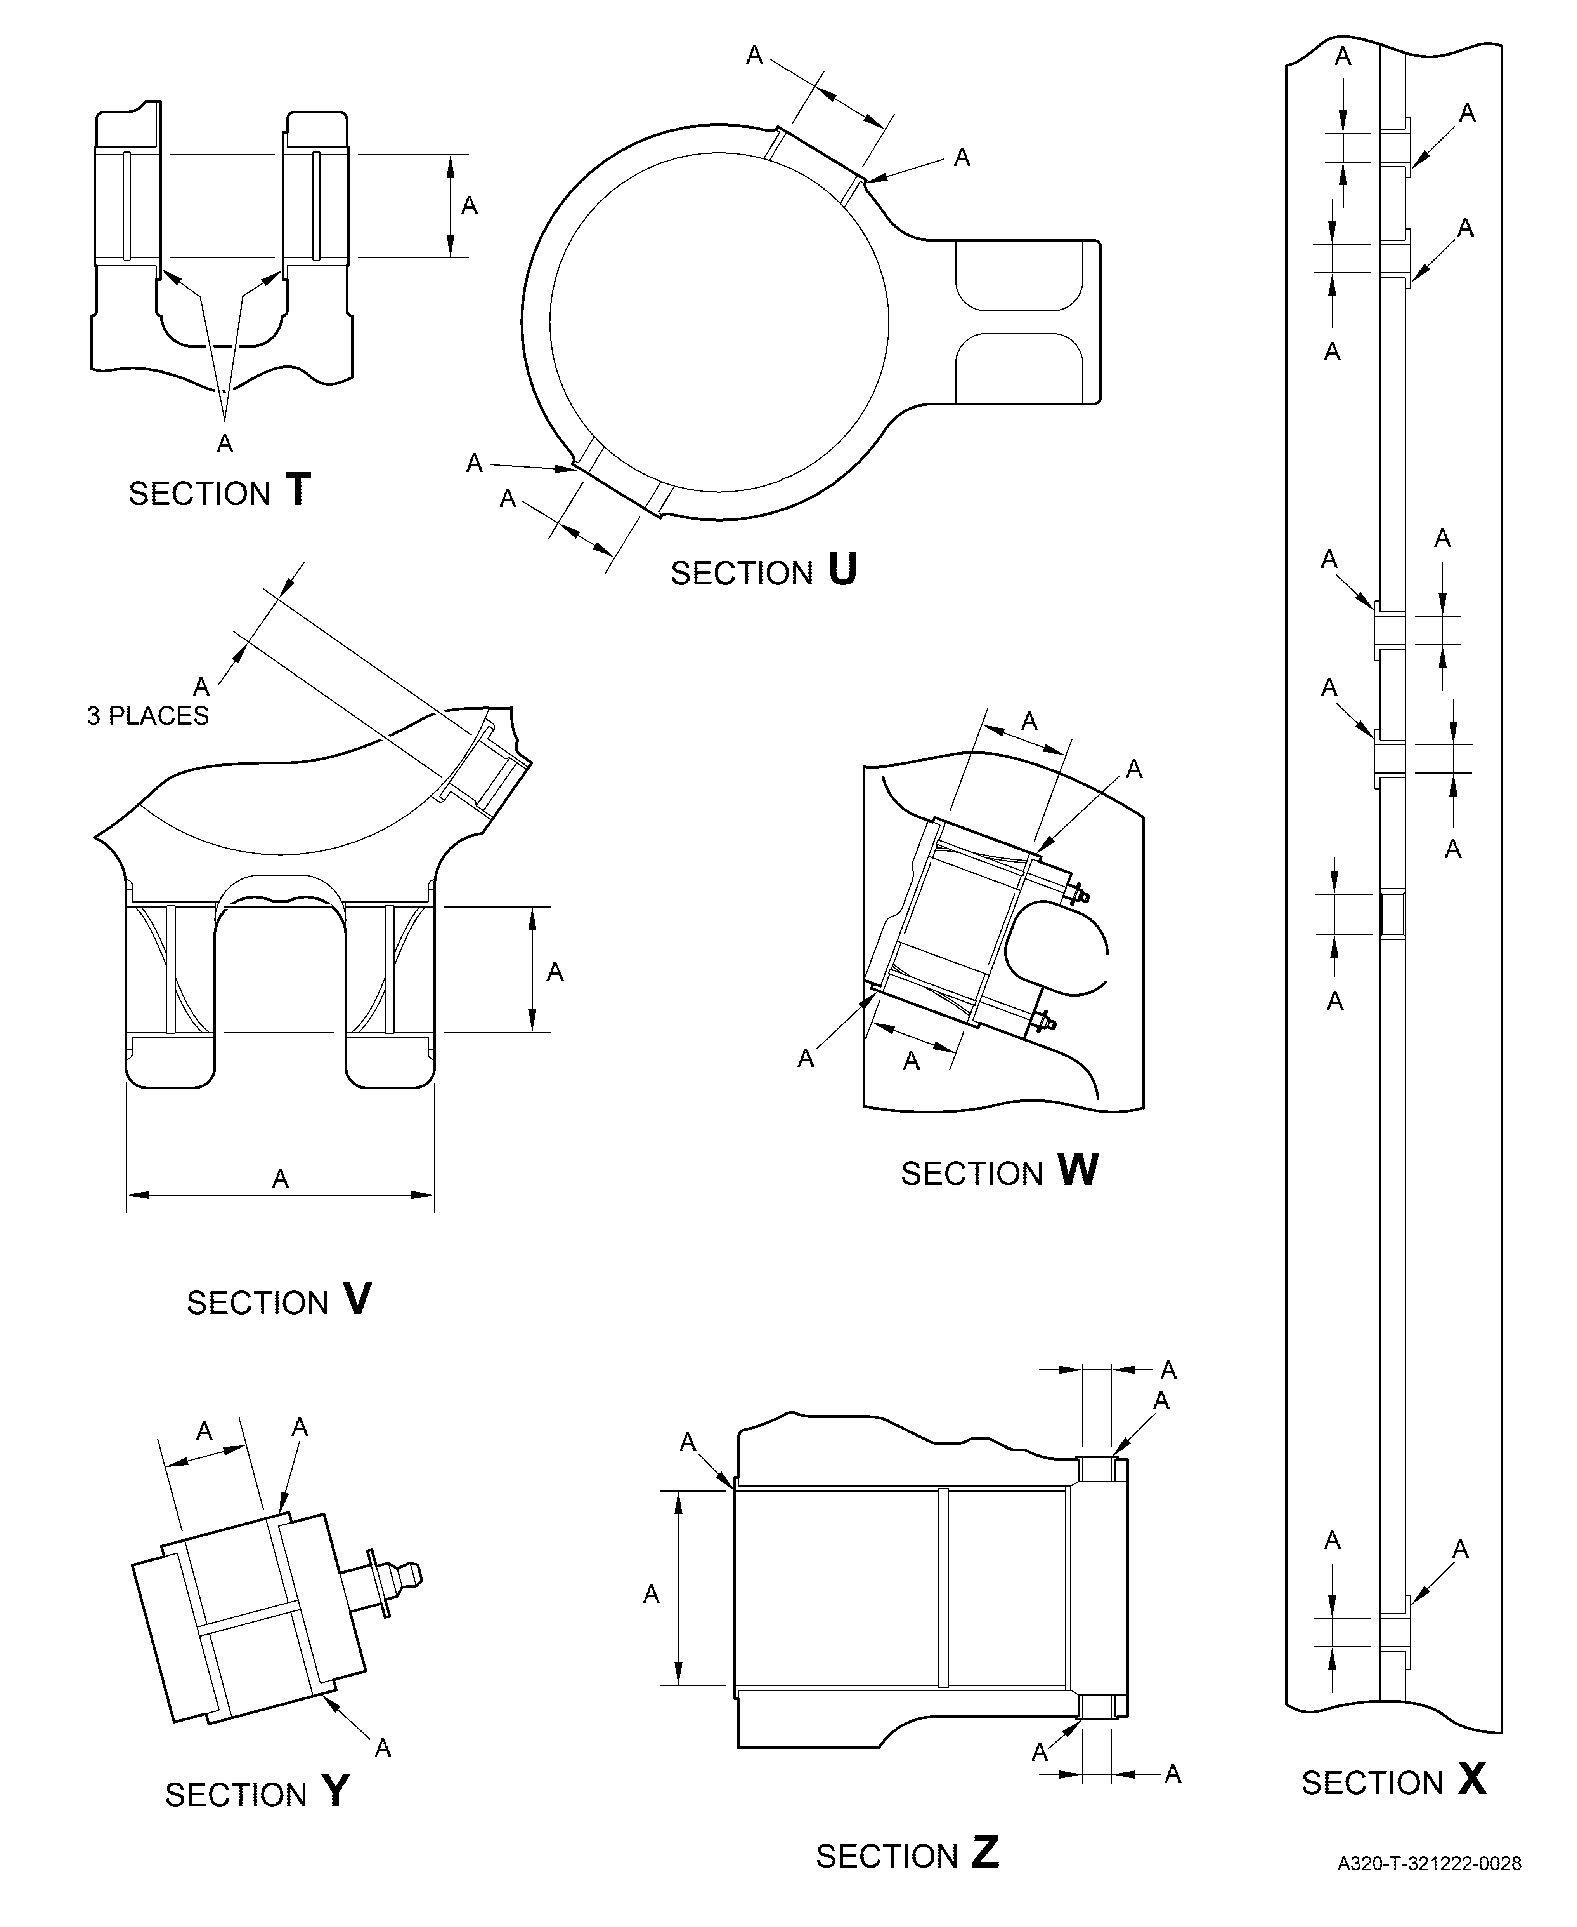

Main Fitting Subassembly (20-90B and 20-100B) - Protective Treatment  
Figure 638 - Sheet 2

32-12-22

Page 672

Mar 18/2025

**SAFRAN LANDING SYSTEMS UK Ltd**

CAGE: K0654



PART No. 201587001 AND 201587002 COMPONENT MAINTENANCE MANUAL  
MAIN LANDING GEAR LEG

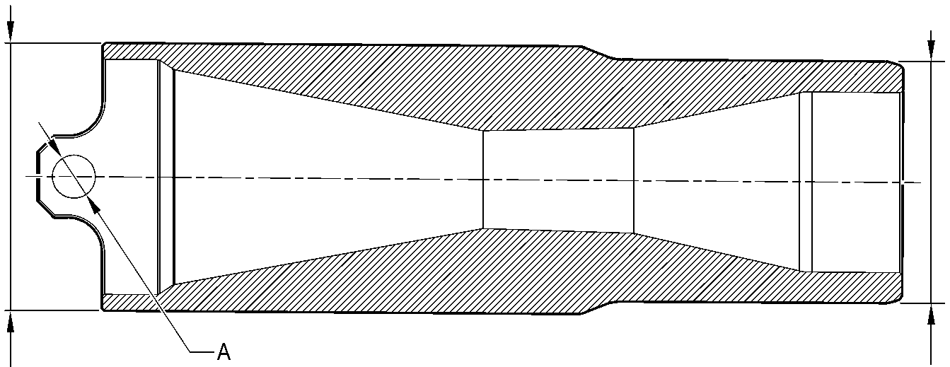

CHROMIUM PLATED TWO PLACES

SURFACE

SECTION **A-A**

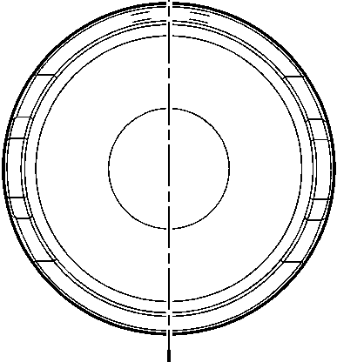

CHROMIUM PLATED  
SURFACE

A321-T-32-12-22-124-0

Forward Pintle Pin (1-60A) - Protective Treatment  
Figure 639

32-12-22

Page 673

Mar 18/2025

**SAFRAN LANDING SYSTEMS UK Ltd**

CAGE: K0654



PART No. 201587001 AND 201587002 COMPONENT MAINTENANCE MANUAL  
MAIN LANDING GEAR LEG

A

A

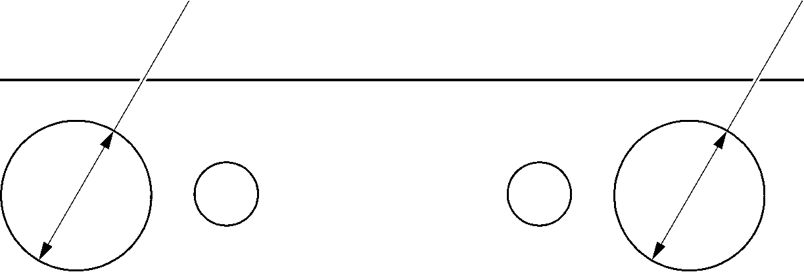

A321-T-32-12-22-131-00

Spacer (4-180) Only - Protective Treatment  
Figure 640

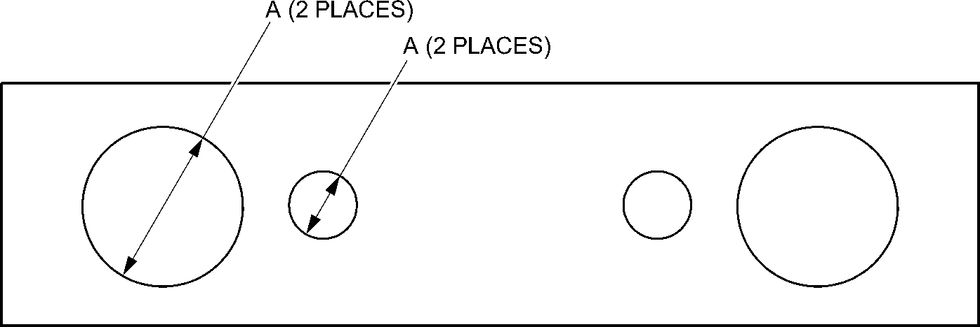

A321-T-32-12-22-132-00

Drag-arm Spacer (4-180A) - Protective Treatment  
Figure 641

32-12-22

Page 674

Mar 18/2025

**SAFRAN LANDING SYSTEMS UK Ltd**

CAGE: K0654

PART No. 201587001 AND 201587002 COMPONENT MAINTENANCE MANUAL  
MAIN LANDING GEAR LEG

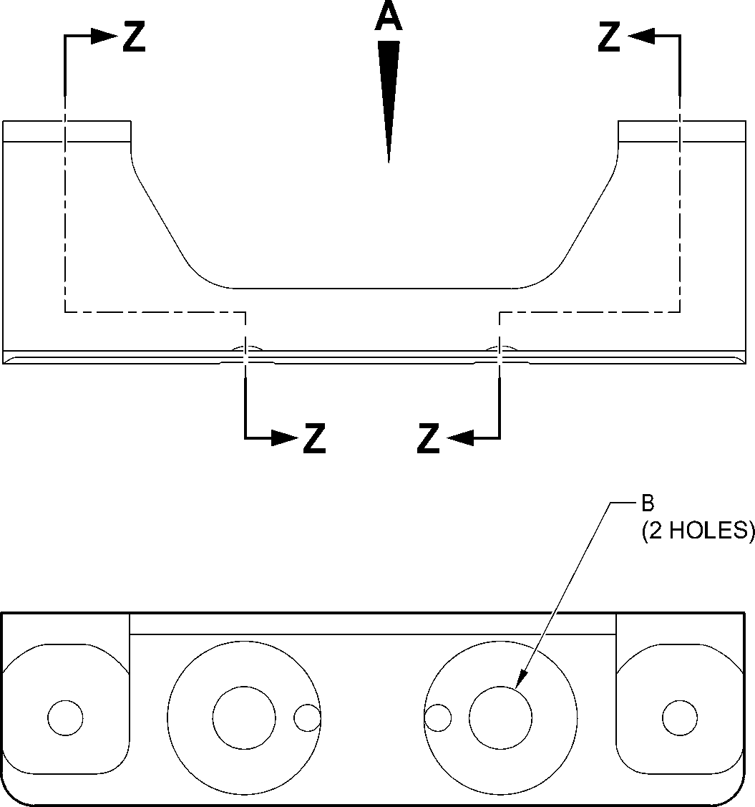

VIEW **A**

A

23,750 to 24,250mm  
(0.9351 to 0.9547in) DIA.

SPOTFACE

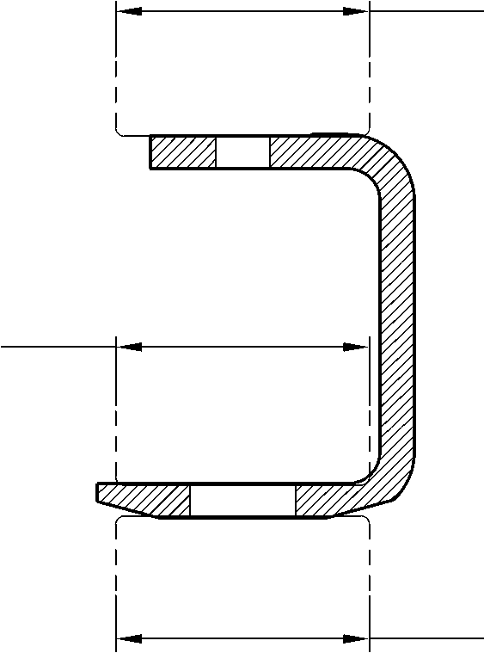

A

23,750 to 24,250mm  
(0.9351 to 0.9547in) DIA.

SPOTFACE

A

23,750 to 24,250mm  
(0.9351 to 0.9547in) DIA.

SPOTFACE

SECTION **Z-Z**TYPICAL

A321-T-32-12-22-106-0

Bracket (4-210) - Protective Treatment  
Figure 642

32-12-22

Page 675

Mar 18/2025

**SAFRAN LANDING SYSTEMS UK Ltd**

CAGE: K0654



PART No. 201587001 AND 201587002 COMPONENT MAINTENANCE MANUAL  
MAIN LANDING GEAR LEG

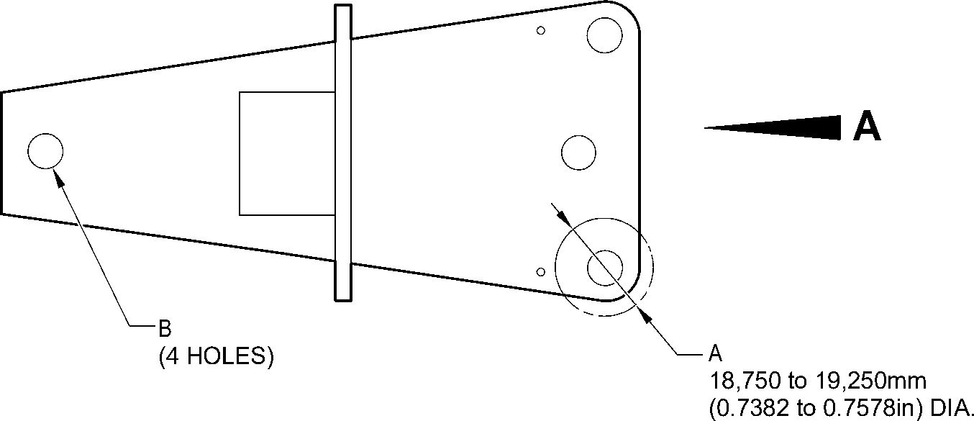

SPOTFACE

(BOTH SIDES)

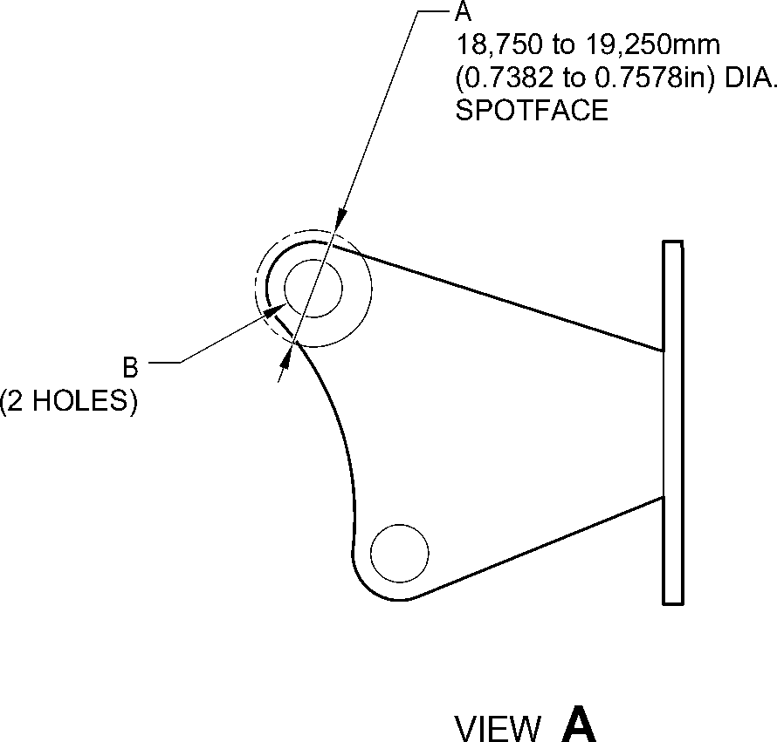

A321-T-32-12-22-103-0

Bracket (9-150) Only - Protective Treatment  
Figure 643

32-12-22

Page 676

Mar 18/2025

**SAFRAN LANDING SYSTEMS UK Ltd**

CAGE: K0654



PART No. 201587001 AND 201587002 COMPONENT MAINTENANCE MANUAL  
MAIN LANDING GEAR LEG

**A**

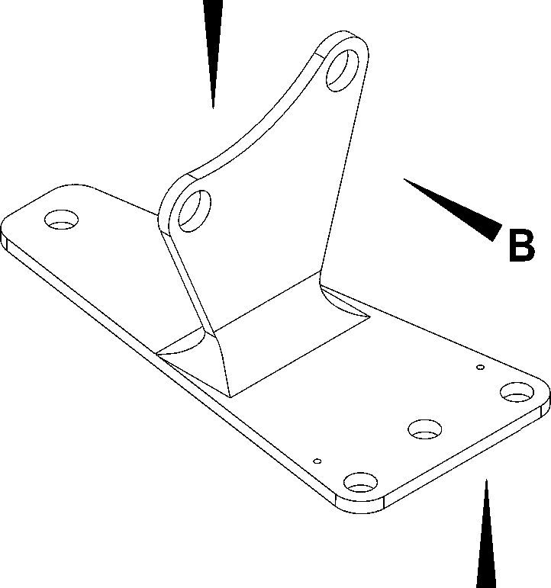

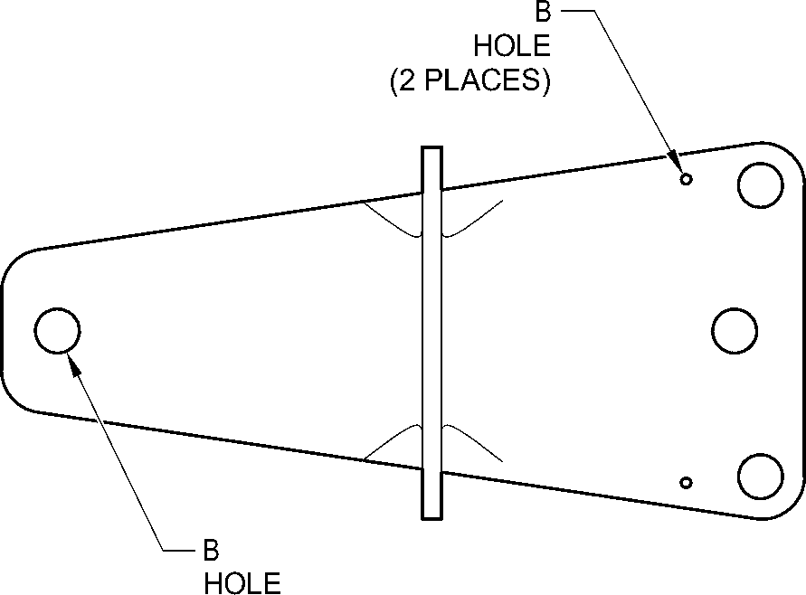

(4 PLACES)

VIEW **A**

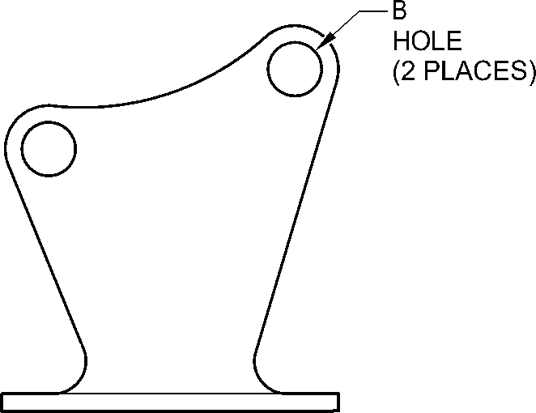

VIEW **B**

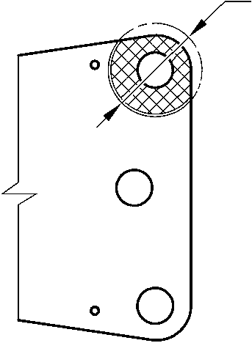

A

18,750 to 19,250mm  
(0.7382 to 0.7578in) DIA.

SPOTFACE

VIEW **C**

A321-T-32-12-22-105-0

Bracket (9-150A) - Protective Treatment  
Figure 644

32-12-22

Page 677

Mar 18/2025

**SAFRAN LANDING SYSTEMS UK Ltd**

CAGE: K0654



PART No. 201587001 AND 201587002 COMPONENT MAINTENANCE MANUAL  
MAIN LANDING GEAR LEG

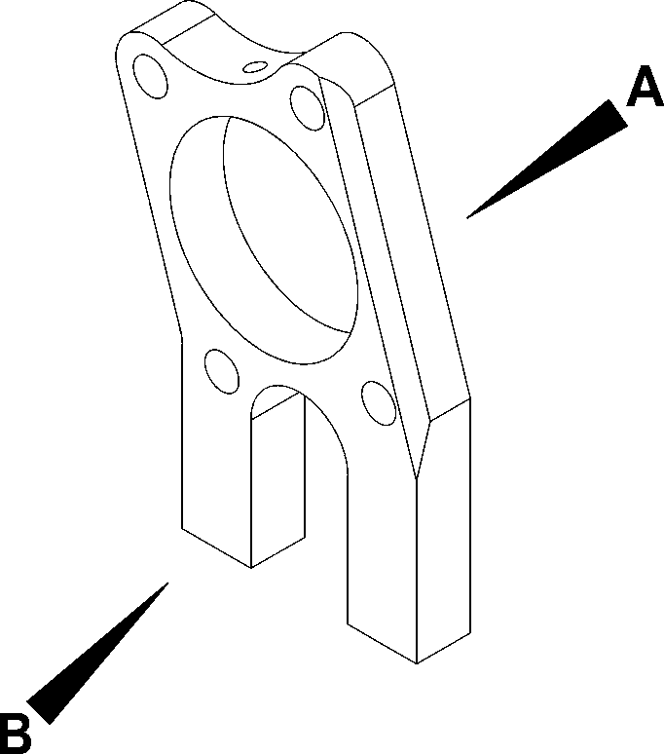

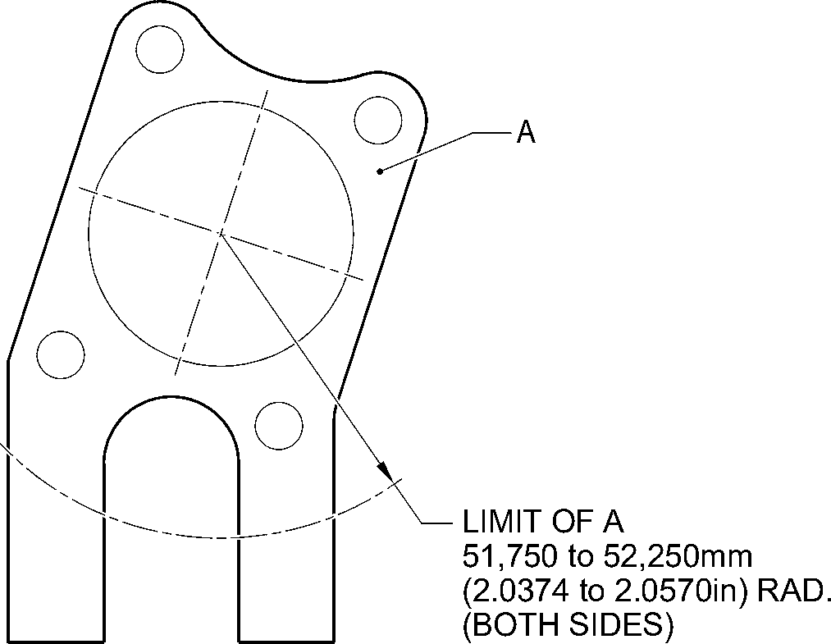

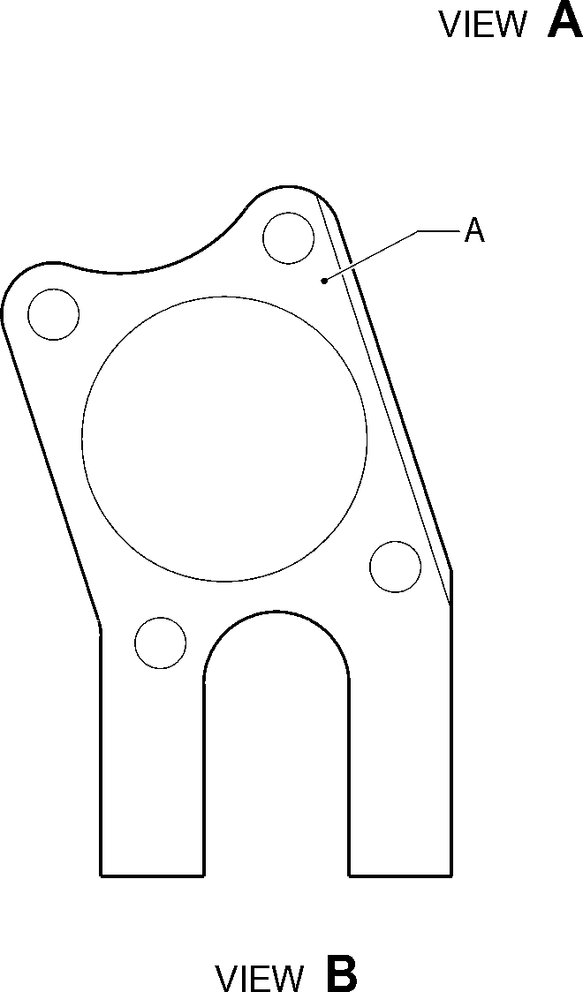

A321-T-32-12-22-102-0

Spacer (9-190) Only - Protective Treatment

Figure 645

32-12-22

Page 678

Mar 18/2025

**SAFRAN LANDING SYSTEMS UK Ltd**

CAGE: K0654



PART No. 201587001 AND 201587002 COMPONENT MAINTENANCE MANUAL  
MAIN LANDING GEAR LEG

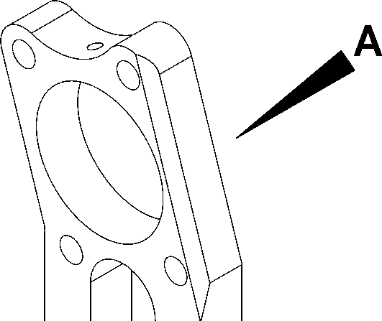

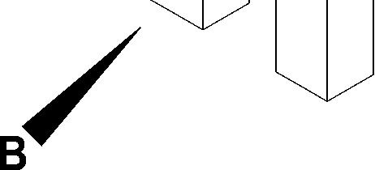

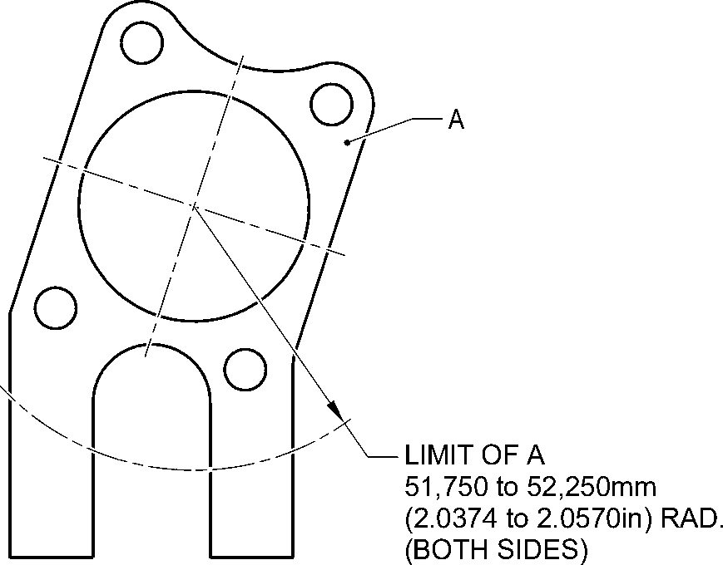

VIEW **A**

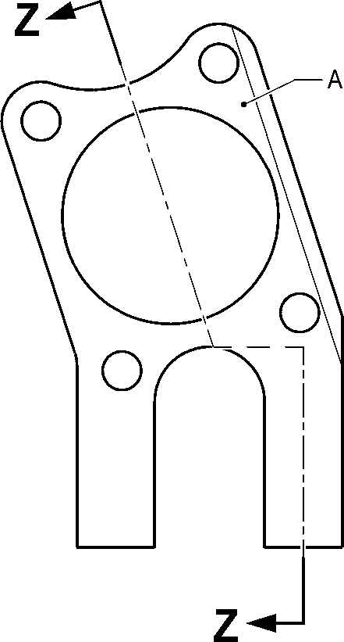

VIEW **B**

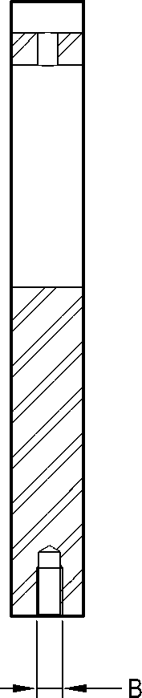

(2 PLACES)

SECTION **Z-Z**

A321-T-32-12-22-104-0

Spacer (9-190A) - Protective Treatment  
Figure 646

32-12-22

Page 679

Mar 18/2025

**SAFRAN LANDING SYSTEMS UK Ltd**

CAGE: K0654

PART No. 201587001 AND 201587002 COMPONENT MAINTENANCE MANUAL  
MAIN LANDING GEAR LEG

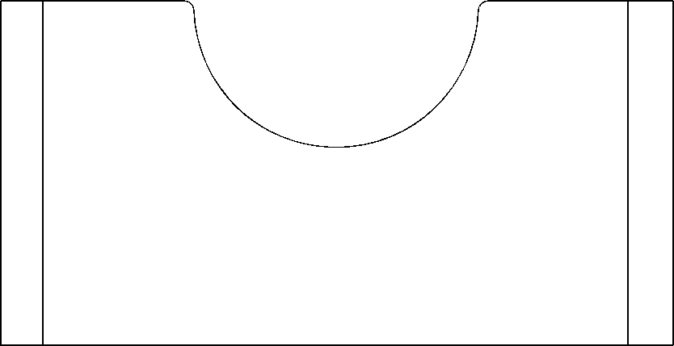

**A**

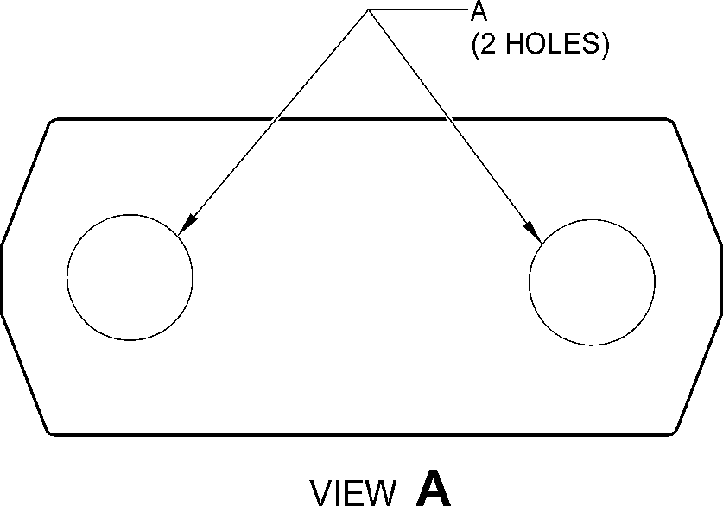

A321-T-32-12-22-101-0

Spacer (11-30) - Protective Treatment

Figure 647

32-12-22

Page 680

Mar 18/2025

**SAFRAN LANDING SYSTEMS UK Ltd**

CAGE: K0654

PART No. 201587001 AND 201587002 COMPONENT MAINTENANCE MANUAL  
MAIN LANDING GEAR LEG

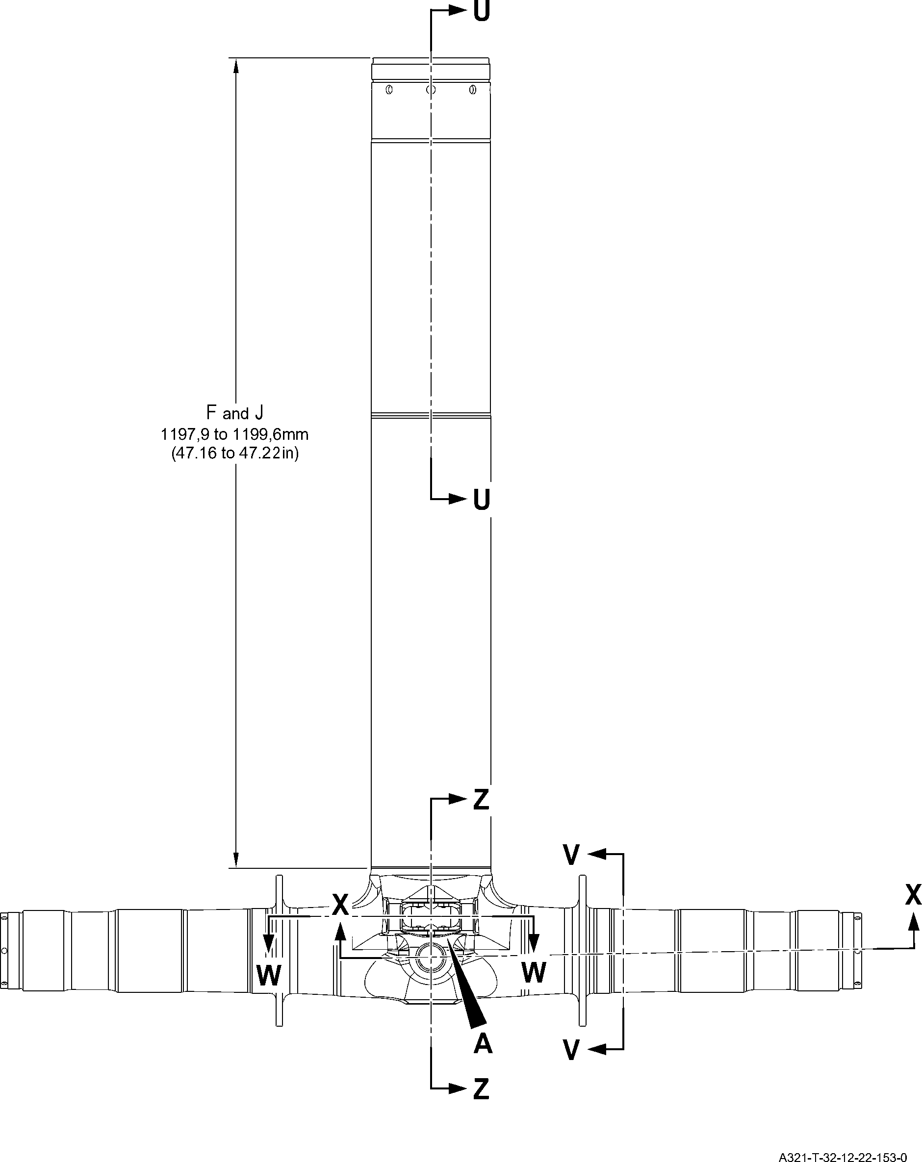

Sliding tube (18-80D, 18-80E, 18-80F and 18-80G) - Protective Treatment

Figure 648 - Sheet 1

32-12-22

Page 681

Mar 18/2025

**SAFRAN LANDING SYSTEMS UK Ltd**

CAGE: K0654

PART No. 201587001 AND 201587002 COMPONENT MAINTENANCE MANUAL  
MAIN LANDING GEAR LEG

**C**

**Y**

**Y**

C and G

17,750 to 18,250mm  
(0.6988 to 0.7185in)

C and G

71,750 to 72,250mm  
(2.8248 to 2.8444in) DIA.

16,750 to 17,250mm  
(0.6595 to 0.6791in)

C and J

SECTION **Z-Z**

KNUCKLE BORES

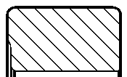

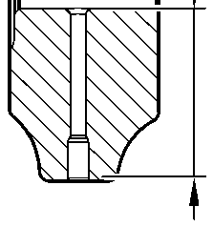

F and J  
TYPICAL  
2 PLACES

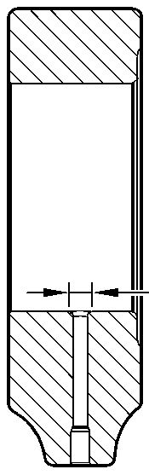

SECTION **Y-Y**

KNUCKLE TOOLING LUG  
GREASE HOLES

**D**

F and H  
TYPICAL  
2 PLACES  
INCLUDING

RADIUS

D

19,500 to 20,500mm  
(0.7677 to 0.8070in)

A and J  
119,929 to 119,964mm  
(4.7216 to 4.7229in) DIA.

A and J  
126,917 to 126,957mm  
(4.9967 to 4.9982in) DIA.

**G**

G

220,000mm  
(8.6614in) MIN.

A and J

131,294 to 131,357mm  
(5.1690 to 5.1715in) DIA.

limit of D  
25,000mm  
(0.9842in) DIA. MAX.

12 PLACES

95,500 to 107,500mm  
(3.7598 to 4.2323in)  
EXTERNAL THICK ZINC-NICKEL  
PLATING LIMIT

84,000 to 96,000mm  
(3.3071 to 3.7795in)

INTERNAL THICK ZINC-NICKEL  
PLATING LIMIT

SECTION **X-X**(BOTH SIDES)  
AXLE BORE

A321-T-32-12-22-154-0

Sliding tube (18-80D, 18-80E, 18-80F and 18-80G) - Protective Treatment

Figure 648 - Sheet 2

32-12-22

Page 682

Mar 18/2025

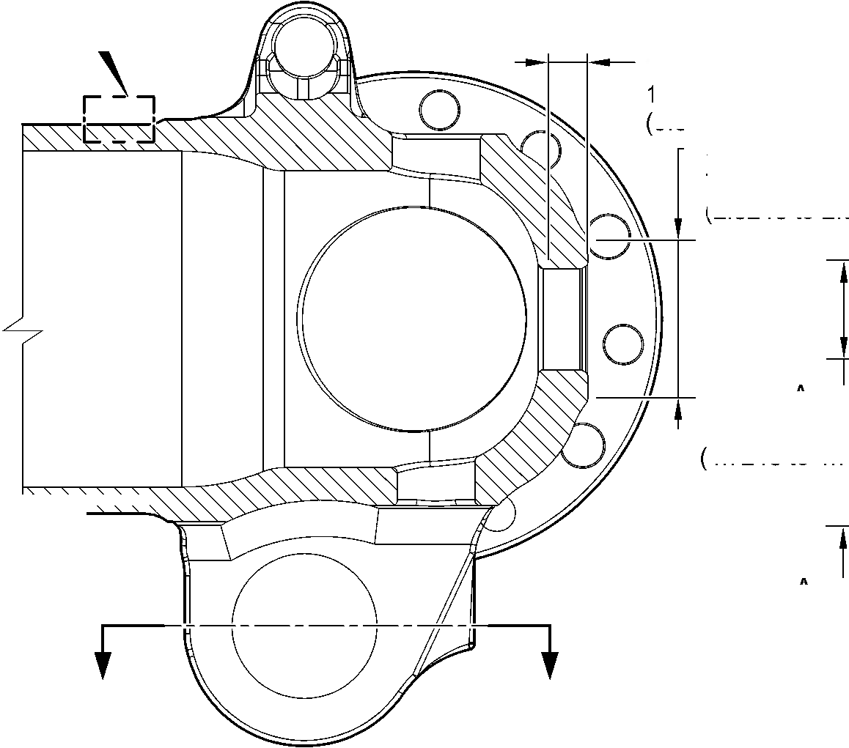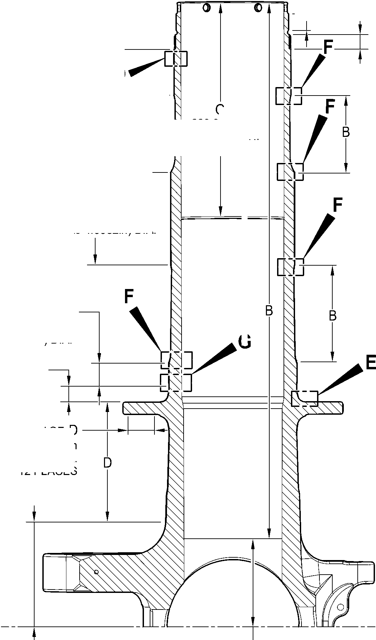

**SAFRAN LANDING SYSTEMS UK Ltd**

CAGE: K0654

PART No. 201587001 AND 201587002 COMPONENT MAINTENANCE MANUAL  
MAIN LANDING GEAR LEG

J

5,000 to 7,000mm  
(0.1968 to 0.2755in)

TYPICAL 2 PLACES

19,000 to 21,000mm  
(0.7481 to 0.8267in)  
TYPICAL 2 PLACES

C and G  
TYPICAL  
2 PLACES

C and G  
23,400mm  
(0.9213in) MIN.  
TYPICAL 2 PLACES  
INCLUDING CHAMFER

C and G  
69,750 to 70,250mm  
(2.7461 to 2.7657in) DIA.

TYPICAL 2 PLACES

C and G  
81,750 to 82,250mm

(3. 2185 to 3. 2381 in) DIA.  
TYPICAL 2 PLACES

C and G  
38,750 to 39,250mm  
(1.5256 to 1.5453in) DIA.  
TYPICAL 2 PLACES

G

6,50 to 6,70mm  
(0.256 to 0.263in) DIA.

TYPICAL 4 PLACES

J  
13,000mm  
(0.5118in) DIA.  
SPOTFACE  
INCLUDING CHAMFER

VIEW **A**

A321-T-32-12-22-155-0

C and J

TYPICAL 12 PLACES

SECTION **W-W**

LUG BORES

G

30,750 to 31,250mm  
(1.2106 to 1.2303in) DIA.

SPOTFACE TYPICAL  
12 PLACES INCLUDING  
CHAMFER

SECTION **V-V**(BOTH SIDES)  
BRAKE FLANGE

Sliding tube (18-80D, 18-80E, 18-80F and 18-80G) - Protective Treatment

Figure 648 - Sheet 3

32-12-22

Page 683

Mar 18/2025

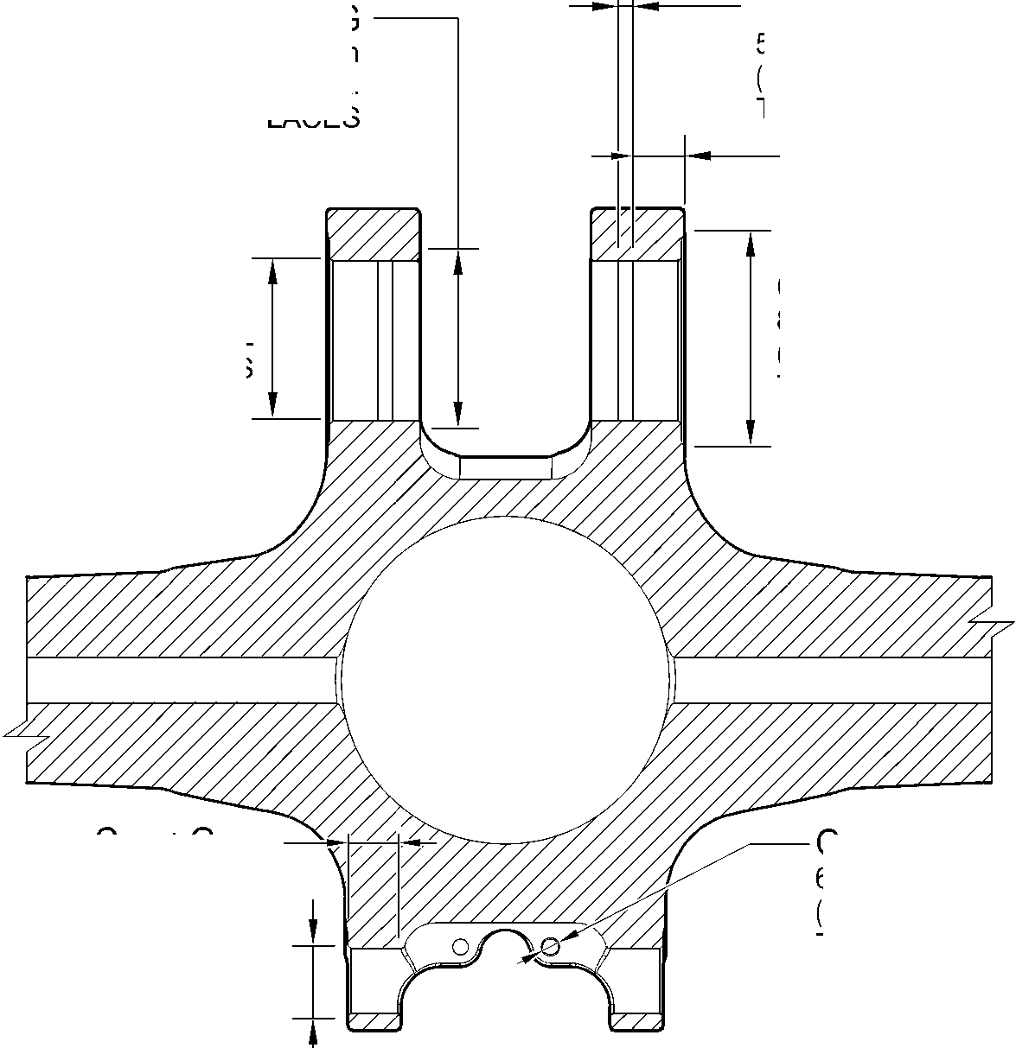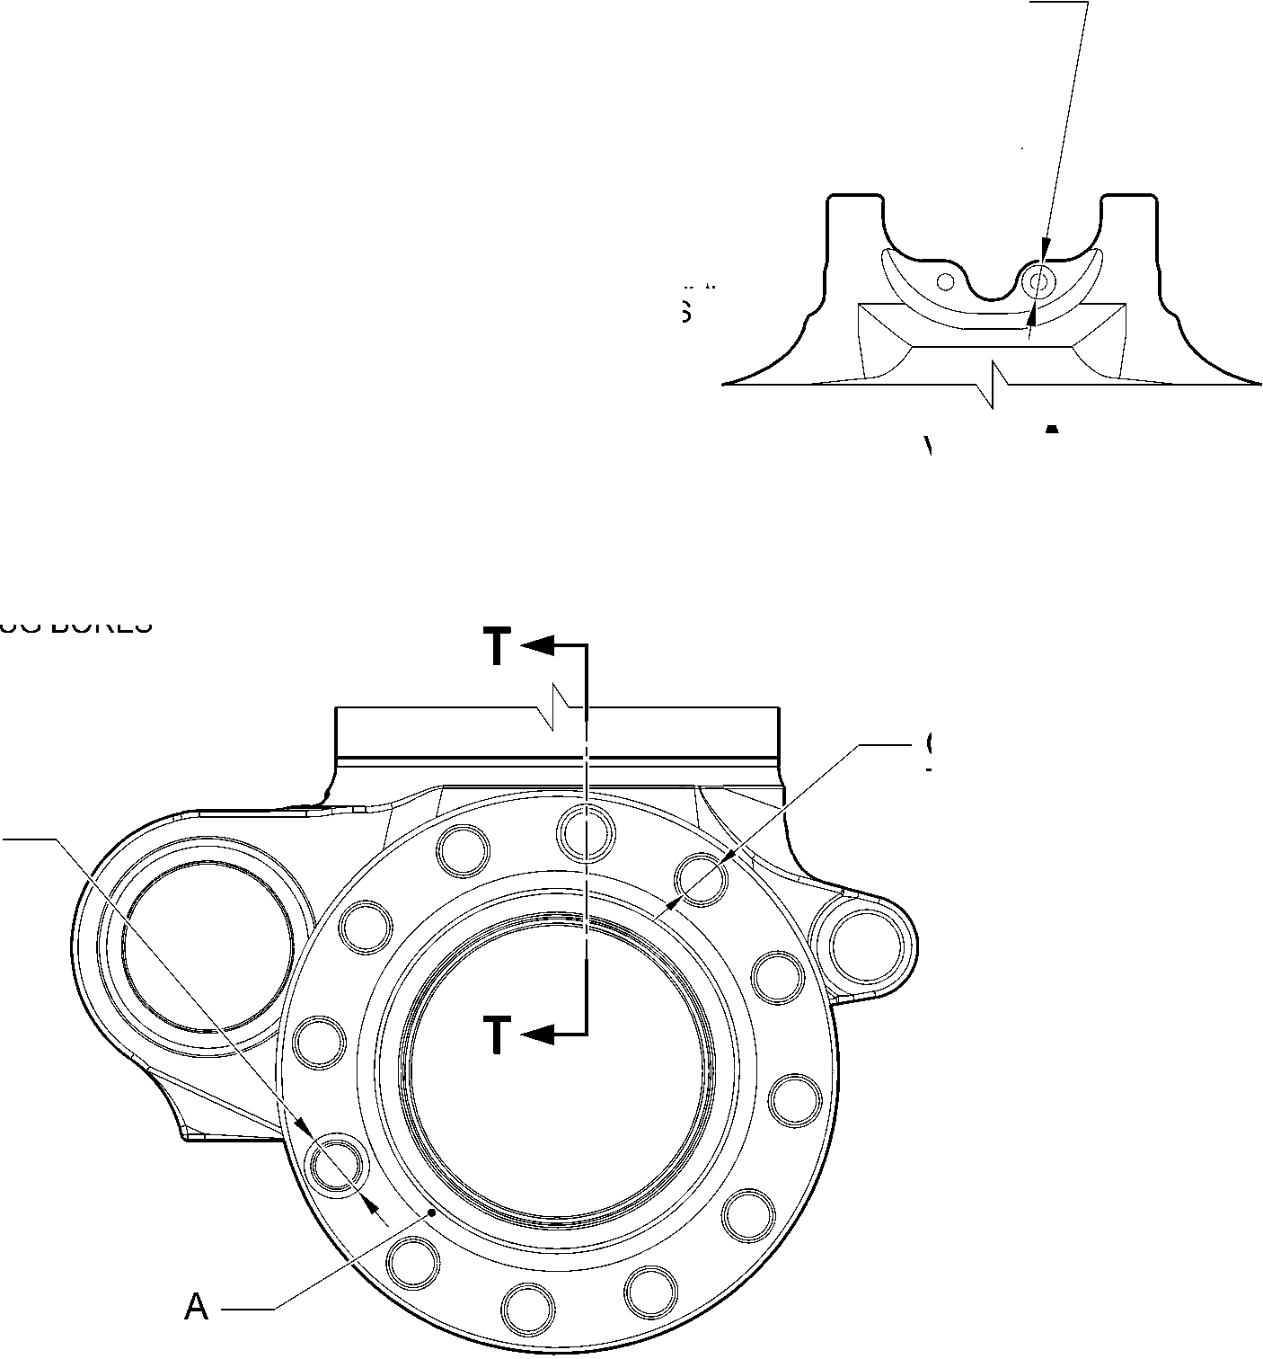

**SAFRAN LANDING SYSTEMS UK Ltd**

CAGE: K0654



PART No. 201587001 AND 201587002 COMPONENT MAINTENANCE MANUAL  
MAIN LANDING GEAR LEG

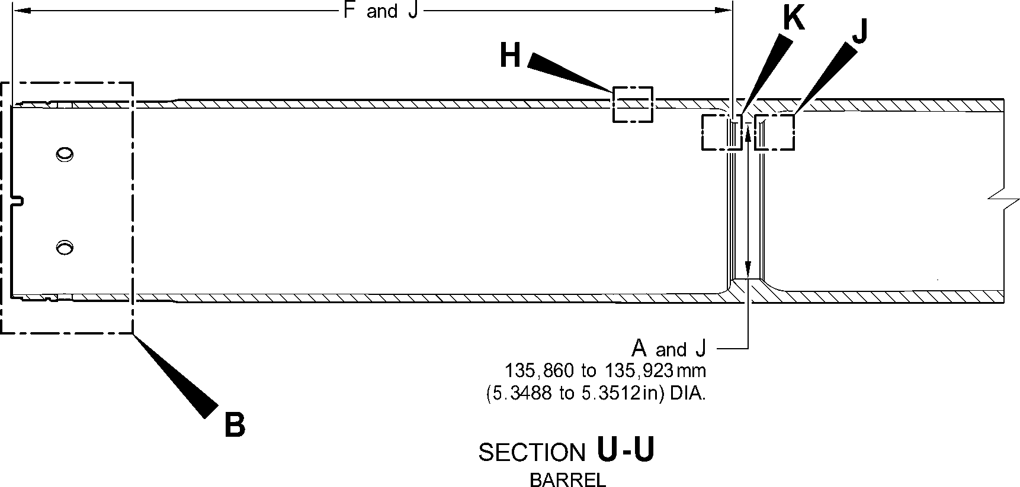

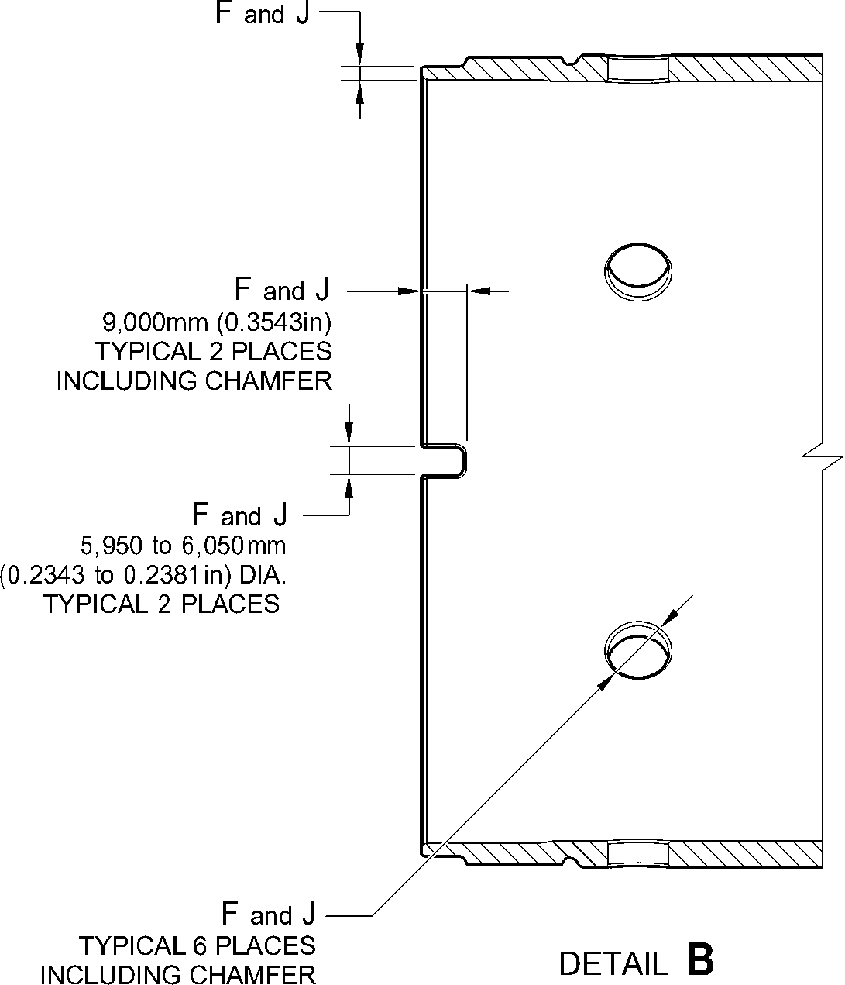

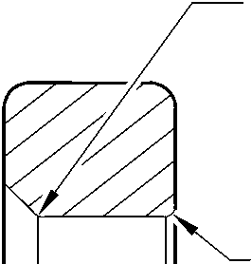

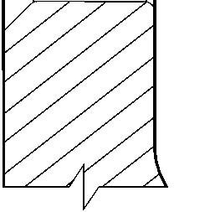

SECTION **T-T**

BRAKE FLANGE

TYPICAL 12 PLACES

A321-T-32-12-22-156-0

Sliding tube (18-80D, 18-80E, 18-80F and 18-80G) - Protective Treatment

Figure 648 - Sheet 4

32-12-22

Page 684

Mar 18/2025

**SAFRAN LANDING SYSTEMS UK Ltd**

CAGE: K0654

PART No. 201587001 AND 201587002 COMPONENT MAINTENANCE MANUAL  
MAIN LANDING GEAR LEG

FULL CHROME  
PLATING THICKNESS

RUN OUT BAND

2,000mm (0.0787in) MAX.

DIA. AFTER  
GRINDING CHROME

NO ZINC-NICKEL OR  
PAINT DEPOSIT TO REMAIN ON  
OR PROUD OF WORKING DIA.  
AFTER GRINDING CHROME

ZINC-NICKEL

DEPOSIT OVERLAP

PAINT DEPOSIT  
OVERLAP

EDGE BLENDED WITH  
A SMOOTH TRANSITION  
WAVY OR IRREGULAR

LINE PERMISSIBLE

DETAIL **C**

BARREL OUTER DIA. LOWER  
CHROME TERMINATION

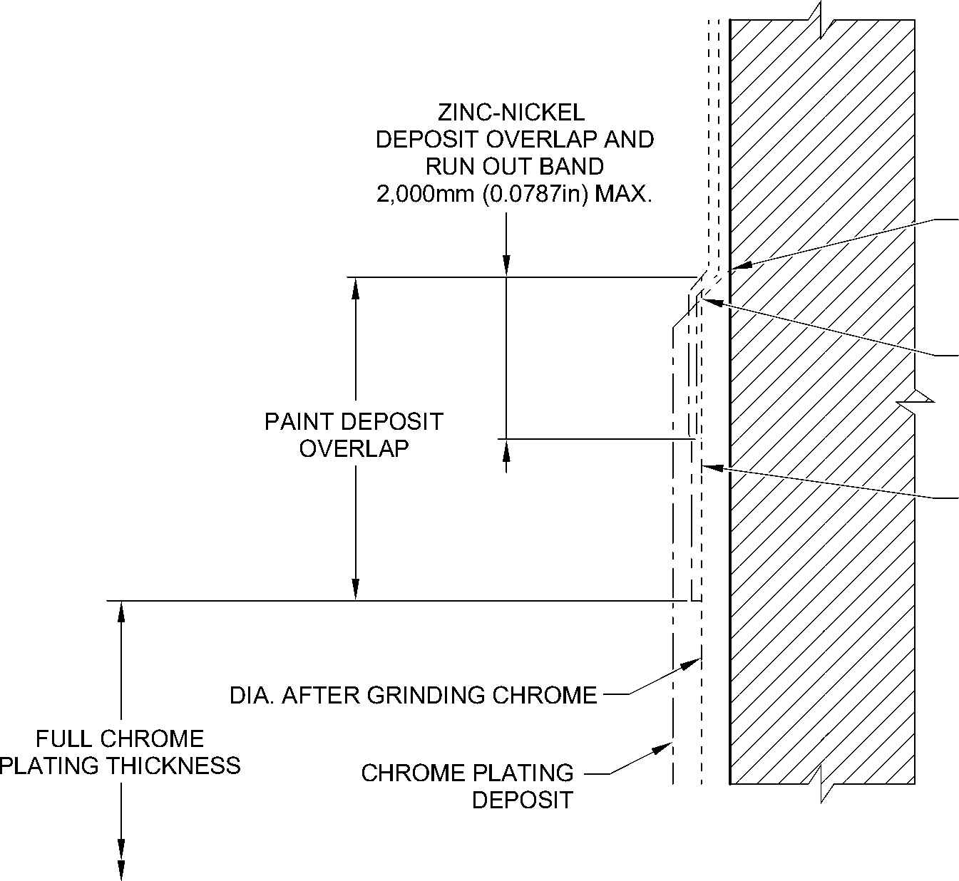

WAVY OR IRREGULAR  
LINE PERMISSIBLE

EDGE BLENDED WITH

A SMOOTH TRANSITION

NO ZINC-NICKEL OR PAINT  
DEPOSIT TO REMAIN ON OR  
PROUD OF WORKING DIA.  
AFTER GRINDING CHROME

DETAIL **D**

JOURNAL A OUTER CHROME TERMINATION

(TYPICAL)

A321-T-32-12-22-157-0

Sliding tube (18-80D, 18-80E, 18-80F and 18-80G) - Protective Treatment

Figure 648 - Sheet 5

32-12-22

Page 685

Mar 18/2025

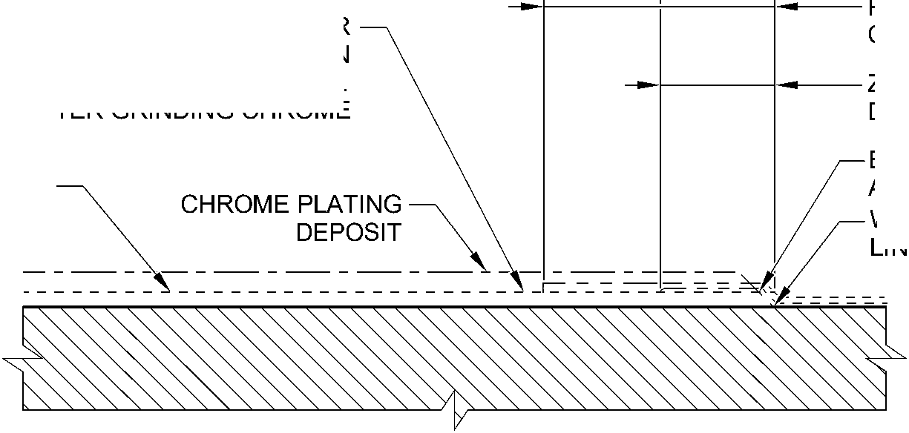

**SAFRAN LANDING SYSTEMS UK Ltd**

CAGE: K0654



PART No. 201587001 AND 201587002 COMPONENT MAINTENANCE MANUAL  
MAIN LANDING GEAR LEG

159,750 to 160,250mm  
(6.2894 to 6.3090in) DIA.

PAINT DEPOSIT OVERLAP  
157,750mm (6.2106) DIA.

MIN.

PAINT DEPOSIT OVERLAP

^ ^ 150,000mm (5.9054in) DIA.

MAX.

147,500 to 148,000mm  
(5.8071 to 5.8267in) DIA.

RUN OUT BAND  
0,000 to 2,000mm  
(0.000 to 0.0787in)

ZINC-NICKEL

DEPOSIT OVERLAP

NO ZINC-NICKEL OR  
PAINT ON THIS  
SURFACE

DIA. AFTER  
GRINDING CHROME

ZINC-NICKEL

DEPOSIT OVERLAP

RUN OUT BAND  
0,000 to 2,000mm  
(0.000 to 0.0787in)

DETAIL **E**

BREAK FLANGE FACE CHROME TERMINATION  
(TYPICAL)

ZINC-NICKEL

DEPOSIT OVERLAP

CHROME RUN OUT BAND  
(TO RADIUS INTERSECTION POINT)  
1,000 to 5,000mm (0.0394 to 0.1968in)

PAINT DEPOSIT  
OVERLAP

EDGE BLENDED WITH  
A SMOOTH TRANSITION

NO ZINC-NICKEL OR  
PAINT DEPOSIT TO REMAIN  
FULL CHROME ON OR PROUD OF WORKING DIA.  
PLATING THICKNESS AFTER GRINDING CHROME

CHROME PLATING

DEPOSIT

DETAIL **F**

WAVY OR IRREGULAR  
LINE PERMISSIBLE

DIA. AFTER

GRINDING CHROME

JOURNAL A,B,C CHROME TERMINATION  
(TYPICAL)

A321-T-32-12-22-158-0

Sliding tube (18-80D, 18-80E, 18-80F and 18-80G) - Protective Treatment

Figure 648 - Sheet 6

32-12-22

Page 686

Mar 18/2025

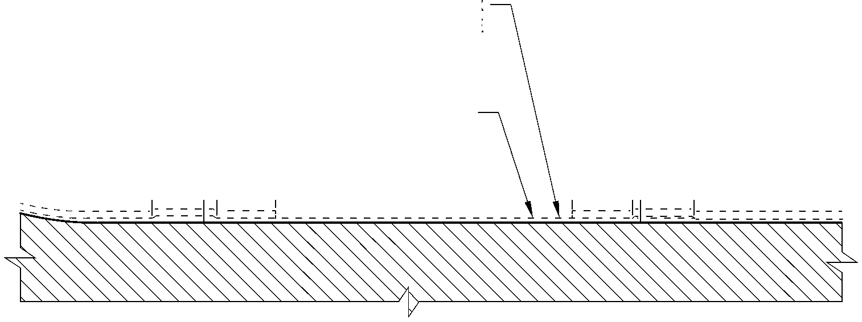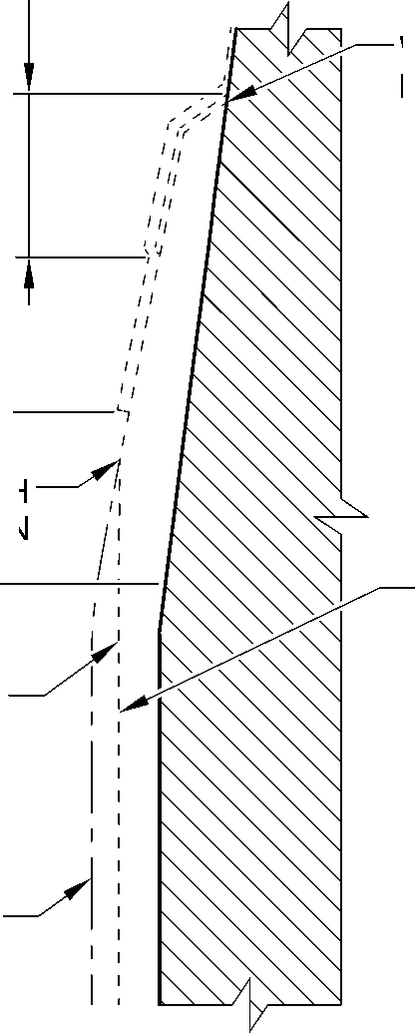

**SAFRAN LANDING SYSTEMS UK Ltd**

CAGE: K0654



PART No. 201587001 AND 201587002 COMPONENT MAINTENANCE MANUAL  
MAIN LANDING GEAR LEG

FULL CHROME  
PLATING THICKNESS

NO ZINC-NICKEL OR  
PAINT DEPOSIT TO REMAIN  
ON OR PROUD OF WORKING DIA.  
AFTER GRINDING CHROME

DIA. AFTER  
GRINDING CHROME

CHROME PLATING  
DEPOSIT

EDGE BLENDED WITH  
A SMOOTH TRANSITION

WAVY OR IRREGULAR  
LINE PERMISSIBLE

ZINC-NICKEL

DEPOSIT OVERLAP

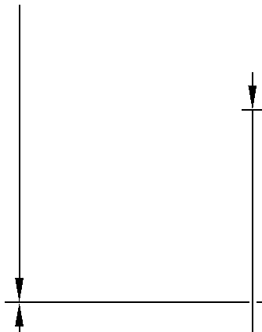

RUN OUT BAND  
2,000mm (0.0787in) MAX.

ZINC NICKEL PLATE

PAINT DEPOSIT  
OVERLAP

DETAIL **G**

JOURNAL C INNER CHROME TERMINATION  
(TYPICAL)

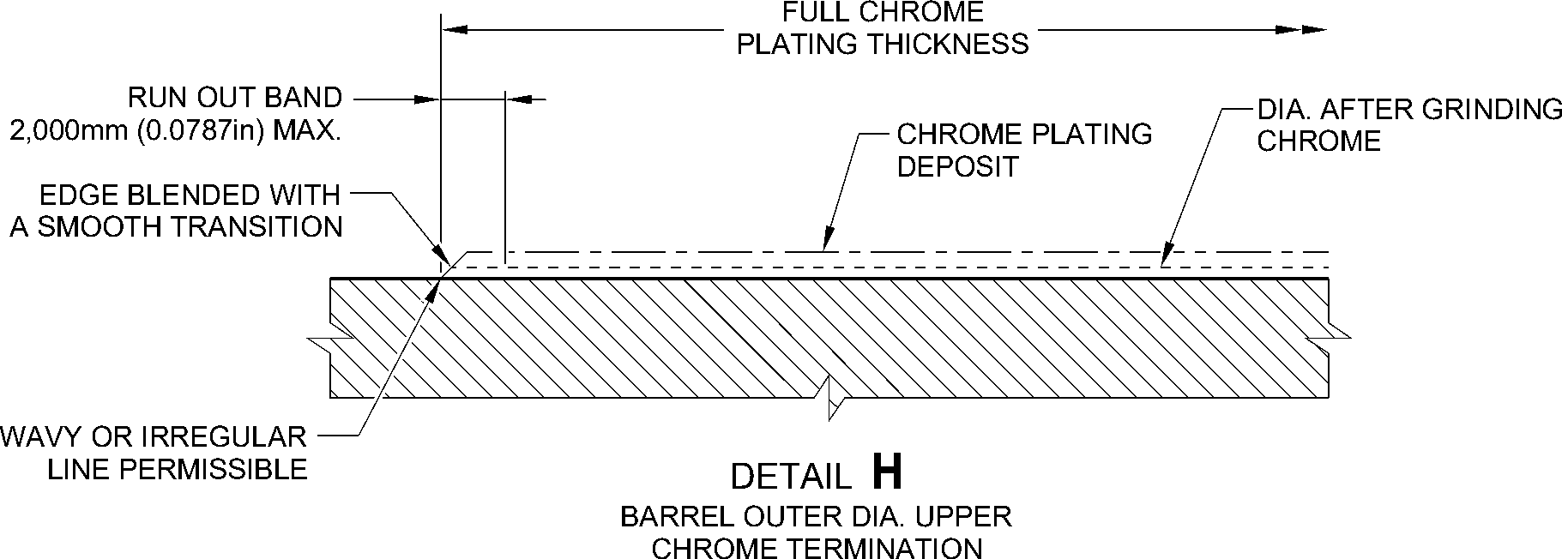

A321-T-32-12-22-159-0

Sliding tube (18-80D, 18-80E, 18-80F and 18-80G) - Protective Treatment

Figure 648 - Sheet 7

32-12-22

Page 687

Mar 18/2025

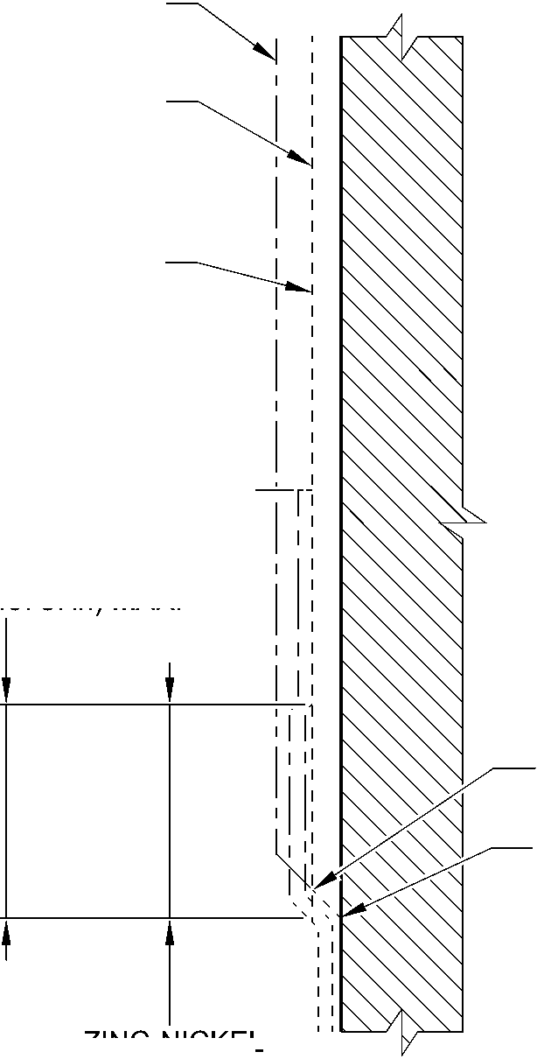

**SAFRAN LANDING SYSTEMS UK Ltd**

CAGE: K0654



PART No. 201587001 AND 201587002 COMPONENT MAINTENANCE MANUAL  
MAIN LANDING GEAR LEG

DIA. AFTER CHROME PLATING

NO ZINC-NICKEL OR  
PAINT DEPOSIT  
TO REMAIN ON WORKING DIA.  
AFTER CHROME PLATING

CHROME RUN OUT BAND  
(TO RADIUS INTERSECTION POINT)  
1,000 to 5,000mm (0.0394 to 0.1968in)

F and J  
WORKING DIA.  
26,000mm (1.0236in) MIN.  
(TO HPC ABUTMENT FACE)

PAINT DEPOSIT OVERLAP

ZINC-NICKEL

DEPOSIT OVERLAP

DETAIL **J**

HPC SEAL ABUTMENT LOWER  
CHROME TERMINATION

CHROME PLATING WILL  
TERMINATE ANYWHERE  
ON THE CHAMFER

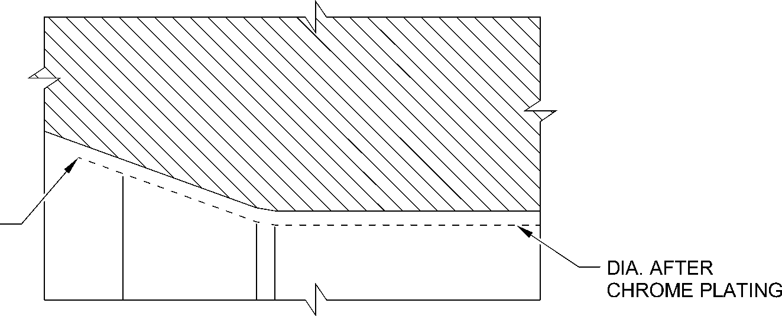

DETAIL **K**

HPC SEAL ABUTMENT UPPER  
CHROME TERMINATION

A321-T-32-12-22-160-0

Sliding tube (18-80D, 18-80E, 18-80F and 18-80G) - Protective Treatment

Figure 648 - Sheet 8

32-12-22

Page 688

Mar 18/2025

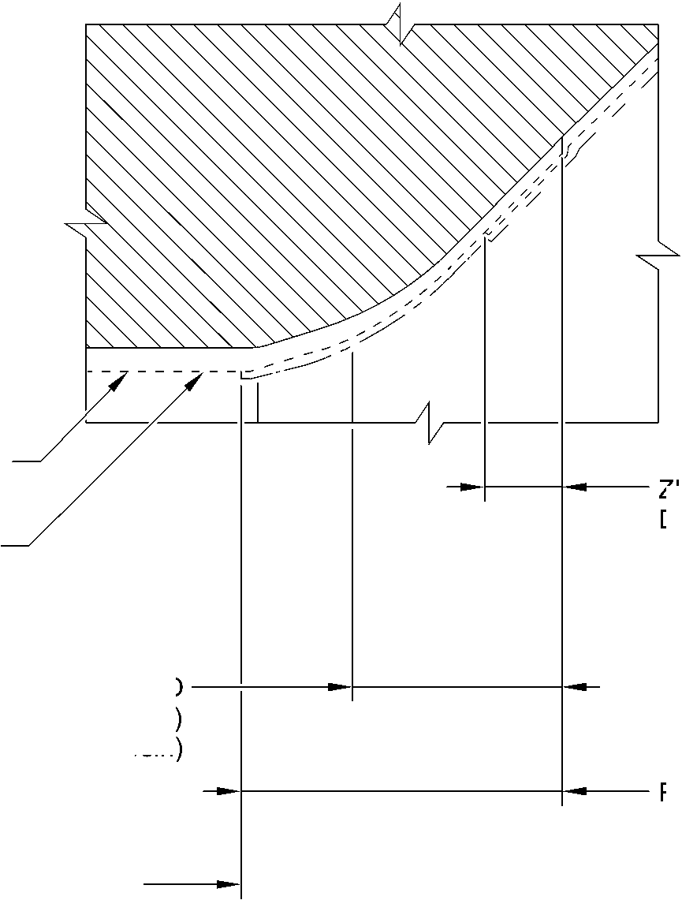

**SAFRAN LANDING SYSTEMS UK Ltd**

CAGE: K0654

PART No. 201587001 AND 201587002 COMPONENT MAINTENANCE MANUAL  
MAIN LANDING GEAR LEG

1. Approved Repairs

A. Refer to Figures 649 to 657 and Table 602.

Approved Repairs  
Table 602

|  |  |  |
| --- | --- | --- |
| Repair No. | Messier-Dowty Limited or Safran Landing Systems Repair No. | Applicable Part |
| 1-1 | 450237790 | Lower bearing subassembly (16-110) |
| 1-2 | 450237610 | Lower bearing subassembly (16-110) |
| 2-1 | 450217145 | Pin (13-190 and 13-190A) |
| 3-1 | 450217385 | Pivot pin (6-90) |
| 4-1 | 450237490 | Uplock pin (5-400) |
| 5-1 | 450217170 | Pin (3-50) |
| 6-1 | 450258420 | Pin (10-80) |
| 6-2 | 450258260 | Pin (10-80) |
| 6-3 | 450266211 | Pin (10-80) |
| 7-1 | 450258410 | Pin (11-130) |
| 7-2 | 450258430 | Pin (11-130) |
| 8-1 | 450217195 | Bracket (5-300) |
| 8-2 | 450217205 | Bracket (5-300) |
| 9-1 | 450258460 | Sliding tube (18-80 and 18-80A) |
| 9-2 | 450266100 | Sliding tube (18-80 and 18-80A) |
| 9-3 | 450258400 (Superseded) | Sliding tube (18-80) |
| 9-4 | 450266290 | Sliding tube (18-80 and 18-80A) |
| 9-5 | 450237720 | Sliding tube (18-80 and 18-80A) |
| 9-6 | 450258470 | Sliding tube (18-80 and 18-80A) |
| 9-7 | 450265140 | Sliding tube (18-80 and 18-80A) |
| 9-8 | 450266310 | Sliding tube (18-80 and 18-80A) |
| 9-9 | 450265180 | Sliding tube (18-80 and 18-80A) |
| 9-10 | 450258401 | Sliding tube (18-80 and 18-80A) |
| 9-11 | 450266295 | Sliding tube (18-80 and 18-80A) |
| 10-1 | 450266210 | Pin (9-70) |
| 11-1 | 450266060 | Main Fitting (20-410, 20-410A, 20-420 and 20-420A) |
| 11-2 | 450266070 | Main Fitting (20-410, 20-410A, 20-420 and 20-420A) |
| 11-3 | 450266020 | Main Fitting (20-410, 20-410A, 20-420 and 20-420A) |

32-12-22

Page 689

Mar 18/2025

**sSAFRAN SAFRAN LANDING SYSTEMS UK Ltd**

CAGE: K0654

PART No. 201587001 AND 201587002 COMPONENT MAINTENANCE MANUAL

MAIN LANDING GEAR LEG

Approved Repairs

Table 602 (Continued)

|  |  |  |
| --- | --- | --- |
| Repair No. | Messier-Dowty Limited or Safran Landing Systems Repair No. | Applicable Part |
| 11-4 | 450266075 | Main Fitting (20-410, 20-410A, 20-420 and 20-420A) |
| 11-5 | 450266080 | Main Fitting (20-410, 20-410A, 20-420 and 20-420A) |
| 11-6 | 450266085 | Main Fitting (20-410, 20-410A, 20-420 and 20-420A) |
| 11-7 | 450266045 | Main Fitting (20-410, 20-410A, 20-420 and 20-420A) |
| 11-8 | 450266010 | Main Fitting (20-410, 20-410A, 20-420 and 20-420A) |
| 11-9 | 450266030 | Main Fitting (20-410, 20-410A, 20-420 and 20-420A) |
| 11-10 | 450267270 (Withdrawn) | Main Fitting (20-410 and 20-420 Only) |
| 11-11 | 450266015 | Main Fitting (20-410, 20-410A, 20-420 and 20-420A) |
| 11-12 | 450266035 | Main Fitting (20-410, 20-410A, 20-420 and 20-420A) |
| 11-13 | 450266050 | Main Fitting (20-410, 20-410A, 20-420 and 20-420A) |
| 11-14 | 450266110 | Main Fitting (20-410, 20-410A, 20-420 and 20-420A) |
| 11-15 | 450267230 | Main Fitting (20-410 and 20-420 Only) |
| 11-16 | 450237690 | Main Fitting (20-410 and 20-420 Only) |
| 11-17 | 450237695 | Main Fitting (20-410, 20-410A, 20-420 and 20-420A) |
| 11-18 | 450217235 | Main Fitting (20-410, 20-410A, 20-420 and 20-420A) |
| 11-19 | 450258210 | Main Fitting (20-410, 20-410A, 20-420 and 20-420A) |
| 11-20 | 450265100 (Withdrawn) | Main Fitting (20-410 and 20-420 Only) |
| 11-21 | 450258230 | Main Fitting (20-410, 20-410A, 20-420 and 20-420A) |
| 11-22 | 450266450 | Main Fitting (20-410, 20-410A, 20-420 and 20-420A) |
| 11-23 | 450266400 | Main Fitting (20-410, 20-410A, 20-420 and 20-420A) |
| 11-24 | 450266390 | Main Fitting (20-410, 20-410A, 20-420 and 20-420A) |

32-12-22

Page 690

Mar 18/2025

**sSAFRAN SAFRAN LANDING SYSTEMS UK Ltd**

CAGE: K0654

PART No. 201587001 AND 201587002 COMPONENT MAINTENANCE MANUAL

MAIN LANDING GEAR LEG

Approved Repairs

Table 602 (Continued)

|  |  |  |
| --- | --- | --- |
| Repair No. | Messier-Dowty Limited or Safran Landing Systems Repair No. | Applicable Part |
| 11-25 | 450266395 | Main Fitting (20-410, 20-410A, 20-420 and 20-420A) |
| 11-26 | 450267370 | Main Fitting (20-410 and 20-420 Only) |
| 11-27 | 450266040 | Main Fitting (20-410, 20-410A, 20-420 and 20-420A) |
| 11-28 | 450266405 | Main Fitting (20-410, 20-410A, 20-420 and 20-420A) |
| 11-29 | 450267275 | Main Fitting (20-410A and 20-420A Only) |
| 11-30 | 450267385 | Main Fitting (20-410A and 20-420A Only) |
| 11-31 | 64-4505236-00 | Main Fitting (20-410B, 20-410C, 20-410D, 20-420B, 20-420C and 20-420D) |
| 11-32 | 64-4505233-00 | Main Fitting (20-410B, 20-410C, 20-410D, 20-420B, 20-420C and 20-420D) |
| 11-33 | 64-4505109-00 | Main Fitting (20-410B, 20-410C, 20-410D, 20-420B, 20-420C and 20-420D) |
| 11-34 | 64-4505112-00 | Main Fitting (20-410B, 20-410C, 20-410D, 20-420B, 20-420C and 20-420D) |
| 11-35 | 64-4505111-00 | Main Fitting (20-410B, 20-410C, 20-410D, 20-420B, 20-420C and 20-420D) |
| 11-36 | 64-4505234-00 | Main Fitting (20-410B, 20-410C, 20-410D, 20-420B, 20-420C and 20-420D) |
| 11-37 | 64-4505126-00 | Main Fitting (20-410B, 20-410C, 20-410D, 20-420B, 20-420C and 20-420D) |
| 12-1 | 450266350 | Lower Torque Link (11-240) |
| 12-2 | 450266340 | Upper Torque Link (10-260) |
| 12-3 | 450266345 | Upper Torque Link (10-260) |
| 12-4 | 450266355 | Lower Torque Link (11-240) |
| 12-5 | 450266525 | Upper Torque Link (10-260) |
| 13-1 | 450266215 | Upper Slave Link (6-230 and 6-230A) |

32-12-22

Page 691

Mar 18/2025

**sSAFRAN SAFRAN LANDING SYSTEMS UK Ltd**

CAGE: K0654

PART No. 201587001 AND 201587002 COMPONENT MAINTENANCE MANUAL

MAIN LANDING GEAR LEG

Approved Repairs

Table 602 (Continued)

|  |  |  |
| --- | --- | --- |
| Repair No. | Messier-Dowty Limited or Safran Landing Systems Repair No. | Applicable Part |
| 13-2 | 450266216 | Upper Slave Link (6-230 and 6-230A) |
| 14-1 | 450266255 | Upper Diaphragm Tube (15-390) |
| 14-2 | 450266285 | Upper Diaphragm Tube (15-390) |
| 14-3 | 450266430 | Upper Diaphragm Tube (15-390) |
| 14-4 | 64-4505141-00 | Upper Diaphragm Tube (15-390A) |
| 15-1 | 450266095 | Bracket (4-360) |
| 15-2 | 450266096 | Bracket (4-360) |
| 16-1 | 450266360 | Bracket (8-170) |
| 17-1 | 450266365 | Pivot Bracket (7-140) |
| 18-1 | 450237795 | Cylinder (17-230) |
| 18-2 | 450258320 | Cylinder (17-230) |
| 18-3 | 450237480 (Withdrawn) | Cylinder (17-230) |
| 18-4 | 450265290 | Cylinder (17-230) |
| 18-5 | 450266505 | Cylinder (17-230) |
| 18-6 | 450266425 | Cylinder (17-230) |
| 18-7 | 450267365 | Cylinder (17-230) |
| 18-8 | 64-4505242-00 | Cylinder (17-230A) |
| 19-1 | 450266104 | Lock Stay Cardan (3-170) |
| 19-2 | 450266105 | Lock Stay Cardan (3-170) |
| 20-1 | 450266270 | Lower Slave Link (6-310) |
| 21-1 | 450266410 | Transfer Block (2-340) Only |
| 21-2 | 450266415 | Transfer Block (2-340) Only |
| 21-3 | 450266420 | Transfer Block (2-340) Only |
| 21-4 | 450266411 | Transfer Block (2-350) Only |
| 21-5 | 450266416 | Transfer Block (2-350) Only |
| 21-6 | 450266421 | Transfer Block (2-350) Only |
| 22-1 | 450266520 | Spherical Bearing (19-50) |
| 23-1 | 450217290 | Pintle Pin (1-60) |
| 23-2 | 450258270 | Pintle Pin (1-60) |
| 24-1 | 450265230 | Harness Support Bracket (11-140) |
| 25-1 | 450266201 | Retaining Pin (13-10A) |
| 25-2 | 450266200 | Retaining Pin (13-10) |
| 26-1 | 450265250 | Upper Pivot Bracket (10-160) |

32-12-22

Page 692

Mar 18/2025

**SAFRAN LANDING SYSTEMS UK Ltd**

CAGE: K0654

PART No. 201587001 AND 201587002 COMPONENT MAINTENANCE MANUAL  
MAIN LANDING GEAR LEG

REPAIR No. 22-1

REPAIR No. 5-1

REPAIR No. 19-1 and 19-2

REPAIR No.

REPAIR No. 2-1

**A**

UPPER TORQUE LINK

REPAIR No.

REPAIR No.

REPAIR No. 10-1

REPAIR No.

REPAIR No. 20-1

UPPER PIVOT BRACKET  
REFER TO FIGURE 657

TRANSFER BLOCK  
REFER TO FIGURE 655

MAIN FITTING

REFER TO FIGURE 650

REPAIR No. 23-1  
and 23-2

15-1 and 15-2

00

REPAIR No. 8-1 and 8-2

DETAIL **A**

REPAIR No. 25-1 and 25-2

REPAIR No. 6-1, 6-2 and 6-3

REPAIR No. 17-1

REPAIR No. 3-1

13-2

1-1 and 1-2

13-1

LOWER TORQUE LINK

REPAIR No. 16-1

UPPER DIAPHRAGM TUBE

REFER TO FIGURE 653

SLIDING TUBE

REFER TO FIGURE 652

HARNESS SUPPORT BRACKET  
REFER TO FIGURE 656

CYLINDER

REFER TO FIGURE 654

REPAIR No. 4-1

A321-S-32-12-22-008-8

Approved Repairs - Key Diagram  
Figure 649

32-12-22

Page 693

Mar 18/2025

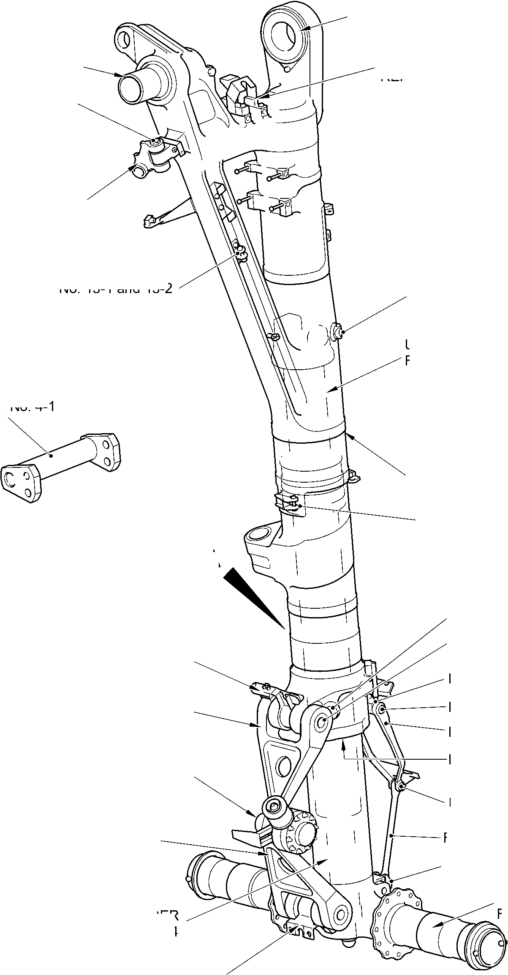

**SAFRAN LANDING SYSTEMS UK Ltd**

CAGE: K0654



PART No. 201587001 AND 201587002 COMPONENT MAINTENANCE MANUAL  
MAIN LANDING GEAR LEG

REPAIR No. 11-14, 11-25 and

11-33

REPAIR No. 11-13

REPAIR No. 11-27

REPAIR No. 11-1

REPAIR No. 11-2 and 11-35

REPAIR No. 11-4, 11-19 and 11-34

REPAIR No.11-6 and 11-20

REPAIR No. 11-21

and 11-24

REPAIR No. 11-31

REPAIR No. 11-11

REPAIR No. 11-22 and 11-36

REPAIR No. 11-12

REPAIR No. 11-9

REPAIR No. 11-5 and 11-18

REPAIR No.11-17

REPAIR No. 11-15 and 11-37

REPAIR No. 11-28

REPAIR No. 11-8

REPAIR No. 11-3, REPAIR 11-23 and 11-32

REPAIR No. 11-7

REPAIR No.11-10, 11-16, 11-26,  
11-29 and 11-30

A321-S-32-12-22-063-2

Main Fitting Repairs - Key Diagram  
Figure 650

32-12-22

Page 694

Mar 18/2025

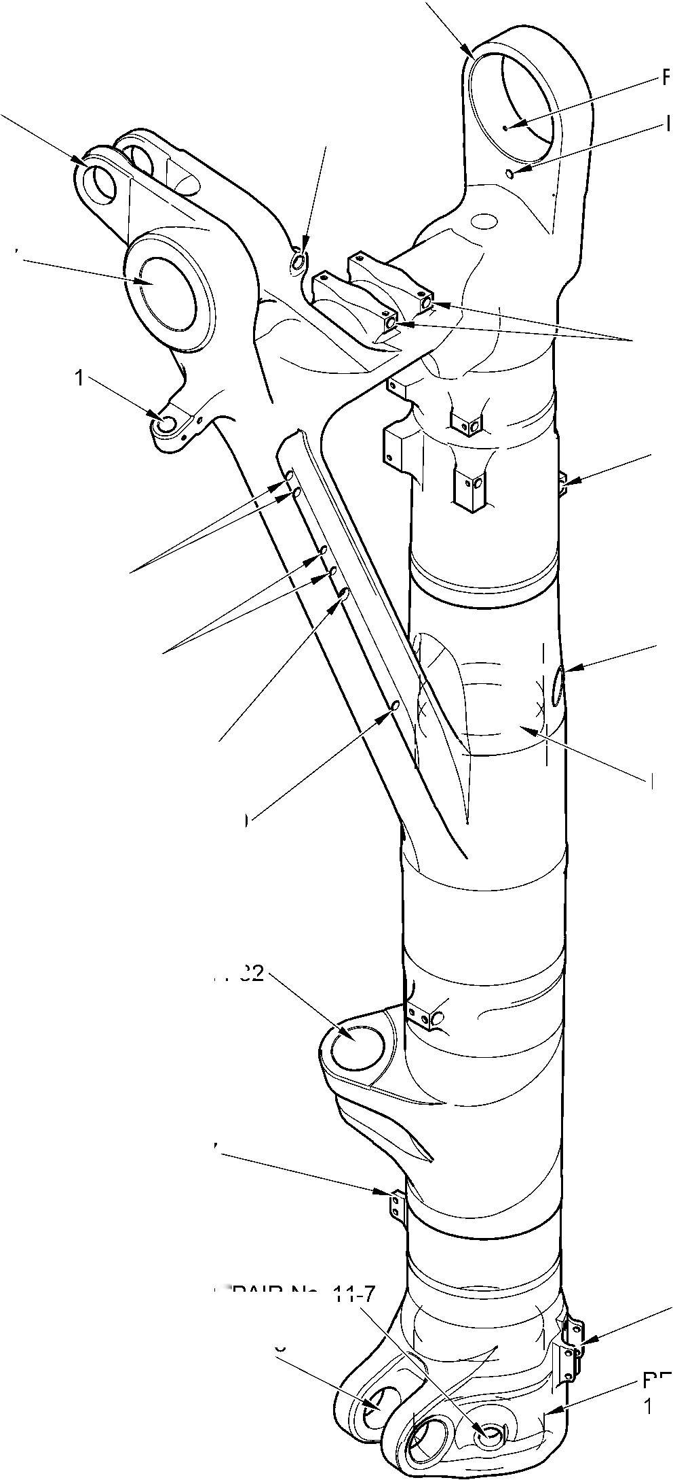

**SAFRAN LANDING SYSTEMS UK Ltd**

CAGE: K0654



PART No. 201587001 AND 201587002 COMPONENT MAINTENANCE MANUAL  
MAIN LANDING GEAR LEG

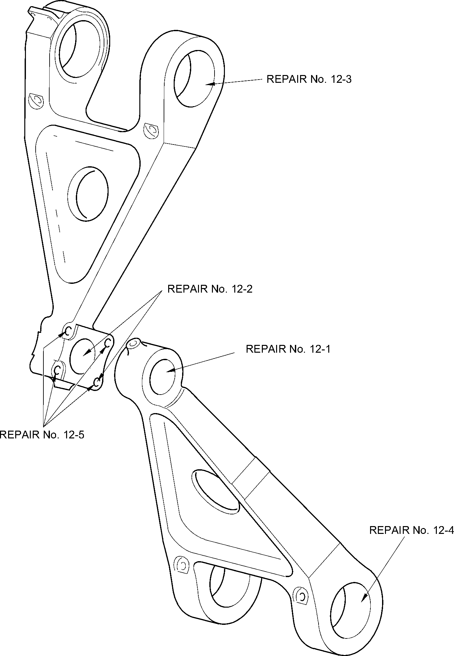

A321-S-32-12-22-029-1

Torque Link Repairs - Key Diagram  
Figure 651

32-12-22

Page 695

Mar 18/2025

**SAFRAN LANDING SYSTEMS UK Ltd**

CAGE: K0654



PART No. 201587001 AND 201587002 COMPONENT MAINTENANCE MANUAL  
MAIN LANDING GEAR LEG

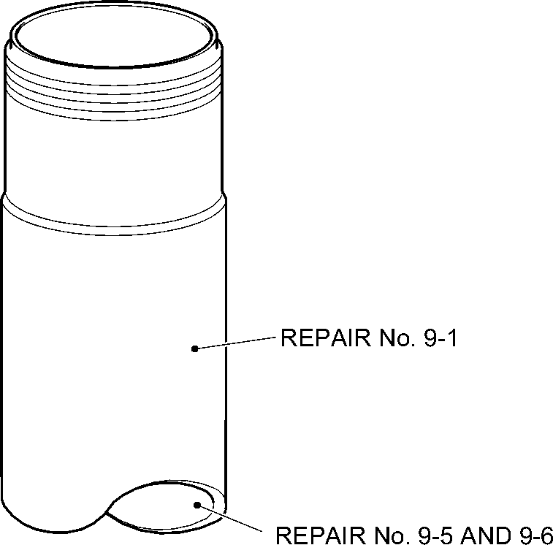

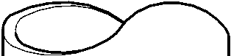

REPAIR No. 9-3 AND 9-10

REPAIR No.9-7

REPAIR No. 9-4

REPAIR No. 9-3 AND 9-10

REPAIR No. 9-8

REPAIR No. 9-9

REPAIR No. 9-11

A321-S-32-12-22-055-1

Sliding Tube Repairs - Key Diagram  
Figure 652

32-12-22

Page 696

Mar 18/2025

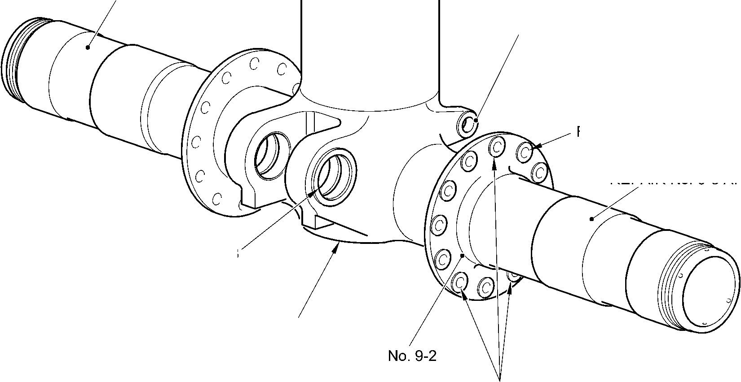

**SAFRAN LANDING SYSTEMS UK Ltd**

CAGE: K0654



PART No. 201587001 AND 201587002 COMPONENT MAINTENANCE MANUAL  
MAIN LANDING GEAR LEG

REPAIR No. 14-2

REPAIR No. 14-3 and 14-4

REPAIR No. 14-1

A321A5909-3

Upper Diaphragm Tube Repairs - Key Diagram

Figure 653

32-12-22

Page 697

Mar 18/2025

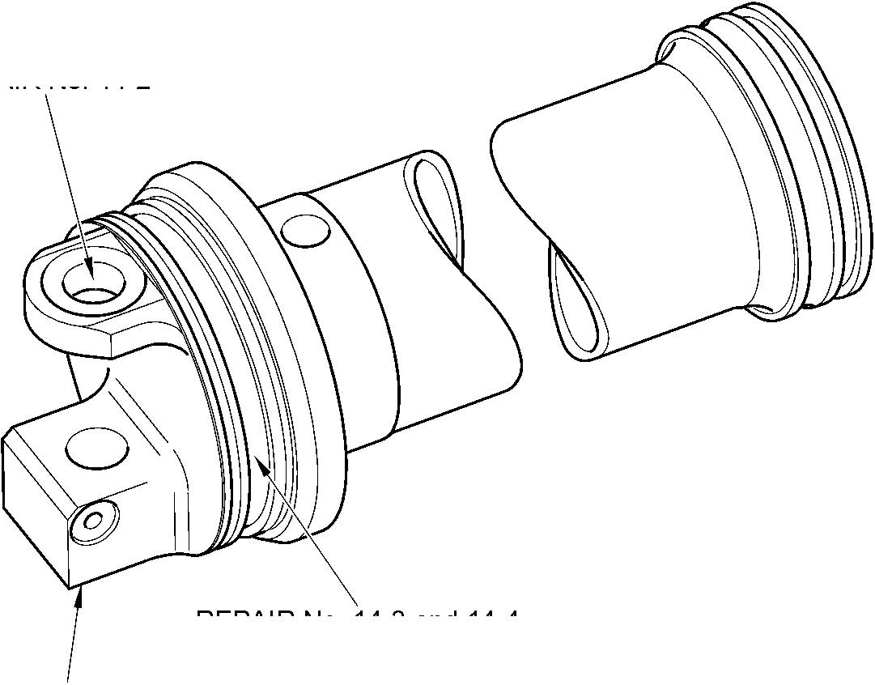

**SAFRAN LANDING SYSTEMS UK Ltd**

CAGE: K0654



PART No. 201587001 AND 201587002 COMPONENT MAINTENANCE MANUAL  
MAIN LANDING GEAR LEG

REPAIR No. 18-1

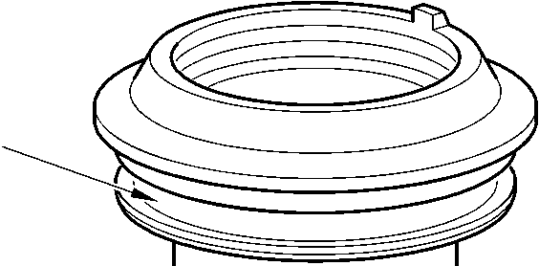



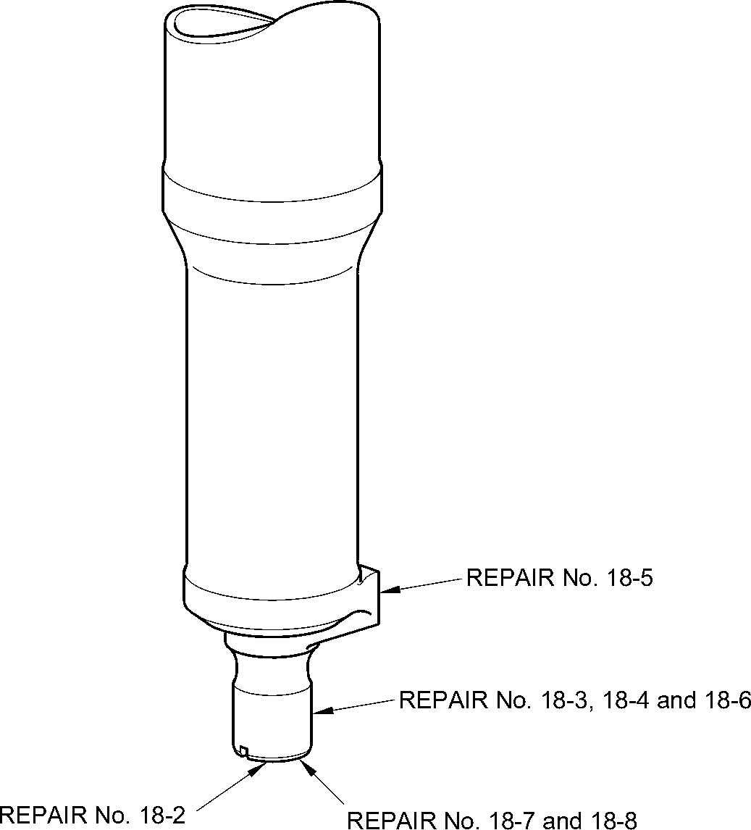

A321-S-32-12-22-043-2

Cylinder Repairs - Key Diagram  
Figure 654

32-12-22

Page 698

Mar 18/2025

**SAFRAN LANDING SYSTEMS UK Ltd**

CAGE: K0654



PART No. 201587001 AND 201587002 COMPONENT MAINTENANCE MANUAL  
MAIN LANDING GEAR LEG

REPAIR No. 21-3 and 21-6

REPAIR No. 21-1 and 21-4

REPAIR No. 21-2 and 21-5

A321-S-32-12-22-014-1

Transfer Block Repairs - Key Diagram  
Figure 655

32-12-22

Page 698.1

Mar 18/2025

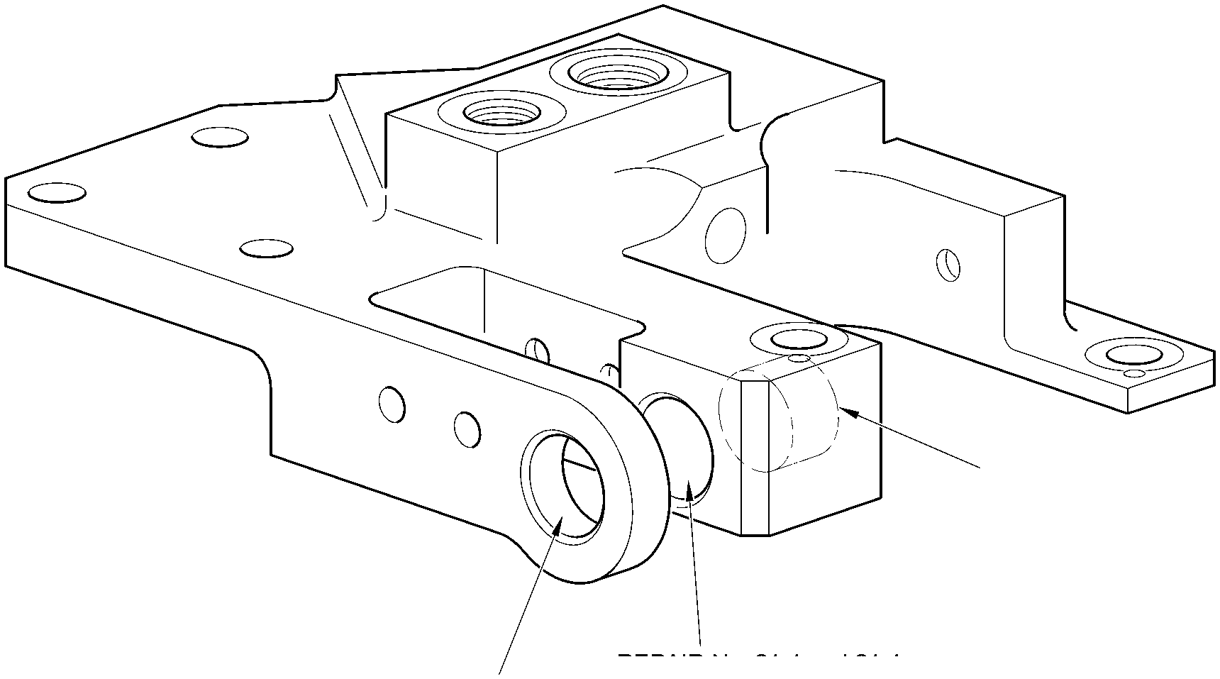

**SAFRAN LANDING SYSTEMS UK Ltd**

CAGE: K0654



PART No. 201587001 AND 201587002 COMPONENT MAINTENANCE MANUAL  
MAIN LANDING GEAR LEG

REPAIR No. 24-1

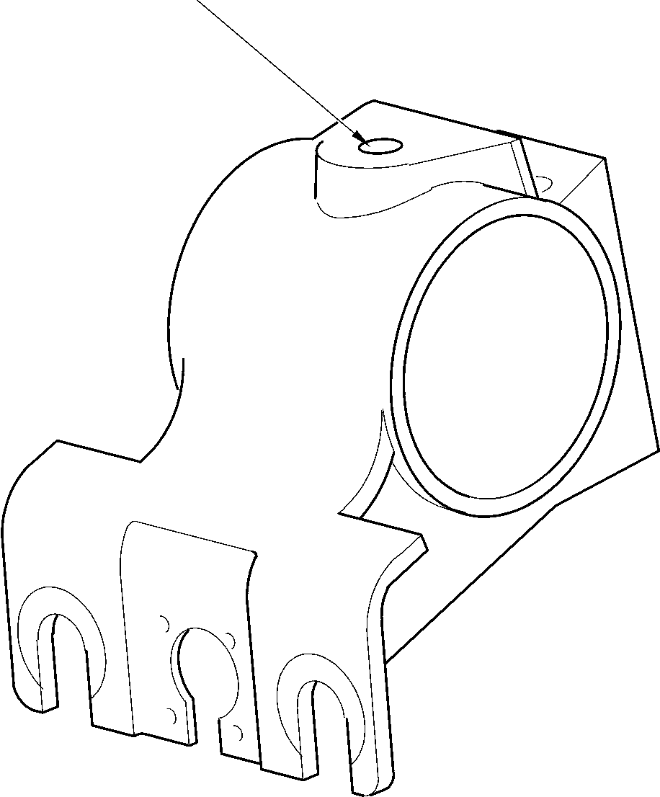

A321-S-32-12-22-007-0

Harness Support Bracket Repairs - Key Diagram  
Figure 656

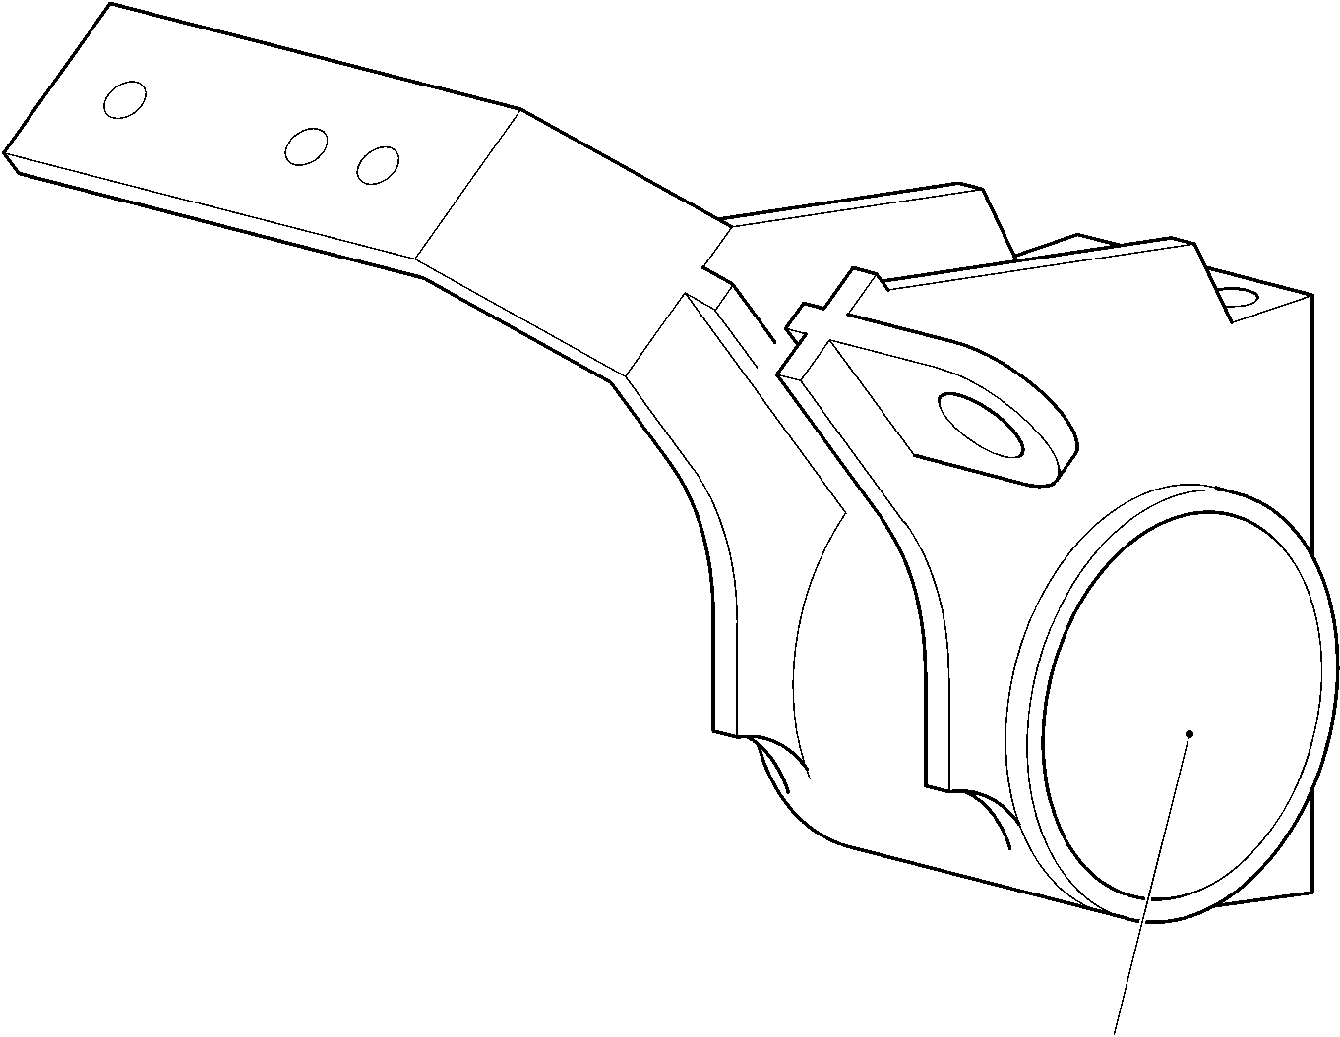

REPAIR No. 26-1

A321-S-32-12-22-057-0

Upper Pivot Bracket Repairs - Key Diagram  
Figure 657

32-12-22

Page 698.2

Mar 18/2025

**sSAFRAN SAFRAN LANDING SYSTEMS UK Ltd**

CAGE: K0654

PART No. 201587001 AND 201587002 COMPONENT MAINTENANCE MANUAL  
MAIN LANDING GEAR LEG

1. Repair No. 1-1 Lower Bearing Subassembly (16-110)
2. Specified Damage and Material Specification.
3. Specified Damage

(a) Damaged or loose liner.

1. Material Specification

|  |  |  |
| --- | --- | --- |
| IPL Figure and Item No. | Name | Material Specification |
| 16-140 | Gland housing | Aluminium Alloy, 2024T35 |

1. Special Tools
2. Special tools are not necessary.
3. Materials
4. These materials are necessary:

**NOTE: Alternative equivalents are permitted.**

|  |  |
| --- | --- |
| Ref. Item | Material |
| TBA | Accomet C |
| TBA | Adhesive PVC tape |
| TBA | Araldite, 2015 |
| TBA | Cleaning tissues |
| TBA | Emery cloth, 60-100 grit |
| 08-715 | Masking tape |
| 08-722 | Adhesive |
| 11-583 | Cleaning agent |
| 13-501 | Alocrom |

1. Repair Parts

(1) These repair parts are necessary:

|  |  |  |
| --- | --- | --- |
| Part No. | Repair Part | Material Specification |
| 450237823 | Repair liner | Fibreslip B40 |

1. Procedure (Refer to Figure 601)
2. Repair loose but undamaged liner:
3. Remove all of the adhesive from the external diameter of the gland housing and  
   the internal diameter of the liner: refer to CLEANING.

Repair No. 1-1

32-12-22

Page 601

Dec 6/2019

**sSAFRAN SAFRAN LANDING SYSTEMS UK Ltd**

CAGE: K0654

PART No. 201587001 AND 201587002 COMPONENT MAINTENANCE MANUAL  
MAIN LANDING GEAR LEG

1. Measure the diameter of the gland housing across the contact area: this must be  
   between 211,328 and 211,368 mm (8.3200 and 8.3215 in).
2. Temporarily put the liner in position on the gland housing. If necessary, cut the liner  
   at the scarf joints to adjust its length.
3. Remove the liner from the gland housing.
4. Clean the contact surfaces of the liner and the gland housing: use the cleaning  
   tissues, Material Ref. Item TBA, and the cleaning agent, Material Ref. Item 11-583.
5. Apply adhesive, Material Ref. Item 08-722, to the contact surface of the liner near  
   to the scarf joints: refer to M-DLPS724.
6. Assemble the liner to the gland housing.
7. Identify the part with the Messier-Dowty Limited repair number 450237790A  
   adjacent to the part number: refer to PCS-6000-05.
8. Examine the part to make sure that you have obeyed all the repair instructions  
   correctly.
9. Repair damaged liner:
10. Remove the damaged liner and remove all of the adhesive from the external  
    diameter of the gland housing: refer to CLEANING.
11. Machine the gland housing to the dimensions given in Figure 601 with a surface  
    finish of 3,2 micrometers (125 micro-inches).
12. Examine the gland housing for flaws: refer to M-DLNDT8.
13. Apply Alocrom, Material Ref. Item 13-501, to the machined areas: refer to  
    PCS-2220.
14. Temporarily put the repair liner in position on the gland housing. If necessary, cut  
    the repair liner at the scarf joints to adjust its length.
15. Apply adhesive PVC tape, Material Ref. Item TBA, around the gland housing to the  
    sides of and touching the repair liner. Make sure that the edges of the adhesive  
    PVC tape, Material Ref. Item TBA, bond tightly to the gland housing.
16. Remove the repair liner from the gland housing.
17. Use the Emery cloth, 60-100 grit, Material Ref. Item TBA, to roughen the surfaces  
    to be bonded. Do not damage the edges of the adhesive PVC tape, Material Ref.  
    Item TBA.
18. Use the cleaning agent, Material Ref. Item 11-583, and cleaning tissues, Material  
    Ref. Item TBA, to clean the roughened surfaces.
19. Preheat an oven to between 35 and 45 oC (95 and 113 oF).
20. Prepare a surface treatment mixture of 1 part by volume of Accomet C, Material  
    Ref. Item TBA, and 4 parts by volume of clean cold water.
21. Use a brush to apply a smooth layer of the prepared surface treatment mixture to  
    the contact surface of the gland housing.

32-12-22

Repair No. 1-1

Page 602

Dec 6/2019

**sSAFRAN SAFRAN LANDING SYSTEMS UK Ltd**

CAGE: K0654

PART No. 201587001 AND 201587002 COMPONENT MAINTENANCE MANUAL  
MAIN LANDING GEAR LEG

1. Put the gland housing in the preheated oven for a minimum of 4 minutes and until  
   the applied surface treatment mixture is dry.
2. Alternative procedure for paragraphs (j) to (m): apply Alocrom to the contact  
   surface of the gland housing: refer to PCS-2220, type 2.
3. Use a brush to apply Araldite, 2015, Material Ref. Item TBA, to the gland housing.
4. Assemble the repair liner to the gland housing and use masking tape, Material Ref.  
   Item 08-715, to hold it in that position. Use one layer of masking tape, Material  
   Ref. Item 08-715, at each side of the repair liner. The masking tape must be  
   sufficiently wide to bond to the repair liner and the adhesive PVC tape, Material  
   Ref. Item TBA: make sure the ends touch but do not overlap.
5. Clamp the repair liner to the gland housing using an applicable tool.
6. Put the gland housing in the preheated oven, kept at between 35 and 45 °C  
   (95 and 113 °F), for 345 to 375 minutes.
7. Remove the gland housing from the oven and allow to cool for a minimum of 30  
   minutes.
8. Machine the diameter and width of the repair liner to the dimensions given in  
   Figure 601 then remove the adhesive PVC tape, Material Ref. Item TBA.
9. Remove all of the tape and clean the parts as necessary.
10. Identify the part with the Messier-Dowty Limited repair number 450237790B  
    adjacent to the part number: refer to PCS-6000-05.
11. Examine the part to make sure that you have obeyed all the repair instructions  
    correctly.

Repair No. 1-1

Page 603

Dec 6/2019

32-12-22

**SAFRAN LANDING SYSTEMS UK Ltd**

CAGE: K0654



PART No. 201587001 AND 201587002 COMPONENT MAINTENANCE MANUAL  
MAIN LANDING GEAR LEG

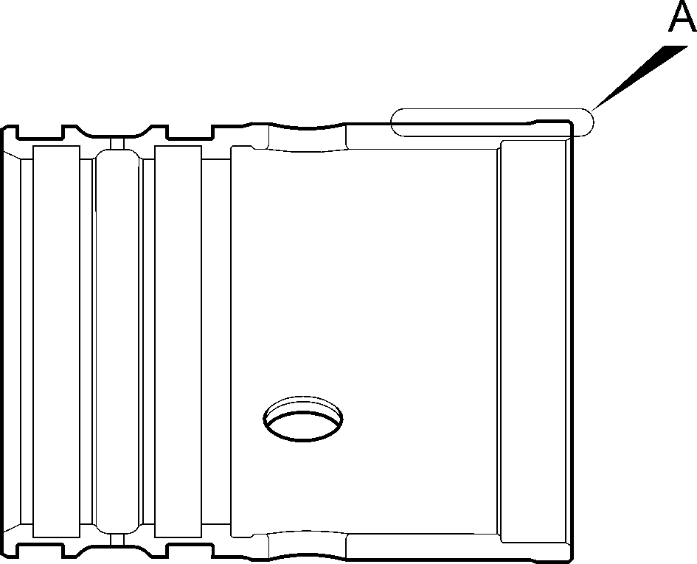

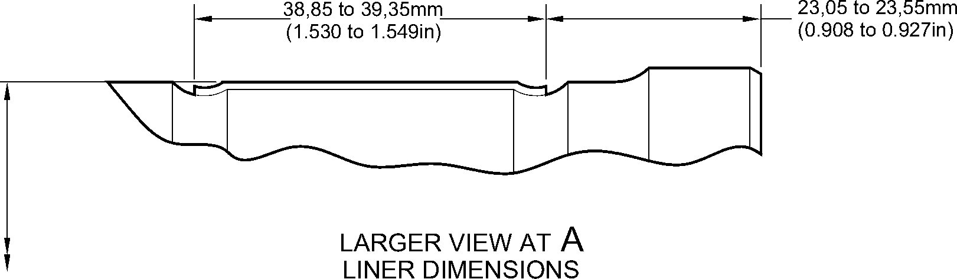

211,868 to 211,938mm  
(8.3413 to 8.3440in)

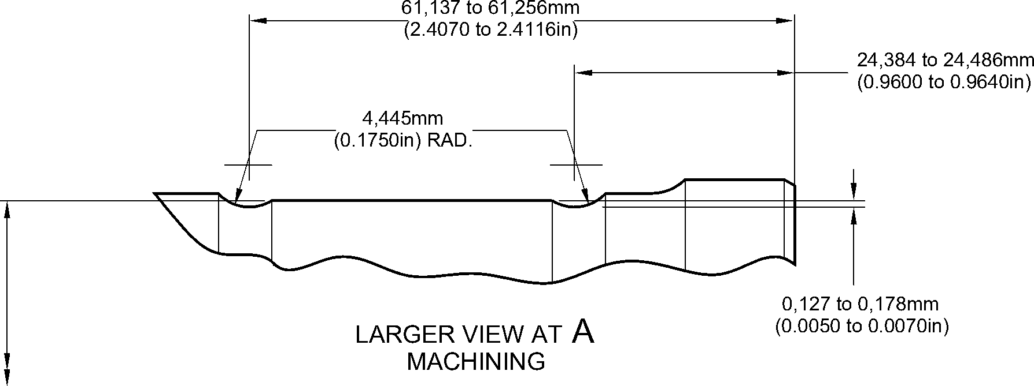

A3219685-1

210,795 to 210,845mm  
(8.2991 to 8.3009in)

Repair to Lower Bearing Subassembly  
Figure 601

32-12-22

Repair No. 1-1

Page 604

Dec 6/2019

**sSAFRAN SAFRAN LANDING SYSTEMS UK Ltd**

CAGE: K0654

PART No. 201587001 AND 201587002 COMPONENT MAINTENANCE MANUAL  
MAIN LANDING GEAR LEG

1. Repair No. 1-2 Lower Bearing Subassembly (16-110A)
2. Specified Damage and Material Specification.
3. Specified Damage

(a) Loose or damaged liner.

1. Material Specification

|  |  |  |
| --- | --- | --- |
| IPL Figure and Item No. | Name | Material Specification |
| 16-140 | Gland housing | Aluminium Alloy, 2024T35 |

1. Special Tools
2. Special tools are not necessary.
3. Materials
4. These materials are necessary:

**NOTE: Alternative equivalents are permitted.**

|  |  |
| --- | --- |
| Ref. Item | Material |
| TBA | Accomet C |
| TBA | Adhesive PVC tape |
| TBA | Araldite, 2015 |
| TBA | Cleaning tissues |
| TBA | Emery cloth, 60-100 grit |
| 08-715 | Masking tape |
| 08-722 | Adhesive |
| 11-583 | Cleaning agent |

1. Repair Parts
2. These repair parts are necessary:

|  |  |  |
| --- | --- | --- |
| Part No. | Repair Part | Material Specification |
| 450237823 | Repair liner | Fibreslip, B40 |

1. Procedure (Refer to Figure 601)
2. Repair loose but undamaged liner:
3. Remove the used adhesive from the external diameter of the gland housing and  
   the internal diameter of the liner: refer to CLEANING.
4. Put the liner in position on the gland housing. If necessary, cut the liner at the scarf  
   joints to adjust its length.
5. Remove the liner from the gland housing.

Repair No. 1-2

32-12-22

Page 601

Dec 6/2019

**SAFRAN LANDING SYSTEMS UK Ltd**

CAGE: K0654

**SSAFRAN**

PART No. 201587001 AND 201587002 COMPONENT MAINTENANCE MANUAL  
MAIN LANDING GEAR LEG

1. Clean the surfaces of the liner and the gland housing that will touch: use the  
   cleaning tissues, Material Ref. Item TBA and the cleaning agent, Material Ref.  
   Item 11-583.
2. Apply adhesive, Material Ref. Item 08-722, to the cleaned surface of the liner near  
   to the scarf joints: refer to M-DLPS724.
3. Assemble the liner to the gland housing.
4. Identify the part with the Messier-Dowty Limited repair number 450237610A  
   adjacent to the part number: refer to PCS-6000-05.
5. Examine the part to make sure that you have obeyed all the repair instructions  
   correctly.
6. Repair damaged liner:
7. Remove the damaged liner and remove the used adhesive from the external  
   diameter of the gland housing: refer to CLEANING.
8. Put the repair liner in position on the gland housing. If necessary, cut the repair  
   liner at the scarf joints to adjust its length.
9. Apply adhesive PVC tape, Material Ref. Item TBA, around the gland housing to the  
   sides of and touching the repair liner. Make sure that the edges of the adhesive  
   PVC tape, Material Ref. Item TBA, bond tightly to the gland housing.
10. Remove the repair liner from the gland housing.
11. Use the Emery cloth, 60-100 grit, Material Ref. Item TBA, to make rough, the  
    surfaces that will bond. Do not damage the edges of the adhesive PVC tape,  
    Material Ref. Item TBA.
12. Use the cleaning agent, Material Ref. Item 11-583, and cleaning tissues, Material  
    Ref. Item TBA, to clean the surfaces made rough.
13. Set the temperature of an oven to between 35 and 45 oC (95 and 113 oF).
14. Prepare a mixture of 1 part by volume of Accomet C, Material Ref. Item TBA, and  
    4 parts by volume of clean cold water.
15. Use a brush to apply a flat layer of the prepared mixture to the surfaces of the  
    gland housing made rough.
16. Put the gland housing in the oven for a minimum of 4 minutes and until the applied  
    mixture is dry.
17. Alternative procedure for paragraphs (g) to (j): apply Alocrom to the contact surface  
    of the gland housing: refer to PCS-2220, type 2.
18. Use a brush to apply Araldite, 2015, Material Ref. Item TBA, to the gland housing.
19. Assemble the repair liner to the gland housing and hold it tightly with the masking  
    tape, Material Ref. Item 08-715. Bond the masking tape, Material Ref. Item  
    08-715, to the adjacent adhesive PVC tape, Material Ref. Item TBA. Use one layer  
    of the masking tape, Material Ref. Item 08-715, only at each side of the repair liner:  
    make sure that the ends touch but do not overlap.
20. Use a clamp to attach the repair liner to the gland housing.
21. Put the gland housing in the oven, kept at between 35 and 45 oC (95 and 113 oF),  
    for 345 to 375 minutes.

Repair No. 1-2

Page 602

Dec 6/2019

**sSAFRAN SAFRAN LANDING SYSTEMS UK Ltd**

CAGE: K0654

PART No. 201587001 AND 201587002 COMPONENT MAINTENANCE MANUAL

MAIN LANDING GEAR LEG

1. Remove the gland housing from the oven and let its temperature decrease for a  
   minimum of 30 minutes.
2. Machine the diameter and width of the repair liner to the dimensions shown before  
   you remove the adhesive PVC tape, Material Ref. Item TBA.
3. Remove all of the tape and clean the parts as necessary.
4. Identify the part with the Messier-Dowty Limited repair number 450237610B  
   adjacent to the part number: refer to PCS-6000-05.
5. Examine the part to make sure that you have obeyed all the repair instructions  
   correctly.

Repair No. 1-2

32-12-22

Page 603

Dec 6/2019

**SAFRAN LANDING SYSTEMS UK Ltd**

CAGE: K0654



PART No. 201587001 AND 201587002 COMPONENT MAINTENANCE MANUAL  
MAIN LANDING GEAR LEG

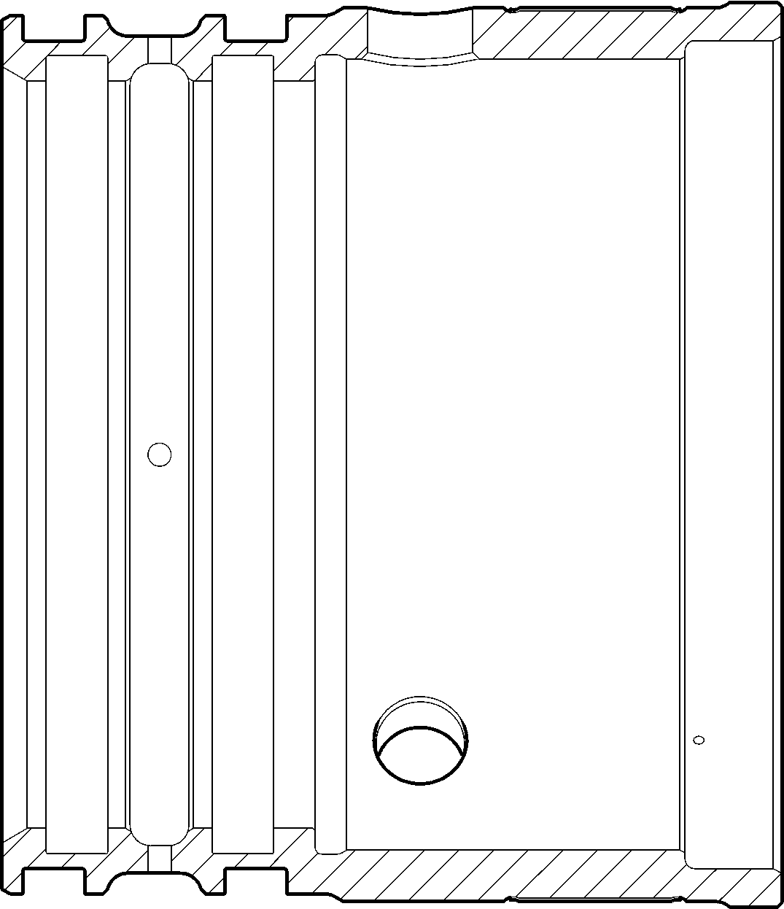

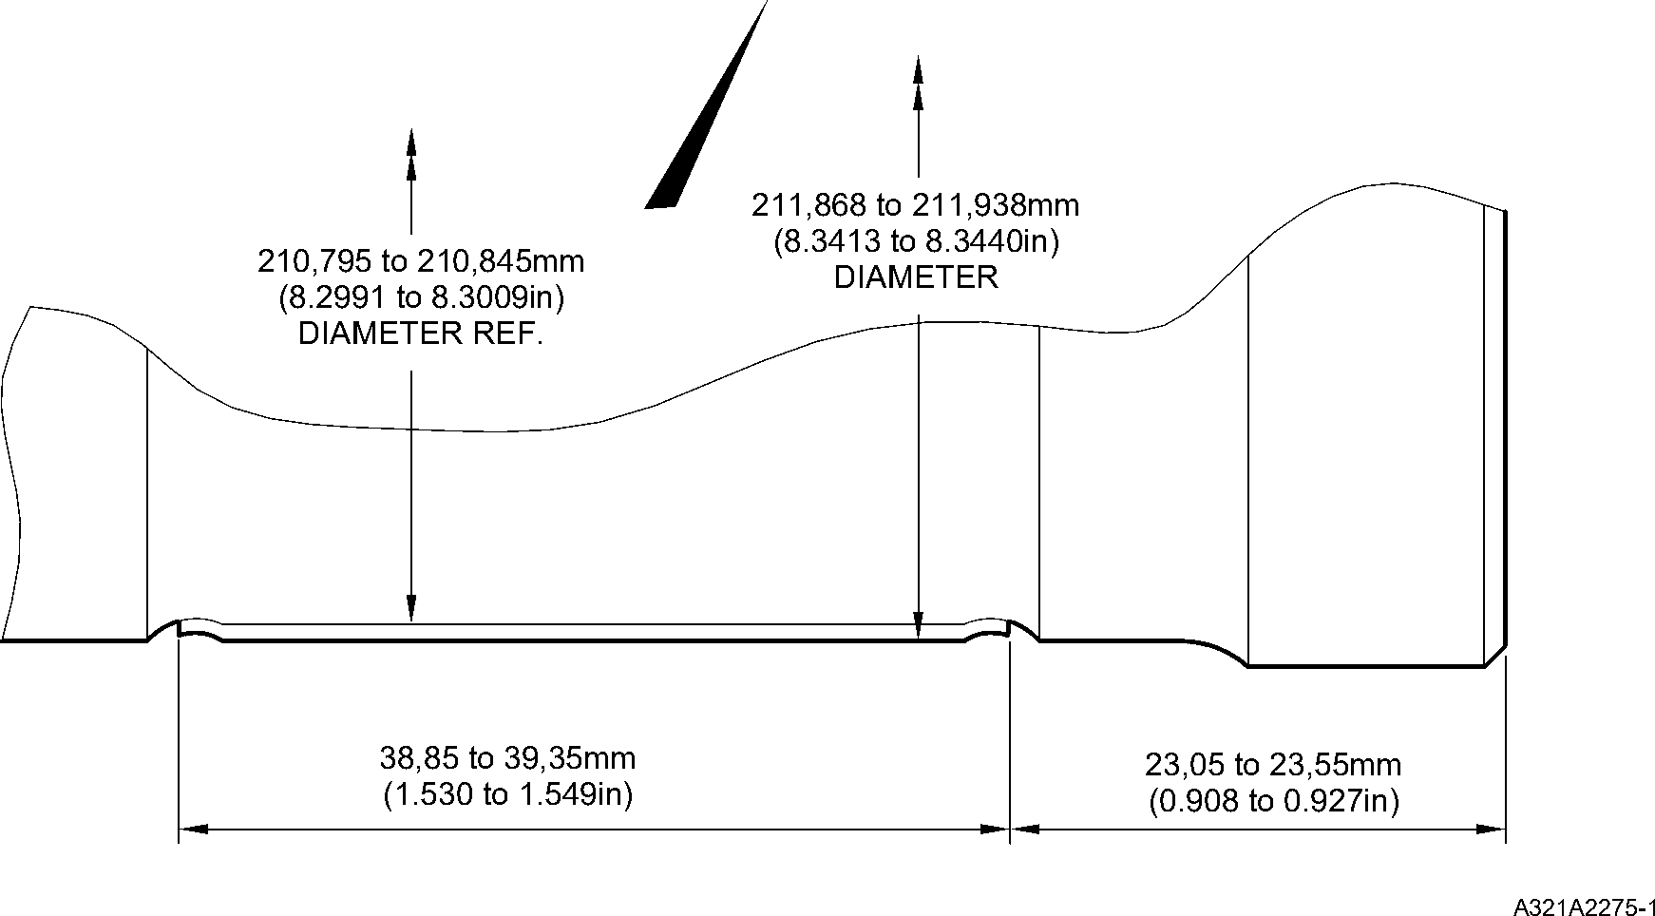

Repair to Lower Bearing Subassembly  
Figure 601

32-12-22

Repair No. 1-2

Page 604

Dec 6/2019

**sSAFRAN SAFRAN LANDING SYSTEMS UK Ltd**

CAGE: K0654

PART No. 201587001 AND 201587002 COMPONENT MAINTENANCE MANUAL  
MAIN LANDING GEAR LEG

1. Repair No. 2-1 Pin (13-190 and 13-190A)
2. Specified Damage and Material Specification.
3. Specified Damage

(a) Damage or wear to the diameters A and B.

1. Material Specification

|  |  |  |
| --- | --- | --- |
| IPL Figure and Item No. | Name | Material Specification |
| 13-190 and  13-190A | Pin | Steel, 35NCD16 |

1. Special Tools
2. Special tools are not necessary.
3. Materials
4. Materials are not necessary.
5. Repair Parts
6. Repair parts are not necessary.
7. Procedure (Refer to Figure 601)
8. Remove the chromium plate from diameters A and B.
9. Machine the diameters A and B to remove damage or wear after removal of the  
   chromium plate. Remove the minimum amount of material necessary, to the dimensions  
   shown in Figure 601, to remove the damage or wear.
10. Examine the pin for flaws: refer to PCS-3600 and PCS-3100 inclusion class 3.
11. Shot peen the machined areas: refer to M-DLPS123.
12. Apply chromium plate to the diameters A and B: refer to M-DLPS101-2. Make sure the  
    chromium plate terminations are smooth: refer to M-DLPS1031.
13. Finish grind the pin to the dimensions shown in Figure 601.
14. Examine the pin for flaws: refer to M-DLNDT3.
15. Identify the part with the Messier-Dowty Limited repair number 450217145 adjacent to  
    the part number: refer to PCS-6000-05.
16. Examine the part to make sure that you have obeyed all the repair instructions correctly.

Repair No. 2-1

32-12-22

Page 601

Dec 6/2019

**SAFRAN LANDING SYSTEMS UK Ltd**

CAGE: K0654



PART No. 201587001 AND 201587002 COMPONENT MAINTENANCE MANUAL  
MAIN LANDING GEAR LEG

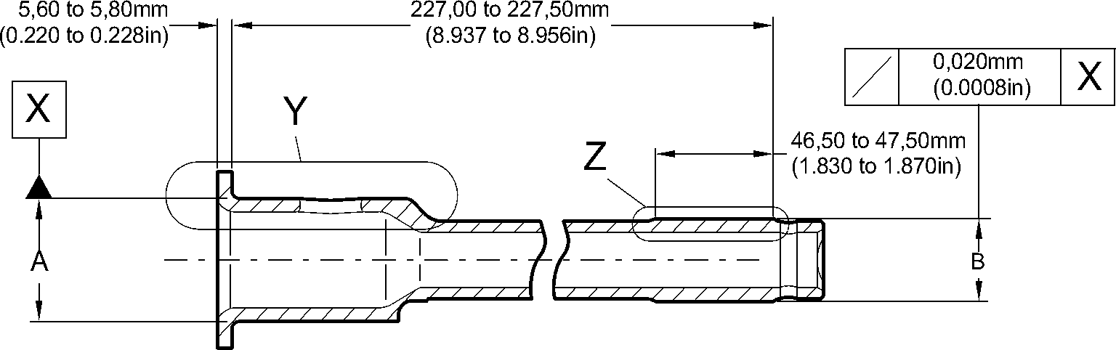

63,50 to 64,50mm  
(2.500 to 2.539in)

4,75 to 5,25mm  
(0.187 to 0.206in)

LENGTH OF CHROMIUM PLATE

1,00mm (0.039in)  
MAXIMUM

1,75 to 2,25mm  
(0.068 to 0.088in)  
RADIUS

2,00 to 2,50mm  
(0.078 to 0.098in)

1,00 to 2,00mm  
(0.039 to 0.078in)

45,300mm (1.7834in)

DIAMETER MINIMUM

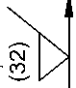

2,00mm  
(0.078in)  
MAXIMUM

48,00 to 49,00mm

(1.889 to 1.929in)

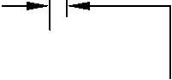

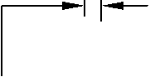

2,00mm  
(0.078in)  
MAXIMUM

45,950 to 45,975mm  
(1.8090 to 1.8100in)

AFTER GRINDING

THE CHROMIUM PLATE MUST STOP  
IN THIS LENGTH. AN IRREGULAR  
LINE IS PERMITTED

LARGER VIEW AT

Y

CHROMIUM  
DEPOSIT



**T**

LENGTH OF CHROMIUM PLATE

1,00 to 2,00mm  
(0.039 to 0.078in)

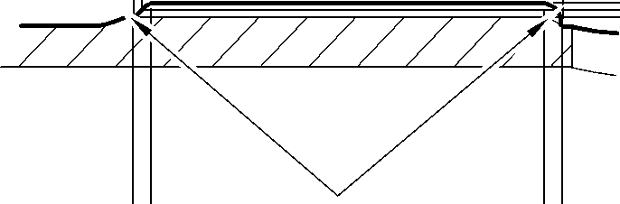

2,00 to 3,00mm  
(0.078 to 0.118in)  
RADIUS

30,300mm (1.1929in)

DIAMETER MINIMUM

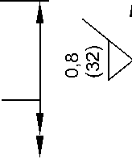

30,950 to 30,975mm  
(1.2186 to 1.2195in)

AFTER GRINDING

2,00mm  
(0.078in)  
MAXIMUM

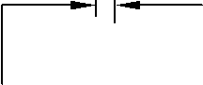

2,00mm  
(0.078in)  
MAXIMUM

CHROMIUM  
DEPOSIT

THE CHROMIUM PLATE MUST STOP  
IN THIS LENGTH. AN IRREGULAR  
LINE IS PERMITTED

LARGER VIEW AT

Z

A3219755-2

Repair to Pin  
Figure 601

32-12-22

Repair No. 2-1

Page 602

Dec 6/2019

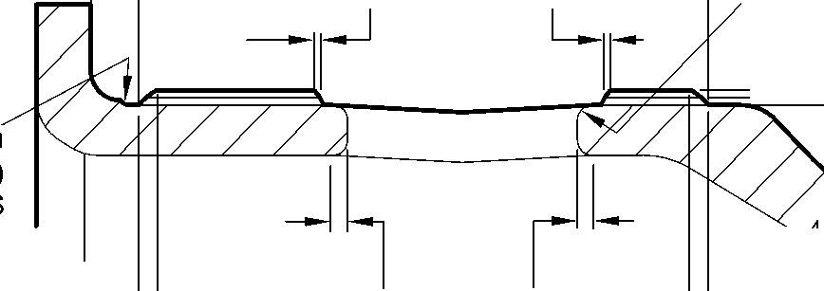

**SAFRAN LANDING SYSTEMS UK Ltd**

CAGE: K0654



PART No. 201587001 AND 201587002 COMPONENT MAINTENANCE MANUAL  
MAIN LANDING GEAR LEG

1. Repair No. 3-1 Pivot Pin (6-90)
2. Specified Damage and Material Specification.
3. Specified Damage

(a) Damage or wear to the diameter A.

1. Material Specification

|  |  |  |
| --- | --- | --- |
| IPL Figure and Item No. | Name | Material Specification |
| 6-90 | Pivot Pin | Steel, S99 |

1. Special Tools
2. Special tools are not necessary.
3. Materials

(1) Materials are not necessary.

1. Repair Parts

(1) Repair parts are not necessary.

E. Procedure (Refer to Figure 601)

1. Remove the chromium plate only from the diameter A to show the parent metal.
2. If the parent metal is not damaged or worn:
3. Examine the pivot pin for flaws: refer to PCS-3600 and PCS-3100, inclusion  
   class 3.
4. Apply chromium plate to the diameter A: refer to PCS-2110 Type B. Refer to  
   Figure 601 for chromium plate termination information.
5. Grind the diameter A to between 15,960 and 15,987 mm (0.6284 and 0.6294 in).  
   The surface finish must be 0,8 micrometers (32 micro-inches).
6. Examine the pivot pin for flaws: refer to PCS-3002, PCS-3100, inclusion class 3  
   and PCS-3600.
7. Identify the part with the Messier-Dowty Limited repair number 450217385A  
   adjacent to the part number: refer to PCS-6000-05.
8. Examine the part to make sure that you have obeyed all the repair instructions  
   correctly.
9. If the parent metal is damaged or worn:
10. Machine the diameter A sufficiently to remove damage and wear, down to a  
    minimum of 15,377 mm (0.6054 in).
11. Examine the pivot pin for flaws: refer to PCS-3600 and PCS-3100, inclusion  
    class 3.
12. Apply chromium plate to the diameter A: refer to PCS-2110 Type B. Refer to  
    Figure 601 for chromium plate termination information.

Repair No. 3-1

Page 601  
May 31/2019

32-12-22

**sSAFRAN SAFRAN LANDING SYSTEMS UK Ltd**

CAGE: K0654

PART No. 201587001 AND 201587002 COMPONENT MAINTENANCE MANUAL  
MAIN LANDING GEAR LEG

1. Grind the diameter A to between 15,960 and 15,987 mm (0.6284 and 0.6294 in).  
   The surface finish must be 0,8 micrometers (32 micro-inches).
2. Examine the pivot pin for flaws: refer to PCS-3002, PCS-3100, inclusion class 3  
   and PCS-3600.
3. Identify the part with the Messier-Dowty Limited repair number 450217385B  
   adjacent to the part number: refer to PCS-6000-05.
4. Examine the part to make sure that you have obeyed all the repair instructions  
   correctly.

32-12-22

Repair No. 3-1

Page 602

May 31/2019

**SAFRAN LANDING SYSTEMS UK Ltd**

CAGE: K0654



PART No. 201587001 AND 201587002 COMPONENT MAINTENANCE MANUAL  
MAIN LANDING GEAR LEG

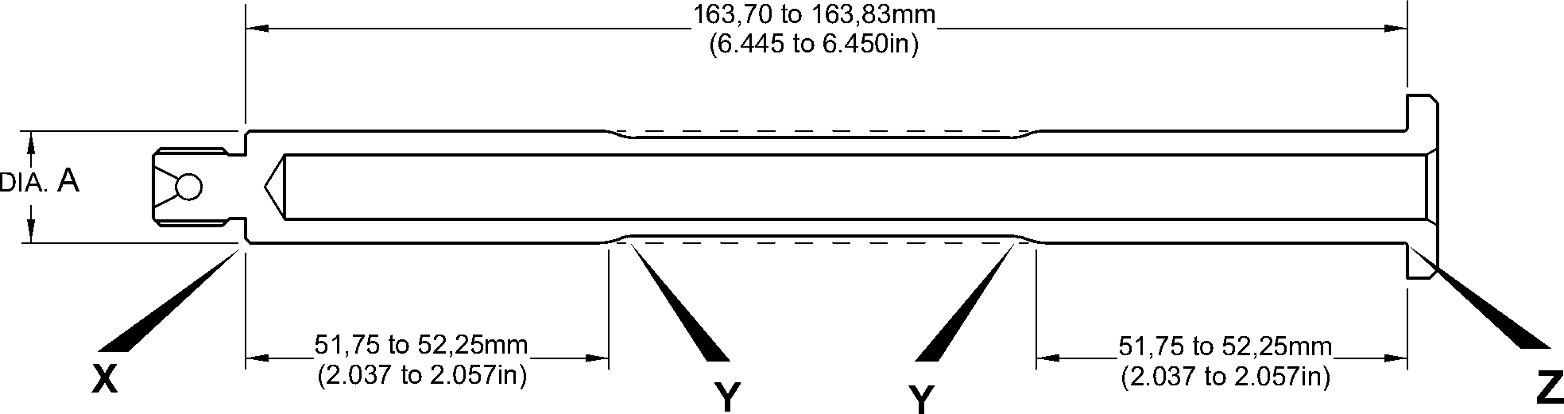

CHROMIUM PLATE CAN STOP  
ANYWHERE ON THE CHAMFER.  
IT CAN BE FINISHED BY GRINDING

0,92 to 1,45mm  
(0.036 to 0.057in)

MAKE EDGES SMOOTH

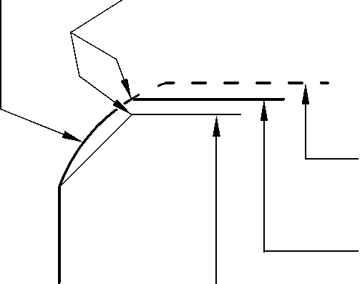

AFTER CHROMIUM PLATE  
IS APPLIED AND BEFORE  
GRINDING

AFTER GRINDING

0,120 to 0,250mm  
(0.0047 to 0.0100in)  
RAD.

0,80mm (0.031in)  
RAD. MIN.

BEFORE CHROMIUM  
PLATE IS APPLIED

CHROMIUM PLATE

TEMINATION TO M-DLPS1031-6

AFTER GRINDING

AFTER CHROMIUM PLATE  
IS APPLIED AND BEFORE

BEFORE CHROMIUM  
PLATE IS APPLIED

GRINDING

DETAIL **X**

CHROMIUM PLATE  
TEMINATION TO M-DLPS1031-3

DETAIL **Z**

2,00mm (0.079in) MAX.  
CHROMIUM PLATE MUST STOP  
IN THIS LENGTH.  
AN IRREGULAR LINE IS PERMITTED.

2,00mm (0.079in)  
MIN. LENGTH  
NOT CHROMIUM PLATED





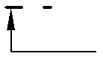

CHROMIUM PLATED LENGTH

AFTER CHROMIUM PLATE  
IS APPLIED AND BEFORE  
GRINDING

CHROMIUM PLATE

TEMINATION TO M-DLPS1031-1

DETAIL **Y**

AFTER GRINDING

BEFORE CHROMIUM  
PLATE IS APPLIED

A321-S-32-12-22-099-0

Repair to Pivot Pin  
Figure 601

Repair No. 3-1

32-12-22

Page 603

Dec 8/2017

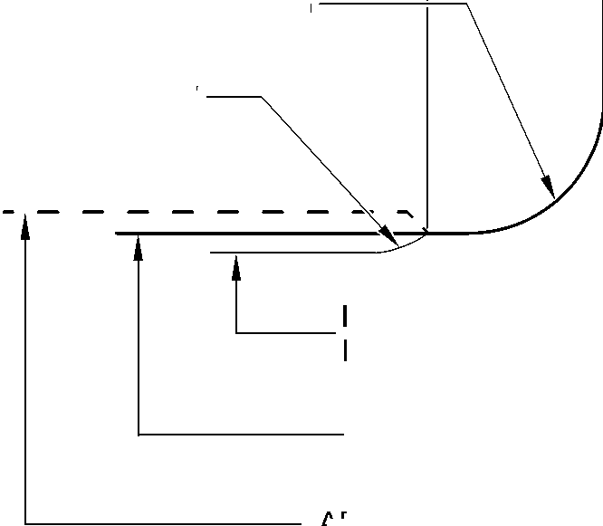

**SAFRAN LANDING SYSTEMS UK Ltd**

CAGE: K0654



PART No. 201587001 AND 201587002 COMPONENT MAINTENANCE MANUAL  
MAIN LANDING GEAR LEG

INTENTIONALLY BLANK

32-12-22

Repair No. 3-1

Page 604

**sSAFRAN SAFRAN LANDING SYSTEMS UK Ltd**

CAGE: K0654

PART No. 201587001 AND 201587002 COMPONENT MAINTENANCE MANUAL  
MAIN LANDING GEAR LEG

1. Repair No. 4-1 Uplock Pin (5-400)
2. Specified Damage and Material Specification.
3. Specified Damage

(a) Damage or wear to diameter A.

1. Material Specification

|  |  |  |
| --- | --- | --- |
| IPL Figure and Item No. | Name | Material Specification |
| 5-400 | Uplock pin | Steel, S99 |

1. Special Tools
2. Special tools are not necessary.
3. Materials
4. Materials are not necessary.
5. Repair Parts
6. Repair parts are not necessary.
7. Procedure (Refer to Figure 601)
8. Remove the chromium plate from diameter A.
9. Machine diameter A to remove the damage or wear after removal of the chromium plate.  
   The minimum diameter is 24,36 mm (0.960 in) and the surface finish must be  
   0,4 micrometers (16 micro-inches).
10. Examine the uplock pin for flaws: refer to PCS-3600 and PCS-3100, inclusion class 3.
11. If diameter A has been machined (see para (2)), shot peen the machined area: refer to  
    M-DLPS123.
12. Apply chromium plate to diameter A as shown with a minimum chromium plate thickness  
    of 0,075 mm (0.0030 in): refer to M-DLPS101-2.
13. Machine diameter A to between 24,947 and 24,980 mm (0.9822 and 0.9834 in) with a  
    surface finish of 0,4 micrometers (16 micro-inches).
14. Examine the chromium plated surface for flaws: refer to M-DLNDT3.
15. Apply cadmium plate to the machined areas but not where chromium plated: refer to  
    PCS-2141.
16. Spray primer paint lightly on the cadmium plated surface: refer to PCS-2500.
17. Refer to PCS-6000-07 and identify the part with the applicable Messier-Dowty Limited  
    repair number, adjacent to the part number, after painting:

* 450237490A if only the chromium plate has been repaired, or
* 450237490B if chromium plate and parent metal have been repaired.

1. Examine the part to make sure that you have obeyed all the repair instructions correctly.

Repair No. 4-1

32-12-22

Page 601

Dec 6/2019

**SAFRAN LANDING SYSTEMS UK Ltd**

CAGE: K0654



PART No. 201587001 AND 201587002 COMPONENT MAINTENANCE MANUAL  
MAIN LANDING GEAR LEG

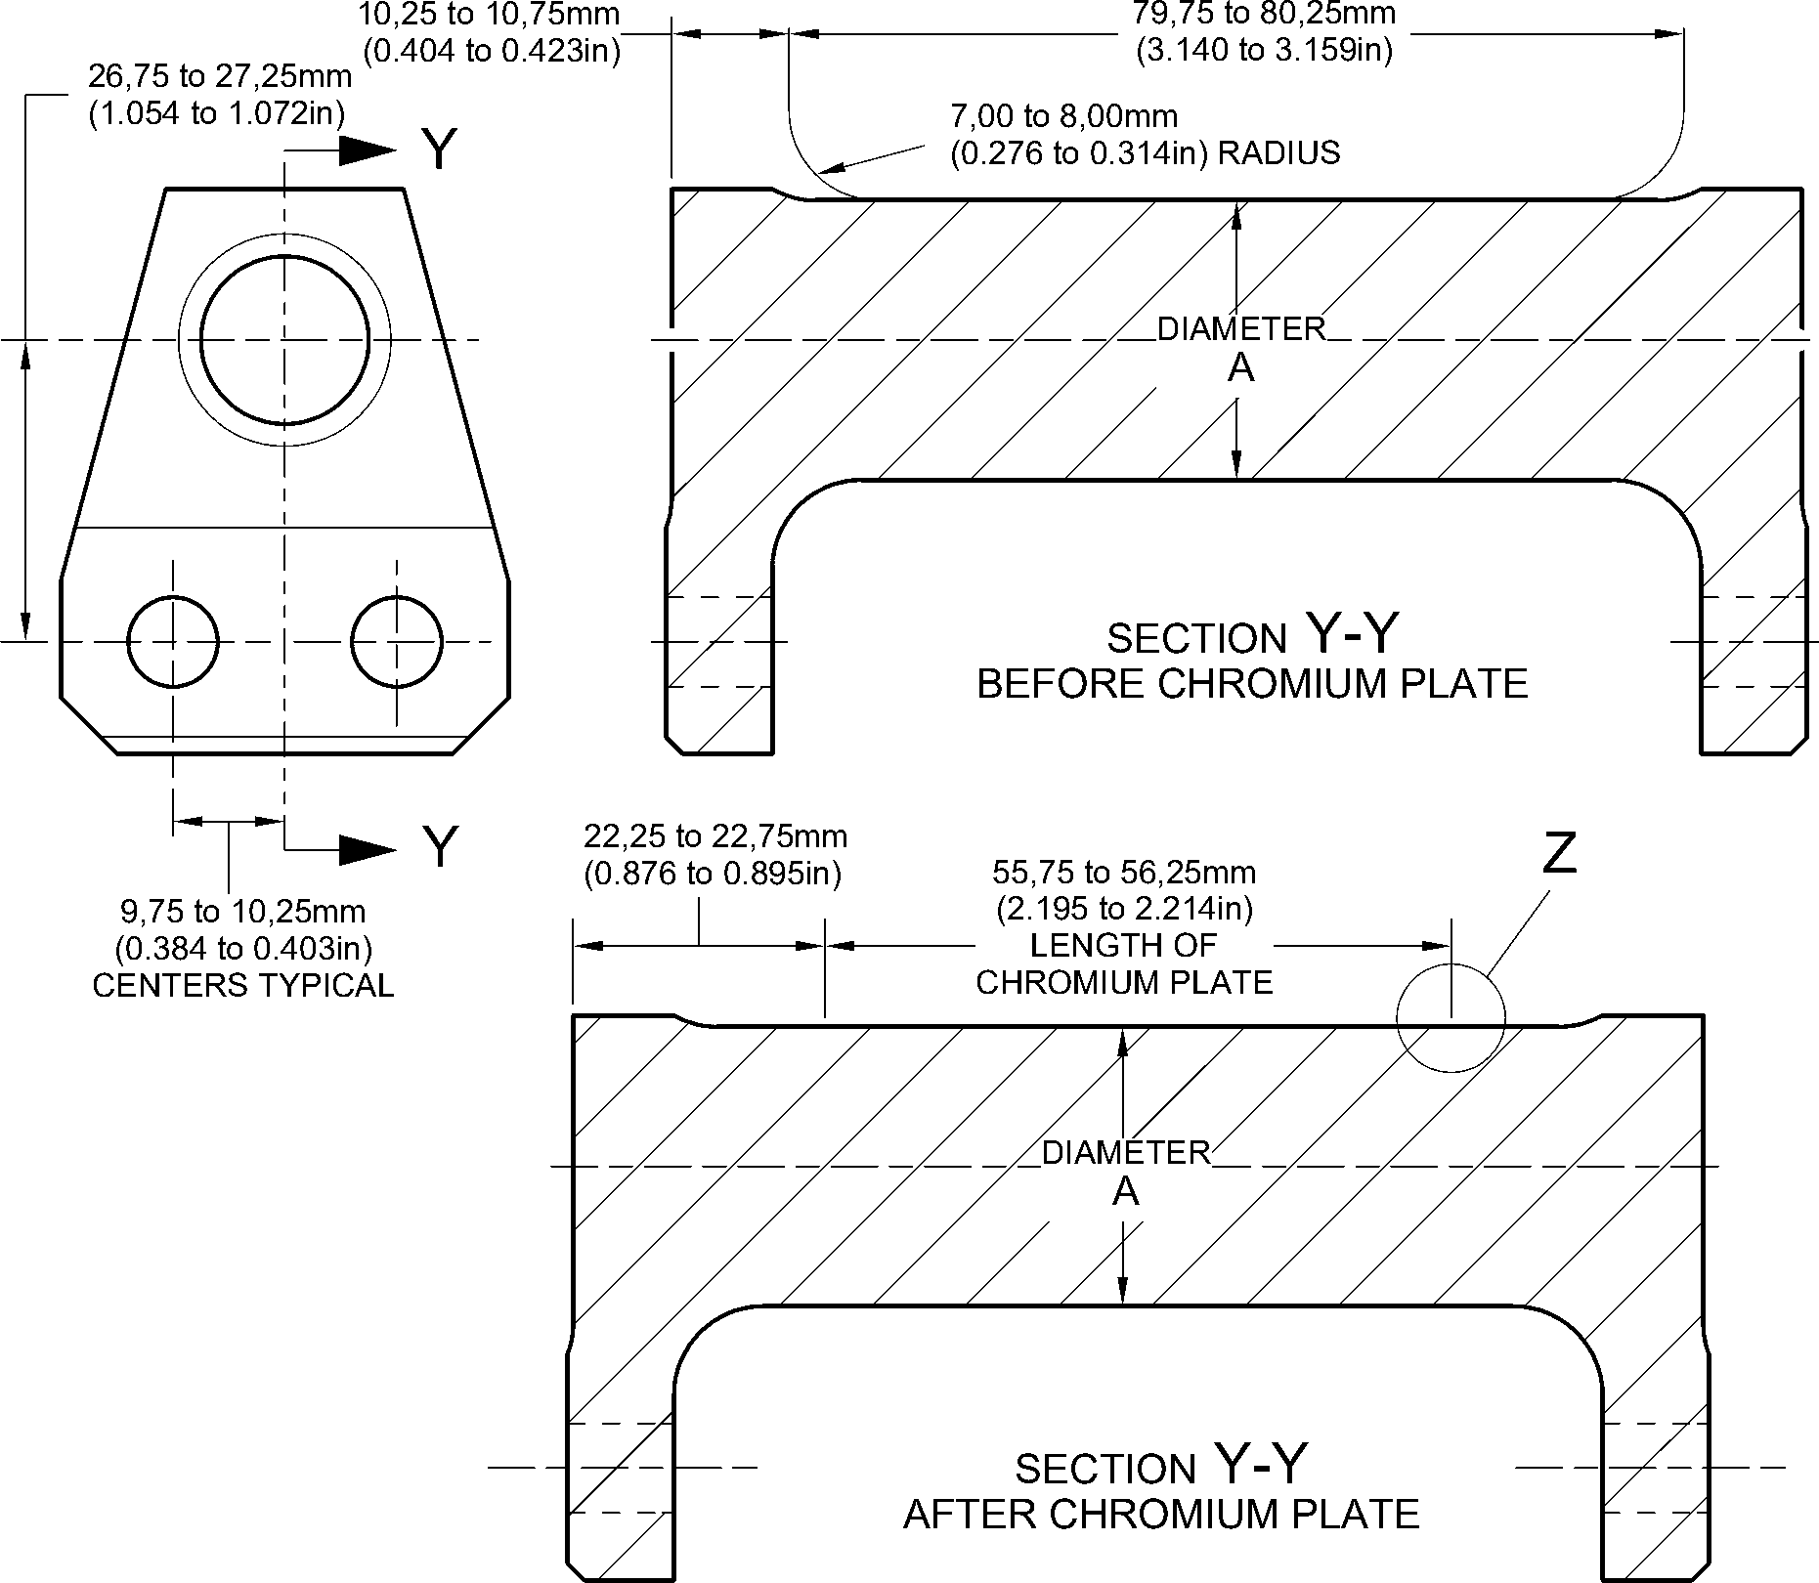

LENGTH OF  
CHROMIUM PLATE

M-DLPS1031-2 CHROMIUM PLATE TERMINATION  
CHROMIUM PLATE MUST NOT EXTENDED ONTO  
7,00 to 8,00mm (0.276 to 0.314in) RADIUS

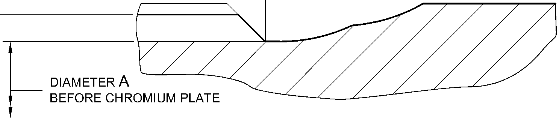

diameter A

AFTER CHROMIUM PLATE AND GRINDING

larger detail Z  
NOT TO SCALE

A321A1270-2

Repair to Uplock Pin

Figure 601

32-12-22

Repair No. 4-1

Page 602

Dec 6/2019

**sSAFRAN SAFRAN LANDING SYSTEMS UK Ltd**

CAGE: K0654

PART No. 201587001 AND 201587002 COMPONENT MAINTENANCE MANUAL  
MAIN LANDING GEAR LEG

1. Repair No. 5-1 Pin (3-50)
2. Specified Damage and Material Specification.
3. Specified Damage

(a) Damage or wear to diameter A.

1. Material Specification

|  |  |  |
| --- | --- | --- |
| IPL Figure and Item No. | Name | Material Specification |
| 3-50 | Pin | Steel, S99 |

1. Special Tools
2. Special tools are not necessary.
3. Materials
4. Materials are not necessary.
5. Repair Parts
6. Repair parts are not necessary.
7. Procedure (Refer to Figure 601)
8. Machine diameter A sufficiently to remove the damage or wear and to the dimensions  
   shown in Figure 601.
9. Examine the pin for flaws: refer to PCS-3600 and PCS-3100, inclusion class 2.
10. Shot peen the pin: refer to M-DLPS123.
11. Apply chromium plate to diameter A to give a minimum diameter of 20,120 mm  
    (0.7921 in): refer to M-DLPS101-2P.
12. Grind diameter A to the dimensions shown with a surface finish of 0,4 micrometers  
    (16 micro-inches). Refer to M-DLPS1031-3 and M-DLPS1031-6 for the chromium plate  
    terminations where shown.
13. Examine the pin for flaws: refer to M-DLNDT3.
14. Identify the part with the Messier-Dowty Limited repair number 450217170 adjacent to  
    the part number: refer to PCS-6000-05.
15. Apply cadmium plate all over the pin, but not on the chromium plated areas: refer to  
    M-DLPS100-2 or PCS-2141.
16. Paint the pin all over, but not on the threads, the thread undercut and the chromium  
    plated areas: refer to PCS-2500.
17. Examine the part to make sure that you have obeyed the repair instructions correctly.

Repair No. 5-1

Page 601

Dec 9/2016

32-12-22

**SAFRAN LANDING SYSTEMS UK Ltd**

CAGE: K0654



PART No. 201587001 AND 201587002 COMPONENT MAINTENANCE MANUAL  
MAIN LANDING GEAR LEG

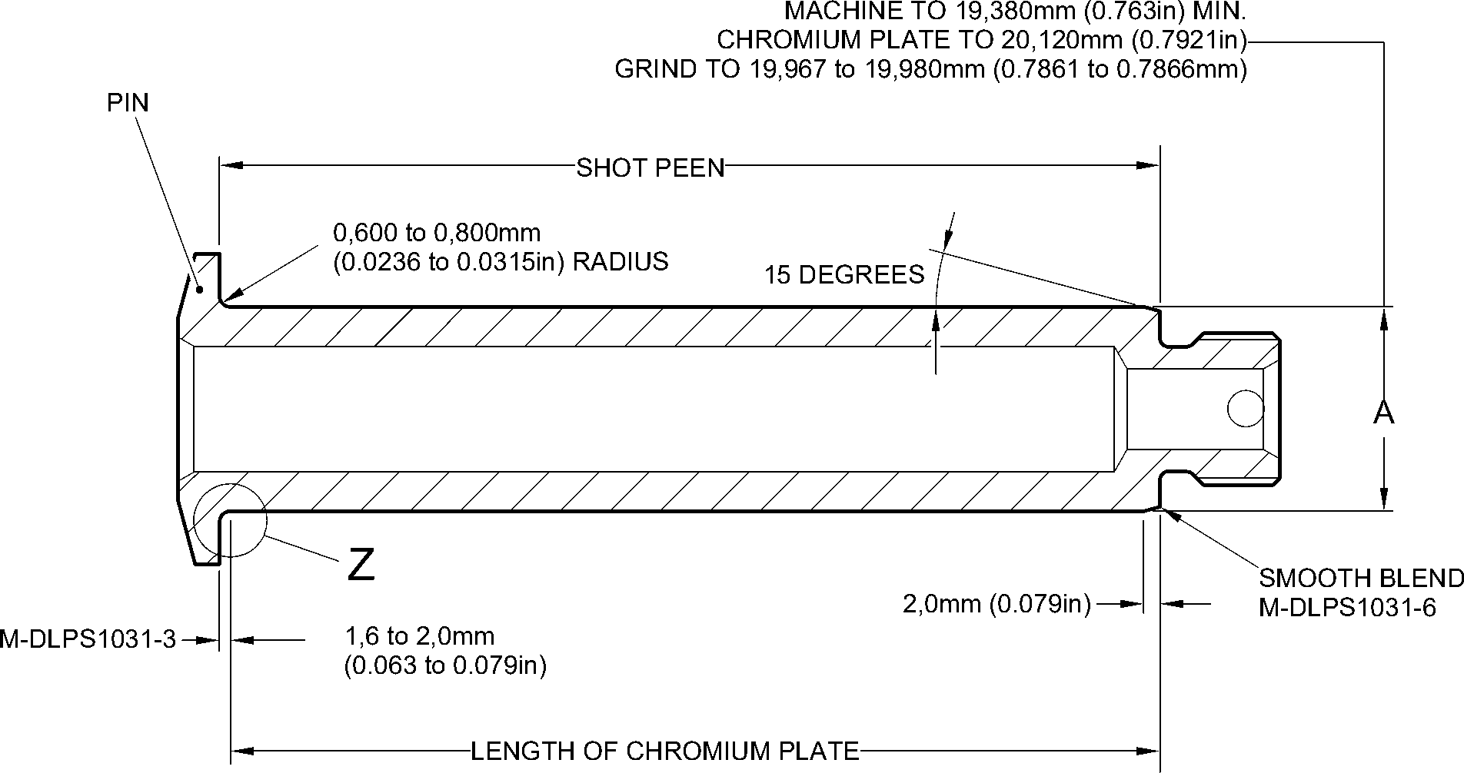

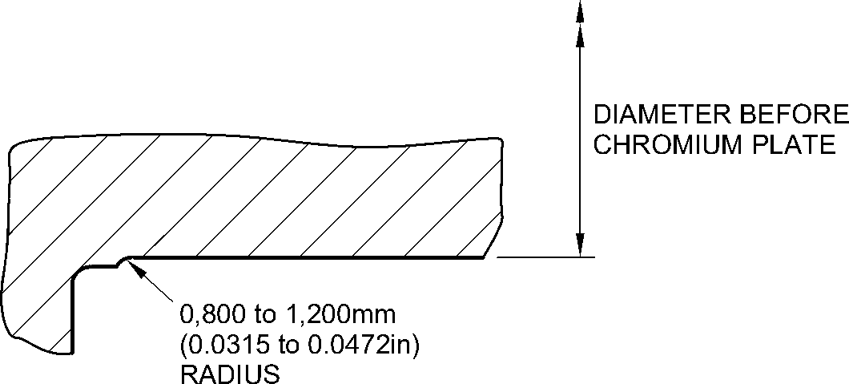

detail Z

A321A2276-1

Repair to Pin  
Figure 601

32-12-22

Repair No. 5-1

Page 602

Dec 9/2016

**sSAFRAN SAFRAN LANDING SYSTEMS UK Ltd**

CAGE: K0654

PART No. 201587001 AND 201587002 COMPONENT MAINTENANCE MANUAL  
MAIN LANDING GEAR LEG

1. Repair No. 6-1 Pin (10-80)
2. Specified Damage and Material Specification.
3. Specified Damage

(a) Damage or corrosion to diameter A.

1. Material Specification

|  |  |  |
| --- | --- | --- |
| IPL Figure and Item No. | Name | Material Specification |
| 10-80 | Pin | UHT Steel (300M), MTL 1201 |

1. Special Tools
2. Special tools are not necessary.
3. Materials
4. Materials are not necessary.
5. Repair Parts
6. Repair parts are not necessary.
7. Procedure (Refer to Figure 601)
8. Remove the chromium plate from diameter A: refer to PCS-2110.
9. If the bare metal is not damaged or corroded:
10. Examine the pin for flaws: refer to PCS-3600 and PCS-3100, inclusion  
    class 4.
11. Shot peen diameter A: refer to M-DLPS123.
12. Apply chromium plate to diameter A: refer to PCS-2110, Type C. Refer to  
    Figure 601 for chromium plate termination information.
13. Grind diameter A to between 59,951 and 59,970 mm (2.3603 and 2.3610 in).  
    The surface finish must be 0,8 micrometers (32 micro-inches).
14. Examine the ground chromium plate for flaws: refer to PCS-3100, inclusion  
    class 4 and PCS-3002.
15. Identify the part with the Messier-Dowty Limited repair number 450258420A  
    adjacent to the part number: refer to PCS-6000-04 and PCS-6000-07.
16. Examine the part to make sure that you have obeyed all the repair  
    instructions correctly.
17. If the bare metal is damaged or corroded:
18. Machine diameter A just sufficiently to remove the damage or corrosion: refer  
    to M-DLPS1004-4-1. The diameter must not be less than 59,370 mm  
    (2.3374 in). The surface finish must be 1,6 micrometers (63 micro-inches).
19. Examine the pin for flaws: refer to PCS-3600 and PCS-3100, inclusion  
    class 4.

Repair No. 6-1

32-12-22

Page 601

Dec 6/2019

**sSAFRAN SAFRAN LANDING SYSTEMS UK Ltd**

CAGE: K0654

PART No. 201587001 AND 201587002 COMPONENT MAINTENANCE MANUAL  
MAIN LANDING GEAR LEG

1. Shot peen and apply chromium plate to diameter A: refer to M-DLPS123 and  
   PCS-2110, Type C. Refer to Figure 601 for chromium plate termination  
   information.
2. Grind diameter A to between 59,951 and 59,970 mm (2.3603 and 2.3610 in).  
   The surface finish must be 0,8 micrometers (32 micro-inches).
3. Examine the ground chromium plate for flaws: refer to PCS-3100, inclusion  
   class 4 and PCS-3002.
4. Identify the part with the Messier-Dowty Limited repair number 450258420B  
   adjacent to the part number: refer to PCS-6000-04 and PCS-6000-07.
5. Examine the part to make sure that you have obeyed all the repair  
   instructions correctly.

32-12-22

Repair No. 6-1

Page 602

Dec 6/2019

**SAFRAN LANDING SYSTEMS UK Ltd**

CAGE: K0654



PART No. 201587001 AND 201587002 COMPONENT MAINTENANCE MANUAL  
MAIN LANDING GEAR LEG

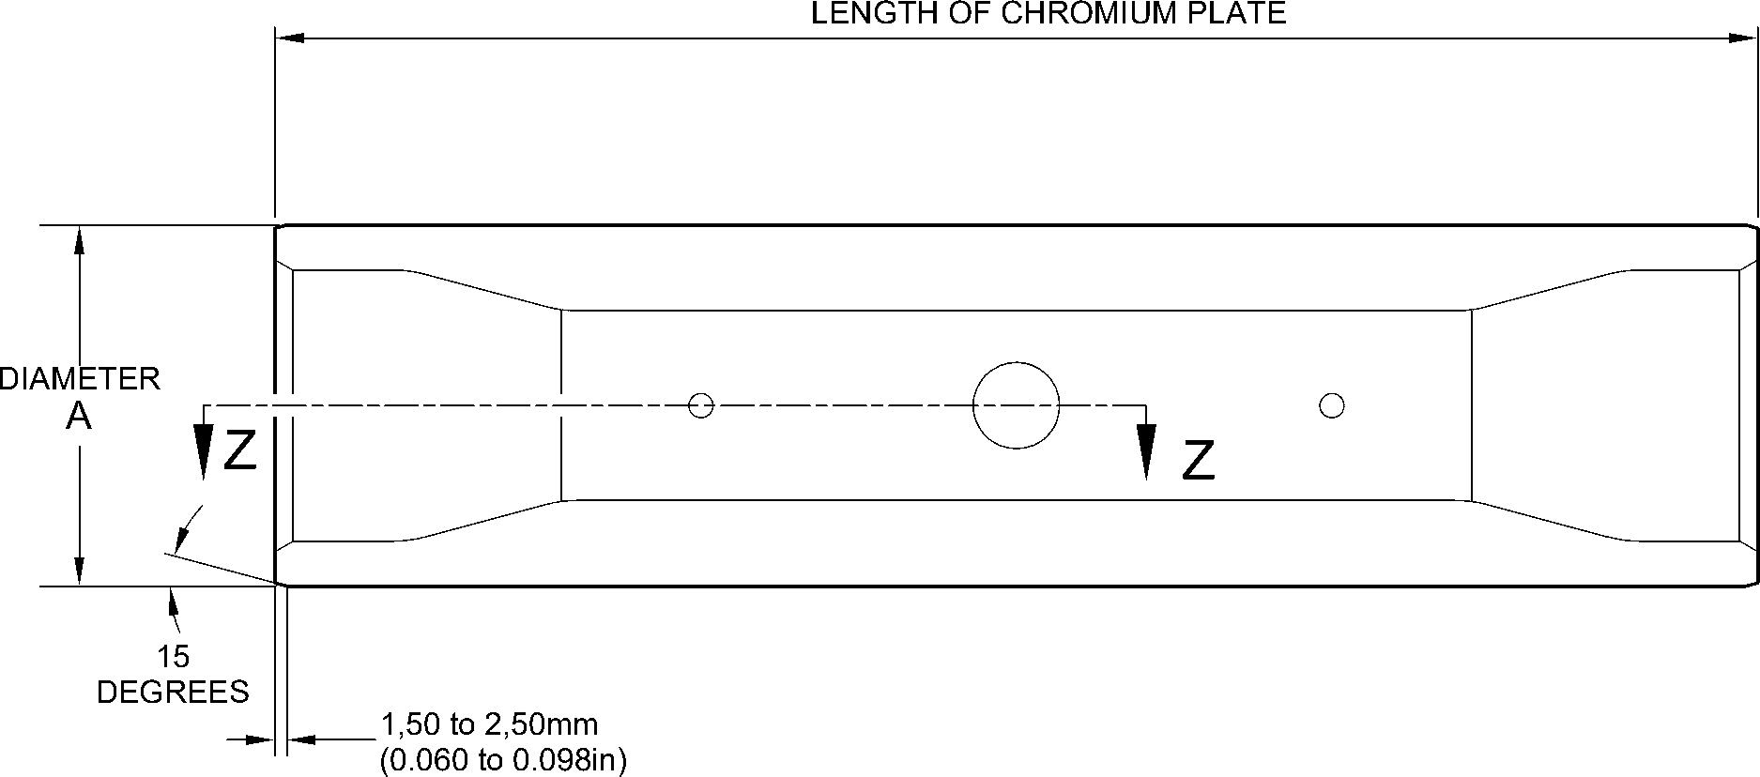

EDGES SMOOTHED OUT. CHROMIUM PLATE TERMINATION

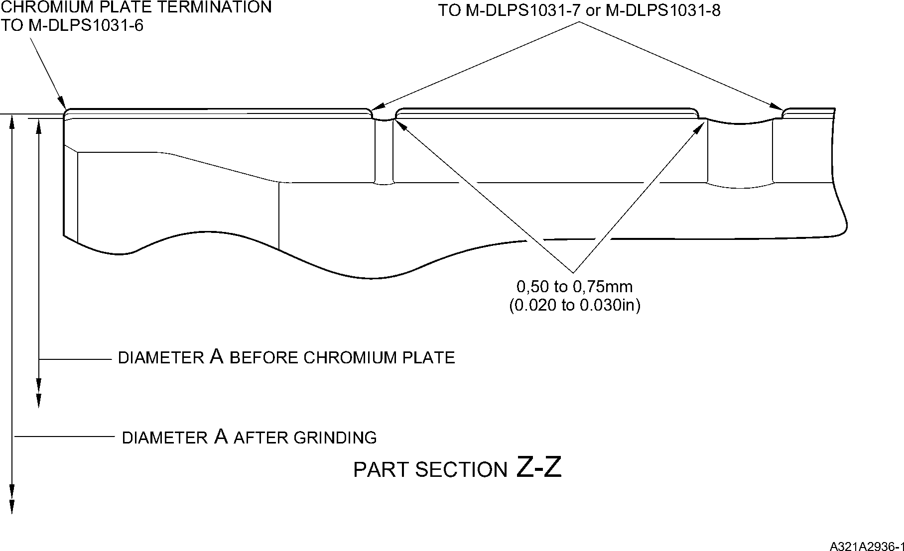

Repair to Pin  
Figure 601

Repair No. 6-1

32-12-22

Page 603

Dec 6/2019

**SAFRAN LANDING SYSTEMS UK Ltd**

CAGE: K0654



PART No. 201587001 AND 201587002 COMPONENT MAINTENANCE MANUAL  
MAIN LANDING GEAR LEG

INTENTIONALLY BLANK

Repair No. 6-1

32-12-22 Page 604

**sSAFRAN SAFRAN LANDING SYSTEMS UK Ltd**

CAGE: K0654

PART No. 201587001 AND 201587002 COMPONENT MAINTENANCE MANUAL  
MAIN LANDING GEAR LEG

1. Repair No. 6-2 Pin (10-80)
2. Specified Damage and Material Specification.
3. Specified Damage

(a) Damage or wear to diameter A.

1. Material Specification

|  |  |  |
| --- | --- | --- |
| IPL Figure and Item No. | Name | Material Specification |
| 10-80 | Pin | Steel, MTL 1201 |

1. Special Tools
2. Special tools are not necessary.
3. Materials
4. These materials are necessary:

**NOTE: Alternative equivalents are permitted.**

|  |  |
| --- | --- |
| Ref. Item | Material |
| 08-665 | Adhesive |

1. Repair Parts
2. These repair parts are necessary:

|  |  |  |
| --- | --- | --- |
| Part No. | Repair Part | Material Specification |
| 450258261 | Repair bush (Qty 2) | Steel, S154 |

1. Procedure (Refer to Figure 601)
2. Machine diameter A sufficiently to remove the damage or wear and to between 15,90  
   and 16,50 mm (0.626 and 0.649 in): refer to M-DLPS1004-4-1. Machine a surface finish  
   of 1,6 micrometers (63 micro-inches).
3. Examine the pin for flaws: refer to PCS-3600 and PCS-3100, inclusion class 4.
4. Shot peen the machined areas: refer to M-DLPS123.
5. Measure the new diameter A.
6. Apply cadmium plate to the machined areas: refer to PCS-2141.
7. Calculate diameter C of the repair bushes:

C = A (as measured) + 0,010 to 0,039 mm (0.0004 to 0.0015 in).

1. Machine the repair bushes to the dimensions shown and calculated. Machine a surface  
   finish of 1,6 micrometers (63 micro-inches).
2. Examine the repair bushes for flaws: refer to PCS-3100, inclusion class 3.

Repair No. 6-2

Page 601

Dec 6/2019

32-12-22

**sSAFRAN SAFRAN LANDING SYSTEMS UK Ltd**

CAGE: K0654

PART No. 201587001 AND 201587002 COMPONENT MAINTENANCE MANUAL  
MAIN LANDING GEAR LEG

1. Apply cadmium plate to all surfaces of the repair bushes: refer to M-DLPS100-1.
2. Apply adhesive, Material Ref. Item 08-665, to the outside diameter of the repair bushes:  
   refer to M-DLPS709-6.
3. Install the repair bushes to diameter A until aligned with the outside diameter of the pin:  
   refer to M-DLPS1011-5.
4. Machine the repair bushes to the contour of the pin and the dimensions shown.
5. Identify the part with the Messier-Dowty Limited repair number 450258260 adjacent to  
   the part number: refer to PCS-6000-04 and PCS-6000-07.
6. Examine the part to make sure that you have obeyed all the repair instructions correctly.

32-12-22

Repair No. 6-2

Page 602

Dec 6/2019

**SAFRAN LANDING SYSTEMS UK Ltd**

CAGE: K0654



PART No. 201587001 AND 201587002 COMPONENT MAINTENANCE MANUAL  
MAIN LANDING GEAR LEG

Z

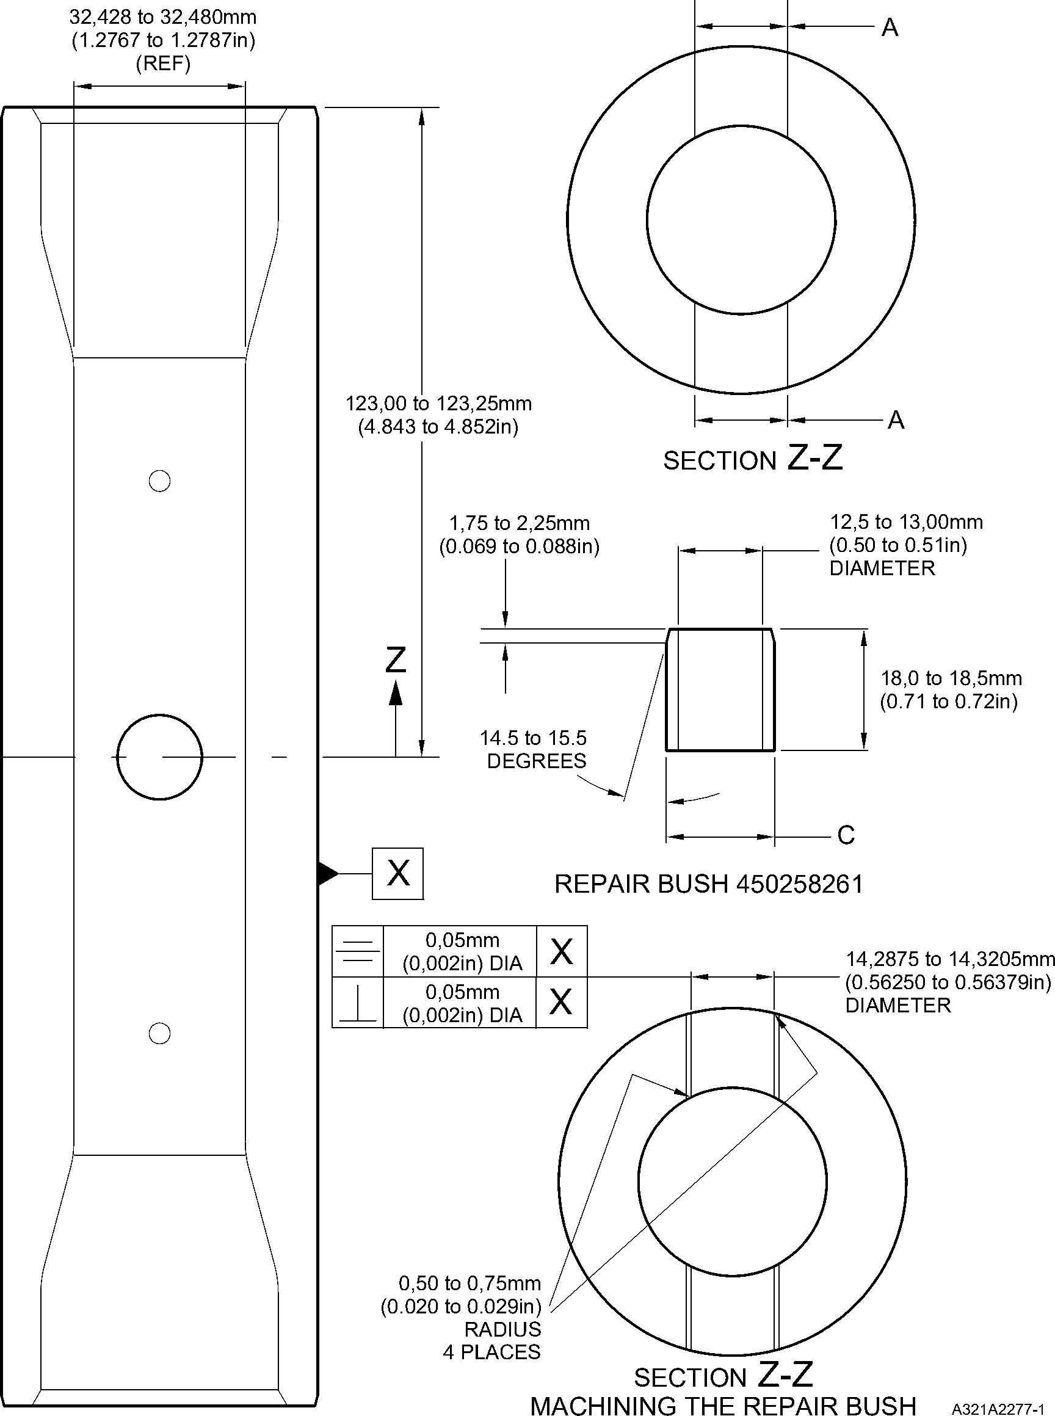

Repair to Pin  
Figure 601

Repair No. 6-2

Page 603

Dec 6/2019

32-12-22

**SAFRAN LANDING SYSTEMS UK Ltd**

CAGE: K0654



PART No. 201587001 AND 201587002 COMPONENT MAINTENANCE MANUAL  
MAIN LANDING GEAR LEG

INTENTIONALLY BLANK

Repair No. 6-2

32-12-22 Page 604

**sSAFRAN SAFRAN LANDING SYSTEMS UK Ltd**

CAGE: K0654

PART No. 201587001 AND 201587002 COMPONENT MAINTENANCE MANUAL  
MAIN LANDING GEAR LEG

1. Repair No. 6-3 Pin (10-80)
2. Specified Damage and Material Specification
3. Specified Damage

(a) Damage or corrosion to diameter A.

1. Material Specification

|  |  |  |
| --- | --- | --- |
| IPL Figure and Item No. | Name | Material Specification |
| 10-80 | Pin | Steel, MTL1201 |

1. Special Tools
2. Special tools are not necessary.
3. Materials
4. Materials are not necessary.
5. Repair Parts
6. Repair parts are not necessary.
7. Procedure (Refer to Figure 601)

**CAUTION: FOR DAMAGE MORE THAN THE LIMITS OF THIS REPAIR SCHEME, WRITE  
TO MESSIER-DOWTY LIMITED: REFER TO GUIDE-CS-001.**

1. Remove the cadmium plate from the pin: refer to PCS-2100.
2. Machine the diameter A to remove the minimum amount of material necessary to  
   remove the damage or wear, restore the 20,00 mm (0.787 in) radius in two places as  
   shown: refer to M-DLPS1004-4-1 and Figure 601. Do not machine diameter A more  
   than 33,99 mm (1.3383 in). Make the surface finish 1,6 micrometers (63 micro-inches).
3. Machine the radii to the dimensions as shown: refer to Figure 601.
4. Examine the part for flaws: refer to PCS-3100 inclusion class 4 and PCS-3600.
5. Shot peen the reworked areas over lapping adjacent angled surface by at least 6,35 mm  
   (0.250 in). Almen A intensity to be 0,20 to 0,030 mm (0.008 to 0.012 in): refer to  
   M-DLPS123.
6. Grit blast the reworked areas: refer to PCS-2610.
7. Apply sulphamate nickel plate to the reworked areas: refer to MIL STD 868A solution 2,  
   PCS-2120 and Figure 601. The sulphamate nickel plate thickness must be sufficient to  
   get the correct diameter after machining. Make sure that the cross hole and the  
   lubrication holes are sufficiently masked: refer to Figure 601.

**NOTE: The above procedure includes de-embrittle for 23 hours at 185oC to 195oC  
(366oF to 383oF).**

Repair No. 6-3

32-12-22

Page 601

Dec 6/2019

**sSAFRAN SAFRAN LANDING SYSTEMS UK Ltd**

CAGE: K0654

PART No. 201587001 AND 201587002 COMPONENT MAINTENANCE MANUAL  
MAIN LANDING GEAR LEG

1. Machine (do not grind) the sulphamate nickel plate to get the bore diameter of 32,468 to  
   32,500 mm (1.2783 to 1.2795 in): refer to Figure 601. Make the surface finish 1,6  
   micrometers (63 micro-inches).
2. Machine the 20,000 mm (0.7874 in) radii as shown: refer to Figure 601.
3. If the pin base metal has been machined, examine the machined areas for flaws: refer to  
   PCS-3600.

**NOTE: The above procedure includes de-embrittle for 4 hours at 185oC to 195oC  
(366oF to 383oF).**

1. Grit blast the sulphamate nickel area: refer to PCS-2610. Make sure that the remainder  
   of the pin is sufficiently masked.
2. Examine the edges of sulphamate nickel plate to make sure they are properly bonded:  
   use 5 or 10X magnification.
3. If there is evidence of delamination, remove the sulphamate nickel plate and do the  
   repair again.
4. Apply cadmium plate all over the pin except where chromium plated: refer to PCS-2100  
   and Figure 601. The cadmium plate thickness must be between 0,010 and 0,020 mm  
   (0.0004 and 0.0008 in). Make sure the sulphamate nickel plate is fully encapsulated by  
   cadmium plate.
5. Identify the part with the Messier-Dowty Limited repair number 450266211 adjacent to  
   the part number: refer to PCS-6000-04.
6. Apply paint to the reworked areas: refer to REPAIR and PCS-2500.
7. Identify the part with the Messier-Dowty Limited repair number 450266211 adjacent to  
   the part number: refer to PCS-6000-07.
8. Examine the part to make sure that you have obeyed all the repair instructions correctly.

32-12-22

Repair No. 6-3

Page 602

Dec 6/2019

**SAFRAN LANDING SYSTEMS UK Ltd**

CAGE: K0654



PART No. 201587001 AND 201587002 COMPONENT MAINTENANCE MANUAL  
MAIN LANDING GEAR LEG

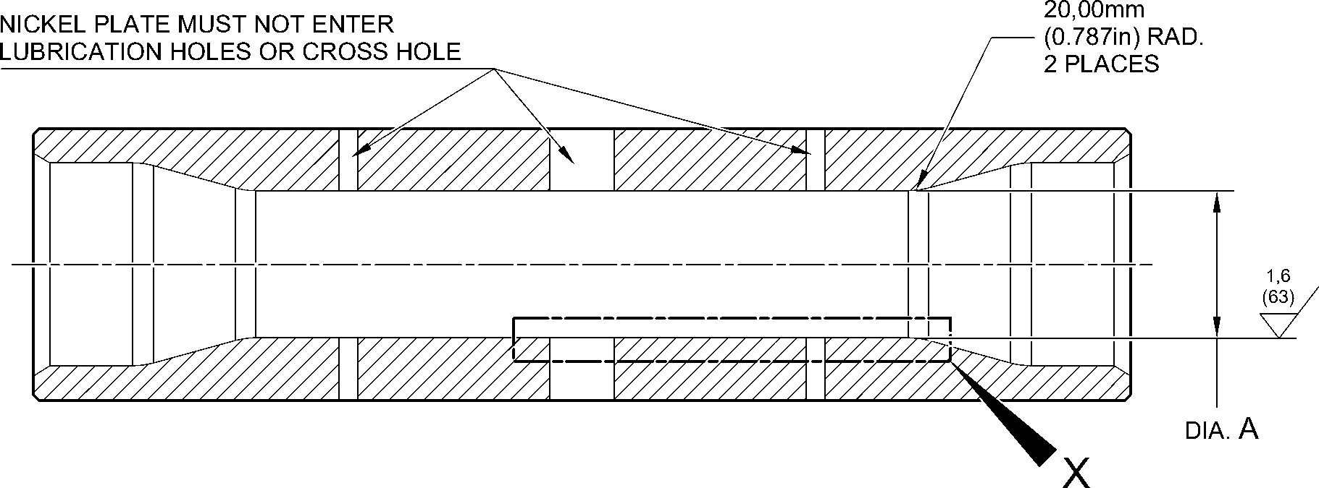

SULPHAMATE NICKEL PLATE DEPOSIT

16,30 to 17,30mm  
(0.642 to 0.681in) DIA.

2 PLACES

6,00 to 7,00mm

32,428 to 32,480mm (1.2767 to 1.2787in) DIA. (0.236 to 0.276in) DIA.

AFTER CADMIUM PLATE 4 PLACES

32,468 to 32,500mm (1.2783 to 1.2795in) DIA.  
AFTER SULPHAMATE NICKEL PLATE

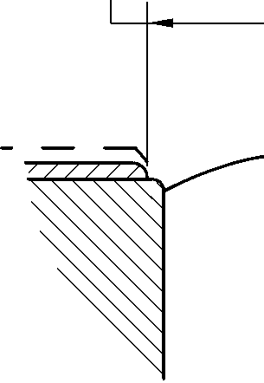

33,99mm (1.3383in) MAXIMUM  
DIA. BEFORE SULPHAMATE

NICKEL PLATE

0,500 to 0,750mm

(0.0197 to 0.0295in) RAD. (32)

0,500 to 0,750mm

(0.0197 to 0.0295in) RAD.

1,6  
20,00mm (63)(0.787in) RAD.

2 PLACES

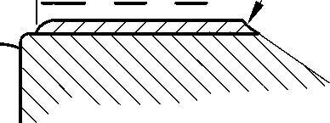

14,30mm

(0.563in) DIA. REF.

4,00mm  
(0.157in) DIA. REF.  
2 PLACES

detail X

A321-S-32-12-22-001-0

Repair to Pin  
Figure 601

Repair No. 6-3

Page 603

Dec 6/2019

32-12-22

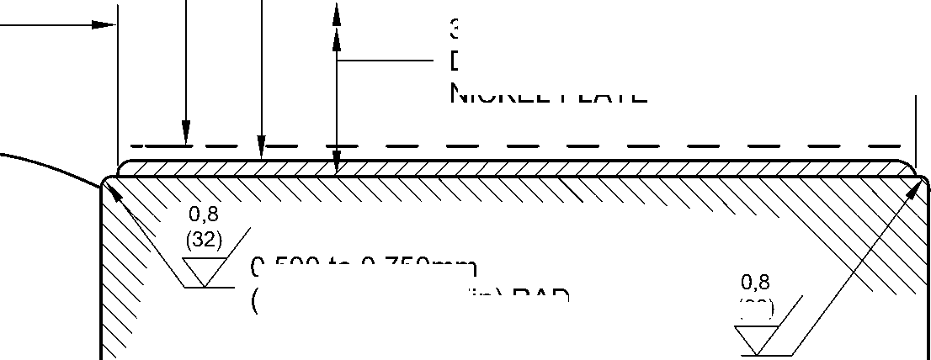

**SAFRAN LANDING SYSTEMS UK Ltd**

CAGE: K0654



PART No. 201587001 AND 201587002 COMPONENT MAINTENANCE MANUAL  
MAIN LANDING GEAR LEG

INTENTIONALLY BLANK

Repair No. 6-3

32-12-22 Page 604

**sSAFRAN SAFRAN LANDING SYSTEMS UK Ltd**

CAGE: K0654

PART No. 201587001 AND 201587002 COMPONENT MAINTENANCE MANUAL  
MAIN LANDING GEAR LEG

1. Repair No. 7-1 Pin (11-130)
2. Specified Damage and Material Specification.
3. Specified Damage

(a) Damage or corrosion to diameter A.

1. Material Specification

|  |  |  |
| --- | --- | --- |
| IPL Figure and Item No. | Name | Material Specification |
| 11-130 | Pin | UHT Steel (300M), MTL 1201 |

1. Special Tools
2. Special tools are not necessary.
3. Materials
4. Materials are not necessary.
5. Repair Parts
6. Repair parts are not necessary.
7. Procedure (Refer to Figure 601)

**CAUTION: FOR DAMAGE MORE THAN THE LIMITS OF THIS REPAIR SCHEME, WRITE  
TO MESSIER-DOWTY LTD: REFER TO GUIDE-CS-001.**

1. Remove the chromium plate from diameter A: refer to PCS-2110.
2. If the bare metal is not damaged or corroded:

1 Examine the pin for flaws: refer to PCS-3600 and PCS-3100, inclusion  
class 4.

2 Shot peen diameter A: refer to M-DLPS123.

3 Apply chromium plate to diameter A: refer to PCS-2110, Type C. Refer to  
Figure 601 for chromium plate termination information.

4 Grind diameter A to between 59,951 and 59,970 mm (2.3603 and 2.3610 in).  
The surface finish must be 0,8 micrometers (32 micro-inches).

5 Examine the ground chromium plate for flaws: refer to PCS-3100, inclusion  
class 4 and PCS-3002.

6 Identify the part with the Messier-Dowty Limited repair number 450258410A  
adjacent to the part number: refer to PCS-6000-04 and PCS-6000-07.

7 Examine the part to make sure that you have obeyed all the repair  
instructions correctly.

1. If the bare metal is damaged or corroded:
2. Machine diameter A just sufficiently to remove the damage or corrosion: refer  
   to M-DLPS1004-4-1. The diameter must not be less than 59,370 mm  
   (2.3374 in). The surface finish must be 1,6 micrometers (63 micro-inches).

Repair No. 7-1

Page 601

Dec 6/2019

32-12-22

**sSAFRAN SAFRAN LANDING SYSTEMS UK Ltd**

CAGE: K0654

PART No. 201587001 AND 201587002 COMPONENT MAINTENANCE MANUAL  
MAIN LANDING GEAR LEG

1. Examine the pin for flaws: refer to PCS-3600 and PCS-3100, inclusion  
   class 4.
2. Shot peen and apply chromium plate to diameter A: refer to M-DLPS123 and  
   PCS-2110, Type C. Refer to Figure 601 for chromium plate termination  
   information.
3. Grind diameter A to between 59,951 and 59,970 mm (2.3603 and 2.3610 in).  
   The surface finish must be 0,8 micrometers (32 micro-inches).
4. Examine the ground chromium plate for flaws: refer to PCS-3100, inclusion  
   class 4 and PCS-3002.
5. Identify the part with the Messier-Dowty Limited repair number 450258410B  
   adjacent to the part number: refer to PCS-6000-04 and PCS-6000-07.
6. Examine the part to make sure that you have obeyed all the repair  
   instructions correctly.

32-12-22

Repair No. 7-1

Page 602

Dec 6/2019

**SAFRAN LANDING SYSTEMS UK Ltd**

CAGE: K0654



PART No. 201587001 AND 201587002 COMPONENT MAINTENANCE MANUAL  
MAIN LANDING GEAR LEG

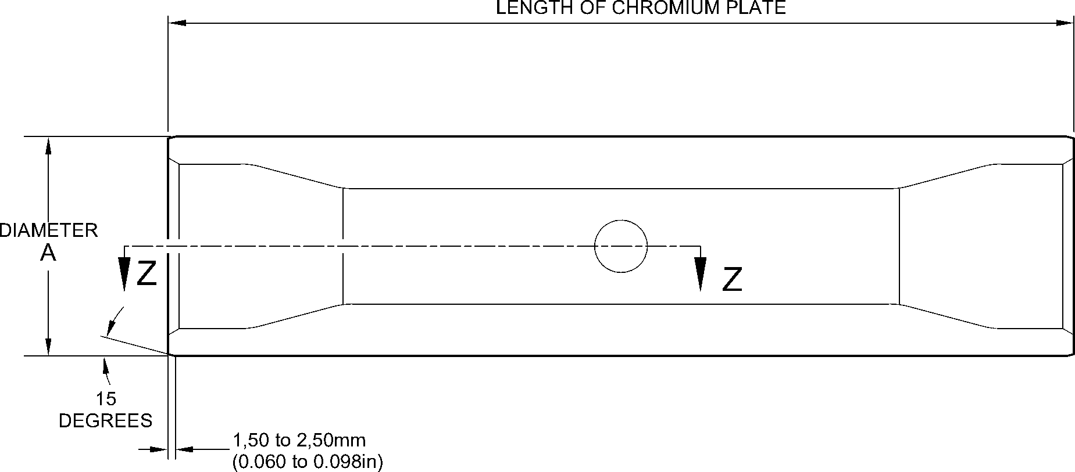

EDGES SMOOTHED OUT. CHROMIUM PLATE TERMINATION

CHROMIUM PLATE TERMINATION TO M-DLPS1031-7 or M-DLPS1031-8

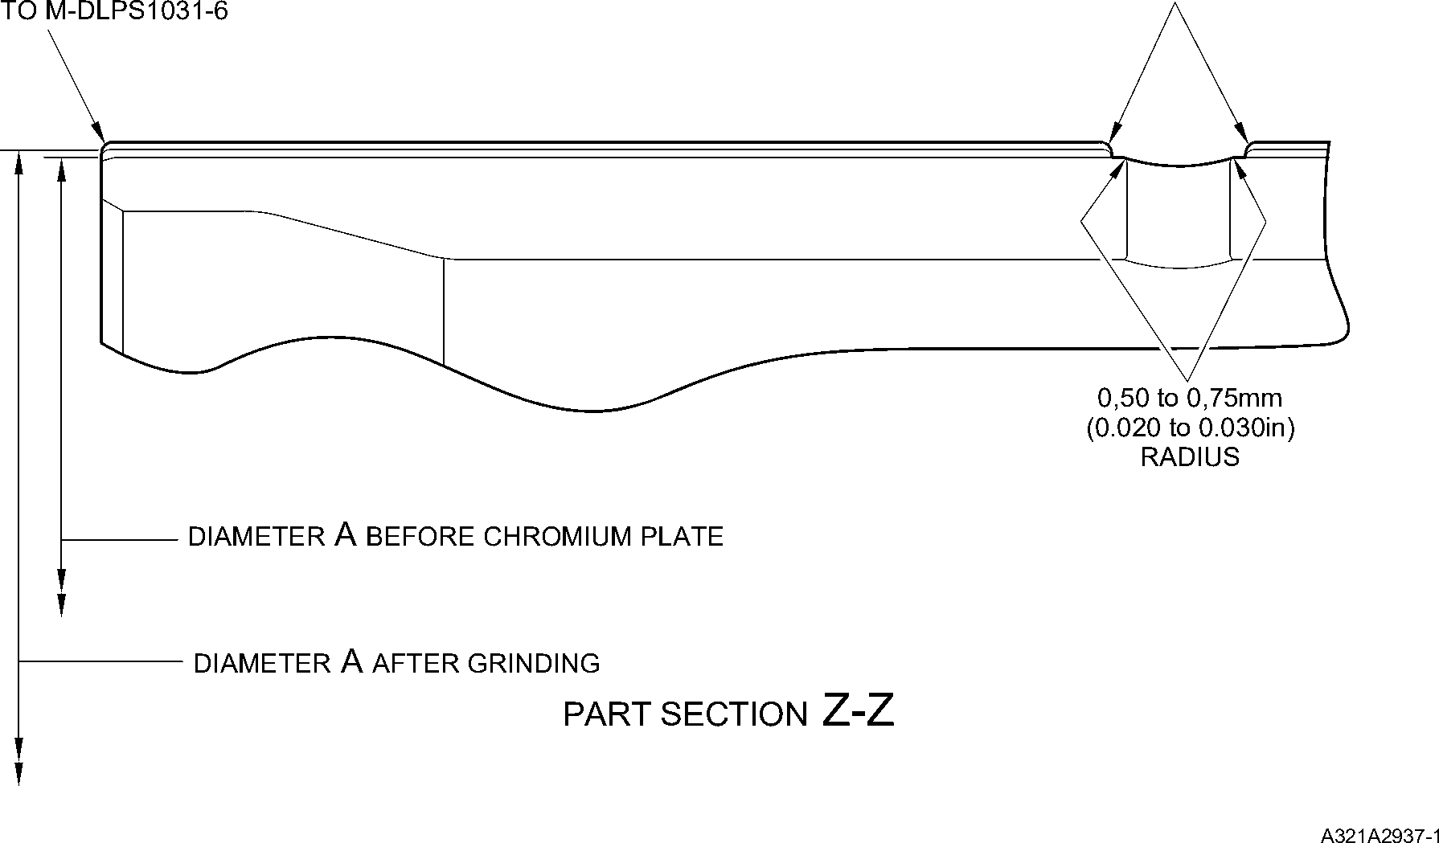

Repair to Pin  
Figure 601

Repair No. 7-1

32-12-22

Page 603

Dec 6/2019

**SAFRAN LANDING SYSTEMS UK Ltd**

CAGE: K0654



PART No. 201587001 AND 201587002 COMPONENT MAINTENANCE MANUAL  
MAIN LANDING GEAR LEG

INTENTIONALLY BLANK

Repair No. 7-1

32-12-22 Page 604

**SAFRAN LANDING SYSTEMS UK Ltd**

CAGE: K0654



PART No. 201587001 AND 201587002 COMPONENT MAINTENANCE MANUAL  
MAIN LANDING GEAR LEG

1. Repair No. 7-2 Pin (11-130)
2. Specified Damage and Material Specification.
3. Specified Damage

(a) Damage or corrosion to diameter A.

1. Material Specification

|  |  |  |
| --- | --- | --- |
| IPL Figure and Item No. | Name | Material Specification |
| 11-130 | Pin | UHT Steel (300M), MTL 1201 |

1. Special Tools
2. Special tools are not necessary.
3. Materials
4. These materials are necessary:

**NOTE: Alternative equivalents are permitted.**

|  |  |
| --- | --- |
| Ref. Item | Material |
| 08-665 | Adhesive (Loctite Grade 601) |

1. Repair Parts

(1) These repair parts are necessary:

|  |  |  |
| --- | --- | --- |
| Part No. | Repair Part | Material Specification |
| 450258431 | Repair sleeve (Qty 2) | Steel, S154 |

1. Procedure (Refer to Figure 601)

**CAUTION: FOR DAMAGE MORE THAN THE LIMITS OF THIS REPAIR SCHEME, WRITE  
TO MESSIER-DOWTY LTD: REFER TO GUIDE-CS-001.**

1. Machine diameter A just sufficiently to remove the damage or corrosion and to between  
   14,25 and 14,75 mm (0.561 and 0.581 in): refer to M-DLPS1004-4-1. The surface finish  
   must be 1,6 micrometers (63 micro-inches).
2. Examine the pin for flaws: refer to PCS-3600 and PCS-3100, inclusion class 4.
3. Measure and record the new diameters A.
4. Shot peen the reworked areas: refer to M-DLPS123 and Figure 601.
5. Locally apply cadmium plate to the reworked areas: refer to PCS-2141.
6. Identify the part with the Messier-Dowty Limited repair number 450258430 adjacent to  
   the part number: refer to PCS-6000-04.
7. Calculate diameter B of the repair sleeves:

Dia. B = Dia. A (as measured) + 0,010 to 0,039 mm (0.0004 to 0.0015 in).

Repair No. 7-2

Page 601

Dec 6/2019

32-12-22

**sSAFRAN SAFRAN LANDING SYSTEMS UK Ltd**

CAGE: K0654

PART No. 201587001 AND 201587002 COMPONENT MAINTENANCE MANUAL  
MAIN LANDING GEAR LEG

1. Refer to Figure 601 and machine the repair sleeves to the dimensions shown and  
   calculated.
2. Apply cadmium plate to the outside diameter and the chamfer of the repair sleeves: refer  
   to PCS-2101.
3. Apply adhesive, Material Ref. Item 08-665, to the outside diameter of the repair sleeves:  
   refer to PCS-5303.
4. Install the repair sleeves to diameters A until aligned with the outside diameter of the pin:  
   refer to M-DLPS1011-5.
5. Machine the bores of the repair sleeves to a diameter between 12,700 and 12,733 mm  
   (0.5000 and 0.5013 in). Machine the inner and outer ends of both sleeves to inner and  
   outer profile of the pin. Make the radius between 0,5 and 0,75 mm (0.020 and 0.029 in)  
   at inside and outside of both the sleeves: refer to Figure 601.
6. Locally apply cadmium plate to the reworked areas of the sleeves: refer to PCS-2141.
7. Identify the part with the Messier-Dowty Limited repair number 450258430 adjacent to  
   the part number: refer to PCS-6000-07.
8. Examine the part to make sure that you have obeyed all the repair instructions correctly.

32-12-22

Repair No. 7-2

Page 602

Dec 6/2019

**SAFRAN LANDING SYSTEMS UK Ltd**

CAGE: K0654



PART No. 201587001 AND 201587002 COMPONENT MAINTENANCE MANUAL  
MAIN LANDING GEAR LEG

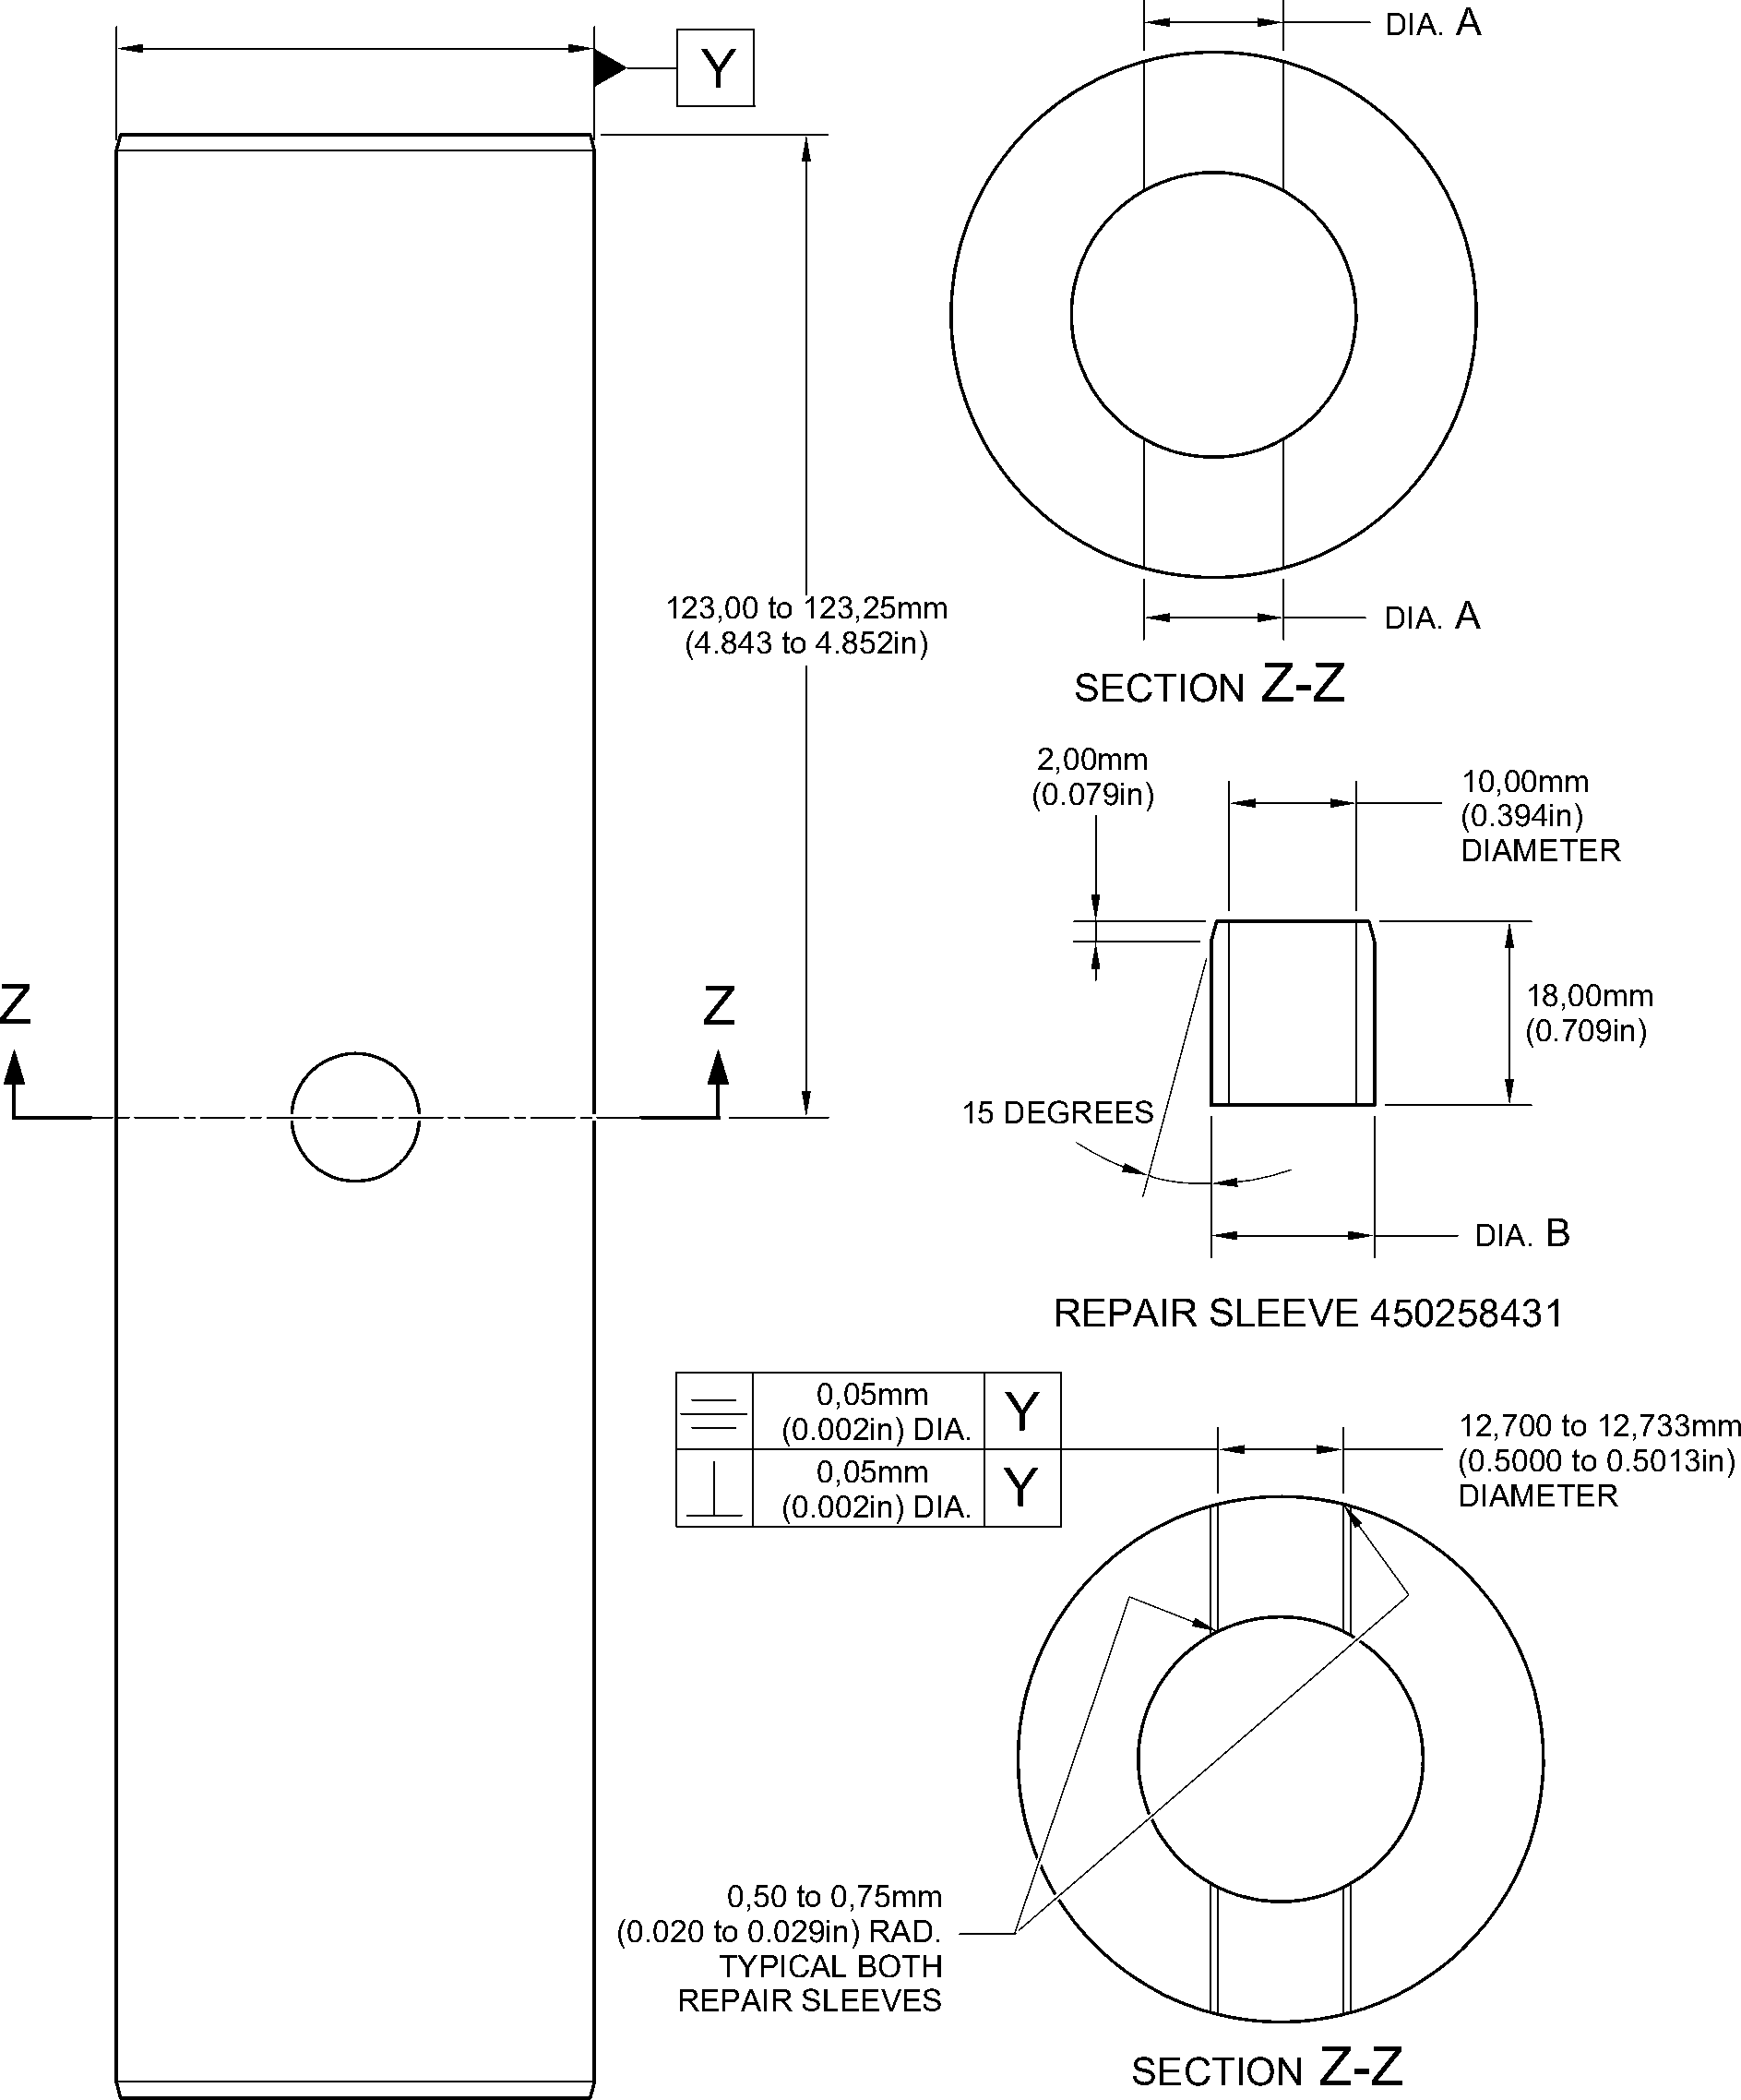

MACHINING REPAIR SLEEVE

A321-S-32-12-22-071-0

Repair to Pin  
Figure 601

Repair No. 7-2

Page 603

Dec 6/2019

32-12-22

**SAFRAN LANDING SYSTEMS UK Ltd**

CAGE: K0654



PART No. 201587001 AND 201587002 COMPONENT MAINTENANCE MANUAL  
MAIN LANDING GEAR LEG

INTENTIONALLY BLANK

32-12-22

Repair No. 7-2

Page 604

**SAFRAN LANDING SYSTEMS UK Ltd**

CAGE: K0654



PART No. 201587001 AND 201587002 COMPONENT MAINTENANCE MANUAL  
MAIN LANDING GEAR LEG

1. Repair No. 8-1 Bracket (5-300)
2. Specified Damage and Material Specification.
3. Specified Damage

(a) Damage or wear to the diameter A and/or the adjacent inside face.

1. Material Specification

|  |  |  |
| --- | --- | --- |
| IPL Figure and Item No. | Name | Material Specification |
| 5-300 | Bracket | Aluminium Alloy, L168T6511 |

1. Special Tools
2. These special tools are necessary:

**NOTE: Alternative equivalents are permitted.**

|  |  |  |
| --- | --- | --- |
| Part No. | Special Tool | Function |
| 460004330/85 | Press Pad | Install oversize bearing |
| 460004331/7 | Drift | Use with 460004330/85 |

1. Materials
2. These materials are necessary:

**NOTE: Alternative equivalents are permitted.**

|  |  |
| --- | --- |
| Ref. Item | Material |
| 09-510A | Sealant |

1. Repair Parts

(1) These repair parts are necessary:

|  |  |  |
| --- | --- | --- |
| Part No. | Repair Part | Material Specification |
| 450217858 | Oversize bearing | Steel, S145 |

1. Procedure (Refer to Figure 601)
2. Machine the diameter A to remove the minimum amount of material necessary to  
   remove the damage or wear: refer to Figure 601 for the dimensions. The surface finish  
   must be 1,6 micrometers (63 micro-inches).
3. Machine the face Q as necessary to remove damage or wear: refer to Figure 601 for the  
   dimensions. The surface finish must be 1,6 micrometers (63 micro-inches).
4. Machine the chamfer to the dimensions shown in Figure 601.
5. Measure and make a record of the new diameter A and the thickness of the lug D.
6. Examine the bracket for flaws: refer to PCS-3200.

Repair No. 8-1

Page 601

Dec 6/2019

32-12-22

**sSAFRAN SAFRAN LANDING SYSTEMS UK Ltd**

CAGE: K0654

PART No. 201587001 AND 201587002 COMPONENT MAINTENANCE MANUAL  
MAIN LANDING GEAR LEG

1. Prepare the machined surfaces of the bracket:

* anodize the surfaces: refer to M-DLPS102-1, or
* apply Alocrom to the surfaces: refer to PCS-2220.

1. Calculate the diameter B and the dimension C of the oversize bearing:

B = A (as measured) - 0,006 to + 0,023 mm (- 0.0002 to + 0.0009 in)  
C = D (as measured) - 0,15 to - 0,25 mm (- 0.006 to - 0.010 in).

1. Machine the oversize bearing to the dimensions shown and calculated: the surface  
   finish must be 1,6 micrometers (63 micro-inches).
2. Passivate the oversize bearing: refer to M-DLPS124.
3. Apply cadmium plate to the oversize bearing, but not on the internal diameter. The  
   thickness of the cadmium plate must be between 0,010 and 0,015 mm (0.0004 and  
   0.0006 in): refer to M-DLPS100-2S.
4. Use the Press Pad 460004330/85 and Drift 460004331/7 to install the oversize bearing  
   to the bracket: refer to M-DLPS1011-14. Check line ream the oversize bearing to the  
   dimension shown in Figure 601.
5. Apply sealant, Material Ref. Item 09-510A, to seal between the ends of the oversize  
   bearing and the bracket: refer to M-DLPS709-19.
6. Identify the part with the Messier-Dowty Limited repair number 450217195 adjacent to  
   the part number: refer to PCS-6000-05 and PCS-6000-07.
7. Examine the part to make sure that you have obeyed all the repair instructions correctly.

32-12-22

Repair No. 8-1

Page 602

Dec 6/2019

**SAFRAN LANDING SYSTEMS UK Ltd**

CAGE: K0654



PART No. 201587001 AND 201587002 COMPONENT MAINTENANCE MANUAL  
MAIN LANDING GEAR LEG

Z



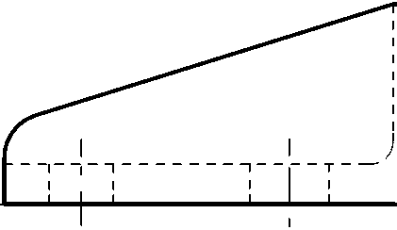

34,750 to 35,250mm  
(1.3681 to 1.3877in)

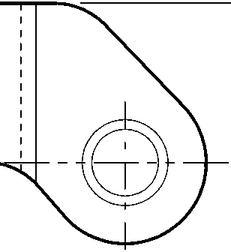

Z

24,750 to 25,250mm  
(0.9744 to 0.9940in)

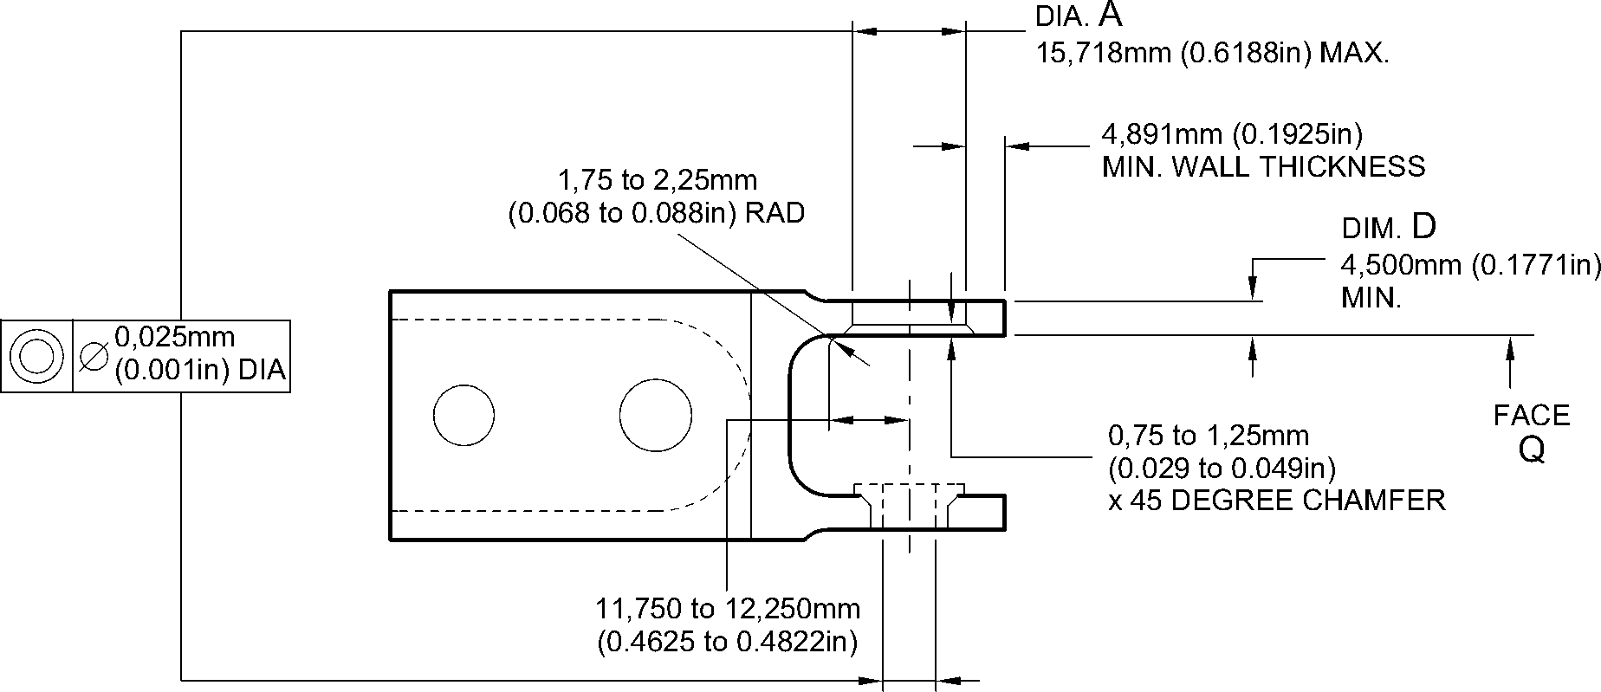

section Z-Z without bearing

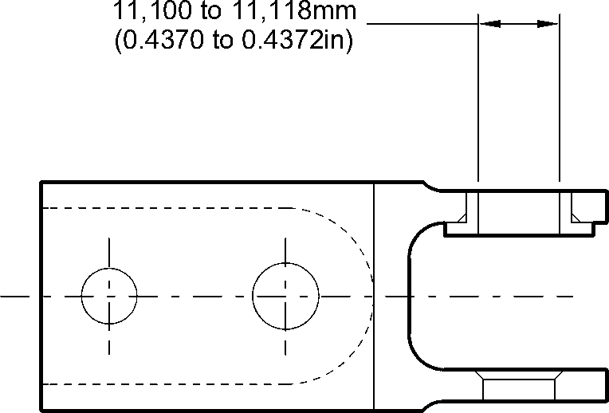

section Z-Z with bearing

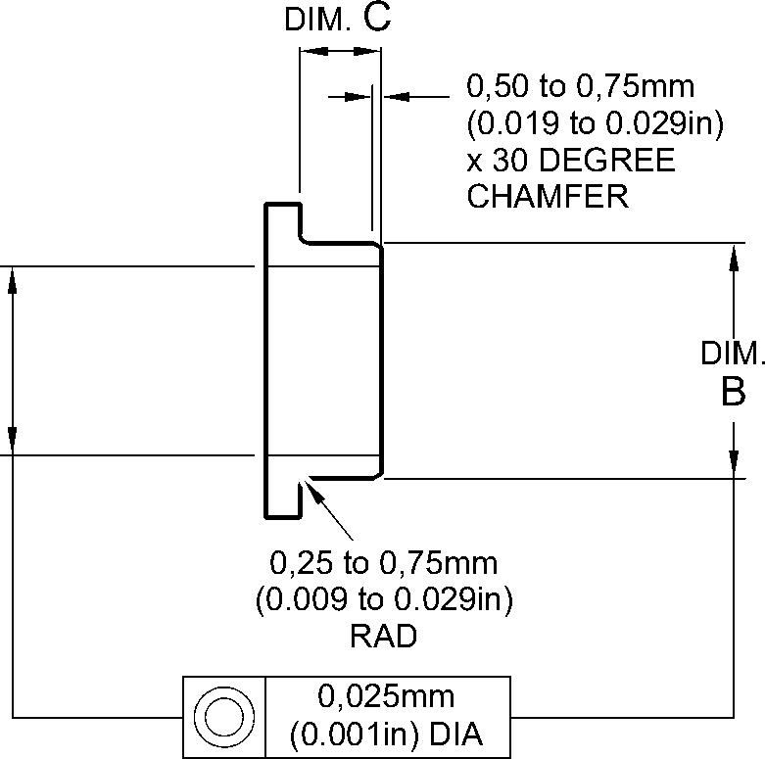

OVERSIZE BEARING - MACHINING

A321A3510-1

Repair to Bracket  
Figure 601

Repair No. 8-1

Page 603

Dec 6/2019

32-12-22

**SAFRAN LANDING SYSTEMS UK Ltd**

CAGE: K0654



PART No. 201587001 AND 201587002 COMPONENT MAINTENANCE MANUAL  
MAIN LANDING GEAR LEG

INTENTIONALLY BLANK

Repair No. 8-1

32-12-22 Page 604

**sSAFRAN SAFRAN LANDING SYSTEMS UK Ltd**

CAGE: K0654

PART No. 201587001 AND 201587002 COMPONENT MAINTENANCE MANUAL  
MAIN LANDING GEAR LEG

1. Repair No. 8-2 Bracket (5-300)
2. Specified Damage and Material Specification.
3. Specified Damage

(a) Damage or wear to the diameter A and/or the adjacent inside face.

1. Material Specification

|  |  |  |
| --- | --- | --- |
| IPL Figure and Item No. | Name | Material Specification |
| 5-300 | Bracket | Aluminium Alloy, L168T6511 |

1. Special Tools

(1) These special tools are necessary:

**NOTE: Alternative equivalents are permitted.**

|  |  |  |
| --- | --- | --- |
| Part No. | Special Tool | Function |
| 460004330/136 | Press Pad | Install the oversize bearing |
| 460004331/7 | Drift | Use with 460004330/136 |

1. Materials

(1) These materials are necessary:

**NOTE: Alternative equivalents are permitted.**

|  |  |
| --- | --- |
| Ref. Item | Material |
| 09-510A | Sealant |

1. Repair Parts

(1) These repair parts are necessary:

|  |  |  |
| --- | --- | --- |
| Part No. | Repair Part | Material Specification |
| 450217859 | Oversize bearing | Steel, S145 |

1. Procedure (Refer to Figure 601)
2. Machine the diameter A sufficiently to remove the damage or wear: refer to Figure 601  
   for the dimensions. The surface finish must be 1,6 micrometers (63 micro-inches).
3. Machine the face Q as necessary to remove the damage or wear: refer to Figure 601 for  
   the dimensions. The surface finish must be 1,6 micrometers (63 micro-inches).
4. Machine the chamfer to the dimensions shown in Figure 601.
5. Measure and make a record of the new diameter A and the thickness of the lug D.
6. Examine the bracket for flaws: refer to PCS-3200.

Repair No. 8-2

Page 601

Dec 6/2019

32-12-22

**sSAFRAN SAFRAN LANDING SYSTEMS UK Ltd**

CAGE: K0654

PART No. 201587001 AND 201587002 COMPONENT MAINTENANCE MANUAL  
MAIN LANDING GEAR LEG

1. Prepare the machined surfaces of the bracket:

* anodize the surfaces: refer to M-DLPS102-1, or
* apply Alocrom to the surfaces: refer to PCS-2220.

1. Calculate the diameter B and the dimension C of the oversize bearing:

B = A (as measured) - 0,006 to + 0,023 mm (- 0.0002 to + 0.0009 in)  
C = D (as measured) - 0,30 to - 0,40 mm (- 0.011 to - 0.015 in).

1. Machine the oversize bearing to the dimensions shown and calculated: the surface  
   finish must be 1,6 micrometers (63 micro-inches).
2. Passivate the oversize bearing: refer to M-DLPS124.
3. Apply cadmium plate to the oversize bearing, but not on the internal diameter. The  
   thickness of the cadmium plate must be between 0,010 and 0,015 mm (0.0004 and  
   0.0006 in): refer to M-DLPS100-2S.
4. Use the Press Pad 460004330/136 and Drift 460004331/7 to install the oversize bearing  
   to the bracket: refer to M-DLPS1011-14. Check line ream the oversize bearing to the  
   dimension shown in Figure 601.
5. Apply sealant, Material Ref. Item 09-510A, to seal between the ends of the oversize  
   bearing and the bracket: refer to M-DLPS709-19.
6. Identify the part with the Messier-Dowty Limited repair number 450217205 adjacent to  
   the part number: refer to PCS-6000-05.
7. Examine the part to make sure that you have obeyed all the repair instructions correctly.

32-12-22

Repair No. 8-2

Page 602

Dec 6/2019

**SAFRAN LANDING SYSTEMS UK Ltd**

CAGE: K0654



PART No. 201587001 AND 201587002 COMPONENT MAINTENANCE MANUAL  
MAIN LANDING GEAR LEG

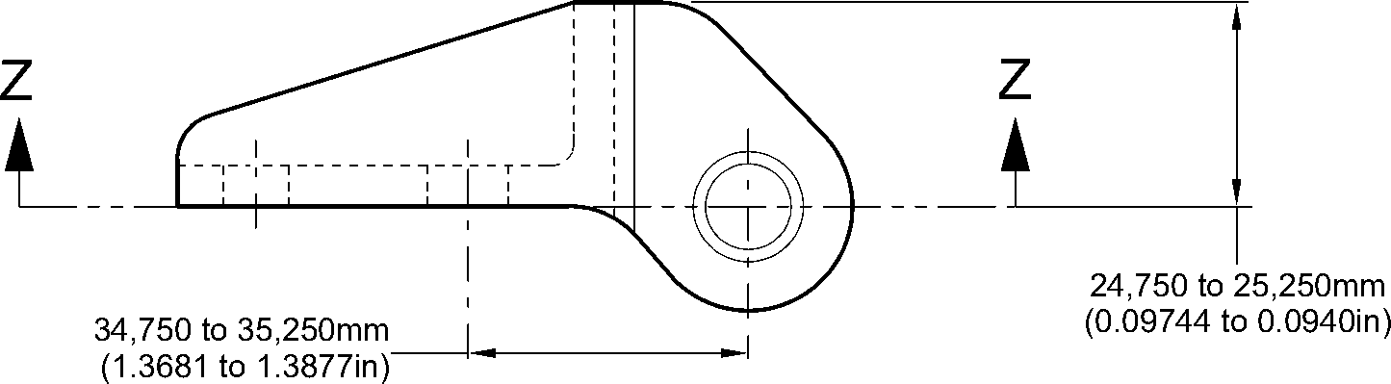

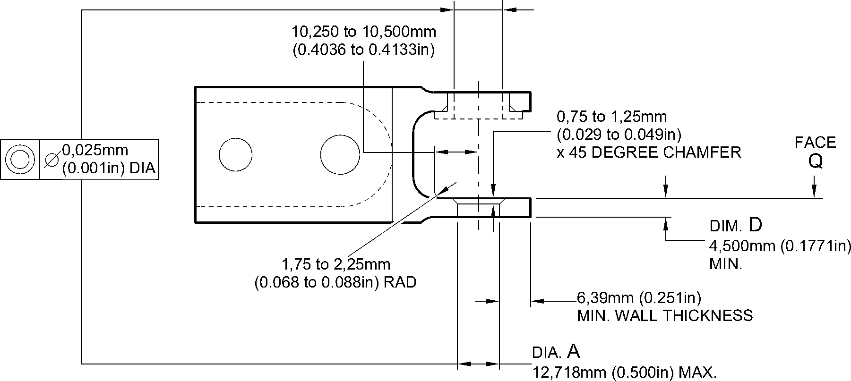

section Z-Z without bearing

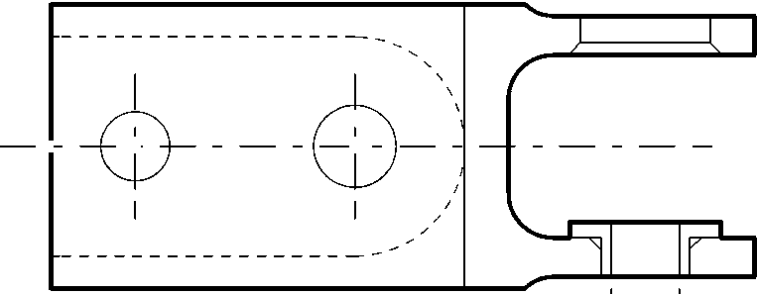

8,000 to 8,015mm  
(0.3150 to 0.3155in)

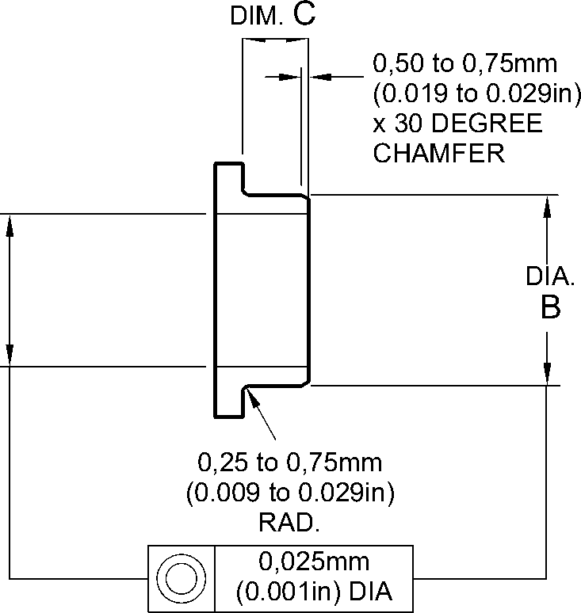

OVERSIZE BEARING - MACHINING

section Z-Z with bearing

A321A3511-1

Repair to Bracket  
Figure 601

Repair No. 8-2

Page 603

Dec 6/2019

32-12-22

**SAFRAN LANDING SYSTEMS UK Ltd**

CAGE: K0654



PART No. 201587001 AND 201587002 COMPONENT MAINTENANCE MANUAL  
MAIN LANDING GEAR LEG

INTENTIONALLY BLANK

Repair No. 8-2

32-12-22 Page 604

**SAFRAN LANDING SYSTEMS UK Ltd**

CAGE: K0654



PART No. 201587001 AND 201587002 COMPONENT MAINTENANCE MANUAL  
MAIN LANDING GEAR LEG

I 1. Repair No. 9-1 Sliding Tube (18-80 and 18-80A)

1. Specified Damage and Material Specification
2. Specified Damage

(a) Damage or corrosion to diameter A.

1. Material Specification

|  |  |  |
| --- | --- | --- |
| IPL Figure and Item No. | Name | Material Specification |
| 18-80 and  18-80A | Sliding tube | Steel, S155 (300M) |

1. Special Tools
2. Special tools are not necessary.
3. Materials
4. Materials are not necessary.
5. Repair Parts
6. Repair parts are not necessary.
7. Procedure (Refer to Figures 601 and 602)
8. Remove the chromium plate from diameter A: refer to PCS-2110.
9. If the base metal is not damaged or corroded:
10. Examine the sliding tube for flaws: refer to PCS-3100, inclusion class 4 and  
    PCS-3600.
11. Apply chromium plate to diameter A: refer to PCS-2110 Type C. Refer  
    to Figure 601 for chromium plate termination information.
12. Grind diameter A to between 177,68 and 177,72 mm (6.995 and 6.997 in).  
    The surface finish must be 0,25 micrometers (10 micro-inches).
13. Examine the ground chromium plate for flaws: refer to M-DLNDT3.
14. Identify the part with the Safran Landing Systems repair number

450258460A adjacent to the part number: refer to PCS-6000-19 and  
PCS-6000-07.

1. Examine the part to make sure that you have obeyed all the repair  
   instructions correctly.
2. If the base metal is damaged or corroded:
3. Machine diameter A just sufficiently to remove the damage or corrosion: refer  
   to M-DLPS1004-4-1. The diameter must not be less than 177,07 mm  
   (6.971 in). The surface finish must be 1,6 micrometers (63 micro-inches).
4. Examine the sliding tube for flaws: refer to PCS-3100, inclusion class 4 and  
   PCS-3600.
5. Shot peen the machined areas: refer to PCS-2300.

Repair No. 9-1

Page 601

Mar 18/2025

32-12-22

**sSAFRAN SAFRAN LANDING SYSTEMS UK Ltd**

CAGE: K0654

PART No. 201587001 AND 201587002 COMPONENT MAINTENANCE MANUAL  
MAIN LANDING GEAR LEG

4 Apply chromium plate to diameter A: refer to PCS-2110 Type C. Refer to  
M-DLPS1031 and Figure 602 for chromium plate termination information.

5 Grind diameter A to between 177,68 and 177,72 mm (6.995 and 6.997 in).  
The surface finish must be 0,25 micrometers (10 micro-inches).

1. Examine the ground chromium plate for flaws: refer to M-DLNDT3.
2. Identify the part with the Safran Landing Systems repair number

450258460B adjacent to the part number: refer to PCS-6000-19 and  
PCS-6000-07.

1. Examine the part to make sure that you have obeyed all the repair  
   instructions correctly.

32-12-22

Repair No. 9-1

Page 602

Mar 18/2025

**SAFRAN LANDING SYSTEMS UK Ltd**

CAGE: K0654



PART No. 201587001 AND 201587002 COMPONENT MAINTENANCE MANUAL  
MAIN LANDING GEAR LEG

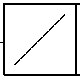

0,04mm  
(0.0016in)

Z

Y

531,00 to 533,00mm  
(20.906 to 20.984in)

X

Z

531,00 to 533,00mm  
(20.906 to 20.984in)

SMOOTH EDGE

0,40 to 1,00mm  
(0.016 to 0.039in) RADIUS

8,00 to 10,00mm  
(0.315 to 0.394in) RADIUS

dia A 1,6 BEFORE CHROMIUM

(63) PLATE

,25 AFTER CHROMIUM

(10) PLATE

2,00mm (0.079in)

CHROMIUM PLATE MUST  
TERMINATE IN THIS LENGTH.  
WAVY OR IRREGULAR LINE IS

PERMITTED

1,00mm (0.039in)

DIAMETER BEFORE CHROMIUM PLATE

detail X

DIAMETER AFTER GRINDING  
OF CHROMIUM PLATE

CHROMIUM PLATE DEPOSIT

2,00mm (0.079in)  
MAXIMUM

CHROMIUM PLATE MUST  
TERMINATE IN THIS LENGTH.  
WAVY OR IRREGULAR LINE IS  
PERMITTED

DIAMETER BEFORE CHROMIUM PLATE

SMOOTH EDGE

15,50 to 16,50mm  
(0.610 to 0.649in)  
RADIUS

18,00mm  
(0.709in)

DIAMETER AFTER GRINDING  
OF CHROMIUM PLATE

CHROMIUM PLATE DEPOSIT

detail Y

A321-S-32-12-22-025-0

Repair to Sliding Tube  
Figure 601

Repair No. 9-1

Page 603

Dec 6/2019

32-12-22

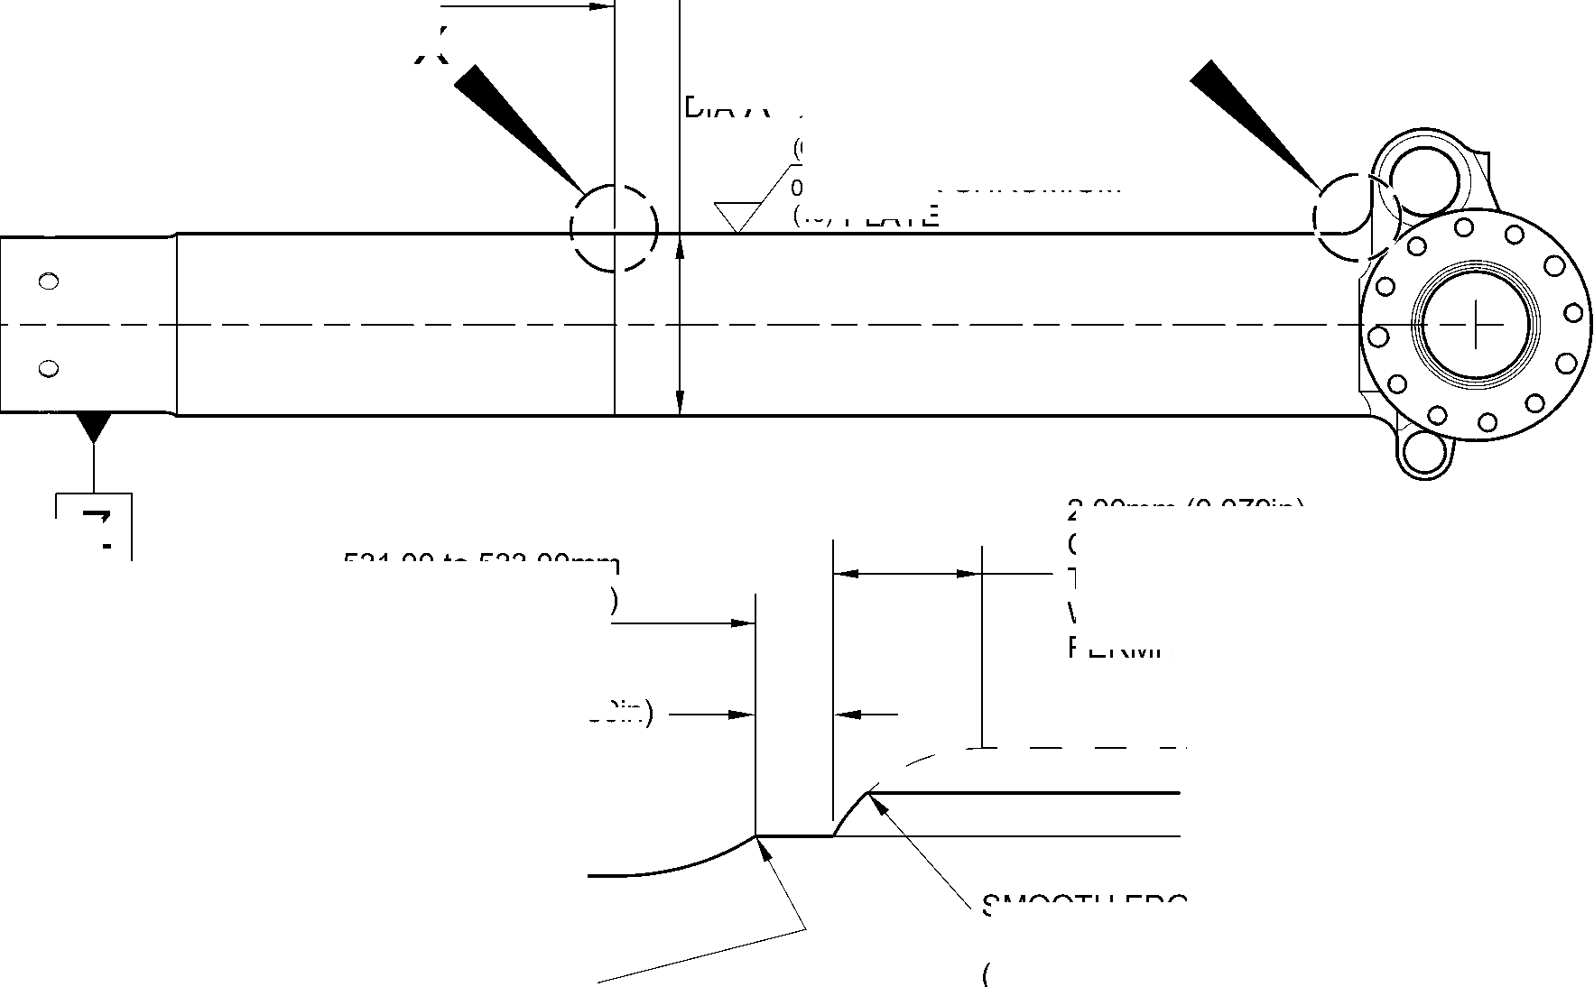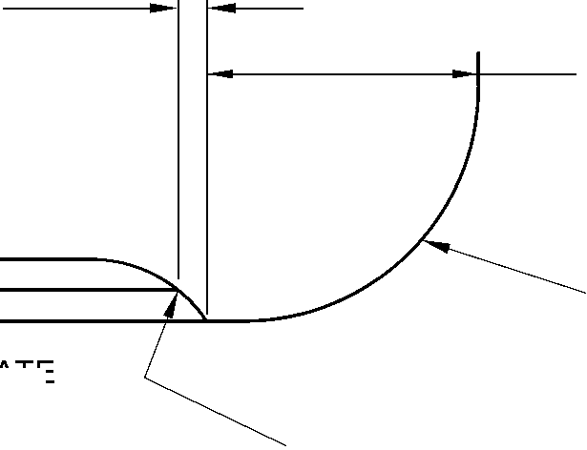

**SAFRAN LANDING SYSTEMS UK Ltd**

CAGE: K0654



PART No. 201587001 AND 201587002 COMPONENT MAINTENANCE MANUAL  
MAIN LANDING GEAR LEG

531,00 to 533,00mm  
(20.906 to 20.984in)  
REF.

EXTENT OF SHOT PEENING

17,75 to 18,25mm  
(0.699 to 0.719in)

0,75 to 1,25mm J  
(0.030 to 0.050in)

UNPLATED LENGTH

2,00mm (0.079in) MAX.

CHROMIUM PLATE MUST  
TERMINATE IN THIS LENGTH.  
WAVY OR IRREGULAR LINE IS PERMITTED

2,00mm (0.079in) MAX.

CHROMIUM PLATE MUST

TERMINATE IN THIS LENGTH.

WAVY OR IRREGULAR  
LINE IS PERMITTED

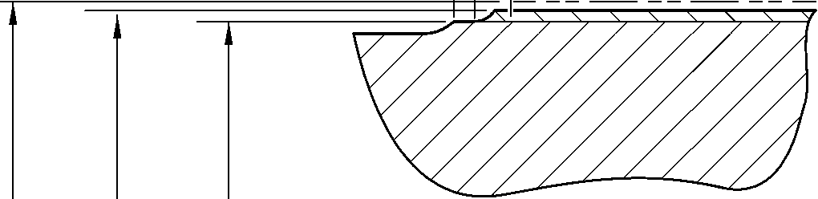

0,40 to 1,00mm  
(0.016 to 0.040in)

RADIUS

DETAIL **X**

(REFER TO FIGURE 601)

DETAIL **Y**

1,50 to 2,00mm  
(0.060 to 0.079in)  
RADIUS BEFORE  
CHROMIUM PLATE

(REFER TO FIGURE 601)

177,07mm (6.971in) MINIMUM DIAMETER  
BEFORE CHROMIUM PLATE

177,68 to 177,72mm (6.995 to 6.997in) DIAMETER  
AFTER GRINDING CHROMIUM PLATE

CHROMIUM PLATE DEPOSIT

A321-S-32-12-22-026-0

Repair to Sliding Tube  
Figure 602

32-12-22

Repair No. 9-1

Page 604

Dec 6/2019

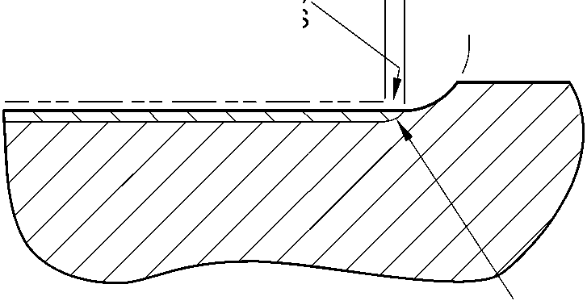

**sSAFRAN SAFRAN LANDING SYSTEMS UK Ltd**

CAGE: K0654

PART No. 201587001 AND 201587002 COMPONENT MAINTENANCE MANUAL  
MAIN LANDING GEAR LEG

I 1. Repair No. 9-2 Sliding Tube (18-80 and 18-80A)

1. Specified Damage and Material Specification.
2. Specified Damage

(a) Damage or corrosion to the chromium plate band(s) on one or both brake flanges.

1. Material Specification

|  |  |  |
| --- | --- | --- |
| IPL Figure and Item No. | Name | Material Specification |
| 18-80 and  18-80A | Sliding tube | Steel, S155 (300M) |

1. Special Tools
2. Special tools are not necessary.
3. Materials
4. Materials are not necessary.
5. Repair Parts
6. Repair parts are not necessary.
7. Procedure (Refer to Figure 601)

**CAUTION: REPAIR WILL NOT BE PERMITTED BEYOND THE LIMITS OF THIS REPAIR  
SCHEME.**

1. Remove the chromium plate band(s) from the brake flange(s): refer to M-DLPS101.
2. Remove the Sermetel W surface treatment from the sliding tube: refer to M-DLPS637.
3. Do this procedure if there is no damage to the parent metal:
4. Examine the sliding tube for flaws: refer to M-DLNDT6 and M-DLNDT2, inclusion  
   class 4.
5. Stress relieve the sliding tube for 4 hours at 185 to 195 oC (366 to 384 oF).
6. Apply chromium plate to make new band(s) on the flange face(s) using one of  
   these procedures: refer to Figure 601.

1 Apply chromium plate bands to the flange(s): refer to M-DLPS101-7. Grind  
the chromium plate to get the dimensions shown in Figure 601: the surface  
finish must be 2,5 micrometers (100 micro-inches). Examine the ground  
chromium plate for flaws: refer to M-DLNDT3.

OR

2 Apply chromium plate bands to the flange(s) to get a deposit that agrees with  
the dimensions shown in Figure 601: refer to M-DLPS101-7. The surface  
finish must be 2,5 micrometers (100 micro-inches).

1. Apply Sermetel W protective treatment: refer to M-DLPS637 and REPAIR,  
   Protective Treatment.

Repair No. 9-2

Page 601

Mar 18/2025

32-12-22

**sSAFRAN SAFRAN LANDING SYSTEMS UK Ltd**

CAGE: K0654

PART No. 201587001 AND 201587002 COMPONENT MAINTENANCE MANUAL  
MAIN LANDING GEAR LEG

1. Identify the part with the Safran Landing Systems repair number 450266100A  
   adjacent to the part number: refer to M-DLPS405-4.
2. Examine the part to make sure that you have obeyed all the repair instructions  
   correctly.
3. Do this procedure if there is corrosion or damage to the parent metal not more than  
   0,25 mm (0.010 in) deep.

**CAUTION: DO NOT MACHINE ALL OF THE FLANGE FACE.**

1. Locally make the area smooth and polish just sufficiently to remove the corrosion  
   or damage from the surface: the minimum flange width is 11,6 mm (0.456 in).
2. Examine the sliding tube for flaws: refer to M-DLNDT6 and M-DLNDT2, inclusion  
   class 4.
3. Stress relieve the sliding tube for 4 hours at 185 to 195 oC (366 to 384 oF).
4. Locally shot peen the sliding tube: refer to M-DLPS123.
5. Refer to Figure 601 and M-DLPS101-7. Apply chromium plate to make new bands  
   on the brake flange surface: make the chromium plate thicker in the areas where  
   the corrosion or damage has been removed.
6. Grind the chromium plate to the dimension shown: refer to Figure 601. The surface  
   finish must be 2,5 micrometers (100 micro-inches).
7. Examine the chromium plate surface: refer to M-DLNDT3.
8. Apply Sermetel W protective treatment: refer to M-DLPS637 and REPAIR,  
   Protective Treatment.
9. Identify the part with the Safran Landing Systems repair number 450266100B  
   adjacent to the part number: refer to M-DLPS405-4.
10. Examine the part to make sure that you have obeyed all the repair instructions  
    correctly.
11. Do this procedure if there is corrosion or damage to the parent metal more than 0,25 mm  
    (0.010 in) deep.

**CAUTION: DO NOT MACHINE ALL OF THE FLANGE FACE.**

1. Locally make the area smooth and polish just sufficiently to remove the corrosion  
   or damage from the face, the minimum flange width is 11,6 mm (0.456 in).
2. Examine the sliding tube for flaws: refer to M-DLNDT6 and M-DLNDT2, inclusion  
   class 4.
3. Stress relieve the sliding tube for 4 hours at 185 to 195 oC (366 to 384 oF).
4. Locally shot peen the sliding tube: refer to M-DLPS123, Almen A intensity of 0,010  
   to 0,014 mm (0.0004 to 0.0006 in).
5. Refer to M-DLPS200-4 and locally grit blast the sliding tube: give protection from  
   the grit blast to the areas adjacent to the flanges.

32-12-22

Repair No. 9-2

Page 602

Mar 18/2025

**sSAFRAN SAFRAN LANDING SYSTEMS UK Ltd**

CAGE: K0654

PART No. 201587001 AND 201587002 COMPONENT MAINTENANCE MANUAL  
MAIN LANDING GEAR LEG

1. Apply sulphamate nickel plate to the smoothed and polished areas. The  
   sulphamate nickel plate must fill the smoothed and polished areas and be 0,25 mm  
   (0.010 in) above the flange face. Refer to MIL STD 868A, solution 2.
2. De-embrittle the sliding tube for 23 hours at 185 to 195oC (366 to 384oF).
3. Machine the sulphamate nickel plate (do not grind), the machined surface must be  
   0,00 to 0,05 mm (0.000 to 0.002 in) above the brake flange surface. The surface  
   finish must be 1,6 micrometers (63 micro-inches).
4. Examine the sliding tube: refer to M-DLNDT6.
5. De-embrittle the sliding tube for 4 hours at 185 to 195oC (366 to 384oF).
6. If the parent metal was machined at para (h), examine the affected area for flaws:  
   refer to M-DLNDT2, inclusion class 4.
7. Shot peen the flange face(s) including the sulphamate nickel plated areas: refer to  
   M-DLPS123, Almen A intensity of 0,010 to 0,014 mm (0.0004 to 0.0006 in).
8. Refer to M-DLPS200-4 and locally grit blast the sliding tube: give protection from  
   the grit blast to the areas adjacent to the flanges.
9. Use 5 or 10 times magnification to examine the sulphamate nickel plate to make  
   sure the bond is satisfactory: do the repair again if the bond is not satisfactory.
10. Apply chromium plate to make new band(s) on the flange face(s) using one of  
    these procedures: refer to Figure 601.
11. Apply chromium plate to the bands: refer to M-DLPS101-7. Grind the  
    chromium plate to get the dimensions shown: the surface finish must be  
    2,5 micrometers (100 micro-inches). Examine the ground chromium plate for  
    flaws: refer to M-DLNDT3.

OR

1. Apply chromium plate to the band to the dimensions shown: refer to  
   M-DLPS101-7. The surface finish must be 2,5 micrometers  
   (100 micro-inches).
2. Apply Sermetel W protective treatment: refer to M-DLPS637 and REPAIR,  
   Protective Treatment.
3. Identify the part with the Safran Landing Systems repair number 450266100C  
   adjacent to the part number: refer to M-DLPS405-4.
4. Examine the part to make sure that you have obeyed all the repair instructions  
   correctly.

Repair No. 9-2

Page 603

Mar 18/2025

32-12-22

**SAFRAN LANDING SYSTEMS UK Ltd**

CAGE: K0654



PART No. 201587001 AND 201587002 COMPONENT MAINTENANCE MANUAL  
MAIN LANDING GEAR LEG

AREA OF CHROMIUM PLATE

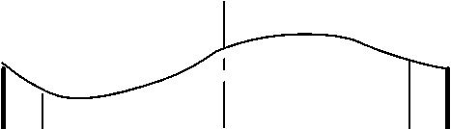



0,020 to 0,045mm  
(0.0008 to 0.0018in)

THICKNESS OF

CHROMIUM PLATE  
ABOVE OUTER  
SURFACE OF FLANGE

0 to 2,00mm  
(0 to 0.078in)  
CHROMIUM RUNOUT

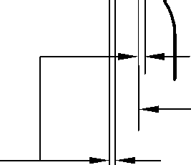

149,90mm  
(5.901in)

160,00mm  
(6.299in)  
section Z-Z

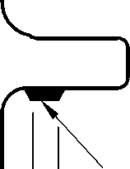

AREA OF CHROMIUM PLATE

NOTE:

THE CHROMIUM PLATE MUST  
NOT EXTEND BEYOND THE

DIMENSIONS SHOWN

A321A3513-1

Repair to Sliding Tube  
Figure 601

32-12-22

Repair No. 9-2

Page 604

Dec 9/2016

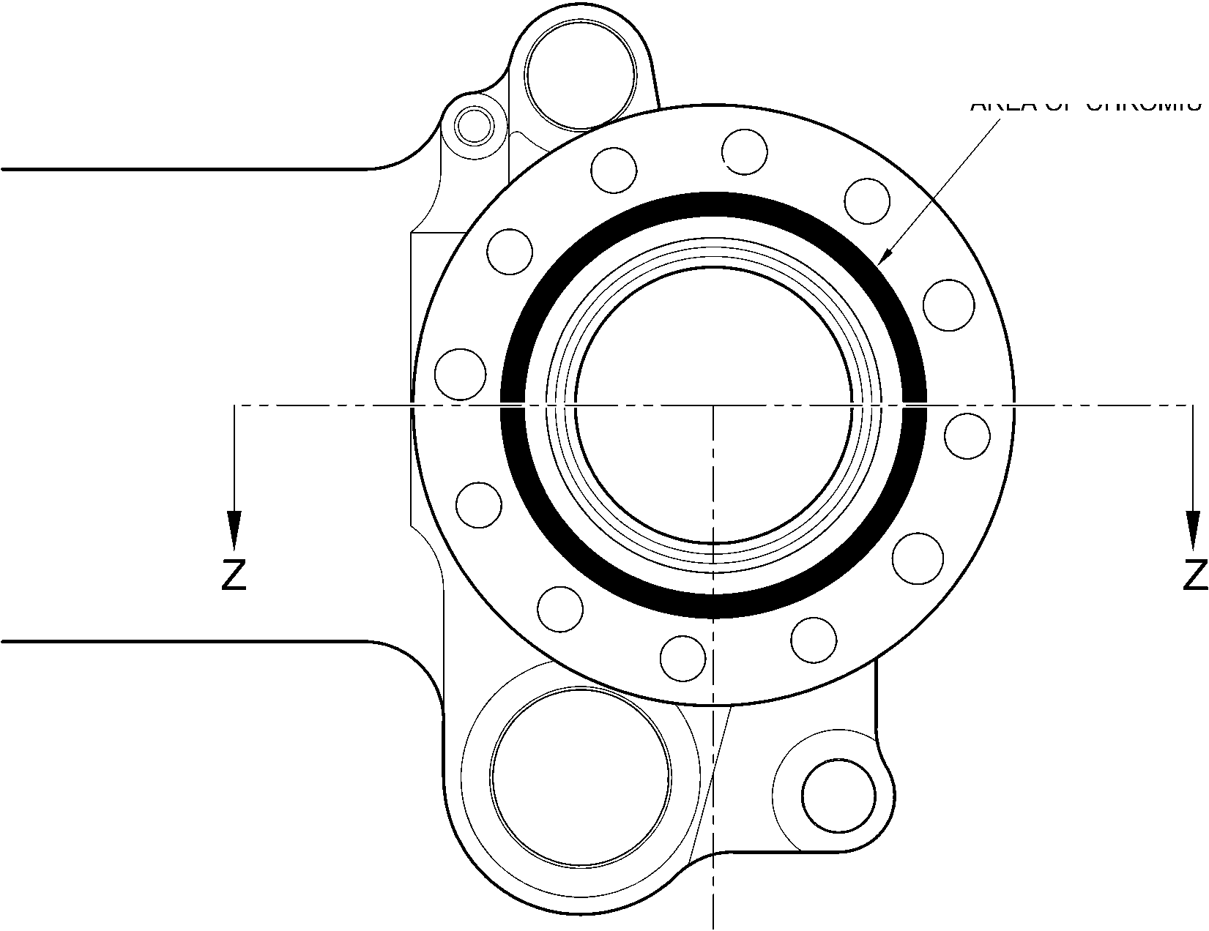

**SAFRAN LANDING SYSTEMS UK Ltd**

CAGE: K0654



PART No. 201587001 AND 201587002 COMPONENT MAINTENANCE MANUAL

MAIN LANDING GEAR LEG

1. Repair No. 9-3 Sliding Tube (18-80)

A. This Repair, Messier-Dowty Limited Repair No. 450258400, has been superseded by  
Repair No. 9-10, Messier-Dowty Limited Repair No. 450258401.

Repair No. 9-3

Page 601

Dec 6/2019

32-12-22

**SAFRAN LANDING SYSTEMS UK Ltd**

CAGE: K0654



PART No. 201587001 AND 201587002 COMPONENT MAINTENANCE MANUAL  
MAIN LANDING GEAR LEG

INTENTIONALLY BLANK

Repair No. 9-3

32-12-22 Page 602

**sSAFRAN SAFRAN LANDING SYSTEMS UK Ltd**

CAGE: K0654

PART No. 201587001 AND 201587002 COMPONENT MAINTENANCE MANUAL  
MAIN LANDING GEAR LEG

I 1. Repair No. 9-4 Sliding Tube (18-80 and 18-80A)

1. Specified Damage and Material Specification.
2. Specified Damage

(a) Damage or wear to the diameter(s) A.

1. Material Specification

|  |  |  |
| --- | --- | --- |
| IPL Figure and Item No. | Name | Material Specification |
| 18-80 and  18-80A | Sliding Tube | Steel, 300M |

1. Special Tools
2. These special tools are necessary:

**NOTE: Alternative equivalents are permitted.**

|  |  |  |
| --- | --- | --- |
| Part No. | Special tool | Function |
| 460004330/105 | Press Pad | Install the repair bush(es) |

1. Material.
2. Materials are not necessary.
3. Repair Parts
4. These repair parts are necessary:

**NOTE: Alternative equivalents are permitted.**

|  |  |  |
| --- | --- | --- |
| Part No. | Repair Part | Material Specification |
| 450266336 | Repair Bush (Qty 18) | Stainless Steel, AMS 5643 or 5659 |

1. Procedure (Refer to Figures 601 and 602).

**CAUTION: FOR DAMAGE MORE THAN THE LIMITS OF THIS REPAIR SCHEME, WRITE  
TO SAFRAN LANDING SYSTEMS: REFER TO GUIDE-CS-001.**

1. Do this procedure if there is a wear or damage to diameter(s) A:
2. Remove the paint locally from the sliding tube: refer to PCS-2700.
3. Remove the sermetel from the sliding tube: refer to M-DLPS637.
4. Remove the chromium plate locally from the sliding tube: refer to PCS-2110, type C  
   and Figure 601.
5. Machine diameter(s) A sufficiently to remove the damage or wear: refer to  
   M-DLPS900, M-DL PS1000 and Figure 601. Do not make diameter(s) A more than  
   18,568 mm (0.7310 in). Make the surface finish 1,6 micrometers (63 micro-inches).
6. Machine the chamfers and radii to the dimensions shown: refer to Figure 601.

Repair No. 9-4

Page 601

Mar 18/2025

32-12-22

**sSAFRAN SAFRAN LANDING SYSTEMS UK Ltd**

CAGE: K0654

PART No. 201587001 AND 201587002 COMPONENT MAINTENANCE MANUAL  
MAIN LANDING GEAR LEG

1. Measure and record the new diameter(s) A.
2. Examine the sliding tube for flaws: refer to PCS-3100 inclusion class 4 and  
   PCS-3600.
3. If necessary, shot peen the machined surfaces: refer to M-DLPS123.
4. Apply chromium plate to the reworked diameter(s) A: refer to PCS-2110, type C,  
   M-DLPS1031-5, M-DLPS1031-7 and Figure 601. Make the chromium plate  
   thickness between 0,020 and 0,025 mm (0.0008 and 0.0010 in).
5. Apply sermetel to the sliding tube: refer to REPAIR and M-DLPS637.
6. Identify the part with the Safran Landing Systems repair number 450266290  
   adjacent to the part number: refer to PCS-6000-05.
7. Calculate diameter C for the repair bushes, use the formula:

Dia. C = Dia. A (as measured) + 0,034 to -0,004 mm (+ 0.0013 to -0.0002 in).

1. Machine the face B to produce a flange thickness of 2,00 to 2,05 mm (0.079 to  
   0.080 in): refer to Figure 602. Make the surface finish 1,6 micrometers  
   (63 micro-inches).
2. Machine the repair bushes to the dimensions shown and calculated: refer to  
   Figure 602. Make the surface finish 1,6 micrometers (63 micro-inches).
3. Passivate the repair bushes: refer to AMS 2700.
4. Apply IVD alloy coating with chromation yellow all over the bushes, but not to the  
   bores: refer to ICT 40-893-01MD and Figure 602. The thickness of the coating  
   must be between 0,007 and 0,012 mm (0.0003 and 0.0005 in).
5. Apply primer paint to the sliding tube where the bush flanges will touch: refer to  
   PCS-2500.
6. Use the Press Pad 460004330/105 and install the repair bushes: refer to  
   M-DLPS1011-20.
7. Check the bore diameter of the repair bushes: refer to Figure 602.
8. If necessary, hone the bore diameter of repair bushes with a surface finish of  
   2,5 micrometers (100 micro-inches): refer to Figure 602.
9. Apply paint locally to the sliding tube: refer to REPAIR and PCS-2500.
10. Identify the part with the Safran Landing Systems repair number 450266290  
    adjacent to the part number: refer to PCS-6000-07.
11. Examine the part to make sure that you have obeyed all the repair instructions  
    correctly.

32-12-22

Repair No. 9-4

Page 602

Mar 18/2025

**SAFRAN LANDING SYSTEMS UK Ltd**

CAGE: K0654



PART No. 201587001 AND 201587002 COMPONENT MAINTENANCE MANUAL  
MAIN LANDING GEAR LEG

6.57  
DEGREES

30

DEGREES

30

DEGREES

30

DEGREES

192,000mm  
(7.5591in) DIA.

30

DEGREES

30

DEGREES

30

DEGREES

60

DEGREES

30

DEGREES

60

DEGREES

**Y**

6,85mm (0.270in)

MINIMUM WALL  
THICKNESS

DIA.  
A

0,05mm  
(0.002in)

30

DEGREES

2,00mm (0.080in)

x 45 DEGREES CHAMFER

0,40 to 1,00mm  
(0.016 to 0.040in)  
RAD.

0,50 to 2,00mm  
(0.020 to 0.080in)  
CHROMIUM PLATE

TERMINATION TO M-DLPS1031-5

PRIMER PAINT  
WHERE BUSH FLANGE

WILL TOUCH

SECTION **Z-Z**

(9 PLACES)  
(WITHOUT REPAIR BUSHES)

CHROMIUM  
PLATE

SERMETEL  
COATING

0,00 to 0,80mm  
(0.000 to 0.013in)  
CHROMIUM PLATE

TERMINATION TO M-DLPS1031-7

FINISH PAINT

DETAIL **Y**

A321A5544-2

Repair to Sliding Tube - Machining  
Figure 601

Repair No. 9-4

Page 603

Aug 11/2023

32-12-22

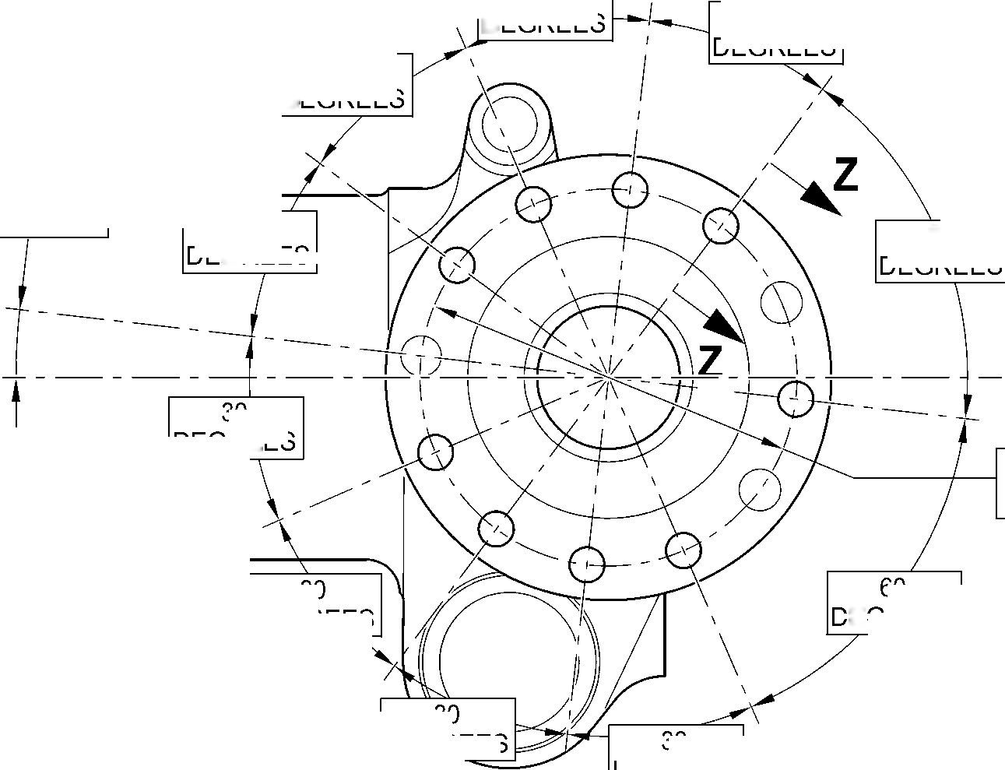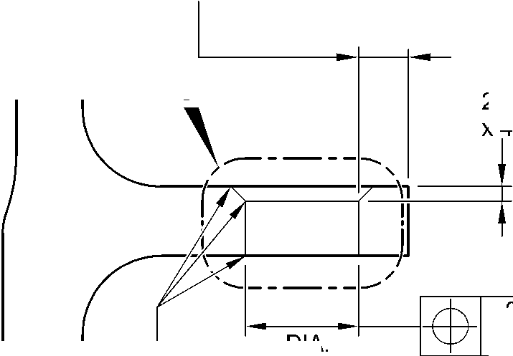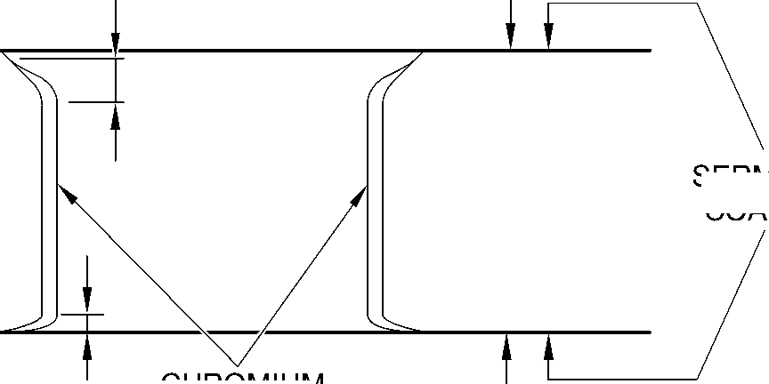

**SAFRAN LANDING SYSTEMS UK Ltd**

CAGE: K0654



PART No. 201587001 AND 201587002 COMPONENT MAINTENANCE MANUAL  
MAIN LANDING GEAR LEG

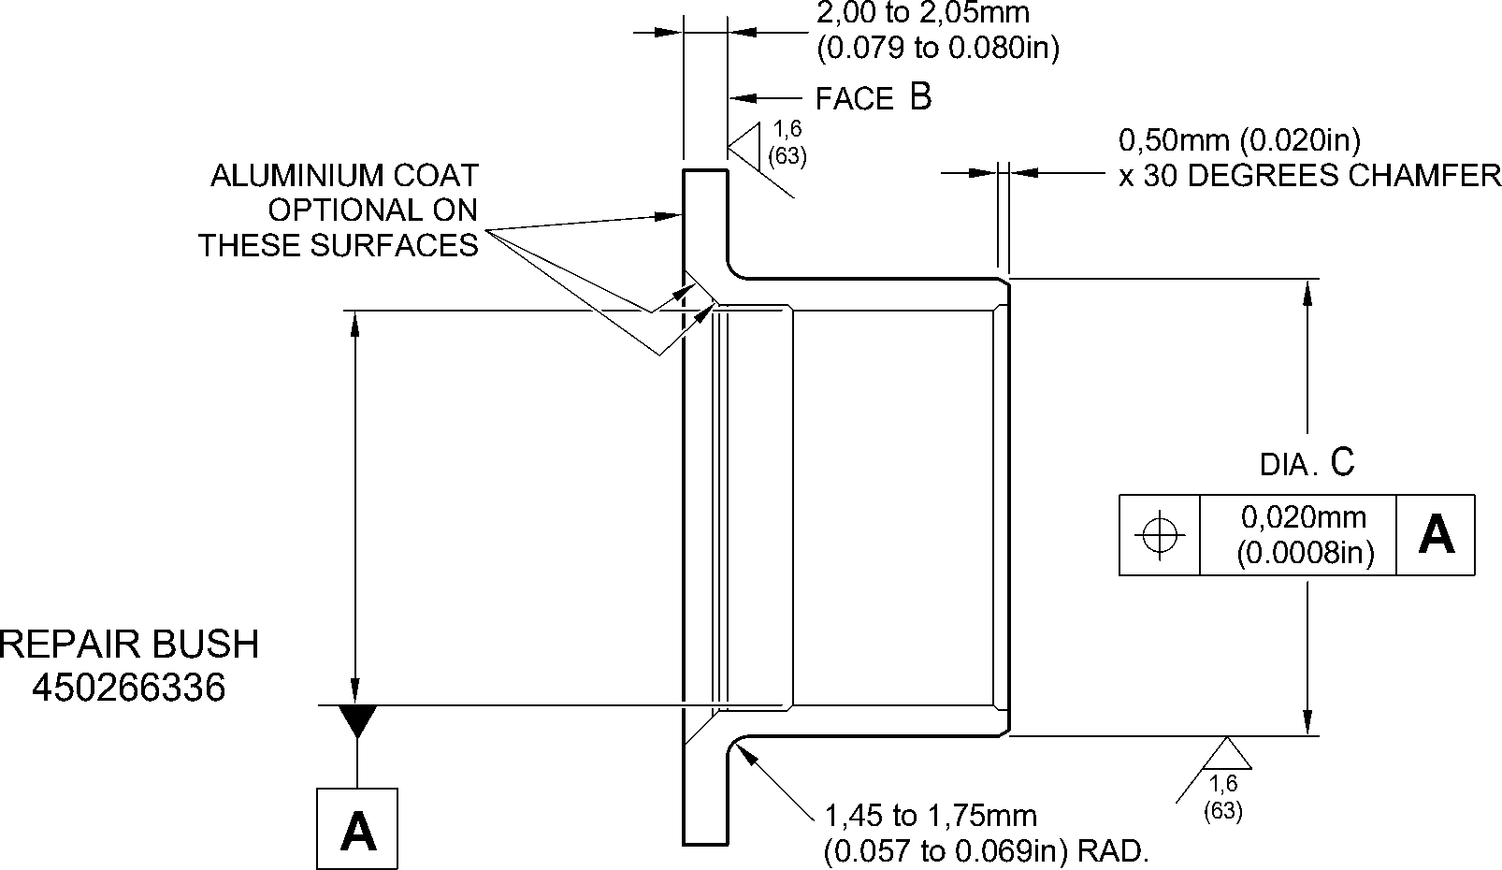

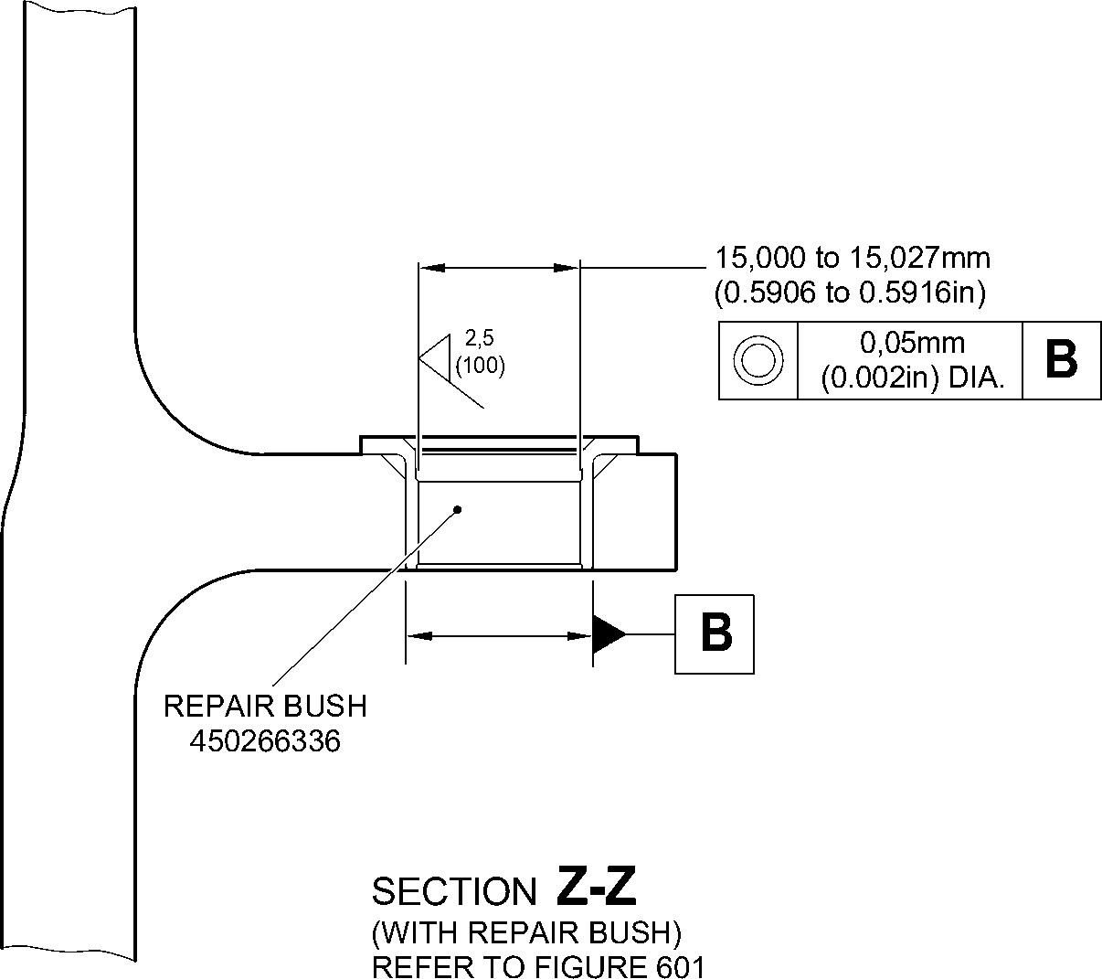

A321A5545-2

Repair Bush - Machining and Installation  
Figure 602

32-12-22

Repair No. 9-4

Page 604

Aug 11/2023

**sSAFRAN SAFRAN LANDING SYSTEMS UK Ltd**

CAGE: K0654

PART No. 201587001 AND 201587002 COMPONENT MAINTENANCE MANUAL  
MAIN LANDING GEAR LEG

I 1. Repair No. 9-5 Sliding Tube (18-80 and 18-80A)

1. Specified Damage and Material Specification.
2. Specified Damage

(a) Damage or wear to diameter A.

1. Material Specification

|  |  |  |
| --- | --- | --- |
| IPL Figure and Item No. | Name | Material Specification |
| 18-80 and  18-80A | Sliding tube | Steel, 300M |

1. Special Tools
2. Special tools are not necessary.
3. Materials
4. Materials are not necessary.
5. Repair Parts
6. Repair parts are not necessary.
7. Procedure (Refer to Figure 601)
8. Do this procedure only if the base metal is not damaged.

**CAUTION: REPAIR WILL NOT BE PERMITTED BEYOND THE LIMITS OF THIS REPAIR  
SCHEME.**

1. Remove the chromium plate from sliding tube: refer to PCS-2110, type C.
2. Examine the sliding tube for flaws: refer to PCS-3100, inclusion class 4 and  
   PCS-3600.

**CAUTION: DO NOT USE A MECHANICAL MOP POLISHER TO GET THE  
SURFACE FINISH.**

1. Apply chromium plate to the diameter A: refer to PCS-2110, type C and Figure 601.  
   Make the surface finish 1,6 micrometers (64 micro-inches). The chromium plate  
   thickness must be between 0,020 and 0,025 mm (0.0008 and 0.0010 in).
2. Identify the part with the Safran Landing Systems repair number 450237720  
   adjacent to the part number: refer to PCS-6000-19.
3. Examine the part to make sure that you have obeyed all the repair instructions  
   correctly.

Repair No. 9-5

Page 601

Mar 18/2025

32-12-22

**SAFRAN LANDING SYSTEMS UK Ltd**

CAGE: K0654



PART No. 201587001 AND 201587002 COMPONENT MAINTENANCE MANUAL  
MAIN LANDING GEAR LEG

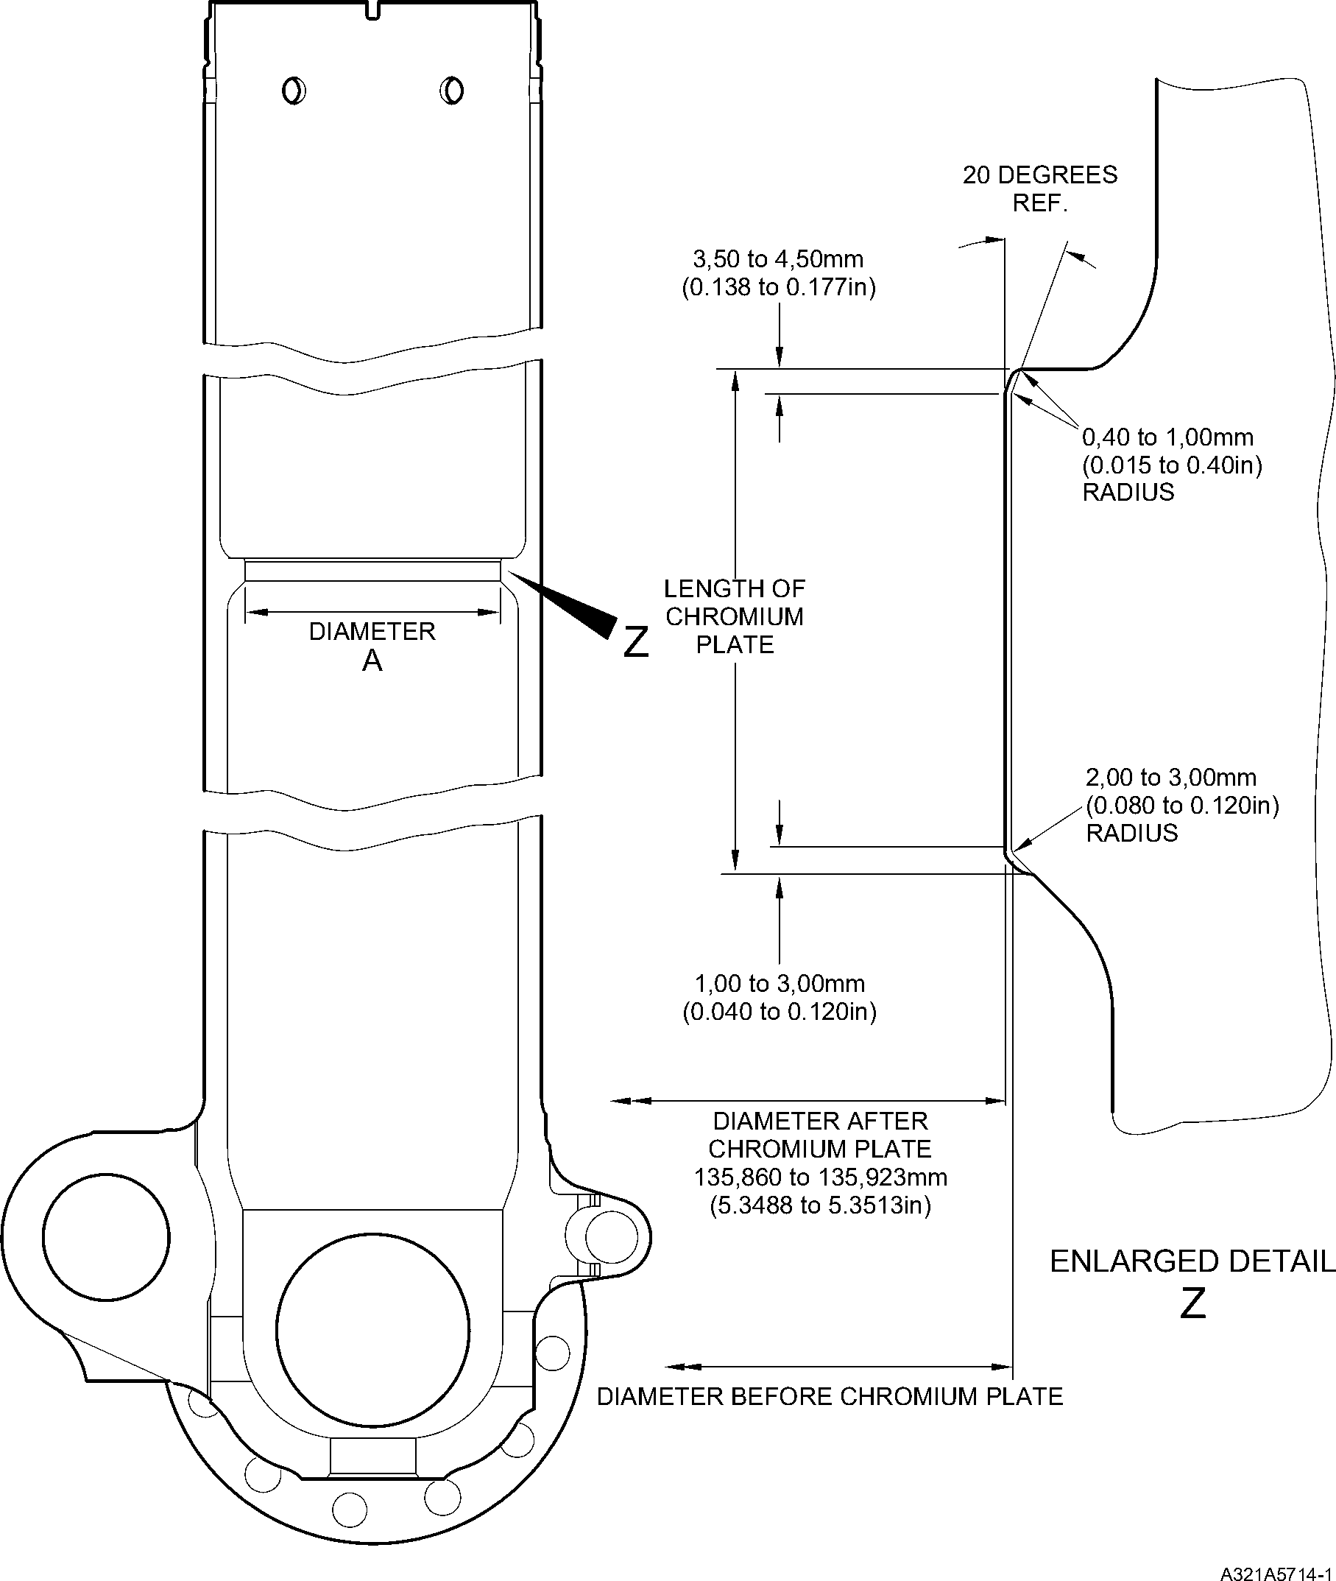

Repair to Sliding Tube  
Figure 601

32-12-22

Repair No. 9-5

Page 602

Dec 6/2019

**SAFRAN LANDING SYSTEMS UK Ltd**

CAGE: K0654



PART No. 201587001 AND 201587002 COMPONENT MAINTENANCE MANUAL  
MAIN LANDING GEAR LEG

I 1. Repair No. 9-6 Sliding Tube (18-80 and 18-80A)

1. Specified Damage and Material Specification.
2. Specified Damage

(a) Damage or corrosion to diameter A.

1. Material Specification

|  |  |  |
| --- | --- | --- |
| IPL Figure and item No. | Name | Material Specification |
| 18-80 and  18-80A | Sliding tube | Steel, S155 (300M) |

1. Special Tools
2. Special tools are not necessary.
3. Materials
4. Materials are not necessary.
5. Repair Parts
6. Repair parts are not necessary.
7. Procedure (Refer to Figure 601)
8. Do this procedure if both the chromium plate and the base metal are damaged.

**NOTE: Refer to** **Repair No. 9-5****, if only the chromium plate is damaged.**

1. Machine diameter A to remove the damage or corrosion within the dimensions  
   shown: refer to M-DLPS1004-4-1 and Figure 601.
2. Machine the radii to the dimensions as shown: refer to Figure 601.
3. Identify the part with the Safran Landing Systems repair number 450258470  
   adjacent to the part number: refer to PCS-6000-04.
4. Examine the reworked area for flaws: refer to PCS-3600 and PCS-3100, inclusion  
   class 4.
5. Shot peen the machined areas: refer to M-DLPS123.
6. Apply Sulphamate Nickel plate to diameter A: refer to PCS-2120 for sequence of  
   operations and to MIL-STD-868A solution 2 and Figure 601.

**NOTE: This operation includes 23 hours de-embrittle at 177 to 205 oC (350 to  
400 oF).**

1. Machine (do not grind) the sulphamate nickel plate to the dimensions shown: refer  
   to Figure 601.
2. Only required, if the parent metal was machined at step (g), examine the machined  
   area for flaws: refer to PCS-3600.

**NOTE: This operation includes 4 hours de-embrittle at 177 to 205 oC (350 to**

**400 oF).**

Repair No. 9-6

Page 601

Mar 18/2025

32-12-22

**sSAFRAN SAFRAN LANDING SYSTEMS UK Ltd**

CAGE: K0654

PART No. 201587001 AND 201587002 COMPONENT MAINTENANCE MANUAL  
MAIN LANDING GEAR LEG

1. Only required, if the parent metal was machined at step (g), examine the machined  
   area for flaws: refer to PCS-3100, inclusion class 4.
2. Shot peen the machined areas: refer to M-DLPS123.
3. Grit blast the shot peened area: refer to PCS-2610. Make sure that the sliding tube  
   is correctly masked.
4. Examine the edges of sulphamate nickel plate to make sure they are properly  
   bonded: use 5 or 10X magnification.
5. If there is evidence of delamination, remove the sulphamate nickel plate and do the  
   repair again.

**CAUTION: DO NOT USE A MECHANICAL MOP POLISHER TO GET THE  
SURFACE FINISH.**

1. Apply chromium plate to the diameter A: refer to PCS-2110 type C and Figure 601.  
   Make the chromium plate thickness between 0,020 and 0,025 mm (0.0008 and  
   0.0010 in). Make the surface finish 1,6 micrometers (63 micro-inches).

**NOTE: This operation includes 18 hours de-embrittle at 177 to 205 oC (350 to  
400 oF).**

1. Identify the part with the Safran Landing Systems repair number 450258470  
   adjacent to the part number: refer to PCS-6000-07.
2. Examine the part to make sure that you have obeyed all the repair instructions  
   correctly.

32-12-22

Repair No. 9-6

Page 602

Mar 18/2025

**SAFRAN LANDING SYSTEMS UK Ltd**

CAGE: K0654

PART No. 201587001 AND 201587002 COMPONENT MAINTENANCE MANUAL  
MAIN LANDING GEAR LEG

Y

Z

LENGTH OF  
NICKEL PLATE

LENGTH OF  
CHROMIUM  
PLATE

2,00 to 3,00mm  
(0.079 to 0.118in)

RADIUS

0,40 to 1,00mm  
(0.015 to 0.40in)  
RADIUS

20 DEGREES  
REF.

DIAMETER

Y

A321A6706-1

0,04mm  
(0.0016in)

DIAMETER BEFORE NICKEL  
AND CHROMIUM PLATE

136,410mm (5.3700in) MAXIMUM

DIAMETER AFTER MACHINING  
NICKEL PLATE  
135,910 to 135,963mm  
(5.3508 to 5.3529in)

3,50 to 4,50mm

(0.138 to 0.177in)

1,00 to 3,00mm  
(0.040 to 0.120in)

DIAMETER AFTER  
CHROMIUM PLATE  
135,860 to 135,923mm  
(5.3488 to 5.3513in)

ENLARGED DETAIL

Z

Repair to Sliding Tube  
Figure 601

Repair No. 9-6

Page 603

Dec 6/2019

32-12-22

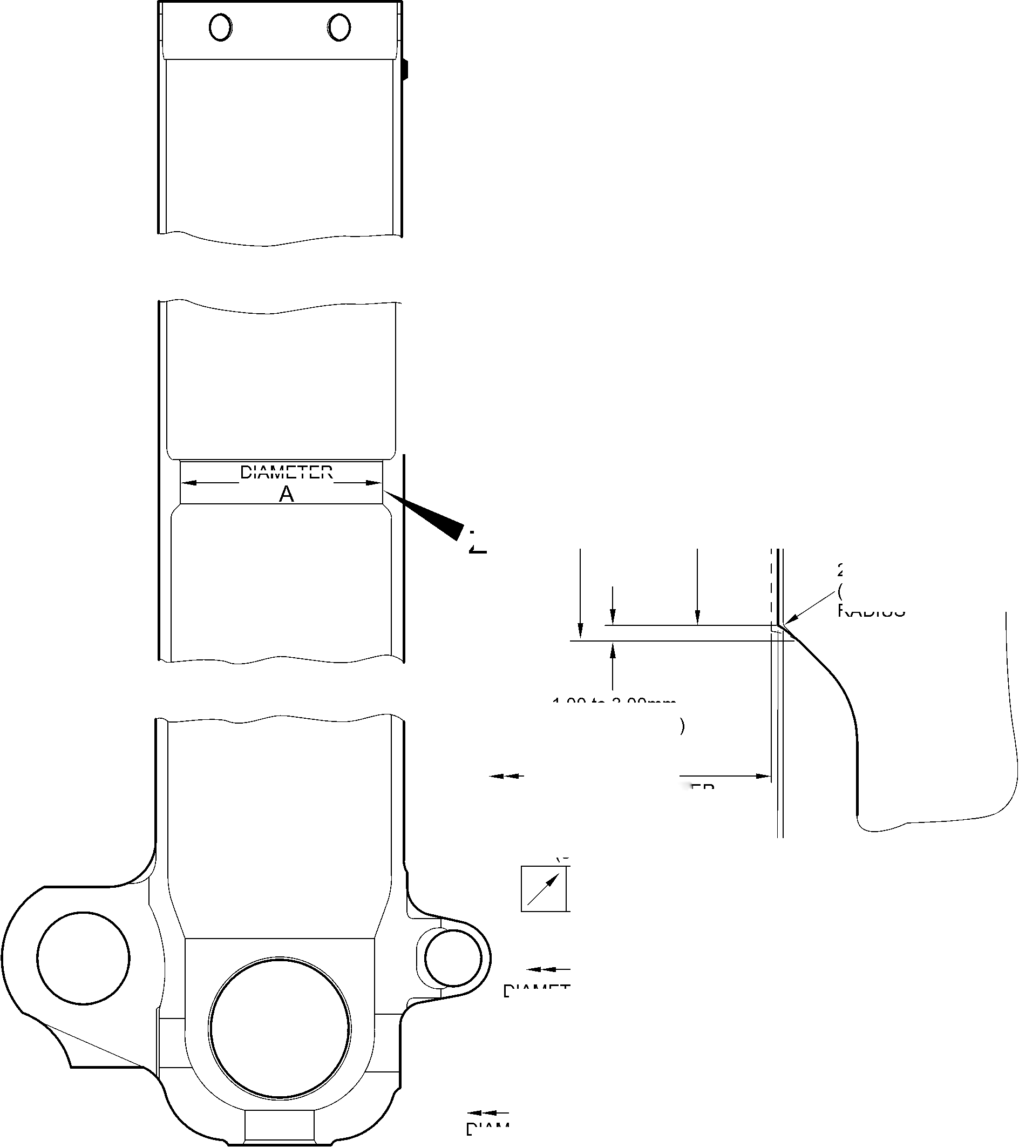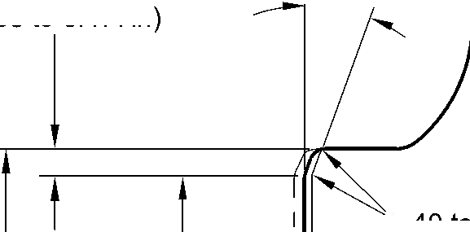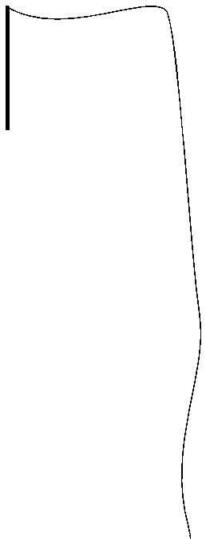

**SAFRAN LANDING SYSTEMS UK Ltd**

CAGE: K0654



PART No. 201587001 AND 201587002 COMPONENT MAINTENANCE MANUAL  
MAIN LANDING GEAR LEG

INTENTIONALLY BLANK

Repair No. 9-6

32-12-22 Page 604

**SAFRAN LANDING SYSTEMS UK Ltd**

CAGE: K0654



PART No. 201587001 AND 201587002 COMPONENT MAINTENANCE MANUAL  
MAIN LANDING GEAR LEG

I 1. Repair No. 9-7 Sliding Tube (18-80 and 18-80A)

1. Specified Damage and Material Specification.
2. Specified Damage

(a) Damage or wear to diameter(s) A and faces D and E.

1. Material Specification

|  |  |  |
| --- | --- | --- |
| IPL Figure and Item No. | Name | Material Specification |
| 18-80 and  18-80A | Sliding Tube | Steel to 300M |

1. Special Tools
2. These special tools are necessary:

**NOTE: Alternative equivalents are permitted.**

|  |  |  |
| --- | --- | --- |
| Part No. | Special Tool | Function |
| 460004330/117 | Press Pad | Install oversize bushes |

1. Materials
2. These materials are necessary:

**NOTE: Alternative equivalents are permitted.**

|  |  |
| --- | --- |
| Ref. Item | Material |
| TBA | Zinc Powder |
| 05-533 | Mastinox D40 |
| 09-510A | Sealant |

1. Repair Parts
2. These repair parts are necessary:

|  |  |  |
| --- | --- | --- |
| Part No. | Repair Part | Material Specification |
| 450258028 | Repair bush (Qty 2) | Aluminium Bronze |

1. Procedure (Refer to Figures 601 and 602)

**CAUTION: FOR DAMAGE MORE THAN THE LIMITS OF THIS REPAIR SCHEME, WRITE  
TO MESSIER-DOWTY LIMITED: REFER TO GUIDE-CS-001.**

1. Remove the paint locally from the sliding tube: refer to PCS-2700.
2. Remove the cadmium plate locally from the sliding tube: refer to PCS-2100.

Repair No. 9-7

Page 601

Mar 18/2025

32-12-22

**sSAFRAN SAFRAN LANDING SYSTEMS UK Ltd**

CAGE: K0654

PART No. 201587001 AND 201587002 COMPONENT MAINTENANCE MANUAL  
MAIN LANDING GEAR LEG

1. Machine diameter(s) A sufficiently to remove the minimum amount of material necessary  
   to remove the wear or damage within the dimensions shown: refer to M-DLPS1004-4-1  
   and Figure 601. Make the surface finish 1,6 micrometers (63 micro-inches).
2. Machine the adjacent spotfaces D and E to remove any damage or wear, within the  
   dimensions shown: refer to Figure 601. Make the surface finish 1,6 micrometers  
   (63 micro-inches).
3. Machine the chamfers and radii to the dimensions shown: refer to Figure 601.
4. Measure and record the new diameter(s) A.
5. Examine the machined areas for flaws: refer to PCS-3600 and PCS-3100, inclusion  
   class 4.
6. Shot peen the machined areas: refer to M-DLPS123.
7. Apply cadmium plate to the reworked areas: refer to PCS-2100 or PCS-2141.
8. Identify the part with the Messier-Dowty Limited repair number 450265140 adjacent to  
   the part number: refer to PCS-6000-05.
9. Calculate diameter B of each repair bush (qty 2), use the formula:

B = A (as measured) - 0,006 mm (0.0002 in) to + 0,028 mm (0.0011 in).

1. Machine the repair bushes to the dimensions shown and calculated. Machine face C to  
   get the correct dimensions after installation: refer to Figure 602. Make the surface finish  
   1,6 micrometers (63 micro-inches). The bushes must not protrude through the lug after  
   installation.
2. Apply cadmium to the repair bushes, but not to the bores and the flange faces: refer to  
   PCS-2101 and Figure 602. The cadmium plate thickness must be between 0,010 and  
   0,015 mm (0.0004 and 0.0006 in).
3. Apply primer paint to the sliding tube where the bush flanges will touch: refer to  
   PCS-2500.
4. Use Press Pad 460004330/117 and install the repair bushes: refer to M-DLPS1011-20.  
   Use electrically conducting Mastinox (made from Mastinox D40, Material Ref.  
   Item 05-533 and Zinc powder, Material Ref. Item TBA): refer to M-DLPS709-14.
5. Check the bores of the repair bushes: refer to Figure 602.
6. If necessary, hone the bores of the repair bushes to the dimensions shown: refer to  
   Figure 602. Make the surface finish 2,5 micrometers (100 micro-inches).
7. Apply paint to the repaired area, but not to the bushes: refer to PCS-2500.
8. Apply sealant, Material Ref. Item 09-510A, around the joints between the repair bushes  
   and the sliding tube: refer to PCS-7200 and Figure 602.
9. Identify the part with the Messier-Dowty Limited repair number 450265140 adjacent to  
   the part number: refer to PCS-6000-07.
10. Examine the part to make sure that you have obeyed all the repair instructions correctly.

32-12-22

Repair No. 9-7

Page 602

Mar 18/2025

**SAFRAN LANDING SYSTEMS UK Ltd**

CAGE: K0654



PART No. 201587001 AND 201587002 COMPONENT MAINTENANCE MANUAL  
MAIN LANDING GEAR LEG

Z

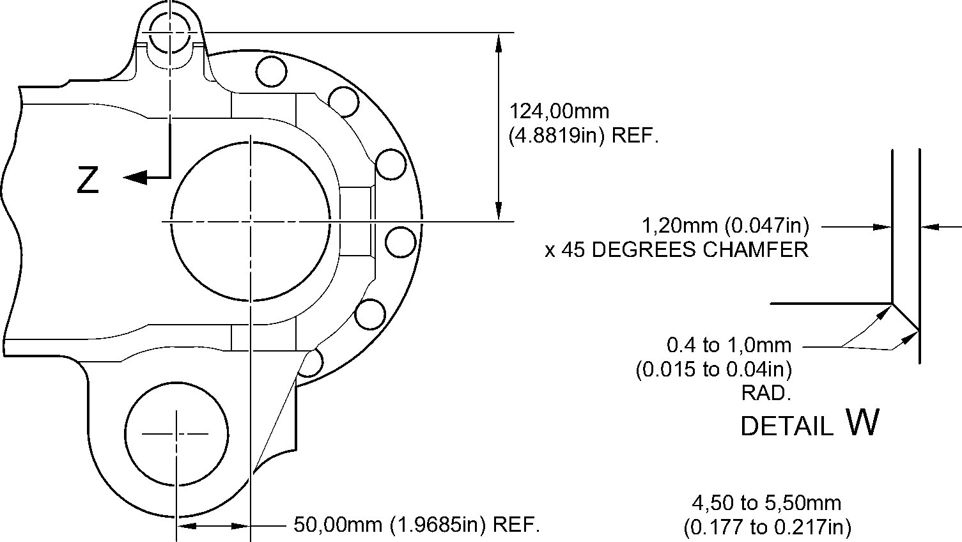

RAD.

49,50 to 50,50mm

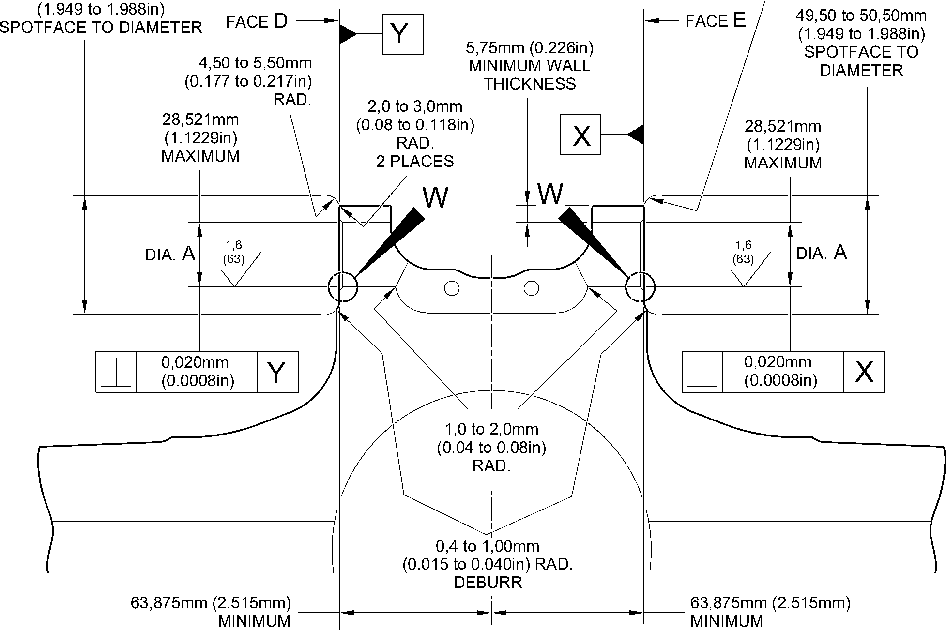

section Z-Z (WITHOUT bushes)

A321-S-32-12-22-038-1

Repair to Sliding Tube - Machining

Figure 601

Repair No. 9-7

Page 603

Dec 6/2019

32-12-22

**SAFRAN LANDING SYSTEMS UK Ltd**

CAGE: K0654



PART No. 201587001 AND 201587002 COMPONENT MAINTENANCE MANUAL  
MAIN LANDING GEAR LEG

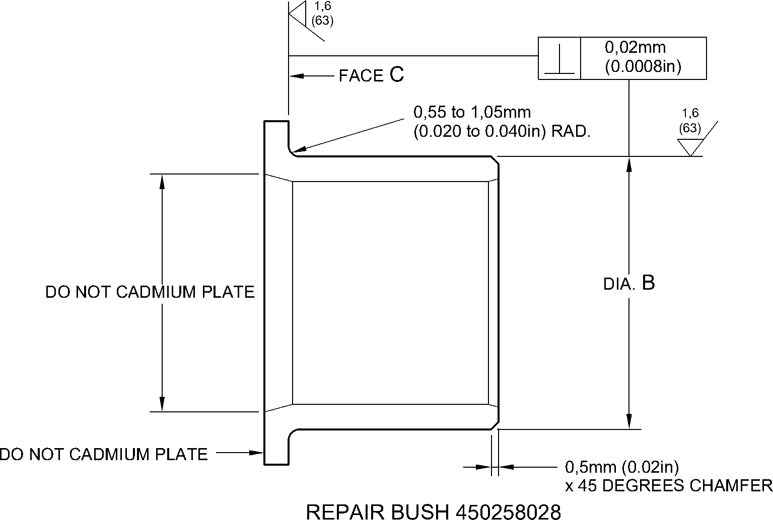

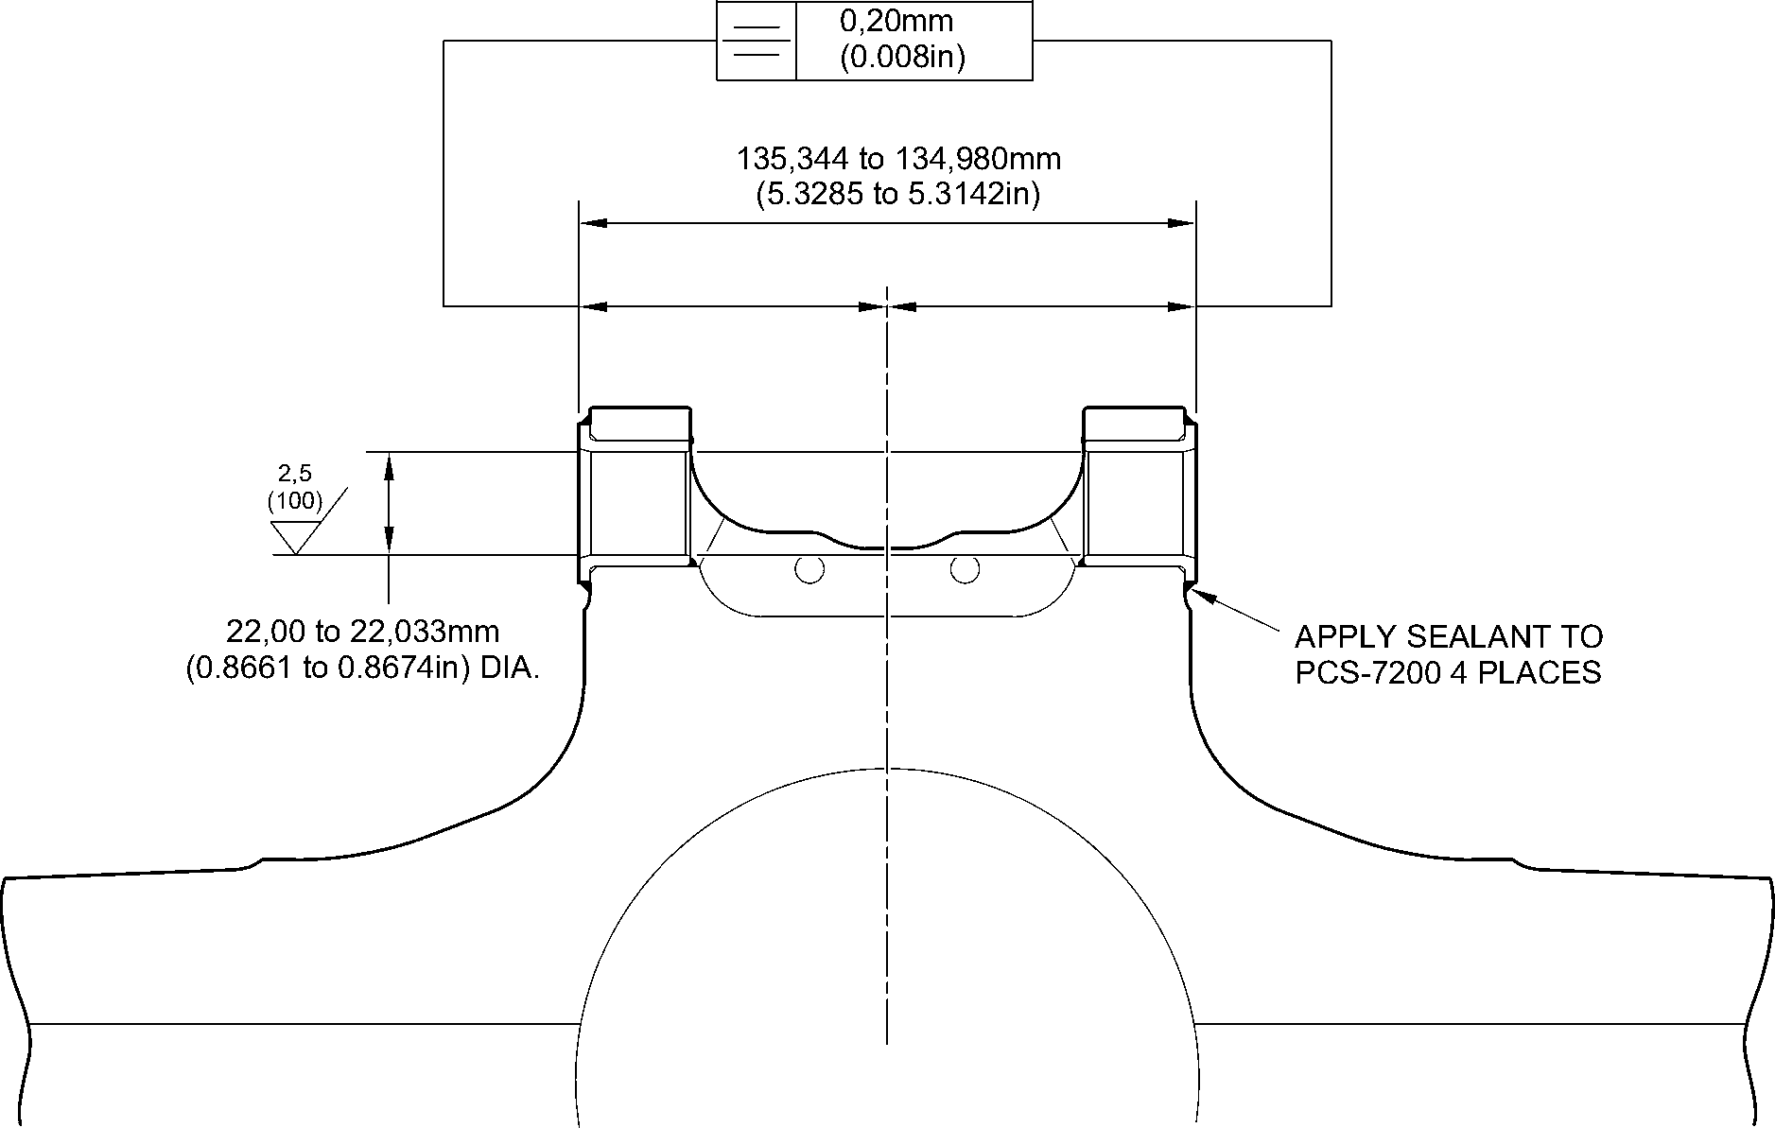

section Z-Z

(WITH BUSHES) A321-S-32-12-22-039-1

Repair Bushes - Machining and Installation  
Figure 602

32-12-22

Repair No. 9-7

Page 604

Dec 6/2019

**sSAFRAN SAFRAN LANDING SYSTEMS UK Ltd**

CAGE: K0654

PART No. 201587001 AND 201587002 COMPONENT MAINTENANCE MANUAL  
MAIN LANDING GEAR LEG

I 1. Repair No. 9-8 Sliding Tube (18-80 and 18-80A)

1. Specified Damage and Material Specification.
2. Specified Damage

(a) Damage or wear to diameter(s) A and/or the adjacent face(s) B.

1. Material Specification

|  |  |  |
| --- | --- | --- |
| IPL Figure and Item No. | Name | Material Specification |
| 18-80 and  18-80A | Sliding Tube | Steel, 300M |

1. Special Tools

(1) These special tools are necessary:

|  |  |  |
| --- | --- | --- |
| Part No. | Special Tool | Function |
| 460006246 | Alignment bar | Install the repair bushes |
| 460006250 | Press Pad Assembly |
| 460006251 | Guide Bush |
| 460006252 | Guide Bush |

1. Materials
2. These materials are necessary:

**NOTE: Alternative equivalents are permitted.**

|  |  |
| --- | --- |
| Ref. Item | Material |
| TBA | Zinc Powder |
| 04-512 | Molykote 111 |
| 09-510A | Sealant |
| 09-581 | Sealant |

1. These repair parts are necessary:

|  |  |  |
| --- | --- | --- |
| Part No. | Repair Part | Material Specification |
| 450217855 | Repair bush (Qty 2) | Bronze, UZ 19A6 |

Repair No. 9-8

Page 601

Mar 18/2025

32-12-22

**sSAFRAN SAFRAN LANDING SYSTEMS UK Ltd**

CAGE: K0654

PART No. 201587001 AND 201587002 COMPONENT MAINTENANCE MANUAL  
MAIN LANDING GEAR LEG

**CAUTION : FOR DEVIATIONS OUTSIDE THE LIMITS OF THIS REPAIR SCHEME CONTACT  
SAFRAN LANDING SYSTEMS.**

1. Procedure (Refer to Figures 601 and 602)
2. Do this procedure if there is damage or wear to diameter(s) A and or adjacent face(s) B:
3. Machine diameter(s) A sufficiently to remove the damage or wear within the  
   dimensions shown: refer to M-DLPS1004-4-1 and Figure 601. Make the surface  
   finish 1,6 micrometers (63 micro-inches).
4. Machine the adjacent face(s) B using spotface cutter sufficiently to remove the  
   damage or wear within the dimensions shown: refer to M-DLPS1004-4-1 and  
   Figure 601. Make the surface finish 1,6 micrometers (63 micro-inches).
5. Machine the chamfers and radii to the dimensions shown: refer to Figure 601.
6. Measure and record the new diameter(s) A.
7. Examine the machined areas for flaws: refer to PCS-3600 and PCS-3100,  
   inclusion class 4.
8. Shot peen the machined areas: refer to M-DLPS123.
9. Identify the part with the Safran Landing Systems repair number 450266310  
   adjacent to the part number: refer to PCS-6000-05 or PCS-6000-06.
10. Apply cadmium plate to the reworked areas: refer to PCS-2141.
11. Calculate diameter C and dimension H of each repair bush (qty 2):

Dia. C = Dia. A (as measured) + 0,090 to + 0,139 mm (+ 0.0035 to + 0.0055 in).  
Dim. H = Dim. G (as measured) (spotface to grease hole center line)

- 0,10 to + 0,10 mm (- 0.004 to + 0.004 in).

1. Machine face D of the repair bush to get the correct dimensions: refer to  
   Figure 602. Make the surface finish 1,6 micrometers (63 micro-inches).
2. Machine the repair bush to the dimensions shown and calculated: refer to  
   M-DLPS900 and Figure 602.
3. Apply cadmium plate to the repair bushes, but not to the bores and the flange  
   faces: refer to PCS-2101 or PCS-2141.
4. Apply primer paint to the sliding tube where the bush flanges will touch: refer to  
   PCS-2500.
5. Apply the electrically conducting Molykote or rubberised sealant to the oversize  
   bushes and the sliding tube over the dimensions shown: refer to Figure 602. Use  
   electrically conducting Molykote (made from Molykote 111, Material Ref. Item  
   04-512 and Zinc powder, Material Ref. Item TBA): refer to PCS-7304. Or use  
   electrically conducting rubberised sealant, Material Ref. Item 09-581: refer to  
   IFC30-145-03MD.
6. Use the alignment bar 460006246, the press pad assembly 460006250 and the  
   guide bushes 460006251 and 460006252 and install the oversize bushes: refer to  
   PCS-5105-2.

32-12-22

Repair No. 9-8

Page 602

Mar 18/2025

**sSAFRAN SAFRAN LANDING SYSTEMS UK Ltd**

CAGE: K0654

PART No. 201587001 AND 201587002 COMPONENT MAINTENANCE MANUAL  
MAIN LANDING GEAR LEG

1. Machine the dimension across the bush flanges between 150,917 and  
   150,957 mm (5.9416 and 5.9432 in). The symmetry must be as shown: refer to  
   Figure 602.
2. Machine the chamfers to the dimensions shown: refer to Figure 602.
3. Check the bore diameters of the repair bushes: refer to Figure 602.
4. If necessary, hone the bore diameters of the repair bushes to the dimensions  
   shown: refer to Figure 602. Make the surface finish 2,6 micrometers (100  
   micro-inches).
5. Apply sealant, Material Ref. Item 09-510A, around the joints between the repair  
   bushes and the sliding tube: refer to PCS-7200 and Figure 602.
6. Apply paint to the repaired area: refer to REPAIR and PCS-2500.
7. Identify the part with the Safran Landing Systems repair number 450266310  
   adjacent to the part number: refer to PCS-6000-07.
8. Examine the part to make sure that you have obeyed all the repair instructions  
   correctly.

Repair No. 9-8

Page 603

Mar 18/2025

32-12-22

**SAFRAN LANDING SYSTEMS UK Ltd**

CAGE: K0654



PART No. 201587001 AND 201587002 COMPONENT MAINTENANCE MANUAL  
MAIN LANDING GEAR LEG

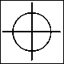



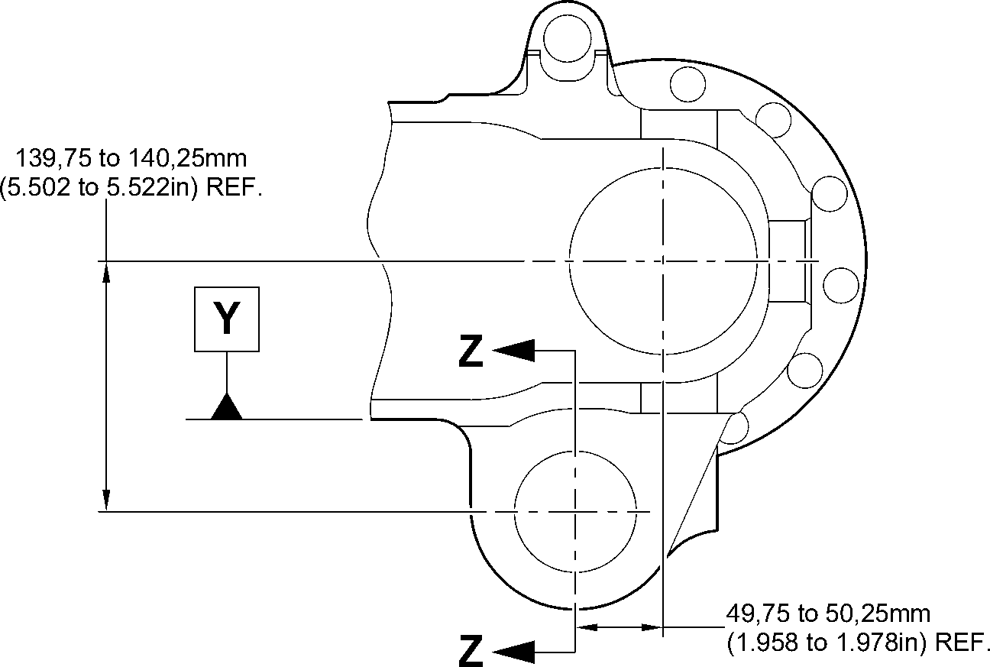

0,5mm

(0.02in) DIA. **Y**

0,075mm  
(0.0030in)

4,50 to 5,50mm  
(0.177 to 0.217in) RAD.  
TYP. 2 PLACES

19,78mm (0.779in)  
MINIMUM WALL  
dia. A THICKNESS

68,130mm (2.6823in) TYP. 2 PLACES

MAXIMUM 1,6

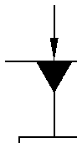

**X**

2,00 to 3,00mm  
(0.080 to 0.118in)  
RAD.  
TYP. 2 PLACES

89,50 to 90,50mm  
(3.524 to 3.563in)  
SPOTFACE DIA.  
TYP. 2 PLACES

35,95mm (1.415in)

MINIMUM LUG WIDTH  
TYP. 2 PLACES

1,2mm (0.047in)

x 45 DEGREES CHAMFER  
TYP. 2 PLACES

0,40 to 1,00mm  
(0.016 to 0.040in)

RAD.

0,40 to 1,00mm  
(0.016 to 0.040in)

RAD.

TYP. 2 PLACES

0,40mm

(0.016in) DIA.

**X**

face B

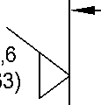

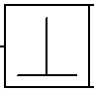

0,05mm  
(0.002in)

SECTION **Z-Z**

(WITHOUT BUSHES)

**X**

1,00 to 2,00mm  
(0.040 to 0.080in) RAD.  
TYP. 2 PLACES

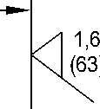

face B

A321A5899-3

Repair to Sliding Tube - Machining  
Figure 601

32-12-22

Repair No. 9-8

Page 604

Aug 11/2023

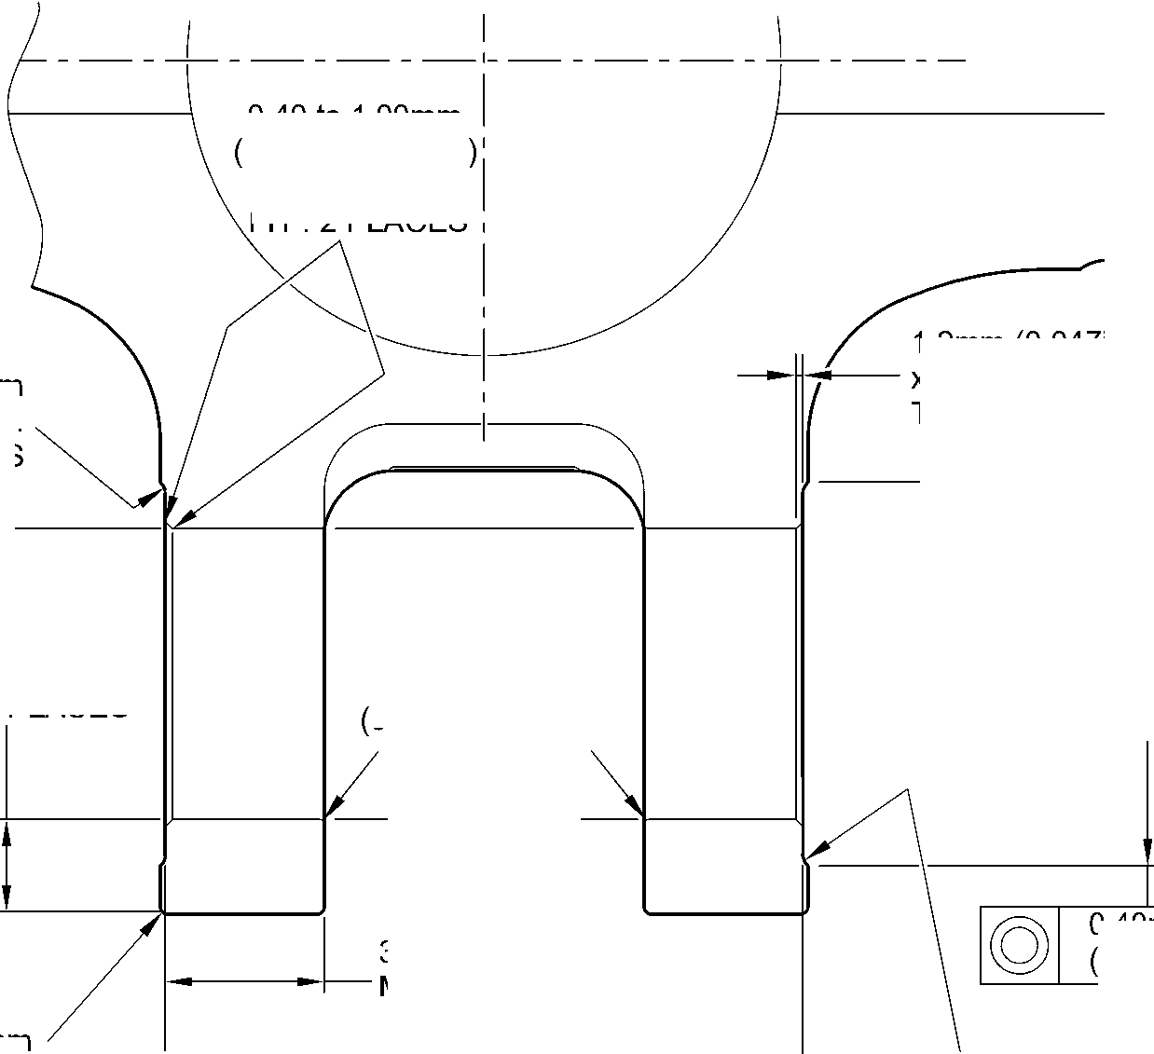

**SAFRAN LANDING SYSTEMS UK Ltd**

CAGE: K0654



PART No. 201587001 AND 201587002 COMPONENT MAINTENANCE MANUAL  
MAIN LANDING GEAR LEG

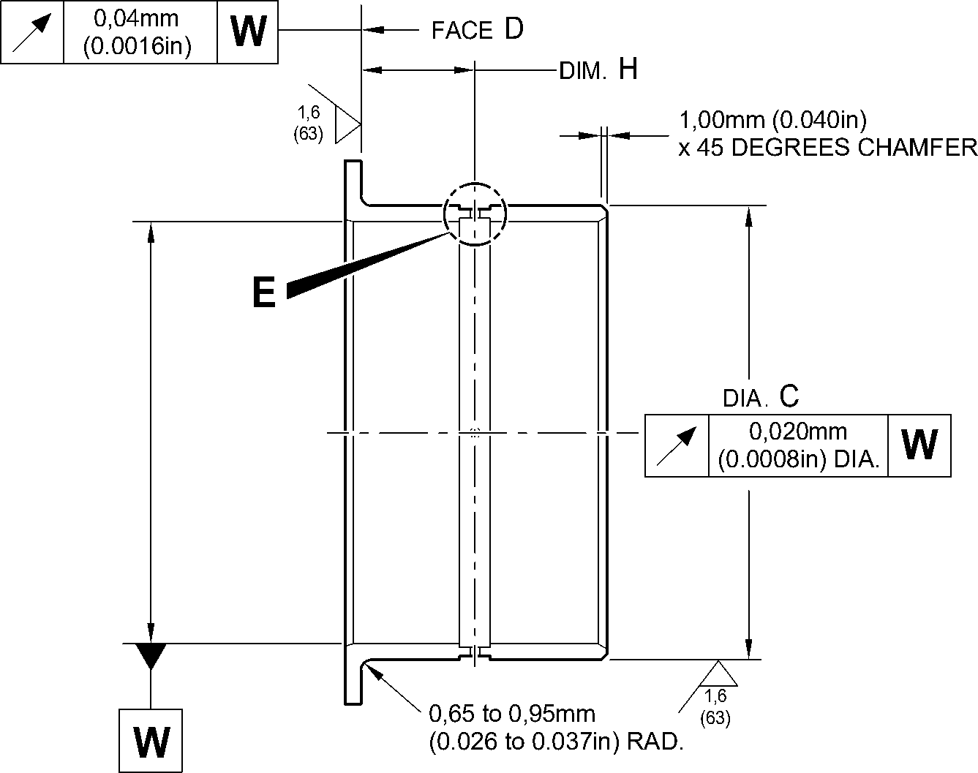

30 30

DEGREES DEGREES

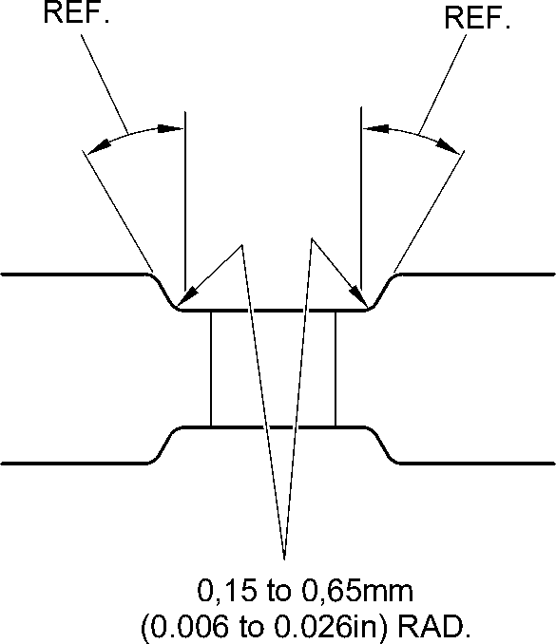

REPAIR BUSH  
450217855

DETAIL **E**

TYP. 4 PLACES

1,00mm (0.039in)

CHAMFER (2 PLACES)

**X**

DIM.G

**Y**

REPAIR BUSH  
450217855

150,917 to 150,957mm  
(5.9416 to 5.9432in)

30 DEGREES  
CHAMFER

(2 PLACES)

DETAIL **X** 60,00 to 60,03mm  
(2.362 to 2.363in)

14,00 to 16,00mm  
(0.551 to 0.630in)  
APPLY ELECTRICALLY

CONDUCTING MOLYKOTE 111  
OR RUBBERISED SEALANT  
IN THE BORES TO

IFC30-145-03MD OR PCS-7304

TYP. 2 PLACES

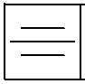

0,1mm  
(0.04in)

12,00 to 14,00mm  
(0.472 to 0.551in)  
APPLY ELECTRICALLY

CONDUCTING MOLYKOTE 111

OR RUBBERISED SEALANT  
ON BOTH BUSHES TO

IFC30-145-03MD OR PCS-7304  
TYP. 2 PLACES

SECTION **Z-Z**

(WITH BUSHES)

APPLY SEALANT

TO PCS-7200

WITHOUT OVERFLOW ON  
FACES OF THE BUSHES

4 PLACES

A321A5900-4

Repair Bushes - Machining and Installation  
Figure 602

Repair No. 9-8

Page 605

Mar 18/2025

32-12-22

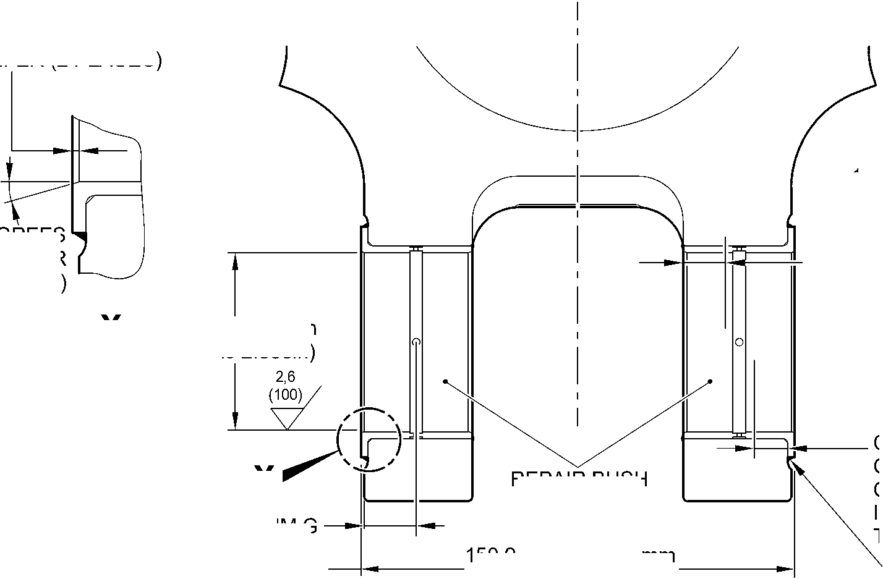

**SAFRAN LANDING SYSTEMS UK Ltd**

CAGE: K0654



PART No. 201587001 AND 201587002 COMPONENT MAINTENANCE MANUAL  
MAIN LANDING GEAR LEG

INTENTIONALLY BLANK

Repair No. 9-8

32-12-22 Page 606

**sSAFRAN SAFRAN LANDING SYSTEMS UK Ltd**

CAGE: K0654

PART No. 201587001 AND 201587002 COMPONENT MAINTENANCE MANUAL  
MAIN LANDING GEAR LEG

I 1. Repair No. 9-9 Sliding Tube (18-80 and 18-80A)

1. Specified Damage and Material Specification.
2. Specified Damage

(a) Damage or wear to diameter A and/or adjacent face.

1. Material Specification

|  |  |  |
| --- | --- | --- |
| IPL Figure and Item No. | Name | Material Specification |
| 18-80 and  18-80A | Sliding Tube | Steel, 300M |

1. Special Tools
2. These special tools are necessary:

**NOTE: Alternative equivalents are permitted.**

|  |  |  |
| --- | --- | --- |
| Tool Part No. | Special Tool | Function |
| 460004330/131 | Press Pad | Install the repair bush |

1. Materials
2. These materials are necessary:

**NOTE: Alternative equivalents are permitted.**

|  |  |
| --- | --- |
| Ref. Item | Material |
| TBA | Zinc Powder |
| 04-512 | Molykote 111 |
| 09-510A | Sealant |

1. Repair Parts
2. These repair parts are necessary:

|  |  |  |
| --- | --- | --- |
| Part No. | Repair Part | Material Specification |
| 450258015 | Repair Bush | Bronze, UZ19A6 |

1. Procedure (Refer to Figures 601 and 602)

**CAUTION: FOR DAMAGE MORE THAN THE LIMITS OF THIS REPAIR SCHEME, WRITE  
TO SAFRAN LANDING SYSTEMS: REFER TO GUIDE-CS-001.**

1. Machine the diameter A and/or the adjacent face to remove the damage or wear within  
   the dimensions shown: refer to M-DLPS1004-4-1 and Figure 601. Do not increase  
   diameter A more than 48,125 mm (1.8947 in). Make the surface finish 1,6 micrometers  
   (63 micro-inches).

Repair No. 9-9

Page 601

Mar 18/2025

32-12-22

**sSAFRAN SAFRAN LANDING SYSTEMS UK Ltd**

CAGE: K0654

PART No. 201587001 AND 201587002 COMPONENT MAINTENANCE MANUAL  
MAIN LANDING GEAR LEG

1. Machine the chamfer and radii to the dimensions shown: refer to Figure 601.
2. Measure and record the new diameter A.
3. Examine the machined areas for flaws: refer to PCS-3600 and PCS-3100, inclusion  
   class 4.
4. Shot peen the machined areas: refer to M-DLPS123.
5. Identify the part with the Safran Landing Systems repair number 450265180 adjacent to  
   the part number: refer to PCS-6000-19.
6. Apply cadmium plate to the reworked areas: refer to PCS-2100. The cadmium plate  
   thickness must be between 0,010 and 0,015 mm (0.0004 and 0.0006 in).
7. Calculate the diameter C for the repair bush, use the formula:  
   C = A (as measured) + 0,018 to 0,059 mm (0.0007 to 0.0023 in).
8. Machine the repair bush to the dimensions shown and calculated. Machine face D to get  
   the correct dimension after installation: refer to M-DLPS900 and Figure 602. Make the  
   surface finish 1,6 micrometers (63 micro-inches).
9. Apply cadmium plate all over to the repair bush: refer to PCS-2101. The cadmium plate  
   thickness must be between 0,005 and 0,009 mm (0.0002 and 0.0004 in).
10. Apply primer paint to the repair bush but not to the areas shown: refer to PCS-2500 and  
    Figure 602.
11. Use the Press Pad 460004330/131 and install the repair bush: refer to M-DLPS1011-14.  
    Use zinc loaded Molykote (made from Molykote 111, Material Ref. Item 04-512 and Zinc  
    powder, Material Ref. Item TBA): refer to PCS-7304. The slot in the repair bush must be  
    in the correct angular position: refer to Figure 602.
12. Check the bore of the repair bush: refer to Figure 602.
13. If necessary, hone the repair bush bore to the dimensions shown: refer to Figure 602.
14. Apply a bead of sealant, Material Ref. Item 09-510A, to the joints between the repair  
    bush and the sliding tube: refer to PCS-7200 and Figure 602.
15. Apply paint locally to the sliding tube: refer to REPAIR and PCS-2500.
16. Identify the part with the Safran Landing Systems repair number 450265180 adjacent to  
    the part number: refer to PCS-6000-07.
17. Examine the part to make sure that you have obeyed all the repair instructions correctly.

32-12-22

Repair No. 9-9

Page 602

Mar 18/2025

**SAFRAN LANDING SYSTEMS UK Ltd**

CAGE: K0654



PART No. 201587001 AND 201587002 COMPONENT MAINTENANCE MANUAL  
MAIN LANDING GEAR LEG

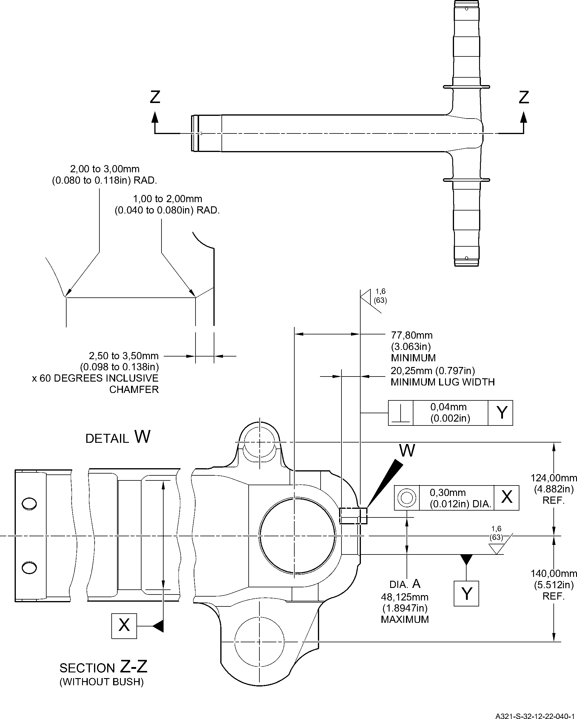

Repair to Sliding Tube - Machining  
Figure 601

Repair No. 9-9

Page 603

Dec 6/2019

32-12-22

**SAFRAN LANDING SYSTEMS UK Ltd**

CAGE: K0654



PART No. 201587001 AND 201587002 COMPONENT MAINTENANCE MANUAL  
MAIN LANDING GEAR LEG

83,00 to 83,50mm  
(3.268 to 3.287in)

section Z-Z

(WITH BUSH)

REFER TO FIGURE 601

35,40 to 35,60mm  
(1.394 to 1.402in) DIA.

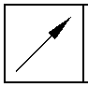

0,05mm  
(0.002in)

TRACES OF

PAINT  
PERMITTED

Y

REPAIR BUSH  
450258015

APPLY SEALANT TO PCS-7200  
2 PLACES

view Y

-3 to 3 DEGREES  
ORIENTATION IS IMPORTANT

face D

DO NOT PRIMER PAINT

0,50mm (0.020in)

x 45 DEGREES CHAMFER

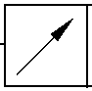

0,03mm  
(0.001in)

X

1,00mm (0.040in)

x 60 DEGREES INCLUSIVE  
CHAMFER

1,35 to 1,85mm  
(0.053 to 0.073in) RAD.

REPAIR BUSH 450258015

X

1,6

dia. C

DO NOT PRIMER

PAINT

A321-S-32-12-22-041-1

Repair Bush - Machining and Installation

Figure 602

32-12-22

Repair No. 9-9

Page 604

Dec 6/2019

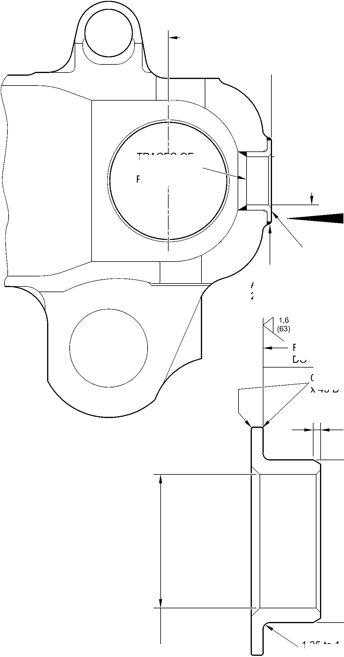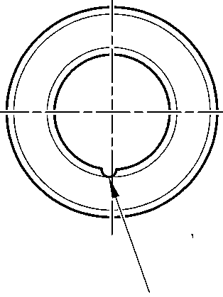

**sSAFRAN SAFRAN LANDING SYSTEMS UK Ltd**

CAGE: K0654

PART No. 201587001 AND 201587002 COMPONENT MAINTENANCE MANUAL  
MAIN LANDING GEAR LEG

I 1. Repair No. 9-10 Sliding Tube (18-80 and 18-80A)

1. Specified Damage and Material Specification.
2. Specified Damage

(a) Damage or wear to diameters A and/or B and/or C.

1. Material Specification

|  |  |  |
| --- | --- | --- |
| IPL Figure and Item No. | Name | Material Specification |
| 18-80 and  18-80A | Sliding Tube | Steel, S155 (300M) |

1. Special Tools
2. Special tools are not necessary.
3. Materials
4. Materials are not necessary.
5. Repair Parts
6. Repair parts are not necessary.

**CAUTION: FOR DEVIATIONS OUTSIDE THE LIMITS OF THIS REPAIR SCHEME CONTACT  
SAFRAN LANDING SYSTEMS.**

1. Procedure (Refer to Figures 601 and 602)
2. Do this procedure, if diameter(s) A is damaged or worn:
3. Remove the paint from the sliding tube, if necessary: refer to PCS-2700 and  
   Figure 601.
4. Remove the Sermetel from the sliding tube, if necessary: refer to M-DLPS637.
5. Remove the cadmium plate from the sliding tube, if necessary: refer to PCS-2100.
6. Remove the chromium plate from diameter(s) A: refer to PCS-2110 Type C.
7. If the base metal is not damaged or worn:
8. Examine the sliding tube for flaws: refer to PCS-3600 and PCS-3100,  
   inclusion class 4.
9. Apply chromium plate to diameter(s) A: refer to PCS-2110 Type C,  
   M-DLPS1031-1, M-DLPS1031-6 and Figure 601. The chromium plate  
   thickness must be sufficient to give a minimum thickness of 0,10 mm  
   (0.004 in) after grinding.
10. Finish grind diameter A: refer to M-DLPS1004-4-1 and Figure 601. Make the  
    surface finish 0,8 micrometers (32 micro-inches).
11. Examine the ground chromium plate for flaws: refer to M-DLNDT3.
12. Identify the part with the Safran Landing Systems repair number 450258401A  
    adjacent to the part number: refer to PCS-6000-05 or PCS-6000-19.

Repair No. 9-10

Page 601

Mar 18/2025

32-12-22

**sSAFRAN SAFRAN LANDING SYSTEMS UK Ltd**

CAGE: K0654

PART No. 201587001 AND 201587002 COMPONENT MAINTENANCE MANUAL  
MAIN LANDING GEAR LEG

1. If the base metal is damaged or worn:
2. Machine the diameter(s) A to remove the damage or wear within the  
   dimensions shown: refer to M-DLPS1004-4-1 and Figure 601. Make the  
   surface finish 0,8 micrometers (32 micro-inches).

2 Examine the machined area for flaws: refer to PCS-3600 and PCS-3100,  
inclusion class 4.

1. Shot peen the machined area: refer to M-DLPS123.

4 Apply chromium plate to diameter(s) A: refer to PCS-2110 Type C,  
M-DLPS1031-1, M-DLPS1031-6 and Figure 601. The chromium plate  
thickness must be sufficient to give a minimum thickness of 0,10 mm  
(0.004 in) after grinding.

1. Finish grind diameter A: refer to M-DLPS1004-4-1 and Figure 601. Make the  
   surface finish 0,8 micrometers (32 micro-inches).
2. Examine the ground chromium plate for flaws: refer to M-DLNDT3.
3. Identify the part with the Safran Landing Systems repair number 450258401B  
   adjacent to the part number: refer to PCS-6000-05 or PCS-6000-19.
4. Apply cadmium plate to the sliding tube but not on the chromium plated areas: refer  
   to REPAIR and PCS-2100. Make the cadmium plate thickness between 0,010 and  
   0,020 mm (0.0004 and 0.0008 in).
5. Apply Sermetel to the sliding tube but not on the chromium plated or the cadmium  
   plated areas: refer to REPAIR and M-DLPS637.
6. Apply paint to the sliding tube but not on the chromium plated areas: refer to  
   REPAIR and PCS-2500.
7. Identify the part with the Safran Landing Systems repair number adjacent to the  
   part number: refer to PCS-6000-07.

- Use the repair number 450258401A if there was no damage to the base metal or  
- Use the repair number 450258401B if there was damage to the base metal.

1. Examine the part to make sure that you have obeyed all the repair instructions  
   correctly.
2. Do this procedure, if diameter(s) B is damaged or worn:
3. Remove the paint from the sliding tube, if necessary: refer to PCS-2700 and  
   Figure 601.
4. Remove the Sermetel from the sliding tube, if necessary: refer to M-DLPS637.
5. Remove the cadmium plate from the sliding tube, if necessary: refer to PCS-2100.
6. Remove the chromium plate from diameter(s) B: refer to PCS-2110 Type C and  
   Figure 601.
7. If the base metal is not damaged or worn:

1 Examine the sliding tube for flaws: refer to PCS-3600 and PCS-3100,  
inclusion class 4.

Repair No. 9-10

32

Page 602

-- Mar 18/2025

**sSAFRAN SAFRAN LANDING SYSTEMS UK Ltd**

CAGE: K0654

PART No. 201587001 AND 201587002 COMPONENT MAINTENANCE MANUAL  
MAIN LANDING GEAR LEG

2 Apply chromium plate to diameter(s) B: refer to PCS-2110 Type C,  
M-DLPS1031-1, M-DLPS1031-6 and Figure 601. The chromium plate  
thickness must be sufficient to give a minimum thickness of 0,10 mm (0.004  
in) after grinding.

1. Finish grind diameter B: refer to M-DLPS1004-4-1 and Figure 601. Make the  
   surface finish 0,8 micrometers (32 micro-inches).
2. Examine the ground chromium plate for flaws: refer to M-DLNDT3.
3. Identify the part with the Safran Landing Systems repair number 450258401C  
   adjacent to the part number: refer to PCS-6000-05 or PCS-6000-19.
4. If the base metal is damaged or worn:
5. Machine the diameter(s) B to remove the damage or wear within the  
   dimensions shown: refer to M-DLPS1004-4-1 and Figure 601. Make the  
   surface finish 0,8 micrometers (32 micro-inches).

2 Examine the machined area for flaws: refer to PCS-3600 and PCS-3100,  
inclusion class 4.

1. Shot peen the machined area: refer to M-DLPS123.
2. Apply chromium plate to diameter(s) B: refer to PCS-2110 Type C,  
   M-DLPS1031-1, M-DLPS1031-6 and Figure 601. The chromium plate  
   thickness must be sufficient to give a minimum thickness of 0,10 mm  
   (0.004 in) after grinding.
3. Finish grind diameter B: refer to M-DLPS1004-4-1 and Figure 601. Make the  
   surface finish 0,8 micrometers (32 micro-inches).
4. Examine the ground chromium plate for flaws: refer to M-DLNDT3.
5. Identify the part with the Safran Landing Systems repair number 450258401D  
   adjacent to the part number: refer to PCS-6000-05 or PCS-6000-19.
6. Apply cadmium plate to the sliding tube but not on the chromium plated areas: refer  
   to REPAIR and PCS-2100. Make the cadmium plate thickness between 0,010 and  
   0,020 mm (0.0004 and 0.0008 in).
7. Apply Sermetel to the sliding tube but not on the chromium plated or the cadmium  
   plated areas: refer to REPAIR and M-DLPS637.
8. Apply paint to the sliding tube but not on the chromium plated areas: refer to  
   REPAIR and PCS-2500.
9. Identify the part with the Safran Landing Systems repair number adjacent to the  
   part number: refer to PCS-6000-07.

* Use the repair number 450258401C if there was no damage to the base metal or
* Use the repair number 450258401D if there was damage to the base metal.

1. Examine the part to make sure that you have obeyed all the repair instructions  
   correctly.

Repair No. 9-10

Page 603

Mar 18/2025

32-12-22

**sSAFRAN SAFRAN LANDING SYSTEMS UK Ltd**

CAGE: K0654

PART No. 201587001 AND 201587002 COMPONENT MAINTENANCE MANUAL  
MAIN LANDING GEAR LEG

1. Do this procedure, if diameter(s) C is damaged or worn:
2. Remove the paint from the sliding tube, if necessary: refer to PCS-2700 and  
   Figure 601.
3. Remove the Sermetel from the sliding tube, if necessary: refer to M-DLPS637.
4. Remove the cadmium plate from the sliding tube, if necessary: refer to PCS-2100.
5. Remove the chromium plate from diameter(s) C: refer to PCS-2110 Type C and  
   Figure 602.
6. If the base metal is not damaged or worn:

1 Apply chromium plate to diameter(s) C: refer to PCS-2110 Type C,  
M-DLPS1031-6, Figure 601 and Figure 602. The chromium plate thickness  
must be sufficient to give a minimum thickness of 0,10 mm (0.004 in) after  
grinding.

2 Finish grind diameter C: refer to M-DLPS1004-4-1 and Figure 602. Make the  
surface finish 0,8 micrometers (32 micro-inches).

3 Examine the ground chromium plate for flaws: refer to M-DLNDT3.

4 Identify the part with the Safran Landing Systems repair number 450258401E  
adjacent to the part number: refer to PCS-6000-05 or PCS-6000-19.

1. If the base metal is damaged or worn:
2. Machine the diameter(s) C to remove the damage or wear within the  
   dimensions shown: refer to M-DLPS1004-4-1 and Figure 602. Make the  
   surface finish 0,8 micrometers (32 micro-inches).

2 Examine the machined area for flaws: refer to PCS-3600 and PCS-3100,  
inclusion class 4.

1. Shot peen the machined area: refer to M-DLPS123.

4 Apply chromium plate to diameter(s) C: refer to PCS-2110 Type C,  
M-DLPS1031-2, M-DLPS1031-6 and Figure 602. The chromium plate  
thickness must be sufficient to give a minimum thickness of 0,10 mm  
(0.004 in) after grinding.

1. Finish grind diameter C: refer to M-DLPS1004-4-1 and Figure 602. Make the  
   surface finish 0,8 micrometers (32 micro-inches).
2. Examine the ground chromium plate for flaws: refer to M-DLNDT3.

7 Identify the part with the Safran Landing Systems repair number 450258401F  
adjacent to the part number: refer to PCS-6000-05 or PCS-6000-19.

1. Apply cadmium plate to the sliding tube but not on the chromium plated areas: refer  
   to REPAIR and PCS-2100. Make the cadmium plate thickness between 0,010 and  
   0,020 mm (0.0004 and 0.0008 in).
2. Apply Sermetel to the sliding tube but not on the chromium plated or the cadmium  
   plated areas: refer to REPAIR and M-DLPS637.

Repair No. 9-10

32

Page 604

-12-22 Mar 18/2025

**sSAFRAN SAFRAN LANDING SYSTEMS UK Ltd**

CAGE: K0654

PART No. 201587001 AND 201587002 COMPONENT MAINTENANCE MANUAL  
MAIN LANDING GEAR LEG

1. Apply paint to the sliding tube but not on the chromium plated areas: refer to  
   REPAIR and PCS-2500.
2. Identify the part with the Safran Landing Systems repair number adjacent to the  
   part number: refer to PCS-6000-07.

* Use the repair number 450258401E if there was no damage to the base metal or
* Use the repair number 450258401F if there was damage to the base metal.

1. Examine the part to make sure that you have obeyed all the repair instructions  
   correctly.

Repair No. 9-10

Page 605

Mar 18/2025

32-12-22

**SAFRAN LANDING SYSTEMS UK Ltd**

CAGE: K0654

PART No. 201587001 AND 201587002 COMPONENT MAINTENANCE MANUAL  
MAIN LANDING GEAR LEG

W

V

X

T

0,060mm  
(0.0024in)

0,060mm  
(0.0024in)

dia A



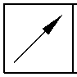

0,040mm  
(0.0016in)

Y

dia B



Z

DIA C

T

SLIDING TUBE

OUTSIDE DIAMETER

V

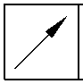

0,040mm  
(0.0016in)

V

EDGE SMOOTHED  
OUT

EDGE SMOOTHED  
OUT

1,00 to 3,00mm  
(0.039 to 0.118in)  
CHROMIUM PLATE

1,00 to 3,00mm  
(0.039 to 0.118in)  
CHROMIUM PLATE  
TERMINATION TO M-DLPS1031-1

TERMINATION TO M-DLPS1031-6

119,319mm (4.6976in) MINIMUM DIAMETER  
BEFORE CHROMIUM PLATE

CHROMIUM PLATE TERMINATION  
TYPICAL AROUND 4 SLOTS.  
IRREGULAR LINE IS PERMITTED

2,00 to 3,00mm  
(0.079 to 0.118in) RADIUS

detail X

detail W

DIA A

119,929 to 119,964mm (4.7216 to 4.7230in)

DIAMETER AFTER GRINDING THE CHROMIUM PLATE

CHROMIUM PLATE DEPOSIT

1,00 to 3,00mm

(0.039 to 0.118in)

CHROMIUM PLATE

TERMINATION TO M-DLPS1031-6.  
IRREGULAR LINE IS PERMITTED

EDGE SMOOTHED

OUT

2,00 to 3,00mm  
(0.079 to 0.118in)  
RADIUS

126,307mm (4.9727in) MINIMUM DIAMETER  
BEFORE CHROMIUM PLATE

detail Y

CHROMIUM PLATE  
DEPOSIT

dia B

126,917 to 126,957mm (4.9967 to 4.9983in)

DIAMETER AFTER GRINDING THE CHROMIUM PLATE

A321A6875-1

Repair to Sliding Tube  
Figure 601

32-12-22

Repair No. 9-10

Page 606

Mar 18/2025

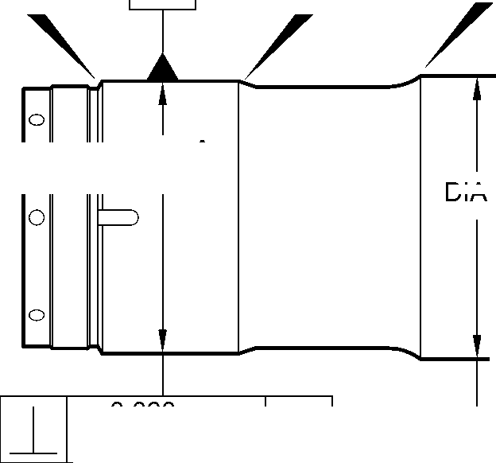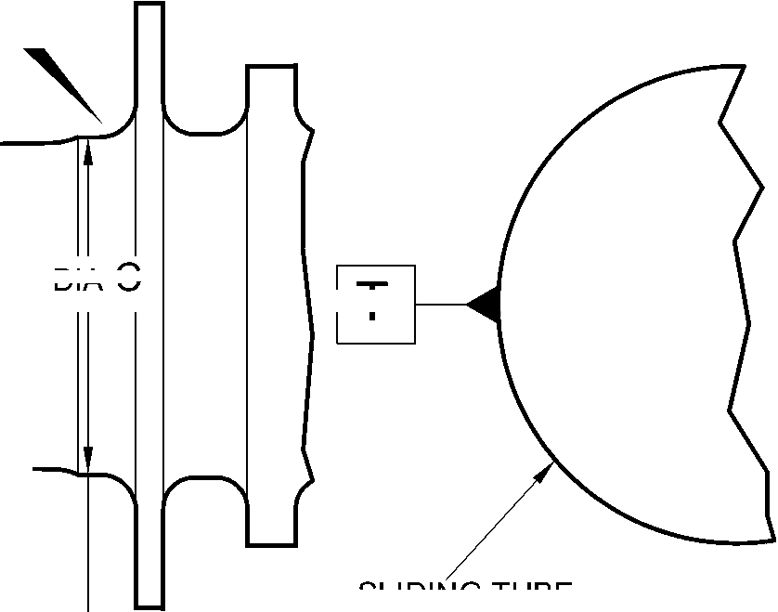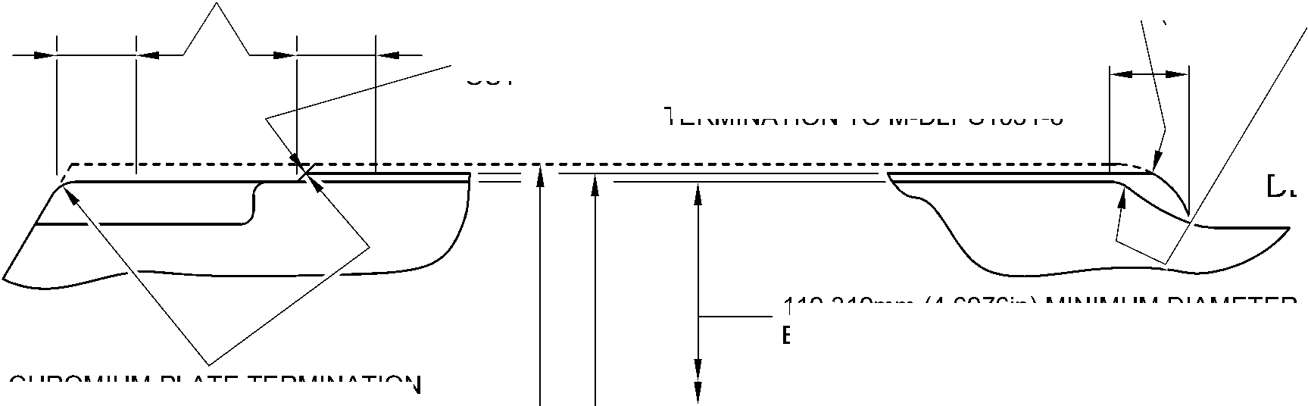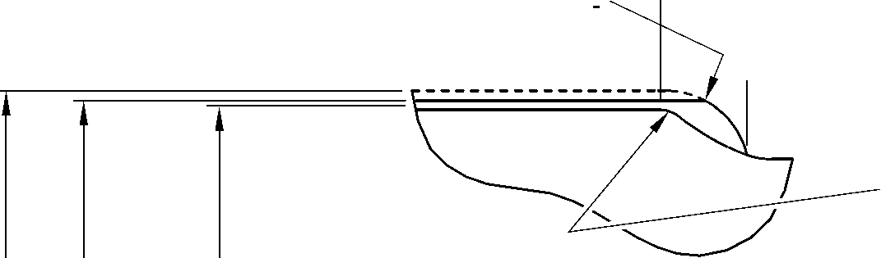

**SAFRAN LANDING SYSTEMS UK Ltd**

CAGE: K0654

PART No. 201587001 AND 201587002 COMPONENT MAINTENANCE MANUAL  
MAIN LANDING GEAR LEG

14,500mm (0.5708in)  
REF.

0,0 to 2,0mm (0.00 to 0.08in) CHROMIUM PLATE  
MUST TERMINATE WITHIN THIS LENGTH.

WAVY OR IRREGULAR LINE IS PERMITTED.

2,0 to 3,00mm

(0.08 to 0.118in) RAD.

17,750 to 18,250mm  
(0.6988 to 0.7185in)  
REF.

1,0 to 3,00mm (0.04 to 0.118in) CHROMIUM PLATE  
MUST TERMINATE WITHIN THIS LENGTH.

WAVY OR IRREGULAR LINE IS PERMITTED.

EDGE

SMOOTHED  
OUT

8,00mm (0.315in)  
REF.

30,00mm (1.181in)  
RAD. REF.

DIAMETER BEFORE CHROMIUM PLATE

dia C

131,294 to 131,357mm (5.1690 to 5.1715in) AFTER GRINDING

DETAIL **Z**

(REFER TO FIGURE 601)  
IF THE BASE METAL  
IS NOT DAMAGED

0,0 to 2,00mm (0.00 to 0.079in)

CHROMIUM PLATE TERMINATION

TO M-DLPS1031-2

CHROMIUM PLATE MUST TERMINATE WITHIN

THIS LENGTH.

WAVY OR IRREGULAR LINE IS PERMISSIBLE.

CHROMIUM PLATE DEPOSIT

2,00 to 3,00mm  
(0.079 to 0.118in) RAD.

CHROMIUM PLATE DEPOSIT

2,00 to 3,00mm  
(0.079 to 0.118in) RAD.

8,00mm (0.315in)  
RAD. REF.

30,00mm (1.181in)  
RAD. REF.

1,0 to 2,0mm  
(0.04 to 0.08in) RAD.

130,683mm (5.145in) MINIMUM DIAMETER

BEFORE CHROMIUM PLATE

dia C

131,294 to 131,357mm (5.1690 to 5.1715in) AFTER GRINDING

1,750 to 2,250mm  
(0.0689 to 0.0886in)

16,25mm (0.640in)

1,0 to 3,00mm (0.04 to 0.118in)

CHROMIUM PLATE TERMINATION TO M-DLPS1031-6  
CHROMIUM PLATE MUST TERMINATE WITHIN

THIS LENGTH.

WAVY IRREGULAR LINE IS PERMISSIBLE.

14,500mm (0.5708in)  
REF.

DETAIL **Z**(REFER TO FIGURE 601)  
IF THE BASE METAL  
IS DAMAGED

A321A6876-2

Repair to Sliding Tube  
Figure 602

Repair No. 9-10

Page 607

Mar 18/2025

32-12-22

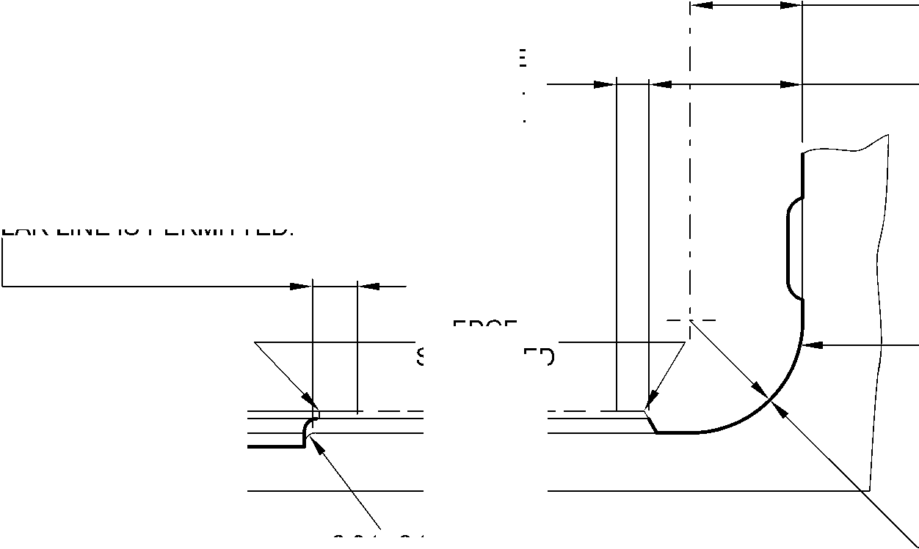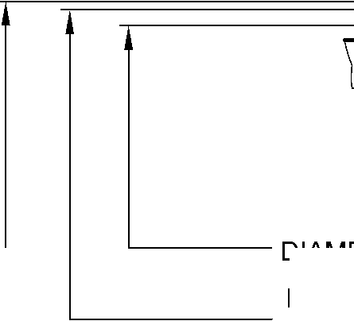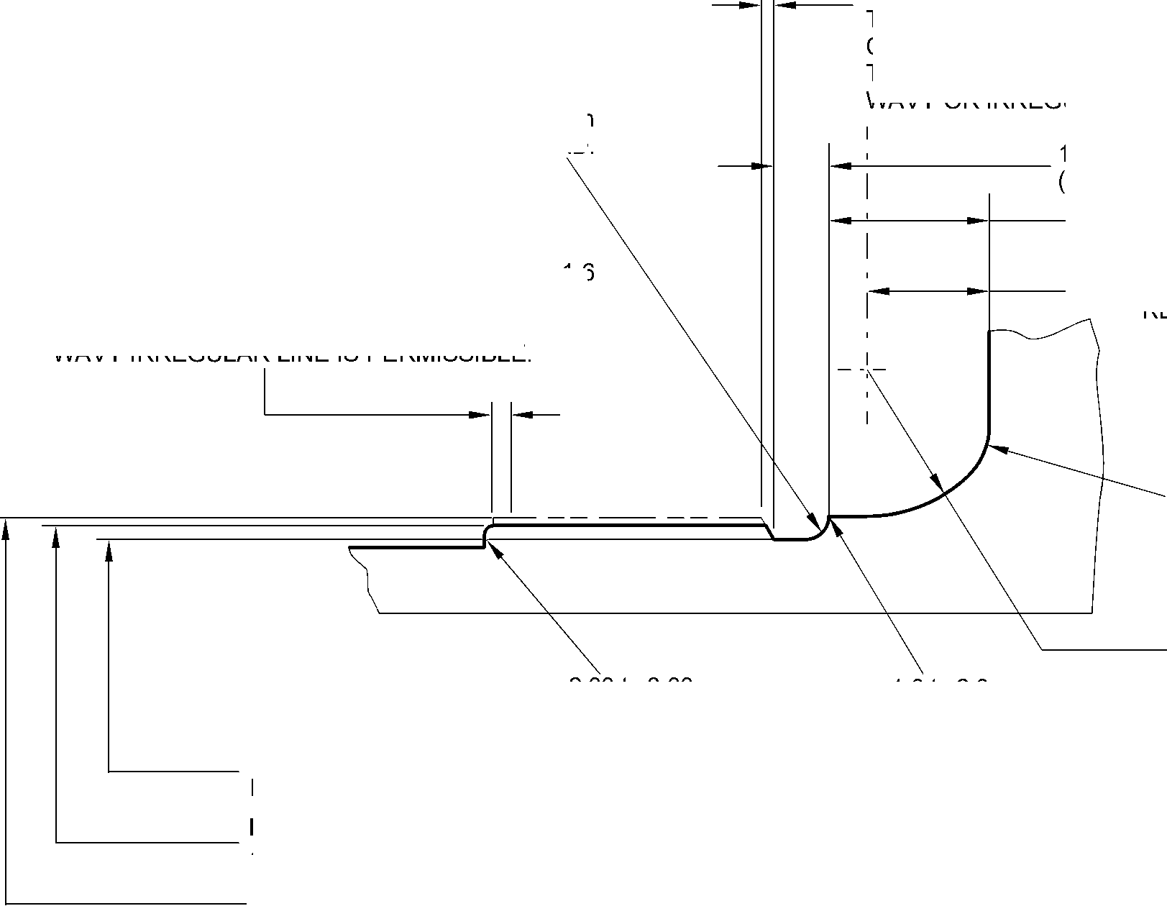

**SAFRAN LANDING SYSTEMS UK Ltd**

CAGE: K0654



PART No. 201587001 AND 201587002 COMPONENT MAINTENANCE MANUAL  
MAIN LANDING GEAR LEG

INTENTIONALLY BLANK

Repair No. 9-10

32-12-22 Page 608

**SAFRAN LANDING SYSTEMS UK Ltd**

CAGE: K0654



PART No. 201587001 AND 201587002 COMPONENT MAINTENANCE MANUAL  
MAIN LANDING GEAR LEG

I 1. Repair No. 9-11 Sliding Tube (18-80 and 18-80A)

1. Specified Damage and Material Specification.
2. Specified Damage

(a) Damage or wear to the diameter A.

1. Material Spcification

|  |  |  |
| --- | --- | --- |
| IPL Figure and Item No. | Name | Material Specification |
| 18-80 and  18-80A | Sliding Tube | Steel, 300M |

1. Special Tools
2. These special tools are necessary:

**NOTE: Alternative equivalents are permitted.**

|  |  |  |
| --- | --- | --- |
| Tool Part No. | Special Tool | Function |
| 460004330/105 | Press Pad | To install the repair bush 450266800 |

1. Materials
2. Materials are not necessary.
3. Repair Parts
4. These repair parts are necessary:

|  |  |  |
| --- | --- | --- |
| Part No. | Repair Part | Material Specification |
| 450266800 | Repair Bush | Stainless Steel, AMS5643 or  AMS5659 |

1. Procedure (Refer to Figures 601 to 603)

**CAUTION: FOR DAMAGE MORE THAN THE LIMITS OF THIS REPAIR SCHEME, WRITE  
TO SAFRAN LANDING SYSTEMS: REFER TO GUIDE-CS-001.**

1. Do this procedure if there is wear or damage to diameter A:
2. Locally remove the Sermetel layer from the sliding tube: refer to REPAIR and  
   M-DLPS637.
3. Locally remove the chromium plate from the sliding tube: refer to REPAIR  
   PCS-2110 and Figures 601 and 602.
4. If necessary, machine the diameter(s) A to remove the minimum amount of  
   material necessary to remove the damage or wear: refer to M-DLPS1004-4-1 and  
   Figure 602. Do not make the diameter A more than 21,073 mm (0.8296 in). Make  
   the surface finish 1,6 micrometers (63 micro-inches) or better.
5. Measure and record the new diameter(s) A.
6. Machine the chamfers and radii as shown: refer to Figure 602.

Repair No. 9-11

Page 601

Mar 18/2025

32-12-22

**sSAFRAN SAFRAN LANDING SYSTEMS UK Ltd**

CAGE: K0654

PART No. 201587001 AND 201587002 COMPONENT MAINTENANCE MANUAL  
MAIN LANDING GEAR LEG

1. Examine the bare metal for flaws: refer to PCS-3100, inclusion class 4 and  
   PCS-3600.
2. Shot peen the reworked areas: refer to M-DLPS123.
3. Apply chromium plate to diameter(s) A: refer to PCS-2110 Type C, M-DLPS1031-5  
   and Figure 602. The chromium plate thickness must be between 0,020 and  
   0,025 mm (0.0008 and 0.0010 in).
4. Apply Sermetel to the repaired area: refer to M-DLPS637 and Figure 602.
5. Identify the part with the Safran Landing Systems repair number 450266295

adjacent to the part number: refer to PCS-6000-05.

1. Machine diameter B of the repair bush(es), use formula:

Dia. B = Dia. A (as measured) - 0,005 to + 0,041 mm (- 0.0002 to + 0.0016 in).

1. Machine the face R to get the flange thickness of between 2,00 and 2,05 mm  
   (0.079 and 0.081 in).
2. Passivate the repair bush(es): refer to AMS-2700.
3. Apply a layer of IVD alloy with elecromation yellow all over the repair bush(es) but  
   not in the bores: refer to ICT 40-893-01MD and Figure 603. The thickness of the  
   IVD layer must be between 0,0075 and 0,0125 mm (0.0003 and 0.0005 in).
4. Apply primer paint to the sliding tube where the repair bush flanges will touch: refer  
   to PCS-2500.
5. Install the repair bush(es): refer to M-DLPS1011-20 and Figure 603.
6. Apply paint to the repaired area: refer to PCS-2500 and REPAIR.
7. Identify the part with the Safran Landing Systems repair number 450266295  
   adjacent to the part number: refer to PCS-6000-07.
8. Examine the part to make sure that you have obeyed all the repair instructions  
   correctly.

32-12-22

Repair No. 9-11

Page 602

Mar 18/2025

**SAFRAN LANDING SYSTEMS UK Ltd**

CAGE: K0654

PART No. 201587001 AND 201587002 COMPONENT MAINTENANCE MANUAL  
MAIN LANDING GEAR LEG

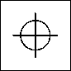

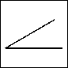

1,60mm  
(0.063in)

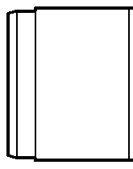

0,20mm  
(0.008in) DIA.

X

Z

6 DEGREES

57 MINUTES

dia. A

(3 PLACES)  
(BOTH FLANGES)

Z

Y

150 DEGREES

V

V

Y

192,000mm  
(7.5591in)  
DIA.

6,140mm (0.2417in)  
MINIMUM WALL  
THICKNESS

W

SEE FIG. 602

X

60 DEGREES

section Z-Z

A321-S-32-12-22-052-0

Repair to Sliding Tube  
Figure 601

Repair No. 9-11

32

Page 603

-12-22 Dec 6/2019

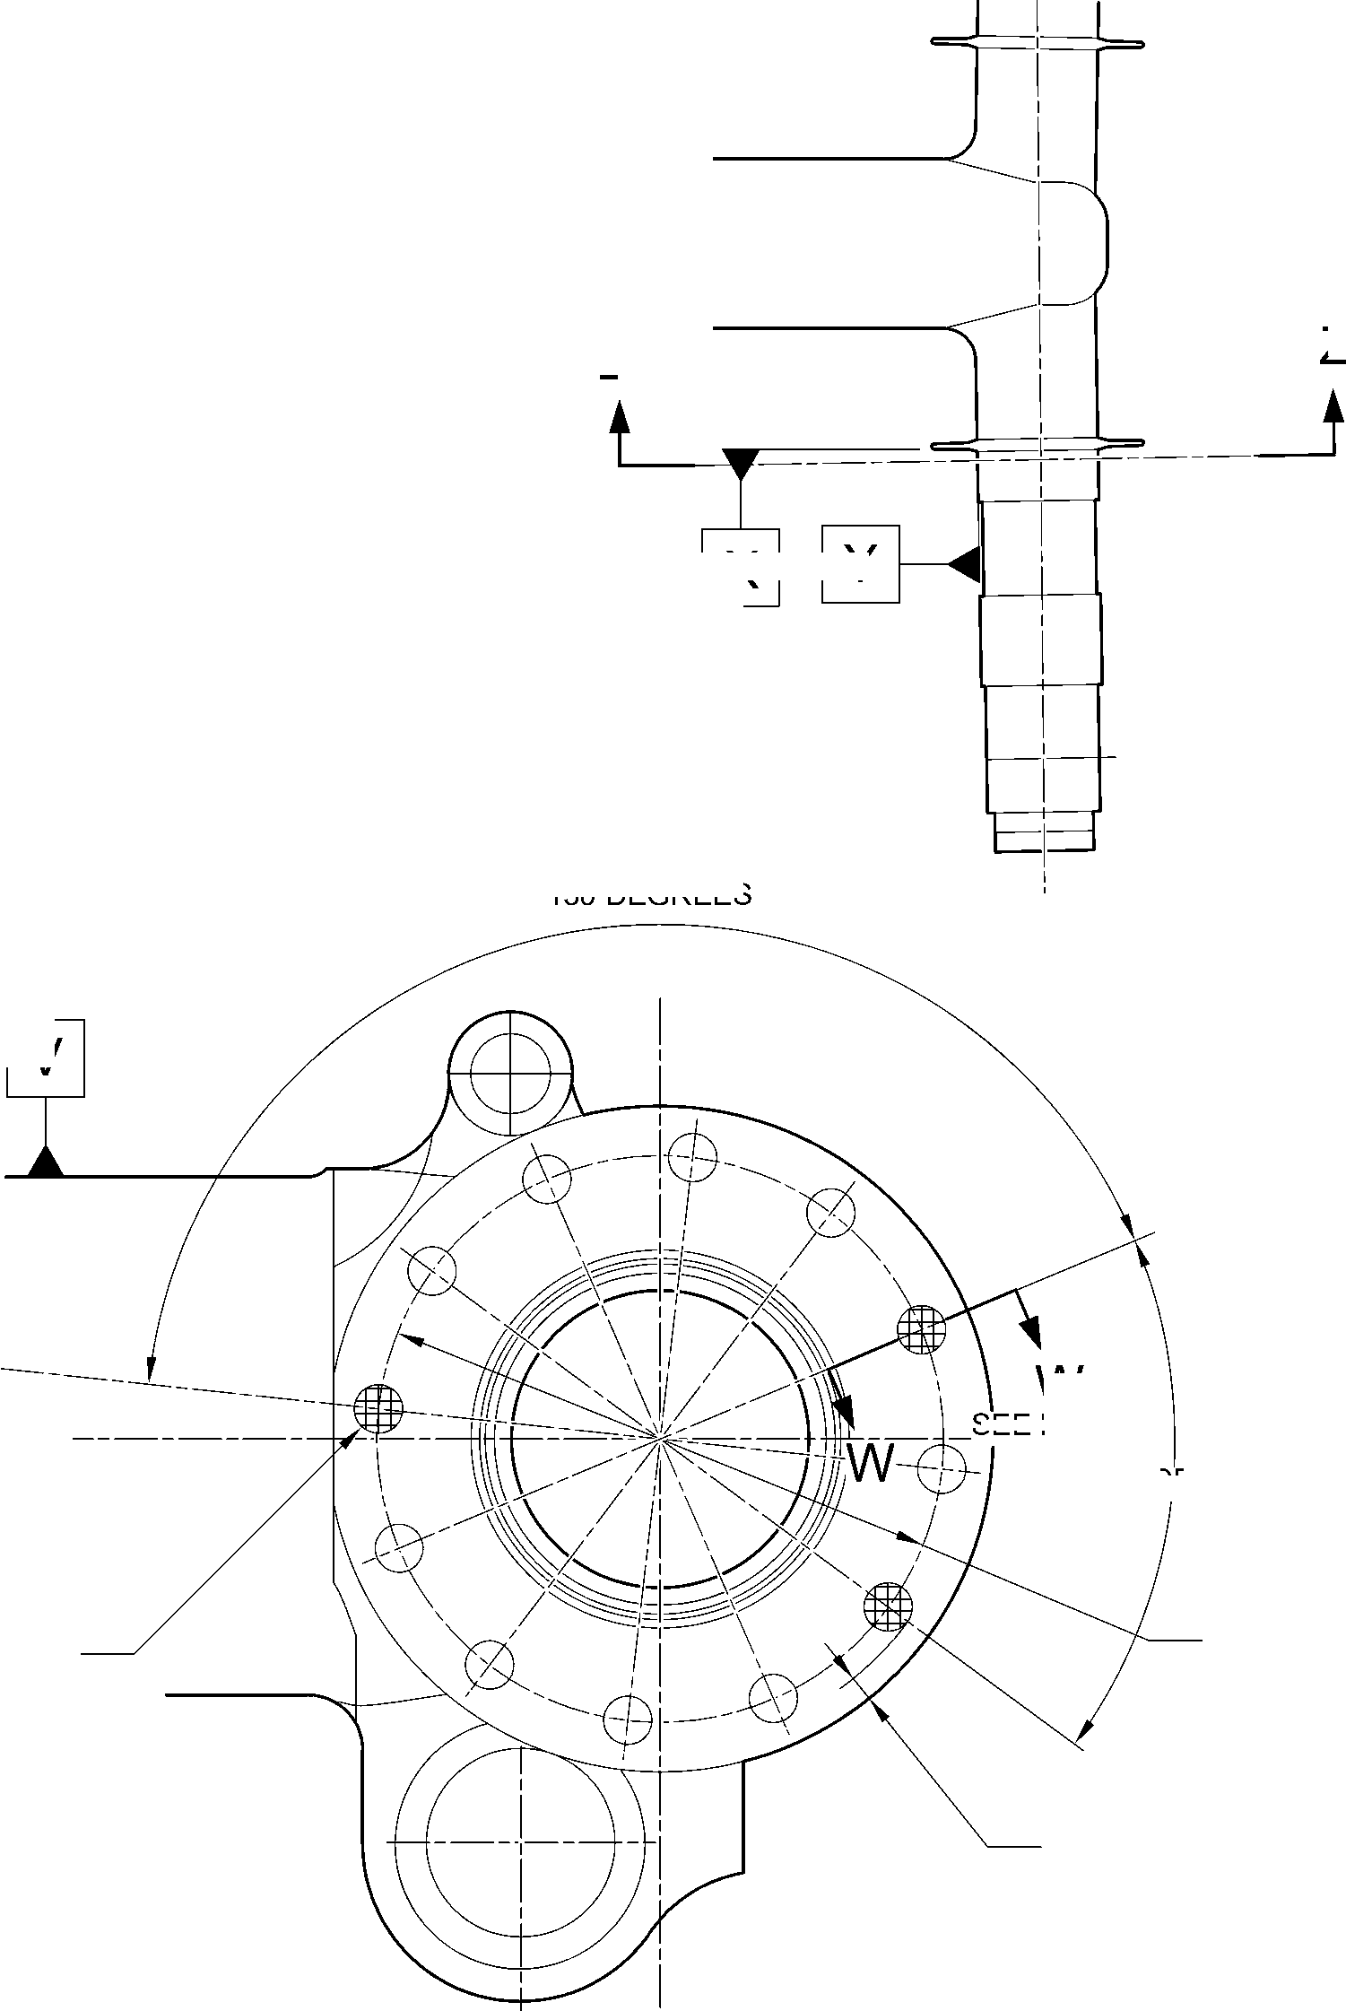

**SAFRAN LANDING SYSTEMS UK Ltd**

CAGE: K0654



PART No. 201587001 AND 201587002 COMPONENT MAINTENANCE MANUAL  
MAIN LANDING GEAR LEG

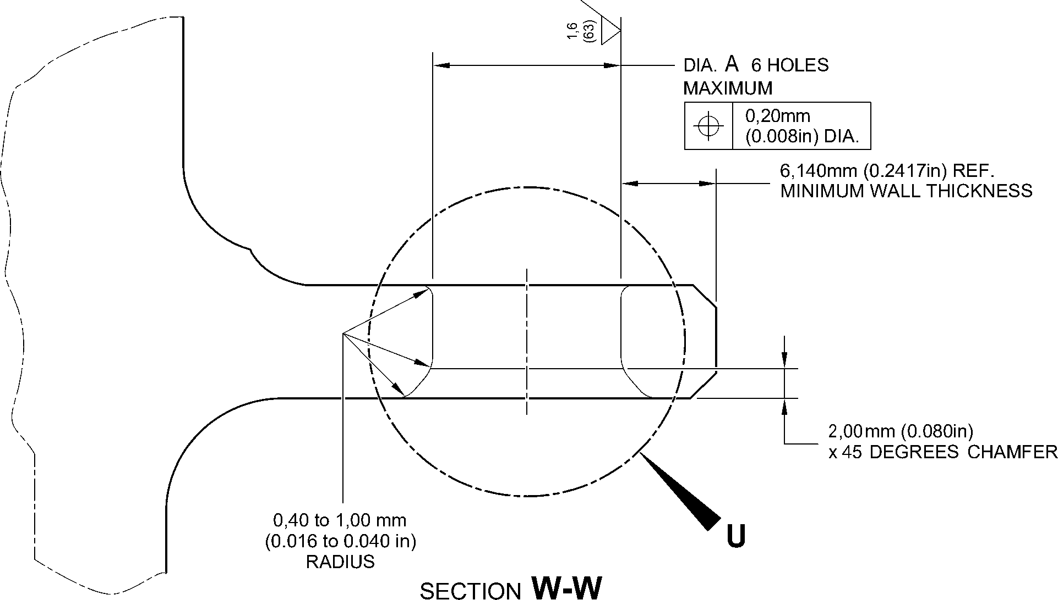

(WITHOUT BUSHES)

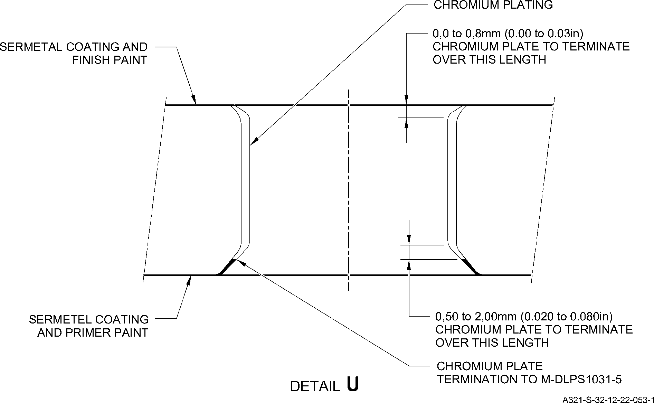

Repair to Sliding Tube - Machining

Figure 602

32-12-22

Page 604

Aug 11/2023

Repair No. 9-11

**SAFRAN LANDING SYSTEMS UK Ltd**

CAGE: K0654

PART No. 201587001 AND 201587002 COMPONENT MAINTENANCE MANUAL  
MAIN LANDING GEAR LEG

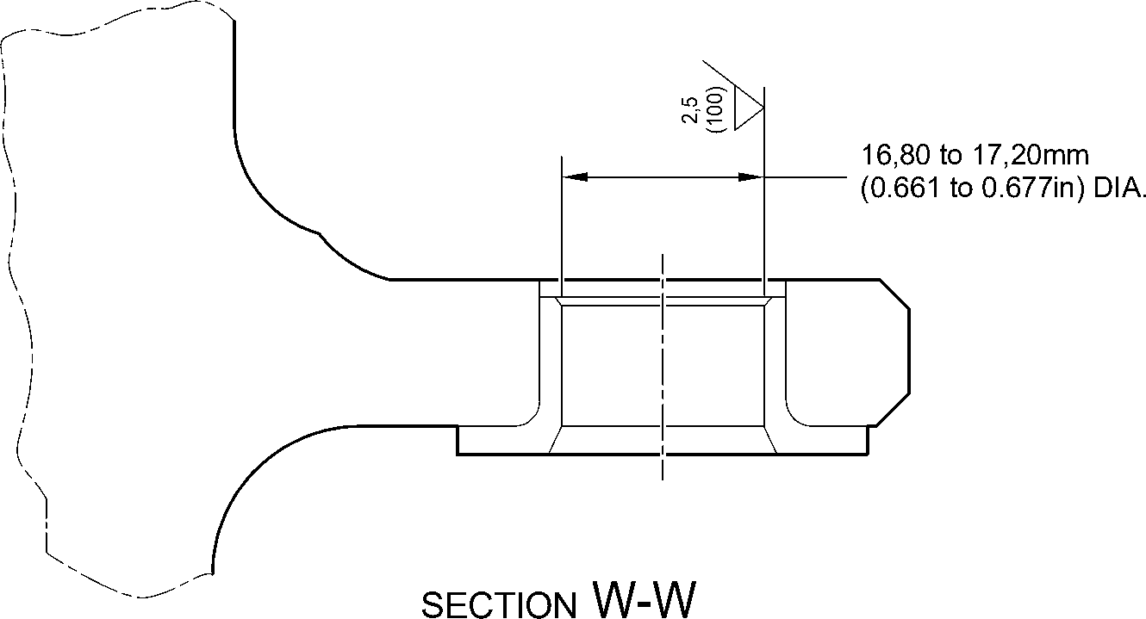

(WITH BUSHES)

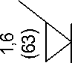

|  |  |  |  |
| --- | --- | --- | --- |
|  | **L** | 0,015mm (0.0006in) | S |

face R

IVD COATING OPTIONAL IN END FACE

APPLY COAT OF ALUMINIUM (IVD)

IVD COATING OPTIONAL

28,75 to 29,25mm  
(1.132 to 1.152in) DIA. REF.  
APPLY COAT OF ALUMINIUM (IVD)

11,90 to 12,30mm  
(0.469 to 0.484in)

2,00 to 2,05mm

(0.079 to 0.081in)

S

0,100mm  
(0.0040in)

dia. B

APPLY COAT OF ALUMINIUM (IVD)

16,80 to 17,20mm

(0.661 to 0.677in) DIA. REF.

0,5mm (0.020in) x 60 DEGREES

INCLUSIVE CHAMFER  
IVD COATING OPTIONAL

T

RADIUS 1,45 to 1,75mm

(0.057 to 0.069in)

APPLY COAT OF ALUMINIUM (IVD)

REPAIR BUSH 450266800

A321-S-32-12-22-054-1

Repair Bushes - Machining and Installation

Figure 603

Repair No. 9-11

Page 605

Mar 18/2025

32-12-22

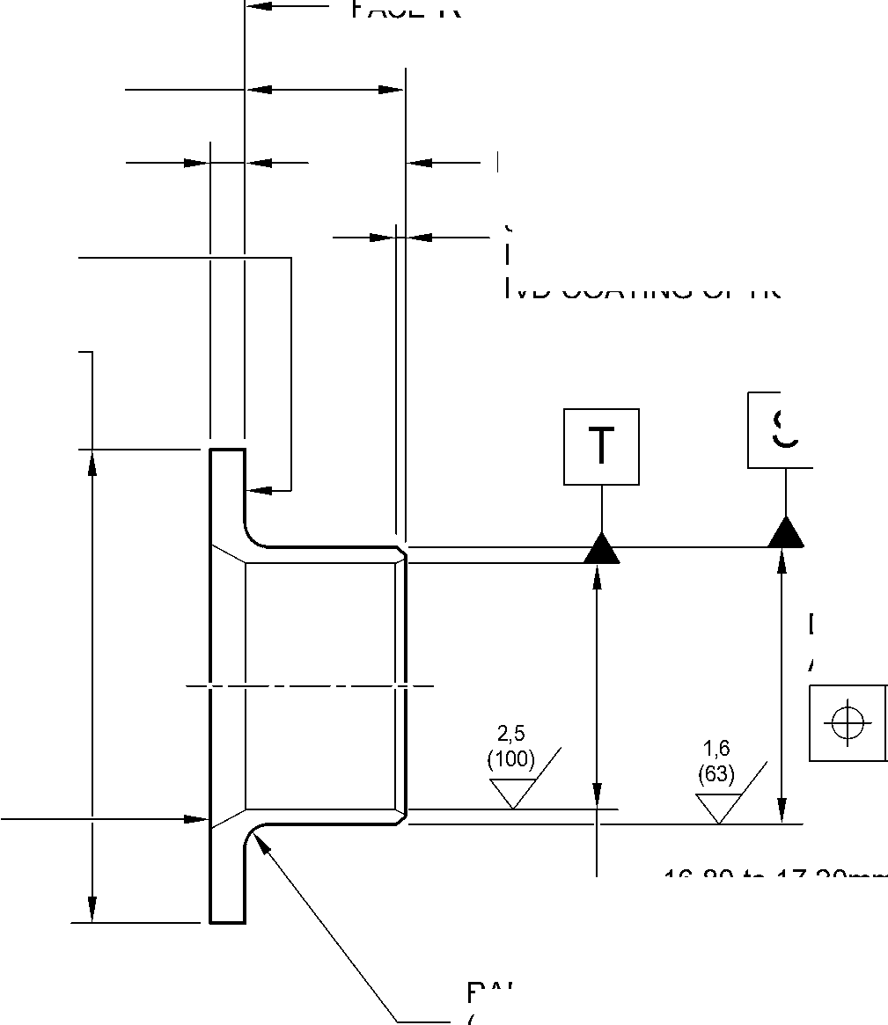

**SAFRAN LANDING SYSTEMS UK Ltd**

CAGE: K0654



PART No. 201587001 AND 201587002 COMPONENT MAINTENANCE MANUAL  
MAIN LANDING GEAR LEG

INTENTIONALLY BLANK

Repair No. 9-11

32-12-22 Page 606

**sSAFRAN SAFRAN LANDING SYSTEMS UK Ltd**

CAGE: K0654

PART No. 201587001 AND 201587002 COMPONENT MAINTENANCE MANUAL  
MAIN LANDING GEAR LEG

1. Repair No. 10-1 Pin (9-70)
2. Specified Damage and Material Specification.
3. Specified Damage

(a) Damage or corrosion to diameter A.

1. Material Specification

|  |  |  |
| --- | --- | --- |
| IPL Figure and Item No. | Name | Material Specification |
| 9-70 | Pin | UHT Steel, MTL1201 |

1. Special Tools
2. Special tools are not necessary.
3. Materials
4. Materials are not necessary.
5. Repair Parts
6. Repair parts are not necessary.
7. Procedure (Refer to Figure 601)
8. Remove the chromium plate from diameter A: refer to PCS-2110.
9. If the base metal is not damaged or corroded:
10. Examine the pin for flaws: refer to PCS-3600 and PCS-3100, inclusion  
    class 4.
11. Apply chromium plate to diameter A: refer to PCS-2110, type C: refer  
    to Figure 601.
12. Grind diameter A to between 30,950 and 30,975 mm (1.2185 and 1.2194 in).  
    The surface finish must be 0,8 micrometers (31 micro-inches).
13. Examine the ground chromium plate for flaws: refer to PCS-3100 and  
    PCS-3002.
14. Apply cadmium plate to the areas that do not have chromium plate: refer to  
    PCS-2141.
15. Identify the part with the Messier-Dowty Limited repair number 450266210A  
    adjacent to the part number: refer to PCS-6000-04, PCS-6000-06 and  
    PCS-6000-07.
16. Examine the part to make sure that you have obeyed all the repair  
    instructions correctly.

Repair No. 10-1

Page 601

Dec 6/2019

32-12-22

**sSAFRAN SAFRAN LANDING SYSTEMS UK Ltd**

CAGE: K0654

PART No. 201587001 AND 201587002 COMPONENT MAINTENANCE MANUAL  
MAIN LANDING GEAR LEG

1. If the bare metal is damaged or corroded:

1 Refer to M-DLPS1004-4-1 and machine diameter A just sufficiently to remove  
the damage or corrosion: the diameter must not be less than 30,365 mm  
(1.1956 in). The surface finish must be 1,6 micrometers (63 micro-inches).

2 Examine the pin for flaws: refer to PCS-3600 and PCS-3100, inclusion  
class 4.

1. Shot peen the machined areas: refer to M-DLPS123.
2. Apply chromium plate to diameter A: refer to PCS-2110, type C  
   and Figure 601.

5 Grind diameter A to between 30,950 and 30,975 mm (1.2185 and 1.2194 in).  
The surface finish must be 0,8 micrometers (31 micro-inches).

1. Examine the ground chromium plate for flaws: refer to PCS-3100 and  
   PCS-3002.
2. Apply cadmium plate to the areas that do not have chromium plate: refer to  
   PCS-2141.

8 Identify the part with the Messier-Dowty Limited repair number 450266210B  
adjacent to the part number: refer to PCS-6000-04, PCS-6000-06 and  
PCS-6000-07.

1. Examine the part to make sure that you have obeyed all the repair  
   instructions correctly.

32-12-22

Repair No. 10-1

Page 602

Dec 6/2019

**SAFRAN LANDING SYSTEMS UK Ltd**

CAGE: K0654



PART No. 201587001 AND 201587002 COMPONENT MAINTENANCE MANUAL  
MAIN LANDING GEAR LEG

Z

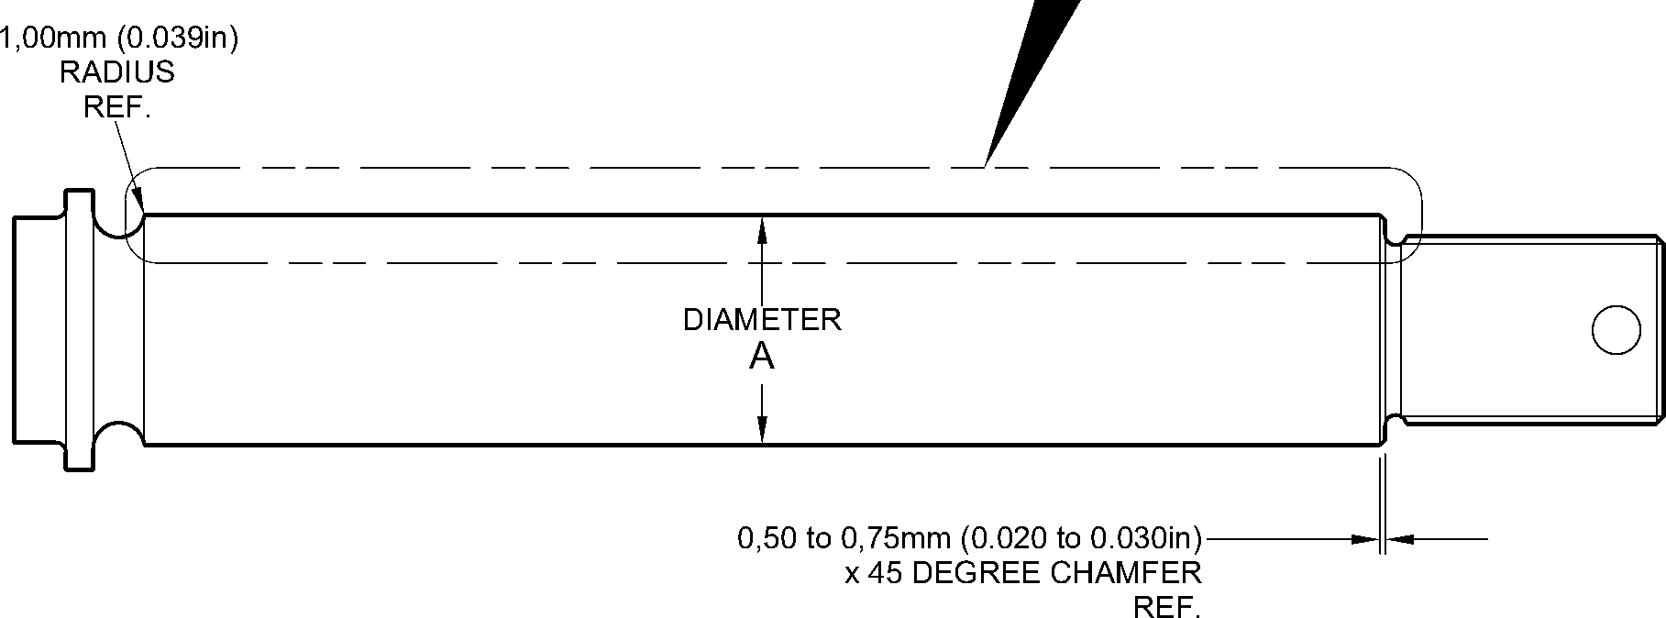

CHROMIUM PLATE  
TERMINATION TO

CHROMIUM PLATE  
TERMINATION TO

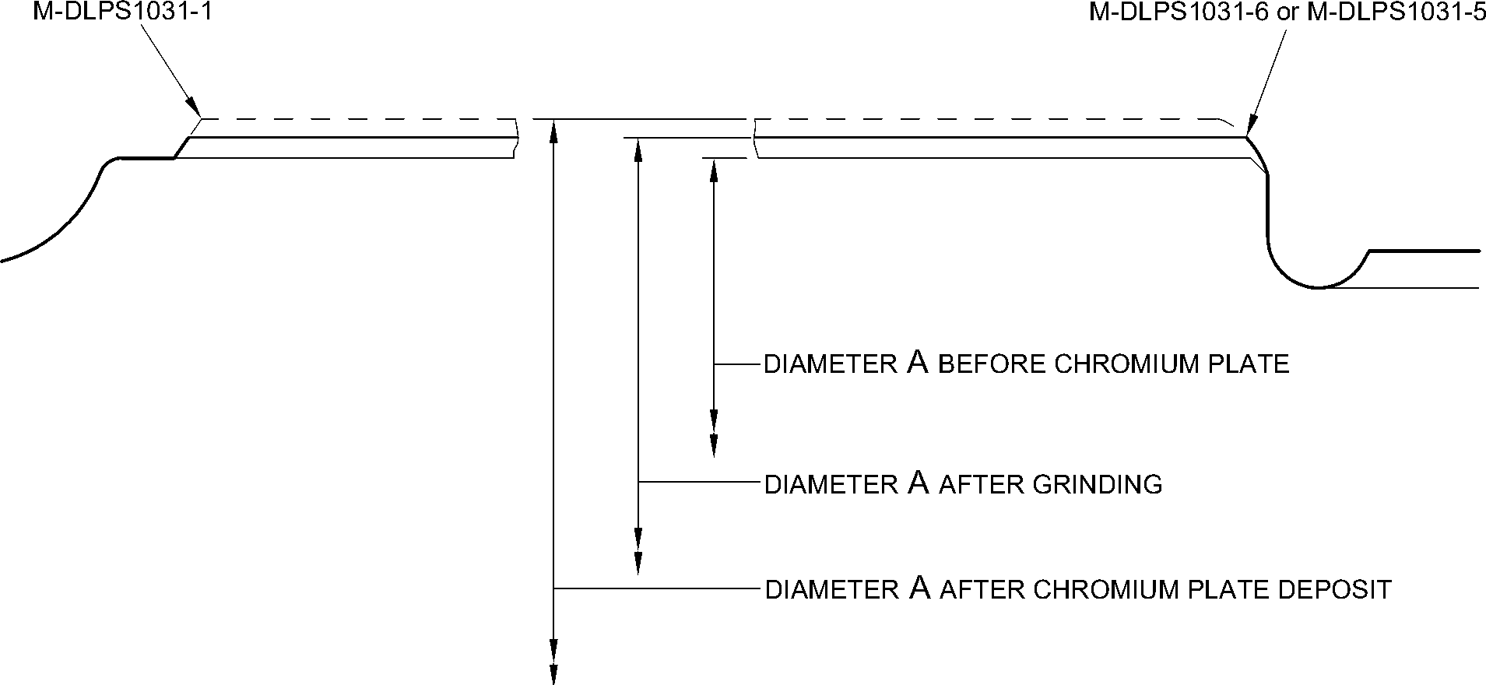

detail Z

A321A3760-1

Repair to Pin  
Figure 601

Repair No. 10-1

Page 603

Dec 6/2019

32-12-22

**SAFRAN LANDING SYSTEMS UK Ltd**

CAGE: K0654



PART No. 201587001 AND 201587002 COMPONENT MAINTENANCE MANUAL  
MAIN LANDING GEAR LEG

INTENTIONALLY BLANK

Repair No. 10-1

32-12-22 Page 604

**sSAFRAN SAFRAN LANDING SYSTEMS UK Ltd**

CAGE: K0654

PART No. 201587001 AND 201587002 COMPONENT MAINTENANCE MANUAL  
MAIN LANDING GEAR LEG

I 1. Repair No. 11-1 Main Fitting (20-410, 20-410A, 20-420 and 20-420A)

1. Specified Damage and Material Specification.
2. Specified Damage

(a) Damage or wear to the diameter A and/or the adjacent face(s).

1. Material Specification

|  |  |  |
| --- | --- | --- |
| IPL Figure and Item No. | Name | Material Specification |
| 20-410, 20-410A, 20-420 and 20-420A | Main fitting | Steel, MAT135, 35NCD16THQ |

1. Special Tools
2. Special tools are not necessary.
3. Materials
4. These materials are necessary:

**NOTE: Alternative equivalents are permitted.**

|  |  |
| --- | --- |
| Ref. Item | Material |
| TBA | Electrically conducting Mastinox to M-DLPS709-14 |
| 09-510A | Sealant |

1. Repair Parts
2. These repair parts are necessary:

|  |  |  |
| --- | --- | --- |
| Part No. | Repair Part | Material Specification |
| 450266061 | Blank bushes | Aluminium Bronze, DTD197 |

1. Procedure (Refer to Figures 601 and 602)
2. Machine the diameter A sufficiently only to remove the damage or wear: refer to  
   M-DLPS1004-4-1. The machined diameter A must not be more than 26,921 mm (1.0599  
   in). The surface finish must be 1,6 micrometers (63 micro-inches). Remove the sharp  
   edge at the intersection of the lubrication hole with a 0,50 to 2,00 mm (0.020 to 0.079 in)  
   radius.
3. Machine the adjacent face(s) sufficiently only to remove the damage or wear: refer to  
   M-DLPS1004-4-1. Do not remove more than 1,00 mm (0.039 in) from each face. The  
   surface finish must be 1,6 micrometers (63 micro-inches).
4. Machine the chamfers and radii to the dimensions shown in Figure 601.
5. Examine the machined areas for flaws: refer to PCS-3600 and PCS-3100, inclusion  
   class 4.

Repair No. 11-1

Page 601

Mar 18/2025

32-12-22

**sSAFRAN SAFRAN LANDING SYSTEMS UK Ltd**

CAGE: K0654

PART No. 201587001 AND 201587002 COMPONENT MAINTENANCE MANUAL  
MAIN LANDING GEAR LEG

1. Measure and make a record of the new diameter A and the dimensions B and E.
2. Shot peen the machined areas: refer to M-DLPS123.
3. Apply cadmium plate to the machined areas: refer to PCS-2141.
4. Identify the part with the Safran Landing Systems repair number 450266060 adjacent to  
   the part number: refer to PCS-6000-04, an alternative reference is PCS-6000-06. If the  
   alternative reference is used, the characters must be 0,051 to 0,102 mm (0.0020 to  
   0.0040 in) deep and approximately 3,00 mm (0.118 in) high.
5. Calculate the diameters F and the dimensions D of the oversize bushes:

F = A (as measured) + 0,007 to 0,041 mm (0.0003 to 0.0016 in)

D (for Bush 1) = B (as measured) - 2,50 to - 2,55 mm (- 0.098 to - 0.100 in)

D (for Bush 2) = 45,733 to 45,820 mm (1.8005 to 1.8039 in) - E (as measured).

1. Machine the blank bushes to the dimensions shown and calculated: the surface finish  
   must be 1,6 micrometers (63 micro-inches). Identify each oversize bush for reference.
2. Apply cadmium plate to the oversize bushes, but not on the internal diameter and where  
   shown: refer to Figure 602 and PCS-2101 or PCS-2141 but do not de-embrittle. The  
   thickness of the cadmium plate must be between 0,010 and 0,015 mm (0.0004 and  
   0.0006 in).
3. Install the oversize bushes to their correct locations: refer to M-DLPS1011-20 and use  
   the electrically conducting Mastinox to M-DLPS709-14. Primer paint the gap between  
   the internal ends of the oversize bushes and keep it free from sealant.
4. Check line ream the oversize bushes to the dimension shown in Figure 602.
5. Apply sealant, Material Ref. Item 09-510A, around the flanges of the oversize bushes:  
   refer to PCS-7200.
6. Identify the part with the Safran Landing Systems repair number 450266060 adjacent to  
   the part number: refer to PCS-6000-07.
7. Examine the part to make sure that you have obeyed all the repair instructions correctly.

32-12-22

Repair No. 11-1

Page 602

Mar 18/2025

**SAFRAN LANDING SYSTEMS UK Ltd**

CAGE: K0654

PART No. 201587001 AND 201587002 COMPONENT MAINTENANCE MANUAL  
MAIN LANDING GEAR LEG

656,085mm

(25.8301in)

23,50 to 24,50mm  
(0.925 to 0.965in)

PLANE PASSES  
THROUGH

POINT

3,00 to 4,00mm  
(0.118 to 0.157in) RADIUS

TYPICAL AROUND LUG

point C

Z

POINT C

Y

view on arrow Z

dimenSiOn E

35,90mm (1.413in) MINIMUM

diameter A

20 DEGREES

4 MINUTES

27 SECONDS

0,25 to 0,75mm  
(0.010 to 0.030in)

x 45 DEGREE CHAMFER

SMOOTH TO RADIUS.  
2 PLACES

section Y-Y  
WITHOUT BUSHES

dimenSiOn B  
6,50mm (0.256in)  
MAXIMUM  
(REFERENCE)

4 DEGREES 57 MINUTES

31 SECONDS  
(REFERENCE)

dimension B  
6,50mm (0.256in)  
MAXIMUM

A321A4812-1

Repair to Main Fitting  
Figure 601

Repair No. 11-1

Page 603

Dec 6/2019

32-12-22

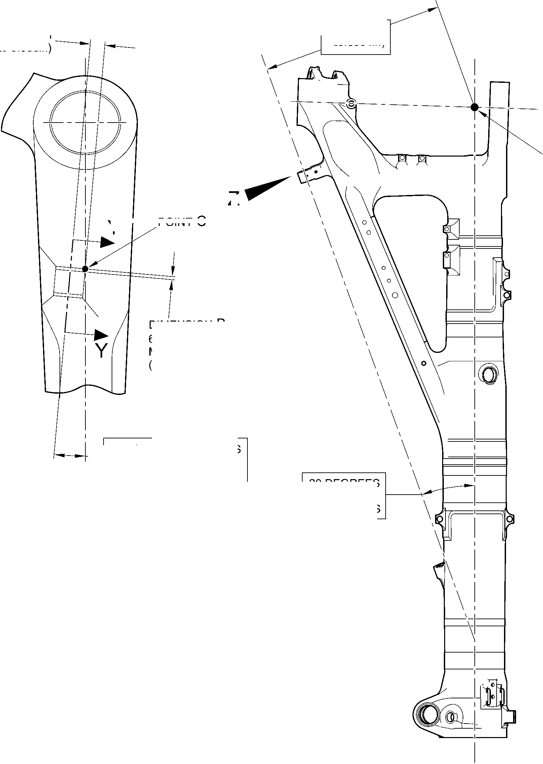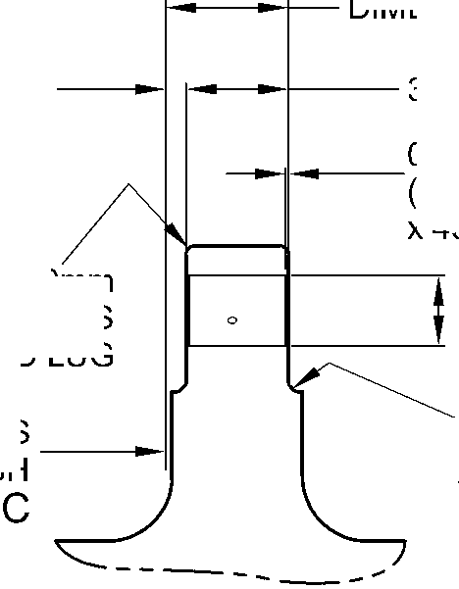

**SAFRAN LANDING SYSTEMS UK Ltd**

CAGE: K0654



PART No. 201587001 AND 201587002 COMPONENT MAINTENANCE MANUAL  
MAIN LANDING GEAR LEG

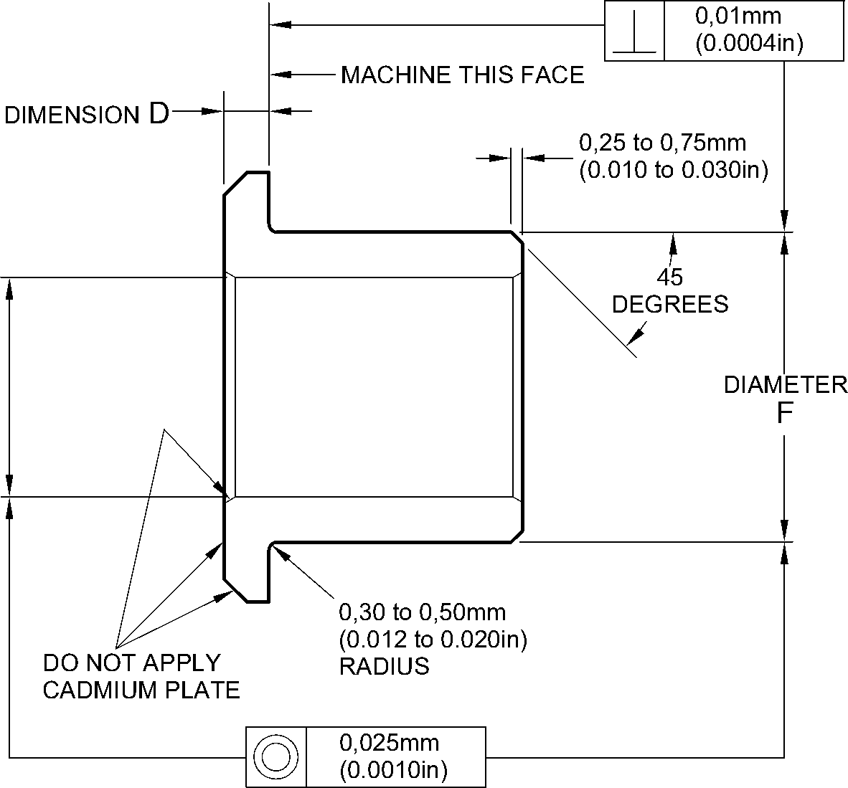

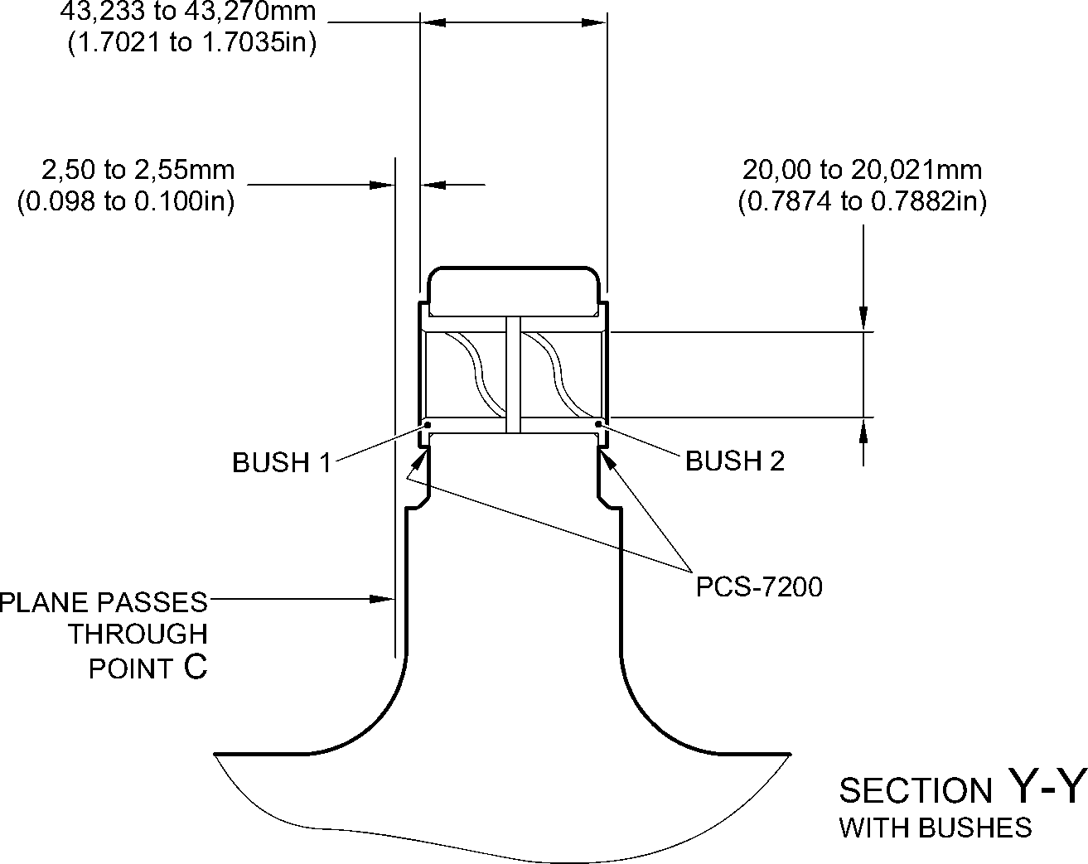

A321A4813-1

Oversize Bushes - Machining and Installation  
Figure 602

32-12-22

Repair No. 11-1

Page 604

Dec 6/2019

**SAFRAN LANDING SYSTEMS UK Ltd**

CAGE: K0654



PART No. 201587001 AND 201587002 COMPONENT MAINTENANCE MANUAL  
MAIN LANDING GEAR LEG

I 1. Repair No. 11-2 Main Fitting (20-410, 20-410A, 20-420 and 20-420A)

1. Specified Damage and Material Specification.
2. Specified Damage

(a) Damage or corrosion to the diameter(s) A.

1. Material Specification

|  |  |  |
| --- | --- | --- |
| IPL Figure and Item No. | Name | Material Specification |
| 20-410, 20-410A, 20-420 and 20-420A | Main fitting | Steel, MAT135, 35NCD16THQ |

1. Special Tools

(1) These special tools are necessary:

**NOTE: Alternative equivalents are permitted.**

|  |  |  |
| --- | --- | --- |
| Part No. | Special Tool | Function |
| 460007257 | Press Pad | Install the oversize bush(es) |

1. Materials
2. These materials are necessary:

**NOTE: Alternative equivalents are permitted.**

|  |  |
| --- | --- |
| Ref. Item | Material |
| TBA | Electrically conducting Mastinox to M-DLPS709-14 |
| 09-510A | Sealant |

1. Repair Parts
2. These repair parts are necessary:

|  |  |  |
| --- | --- | --- |
| Part No. | Repair Part | Material Specification |
| 450258808 | Blank bush | Aluminium Bronze, BSB23 or AMS4640 |

E. Procedure (Refer to Figures 601 and 602)

1. Machine the diameter(s) A sufficiently to remove the damage or corrosion: refer to  
   M-DLPS1004-4-1 and to Figure 601 for the dimensions. The surface finish must be  
   1,6 micrometers (63 micro-inches).
2. Examine the part for flaws: refer to PCS-3600 and PCS-3100, inclusion class 4.
3. Measure and make a record of the new diameter A.

(4)

Shot peen the machined areas: refer to M-DLPS123.

32-12-22

Repair No. 11-2

Page 601

Mar 18/2025

**sSAFRAN SAFRAN LANDING SYSTEMS UK Ltd**

CAGE: K0654

PART No. 201587001 AND 201587002 COMPONENT MAINTENANCE MANUAL  
MAIN LANDING GEAR LEG

1. Apply cadmium plate to the machined areas: refer to PCS-2141.
2. Identify the part with the Safran Landing Systems repair number 450266070 adjacent to  
   the part number: refer to PCS-6000-04, an alternative reference is PCS-6000-06. If the  
   alternative reference is used, the characters must be 0,051 to 0,102 mm (0.0020 to  
   0.0040 in) deep and approximately 3,00 mm (0.118 in) high.
3. Calculate the diameter D of the oversize bush(es):

D = A (as measured) - 0,009 to + 0,029 mm (- 0.0003 to + 0.0012 in).

1. Machine the oversize bush(es) from the blank bush(es) to the dimensions shown and  
   calculated: the surface finish must be 1,6 micrometers (63 micro-inches).
2. Apply cadmium plate to the oversize bush(es). The thickness of the cadmium plate must  
   be between 0,010 and 0,015 mm (0.0004 and 0.0006 in): refer to PCS-2101 or  
   PCS-2141 and do not de-embrittle.
3. Use the Press Pad 460007257 to install the oversize bush(es): refer to M-DLPS1011-20  
   and use the electrically conducting Mastinox to M-DLPS709-14, Material Ref Item TBA.
4. Check the internal diameter(s) of the installed oversize bush(es) to the dimension shown  
   in Figure 602.
5. Apply sealant, Material Ref. Item 09-510A, around the flanges of the oversize bush(es):  
   refer to PCS-7200.
6. Identify the part with the Safran Landing Systems repair number 450266070 adjacent to  
   the part number: refer to PCS-6000-07.
7. Examine the part to make sure that you have obeyed all the repair instructions correctly.

32-12-22

Repair No. 11-2

Page 602

Mar 18/2025

**SAFRAN LANDING SYSTEMS UK Ltd**

CAGE: K0654



PART No. 201587001 AND 201587002 COMPONENT MAINTENANCE MANUAL  
MAIN LANDING GEAR LEG

412,50 to 413,50mm  
(16.240 to 16.280in)

36,86mm  
(1.451in)

point C

Z

15,54mm  
(0.612in)

section Z-Z

WITHOUT BUSHES

0,80 to 1,20mm  
(0.032 to 0.047in)  
TYPICAL BOTH BORES

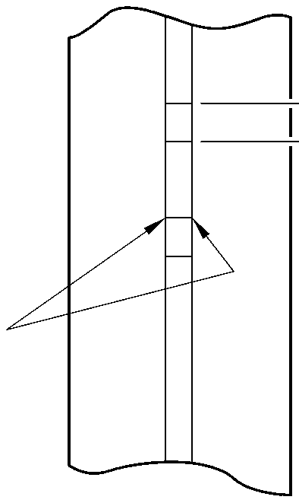

g—0

Z

diameter A

15,727mm (0.6192in)  
MAXIMUM

TYPICAL BOTH BORES

Repair to Main Fitting  
Figure 601

396,37 to 397,37mm  
(15.605 to 15.644in)

A321A4810-1

Repair No. 11-2

Page 603

Dec 6/2019

32-12-22

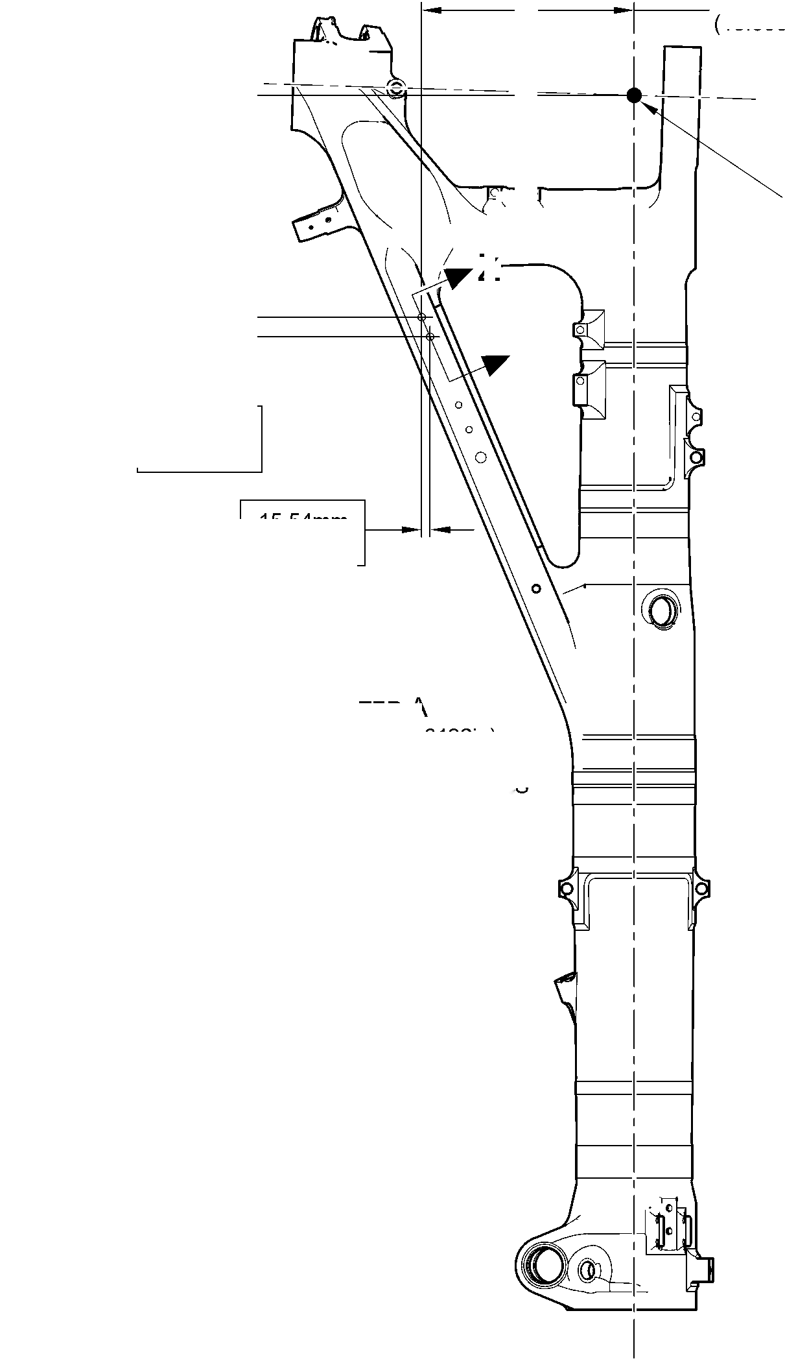

**SAFRAN LANDING SYSTEMS UK Ltd**

CAGE: K0654



PART No. 201587001 AND 201587002 COMPONENT MAINTENANCE MANUAL  
MAIN LANDING GEAR LEG

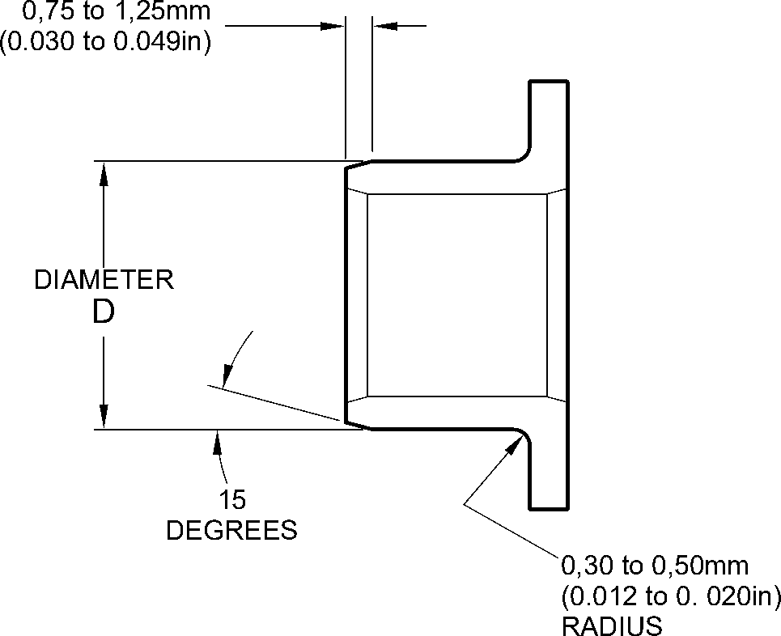

REPAIR BUSH 450258808

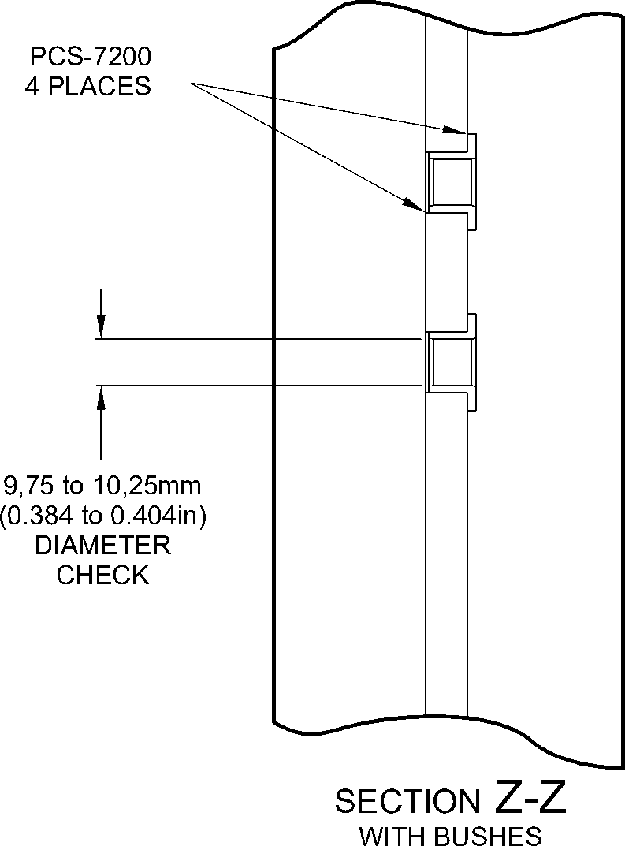

A321A4811-1

Oversize Bush(es) - Machining and Installation  
Figure 602

Repair No. 11-2

32

Page 604

Dec 6/2019

**sSAFRAN SAFRAN LANDING SYSTEMS UK Ltd**

CAGE: K0654

PART No. 201587001 AND 201587002 COMPONENT MAINTENANCE MANUAL  
MAIN LANDING GEAR LEG

I 1. Repair No. 11-3 Main Fitting (20-410, 20-410A, 20-420 and 20-420A)

1. Specified Damage and Material Specification.
2. Specified Damage

(a) Damage or corrosion to the diameter A and/or faces B and C (Refer to Figure 601).

1. Material Specification

|  |  |  |
| --- | --- | --- |
| IPL Figure and Item No. | Name | Material Specification |
| 20-410, 20-410A, 20-420 and 20-420A | Main fitting | Steel, MAT135, 35NCD16THQ |

1. Special Tools

(1) These special tools are necessary:

|  |  |  |
| --- | --- | --- |
| Part No. | Special Tool | Function |
| 460004330/259 | Press Pad | Install the repair bush 450258811 |
| 460004330/260 | Press Pad | Install the repair bush 450258812 |

1. Materials

(1) These materials are necessary:

**NOTE: Alternative equivalents are permitted.**

|  |  |
| --- | --- |
| Ref. Item | Material |
| 09-510A | Sealant: refer to PCS-7200 |
| TBA | Electrically conducting zinc loaded Mastinox D40: refer to M-DLPS709-14 |

1. Repair Parts

(1) These repair parts are necessary:

|  |  |  |
| --- | --- | --- |
| Part No. | Repair Part | Material Specification |
| 450258811 | Repair bush | Aluminium bronze AMS4590 or  AMS4881 centrifugally cast |
| 450258812 | Repair bush | Aluminium bronze AMS4590 or  AMS4881 centrifugally cast |

Repair No. 11-3

Page 601

Mar 18/2025

32-12-22

**sSAFRAN SAFRAN LANDING SYSTEMS UK Ltd**

CAGE: K0654

PART No. 201587001 AND 201587002 COMPONENT MAINTENANCE MANUAL  
MAIN LANDING GEAR LEG

1. Procedure (Refer to Figures 601, 602 and 603)
2. Machine the diameter A, sufficiently only to remove the damage or corrosion: refer to  
   M-DLPS1004-4-1. Diameter A must not be more than 77,13 mm (3.037 in). The  
   minimum wall dimension F must not be less than 17,385 mm (0.6844 in). The minimum  
   wall dimension G must not be less than 11,935 mm (0.4699 in). The surface finish must  
   be 1,6 micrometers (63 micro-inches): refer to Figure 602.
3. Measure and make a record of the new diameter A.
4. Measure and make a record of the dimension D1.
5. Machine the face B, sufficiently only to remove the damage or corrosion: refer to  
   M-DLPS1004-4-1. Do not remove more than 1,00 mm (0.039 in) of material from the  
   face B. The surface finish must be 1,6 micrometers (63 micro-inches).
6. Measure and make a record of the dimension D2.
7. Measure and make a record of the dimension E.
8. Machine the face C, sufficiently only to remove the damage or corrosion: refer to  
   M-DLPS1004-4-1. Do not remove more than 1,00 mm (0.039 in) of material from the  
   face C. The surface finish must be 1,6 micrometers (63 micro-inches). Dimension E  
   must not be less than 128,00 mm (5.039 in).
9. Measure and make a record of the new dimension E. Calculate the amount of material,  
   K, removed from the face C, as follows:

(a) K = Dimension E (as measured in para (6)) - Dimension E (as measured in  
para (8)).

1. Machine the chamfers and radii as shown: refer to Figure 602.
2. Examine the bare metal for flaws: refer to PCS-3600 and PCS-3100, inclusion class 4.
3. Shot peen the machined area: refer to M-DLPS123.
4. Apply cadmium plate to the machined area: refer to PCS-2141.
5. Identify the part with the Safran Landing Systems repair number 450266020 adjacent to  
   the part number: refer to PCS-6000-04, an alternative reference is PCS-6000-06. If the  
   alternative reference is used, the characters must be 0,051 to 0,102 mm (0.0020 to  
   0.0040 in) deep and approximately 3,00 mm (0.118 in) high.
6. Prepare the repair bush 450258812 for installation: refer to Figure 603:
7. Machine diameter H of the repair bush to the diameter from this formula:

H = A (as measured in para (2)) + 0,029 to 0,078 mm (+ 0.0012 to 0.0030 in)  
The surface finish must be 1,6 micrometers (63 micro-inches).

1. Machine face L to get the dimension J from this formula:  
   J = 12,5 mm (0.492 in) - K (as measured in para (8) (a))  
   The surface finish must be 1,6 micrometers (63 micro-inches).
2. Apply cadmium plate to the repair bush, but not in the bore and internal grooves:  
   refer to PCS-2101. The cadmium plate thickness must be between 0,010 and  
   0,015 mm (0.0004 and 0.0006 in).

32-12-22

Repair No. 11-3

Page 602

Mar 18/2025

**sSAFRAN SAFRAN LANDING SYSTEMS UK Ltd**

CAGE: K0654

PART No. 201587001 AND 201587002 COMPONENT MAINTENANCE MANUAL  
MAIN LANDING GEAR LEG

1. Prepare the repair bush 450258811 for installation: refer to Figure 603:
2. Machine diameter M of the repair bush to the diameter from this formula:  
   M = A (as measured in para (2)) + 0,029 to 0,078 mm (0.0012 to +0.0030 in)  
   The surface finish must be 1,6 micrometers (63 micro-inches).
3. Machine face N to get the dimension P from this formula:

P = 25,25 mm (0.994 in) - (D1 + D2) (as measured in para (3) and (5))  
The surface finish must be 1,6 micrometers (63 micro-inches).

1. Apply cadmium plate to the repair bush, but not in the bore and internal grooves:  
   refer to PCS-2101. The cadmium plate thickness must be between 0,010 and  
   0,015 mm (0.0004 and 0.0006 in).
2. Use jointing compound, electrically conducting zinc loaded Mastinox D40, Material Ref.  
   Item, TBA and the Press Pad 460004330/259 to install the repair bush 450258811. Use  
   jointing compound, electrically conducting zinc loaded Mastinox D40, Material Ref. Item,  
   TBA and the Press Pad 460004330/260 to install the repair bush 450258812. Refer to  
   M-DLPS709-14, M-DLPS1011-20 and Figure 603.
3. Machine the flange face Q of the repair bush 450258812 to get a dimension R of  
   between 137,917 and 137,957 mm (5.4298 and 5.4314 in). Do not machine face S of  
   the repair bush 450258811. The surface finish must be 1,6 micrometers  
   (63 micro-inches).
4. Check line ream the bores of the repair bushes to between 70,00 and 70,03 mm  
   (2.756 and 2.757 in).
5. Apply sealant, Material Ref. Item 09-510A, between the repair bushes and the main  
   fitting: refer to PCS-7200: refer to Figure 603.
6. Identify the part with the Safran Landing Systems repair number 450266020 adjacent to  
   the part number: refer to PCS-6000-07.
7. Examine the part to make sure that you have obeyed all the repair instructions correctly.

Repair No. 11-3

Page 603

Mar 18/2025

32-12-22

**SAFRAN LANDING SYSTEMS UK Ltd**

CAGE: K0654



PART No. 201587001 AND 201587002 COMPONENT MAINTENANCE MANUAL  
MAIN LANDING GEAR LEG

153,194mm  
(6.0313in)

REFERENCE

Z

point D

detail Y

Z

(REFER TO FIGURE 602)

100,616mm (3.9613in)  
REFERENCE

Y

A321A5064-1

Repair to Main Fitting  
Figure 601

32-12-22

Repair No. 11-3

Page 604

Dec 6/2019

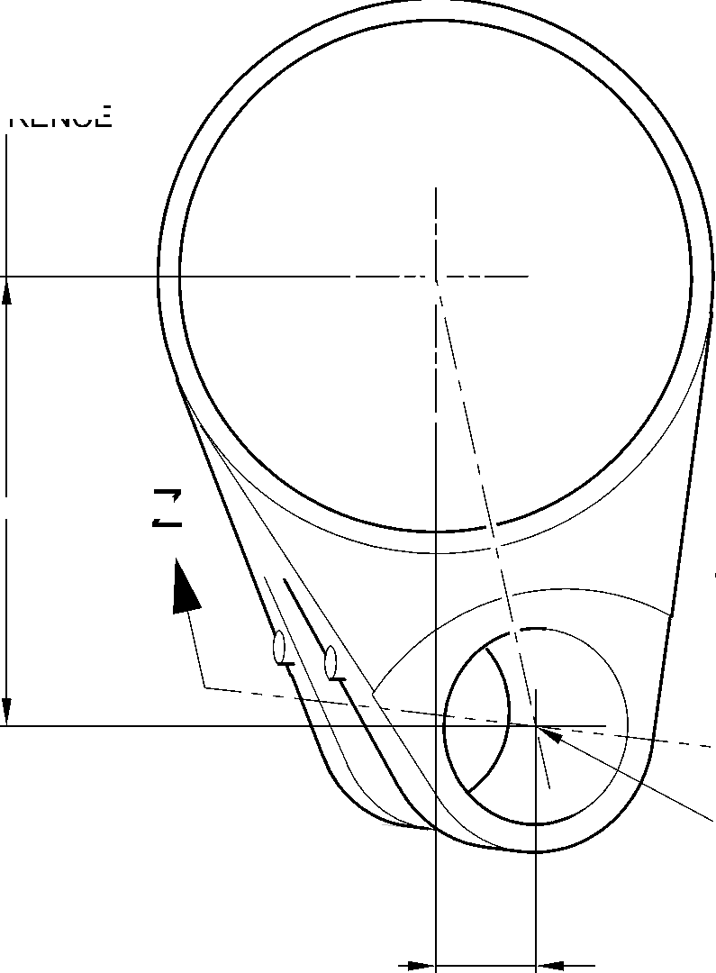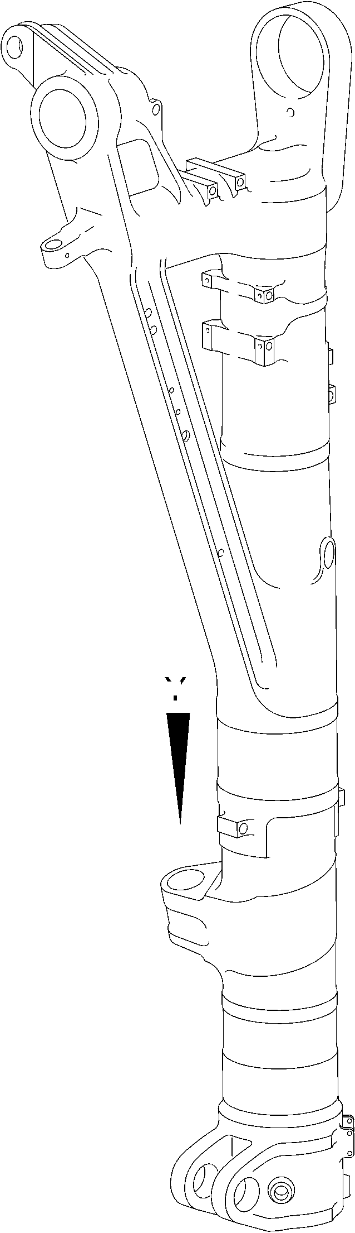

**SAFRAN LANDING SYSTEMS UK Ltd**

CAGE: K0654

PART No. 201587001 AND 201587002 COMPONENT MAINTENANCE MANUAL  
MAIN LANDING GEAR LEG

D1 before machining

D2 after machining

2,00 to 4,00mm  
(0.079 to 0.157in)  
RADIUS ALL AROUND AT  
ENTRY OF LUBRICATION  
bore into diameter A.

(2 PLACES)

V

diameter A

20.653  
DEGREES

X

face C

0,05mm  
(0.002in)

4,00 to 5,00mm  
(0.157 to 0.197in)  
CORNER RADIUS

(2 PLACES) 1,25 to 1,75mm  
(0.049 to 0.069in)  
x 45 DEGREE CHAMFER

(2 PLACES)

W

face B



0,05mm  
(0.002in)

X

X

51,00 to 52,00mm  
(2.008 to 2.047in)  
OVER RADIUS.

100,00mm (3.937in)  
RADIUS MINIMUM

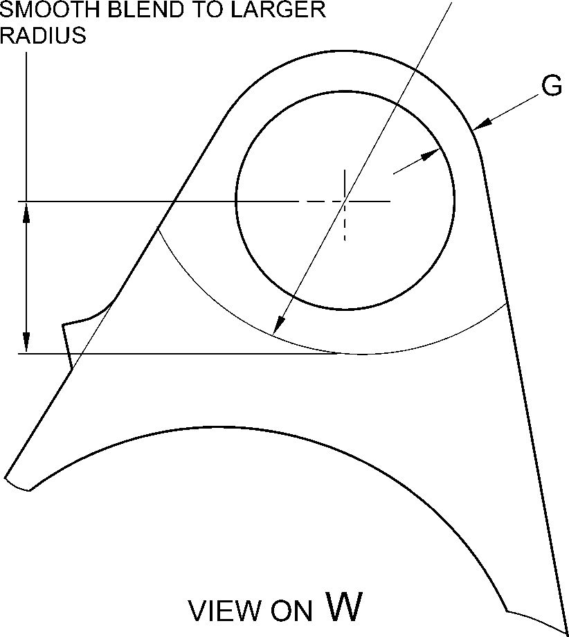

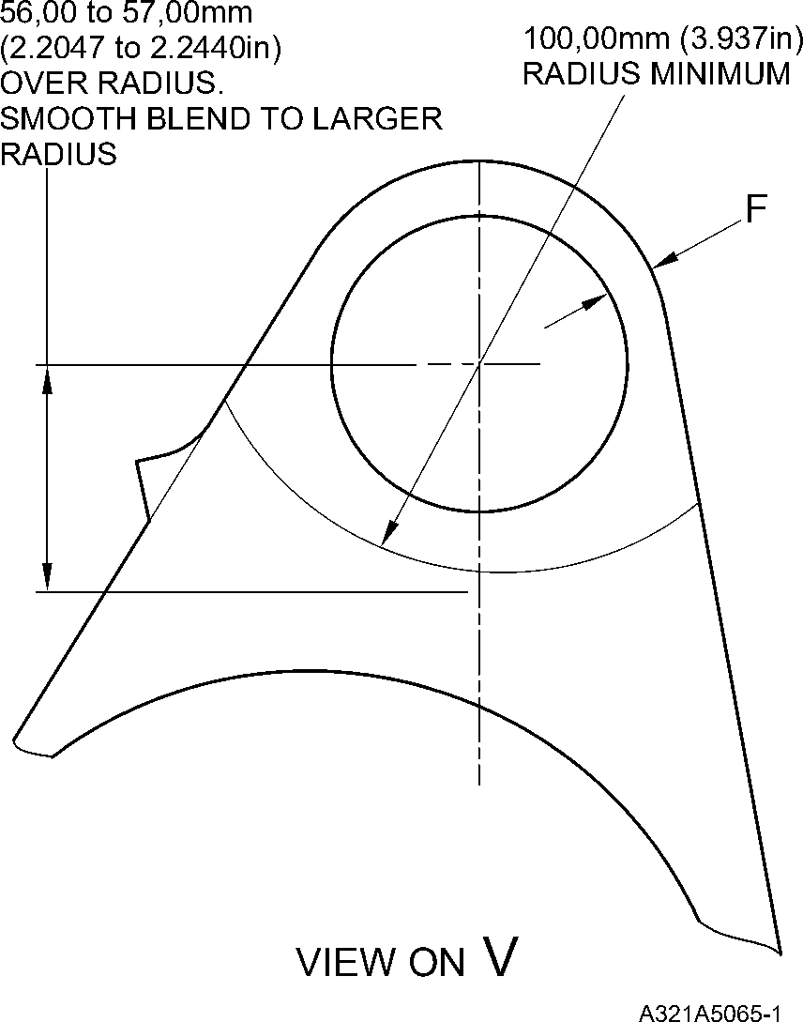

Repair to Main Fitting  
Figure 602

Repair No. 11-3

Page 605

Dec 6/2019

32-12-22

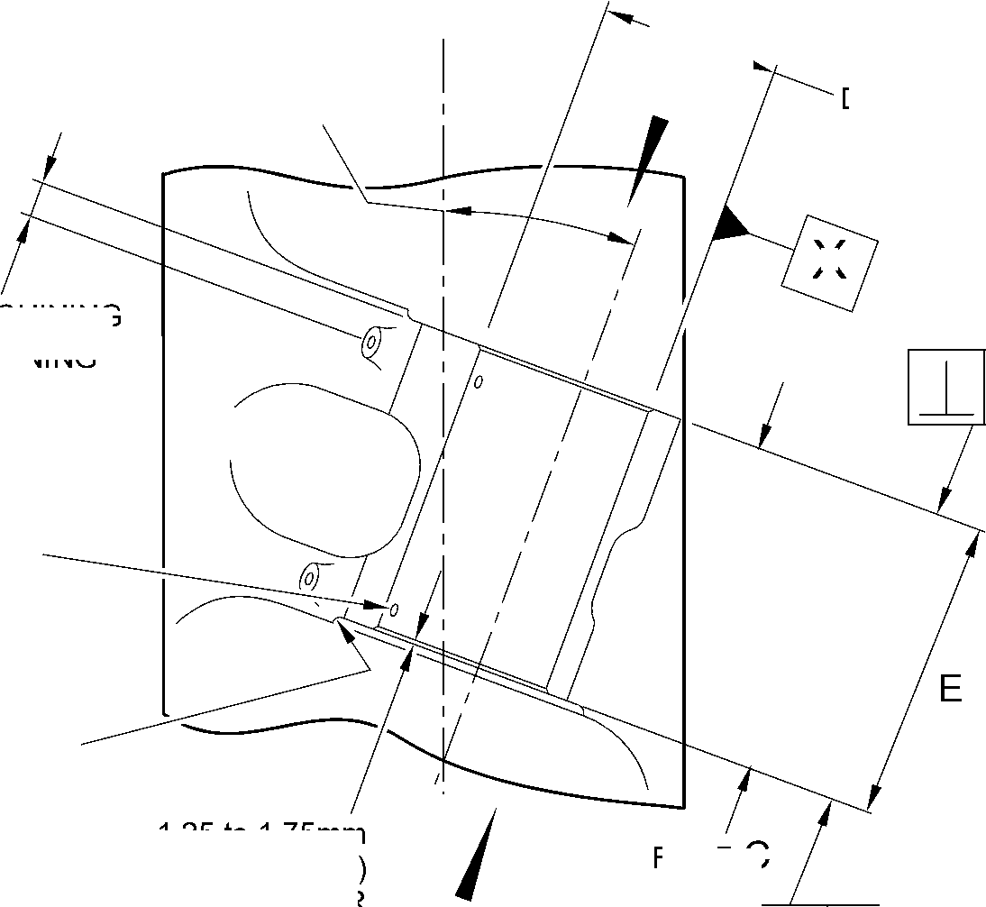

**SAFRAN LANDING SYSTEMS UK Ltd**

CAGE: K0654



PART No. 201587001 AND 201587002 COMPONENT MAINTENANCE MANUAL  
MAIN LANDING GEAR LEG

SEALANT TO PCS-7200

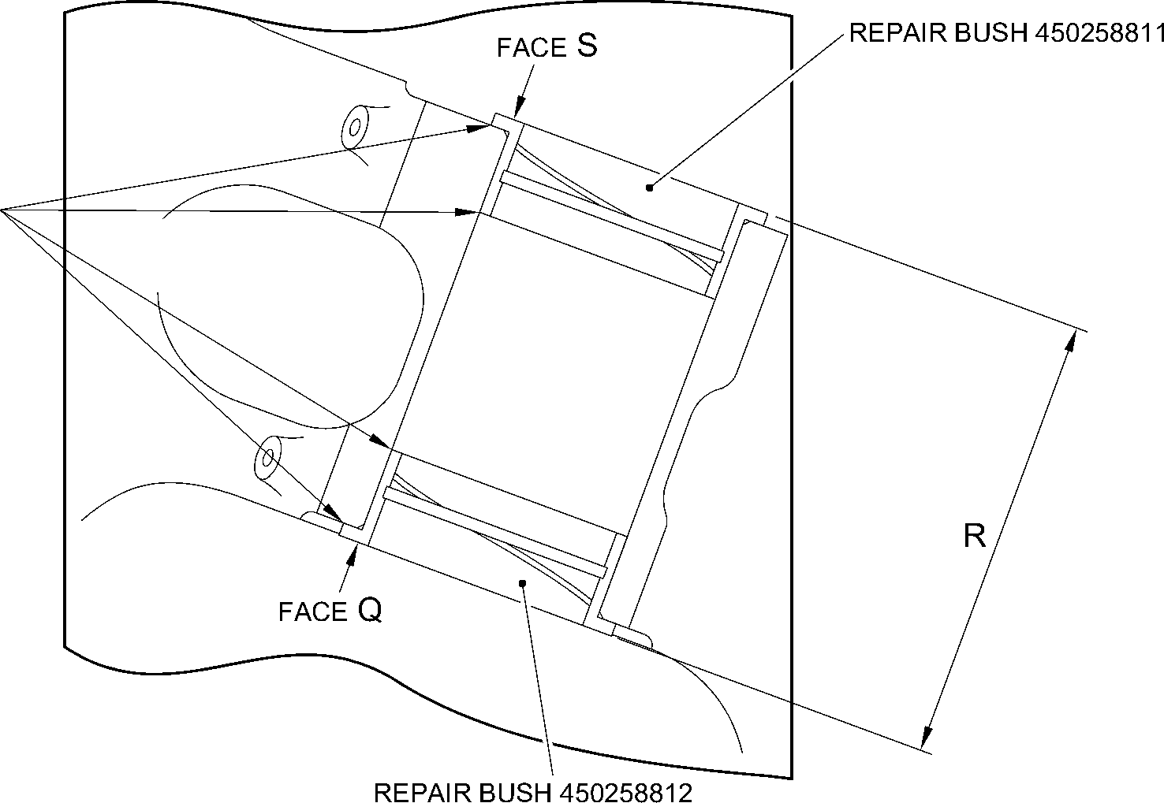

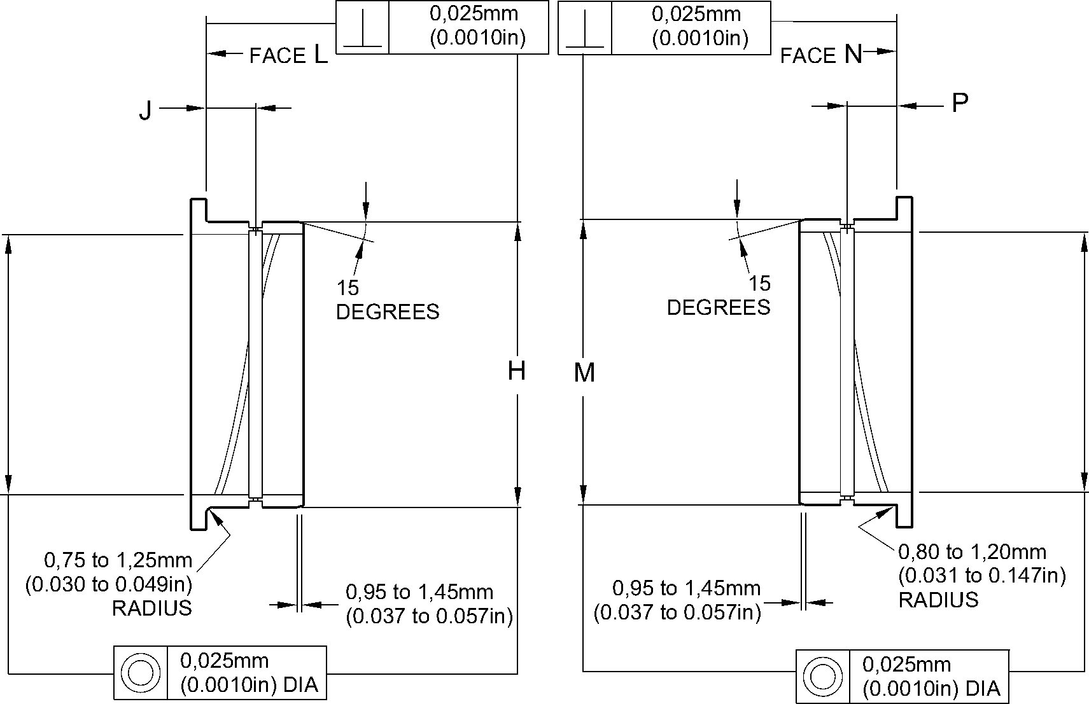

REPAIR BUSH 450258812 MACHINING

REPAIR BUSH 450258811 MACHINING

A321A5066-1

Repair to Main Fitting - Repair Bush Machining and Installation  
Figure 603

32-12-22

Repair No. 11-3

Page 606

Dec 6/2019

**SAFRAN LANDING SYSTEMS UK Ltd**

CAGE: K0654



PART No. 201587001 AND 201587002 COMPONENT MAINTENANCE MANUAL  
MAIN LANDING GEAR LEG

I 1. Repair No. 11-4 Main Fitting (20-410, 20-410A, 20-420 and 20-420A)

1. Specified Damage and Material Specification.
2. Specified Damage

(a) Damage or corrosion to diameter(s) A (Refer to Figure 601).

1. Material Specification

|  |  |  |
| --- | --- | --- |
| IPL Figure and Item No. | Name | Material Specification |
| 20-410, 20-410A, 20-420 and 20-420A | Main fitting | Steel, MAT135, 35NCD16THQ |

1. Special Tools

(1) These special tools are necessary:

**NOTE: Alternative equivalents are permitted.**

|  |  |  |
| --- | --- | --- |
| Part No. | Special Tool | Function |
| 460004330/110 | Press Pad | Install the repair bush 450237819 |

1. Materials

(1) These materials are necessary:

**NOTE: Alternative equivalents are permitted.**

|  |  |
| --- | --- |
| Ref. Item | Material |
| TBA | Electrically conducting Mastinox D40: refer to M-DLPS709-14 |
| 09-510A | Sealant: refer to PCS-7200 |

1. Repair Parts

(1) These repair parts are necessary:

|  |  |  |
| --- | --- | --- |
| Part No. | Repair Part | Material Specification |
| 450237819 | Blank bush | Aluminium Bronze, DTD197 |

E. Procedure (Refer to Figures 601 and 602)

1. Machine the diameter(s) A, sufficiently only to remove the damage or corrosion, do not  
   make diameter A larger than 13,727 mm (0.5404 in): refer to M-DLPS1004-4-1. The  
   surface finish must be 1,6 micrometers (63 micro-inches).
2. Measure and record the new diameter(s) A.
3. Examine the bare metal for flaws: refer to PCS-3600 and PCS-3100, inclusion class 4.

(4)

Shot peen the machined area(s): refer to M-DLPS123.

Repair No. 11-4

Page 601

Mar 18/2025

32-12-22

**sSAFRAN SAFRAN LANDING SYSTEMS UK Ltd**

CAGE: K0654

PART No. 201587001 AND 201587002 COMPONENT MAINTENANCE MANUAL  
MAIN LANDING GEAR LEG

1. Apply cadmium plate to the machined area(s): refer to PCS-2141.
2. Identify the part with the Safran Landing Systems repair number 450266075 adjacent to  
   the part number: refer to PCS-6000-04, an alternative reference is PCS-6000-06. If the  
   alternative reference is used, the characters must be 0,051 to 0,102 mm (0.0020 to  
   0.0040 in) deep and approximately 3,00 mm (0.118 in) high.
3. Calculate diameter B of the repair bush(es):

B = A (as measured) + 0,009 to 0,029 mm (0.0003 to 0.0011 in).

1. Machine the repair bush to the dimensions shown and calculated with a surface finish of  
   1,6 micrometers (63 micro-inches): refer to Figure 602. Diameter B must make a smooth  
   joint with the adjacent corner radius.
2. Apply cadmium plate to the repair bush: refer to PCS-2101. The cadmium plate  
   thickness must be between 0,010 and 0,015 mm (0.0004 and 0.0006 in).
3. Install the repair bush(es): refer to M-DLPS1011-20. Use electrically conducting  
   Mastinox D40, Material Ref. Item. TBA: refer to M-DLPS709-14,.
4. Apply sealant, Material Ref. Item 09-510A, between the repair bush and the main fitting:  
   refer to PCS-7200.
5. Identify the part with the Safran Landing Systems repair number 450266075 adjacent to  
   the part number: refer to PCS-6000-07 and Figure 602.
6. Examine the part to make sure that you have obeyed all the repair instructions correctly.

32-12-22

Repair No. 11-4

Page 602

Mar 18/2025

**SAFRAN LANDING SYSTEMS UK Ltd**

CAGE: K0654

PART No. 201587001 AND 201587002 COMPONENT MAINTENANCE MANUAL  
MAIN LANDING GEAR LEG

point C I

327,22 to 328,22mm  
(12.883 to 12.922in)

46,07mm  
(1.814in)  
CRS

Z

DIAMETER

19,425mm  
(0.7648in)  
CRS

576,50 to 577,50mm  
(22.697 to 22.736in)

Z

DIAMETER

0,80 to 1,20mm  
(0.032 to 0.047in)  
RADIUS  
TYPICAL  
BOTH BORES

section Z-Z  
MACHINING

A321A5058-1

Repair to Main Fitting  
Figure 601

Repair No. 11-4

Page 603

Dec 6/2019

32-12-22

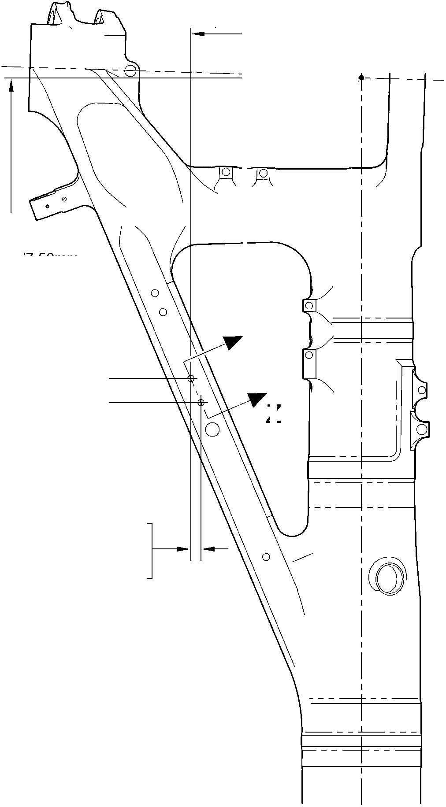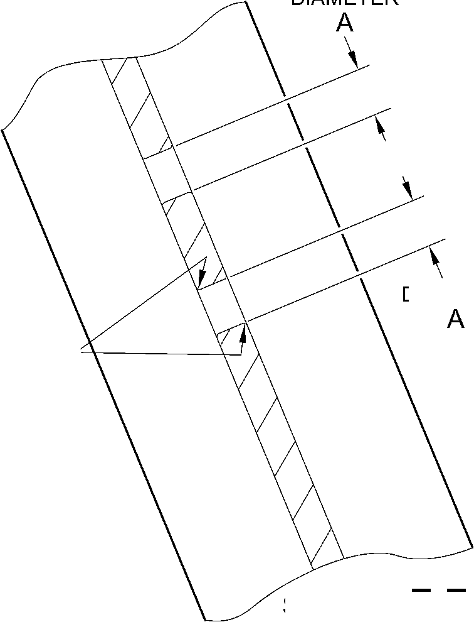

**SAFRAN LANDING SYSTEMS UK Ltd**

CAGE: K0654



PART No. 201587001 AND 201587002 COMPONENT MAINTENANCE MANUAL  
MAIN LANDING GEAR LEG

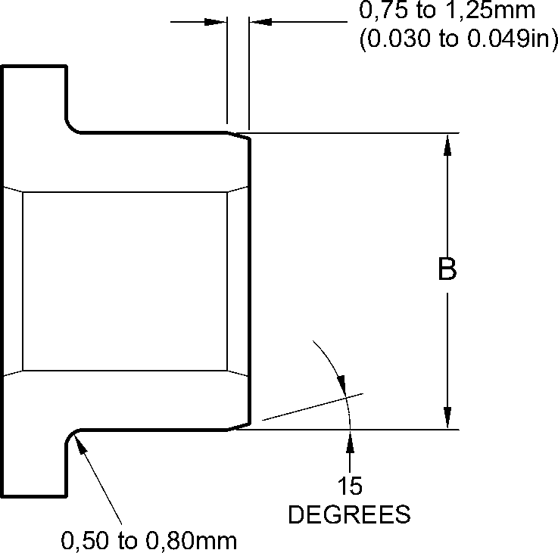

(0.020 to 0.032in) RAD.

REPAIR BUSH 450237819

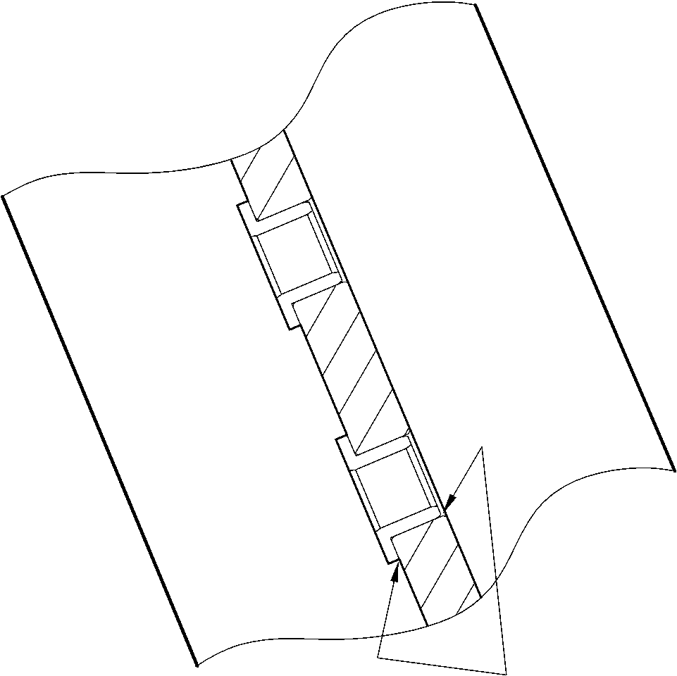

SEALANT TO  
PCS 7200  
4 PLACES

part section Z-Z

WITH REPAIR BUSHES

A321A5059-1

Repair Bush - Machining and Installation  
Figure 602

32-12-22

Repair No. 11-4

Page 604

Dec 6/2019

**SAFRAN LANDING SYSTEMS UK Ltd**

CAGE: K0654



PART No. 201587001 AND 201587002 COMPONENT MAINTENANCE MANUAL  
MAIN LANDING GEAR LEG

I 1. Repair No. 11-5 Main Fitting (20-410, 20-410A, 20-420 and 20-420A)

1. Specified Damage and Material Specification.
2. Specified Damage

(a) Damage or corrosion to diameter A (Refer to Figure 601).

1. Material Specification

|  |  |  |
| --- | --- | --- |
| IPL Figure and Item No. | Name | Material Specification |
| 20-410, 20-410A, 20-420 and 20-420A | Main fitting | Steel, MAT135, 35NCD16THQ |

1. Special Tools

(1) These special tools are necessary:

**NOTE: Alternative equivalents are permitted.**

|  |  |  |
| --- | --- | --- |
| Part No. | Special Tool | Function |
| 460006267 | Press Pad | Install the repair bearing 450266081 |

1. Materials
2. These materials are necessary:

**NOTE: Alternative equivalents are permitted.**

|  |  |
| --- | --- |
| Ref. Item | Material |
| TBA | Electrically conducting Mastinox D40: refer to M-DLPS709-14 |
| 09-510A | Sealant: refer to PCS-7200 |

1. Repair Parts
2. These repair parts are necessary:

|  |  |  |
| --- | --- | --- |
| Part No. | Repair Part | Material Specification |
| 450266081 | Blank bearing | Aluminium Bronze, DTD197 |

E. Procedure (Refer to Figures 601 and 602)

1. Machine the diameter A, sufficiently only to remove the damage or corrosion, do not  
   make diameter A larger than 21,933 mm (0.8635 in): refer to M-DLPS1004-4-1. The  
   surface finish must be 1,6 micrometers (63 micro-inches).
2. Machine the radii as shown.
3. Measure and record the new diameter A.

(4)

Examine the bare metal for flaws: refer to PCS-3600 and PCS-3100, inclusion class 4.

Repair No. 11-5

Page 601

Mar 18/2025

32-12-22

**sSAFRAN SAFRAN LANDING SYSTEMS UK Ltd**

CAGE: K0654

PART No. 201587001 AND 201587002 COMPONENT MAINTENANCE MANUAL  
MAIN LANDING GEAR LEG

1. Shot peen the machined area: refer to M-DLPS123.
2. Apply cadmium plate to the machined area: refer to PCS-2141.
3. Identify the part with the Safran Landing Systems repair number 450266080 adjacent to  
   the part number: refer to PCS-6000-04, an alternative reference is PCS-6000-06. If the  
   alternative reference is used, the characters must be 0,051 to 0,102 mm (0.0020 to  
   0.0040 in) deep and approximately 3,00 mm (0.118 in) high.
4. Calculate diameter B of the repair bearing:

B = A (as measured) + 0,002 to 0,048 mm (0.0008 to 0.0019 in).

1. Machine the repair bearing to the dimensions shown and calculated with a surface finish  
   of 1,6 micrometers (63 micro-inches): refer to Figure 602.
2. Apply cadmium plate to the repair bearing: refer to PCS-2101. The cadmium plate  
   thickness must be between 0,010 and 0,015 mm (0.0004 and 0.0006 in).
3. Install the repair bearing: refer to M-DLPS1011-20. Use electrically conducting Mastinox  
   D40, Material Ref. Item. TBA: refer to M-DLPS709-14.
4. Check line ream the repair bearing to the dimension shown: refer to Figure 602.
5. Apply sealant, Material Ref. Item 09-510A, between the repair bearing and the main  
   fitting: refer to PCS-7200 and Figure 602.
6. Identify the part with the Safran Landing Systems repair number 450266080 adjacent to  
   the part number: refer to PCS-6000-07.
7. Examine the part to make sure that you have obeyed all the repair instructions correctly.

32-12-22

Repair No. 11-5

Page 602

Mar 18/2025

**SAFRAN LANDING SYSTEMS UK Ltd**

CAGE: K0654



PART No. 201587001 AND 201587002 COMPONENT MAINTENANCE MANUAL  
MAIN LANDING GEAR LEG

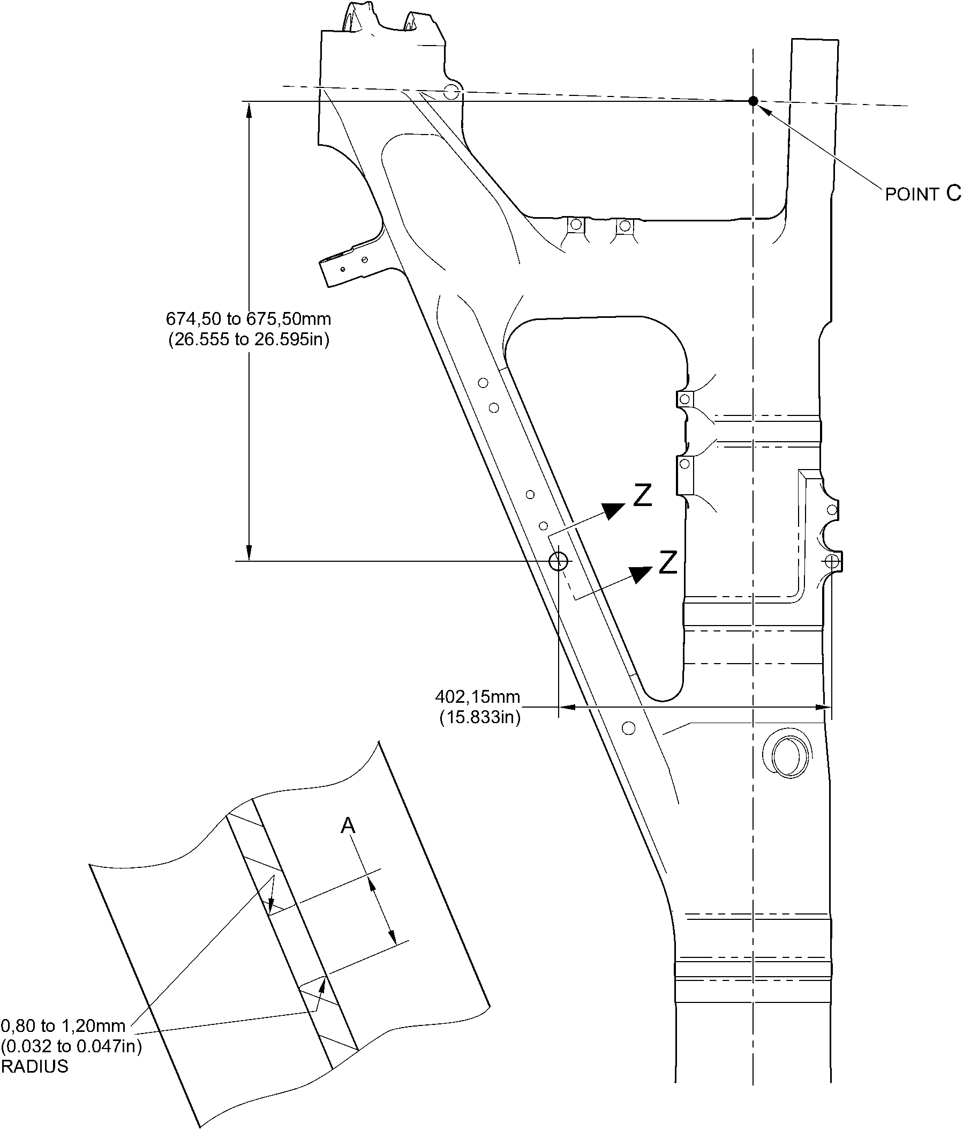

section Z-Z machining

A321A5060-1

Repair to Main Fitting  
Figure 601

Repair No. 11-5

Page 603

Dec 6/2019

32-12-22

**SAFRAN LANDING SYSTEMS UK Ltd**

CAGE: K0654



PART No. 201587001 AND 201587002 COMPONENT MAINTENANCE MANUAL  
MAIN LANDING GEAR LEG

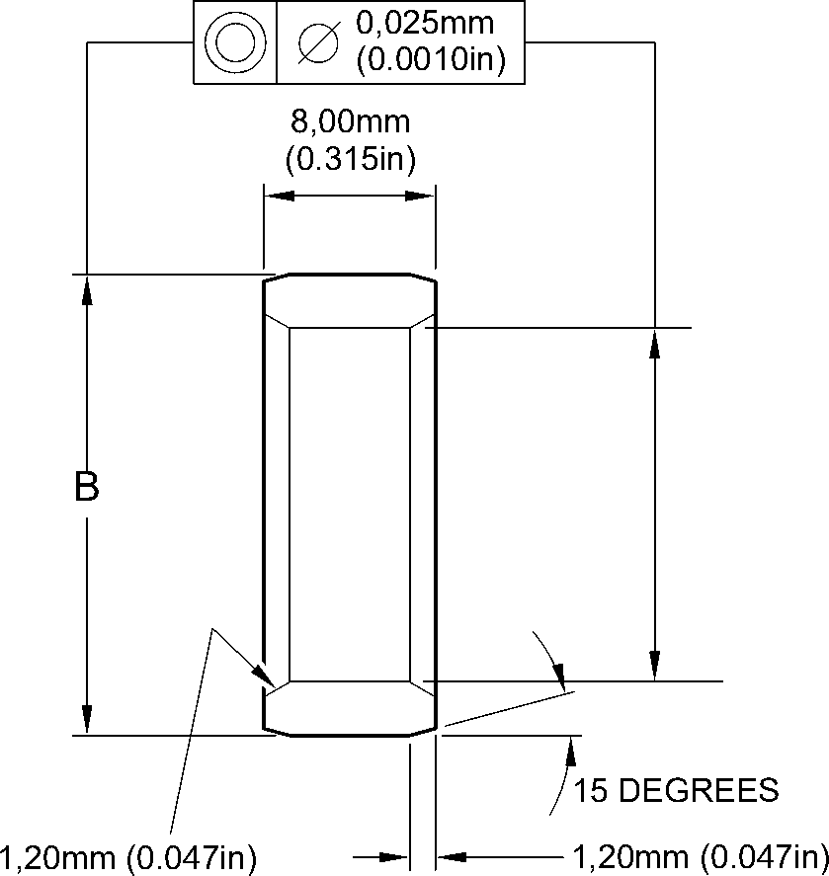

CHAMFER BOTH ENDS

X 60 DEGREES INCLUSIVE

BOTH ENDS

INSTALL BEARING

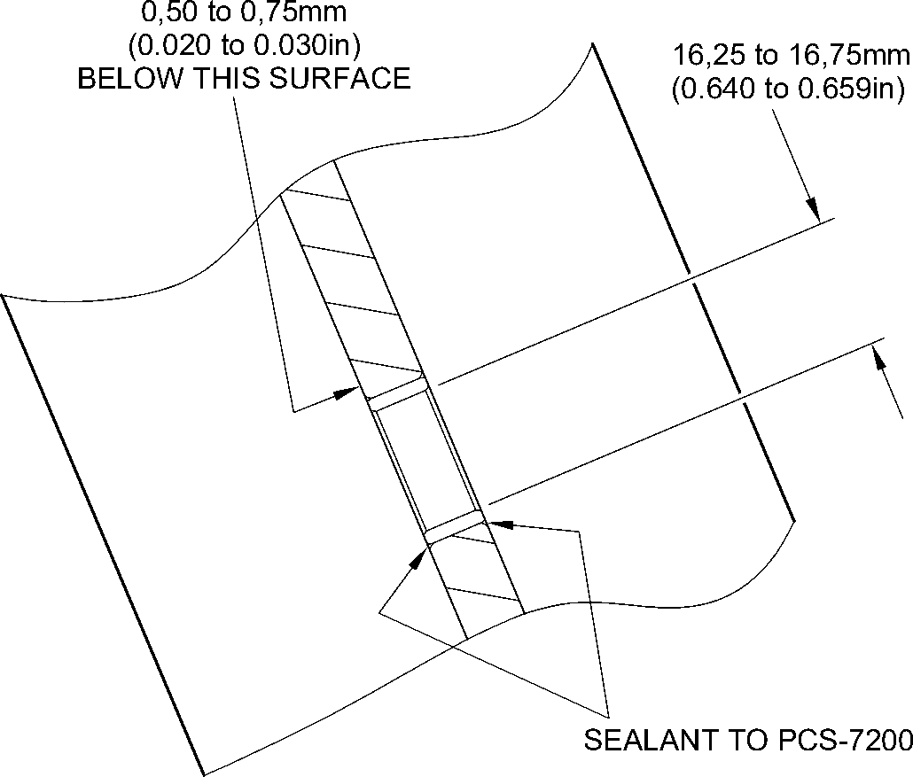

part section Z-Z  
WITH BEARING

A321A5061-1

Repair Bush - Machining and Installation  
Figure 602

32-12-22

Repair No. 11-5

Page 604

Dec 6/2019

**SAFRAN LANDING SYSTEMS UK Ltd**

CAGE: K0654



PART No. 201587001 AND 201587002 COMPONENT MAINTENANCE MANUAL  
MAIN LANDING GEAR LEG

I 1. Repair No. 11-6 Main Fitting (20-410, 20-410A, 20-420 and 20-420A)

1. Specified Damage and Material Specification
2. Specified Damage

(a) Damage or corrosion to diameter A.

1. Material Specification

|  |  |  |
| --- | --- | --- |
| IPL Figure and Item No. | Name | Material Specification |
| 20-410, 20-410A, 20-420 and 20-420A | Main fitting | Steel, MAT135, 35NCD16THQ |

1. Special Tools

(1) These special tools are necessary:

**NOTE: Alternative equivalents are permitted.**

|  |  |  |
| --- | --- | --- |
| Part No. | Special Tool | Function |
| 460004330/169 | Press Pad | Install the blank bush 450237817 |

1. Materials

(1) These materials are necessary:

**NOTE: Alternative equivalents are permitted.**

|  |  |
| --- | --- |
| Ref. Item | Material |
| TBA | Electrically conducting Mastinox D40 |
| 09-510A | Sealant |

1. Repair Parts

(1) These repair parts are necessary:

|  |  |  |
| --- | --- | --- |
| Part No. | Repair Part | Material Specification |
| 450237817 | Blank bush | Aluminium Bronze, BSB23 or AMS4640 |

E. Procedure (Refer to Figures 601 and 602)

1. Machine the diameter A, sufficiently only to remove the damage or corrosion, do not  
   make diameter A larger than 15,727 mm (0.6192 in): refer to M-DLPS1004-4-1  
   and Figure 601. The surface finish must be 1,6 micrometers (63 micro-inches).
2. Measure and record the new diameter A.
3. Examine the bare metal for flaws: refer to PCS-3100, inclusion class 4 and PCS-3600.

(4)

Locally cadmium plate the reworked areas: refer to PCS-2141.

Repair No. 11-6

Page 601

Mar 18/2025

32-12-22

**sSAFRAN SAFRAN LANDING SYSTEMS UK Ltd**

CAGE: K0654

PART No. 201587001 AND 201587002 COMPONENT MAINTENANCE MANUAL  
MAIN LANDING GEAR LEG

1. Identify the part with the Safran Landing Systems repair number 450266085 adjacent to  
   the part number: refer to PCS-6000-04, an alternative reference is PCS-6000-06. If the  
   alternative reference is used, the characters must be 0,051 to 0,102 mm (0.0020 to  
   0.0040 in) deep and approximately 3,00 mm (0.118 in) high.
2. Calculate diameter B of the repair bush:

Dia. B = Dia. A (as measured) + 0,029 to - 0,009 mm (+ 0.0012 to - 0.0003 in).

1. Machine the blank bush 450237817 to the dimensions shown and calculated. Machine  
   face C to get a dimension D of between 1,75 and 2,00 mm (0.069 and 0.078 in). The  
   surface finish must be 1,6 micrometers (63 micro-inches) all over the bush: refer  
   to Figure 602.
2. Apply cadmium plate all over the oversize bush: refer to PCS-2101. The cadmium plate  
   thickness must be between 0,010 and 0,015 mm (0.0004 and 0.0006 in).
3. Install the oversize bush: refer to M-DLPS1011-20. Use electrically conducting Mastinox  
   D40, Material Ref. Item. TBA: refer to PCS-7304 and Figure 602.
4. Apply a bead of sealant, Material Ref. Item 09-510A, to the oversize bush: refer to  
   PCS-7200 and Figure 602.
5. Identify the part with the Safran Landing Systems repair number 450266085 adjacent to  
   the part number: refer to PCS-6000-07.
6. Examine the part to make sure that you have obeyed all the repair instructions correctly.

32-12-22

Repair No. 11-6

Page 602

Mar 18/2025

**SAFRAN LANDING SYSTEMS UK Ltd**

CAGE: K0654



PART No. 201587001 AND 201587002 COMPONENT MAINTENANCE MANUAL  
MAIN LANDING GEAR LEG

0,80 to 1,20mm  
(0.032 to 0.047in)

RADIUS

diameter A

15,727mm (0.6192in)  
MAXIMUM

point C

**Z**

**Z**

919,50 to 920,50mm  
(36.201 to 36.240in)

182,61 to 183,61mm  
(7.189 to 7.229in)

SECTION **Z-Z**

WITHOUT BUSH

A321-S-32-12-22-022-0

Repair to Main Fitting  
Figure 601

Repair No. 11-6

Page 603

Dec 6/2019

32-12-22

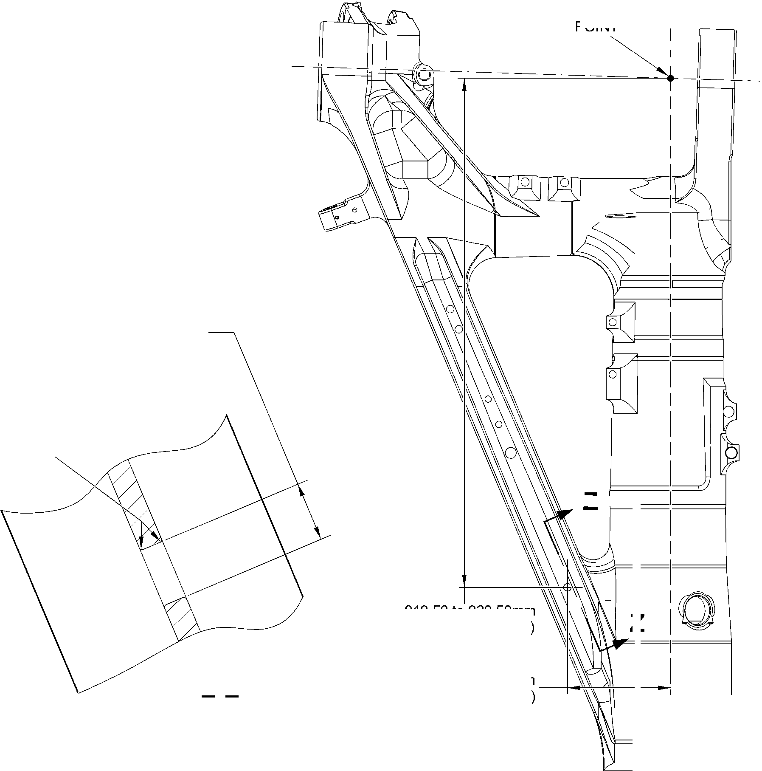

**SAFRAN LANDING SYSTEMS UK Ltd**

CAGE: K0654



PART No. 201587001 AND 201587002 COMPONENT MAINTENANCE MANUAL  
MAIN LANDING GEAR LEG

15

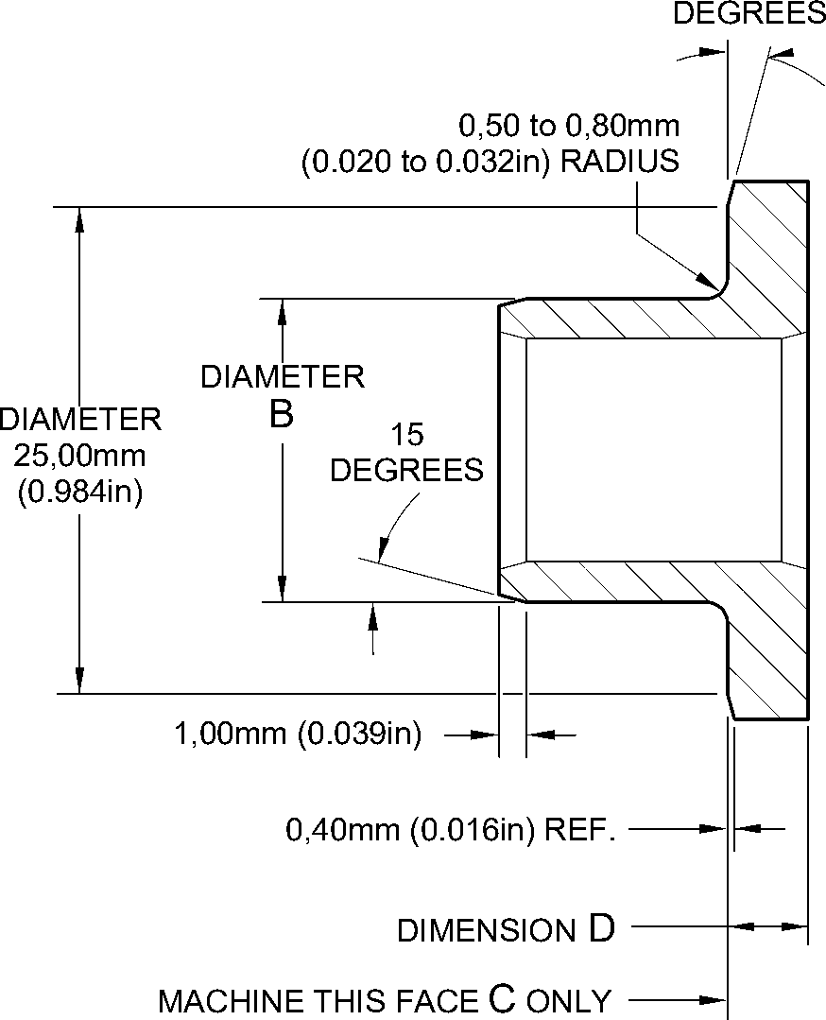

REPAIR BUSH 450237817  
MACHINING

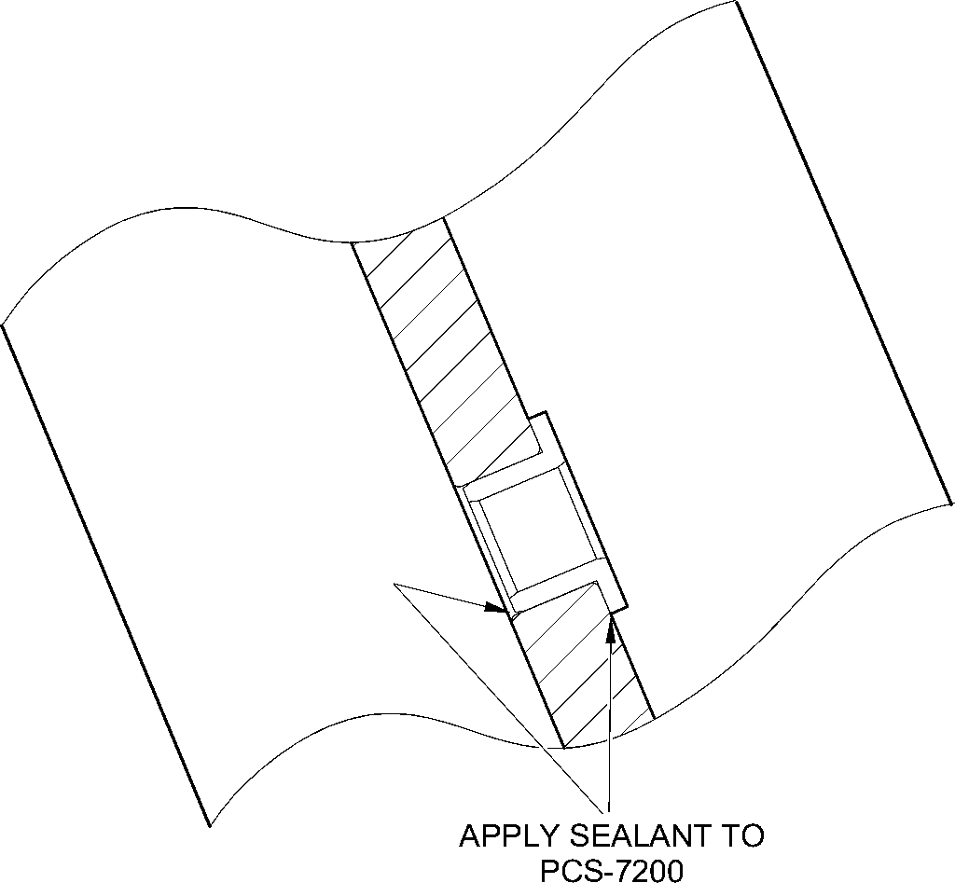

section Z-Z  
WITH BUSH

A321-S-32-12-22-023-0

Repair Bush - Machining and Installation  
Figure 602

32-12-22

Repair No. 11-6

Page 604

Dec 6/2019

**sSAFRAN SAFRAN LANDING SYSTEMS UK Ltd**

CAGE: K0654

PART No. 201587001 AND 201587002 COMPONENT MAINTENANCE MANUAL  
MAIN LANDING GEAR LEG

I 1. Repair No. 11-7 Main Fitting (20-410, 20-410A, 20-420 and 20-420A)

1. Specified Damage and Material Specification.
2. Specified Damage

(a) Damage or wear to the diameter(s) A, B or C or spotface(s) D, E or F or faces G, H  
and/or J.

1. Material Specification

|  |  |  |
| --- | --- | --- |
| IPL Figure and Item No. | Name | Material Specification |
| 20-410, 20-410A, 20-420 and 20-420A | Main fitting | Steel, MAT135, 35NCD16THQ |

1. Special Tools
2. These special tools are necessary:

**NOTE: Alternative equivalents are permitted.**

|  |  |  |
| --- | --- | --- |
| Part No. | Special Tool | Function |
| 460007258 | Press Pad and Drawbolt | Install the repair bush 450258800 |

1. Materials
2. These materials are necessary:

**NOTE: Alternative equivalents are permitted.**

|  |  |
| --- | --- |
| Ref. Item | Material |
| TBA | Zinc Powder |
| 05-533 | Mastinox D40 |
| 09-510A | Sealant |

1. Repair Parts
2. These repair parts are necessary:

|  |  |  |
| --- | --- | --- |
| Part No. | Repair Part | Material Specification |
| 450258800 | Repair bush (Qty 3) | Stainless Steel,S145 |

1. Procedure (Refer to Figures 601, 602 and 603)

**CAUTION: FOR DAMAGE MORE THAN THE LIMITS OF THIS REPAIR SCHEME, WRITE  
TO SAFRAN LANDING SYSTEMS: REFER TO GUIDE-CS-001.**

1. Machine the diameter A and/or diameter B and/or diameter C, sufficiently only to remove  
   the damage or wear: refer to M-DLPS1004-4-1. Diameter A and/or diameter B and/or  
   diameter C must not be more than 33,925 mm (1.3356 in). The surface finish must be  
   1,6 micrometers (63 micro-inches).

Repair No. 11-7

Page 601

Mar 18/2025

32-12-22

**SSAFRAN**

**SAFRAN LANDING SYSTEMS UK Ltd**

CAGE: K0654

PART No. 201587001 AND 201587002 COMPONENT MAINTENANCE MANUAL  
MAIN LANDING GEAR LEG

1. Use a 45,75 to 46,50 mm (1.801 to 1.831 in) spotface cutter with a 2,50 mm (0.1 in)  
   corner radius and machine the spotfaces D and/or E and/or F, suffciently to remove the  
   damage or corrosion: refer to M-DLPS1004-4-1 and Figure 602. Make the surface finish  
   1,6 micrometers (63 micro-inches).
2. Machine the faces G and/or H and/or J to get the lug width dimensions the lug widths K  
   or L or M: refer to M-DLPS1004-4-1 and Figure 602. Do not make the lug widths K or L  
   or M less than 21,50 mm (0.846 in). Make the surface finish 1,6 micrometers  
   (63 micro-inches).
3. Machine the radii to the dimensions shown: refer to M-DLPS1004-4-1 and Figure 602. If  
   necessary, blend any generated sharp edges to the adjacent surface.
4. Measure and record the new diameter(s) A, B and C and the lug widths K, L and M.
5. Examine the machined areas for flaws: refer to PCS-3100, inclusion Class 4 and  
   PCS-3600.
6. Shot peen the machined area: refer to M-DLPS123.
7. Identify the part with the Safran Landing Systems repair number 450266045 adjacent to  
   the part number: refer to PCS-6000-04.
8. Apply cadmium plate to the machined area: refer to PCS-2100 or PCS-2141. The  
   cadmium plate thickness must be between 0,010 to 0,020 mm (0.0004 and 0.0008 in).
9. Apply primer paint to the main fitting, where the bush flanges will touch: refer to  
   PCS-2500.
10. Calculate the dimensions for each repair bush (qty 3), use formula:

Dia N = Dia A or B or C (as measured) + 0,018 to 0,059 mm (0.0007 to 0.0023 in).

Dim P= Lug width K or L or M (as measured) - 0,1 mm (- 0.004 in) to - 0,5 mm  
(- 0.019 in).

1. Machine the repair bushes to the dimensions as calculated and as shown. Machine the  
   face Q of repair bushes to get the correct dimension P: refer to Figure 603. Make the  
   surface finish 1,6 micrometers (63 micro-inches).
2. Examine the machined areas: refer to PCS-3100, inclusion class 3.
3. Passivate the repair bushs: refer to AMS 2700.
4. Use Press Pad and Drawbolt 460007258 and install the repair bushes: refer to  
   M-DLPS1011-20. Use electrically conducting Mastinox (made from Mastinox D40,  
   Material Ref. Item 05-533 and Zinc powder, Material Ref. Item TBA).
5. Check the bore diameters of the repair bushes: refer to Figure 603.
6. If necessary hone or ream the repair bushes to the dimensions shown: refer to  
   Figure 603. Make the surface finish 1,6 micrometers (63 micro-inches).
7. Apply a bead of sealant, Material Ref. Item 09-510A, between the repair bush(es) and  
   the main fitting: refer to PCS-7200 and Figure 603.
8. Apply paint to the repaired areas, but not to the bores of the repair bushes: refer to  
   PCS-2500.
9. Identify the part with the Safran Landing Systems repair number 450266045 adjacent to  
   the part number: refer to PCS-6000-07.
10. Examine the part to make sure that you have obeyed all the repair instructions correctly.

Repair No. 11-7

Page 602

Mar 18/2025

**SAFRAN LANDING SYSTEMS UK Ltd**

CAGE: K0654



PART No. 201587001 AND 201587002 COMPONENT MAINTENANCE MANUAL  
MAIN LANDING GEAR LEG

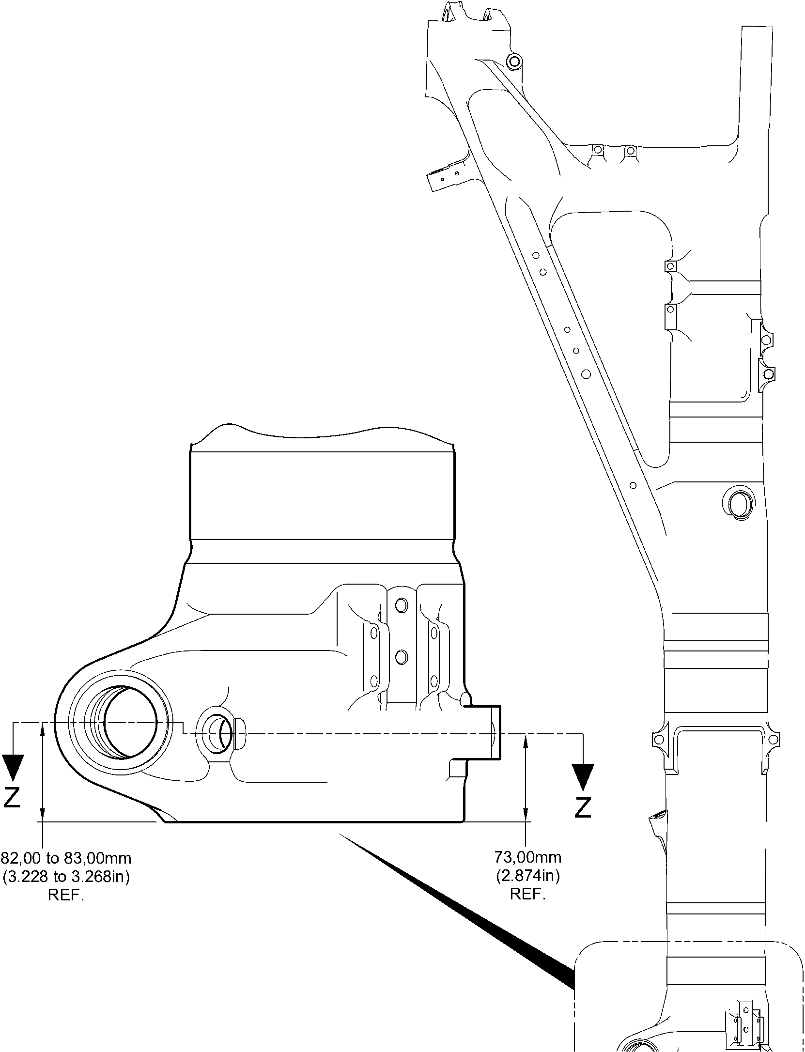

Repair to Main Fitting  
Figure 601

Repair No. 11-7

Page 603

Dec 6/2019

32-12-22

**SAFRAN LANDING SYSTEMS UK Ltd**

CAGE: K0654

PART No. 201587001 AND 201587002 COMPONENT MAINTENANCE MANUAL  
MAIN LANDING GEAR LEG

face G

dia B

face J

dia A

face E

TO SPOTFACE

faCe D

TO SPOTFACE

section Z-Z

face H

face F

TO SPOTFACE

2,50mm (0.098in) RADIUS

TYPICAL 3 PLACES

45,75 to 46,50mm

(1.801 to 1.831in) DIA. SPOTFACE.

TYPICAL 3 PLACES

125

DEGREES

50,00mm (1.969in) DIA  
SPOTFACE  
WITH 5,00mm (0.197in)  
CORNER RADIUS

**YA I**

132,35mm  
(5.211in)  
REF.

125  
DEGREES

WITHOUT REPAIR BUSHES

dia C

W

dia A typical  
dia B and dia C

0,05mm  
(0.002in)

0,14mm

(0.006in) DIA

1,00mm (0.040in)

RADIUS OR

X 45 DEGREES CHAMFER

0,5 to 1,0mm (0.02 to 0.04in)

RADIUS OR

X 45 DEGREES CHAMFER

W

X

section Y-Y

A321A5149-2

Repair to Main Fitting  
Figure 602

32-12-22

Repair No. 11-7

Page 604

Dec 6/2019

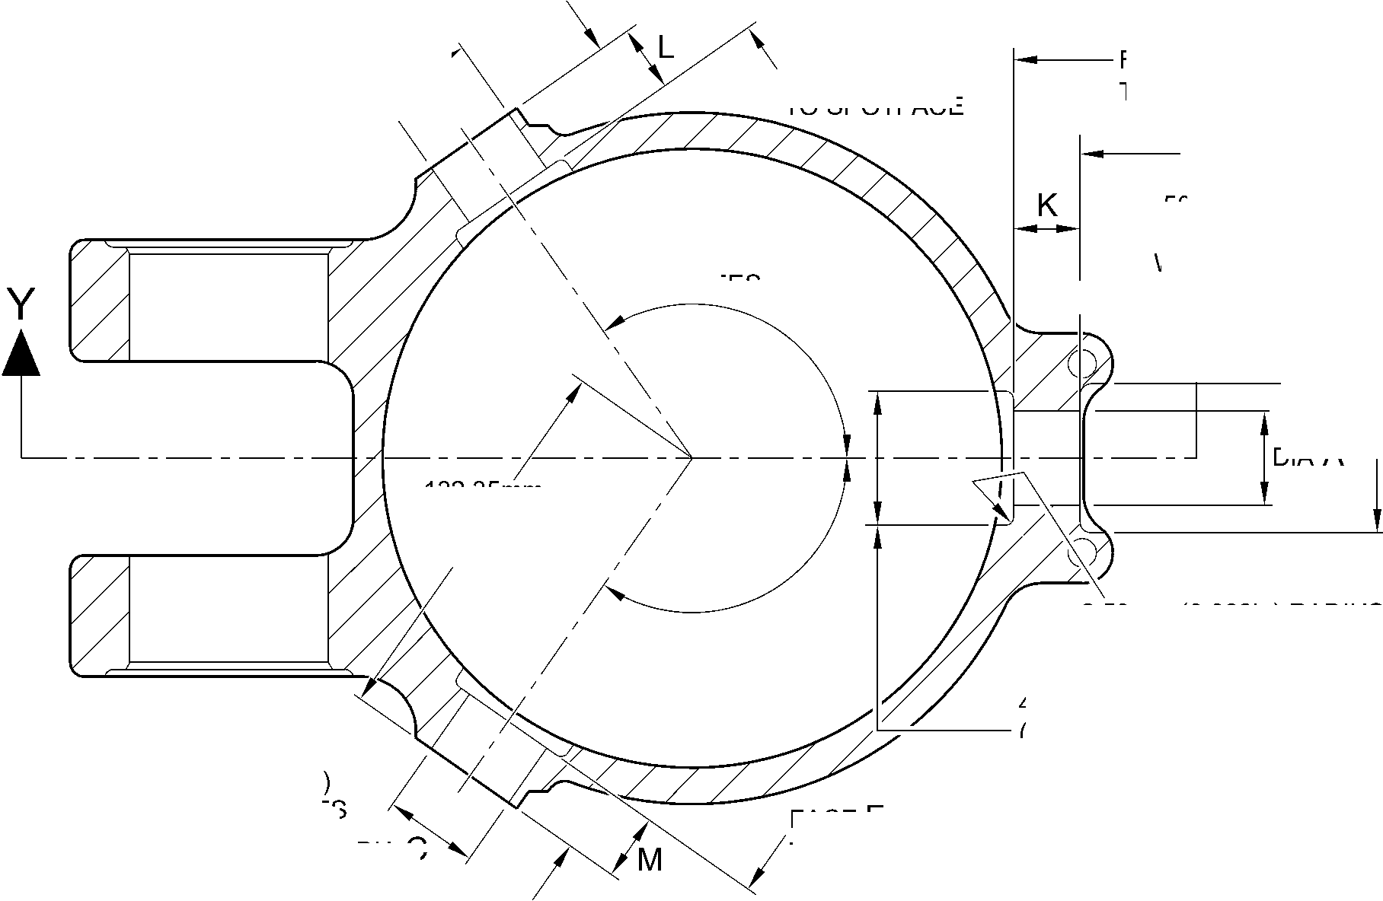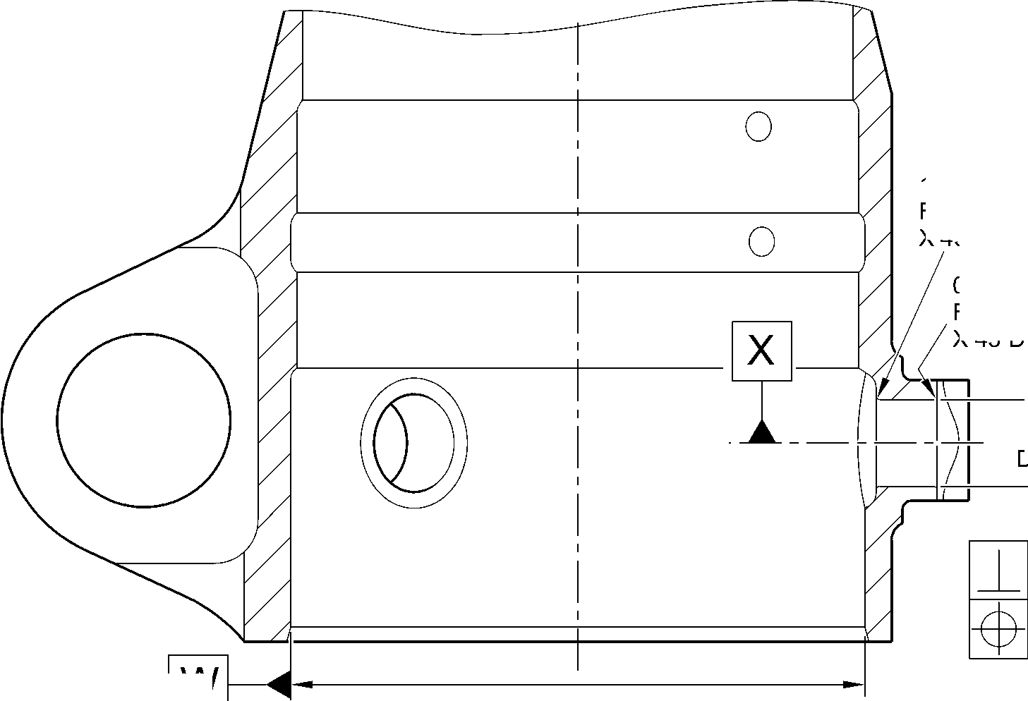

**SAFRAN LANDING SYSTEMS UK Ltd**

CAGE: K0654



PART No. 201587001 AND 201587002 COMPONENT MAINTENANCE MANUAL  
MAIN LANDING GEAR LEG

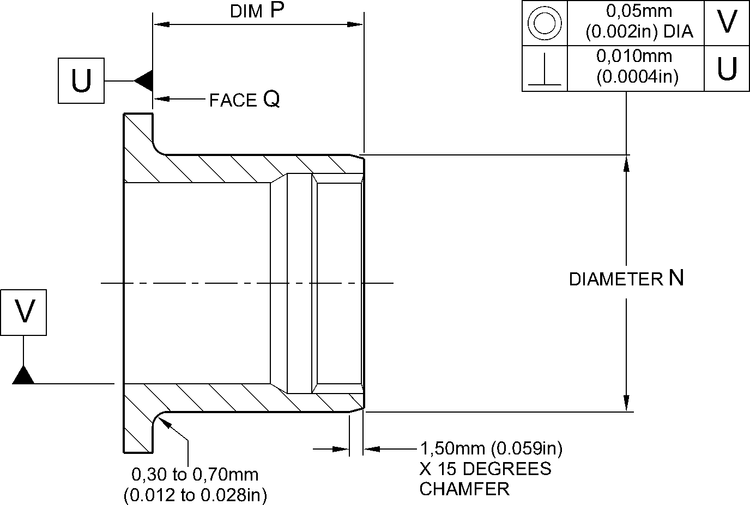

RADIUS

REPAIR BUSH 450258800

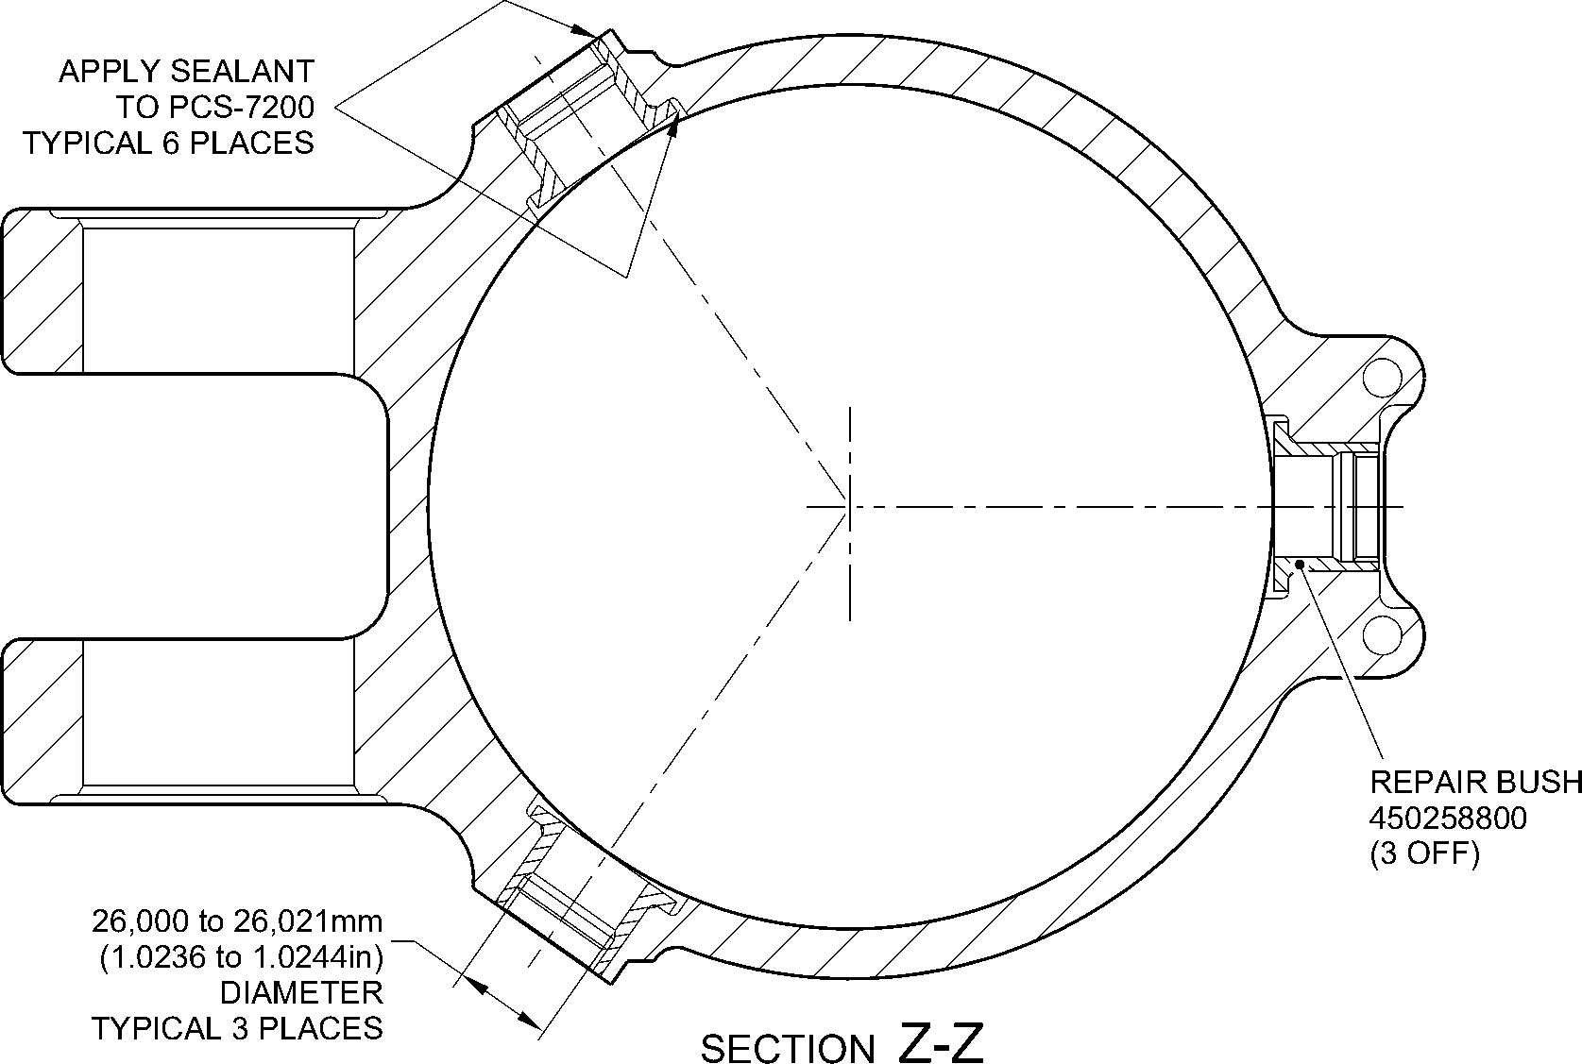

(REFER TO FIGURE 601)  
WITH REPAIR BUSHES INSTALLED

A321A5150-2

Repair to Main Fitting - Repair Bush Machining and Installation  
Figure 603

Repair No. 11-7

Page 605

Dec 6/2019

32-12-22

**SAFRAN LANDING SYSTEMS UK Ltd**

CAGE: K0654



PART No. 201587001 AND 201587002 COMPONENT MAINTENANCE MANUAL  
MAIN LANDING GEAR LEG

INTENTIONALLY BLANK

Repair No. 11-7

32-12-22 Page 606

**SAFRAN LANDING SYSTEMS UK Ltd**

CAGE: K0654



PART No. 201587001 AND 201587002 COMPONENT MAINTENANCE MANUAL  
MAIN LANDING GEAR LEG

I 1. Repair No. 11-8 Main Fitting (20-410, 20-410A, 20-420 and 20-420A)

1. Specified Damage and Material Specification.
2. Specified Damage

(a) Damage or corrosion to the diameter A and/or the adjacent face(s) B. (Refer to  
Figure 601).

1. Material Specification

|  |  |  |
| --- | --- | --- |
| IPL Figure and Item No. | Name | Material Specification |
| 20-410, 20-410A, 20-420 and 20-420A | Main fitting | Steel, MAT135, 35NCD16THQ |

1. Special Tools
2. These special tools are necessary:

|  |  |  |
| --- | --- | --- |
| Part No. | Special Tool | Function |
| 460006246 | Alignment Bar | Install the repair bush 450258806 |
| 460006249/1 | Cutter | Finish machine the repair bush 450258806 |
| 460006250 | Press Pad | Install the repair bush 450258806 |

1. Materials
2. These materials are necessary:

**NOTE: Alternative equivalents are permitted.**

|  |  |
| --- | --- |
| Ref. Item | Material |
| - | Electrically conducting zinc loaded Molykote 111: refer to PCS-7304 |
| 09-510A | Sealant: refer to PCS-7200 |

1. Repair Parts
2. These repair parts are necessary:

|  |  |  |
| --- | --- | --- |
| Part No. | Repair Part | Material Specification |
| 450258806 | Repair bush (Qty 2) | TBA |

E. Procedure (Refer to Figures 601 and 602)

**CAUTION: FOR DAMAGE MORE THAN THE LIMITS OF THIS REPAIR SCHEME, WRITE  
TO SAFRAN LANDING SYSTEMS: REFER TO GUIDE-CS-001.**

(1)

Machine the diameter A, sufficiently only to remove the damage or corrosion: refer to

M-DLPS1004-4-1. Diameter A must not be more than 68,13 mm (2.682 in). Dimension C

must not be less than 22,15 mm (0.872 in). The surface finish must be 1,6 micrometers

(63 micro-inches): refer to Figure 601.

Repair No. 11-8

Page 601

Mar 18/2025

32-12-22

**sSAFRAN SAFRAN LANDING SYSTEMS UK Ltd**

CAGE: K0654

PART No. 201587001 AND 201587002 COMPONENT MAINTENANCE MANUAL  
MAIN LANDING GEAR LEG

1. Measure and record the diameter A.
2. If necessary, machine the spotface(s) sufficiently to remove the damage or corrosion:  
   refer to M-DLPS1004-4-1. Do not remove more than 1,00 mm (0.040 in) of material from  
   each face. Make the chamfers and radii as shown, do not reduce the dimension(s) D to  
   less than 71,250 mm (2.805 in): refer to Figure 601. The surface finish must be  
   1,6 micrometers (63 micro-inches).
3. Measure and record the dimension(s) D.
4. Examine the bare metal for flaws: refer to PCS-3600 and PCS-3100, inclusion class 4.
5. Shot peen the machined areas: refer to M-DLPS123.
6. Apply cadmium plate locally to the machined areas: refer to PCS-2141.
7. Identify the part with the Safran Landing Systems repair number 450266010 adjacent to  
   the part number: refer to PCS-6000-04, an alternative reference is PCS-6000-06. If the  
   alternative reference is used, the characters must be 0,051 to 0,102 mm (0.0020 to  
   0.0040 in) deep and approximately 3,00 mm (0.118 in) high.
8. Prepare the repair bush(es) 450258806 for installation: refer to Figure 602:
9. Machine diameter G of the repair bush to the diameter from this formula:

Dia. G = Dia. A (as measured in para (2)) + 0,029 to 0,078 mm (+ 0.0011 to  
0.0030 in). The surface finish must be 1,6 micrometers (63 micro-inches).

1. Machine face H of the repair bush to get a dimension J from this formula:  
   Dim. J = Dim. D (as measured in para (4)) - 29,745 mm to 30,00 mm (1.171 to  
   1.181 in). The surface finish must be 1,6 micrometers (63 micro-inches).
2. Locally apply cadmium plate all over the repair bush(es) but not to the bore,  
   internal grooves and face M: refer to PCS-2101 or PCS-2141. The cadmium plate  
   thickness must be between 0,010 and 0,015 mm (0.0004 and 0.0006 in).
3. Use zinc loaded molykote 111 and the Alignment Bar 460006246 and Press Pad  
   460006250 to install the repair bush(es): refer to PCS-5105, PCS-7304 and Figure 602.
4. If necessary, hand ream or hone the bore of the repair bushes to between 60,00 and  
   60,03 mm (2.362 and 2.363 in). Do not machine: refer to Figure 602.
5. If necessary, use the Cutter 460006249/1 to machine the flange face(s) M of the repair  
   bushes to get a dimension K of between 75,459 and 75,479 mm (2.9708 and 2.9716 in)  
   and a dimension L of between 150,917 and 150,957 mm (5.9416 and 5.9432 in): refer to  
   Figure 602. The surface finish must be 1,6 micrometers (63 micro-inches).
6. If necessary, machine the internal chamfers of the repair bushes as shown: refer to  
   Figure 602. The surface finish must be 1,6 micrometers (63 micro-inches).
7. Apply sealant, Material Ref. Item 09-510A, between the repair bush(es) and the main  
   fitting: refer to PCS-7200 and Figure 602.
8. Identify the part with the Safran Landing Systems repair number 450266010 adjacent to  
   the part number: refer to PCS-6000-07.
9. Examine the part to make sure that you have obeyed all the repair instructions correctly.

32-12-22

Repair No. 11-8

Page 602

Mar 18/2025

**SAFRAN LANDING SYSTEMS UK Ltd**

CAGE: K0654



PART No. 201587001 AND 201587002 COMPONENT MAINTENANCE MANUAL  
MAIN LANDING GEAR LEG

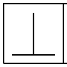

0,05mm  
(0.002in)

**X**

DIM. C  
MINIMUM WALL

THICKNESS

dia. A  
68,13mm  
(2.682in)  
MAXIMUM

face R

0,05mm  
(0.002in)

**X**

face B

**X**

**Z**

160,00mm  
(6.299in)  
REF.

A321-S-32-12-22-080-1

1,75 to 2,25mm  
(0.069 to 0.089in)  
X 45 DEGREES  
CHAMFER  
(2 PLACES)

142,75mm (5.620in) MIN.  
BETWEEN SPOTFACES

DIM. D  
71,250mm  
(2.805in) MIN.

PART SECTION **Z-Z**WITHOUT REPAIR BUSHES

88,75 to 89,25mm  
(3.494 to 3.514in)  
DIAMETER  
SPOTFACE

WITH

4,75 to 5,25mm  
(0.187 to 0.207in)  
CORNER RADIUS

(2 PLACES)

82,00 to 83mm  
(3.228 to 3.268in)

REF.

Repair to Main Fitting  
Figure 601

Repair No. 11-8

Page 603

May 31/2019

32-12-22

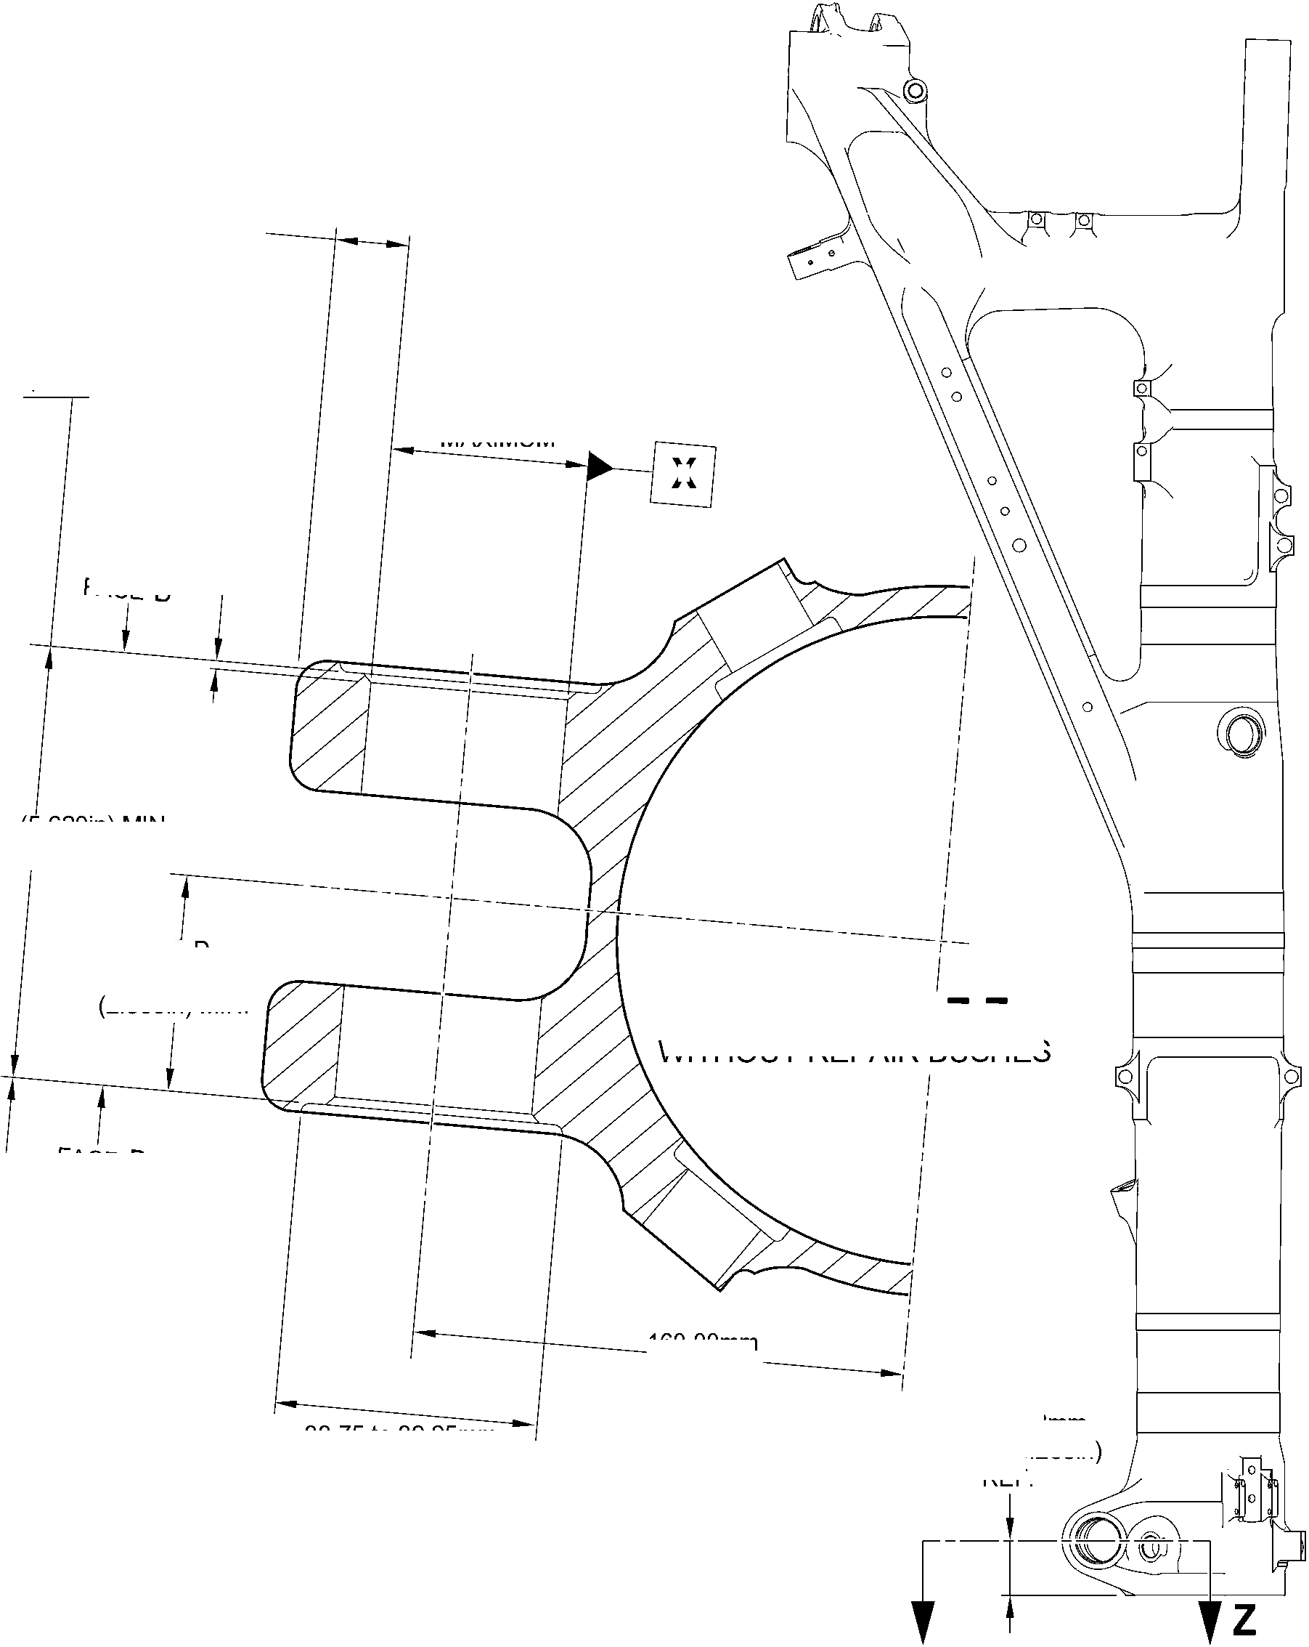

**SAFRAN LANDING SYSTEMS UK Ltd**

CAGE: K0654



PART No. 201587001 AND 201587002 COMPONENT MAINTENANCE MANUAL  
MAIN LANDING GEAR LEG

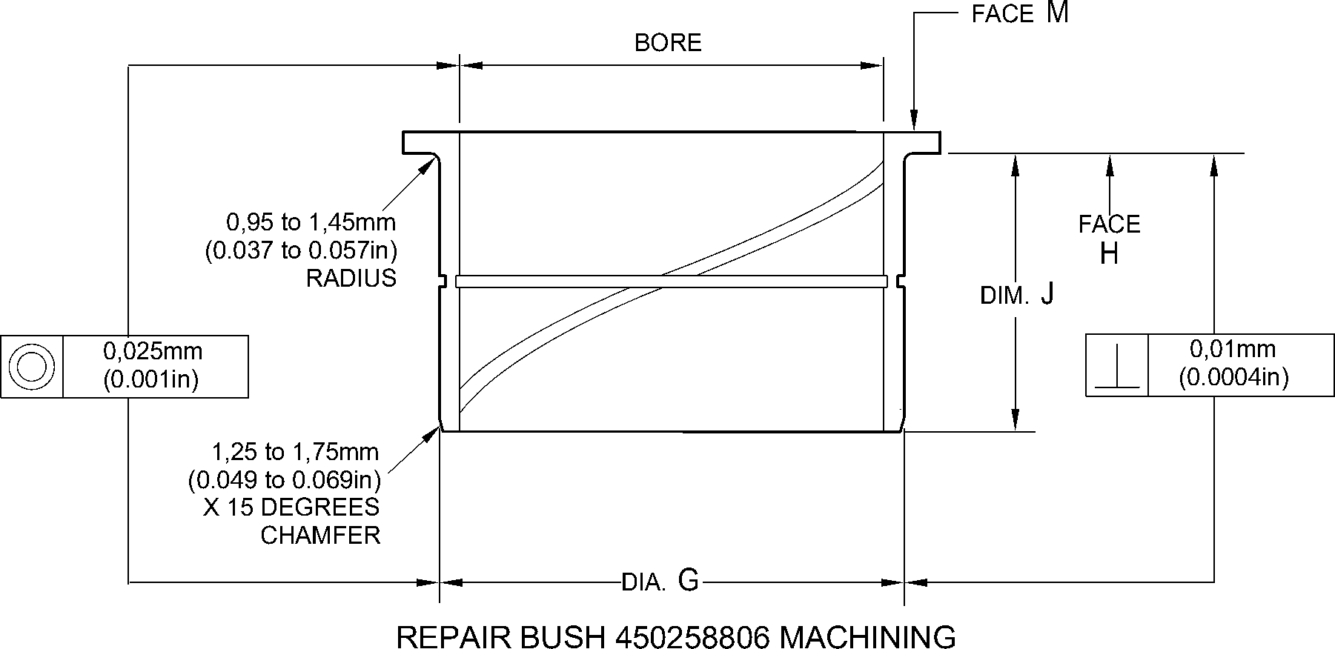

SEALANT TO  
PCS-7200  
(BOTH BUSHES)

DIM. K

0,95 to 1,45mm  
(0.037 to 0.057in)  
X 60 DEGREES  
INCLUSIVE  
CHAMFER

(2 PLACES)

PART SECTION **Z-Z**

WITH REPAIR BUSHES INSTALLED

dim. L

REPAIR BUSH  
450258806

A321-S-32-12-22-081-1

Repair to Main Fitting - Repair Bush Machining and Installation  
Figure 602

32-12-22

Repair No. 11-8

Page 604

May 31/2019

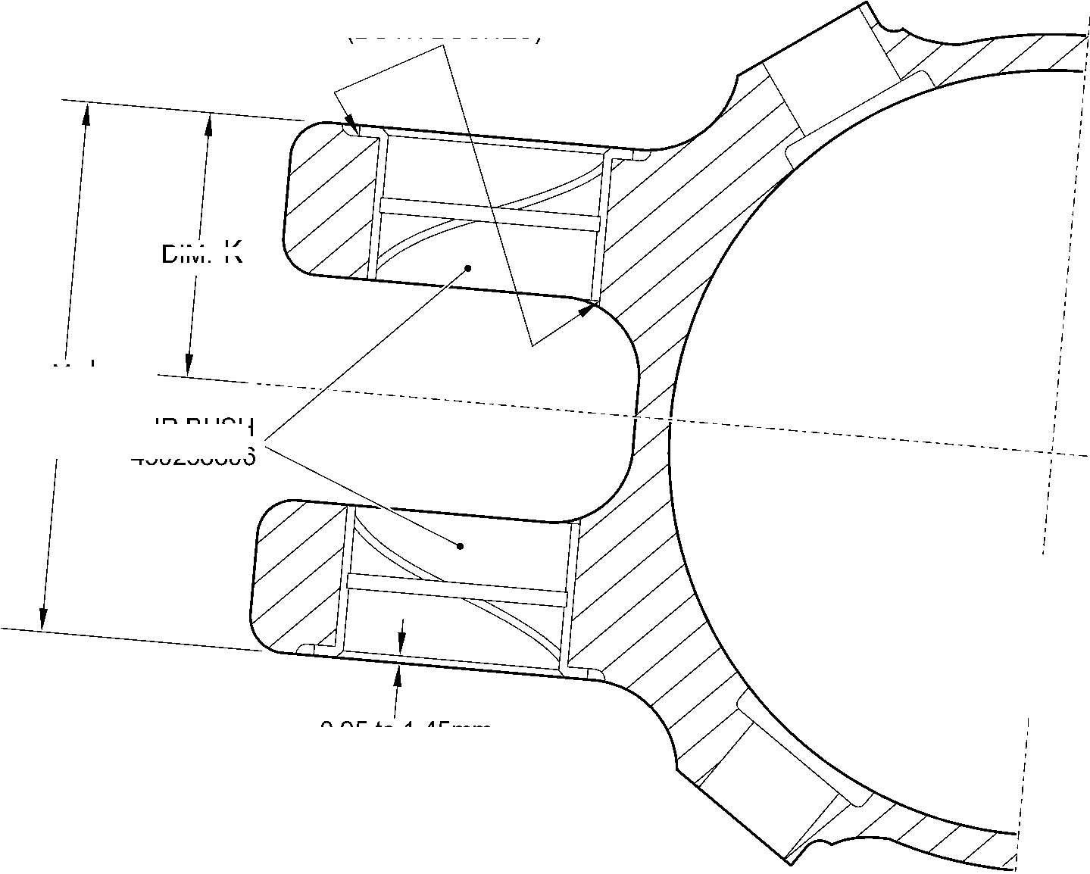

**sSAFRAN SAFRAN LANDING SYSTEMS UK Ltd**

CAGE: K0654

PART No. 201587001 AND 201587002 COMPONENT MAINTENANCE MANUAL  
MAIN LANDING GEAR LEG

I 1. Repair No. 11-9 Main Fitting (20-410, 20-410A, 20-420 and 20-420A)

1. Specified Damage and Material Specification.
2. Specified Damage

(a) Damage or corrosion to the diameter(s) A and the adjacent face(s) B. (Refer to  
Figure 601).

1. Material Specification

|  |  |  |
| --- | --- | --- |
| IPL Figure and Item No. | Name | Material Specification |
| 20-410, 20-410A, 20-420 and 20-420A | Main fitting | Steel, MAT135, 35NCD16THQ |

1. Special Tools
2. These special tools are necessary:

|  |  |  |
| --- | --- | --- |
| Part No. | Special Tool | Function |
| 460004330/122 | Press Pad | Install the repair bush 450217852 |
| 460004330/123 | Press Pad | Install the repair bush 450217851 |

1. Materials
2. These materials are necessary:

**NOTE: Alternative equivalents are permitted.**

|  |  |
| --- | --- |
| Ref. Item | Material |
| 09-510A | Sealant: refer to PCS-7200 |
| TBA | Jointing Compound, zinc loaded Mastinox D40: refer to M-DLPS709-14 |

1. Repair Parts
2. These repair parts are necessary:

|  |  |  |
| --- | --- | --- |
| Part No. | Repair Part | Material Specification |
| 450217851 | Repair bush | Aluminium Bronze, DTD197 |
| 450217852 | Repair bush | Aluminium Bronze, DTD197 |

1. Procedure (Refer to Figures 601, 602 and 603)
2. Machine the diameter(s) A, sufficiently only to remove the damage or corrosion: refer to  
   M-DLPS1004-4-1. Diameter A must not be more than 54,130 mm (2.1311 in). The  
   surface finish must be 1,6 micrometers (63 micro-inches).

Repair No. 11-9

Page 601

Mar 18/2025

32-12-22

**sSAFRAN SAFRAN LANDING SYSTEMS UK Ltd**

CAGE: K0654

PART No. 201587001 AND 201587002 COMPONENT MAINTENANCE MANUAL  
MAIN LANDING GEAR LEG

1. Machine the face(s) B, sufficiently only to remove the damage or wear: refer to  
   M-DLPS1004-4-1. Do not remove more than 1,00 mm (0.039 in) of material from the  
   face(s) B. The surface finish must be 1,6 micrometers (63 micro-inches).
2. Machine the chamfers and radii as shown: refer to Figure 602.
3. Measure and record the new diameter(s) A and the dimensions C1 and C2.
4. Examine the bare metal for flaws: refer to PCS-3600 and PCS-3100, inclusion class 4.
5. Shot peen the machined area: refer to M-DLPS123.
6. Apply cadmium plate to the machined area: refer to PCS-2141.
7. Identify the part with the Safran Landing Systems repair number 450266030 adjacent to  
   the part number: refer to PCS-6000-04, an alternative reference is PCS-6000-06. If the  
   alternative reference is used, the characters must be 0,051 to 0,102 mm (0.0020 to  
   0.0040 in) deep and approximately 3,00 mm (0.118 in) high.
8. Prepare the repair bush(es) 450217851 and 450217852 for installation: refer to  
   Figure 602:
9. Calculate diameter D1 of the repair bush 450217851 from this formula:

D1 = A (as measured in para (4)) + 0,023 to 0,072 mm (+ 0.0009 to 0.0028 in).

1. Calculate dimension F1 of the repair bush 450217851 from this formula:  
   F1 = C1 (as measured in para (4)) + 0,00 to 1,25 mm (+ 0.000 to 0.049 in).
2. Calculate diameter D2 of the repair bush 450217852 from this formula:

D2 = A (as measured in para (4)) + 0,023 to 0,072 mm (+ 0.0009 to 0.0028 in).

1. Calculate dimension F2 of the repair bush 450217852 from this formula:  
   F2 = C2 (as measured in para (4)) + 0,00 to 1,25 mm (+ 0.000 to 0.049 in).
2. Machine the repair bushes to the dimensions shown and calculated. Make the  
   surface finish 1,6 micrometers (63 micro-inches).
3. Apply cadmium plate to the repair bush(es): refer to PCS-2101 or PCS-2141. Do  
   not apply cadmium plate to the bores of the bush(es). The cadmium plate  
   thickness must be between 0,010 and 0,015 mm (0.0004 and 0.0006 in).
4. Use jointing compound, zinc loaded Mastinox D40, Material Ref. Item, TBA and the  
   Press Pads 460004330/122 and 460004330/123 to install the repair bush(es): refer to  
   M-DLPS709-14, M-DLPS1011-20 and Figure 603. Make sure that the drain hole J is  
   free from jointing compound: refer to Figure 603.
5. Machine the flanges of the bush(es) to get:
6. A dimension H of between 111,25 and 111,45 mm (4.380 and 4.388 in): refer to  
   Figure 603. The surface finish must be 1,6 micrometers (63 micro-inches).
7. A dimension G of between 222,50 and 222,75 mm (8.760 and 8.770 in): refer to  
   Figure 603. The surface finish must be 1,6 micrometers (63 micro-inches).
8. Machine the chamfers of the repair bush(es) to the dimensions shown. The surface  
   finish must be 1,6 micrometers (63 micro-inches).

32-12-22

Repair No. 11-9

Page 602

Mar 18/2025

**sSAFRAN SAFRAN LANDING SYSTEMS UK Ltd**

CAGE: K0654

PART No. 201587001 AND 201587002 COMPONENT MAINTENANCE MANUAL  
MAIN LANDING GEAR LEG

1. If necessary, check line ream the bore of the bush 450217851 to between 36,000 and  
   36,025 mm (1.4170 and 1.4180 in).
2. If necessary, check line ream the bore of the bush 450217852 to between 46,825 and  
   46,864 mm (1.8440 and 1.8450 in).
3. Apply sealant, Material Ref. Item 09-510A, between the repair bush(es) and the main  
   fitting: refer to PCS-7200 and Figure 603.
4. Identify the part with the Safran Landing Systems repair number 450266030 adjacent to  
   the part number: refer to PCS-6000-07.
5. Examine the part to make sure that you have obeyed all the repair instructions correctly.

Repair No. 11-9

Page 603

Mar 18/2025

32-12-22

**SAFRAN LANDING SYSTEMS UK Ltd**

CAGE: K0654



PART No. 201587001 AND 201587002 COMPONENT MAINTENANCE MANUAL  
MAIN LANDING GEAR LEG

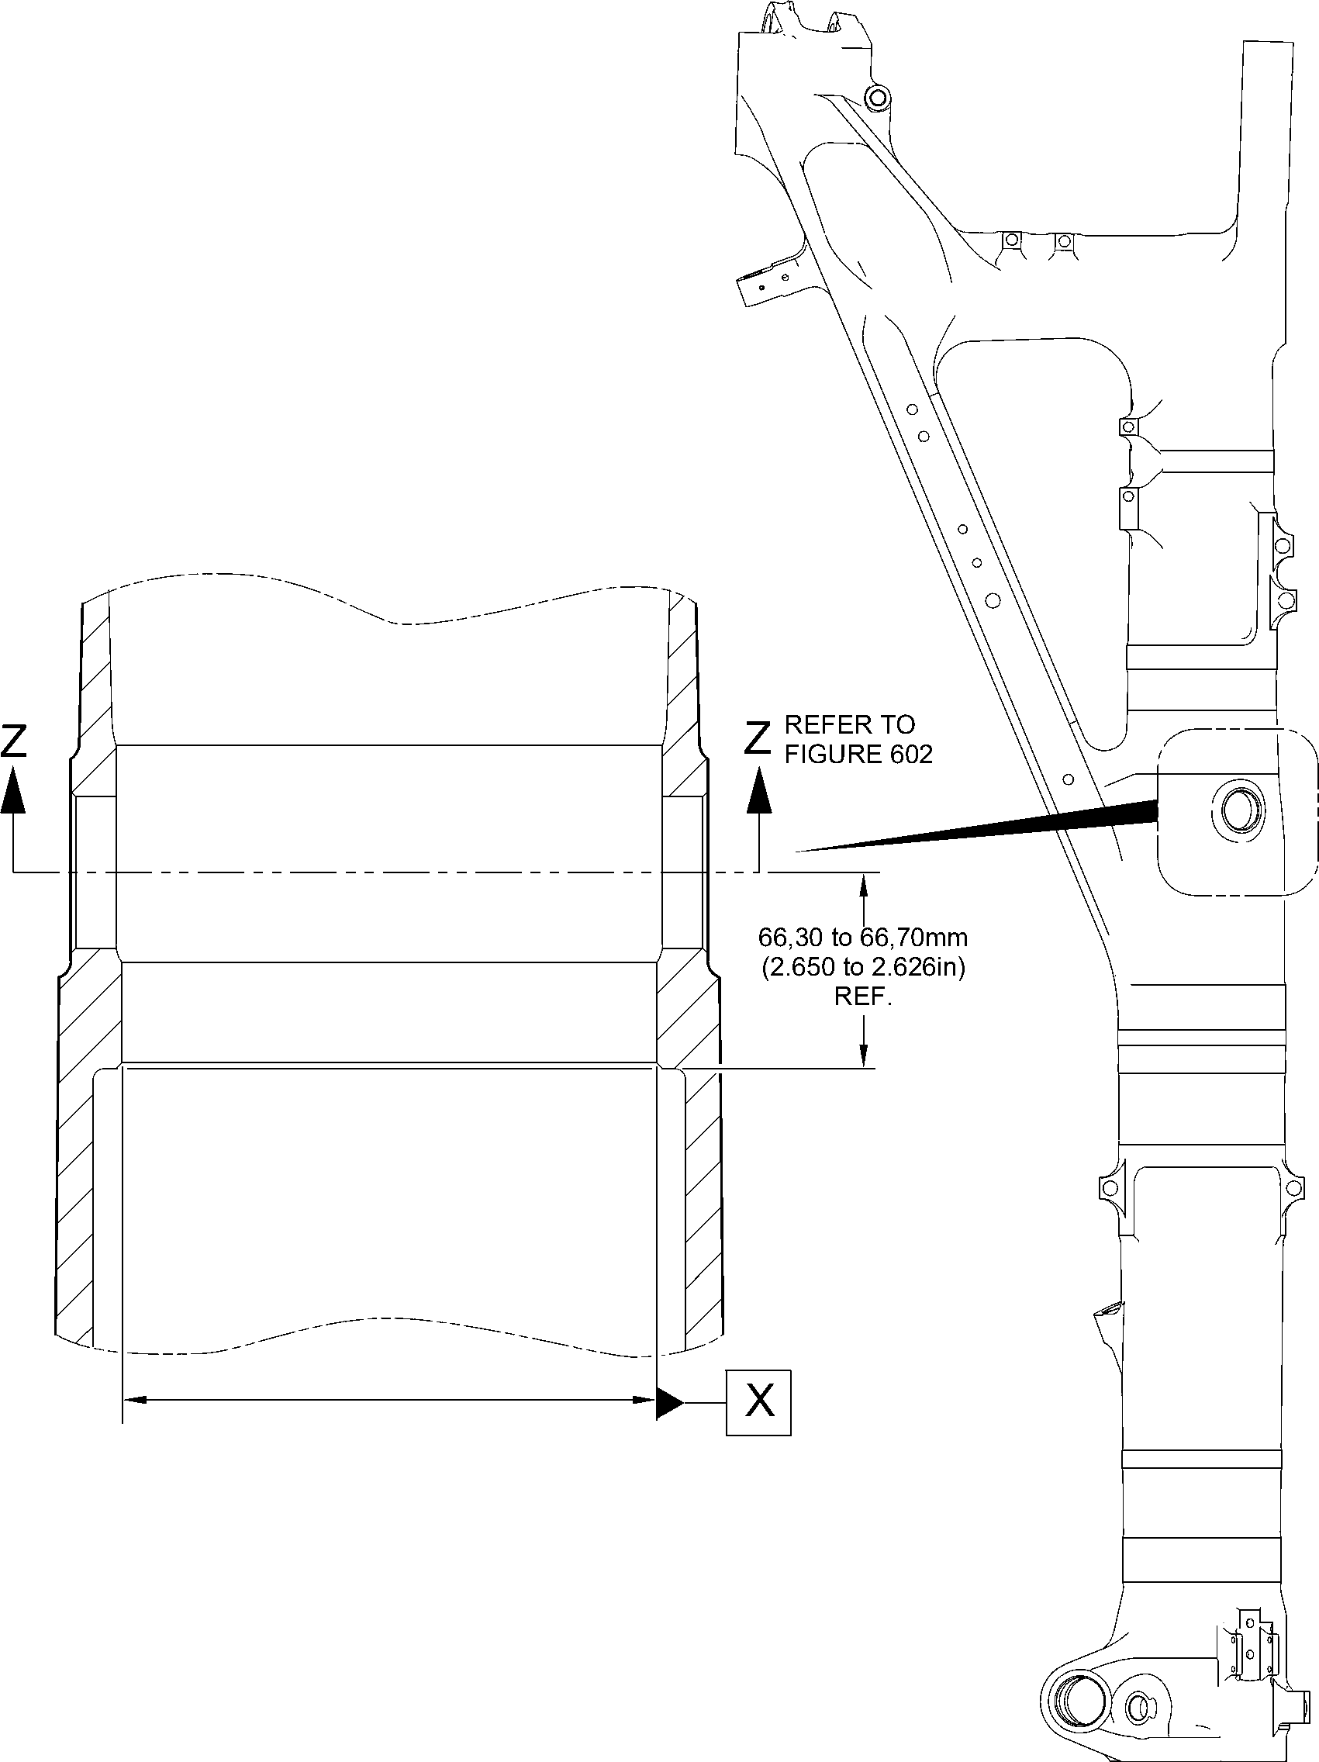

A321A5153-1

Repair to Main Fitting  
Figure 601

32-12-22

Repair No. 11-9

Page 604

Dec 6/2019

**SAFRAN LANDING SYSTEMS UK Ltd**

CAGE: K0654



PART No. 201587001 AND 201587002 COMPONENT MAINTENANCE MANUAL  
MAIN LANDING GEAR LEG

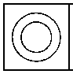

0,05mm  
(0.002in)

faCe B

DIAMETER

0,025mm  
(0.0010in)

C2

face B

C1

Y

1,00 to 2,00mm  
(0.039 to 0.079in)  
RADIUS TYPICAL

1,25 to 1,75mm (0.049 to 0.069in)

X 44.5 to 45.5 DEGREES  
CHAMFER

DIAMETER  
A

section Z-Z

29.5 to 30.5 DEGREES WITHOUT BUSHES

Y

215,50mm (8.484in)  
MINIMUM



0,030mm  
(0.0012in)

Y

107,75mm  
(4.242in)

X

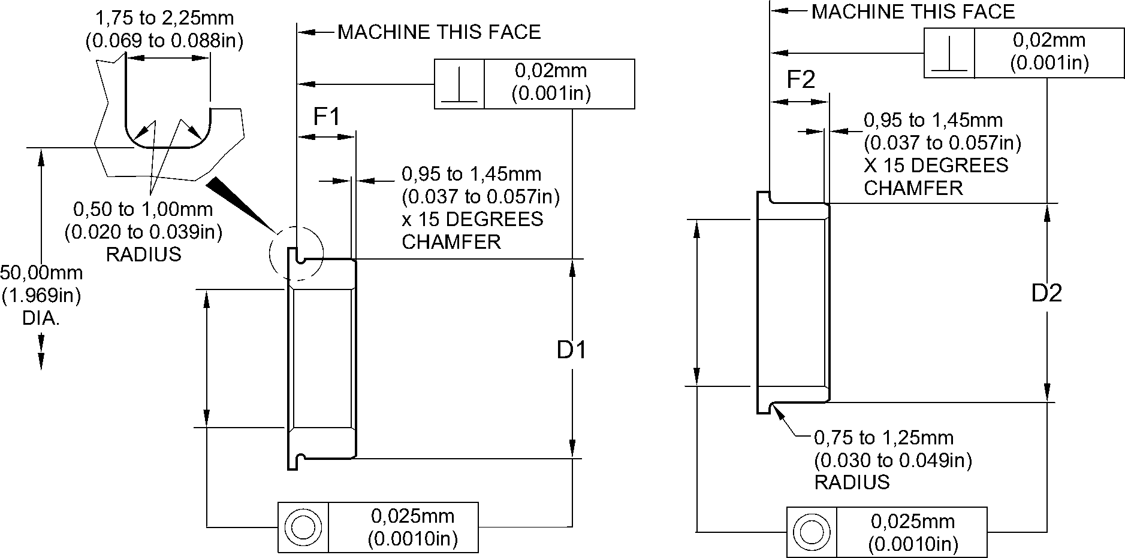

REPAIR BUSH  
450217851

REPAIR BUSH  
450217852

A321A5154-1

Repair to Main Fitting - Machining  
Figure 602

Repair No. 11-9

32-12-22

Page 605

Dec 6/2019

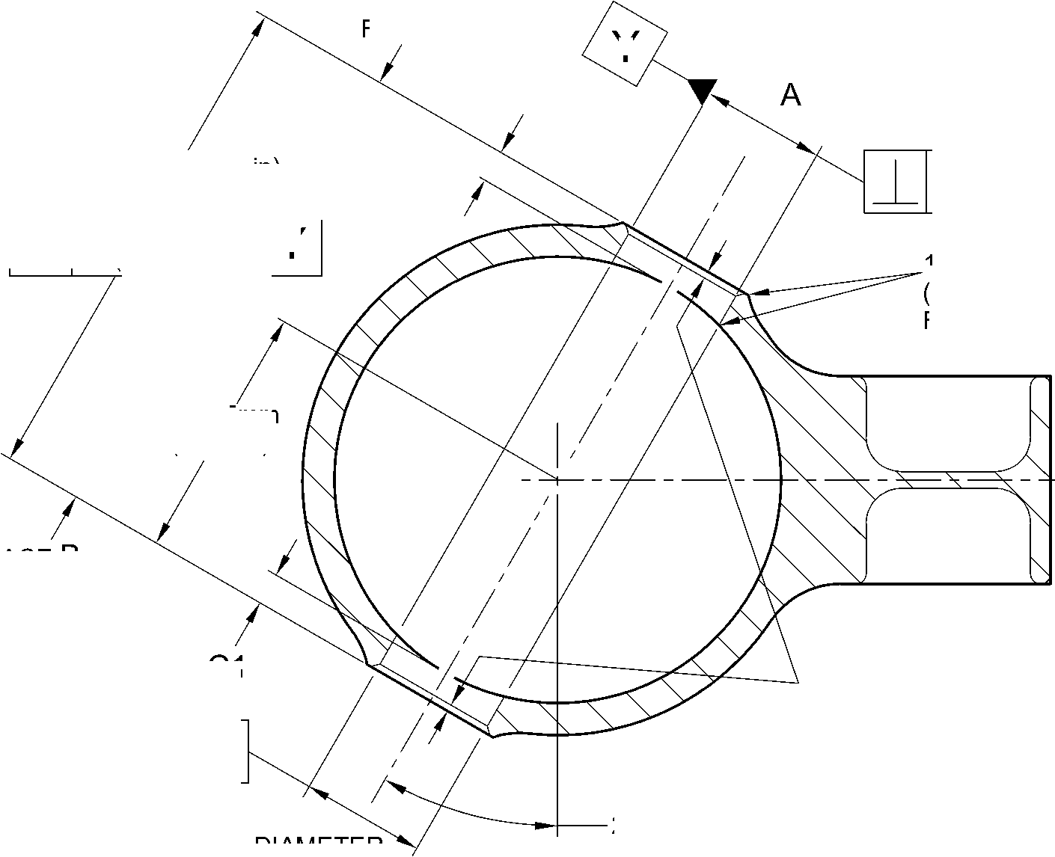

**SAFRAN LANDING SYSTEMS UK Ltd**

CAGE: K0654



PART No. 201587001 AND 201587002 COMPONENT MAINTENANCE MANUAL  
MAIN LANDING GEAR LEG

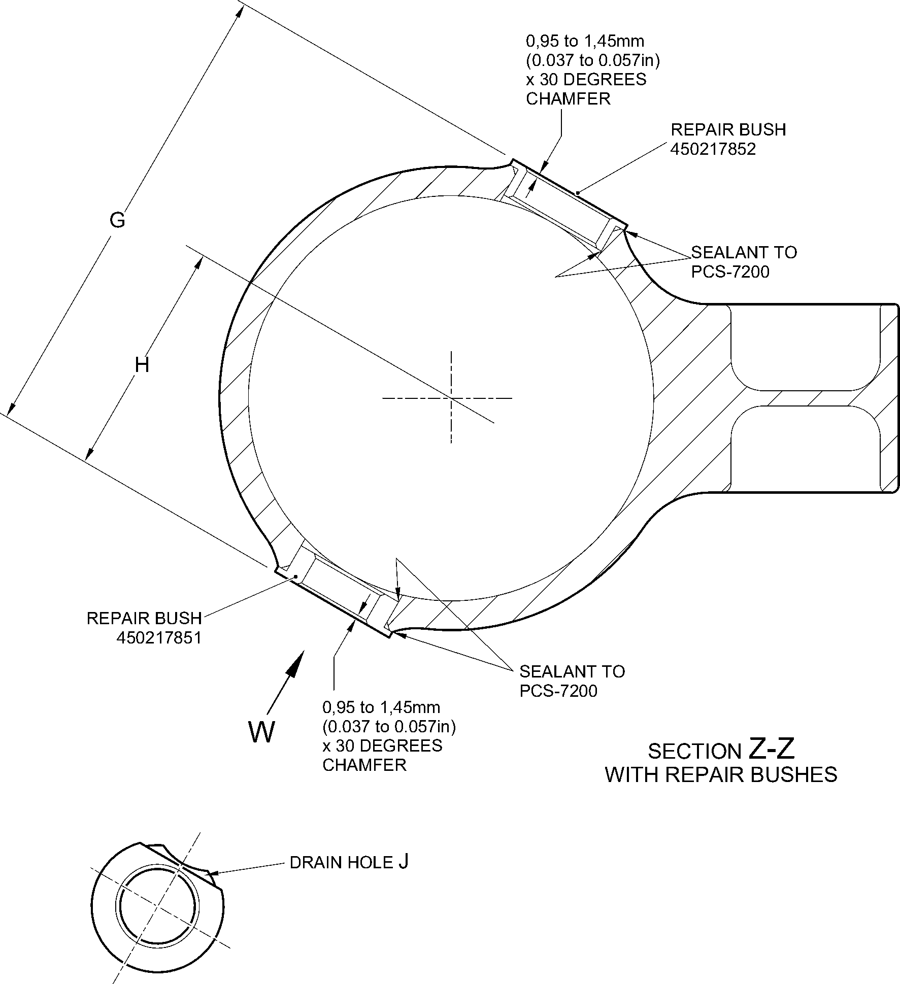

view W

REFERENCE BOTTOM  
OF MAIN FITTING

A321A5155-1

Repair to Main Fitting - Repair Bush Installation  
Figure 603

Repair No. 11-9

32

Page 606

Dec 6/2019

**SAFRAN LANDING SYSTEMS UK Ltd**

CAGE: K0654



PART No. 201587001 AND 201587002 COMPONENT MAINTENANCE MANUAL  
MAIN LANDING GEAR LEG

I 1. Repair No. 11-10 Main Fitting (20-410 and 20-420 Only)

A. This repair, Messier-Dowty Limited Repair No. 450267270, has been withdrawn from use. It is  
superseded by Repair No. 11-29 (450267275) or Repair No. 11-30 (450267385).

Repair No. 11-10

32-12-22

Page 601

Dec 4/2020

**SAFRAN LANDING SYSTEMS UK Ltd**

CAGE: K0654



PART No. 201587001 AND 201587002 COMPONENT MAINTENANCE MANUAL  
MAIN LANDING GEAR LEG

INTENTIONALLY BLANK

Repair No. 11-10

32-12-22 Page 602

**SAFRAN LANDING SYSTEMS UK Ltd**

CAGE: K0654



PART No. 201587001 AND 201587002 COMPONENT MAINTENANCE MANUAL  
MAIN LANDING GEAR LEG

I 1. Repair No. 11-11 Main Fitting (20-410, 20-410A, 20-420 and 20-420A)

1. Specified Damage and Material Specification
2. Specified Damage

(a) Damage or corrosion to the diameter A.

1. Material Specification

|  |  |  |
| --- | --- | --- |
| IPL Figure and Item No. | Name | Material Specification |
| 20-410, 20-410A, 20-420 and 20-420A | Main Fitting | Steel, MAT135, 35NCD16THQ |

1. Special Tools

(1) These special tools are necessary:

**NOTE: Alternative equivalents are permitted.**

|  |  |  |
| --- | --- | --- |
| Part No. | Special Tool | Function |
| 460004330/91 | Press Pad | Install the repair bearing |

1. Materials

(1) These materials are necessary:

**NOTE: Alternative equivalents are permitted.**

|  |  |
| --- | --- |
| Ref. Item | Material |
| 04-512 | Molykote 111 |
| 09-510A | Sealant |

1. Repair Parts

(1) These repair parts are necessary:

|  |  |  |
| --- | --- | --- |
| Part No. | Repair Part | Material Specification |
| 450237824 | Repair Bearing | Aluminium Bronze, DTD197 |

E. Procedure (Refer to Figures 601 and 602)

**CAUTION: FOR DAMAGE MORE THAN THE LIMITS OF THIS REPAIR SCHEME,  
WRITE TO SAFRAN LANDING SYSTEMS: REFER TO GUIDE-CS-001.**

1. Machine diameter A sufficiently to remove the damage or wear and to between 14,018  
   and 14,485 mm (0.5519 and 0.5703 in): refer to M-DLPS914, M-DLPS1004-4-1  
   and Figure 601. Make the surface finish 1,6 micrometers (63 micro-inches) or better.
2. Examine the main fitting for flaws: refer to PCS-3100, inclusion class 4 and PCS-3600.
3. Measure and record the new diameter A.

Repair No. 11-11

32-12-22

Page 601

Mar 18/2025

**sSAFRAN SAFRAN LANDING SYSTEMS UK Ltd**

CAGE: K0654

PART No. 201587001 AND 201587002 COMPONENT MAINTENANCE MANUAL  
MAIN LANDING GEAR LEG

1. Identify the part with the Safran Landing Systems repair number 450266015 adjacent to  
   the part number: refer to PCS-6000-04 or PCS-6000-06.
2. Apply cadmium plate to the reworked area: refer to PCS-2100 and PCS-2141. Fadeout  
   of cadmium plate is permitted in bore.
3. Apply primer paint to reworked areas: refer to PCS-2500.
4. Calculate the diameter B of the repair bearing, use formula:

Dia. B = Dia. A (as measured) - 0,006 to + 0,023 mm (- 0.0002 to + 0.0009 in).

1. Machine the repair bearing to the diameter calculated and as shown: refer  
   to Figure 602. Make the surface finish 1,6 micrometers (63 micro-inches).
2. Apply cadmium plate all over the repair bearing: refer to PCS-2101 or PCS-2141. The  
   cadmium plate thickness must be between 0,010 and 0,015 mm (0.0004 and  
   0.0006 in).
3. Use the press pad 460004330/91 to install the repair bearing. Use Molykote 111,  
   Material Ref. Item 04-512: refer to PCS-7304. The ends of the bearing must be below  
   the end of the bearing hole: refer to Figure 602.
4. Check the bore diameters of the repair bearing: refer to Figure 602.
5. Do not machine the repair bearing. If necessary, hone the bore diameters of the repair  
   bearing to the dimensions shown: refer to Figure 602.
6. Apply sealant, Material Ref. Item 09-510A, to the joints between the repair bearing and  
   main fitting: refer to PCS-7200 and Figure 602.
7. Apply paint to the repaired area, except where indicated: refer to PCS-2500, REPAIR  
   and Figure 602.
8. Identify the part with the Safran Landing Systems repair number 450266015 adjacent to  
   the part number: refer to PCS-6000-07.
9. Examine the part to make sure that you have obeyed all the repair instructions correctly.

32-12-22

Repair No. 11-11

Page 602

Mar 18/2025

**SAFRAN LANDING SYSTEMS UK Ltd**

CAGE: K0654



PART No. 201587001 AND 201587002 COMPONENT MAINTENANCE MANUAL  
MAIN LANDING GEAR LEG

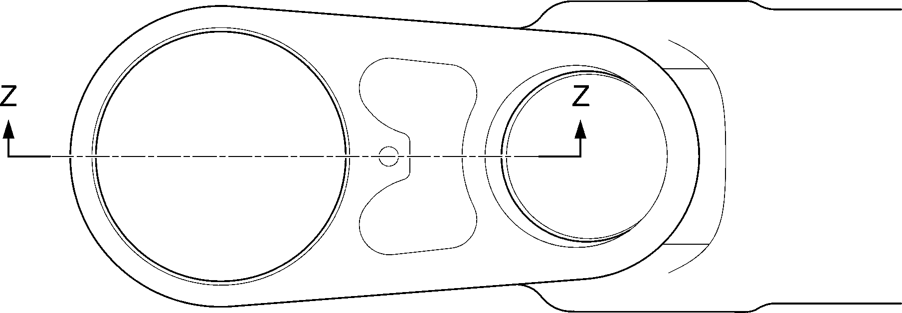

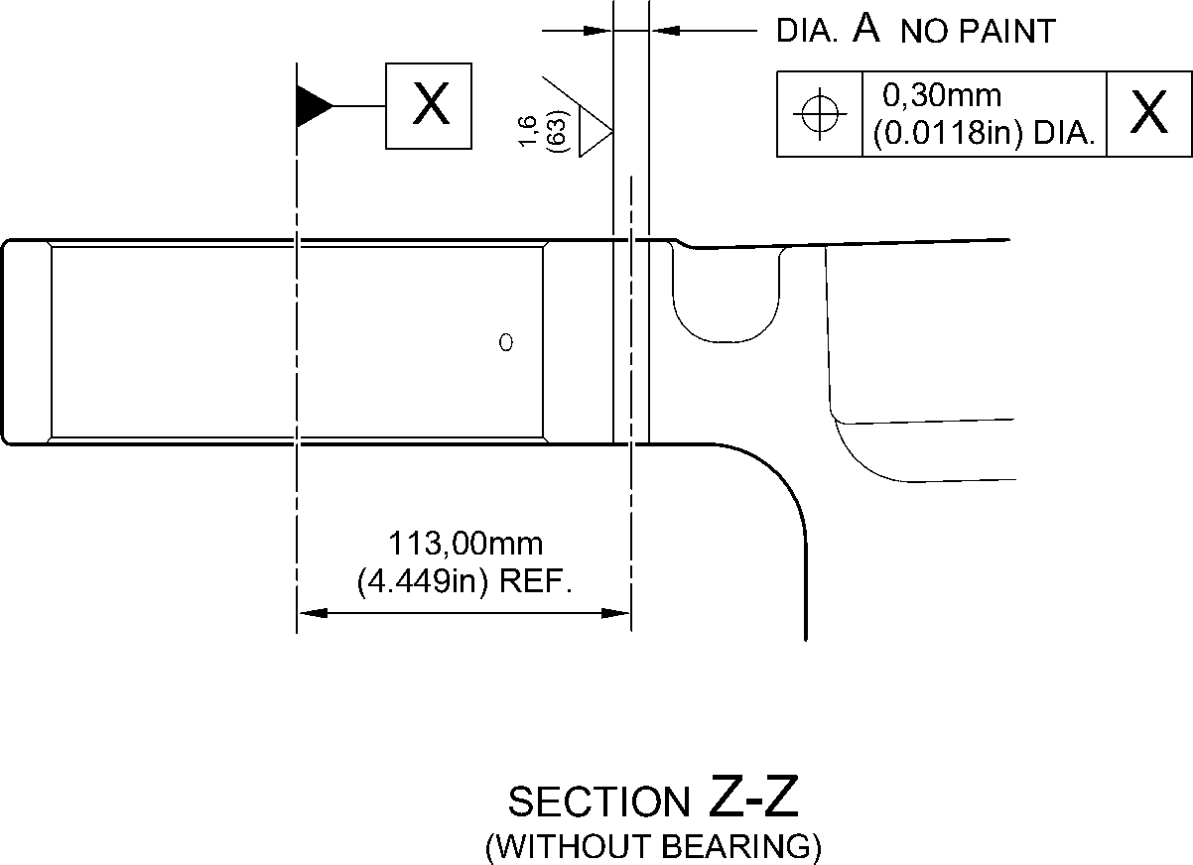

A321-S-32-12-22-018-1

Repair to Main Fitting - Machining  
Figure 601

Repair No. 11-11

32-12-22

Page 603

Dec 6/2019

**SAFRAN LANDING SYSTEMS UK Ltd**

CAGE: K0654

PART No. 201587001 AND 201587002 COMPONENT MAINTENANCE MANUAL  
MAIN LANDING GEAR LEG

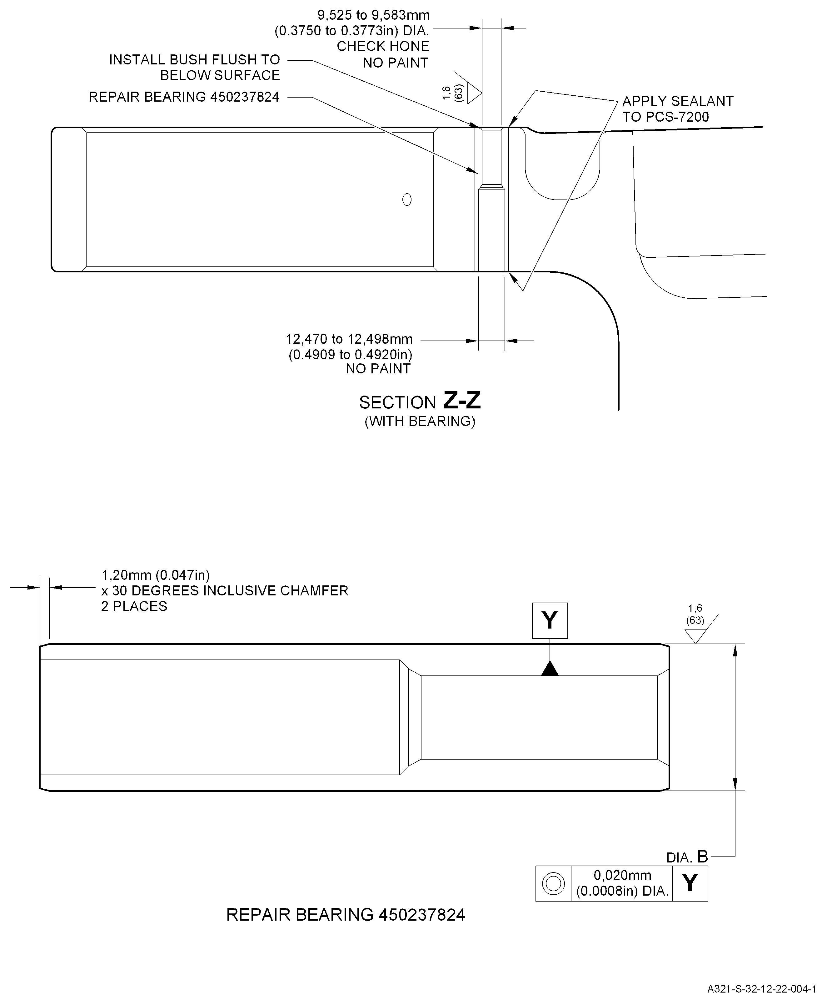

Repair Bearing - Machining and Installation

Figure 602

Repair No. 11-11

32

Page 604

-12-22 Dec 6/2019

**SAFRAN LANDING SYSTEMS UK Ltd**

CAGE: K0654



PART No. 201587001 AND 201587002 COMPONENT MAINTENANCE MANUAL  
MAIN LANDING GEAR LEG

I 1. Repair No. 11-12 Main Fitting (20-410, 20-410A, 20-420 and 20-420A)

1. Specified Damage and Material Specification.
2. Specified Damage

(a) Damage or wear to the diameter A.

1. Material Specification

|  |  |  |
| --- | --- | --- |
| IPL Figure and Item No. | Name | Material Specification |
| 20-410, 20-410A, 20-420 and 20-420A | Main fitting | Steel, MAT135, 35NCD16THQ |

1. Special Tools

(1) These special tools are necessary:

**NOTE: Alternative equivalents are permitted.**

|  |  |  |
| --- | --- | --- |
| Part No. | Special Tool | Function |
| 460006265 | Press Pad | Install the bush 450237800 |

1. Materials

(1) These materials are necessary:

**NOTE: Alternative equivalents are permitted.**

|  |  |
| --- | --- |
| Ref. Item | Material |
| 08-704 | Adhesive |
| 09-510A | Sealant |

1. Repair Parts

(1) These repair parts are necessary:

|  |  |  |
| --- | --- | --- |
| Part No. | Repair Part | Material Specification |
| 450237800 | Blank bush | Aluminium Bronze, DTD197 |

E.

Procedure (Refer to Figures 601 and 602)

**CAUTION: FOR DAMAGE MORE THAN THE LIMITS OF THIS REPAIR SCHEME, WRITE  
TO SAFRAN LANDING SYSTEMS: REFER TO GUIDE-CS-001.**

(1)

(2)

(3)

Remove the paint locally from the main fitting: refer to PCS-2700.

Remove the cadmium plate locally from the main fitting: refer to PCS-2100.

Machine diameter A sufficiently to remove the wear or damage within the dimensions  
shown: refer to M-DLPS914, M-DLPS1004-4-1 and Figure 601. Make the surface finish  
1,6 micrometers (63 micro-inches) or better.

Repair No. 11-12

32

Page 601

-12-22 Mar 18/2025

**sSAFRAN SAFRAN LANDING SYSTEMS UK Ltd**

CAGE: K0654

PART No. 201587001 AND 201587002 COMPONENT MAINTENANCE MANUAL  
MAIN LANDING GEAR LEG

1. Measure and record the new diameter A.
2. Examine the main fitting for flaws: refer to PCS-3600 and PCS-3100, inclusion class 4.
3. Shot peen the reworked areas: refer to M-DLPS123.
4. Identify the part with the Safran Landing Systems repair number 450266035 adjacent to  
   the part number: refer to PCS-6000-04 or PCS-6000-06.
5. Apply cadmium plate to the reworked area: refer to PCS-2100 and PCS-2141. Fadeout  
   of cadmium plate is permitted in bore.
6. Calculate the diameter of the blank bush, use formula:

B = A (as measured) - 0,265 to -0,350 mm (-0.0104 to -0.0138 in).

1. Machine the blank bush to the diameter calculated and as shown: refer to Figure 602.
2. Apply cadmium plate all over the repair bush: refer to PCS-2101. The cadmium plate  
   thickness must be between 0,003 and 0,005 mm (0.00015 and 0.00020 in).
3. Apply adhesive, Material Ref. Item 08-704, to the outside diameter of the repair bush  
   and to the hole of the main fitting where you will install the repair bush: refer to  
   PCS-5303.
4. Use Press Pad 460006265 and install the repair bush: refer to Figure 602. The ends of  
   the bush must be below the main fitting surface after installation.
5. Check the bore diameter of the repair bush: refer to Figure 602.
6. If necessary, hone the bore diameter of the repair bush to the dimensions shown: refer  
   to Figure 602.
7. Apply sealant, Material Ref. Item 09-510A, to the joints between the repair bush and  
   main fitting: refer to PCS-7200 and Figure 602.
8. Apply paint locally to the repaired area, but not to the repair bush bore: refer to  
   PCS-2500 and Figure 602.
9. Identify the part with the Safran Landing Systems repair number 450266035 adjacent to  
   the part number: refer to PCS-6000-07.
10. Examine the part to make sure that you have obeyed all the repair instructions correctly.

32-12-22

Repair No. 11-12

Page 602

Mar 18/2025

**SAFRAN LANDING SYSTEMS UK Ltd**

CAGE: K0654

PART No. 201587001 AND 201587002 COMPONENT MAINTENANCE MANUAL  
MAIN LANDING GEAR LEG

Z

Z

14,25mm (0.5610in) REF.

section Z-Z  
(WITHOUT BUSH)

1,00mm (0.039in)  
x 45 DEGREES

CHAMFER  
(2 PLACES)

dia. A  
21,50mm  
(0.8465in)  
MAXIMUM  
NO PAINT

69,75 to 71,75mm

(2.7461 to 2.8248in)

A321-S-32-12-22-036-1

Repair to Main Fitting - Machining  
Figure 601

Repair No. 11-12

32-12-22

Page 603

Dec 6/2019

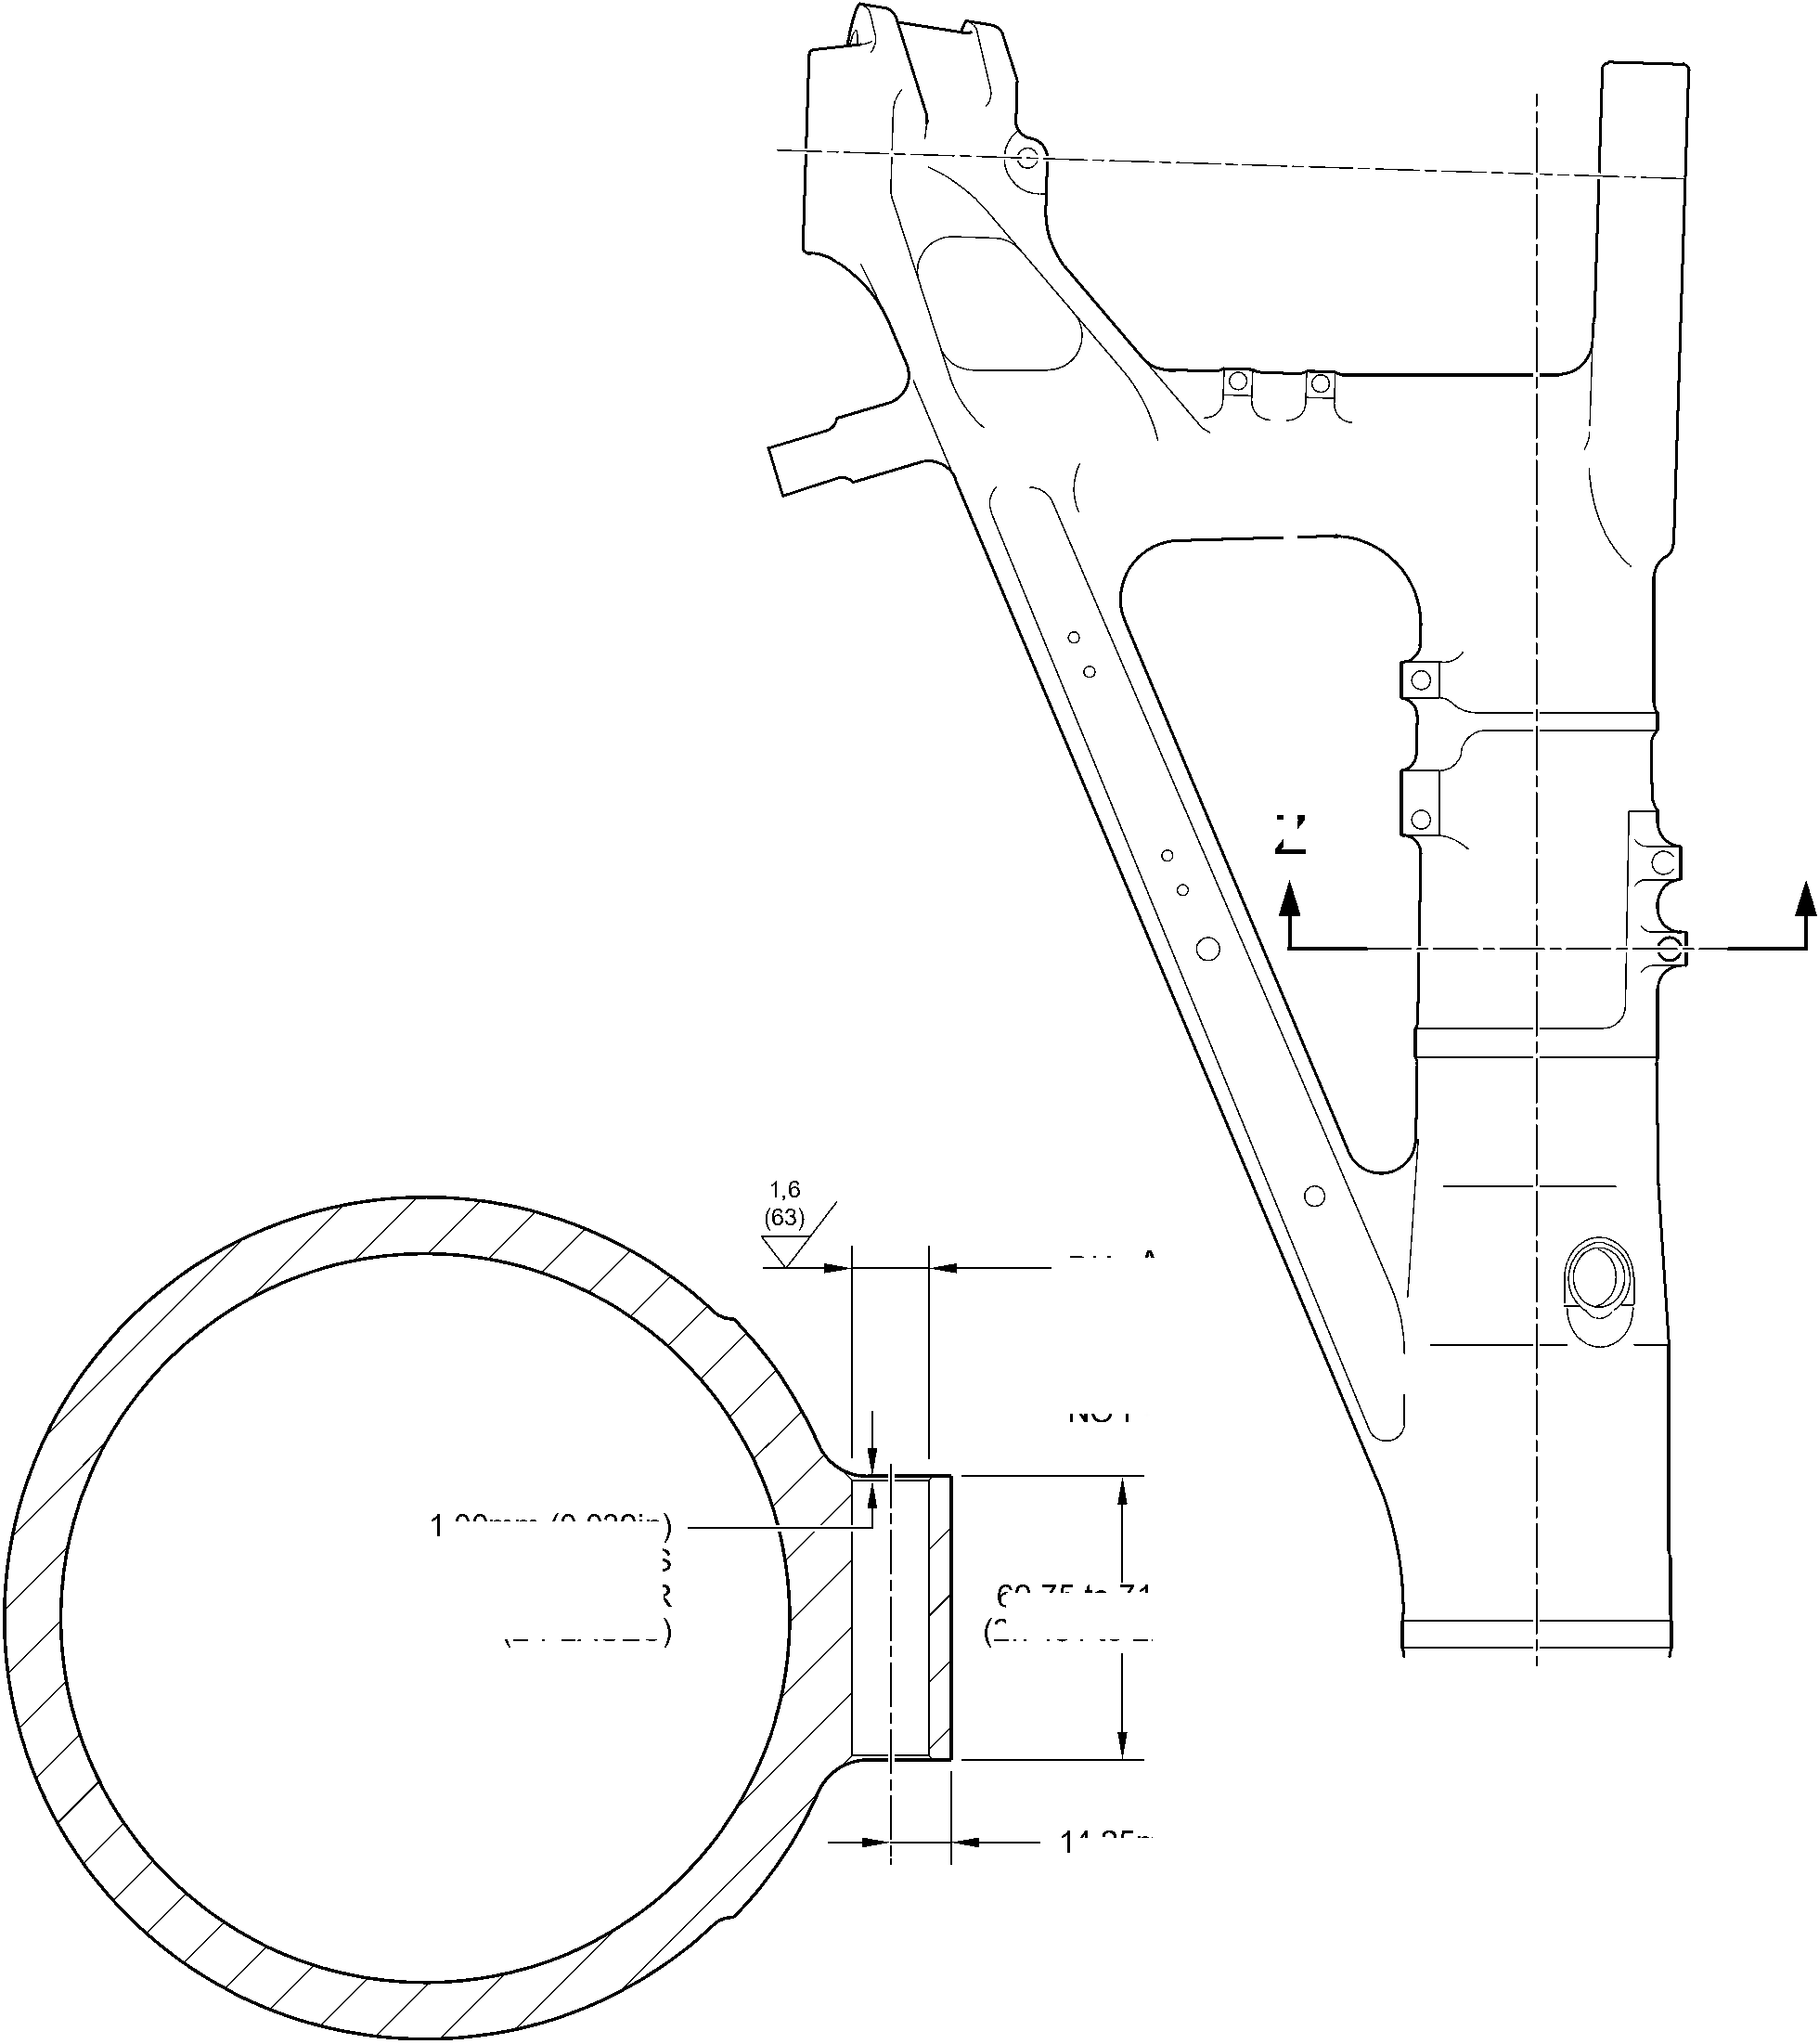

**SAFRAN LANDING SYSTEMS UK Ltd**

CAGE: K0654



PART No. 201587001 AND 201587002 COMPONENT MAINTENANCE MANUAL  
MAIN LANDING GEAR LEG

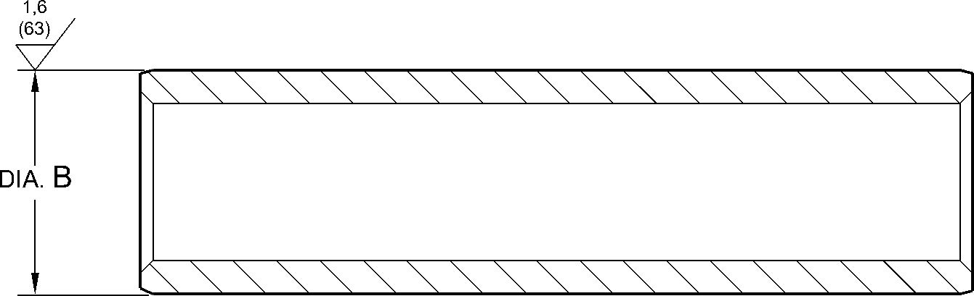

1,20mm (0.047in)

x 30 DEGREES INCLUSIVE CHAMFER  
BOTH ENDS

REPAIR BUSH 450237800

1,6

APPLY SEALANT  
TO PCS-7200

REPAIR  
BUSH  
450237800

16,50mm (0.650in) DIA.

CHECK HONE

NO PAINT

APPLY SEALANT

TO PCS-7200

section Z-Z

(REFER TO FIGURE 601)  
WITH REPAIR BUSH

A321-S-32-12-22-037-1

Repair Bush - Machining and Installation

Figure 602

32-12-22

Repair No. 11-12

Page 604

Dec 6/2019

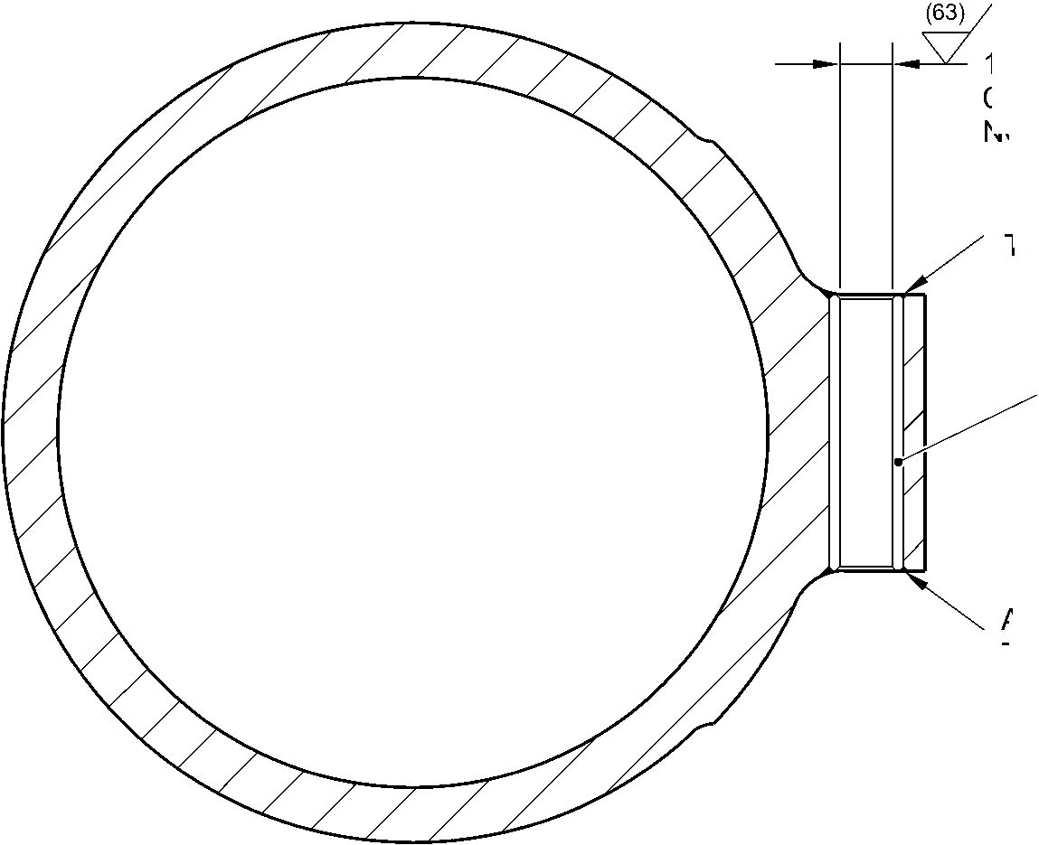

**sSAFRAN SAFRAN LANDING SYSTEMS UK Ltd**

CAGE: K0654

PART No. 201587001 AND 201587002 COMPONENT MAINTENANCE MANUAL  
MAIN LANDING GEAR LEG

I 1. Repair No. 11-13 Main Fitting (20-410, 20-410A, 20-420 and 20-420A)

1. Specified Damage and Material Specification.
2. Specified Damage

(a) Damage or corrosion to the diameters A and/or B and/or adjacent internal faces.

1. Material Specification

|  |  |  |
| --- | --- | --- |
| IPL Figure and Item No. | Name | Material Specification |
| 20-410, 20-410A, 20-420 and 20-420A | Main fitting | Steel, MAT135, 35NCD16THQ |

1. Special Tools
2. These special tools are necessary:

**NOTE: Alternative equivalents are permitted.**

|  |  |  |
| --- | --- | --- |
| Part No. | Special Tool | Function |
| 460006600 | Press Pad Assembly | Install the repair bush 450237810 |
| 460006601 | Alignment Bar | Use with Press Pad 460006600 |
| 460006602 | Cutter | To get the correct dimension across the repair bushes |
| 460006603 | Press Pad Assembly | Install the bush made from 450237811 |
| 460006604 | Guide Bush | Use with Press Pad 460006603 |

1. Materials
2. These materials are necessary:

**NOTE: Alternative equivalents are permitted.**

|  |  |
| --- | --- |
| Ref. Item | Material |
| TBA | Mastinox, D40 |
| TBA | Zinc Powder |
| 09-510A | Sealant |

Repair No. 11-13

32-12-22

Page 601

Mar 18/2025

**sSAFRAN SAFRAN LANDING SYSTEMS UK Ltd**

CAGE: K0654

PART No. 201587001 AND 201587002 COMPONENT MAINTENANCE MANUAL  
MAIN LANDING GEAR LEG

1. Repair Parts

(1) These repair parts are necessary:

|  |  |  |
| --- | --- | --- |
| Part No. | Repair Part | Material Specification |
| 450237810 | Blank Bush | Aluminium Bronze, DTD197 or AMS4-880C |
| 450237811 | Blank Bush  (Refer to Table 1 for oversize bushes) | Steel, S132 |

1. Procedure (Refer to Figures 601 and 602)
2. Machine diameters A and/or B sufficiently to remove the damage or corrosion within the  
   dimensions shown: refer to M-DLPS1004-4-1 and Figure 601. Make the surface finish  
   1,6 micrometers (63 micro-inches).
3. Machine the adjacent internal faces sufficiently to remove the damage or corrosion  
   within the dimensions shown: refer to M-DLPS1004-4-1 and Figure 601. Make the  
   surface finish 1,6 micrometers (63 micro-inches).
4. Machine the radii and chamfers to the dimensions shown: refer to Figure 601.
5. Measure and record the new diameters A and B and dimensions D and E.
6. Examine the main fitting for flaws: refer to PCS-3600 and PCS-3100, inclusion class 4.
7. Shot peen the machined areas: refer to M-DLPS123.
8. Apply cadmium plate to the reworked areas: refer to PCS-2141.
9. Identify the part with the Safran Landing Systems repair number 450266050 adjacent to  
   the part number: refer to PCS-6000-04 or PCS-6000-06. If the PCS-6000-06 is used, the  
   letters must have a depth of 0,051 to 0,102 mm (0.0020 to 0.0040 in) and an  
   approximate height of 3,00 mm (0.118 in).
10. Calculate the dimensions to machine the repair bush 450237810 for diameter A:  
    F = A (as measured) + 0,023 to 0,072 mm (0.0009 to 0.0028 in),  
    G = D (as measured) + 0,65 to 1,35 mm (0.026 to 0.053 in).
11. Machine the repair bush 450237810 to the dimensions shown and calculated: refer to  
    Figure 602. Make the surface finish 1,6 micrometers (63 micro-inches).
12. With the measured dimension E, select the applicable oversize bush from Table 1.
13. Calculate the diameter of the oversize bush for diameter B:  
    H = B (as measured) + 0,023 to 0,072 mm (0.0009 to 0.0028 in).
14. Machine the oversize bush to the dimensions shown and calculated: refer to Figure 602.  
    Make the surface finish 1,6 micrometers (63 micro-inches).
15. If necessary machine the flange face of the repair bush (450237810) to get the correct  
    dimension between the bush faces on assembly as shown: refer to Figure 602.
16. Restore the chamfers to the dimensions as shown: refer to Figure 602.

32-12-22

Repair No. 11-13

Page 602

Mar 18/2025

**sSAFRAN SAFRAN LANDING SYSTEMS UK Ltd**

CAGE: K0654

PART No. 201587001 AND 201587002 COMPONENT MAINTENANCE MANUAL  
MAIN LANDING GEAR LEG

1. Apply cadmium plate all over the repair bush (450237810) and only to the reworked  
   areas of selected oversize bush: refer to PCS-2101 and PCS-2141. Do not apply  
   cadmium plate to the bush bores. Make the cadmium plate thickness between 0,010  
   and 0,015 mm (0.0004 to 0.0006 in).
2. Use press pad assembly 460006600 and alignment bar 460006601 and install the repair  
   bush. Use press pad assembly 460006603, alignment bar 460006601 and guide bush  
   460006604 and install the oversize bush: refer to M-DLPS1011-20. Use electrically  
   conducting mastinox (make from Mastinox D40, Material Ref. Item TBA and Zinc  
   powder, Material Ref. Item TBA): refer to M-DLPS709-14.
3. Check line ream the repair bushes to the dimensions shown: refer to Figure 602.
4. Apply sealant, Material Ref. Item 09-510A to the joints between the repair bushes and  
   the main fitting: refer to PCS-7200 and Figure 602.
5. Identify the main fitting with the Safran Landing Systems repair number 450266050  
   adjacent to the part number: refer to PCS-6000-07.
6. Examine the part to make sure that you have obeyed all the repair instructions correctly.

Table 1

Oversize Bushes For Diameter B

|  |  |  |  |  |
| --- | --- | --- | --- | --- |
| Oversize | Step mm (in) | Oversize Bush | Dimension E (as measured) mm (in) | Dimension J  mm (in) |
| - | Std | 450237351 | 27,75 to 28,25 (1.093 to 1.112) | 2,45 to 2,55 (0.096 to 0.100) |
| 1 | 0,127 (0.005) | 450237352 | 27,62 to 28,12 (1.087 to 1.107) | 2,58 to 2,68 (0.102 to 0.106) |
| 2 | 0,254 (0.010) | 450237353 | 27,50 to 28,00 (1.083 to 1.102) | 2,70 to 2,80 (0.106 to 0.110) |
| 3 | 0,381 (0.015) | 450237354 | 27,37 to 27,87 (1.078 to 1.097) | 2,83 to 2,93 (0.111 to 0.115) |
| 4 | 0,508 (0.020) | 450237355 | 27,24 to 27,74 (1.072 to 1.092) | 2,96 to 3,06 (0.117 to 0.120) |

Repair No. 11-13

32-12-22

Page 603

Mar 18/2025

**SAFRAN LANDING SYSTEMS UK Ltd**

CAGE: K0654



PART No. 201587001 AND 201587002 COMPONENT MAINTENANCE MANUAL  
MAIN LANDING GEAR LEG

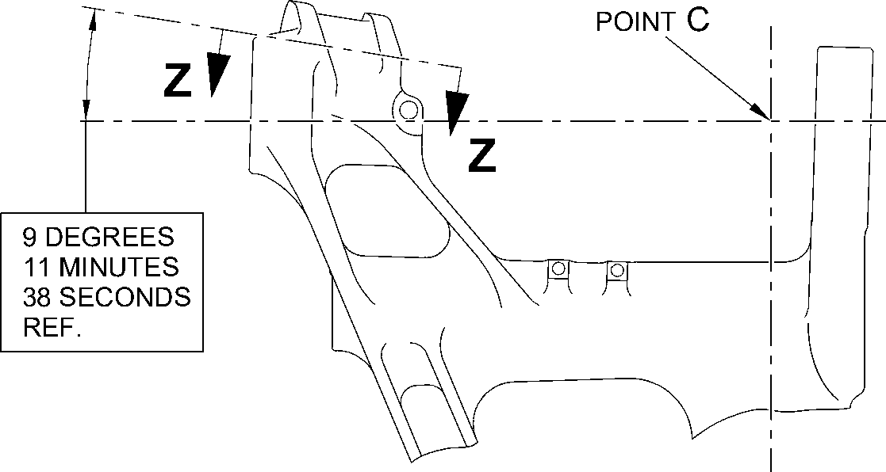

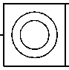

0,05mm  
(0.002in) DIA.

dim. C  
62,760mm  
(2.4709in)  
MAX.

14,515mm (0.5714in)

MIN. WALL THICKNESS

DIA. A

58,13mm (2.2886in) MAXIMUM

262,01mm (10.315in)

to point 'C'

8 DEGREES 13 MINUTES

17 SECONDS

REF.

dim. D  
27,25mm (1.072in)  
MIN.

BLEND SMOOTHLY  
TO EXISTING RADIUS  
4,00 to 5,00mm

(0.157 to 0.197in) RAD.

1,25 to 1,75mm (0.049 to 0.069in)  
x 45 DEGREES CHAMFER

dim. E

27,25mm (1.072in)  
MIN.

PART SECTION **Z-Z**

WITHOUT BUSHES

1,00 to 2,00mm  
(0.039 to 0.079in)

RAD.

dia. B

59,130mm (2.3279in)  
MAX.

A321-S-32-12-22-100-0

Repair to Main Fitting  
Figure 601

32-12-22

Repair No. 11-13

Page 604

Dec 8/2017

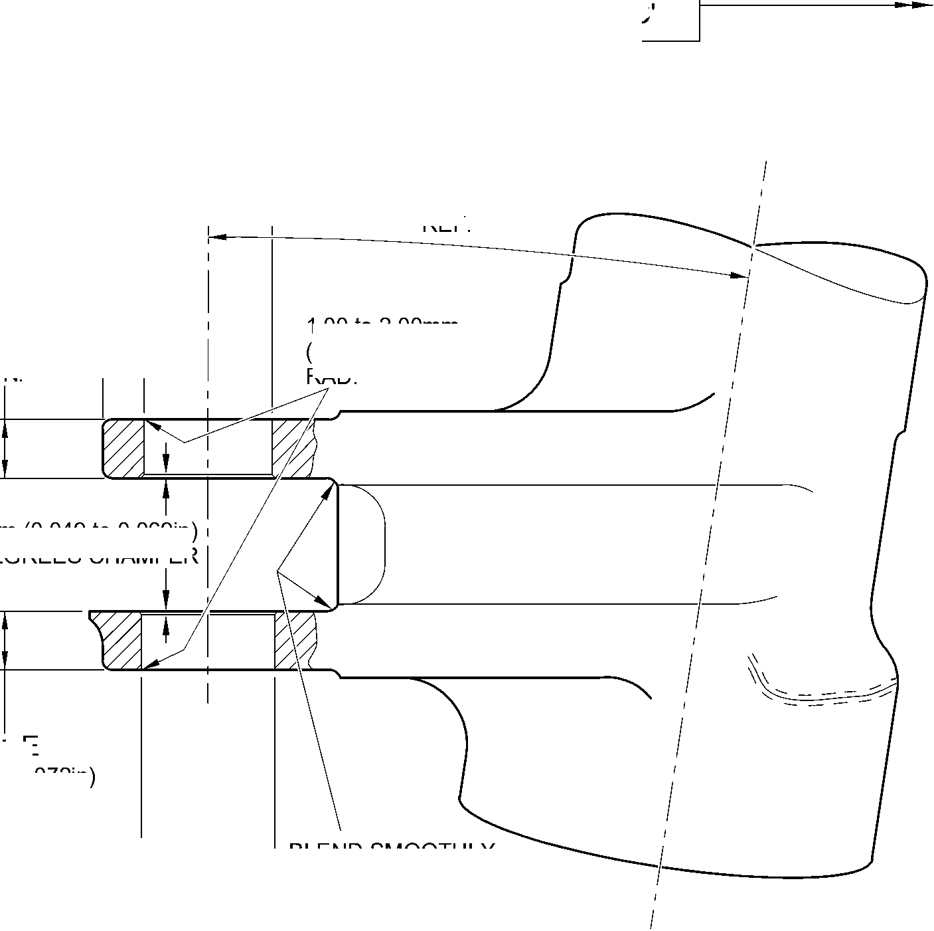

**SAFRAN LANDING SYSTEMS UK Ltd**

CAGE: K0654



PART No. 201587001 AND 201587002 COMPONENT MAINTENANCE MANUAL  
MAIN LANDING GEAR LEG

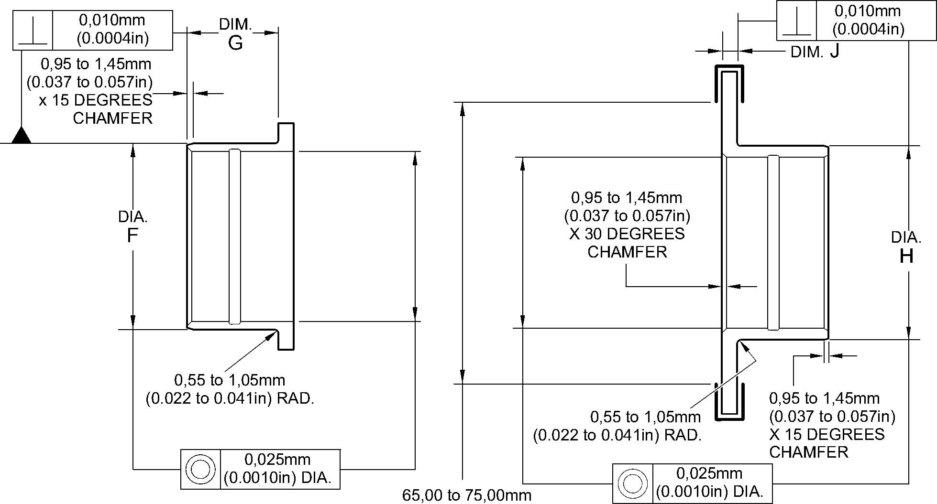

OVERSIZE BUSH 450237810 (2.559 to 2.953in) DIA. OVERSIZE BUSH

(REFER TO TABLE 1)

NITRIDING DEPTH 0,18 to 0,23mm (0.007 to 0.009in), 0,02 to 0,04mm (0.0008 TO  
0.0016in) REMOVAL OVER AREA SHOWN 750HV MIN. ^^^^

**NOTE:** REPAIR BUSHES 450237351, 450237352, 450237353, 450237354 AND 450237355  
ARE TO BE NITRIDED BEFORE DESPATCH TO OVERHAUL AGENCY.

DIAMETER H AND CORNER RADIUS ARE TO BE MACHINED ON RECEIPT

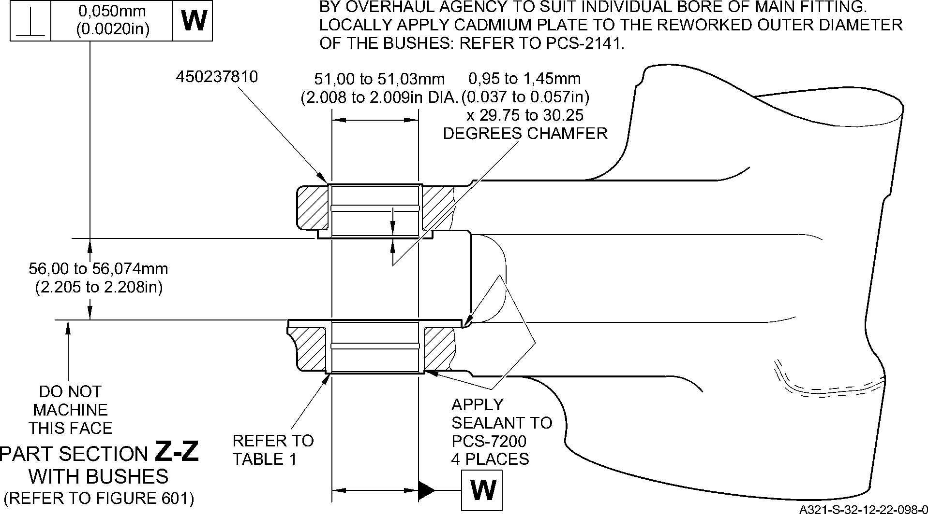

Repair Bushes - Machining and Installation  
Figure 602

Repair No. 11-13

32-12-22

Page 605

Dec 8/2017

**SAFRAN LANDING SYSTEMS UK Ltd**

CAGE: K0654



PART No. 201587001 AND 201587002 COMPONENT MAINTENANCE MANUAL  
MAIN LANDING GEAR LEG

INTENTIONALLY BLANK

Repair No. 11-13

32-12-22 Page 606

**SAFRAN LANDING SYSTEMS UK Ltd**

CAGE: K0654



PART No. 201587001 AND 201587002 COMPONENT MAINTENANCE MANUAL  
MAIN LANDING GEAR LEG

I 1. Repair No. 11-14 Main Fitting (20-410, 20-410A, 20-420 and 20-420A)

1. Specified Damage and Material Specification.
2. Specified Damage

(a) Damage or corrosion to the diameter A and/or adjacent faces B.

1. Material Specification

|  |  |  |
| --- | --- | --- |
| IPL Figure and Item No. | Name | Material Specification |
| 20-410, 20-410A, 20-420 and 20-420A | Main fitting | Steel, MAT135, 35NCD16THQ |

1. Special Tools
2. Special tools are not necessary.
3. Materials
4. These materials are necessary:

**NOTE: Alternative equivalents are permitted.**

|  |  |
| --- | --- |
| Ref. Item | Material |
| TBA | Mastinox, D40 |
| TBA | Zinc Powder |
| 09-510A | Sealant |

1. Repair Parts
2. These repair parts are necessary:

|  |  |  |
| --- | --- | --- |
| Part No. | Repair Part | Material Specification |
| Refer to Table 1 for oversize bearing | | |

1. Procedure (Refer to Figure 601)
2. Machine the diameter A to the smallest oversize shown in Table 1 to remove the  
   damage or corrosion: refer to M-DLPS1004-4-1 and Figure 601. Do not make diameter  
   A more than 167,587 mm (6.598 in). Make the surface finish 1,6 micrometers  
   (63 micro-inches).
3. Machine the face(s) B, sufficiently only to remove the damage or corrosion within the  
   dimensions shown: refer to M-DLPS1004-4-1 and Figure 601. Do not machine more  
   than 0,75 mm (0.0295 in) from each of the faces. Make the surface finish  
   1,6 micrometers (63 micro-inches).
4. Machine the radii and chamfers to the dimensions shown: refer to Figure 601.
5. Examine the main fitting for flaws: refer to PCS-3600 and PCS-3100, inclusion class 4.

Repair No. 11-14

32-12-22

Page 601

Mar 18/2025

**SAFRAN LANDING SYSTEMS UK Ltd**

CAGE: K0654



PART No. 201587001 AND 201587002 COMPONENT MAINTENANCE MANUAL  
MAIN LANDING GEAR LEG

1. Shot peen the machined area: refer to M-DLPS123.
2. Apply cadmium plate locally to the reworked area: refer to PCS-2141.
3. Use the selected spherical bearing assembly in the place of (19-50): refer to  
   ASSEMBL .
4. Identify the part with the Safran Landing Systems repair number 450266110 adjacent to  
   the part number: refer to PCS-6000-07.
5. Examine the part to make sure that you have obeyed all the repair instructions correctly.  
   Table 1

|  |  |  |  |  |
| --- | --- | --- | --- | --- |
| Oversize | Step mm (in) | Diameter A mm (in) | Housing O/D (Ref.) mm (in) | Oversize Bearing Assembly |
| - | Std | 166,000 to 166,063 (6.5354 to 6.5378) | 165,934 to165,959 (6.5328 to 6.5337) | - |
| 1 | 0,127 (.005) | 166,127 to 166,190 (6.5404 to 6.5428) | 166,061 to166,086  (6.5378 to 6.5387) | 450258301 |
| 2 | 0,254 (.010) | 166,254 to 166,317 (6.5454 to 6.5478) | 166,188 to 166,213 (6.5428 to 6.5437) | 450258302 |
| 3 | 0,381 (.015) | 166,381 to 166,444 (6.5504 to 6.5528) | 166,315 to 166,340 (6.5478 to 6.5487) | 450258303 |
| 4 | 0,508 (.020) | 166,508 to 166,571 (6.5554 to 6.5578) | 166,442 to 166,467 (6.5528 to 6.5537) | 450258304 |
| 5 | 0,635 (.025) | 166,635 to 166,698 (6.5604 to 6.5628) | 166,569 to 166,594 (6.5578 to 6.5587) | 450258305 |
| 6 | 0,762 (.030) | 166,762 to 166,825 (6.5654 to 6.5678) | 166,696 to 166,721 (6.5628 to 6.5637) | 450258306 |
| 7 | 0,889 (.035) | 166,889 to 166,952 (6.5704 to 6.5728) | 166,823 to 166,848 (6.5678 to 6.5687) | 450258307 |
| 8 | 1,016 (.040) | 167,016 to 167,079 (6.5754 to 6.5778) | 166,950 to 166,975 (6.5728 to 6.5737) | 450258308 |
| 9 | 1,143 (.045) | 167,143 to 167,206 (6.5804 to 6.5828) | 167,077 to 167,102 (6.5778 to 6.5787) | 450258309 |
| 10 | 1,270 (.050) | 167,270 to 167,333 (6.5854 to 6.5878) | 167,204 to 167,229 (6.5828 to 6.5837) | 450258310 |
| 11 | 1,397 (.055) | 167,397 to 167,460 (6.5904 to 6.5928) | 167,331 to 167,356 (6.5878 to 6.5887) | 450258311 |
| 12 | 1,524 (.060) | 167,524 to 167,587 (6.5954 to 6.5978) | 167,458 to 167,483 (6.5928 to 6.5937) | 450258312 |

32-12-22

Repair No. 11-14

Page 602

Mar 18/2025

**SAFRAN LANDING SYSTEMS UK Ltd**

CAGE: K0654



PART No. 201587001 AND 201587002 COMPONENT MAINTENANCE MANUAL  
MAIN LANDING GEAR LEG

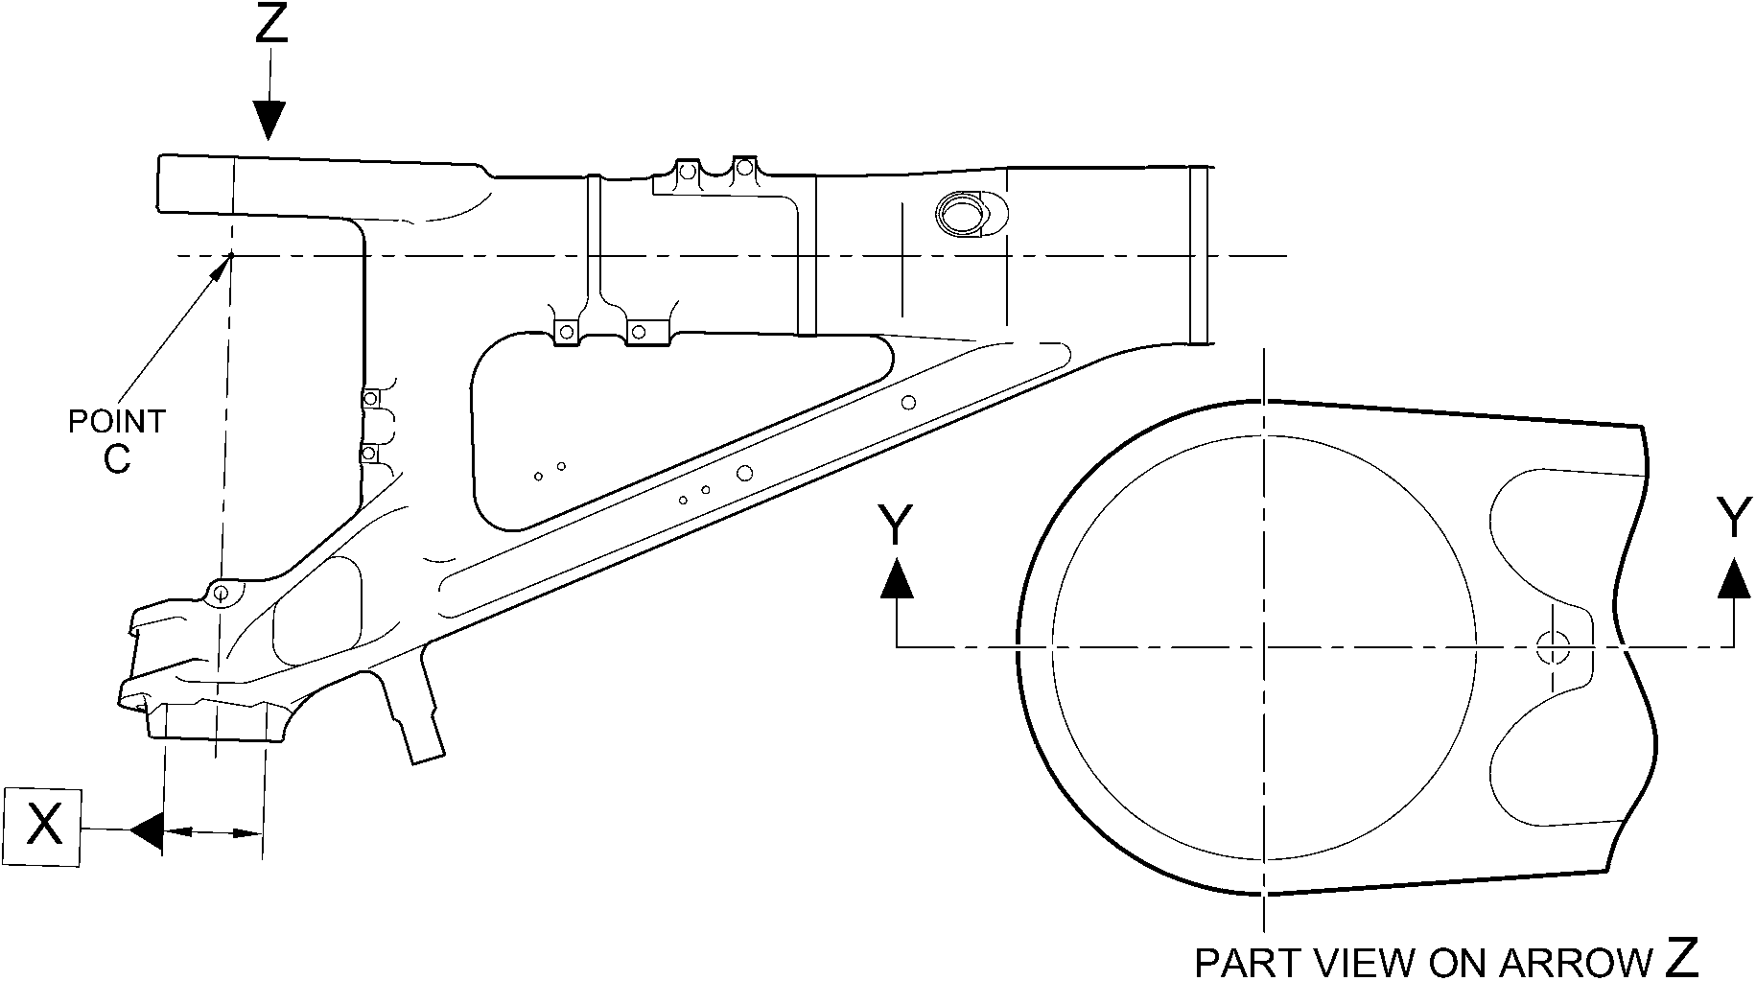

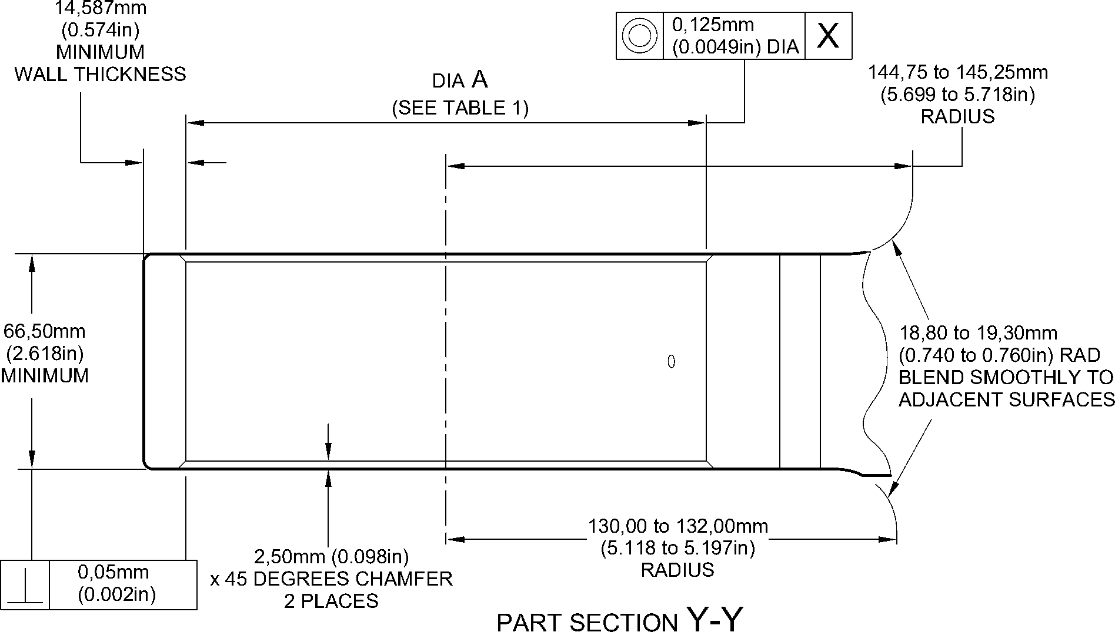

A321A5543-1

(WITHOUT OVERSIZE BEARING)

Repair to Main Fitting - Machining  
Figure 601

Repair No. 11-14

32-12-22

Page 603

Dec 6/2019

**SAFRAN LANDING SYSTEMS UK Ltd**

CAGE: K0654



PART No. 201587001 AND 201587002 COMPONENT MAINTENANCE MANUAL  
MAIN LANDING GEAR LEG

INTENTIONALLY BLANK

Repair No. 11-14

32-12-22 Page 604

**sSAFRAN SAFRAN LANDING SYSTEMS UK Ltd**

CAGE: K0654

PART No. 201587001 AND 201587002 COMPONENT MAINTENANCE MANUAL  
MAIN LANDING GEAR LEG

I 1. Repair No. 11-15 Main Fitting (20-410 and 20-420 Only)

1. Specified Damage and Material Specification.
2. Specified Damage

(a) Damage or corrosion to the diameter(s) A and/or adjacent faces B and/or C.

1. Material Specification

|  |  |  |
| --- | --- | --- |
| IPL Figure and Item No. | Name | Material Specification |
| 20-410 and  20-420 Only | Main fitting | Steel, MAT135, 35NCD16THQ |

1. Special Tools
2. Special tools are not necessary.
3. Materials
4. These materials are necessary:

**NOTE: Alternative equivalents are permitted.**

|  |  |
| --- | --- |
| Ref. Item | Material |
| TBA | Mastinox, D40 |
| TBA | Zinc Powder |
| 08-665 | Adhesive |
| 09-510A | Sealant |

1. Repair Parts
2. These repair parts are necessary:

|  |  |  |
| --- | --- | --- |
| Part No. | Repair Part | Material Specification |
| 450237825 | Repair Bush (Qty 4) | Steel, S154 |

1. Procedure (Refer to Figures 601 to 603).

**CAUTION: REPAIR WILL NOT BE PERMITTED BEYOND THE LIMITS OF THIS REPAIR  
SCHEME.**

**CAUTION: USE THIS PROCEDURE IF THE DAMAGE OR CORROSION TO FACES B  
OR C IS MORE THAN A DEPTH OF 0,75 MM (0.030 IN).**

1. Remove the paint locally from the main fitting: refer to PCS-2700.
2. Remove the cadmium plate locally from the main fitting: refer to PCS-2100.
3. Machine diameter A sufficiently to remove the damage or corrosion: refer to  
   M-DLPS1004-4-1 and Figure 602. Diameter(s) A must be between 9,60 and 10,00 mm  
   (0.378 and 0.394 in). Make the surface finish 1,6 micrometers (63 micro-inches).

Repair No. 11-15

32-12-22

Page 601

Dec 4/2020

**sSAFRAN SAFRAN LANDING SYSTEMS UK Ltd**

CAGE: K0654

PART No. 201587001 AND 201587002 COMPONENT MAINTENANCE MANUAL  
MAIN LANDING GEAR LEG

1. Machine the faces B and/or C sufficiently to remove the damage or corrosion: refer to  
   Figure 602. Do not remove more than 1,0 mm (0.040 in) from each of the faces. Lug  
   width D must not be less than 8,75 mm (0.344 in). Make the surface finish  
   1,6 micrometers (63 micro-inches).
2. Machine the radii as shown: refer to Figure 602.
3. Measure and record the new diameters A.
4. Examine the main fitting for flaws: refer to PCS-3600 and PCS-3100, inclusion class 4.
5. Shot peen the machined areas: refer to M-DLPS123.
6. Apply cadmium plate to the reworked areas: refer to PCS-2100 or PCS-2141.
7. Identify the part with the Messier-Dowty Limited repair number 450267230 adjacent to  
   the part number: refer to PCS-6000-04.
8. Calculate the diameter of each repair bush, use formula:

E = A (as measured) + 0,008 to 0,032 mm (0.0004 to 0.0012 in).

1. Machine the repair bush(es) to the diameter(s) calculated and as shown. Machine the  
   face F to get the correct dimensions after installation: refer to Figure 603.
2. Apply cadmium plate all over the repair bushes: refer to PCS-2101 or PCS-2141. The  
   cadmium plate thickness must be between 0,010 and 0,015 mm (0.0004 and 0.0006 in).
3. Apply primer paint to main fitting, where the bush flanges will touch: refer to PCS-2500.
4. Apply zinc loaded mastinox (made from Mastinox D40, Material Ref. Item TBA and Zinc  
   Powder, Material Ref. Item TBA) to the inner side of bush flanges. Apply adhesive,  
   Material Ref. Item 08-665 to the machined diameter of bushes: refer to PCS-5303.
5. Install the repair bushes: refer to M-DLPS1011-5, M-DLPS1011-20 and Figure 603.
6. If necessary, machine the bush flange faces and bores to get the dimensions as shown:  
   refer to Figure 603.
7. If necessary, apply cadmium plate to the reworked area of repair bushes: refer to  
   PCS-2141.
8. Apply sealant Material Ref. Item 09-510A to the joints between the repair bushes and  
   the main fitting: refer to PCS-7200.
9. Apply paint to the repaired area: refer to REPAIR and PCS-2500.
10. Identify the part with the Messier-Dowty Limited repair number 450267230 adjacent to  
    the part number: refer to PCS-6000-07.
11. Examine the part to make sure that you have obeyed all the repair instructions correctly.

32-12-22

Repair No. 11-15

Page 602

Dec 6/2019

**SAFRAN LANDING SYSTEMS UK Ltd**

CAGE: K0654



PART No. 201587001 AND 201587002 COMPONENT MAINTENANCE MANUAL  
MAIN LANDING GEAR LEG

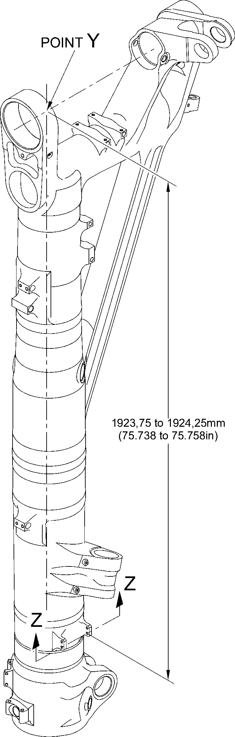

A321A5549-1

Repair to Main Fitting  
Figure 601

Repair No. 11-15

32-12-22

Page 603

Dec 6/2019

**SAFRAN LANDING SYSTEMS UK Ltd**

CAGE: K0654



PART No. 201587001 AND 201587002 COMPONENT MAINTENANCE MANUAL  
MAIN LANDING GEAR LEG

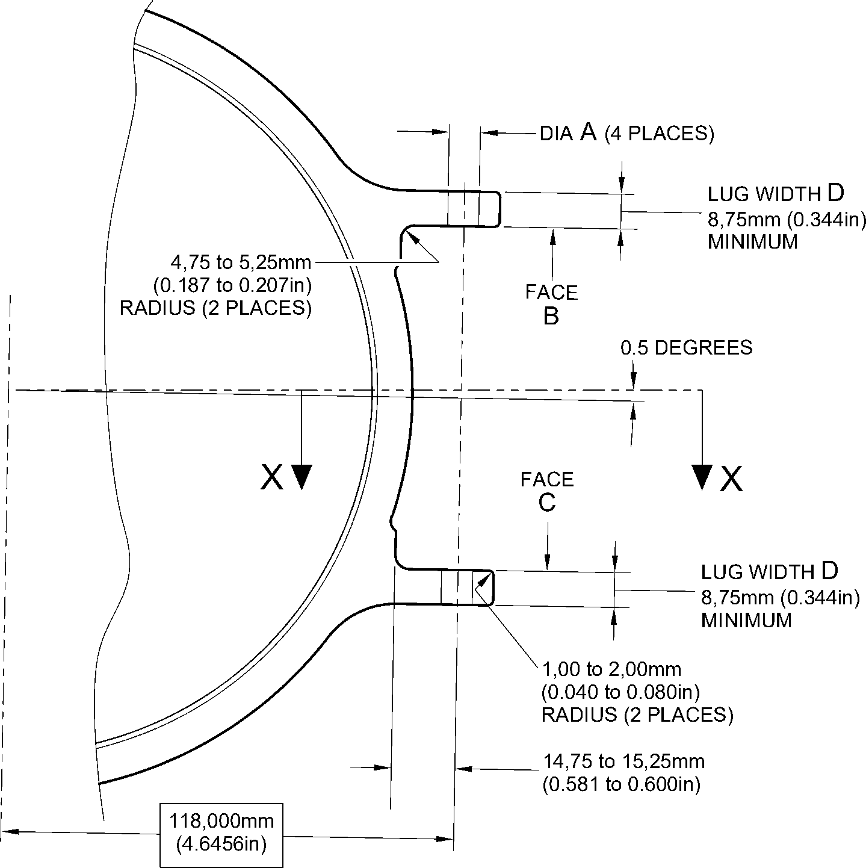

section Z-Z

(WITHOUT BUSHES)

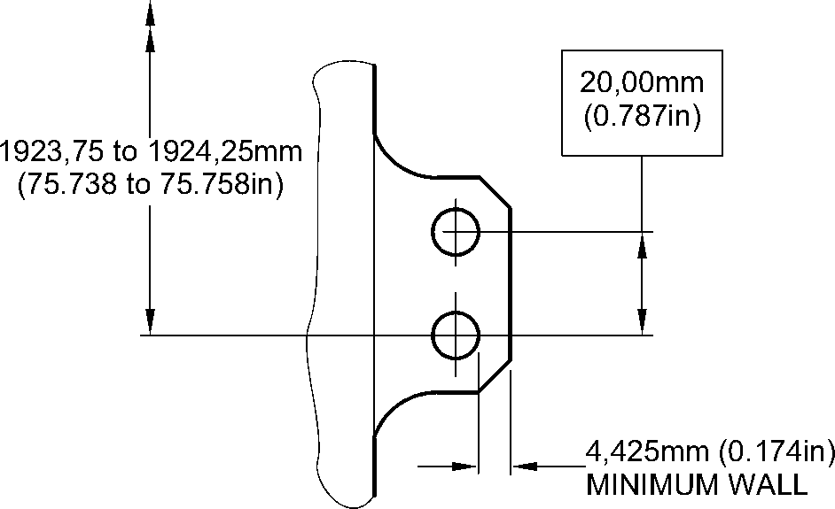

section X-X

(WITHOUT BUSHES)

A321A5550-2

Repair to Main Fitting - Machining  
Figure 602

32-12-22

Repair No. 11-15

Page 604

Dec 6/2019

**SAFRAN LANDING SYSTEMS UK Ltd**

CAGE: K0654



PART No. 201587001 AND 201587002 COMPONENT MAINTENANCE MANUAL  
MAIN LANDING GEAR LEG

0,25 to 0,75mm  
(0.010 to 0.030in)

RADIUS



i 1,00mm(0.040in)

X 15 DEGREES  
t CHAMFER

faCe F

dia E

REPAIR BUSH 450237825

0,030mm  
(0.012in)

REPAIR BUSH  
450237825  
(4 PLACES)

8,00 to 8,15mm (0.315 to 0.321in)  
DIAMETER

M-DLPS1011-5 and

M-DLPS709-6  
(4 PLACES)

M-DLPS1011-20

(4 PLACES)

1,00 to 2,00mm  
(0.040 to 0.080in)

RADIUS  
(8 PLACES)

section Z-Z

(WITH BUSHES)

9,75 to 10,25mm  
(0.384 to 0.404in)

102,00 to 102,127mm  
(4.016 to 4.021in)

9,75 to 10,25mm  
(0.384 to 0.404in)

FLANGES OF REPAIR  
BUSHES MAY BE  
LOCALLY REMOVED  
IF NECESSARY

section X-X  
(WITH BUSHES)

A321A5551-1

Repair Bush - Machining and Installation  
Figure 603

Repair No. 11-15

32-12-22

Page 605

Dec 6/2019

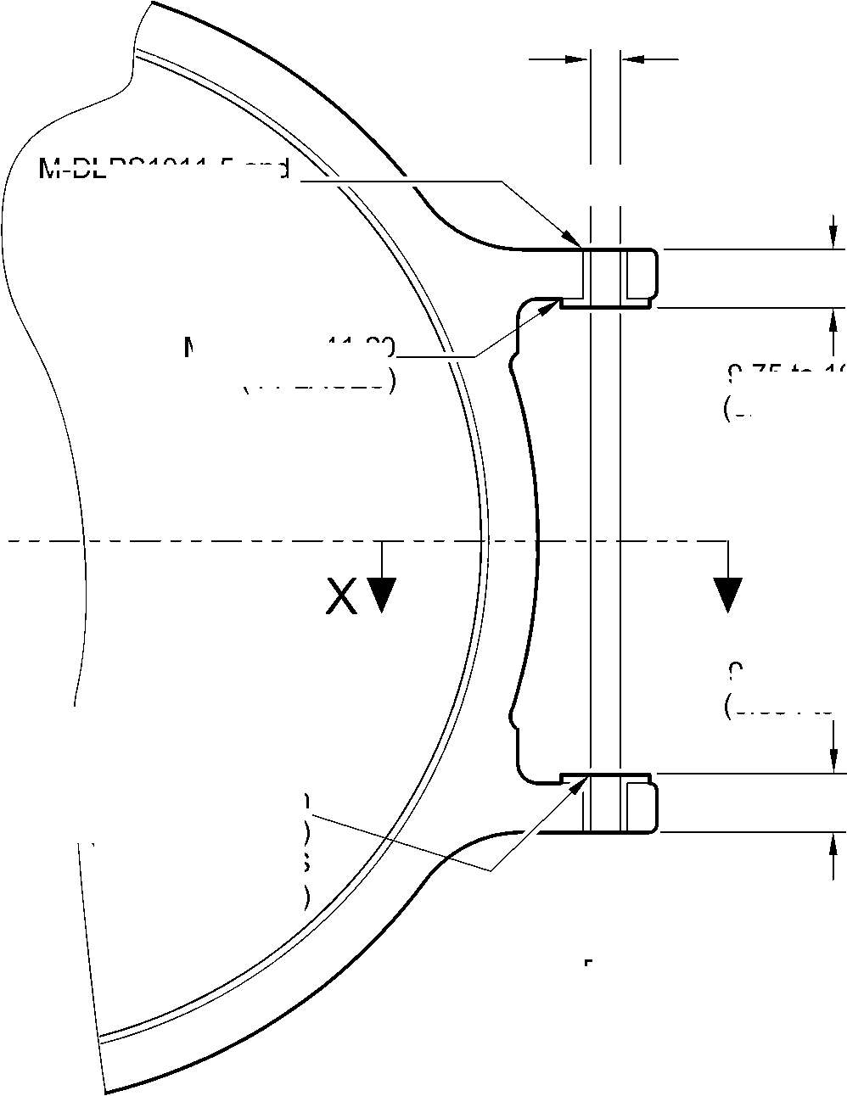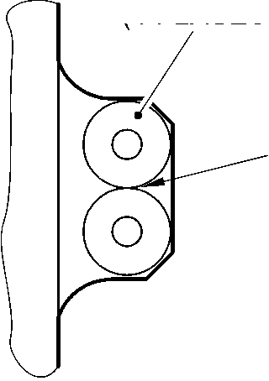

**SAFRAN LANDING SYSTEMS UK Ltd**

CAGE: K0654



PART No. 201587001 AND 201587002 COMPONENT MAINTENANCE MANUAL  
MAIN LANDING GEAR LEG

INTENTIONALLY BLANK

Repair No. 11-15

32-12-22 Page 606

**SAFRAN LANDING SYSTEMS UK Ltd**

CAGE: K0654



PART No. 201587001 AND 201587002 COMPONENT MAINTENANCE MANUAL  
MAIN LANDING GEAR LEG

I 1. Repair No. 11-16 Main Fitting (20-410 and 20-420 Only)

1. Specified Damage and Material Specification.
2. Specified Damage

(a) Damage or corrosion to the chromium plate on diameter A and/or diameter B.

1. Material Specification

|  |  |  |
| --- | --- | --- |
| IPL Figure and Item No. | Name | Material Specification |
| 20-410 and  20-420 Only | Main fitting | Steel, MAT135, 35NCD16THQ |

1. Special Tools
2. Special tools are not necessary.
3. Materials
4. Materials are not necessary.
5. Repair Parts
6. Repair parts are not necessary.
7. Procedure (Refer to Figure 601)

**CAUTION: REPAIR WILL NOT BE PERMITTED BEYOND THE LIMITS OF THIS REPAIR  
SCHEME.**

1. Chemically remove the chromium plate from diameters A and/or B: refer to PCS-2110  
   and Figure 601.
2. Examine the base metal for damage or corrosion:
3. If there is no damage or corrosion to the base metal proceed with the repair.
4. If there is damage or corrosion to the base metal, use another applicable repair or  
   apply for a concession.

**CAUTION: DO NOT USE A MECHANICAL MOP POLISHER TO GET THE SURFACE  
FINISH.**

**CAUTION: DO NOT USE HARD CHROMIUM PLATING TO DIAMETERS A AND B.**

(3)

(4)

(5)

(6)

Apply flash chromium plate to diameters A and/or B to a thickness of between 0,0075  
and 0,0125 mm (0.0003 and 0.0005 in): refer to PCS-2110, type C. The new diameters  
must be:

Diameter A = 212,000 to 212,072 mm (8.3465 to 8.3493 in) with a surface finish of  
1,6 micrometers (64 micro-inches)

Diameter B = 208,890 to 208,966 mm (8.2240 to 8.2270 in) with a surface finish of  
0,8 micrometers (32 micro-inches).

Examine the reworked area for flaws: refer to PCS-3100, inclusion class 4.

Identify the part with the Messier-Dowty Limited repair number 450237690 adjacent to  
the part number: refer to PCS-6000-04.

Examine the part to make sure that you have obeyed all the repair instructions correctly.

Repair No. 11-16

32-12-22

Page 601

Dec 4/2020

**SAFRAN LANDING SYSTEMS UK Ltd**

CAGE: K0654



PART No. 201587001 AND 201587002 COMPONENT MAINTENANCE MANUAL  
MAIN LANDING GEAR LEG

Z

Z

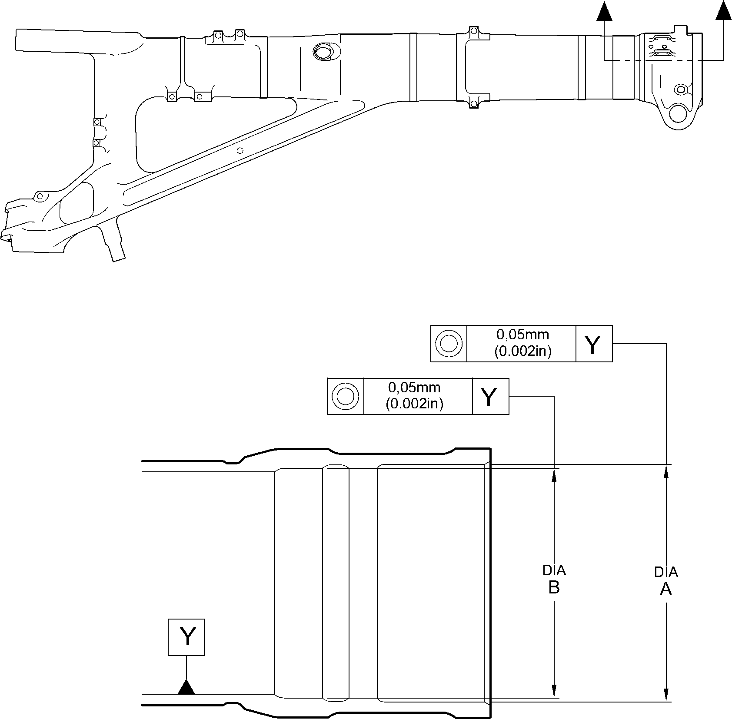

section Z-Z

A321A5695-1

Repair to Main Fitting  
Figure 601

32-12-22

Repair No. 11-16

Page 602

Dec 6/2019

**sSAFRAN SAFRAN LANDING SYSTEMS UK Ltd**

CAGE: K0654

PART No. 201587001 AND 201587002 COMPONENT MAINTENANCE MANUAL  
MAIN LANDING GEAR LEG

I 1. Repair No. 11-17 Main Fitting (20-410, 20-410A, 20-420 and 20-420A)

1. Specified Damage and Material Specification.
2. Specified Damage

(a) Damage or corrosion to the chromium plate on diameter A.

1. Material Specification

|  |  |  |
| --- | --- | --- |
| IPL Figure and Item No. | Name | Material Specification |
| 20-410, 20-410A, 20-420 and 20-420A | Main fitting | Steel, MAT135, 35NCD16THQ |

1. Special Tools
2. Special tools are not necessary.
3. Materials
4. Materials are not necessary.
5. Repair Parts
6. Repair parts are not necessary.
7. Procedure (Refer to Figure 601)
8. Chemically remove the chromium plate from diameter A: refer to PCS-2110 and  
   Figure 601.
9. Examine the base metal for damage or corrosion:
10. If there is no damage or corrosion to the base metal proceed with the repair.
11. If there is damage or corrosion to the base metal, use another applicable repair or  
    apply for a concession.

**CAUTION: DO NOT USE A MECHANICAL MOP POLISHER TO GET THE SURFACE  
FINISH.**

**CAUTION: HARD CHROMIUM PLATE MUST NOT BE USED ON THIS DIAMETER.**

1. Apply flash chromium plate to diameter A as shown: refer to PCS-2110, type C and  
   Figure 601. The chromium plate thickness must be between 0,0075 and 0,0120 mm  
   (0.0003 and 0.0005 in). Make the surface finish 0,8 micrometers (32 micro-inches).  
   Make the surface finish on the chamfer 1,6 micrometers (63 micro-inches).
2. Examine the reworked area for flaws: refer to PCS-3100, inclusion class 4.
3. Identify the part with the Safran Landing Systems repair number 450237695 adjacent to  
   the part number: refer to PCS-6000-04.
4. Examine the part to make sure that you have obeyed all the repair instructions correctly.

Repair No. 11-17

32-12-22

Page 601

Mar 18/2025

**SAFRAN LANDING SYSTEMS UK Ltd**

CAGE: K0654



PART No. 201587001 AND 201587002 COMPONENT MAINTENANCE MANUAL  
MAIN LANDING GEAR LEG

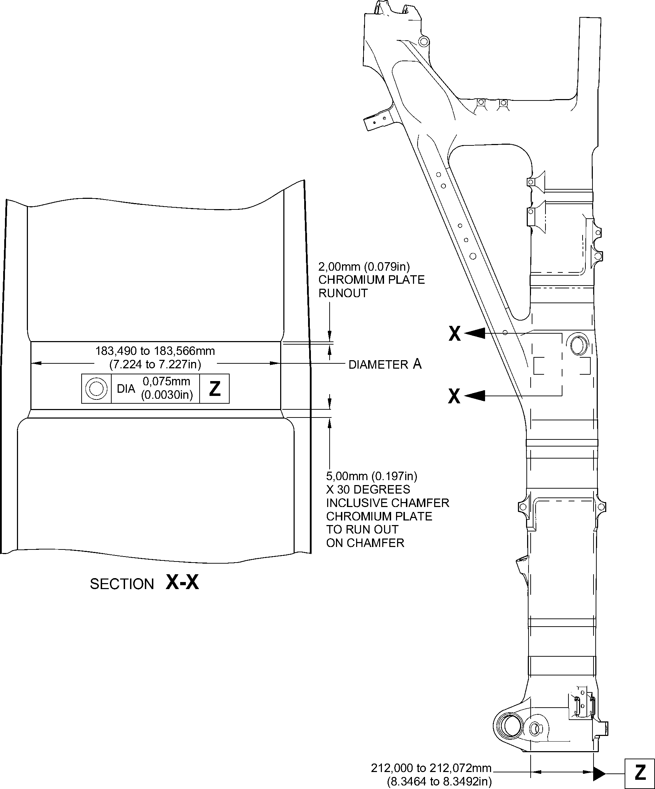

DIAMETER REF.

A321A5708-2

Repair to Main Fitting  
Figure 601

32-12-22

Repair No. 11-17

Page 602

May 31/2019

**sSAFRAN SAFRAN LANDING SYSTEMS UK Ltd**

CAGE: K0654

PART No. 201587001 AND 201587002 COMPONENT MAINTENANCE MANUAL  
MAIN LANDING GEAR LEG

I 1. Repair No. 11-18 Main Fitting (20-410, 20-410A, 20-420 and 20-420A)

1. Specified Damage and Material Specification.
2. Specified Damage

(a) Damage or wear to diameter A.

1. Material Specification

|  |  |  |
| --- | --- | --- |
| IPL Figure and Item No. | Name | Material Specification |
| 20-410, 20-410A, 20-420 and 20-420A | Main fitting | Steel, MAT135, 35NCD16THQ |

1. Special Tools
2. These special tools are necessary:

**NOTE: Alternative equivalents are permitted.**

|  |  |  |
| --- | --- | --- |
| Part No. | Special Tool | Function |
| 460006267 | Press Pad Assembly | Install the repair bearing |

1. Materials
2. These materials are necessary:

**NOTE: Alternative equivalents are permitted.**

|  |  |
| --- | --- |
| Ref. Item | Material |
| 09-510A | Sealant |

1. Repair Parts
2. These repair parts are necessary:

|  |  |  |
| --- | --- | --- |
| Part No. | Repair Part | Material Specification |
| - | Repair bearing | Aluminium Bronze, DTD197 |

1. Procedure (Refer to Figures 601 and 602)
2. Machine diameter A sufficiently to remove the damage or wear within the dimensions  
   shown: refer to M-DLPS1004-4-1 and Figure 601. Make the surface finish  
   1,6 micrometers (63 micro-inches).
3. Machine the radius to the dimensions shown: refer to Figure 601.
4. Measure and record the new diameter A.
5. Examine the machined area for flaws: refer to PCS-3600 and PCS-3100, inclusion  
   class 4.

Repair No. 11-18

32-12-22

Page 601

Mar 18/2025

**sSAFRAN SAFRAN LANDING SYSTEMS UK Ltd**

CAGE: K0654

PART No. 201587001 AND 201587002 COMPONENT MAINTENANCE MANUAL  
MAIN LANDING GEAR LEG

1. Apply cadmium plate to the reworked area: refer to PCS-2100 or PCS-2141.
2. Identify the part with the Messier-Dowty Limited repair number 450217235 adjacent to  
   the part number: refer to PCS-6000-04.
3. Calculate the diameter B for the repair bearing, use the formula:

B = A (as measured) + 0,0020 to 0,0480 mm (0.00008 to 0.00190 in).

1. Machine the repair bearing to the dimensions shown and calculated: refer to Figure 602.  
   Make the surface finish 3,2 micrometers (125 micro-inches).
2. Examine the repair bearing for flaws: refer to PCS-3200.
3. Apply cadmium plate all over the repair bearing: refer to M-DLPS100-1. The cadmium  
   plate thickness must be between 0,010 and 0,015 mm (0.0004 and 0.0006 in).
4. Use press pad assembly 460006267 and install the repair bearing: refer to  
   M-DLPS1011-14. The bearing must be flush or up to 0,250 mm (0.010 in) below the  
   surface of main fitting.
5. Apply sealant, Material Ref. Item 09-510A, to the joints between the repair bearing and  
   the main fitting: refer to PCS-7200 and Figure 602.
6. Identify the part with the Messier-Dowty Limited repair number 450217235 adjacent to  
   the part number: refer to PCS-6000-07.
7. Examine the part to make sure that you have obeyed all the repair instructions correctly.

32-12-22

Repair No. 11-18

Page 602

Mar 18/2025

**SAFRAN LANDING SYSTEMS UK Ltd**

CAGE: K0654



PART No. 201587001 AND 201587002 COMPONENT MAINTENANCE MANUAL  
MAIN LANDING GEAR LEG

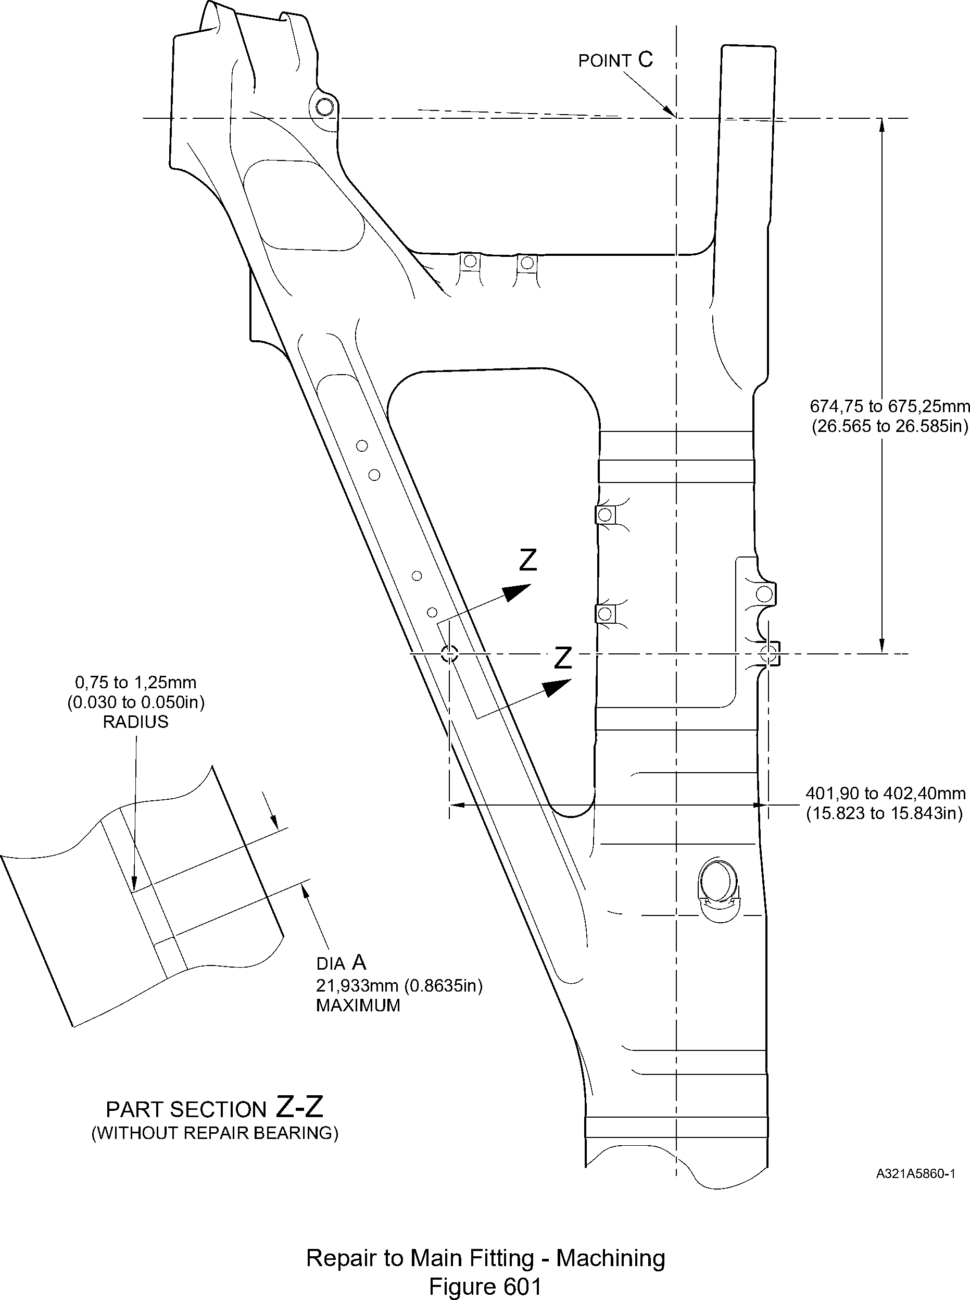

Repair No. 11-18

32-12-22

Page 603

Dec 6/2019

**SAFRAN LANDING SYSTEMS UK Ltd**

CAGE: K0654



PART No. 201587001 AND 201587002 COMPONENT MAINTENANCE MANUAL  
MAIN LANDING GEAR LEG

0,95 to 1,45mm

(0.037 to 0.057in)  
x 15DEGREES

7,75 to 8,25mm CHAMFER

(0.305 to 0.325in) (2 PLACES)

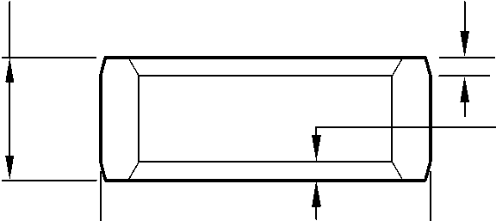

0,95 to 1,45mm  
(0.037 to 0.057in)  
x 30 DEGREES  
CHAMFER

(2 PLACES)

DIA  
B

REPAIR BEARING

APPLY SEALANT  
TO PCS-7200

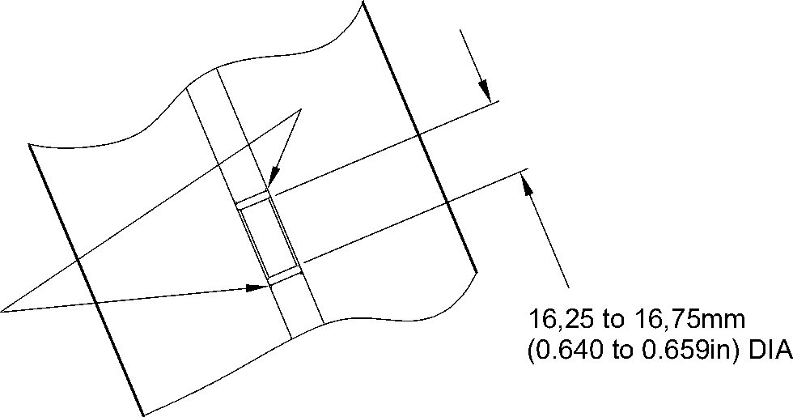

part section Z-Z  
(WITH REPAIR BEARING)

A321A5991-1

Repair Bearing - Machining and Installation  
Figure 602

32-12-22

Repair No. 11-18

Page 604

Dec 6/2019

**sSAFRAN SAFRAN LANDING SYSTEMS UK Ltd**

CAGE: K0654

PART No. 201587001 AND 201587002 COMPONENT MAINTENANCE MANUAL  
MAIN LANDING GEAR LEG

I 1. Repair No. 11-19 Main Fitting (20-410, 20-410A, 20-420 and 20-420A)

1. Specified Damage and Material Specification.
2. Specified Damage

(a) Damage or wear to diameter(s) A.

1. Material Specification

|  |  |  |
| --- | --- | --- |
| IPL Figure and Item No. | Name | Material Specification |
| 20-410, 20-410A, 20-420 and 20-420A | Main fitting | Steel, MAT135, 35NCD16THQ |

1. Special Tools
2. These special tools are necessary:

**NOTE: Alternative equivalents are permitted.**

|  |  |  |
| --- | --- | --- |
| Tool Part No. | Special Tool | Function |
| 460004330/110 | Press Pad | Install the repair bushes |
| 460004331/2 | Drift |

1. Materials
2. These materials are necessary:

**NOTE: Alternative equivalents are permitted.**

|  |  |
| --- | --- |
| Ref. Item | Material |
| TBA | Zinc powder |
| 05-533 | Mastinox, D40 |
| 09-510A | Sealant |

1. Repair Parts
2. These repair parts are necessary:

|  |  |  |
| --- | --- | --- |
| Part No. | Repair Part | Material Specification |
| 450237819 | Repair bush (Qty 2) | Aluminium Bronze, DTD197 |

1. Procedure (Refer to Figures 601 and 602)
2. Machine diameter(s) A sufficiently to remove the damage or wear within the dimensions  
   shown: refer to M-DLPS1004-4-1 and Figure 602. Make the surface finish  
   3,2 micrometers (125 micro-inches).
3. Machine the radii to the dimensions shown: refer to Figure 602.

Repair No. 11-19

32-12-22

Page 601

Mar 18/2025

**sSAFRAN SAFRAN LANDING SYSTEMS UK Ltd**

CAGE: K0654

PART No. 201587001 AND 201587002 COMPONENT MAINTENANCE MANUAL  
MAIN LANDING GEAR LEG

1. Measure and record the new diameter(s) A.
2. Examine the machined area for flaws: refer to PCS-3600 and PCS-3100, inclusion  
   class 4.
3. Shot peen the machined areas: refer to M-DLPS123.
4. Identify the part with the Messier-Dowty Limited repair number 450258210 adjacent to  
   the part number: refer to PCS-6000-05.
5. Apply cadmium plate to the reworked areas: refer to PCS-2141.
6. Apply primer paint to the reworked areas: refer to PCS-2500.
7. Calculate the diameter B for the repair bush(es) (qty 2), use the formula:  
   B = A (as measured) - 0,009 mm (0.0004 in) to + 0,029 mm (0.0011 in).
8. Machine the repair bush(es) to the dimensions shown and calculated: refer to  
   Figure 602. Make the surface finish 1,6 micrometers (63 micro-inches).
9. Apply cadmium plate all over the repair bush(es): refer to M-DLPS100-1. The cadmium  
   plate thickness must be between 0,010 and 0,015 mm (0.0004 and 0.0006 in).
10. Use the Press Pad 460004330/110 and Drift 460004331/2 and install the repair  
    bush(es): refer to M-DLPS1011-20. Use electrically conducting Mastinox (made from  
    Mastinox D40, Material Ref. Item 05-533 and Zinc powder, Material Ref. Item TBA):  
    refer to M-DLPS709-14.
11. Apply sealant, Material Ref. Item 09-510A, to the joints between the repair bush(es) and  
    the main fitting: refer to PCS-7200 and Figure 602.
12. Identify the part with the Messier-Dowty Limited repair number 450258210 adjacent to  
    the part number: refer to PCS-6000-07.
13. Examine the part to make sure that you have obeyed all the repair instructions correctly.

32-12-22

Repair No. 11-19

Page 602

Mar 18/2025

**SAFRAN LANDING SYSTEMS UK Ltd**

CAGE: K0654



PART No. 201587001 AND 201587002 COMPONENT MAINTENANCE MANUAL  
MAIN LANDING GEAR LEG

point C

327,47 to 327,97mm  
(12.893 to 12.912in)

Z

A321A5861-1

19,425mm  
(0.7648in) CRS  
(REF)

576,75 to 577,25mm  
(22.707 to 22.726in)

Z refer to figure 602

46,07mm  
(1.814in)

(REF)

Repair to Main Fitting - Machining  
Figure 601

Repair No. 11-19

32-12-22

Page 603

Dec 6/2019

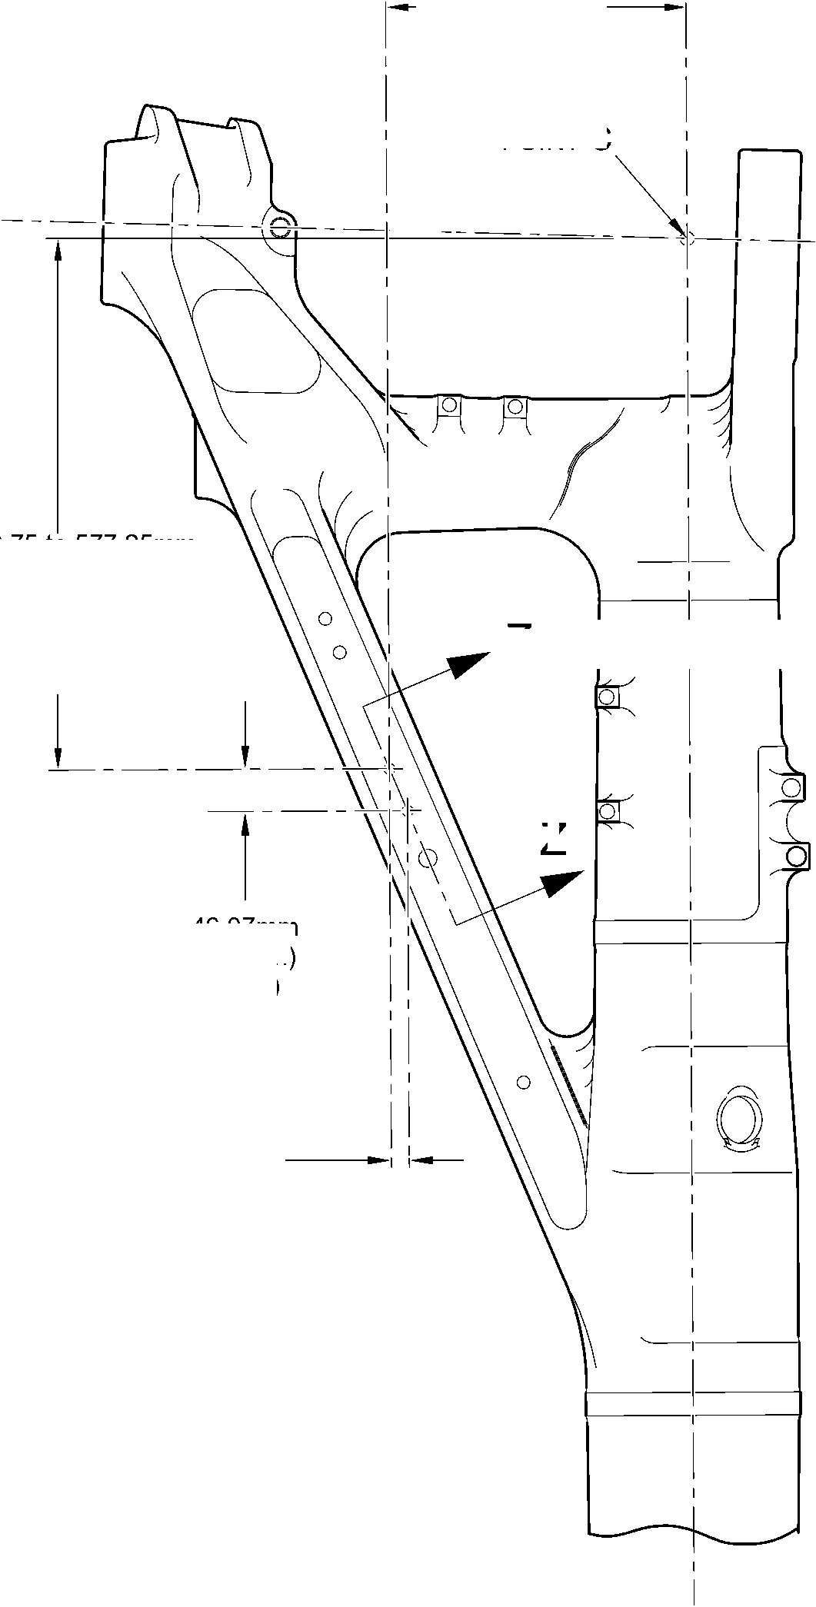

**SAFRAN LANDING SYSTEMS UK Ltd**

CAGE: K0654



PART No. 201587001 AND 201587002 COMPONENT MAINTENANCE MANUAL  
MAIN LANDING GEAR LEG

diameter A

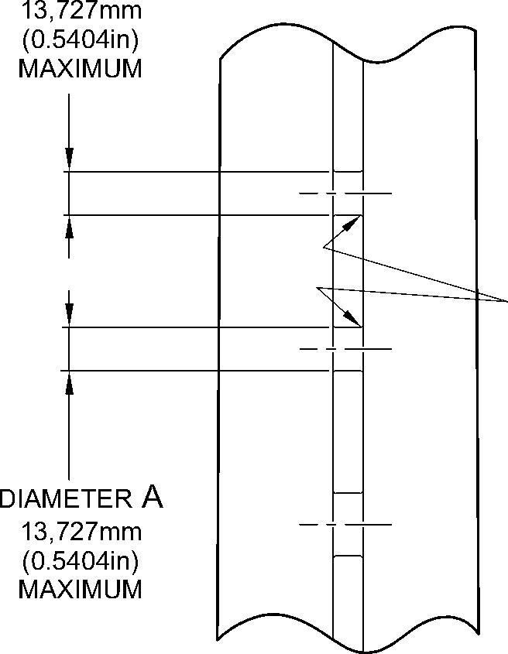

part section Z-Z

REFER TO FIGURE 601  
(WITHOUT REPAIR BUSHES)

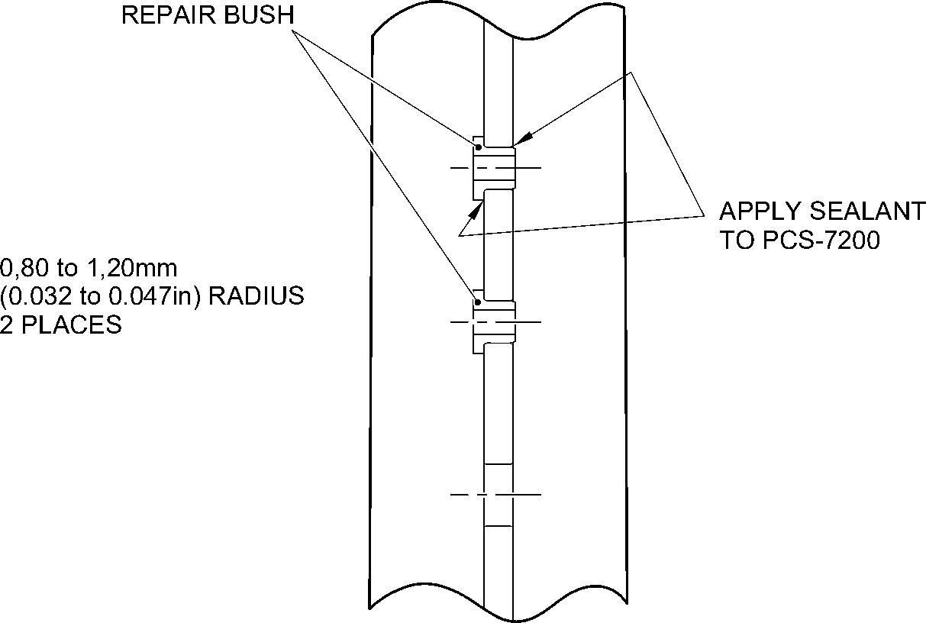

part section Z-Z  
REFER TO FIGURE 601  
(WITH REPAIR BUSHES)

8,25 to 8,75mm  
(0.325 to 0.344in)  
(REF)

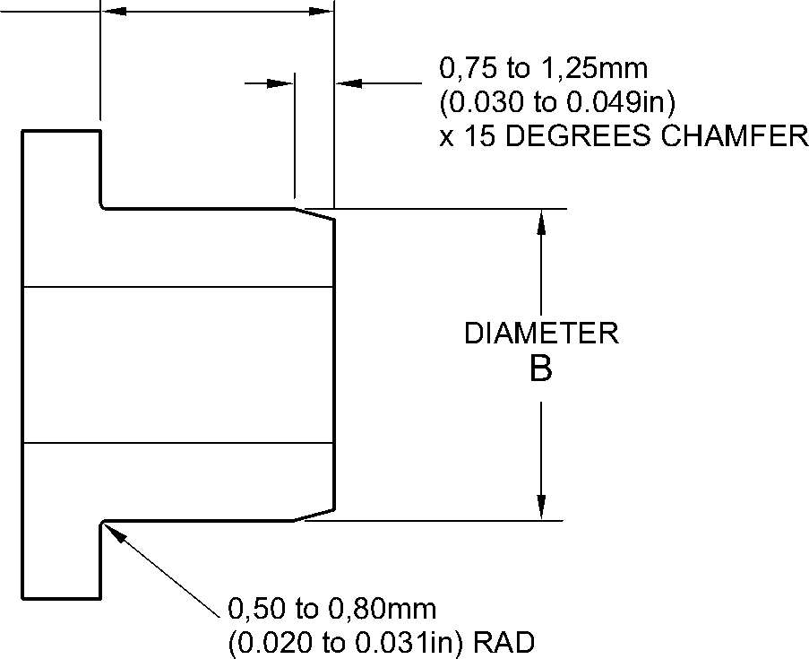

REPAIR BUSH

A321A5992-1

Repair Bushes - Machining and Installation  
Figure 602

32-12-22

Repair No. 11-19

Page 604

Dec 6/2019

**SAFRAN LANDING SYSTEMS UK Ltd**

CAGE: K0654

PART No. 201587001 AND 201587002 COMPONENT MAINTENANCE MANUAL

MAIN LANDING GEAR LEG

1. Repair No. 11-20 Main Fitting (20-410 and 20-420 Only)

A. This Repair, Safran Landing Systems Repair No. 450265100, has been withdrawn from use.

Repair No. 11-20

32-12-22

Page 601

Mar 18/2025

**SAFRAN LANDING SYSTEMS UK Ltd**

CAGE: K0654



PART No. 201587001 AND 201587002 COMPONENT MAINTENANCE MANUAL  
MAIN LANDING GEAR LEG

INTENTIONALLY BLANK

Repair No. 11-20

32-12-22 Page 602

**sSAFRAN SAFRAN LANDING SYSTEMS UK Ltd**

CAGE: K0654

PART No. 201587001 AND 201587002 COMPONENT MAINTENANCE MANUAL  
MAIN LANDING GEAR LEG

I 1. Repair No. 11-21 Main Fitting (20-410, 20-410A, 20-420 and 20-420A)

1. Specified Damage and Material Specification.
2. Specified Damage

(a) Damage or wear to diameters A and/or B and/or adjacent spotfaces.

1. Material Specification

|  |  |  |
| --- | --- | --- |
| IPL Figure and Item No. | Name | Material Specification |
| 20-410, 20-410A, 20-420 and 20-420A | Main fitting | Steel, MAT135, 35NCD16THQ |

1. Special Tools
2. These special tools are necessary:

**NOTE: Alternative equivalents are permitted.**

|  |  |  |
| --- | --- | --- |
| Part No. | Special Tool | Function |
| 460004330/257 | Press Pad | Install the oversize bearing 450258809 |
| 460004330/258 | Press Pad | Install the oversize bearing 450258810 |

1. Materials
2. These materials are necessary:

**NOTE: Alternative equivalents are permitted.**

|  |  |
| --- | --- |
| Ref. Item | Material |
| 09-510A | Sealant |

1. Repair Parts
2. These repair parts are necessary:

|  |  |  |
| --- | --- | --- |
| Part No. | Repair Part | Material Specification |
| 450258809 | Oversize bearing | Aluminium Bronze, DTD197 |
| 450258810 | Oversize bearing | Aluminium Bronze, DTD197 |

1. Procedure (Refer to Figures 601 and 602)
2. Machine diameter(s) A and/or B sufficiently to remove damage or wear within the  
   dimensions shown: refer to M-DLPS1004-4-1, M-DLPS914 and Figure 601. Make the  
   surface finish 1,6 micrometers (63 micro-inches).

Repair No. 11-21

32-12-22

Page 601

Mar 18/2025

**sSAFRAN SAFRAN LANDING SYSTEMS UK Ltd**

CAGE: K0654

PART No. 201587001 AND 201587002 COMPONENT MAINTENANCE MANUAL  
MAIN LANDING GEAR LEG

1. Machine the adjacent spotfaces, sufficiently to remove the damage or wear within the  
   dimensions shown: refer to M-DLPS1004-4-1, M-DLPS914 and Figure 601. Do not  
   machine below the minimum dimensions C and D. Make the surface finish 1,6  
   micrometers (63 micro-inches).
2. Machine the chamfers and radii as shown: refer to Figure 601.
3. Measure and record the new diameters A and B and dimensions C and D.
4. Examine the machined areas for flaws: refer to PCS-3600 and PCS-3100, inclusion  
   class 4.
5. Shot peen the machined areas: refer to M-DLPS123.
6. Apply cadmium plate to the machined areas: refer to PCS-2141.
7. Identify the part with the Messier-Dowty Limited repair number 450258230 adjacent to  
   the part number: refer to PCS-6000-05.
8. Calculate the dimensions of the oversize bearing 450258809, use formulae:  
   E = A (as measured) - 0,006 (0.0002 in) to + 0,028 mm (0.0011 in).

F = C (as measured) - 57,25 to 57,75 mm (2.254 to 2.273 in).

1. Calculate the dimensions of the oversize bearing 450258810, use formulae:

G = B (as measured) - 0,006 (0.0002 in) to + 0,028 mm (0.0011 in).

H = C (as measured) - 57,25 to 57,75 mm (2.254 to 2.273 in).

1. Machine the oversize bearings to the dimensions shown and calculated: refer to  
   Figure 601. Make the surface finish 1,6 micrometers (63 micro-inches).
2. Apply cadmium plate to the oversize bearings all over, but not to the bores: refer to  
   M-DLPS100-1. The cadmium plate thickness must be between 0,010 and 0,015 mm  
   (0.0004 and 0.0006 in).
3. Use the Press Pad 460004330/257 and install the oversize bearing 450258809 to  
   diameter A: refer to M-DLPS1011-20.
4. Use the Press Pad 460004330/258 and install the oversize bearing 450258810 to  
   diameter B: refer to M-DLPS1011-20.
5. Check the bores of oversize bearings to the dimensions shown: refer to Figure 602.
6. Apply sealant, Material Ref. Item 09-510A, to the joints between the oversize bearings  
   and main fitting: refer to PCS-7200 and Figure 602.
7. Apply paint to the reworked areas: refer to REPAIR.
8. Identify the part with the Messier-Dowty Limited repair number 450258230 adjacent to  
   the part number: refer to PCS-6000-07.
9. Examine the part to make sure that you have obeyed all the repair instructions correctly.

32-12-22

Repair No. 11-21

Page 602

Dec 6/2019

**SAFRAN LANDING SYSTEMS UK Ltd**

CAGE: K0654



PART No. 201587001 AND 201587002 COMPONENT MAINTENANCE MANUAL  
MAIN LANDING GEAR LEG

10,75 to 11,25mm  
(0.423 to 0.443in)

Z

5,00 to 6,00mm (0.197 to 0.236in)  
SPOTFACE CORNER RADIUS (TYP)

30,75 to 31,25mm  
(1.211 to 1.230in)

RADIUS

192,75 to 193,25mm  
(7.589 to 7.608in)

2,00 to 3,00mm (0.079 to 0.118in)  
REMOVE SHARP EDGES  
RADIUS (TYP)

Y

dia A 20,721mm (0.8157in) maximum

dim. C  
69,50mm  
(2.736in)  
MINIMUM

1,25 to 1,75mm (0.049 to 0.069in)

x 44.5 to 45.5 DEGREES  
CHAMFER 2 PLACES

dim. D  
139,25mm  
(5.482in)  
MINIMUM  
ACROSS SPOTFACES

dia B

20,721mm (0.8157in)  
MAXIMUM



0,05mm  
(0.002in) DIA

Y

section Z-Z



0,05mm

(0.002in) DIA

Y

A321A6383-1

Repair to Main Fitting - Machining  
Figure 601

Repair No. 11-21

32-12-22

Page 603

Dec 6/2019

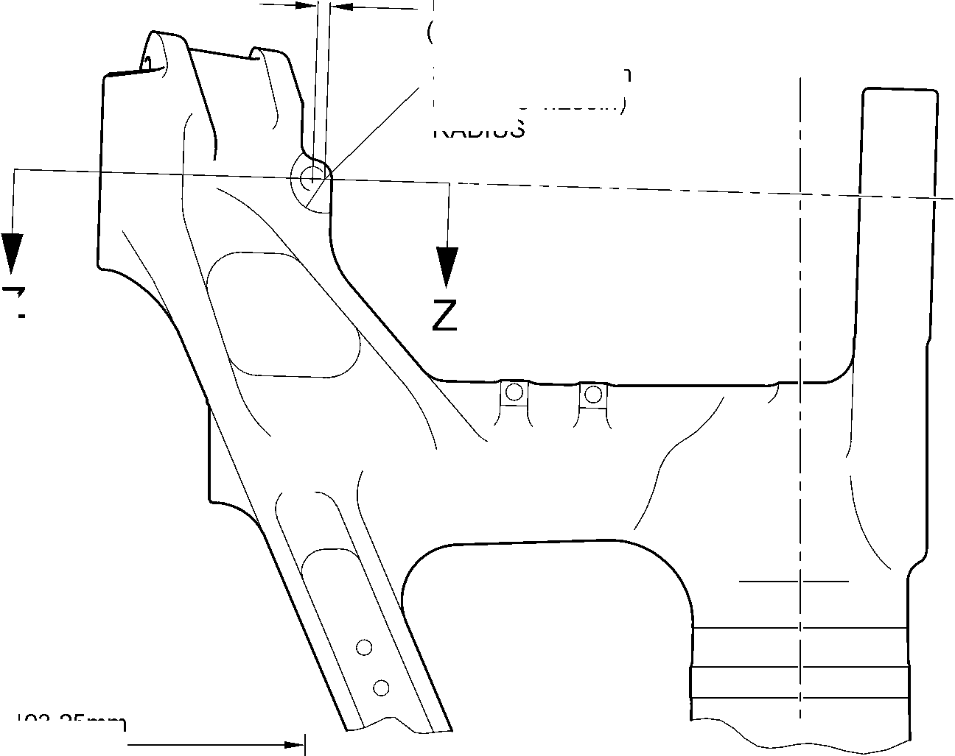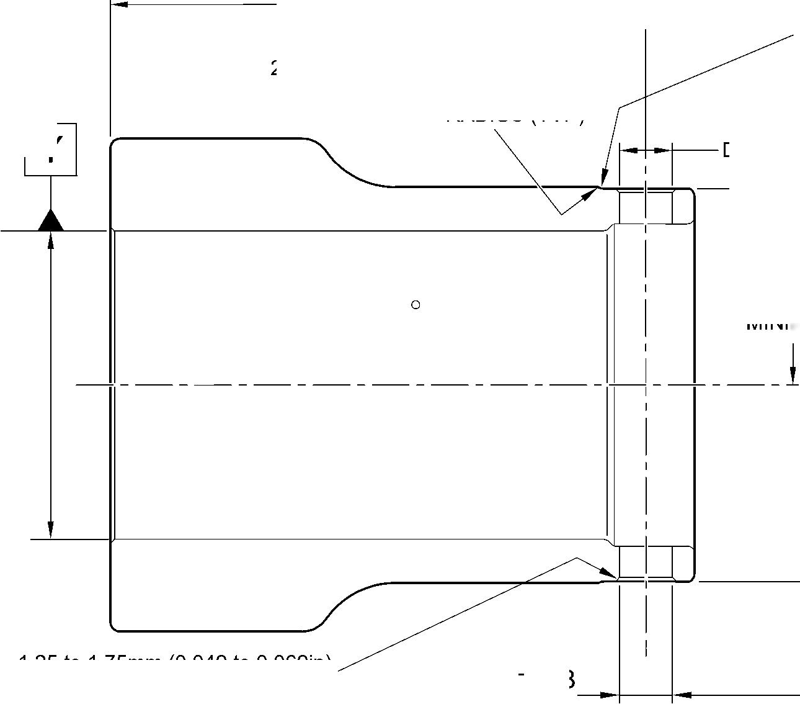

**SAFRAN LANDING SYSTEMS UK Ltd**

CAGE: K0654



PART No. 201587001 AND 201587002 COMPONENT MAINTENANCE MANUAL  
MAIN LANDING GEAR LEG

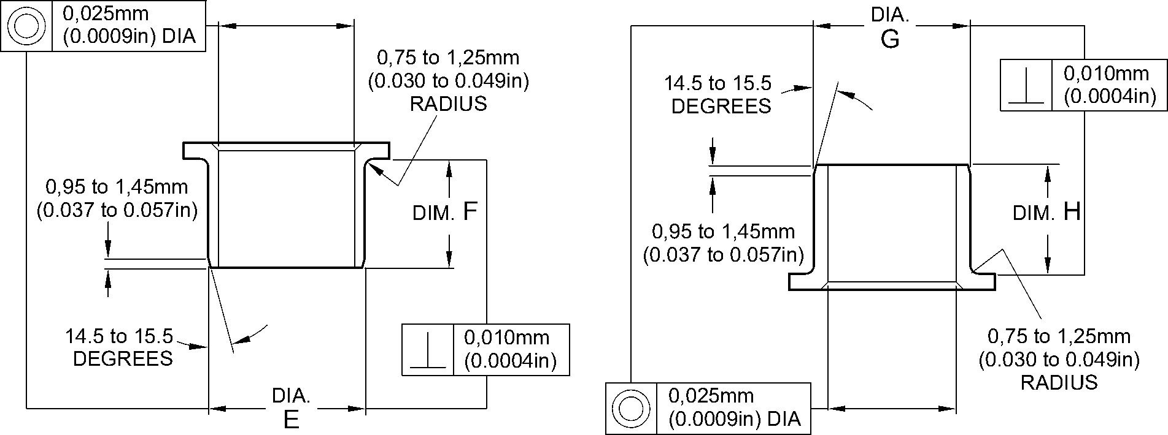

OVERSIZE BEARING  
450258809

OVERSIZE BEARING  
450258810

16,500 to 16,527mm

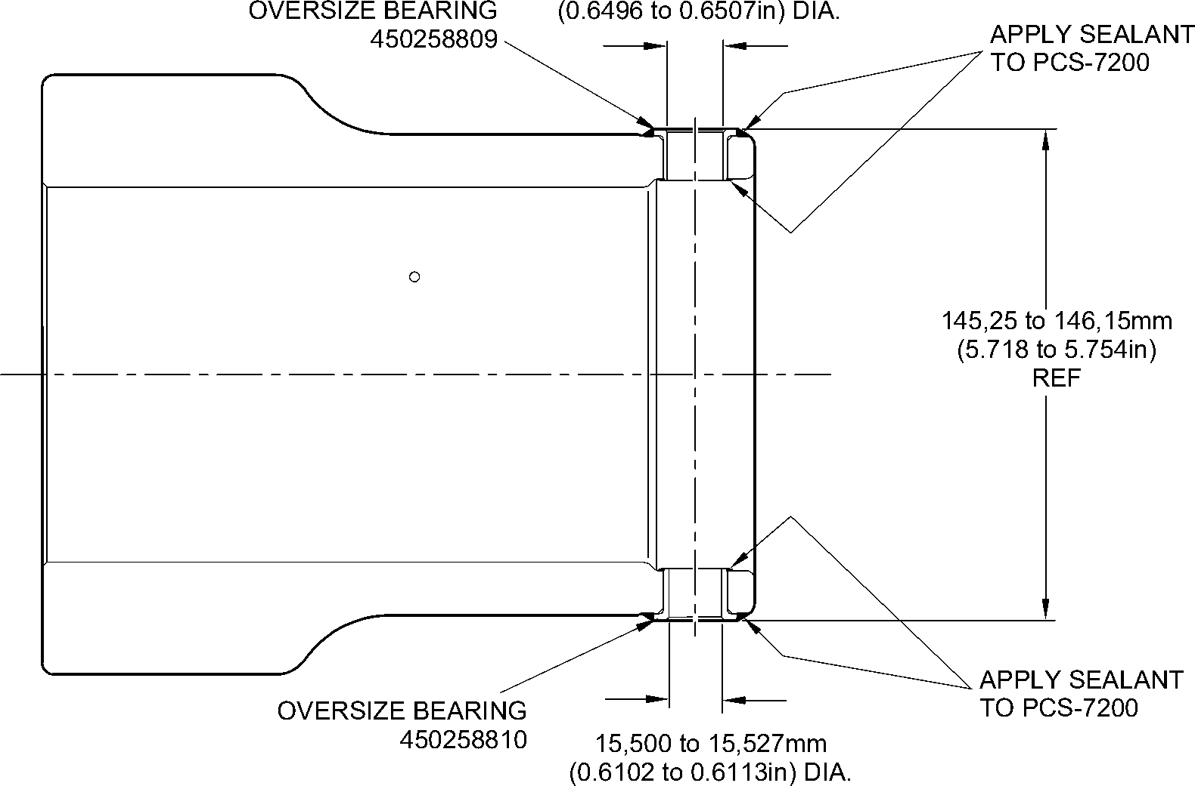

section Z-Z  
(REFER TO FIGURE 601)

A321A6384-2

Oversize Bearings - Machining and Installation  
Figure 602

32-12-22

Repair No. 11-21

Page 604

Dec 6/2019

**sSAFRAN SAFRAN LANDING SYSTEMS UK Ltd**

CAGE: K0654

PART No. 201587001 AND 201587002 COMPONENT MAINTENANCE MANUAL  
MAIN LANDING GEAR LEG

I 1. Repair No. 11-22 Main Fitting (20-410, 20-410A, 20-420 and 20-420A)

1. Specified Damage and Material Specification
2. Specified Damage

(a) Damage or wear to the diameter A.

1. Material Specification

|  |  |  |
| --- | --- | --- |
| IPL Figure and Item No. | Name | Material Specification |
| 20-410, 20-410A, 20-420 and 20-420A | Main Fitting | Steel, MAT135, 35NCD16THQ |

1. Special Tools
2. Special tools are not necessary.
3. Materials
4. Materials are not necessary.
5. Repair Parts
6. Repair parts are not necessary.
7. Procedure (Refer to Figure 601)

**CAUTION: FOR DAMAGE MORE THAN THE LIMITS OF THIS REPAIR SCHEME,  
WRITE TO SAFRAN LANDING SYSTEMS: REFER TO GUIDE-CS-001.**

1. Machine diameter A to remove the damage or wear, removing the minimum amount of  
   material to a maximum diameter of 16,170 mm (0.6366 in) and a minimum wall  
   thickness of 1,915 mm (0.0754 in): refer to M-DLPS1004-4-1 and Figure 601. Make the  
   surface finish 1,6 micrometers (63 micro-inches) or better.
2. Examine the bare metal for flaws: refer to PCS-3100, inclusion class 4 and PCS-3600.
3. Identify the main fitting with the Safran Landing Systems repair number 450266450  
   adjacent to the part number: refer to PCS-6000-04 or PCS-6000-06.
4. Apply cadmium plate to the repaired areas. The cadmium plate thickness must be  
   between 0,010 and 0,020 mm (0.0004 and 0.0008 in): refer to PCS-2141.
5. If necessary, apply paint around the repaired areas, except where shown: refer to  
   PCS-2500 and Figure 601.
6. Identify the main fitting with the Safran Landing Systems repair number 450266450  
   adjacent to the part number: refer to PCS-6000-07.
7. Examine the part to make sure that you have obeyed all the repair procedure  
   instructions correctly.

Repair No. 11-22

32-12-22

Page 601

Mar 18/2025

**SAFRAN LANDING SYSTEMS UK Ltd**

CAGE: K0654

PART No. 201587001 AND 201587002 COMPONENT MAINTENANCE MANUAL  
MAIN LANDING GEAR LEG

72, 00mm  
(2.834in)

10,50mm  
(0.413in)

27,5 to 28,5mm  
(1.08 to 1.12in)

4 PLACES

8,3mm (0.33in) DIA.

4 HOLES

0,50 to 1,00mm  
(0.020 to 0.040in)  
REMOVE EDGES  
RADIUS

4 PLACES

SPHERICAL RAD.

4 PLACES

NO PAINT

144,5 to 145,5mm  
(5.689 to 5.728in)

124,00 mm  
(4.882in)

0,20mm

(0.008in) DIA.

1,915mm  
(0.0754in)

MINIMUM WALL  
THICKNESS  
4 PLACES

DIA. A

16,17mm  
(0.6366in)

MAXIMUM  
4 HOLES

NO PAINT

1,00 to 2,00mm  
(0.040 to 0.080in)  
REMOVE EDGES

RADIUS

4 PLACES  
DETAIL Y

A321-S-32-12-22-024-1

Repair to Main Fitting  
Figure 601

Repair No. 11-22

32

Page 602

-- Mar 24/2017

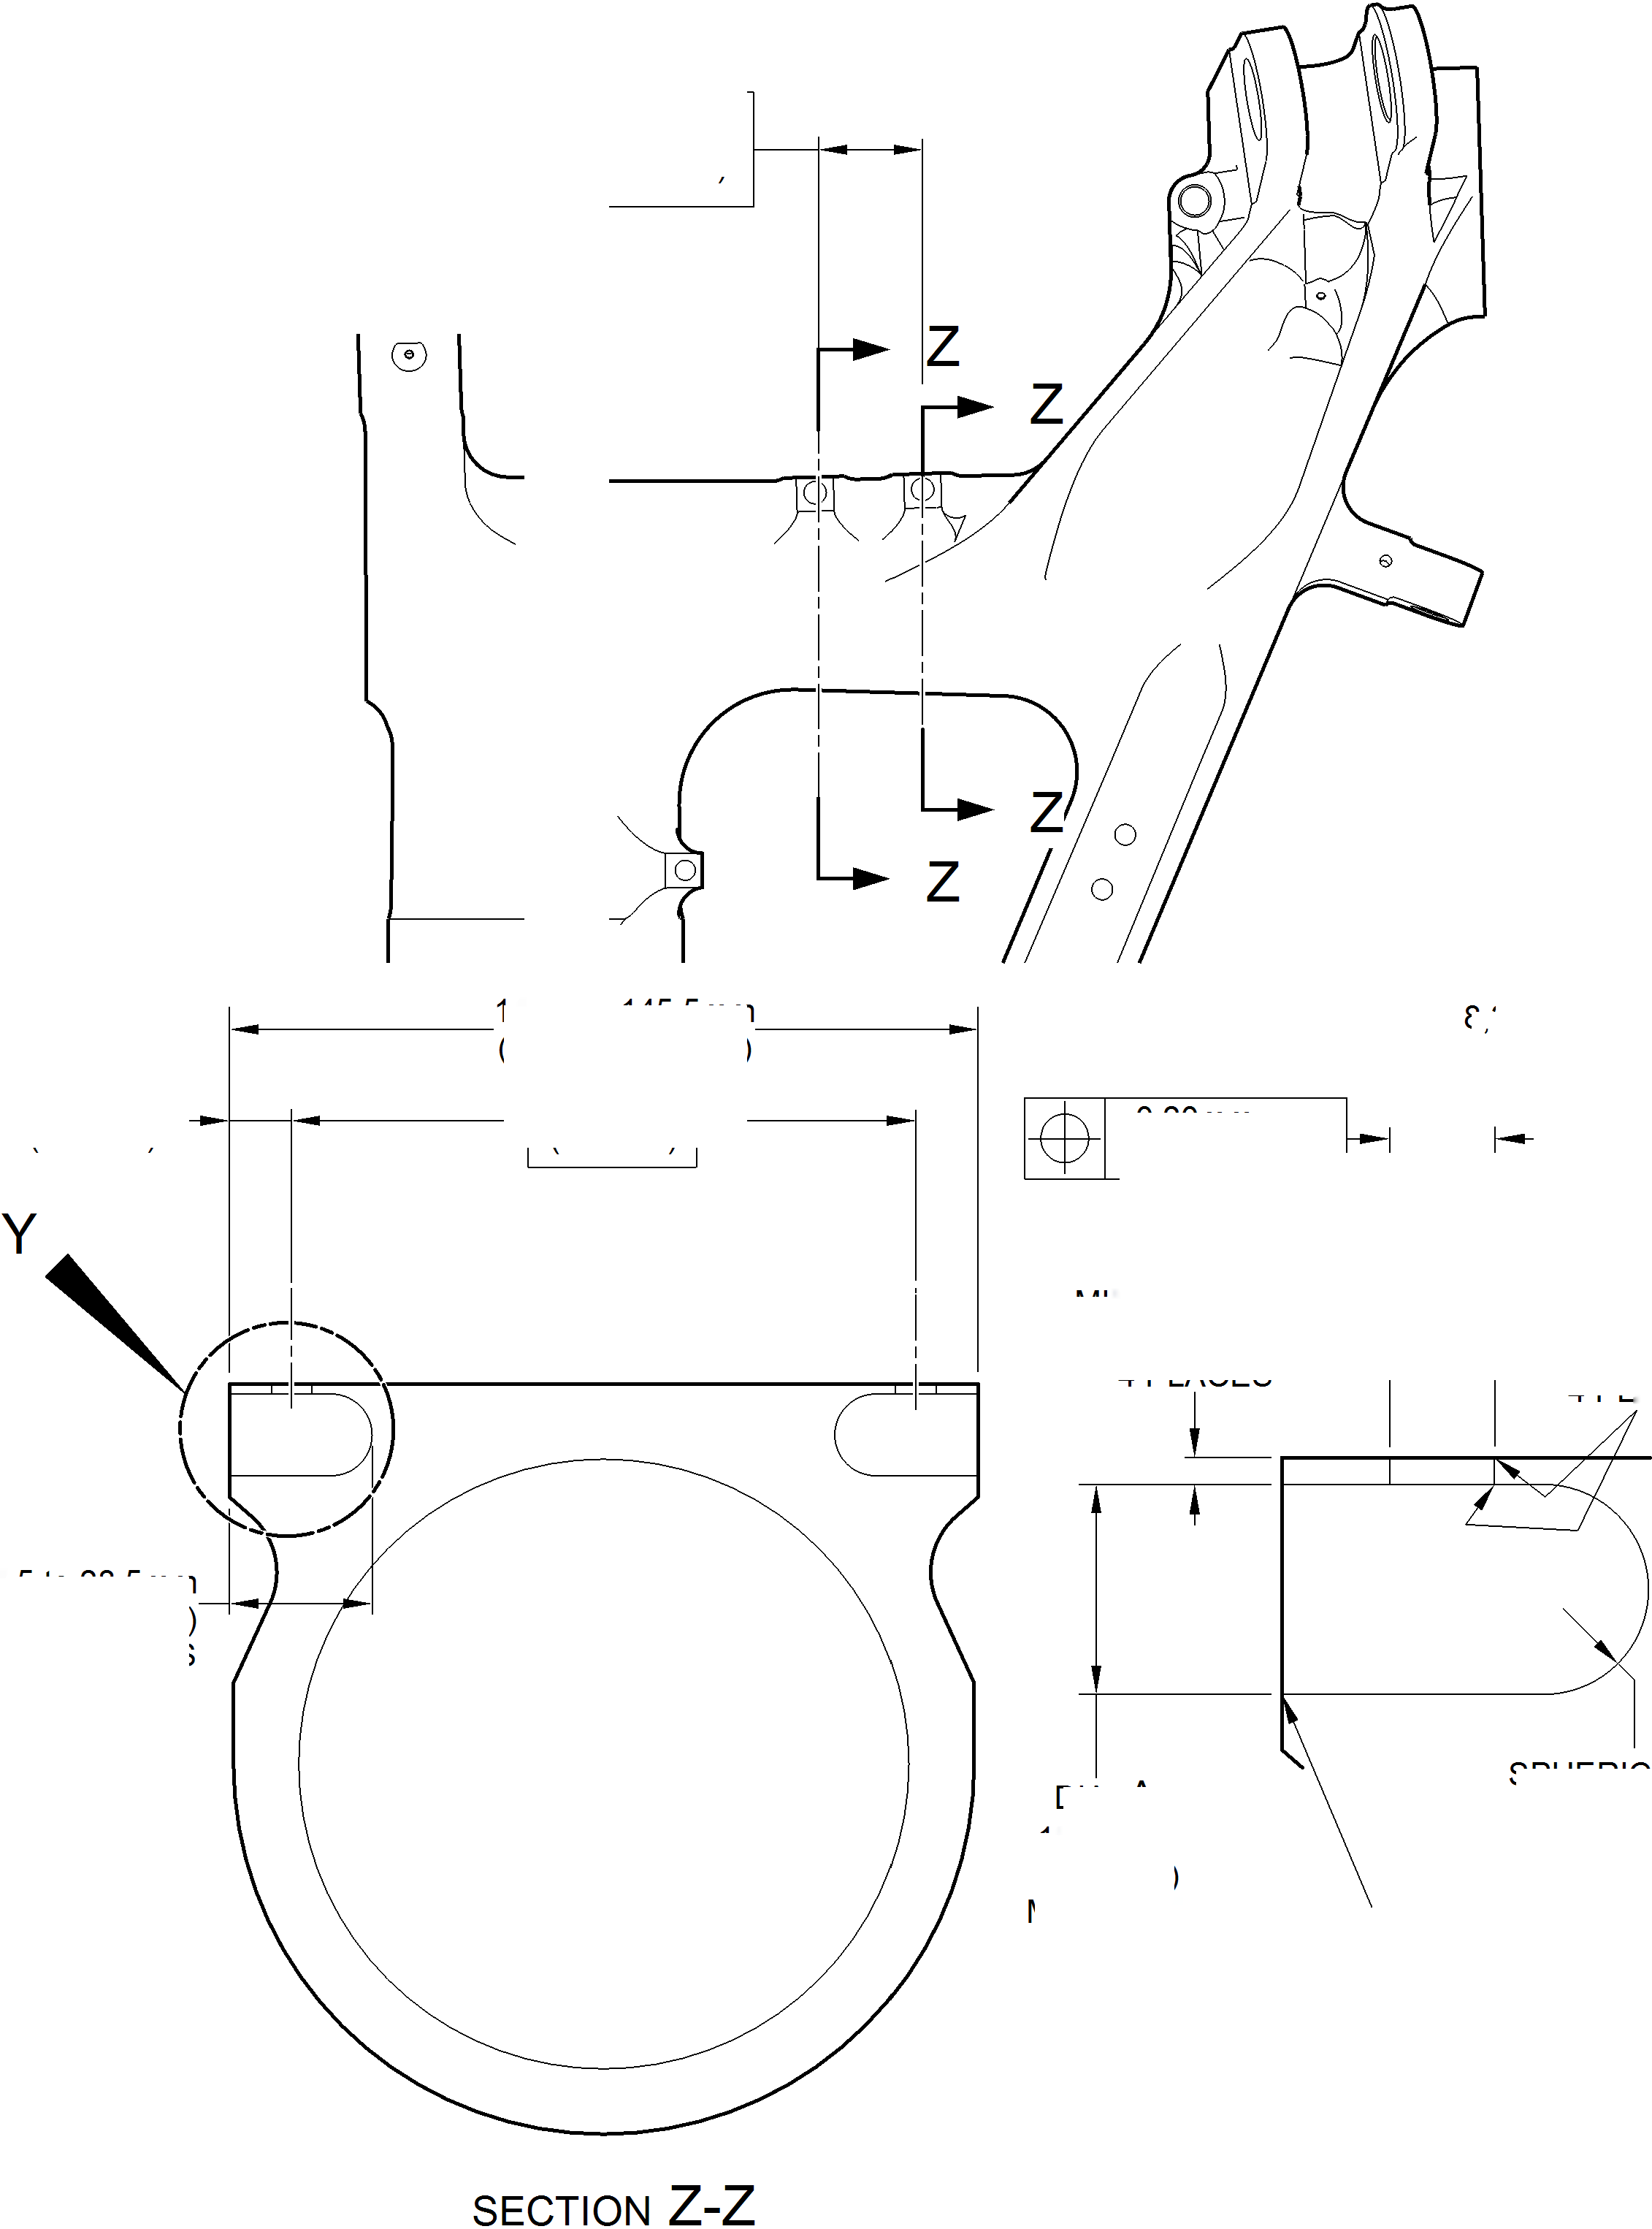

**SAFRAN LANDING SYSTEMS UK Ltd**

CAGE: K0654



PART No. 201587001 AND 201587002 COMPONENT MAINTENANCE MANUAL  
MAIN LANDING GEAR LEG

I 1. Repair No. 11-23 Main Fitting (20-410, 20-410A, 20-420 and 20-420A)

1. Specified Damage and Material Specification.
2. Specified Damage

(a) Damage or wear to the diameter A and/or B.

1. Material Specification

|  |  |  |
| --- | --- | --- |
| IPL Figure and Item No. | Name | Material Specification |
| 20-410, 20-410A, 20-420 and 20-420A | Main Fitting | Steel, MAT135, 35NCD16THQ |

1. Special Tools
2. These special tools are necessary:

**NOTE: Alternative equivalents are permitted.**

|  |  |  |
| --- | --- | --- |
| Tool Part No. | Special Tool | Function |
| 460006268 | Press Pad | Install the oversize lubrication adapters |

1. Materials
2. These materials are necessary:

**NOTE: Alternative equivalents are permitted.**

|  |  |
| --- | --- |
| Ref. Item | Material |
| 08-558 | Adhesive |

1. Repair Parts
2. Refer to Table 1.
3. Procedure (Refer to Figures 601, 602 and 603)

**CAUTION: FOR DAMAGE MORE THAN THE LIMITS OF THIS REPAIR SCHEME, WRITE  
TO SAFRAN LANDING SYSTEMS.**

1. Machine diameter A and/or diameter B to the smallest oversize dimensions shown in  
   Table 1 to remove the damage or wear: refer to M-DLPS1004-4-1. Make the surface  
   finish 1,6 micrometers (63 micro-inches).
2. Machine the chamfers to the dimensions shown: refer to Figure 602.
3. Examine the machined areas for flaws: refer to PCS-3600 and PCS-3100 inclusion  
   class 4.
4. Identify the part with the Safran Landing Systems repair number 450266400 adjacent to  
   the part number: refer to PCS-6000-04 or PCS-6000-06.

Repair No. 11-23

32-12-22

Page 601

Mar 18/2025

**sSAFRAN SAFRAN LANDING SYSTEMS UK Ltd**

CAGE: K0654

PART No. 201587001 AND 201587002 COMPONENT MAINTENANCE MANUAL  
MAIN LANDING GEAR LEG

1. Apply cadmium plate to repaired areas. The cadmium plate thickness must be between  
   0,010 and 0,020 mm (0.0004 and 0.0008 in): refer to PCS-2141.
2. Select the applicable oversize lubrication adaptor (Qty 2) for diameter A and/or diameter  
   B from Table 1.
3. Install the selected lubrication adaptors to the related diameter: refer to PCS-7310. Use  
   adhesive, Material Ref. Item 08-558: refer to PCS-5303.
4. Apply paint to the repaired areas: refer to REPAIR.
5. Identify the part with the Safran Landing Systems repair number 450266400 adjacent to  
   the part number: refer to PCS-6000-07.
6. Examine the part to make sure that you have obeyed all the repair instructions correctly.

Oversize Lubrication Adaptor

Table 1

|  |  |  |
| --- | --- | --- |
| Oversize | Diameter A or B mm (in) | Oversize Lubrication Adaptor Part No. |
| 1 | 4,986 to 5,052 (0.1963 to 0.1989) | 450250161 |
| 2 | 5,113 to 5,179 (0.2013 to 0.2039) | 450250162 |
| 3 | 5,240 to 5,306 (0.2063 to 0.2089) | 450250163 |
| 4 | 5,367 to 5,433 (0.2113 to 0.2139) | 450250164 |
| 5 | 5,494 to 5,560 (0.2163 to 0.2189) | 450250165 |
| 6 | 5,621 to 5,687 (0.2213 to 0.2239) | 450250166 |
| 7 | 5,748 to 5,814 (0.2263 to 0.2289) | 450250241 |
| 8 | 5,875 to 5,941 (0.2313 to 0.2339) | 450250242 |
| 9 | 6,002 to 6,068 (0.2363 to 0.2389) | 450250243 |
| 10 | 6,129 to 6,195 (0.2413 to 0.2439) | 450250244 |
| 11 | 6,256 to 6,322 (0.2463 to 0.2489) | 450250245 |
| 12 | 6,383 to 6,449 (0.2513 to 0.2539) | 450250246 |

32-12-22

Repair No. 11-23

Page 602

Mar 18/2025

**SAFRAN LANDING SYSTEMS UK Ltd**

CAGE: K0654



PART No. 201587001 AND 201587002 COMPONENT MAINTENANCE MANUAL  
MAIN LANDING GEAR LEG

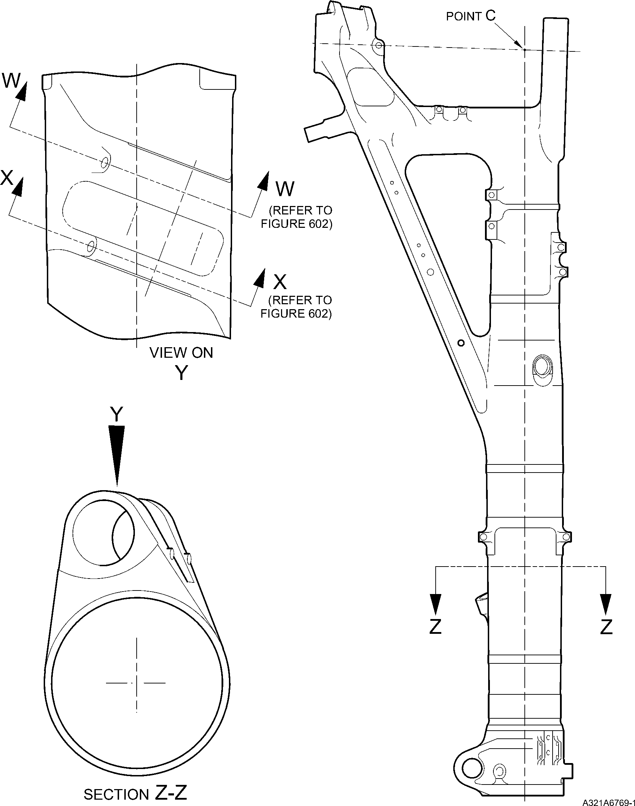

Repair to Main Fitting  
Figure 601

Repair No. 11-23

32-12-22

Page 603

Dec 6/2019

**SAFRAN LANDING SYSTEMS UK Ltd**

CAGE: K0654

PART No. 201587001 AND 201587002 COMPONENT MAINTENANCE MANUAL  
MAIN LANDING GEAR LEG

28,75 to 30,25mm  
(1.132 to 1.191in) REF

5 DEGREES  
REF

11,20 to 12,80mm  
(0.441 to 0.503in) REF

diameter A  
8,00mm (0.315in)  
DEEP WITH  
0,5mm (0.020in)  
x 45 DEGREES CHAMFER

section W-W

(WITHOUT LUBRICATION ADAPTOR)

5 DEGREES  
REF

95,200 to 96,800mm  
(3.7480 to 3.8110in)

REF.

NOTE:

DIAMETERS A MUST FOLLOW  
THE LINE OF EXISTING BORES

diameter B

8,00mm (0.315in)  
DEEP WITH  
0,5mm (0.020in)  
x 45 DEGREES CHAMFER

87,20 to 88,80mm  
(3.433 to 3.496in)  
REF.

section X-X

(WITHOUT LUBRICATION ADAPTOR)

A321A6770-1

Repair to Main Fitting - Machining  
Figure 602

32-12-22

Repair No. 11-23

Page 604

Dec 6/2019

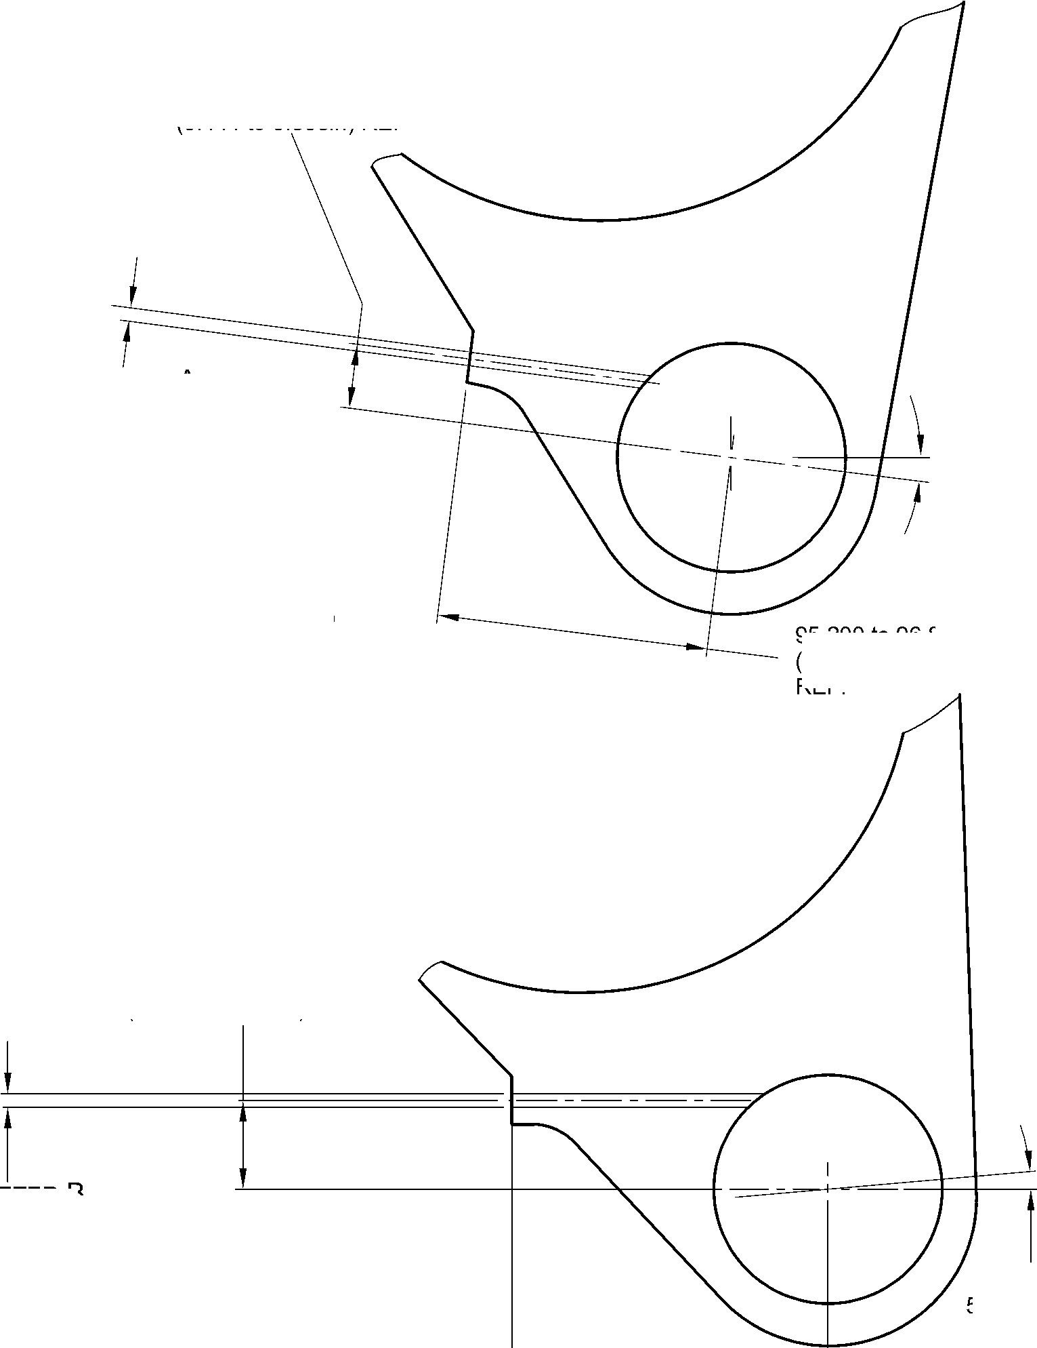

**SAFRAN LANDING SYSTEMS UK Ltd**

CAGE: K0654



PART No. 201587001 AND 201587002 COMPONENT MAINTENANCE MANUAL  
MAIN LANDING GEAR LEG

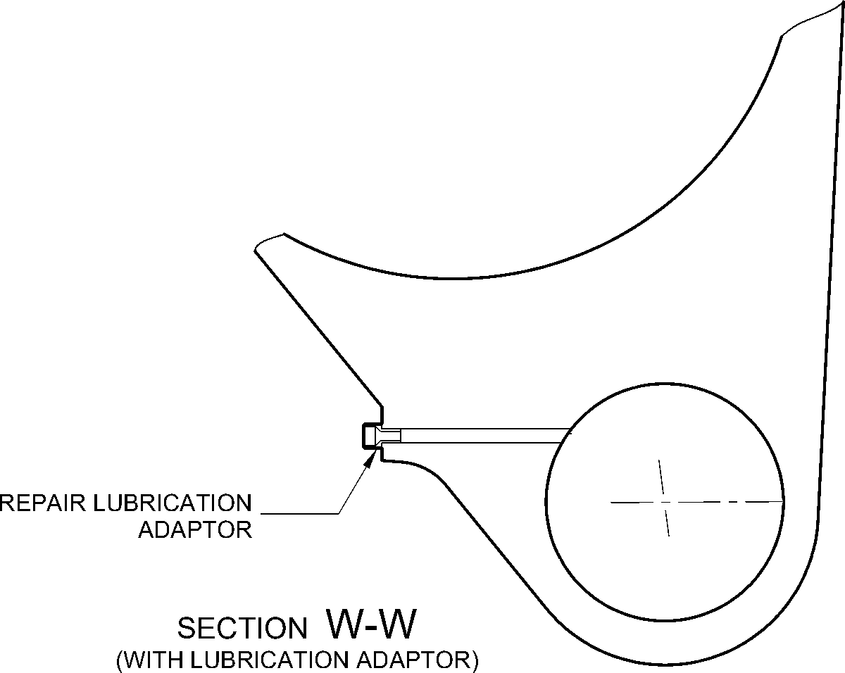

REPAIR LUBRICATION  
ADAPTOR

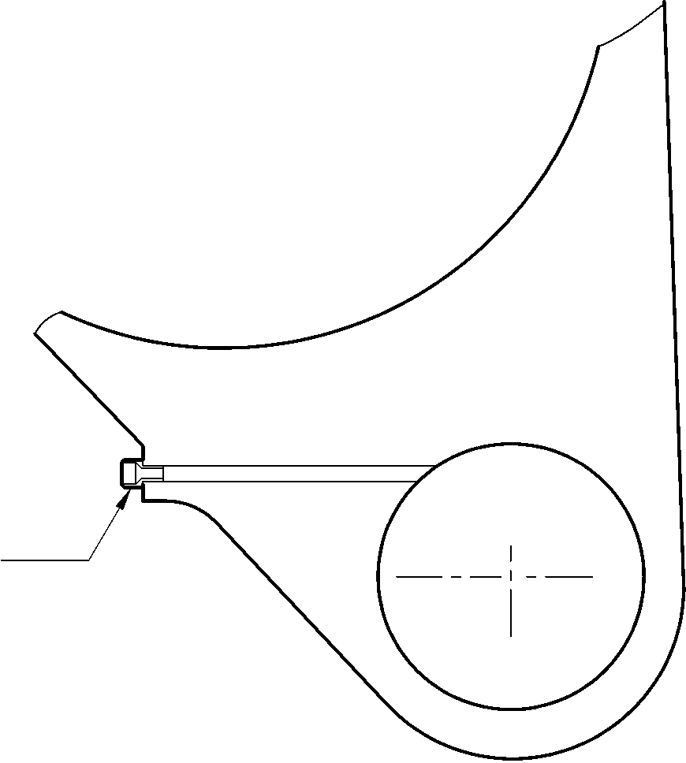

section X-X

(WITH LUBRICATION ADAPTOR)

A321A6771-1

Oversize Lubrication adapter - Installation  
Figure 603

Repair No. 11-23

32-12-22

Page 605

Dec 6/2019

**SAFRAN LANDING SYSTEMS UK Ltd**

CAGE: K0654



PART No. 201587001 AND 201587002 COMPONENT MAINTENANCE MANUAL  
MAIN LANDING GEAR LEG

INTENTIONALLY BLANK

Repair No. 11-23

32-12-22 Page 606

**sSAFRAN SAFRAN LANDING SYSTEMS UK Ltd**

CAGE: K0654

PART No. 201587001 AND 201587002 COMPONENT MAINTENANCE MANUAL  
MAIN LANDING GEAR LEG

I 1. Repair No. 11-24 Main Fitting (20-410, 20-410A, 20-420 and 20-420A)

1. Specified Damage and Material Specification.
2. Specified Damage

(a) Damage or wear to the diameter A.

1. Material Specification

|  |  |  |
| --- | --- | --- |
| IPL Figure and Item No. | Name | Material Specification |
| 20-410, 20-410A, 20-420 and 20-420A | Main Fitting | Steel, MAT135, 35NCD16THQ |

1. Special Tools
2. These special tools are necessary:

**NOTE: Alternative equivalents are permitted.**

|  |  |  |
| --- | --- | --- |
| Tool Part No. | Special Tool | Function |
| 460006268 | Press Pad | Install the oversize lubrication adaptor |

1. Materials
2. These materials are necessary:

**NOTE: Alternative equivalents are permitted.**

|  |  |
| --- | --- |
| Ref. Item | Material |
| 08-558 | Adhesive |

1. Repair Parts
2. Refer to Table 1.

**CAUTION: FOR DEVIATIONS OUTSIDE THE LIMITS OF THIS REPAIR SCHEME CONTACT  
SAFRAN LANDING SYSTEMS.**

1. Procedure (Refer to Figures 601 and 602)
2. Machine diameter A to the smallest oversize dimensions shown in Table 1 to remove the  
   damage or wear: refer to M-DLPS1004-4-1 and Figure 602. Make the surface finish  
   1,6 micrometers (63 micro-inches).
3. Machine the chamfers to the dimensions shown: refer to Figure 602.
4. Examine the machined areas for flaws: refer to PCS-3600 and PCS-3100 inclusion  
   class 4.
5. Identify the part with the Safran Landing Systems repair number 450266390 adjacent to  
   the part number: refer to PCS-6000-04 or PCS-6000-06.

Repair No. 11-24

32-12-22

Page 601

Mar 18/2025

**SAFRAN LANDING SYSTEMS UK Ltd**

CAGE: K0654



PART No. 201587001 AND 201587002 COMPONENT MAINTENANCE MANUAL  
MAIN LANDING GEAR LEG

1. Apply cadmium plate to the machined areas: refer to PCS-2141. The cadmium plate  
   thickness must be between 0,010 and 0,020 mm (0.0004 and 0.0008 in).
2. Select the applicable oversize lubrication adaptor for diameter A from Table 1.
3. Install the selected lubrication adaptor: refer to PCS-7310. Use adhesive, Material Ref.  
   Item 08-558: refer to PCS-5303.
4. Apply paint to the repaired areas: refer to PCS-2500 and REPAIR.
5. Identify the part with the Safran Landing Systems repair number 450266390 adjacent to  
   the part number: refer to PCS-6000-07.
6. Examine the part to make sure that you have obeyed all the repair instructions correctly.

Oversize Lubrication Adaptors

Table 1

|  |  |  |
| --- | --- | --- |
| Oversize | Diameter A mm (in) | Oversize Lubrication Adaptor Part No. |
| 1 | 4,986 to 5,052 (0.1963 to 0.1989) | 450250161 |
| 2 | 5,113 to 5,179 (0.2013 to 0.2039) | 450250162 |
| 3 | 5,240 to 5,306 (0.2063 to 0.2089) | 450250163 |
| 4 | 5,367 to 5,433 (0.2113 to 0.2139) | 450250164 |
| 5 | 5,494 to 5,560 (0.2163 to 0.2189) | 450250165 |
| 6 | 5,621 to 5,687 (0.2213 to 0.2239) | 450250166 |
| 7 | 5,748 to 5,814 (0.2263 to 0.2289) | 450250241 |
| 8 | 5,875 to 5,941 (0.2313 to 0.2339) | 450250242 |
| 9 | 6,002 to 6,068 (0.2363 to 0.2389) | 450250243 |
| 10 | 6,129 to 6,195 (0.2413 to 0.2439) | 450250244 |
| 11 | 6,256 to 6,322 (0.2463 to 0.2489) | 450250245 |
| 12 | 6,383 to 6,449 (0.2513 to 0.2539) | 450250246 |

32-12-22

Repair No. 11-24

Page 602

Mar 18/2025

**SAFRAN LANDING SYSTEMS UK Ltd**

CAGE: K0654



PART No. 201587001 AND 201587002 COMPONENT MAINTENANCE MANUAL  
MAIN LANDING GEAR LEG

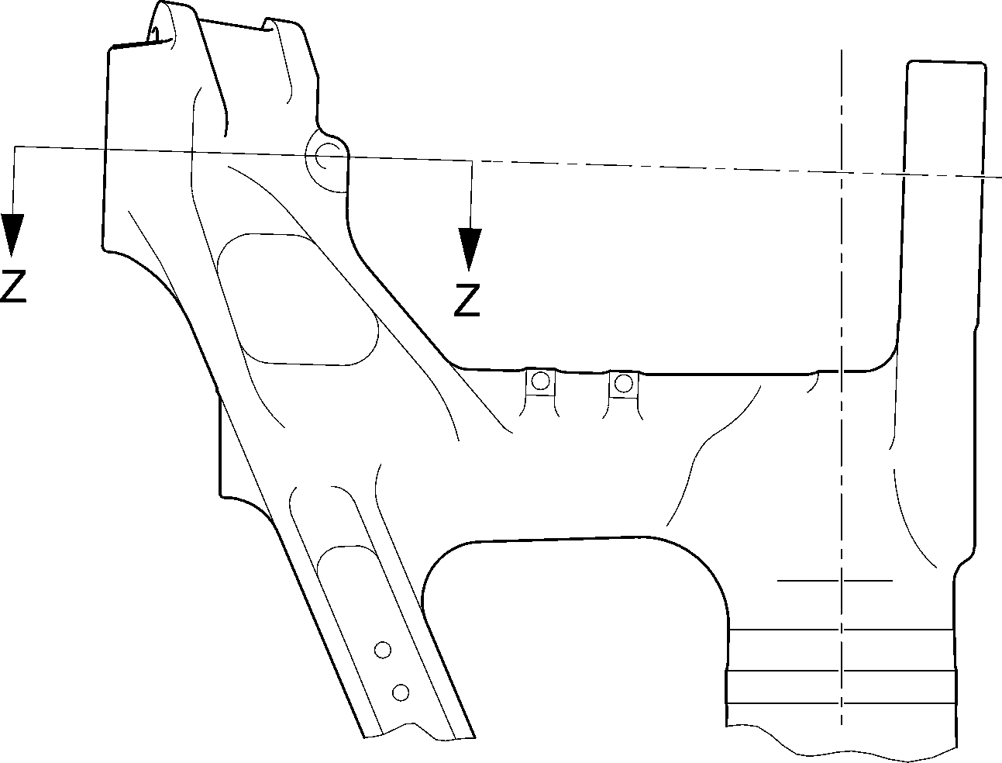

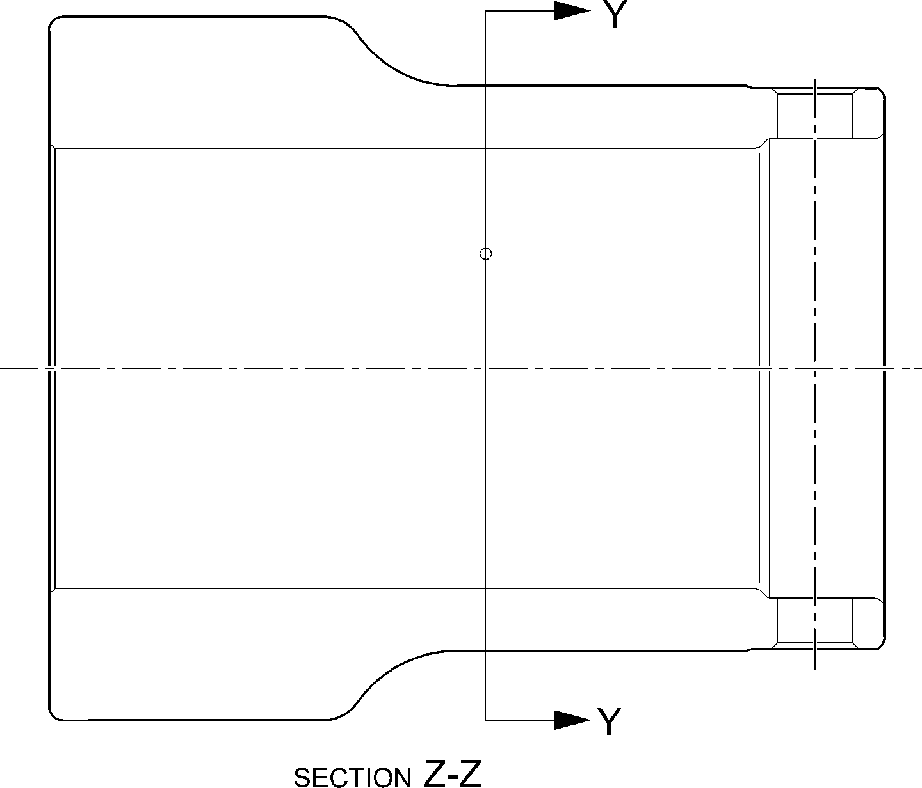

Repair to Main Fitting

Figure 601

A321A6877-1

Repair No. 11-24

32-12-22

Page 603

Dec 6/2019

**SAFRAN LANDING SYSTEMS UK Ltd**

CAGE: K0654



PART No. 201587001 AND 201587002 COMPONENT MAINTENANCE MANUAL  
MAIN LANDING GEAR LEG

49.5 to 50.5  
DEGREES REF.

dia. A  
x 8,00mm  
(0.315in) DEEP

80,00 to 81,60mm  
(3.150 to 3.213in)  
REF.

detail X

X

section Y-Y

REFER TO FIGURE 601  
(WITHOUT LUBRICATION ADAPTOR)

0,50mm (0.020in)  
x 45 DEGREES CHAMFER

18,20 to 19,80mm  
(0.716 to 0.779in) REF.

NOTE:-

diameter A must follow  
THE LINE OF EXISTING BORE

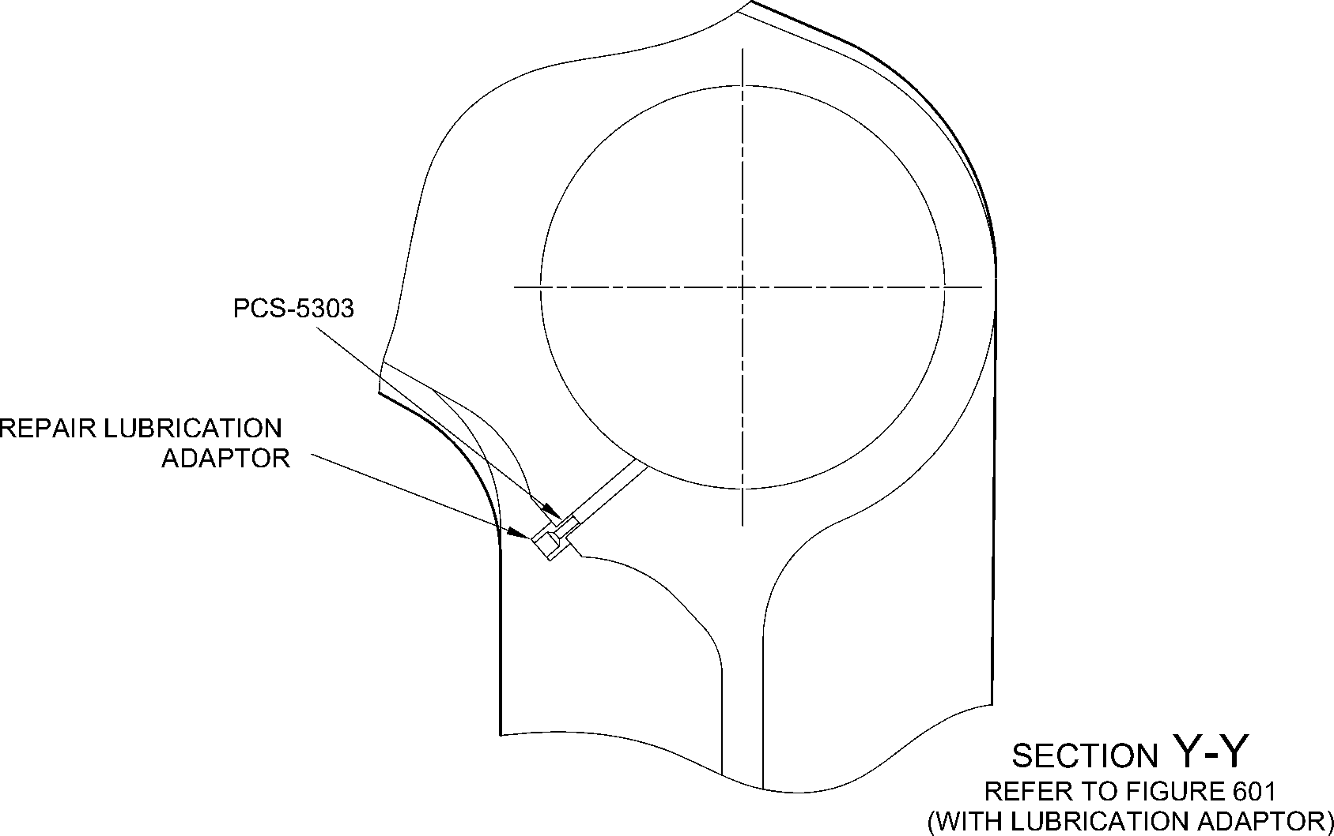

A321A6878-1

Repair to Main Fitting

Figure 602

32-12-22

Repair No. 11-24

Page 604

Dec 6/2019

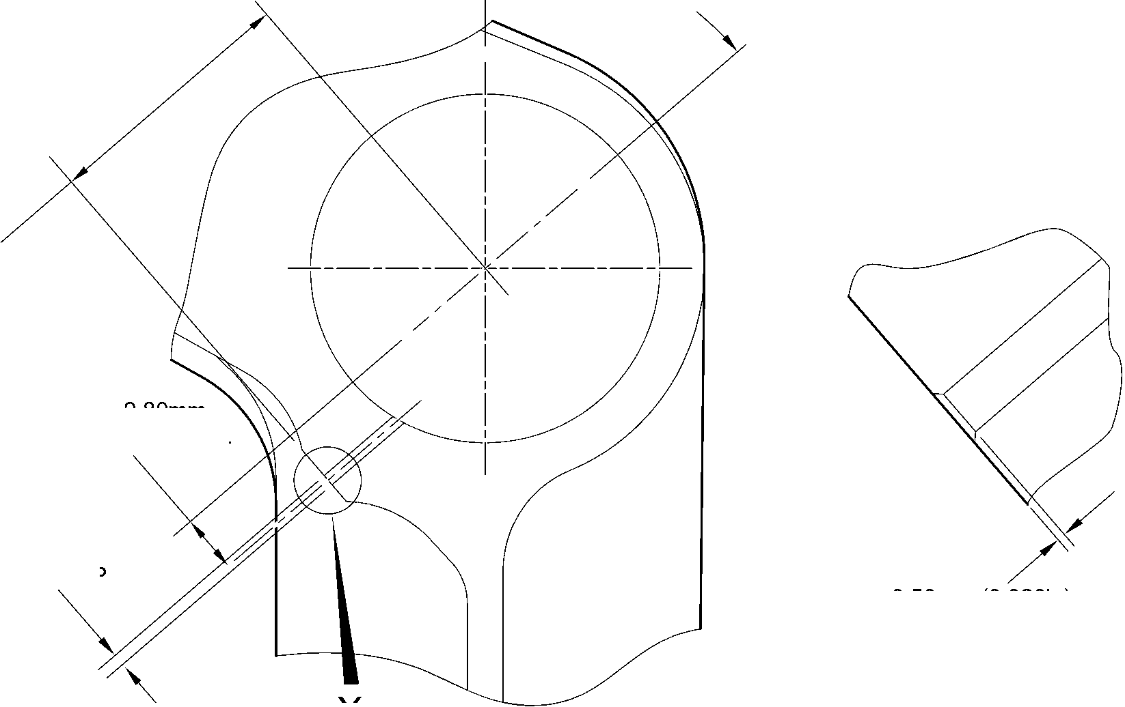

**sSAFRAN SAFRAN LANDING SYSTEMS UK Ltd**

CAGE: K0654

PART No. 201587001 AND 201587002 COMPONENT MAINTENANCE MANUAL  
MAIN LANDING GEAR LEG

I 1. Repair No. 11-25 Main Fitting (20-410, 20-410A, 20-420 and 20-420A)

1. Specified Damage and Material Specification.
2. Specified Damage

(a) Damage or wear to the diameter A.

1. Material Specification

|  |  |  |
| --- | --- | --- |
| IPL Figure and Item No. | Name | Material Specification |
| 20-410, 20-410A, 20-420 and 20-420A | Main Fitting | Steel, MAT135, 35NCD16THQ |

1. Special Tools
2. These special tools are necessary:

**NOTE: Alternative equivalents are permitted.**

|  |  |  |
| --- | --- | --- |
| Tool Part No. | Special Tool | Function |
| 460006268 | Press Pad | Install the oversize lubrication adaptor |

1. Materials
2. These materials are necessary:

**NOTE: Alternative equivalents are permitted.**

|  |  |
| --- | --- |
| Ref. Item | Material |
| 08-558 | Adhesive |

1. Repair Parts
2. Refer to Table 1.

**CAUTION: FOR DEVIATIONS OUTSIDE THE LIMITS OF THIS REPAIR SCHEME CONTACT  
SAFRAN LANDING SYSTEMS.**

1. Procedure (Refer to Figure 601)
2. Machine diameter A to the smallest oversize dimensions shown in Table 1 to remove the  
   damage or wear: refer to M-DLPS1004-4-1. Make the surface finish 1,6 micrometers  
   (63 micro-inches).
3. Machine the chamfer to the dimensions shown: refer to Figure 601.
4. Examine the machined areas for flaws: refer to PCS-3600 and PCS-3100 inclusion  
   class 4.
5. Identify the part with the Safran Landing Systems repair number 450266395 adjacent to  
   the part number: refer to PCS-6000-04 or PCS-6000-06.

Repair No. 11-25

32-12-22

Page 601

Mar 18/2025

**SAFRAN LANDING SYSTEMS UK Ltd**

CAGE: K0654



PART No. 201587001 AND 201587002 COMPONENT MAINTENANCE MANUAL  
MAIN LANDING GEAR LEG

1. Apply cadmium plate to the machined areas. The cadmium plate thickness must be  
   between 0,010 and 0,020 mm (0.0004 and 0.0008 in): refer to PCS-2141.
2. Select the applicable oversize lubrication adaptor for diameter A from Table 1.
3. Install the selected lubrication adaptor: refer to PCS-7310. Use adhesive, Material Ref.  
   Item 08-558: refer to PCS-5303.
4. Apply paint to the repaired areas: refer to REPAIR.
5. Identify the part with the Safran Landing Systems repair number 450266395 adjacent to  
   the part number: refer to PCS-6000-07.
6. Examine the part to make sure that you have obeyed all the repair instructions correctly.

Oversize Lubrication Adaptor

Table 1

|  |  |  |
| --- | --- | --- |
| Oversize | Diameter A mm (in) | Oversize Lubrication Adaptor Part No. |
| 1 | 4,986 to 5,052 (0.1963 to 0.1989) | 450250161 |
| 2 | 5,113 to 5,179 (0.2013 to 0.2039) | 450250162 |
| 3 | 5,240 to 5,306 (0.2063 to 0.2089) | 450250163 |
| 4 | 5,367 to 5,433 (0.2113 to 0.2139) | 450250164 |
| 5 | 5,494 to 5,560 (0.2163 to 0.2189) | 450250165 |
| 6 | 5,621 to 5,687 (0.2213 to 0.2239) | 450250166 |
| 7 | 5,748 to 5,814 (0.2263 to 0.2289) | 450250241 |
| 8 | 5,875 to 5,941 (0.2313 to 0.2339) | 450250242 |
| 9 | 6,002 to 6,068 (0.2363 to 0.2389) | 450250243 |
| 10 | 6,129 to 6,195 (0.2413 to 0.2439) | 450250244 |
| 11 | 6,256 to 6,322 (0.2463 to 0.2489) | 450250245 |
| 12 | 6,383 to 6,449 (0.2513 to 0.2539) | 450250246 |

32-12-22

Repair No. 11-25

Page 602

Mar 18/2025

**SAFRAN LANDING SYSTEMS UK Ltd**

CAGE: K0654



PART No. 201587001 AND 201587002 COMPONENT MAINTENANCE MANUAL  
MAIN LANDING GEAR LEG

Z

Z

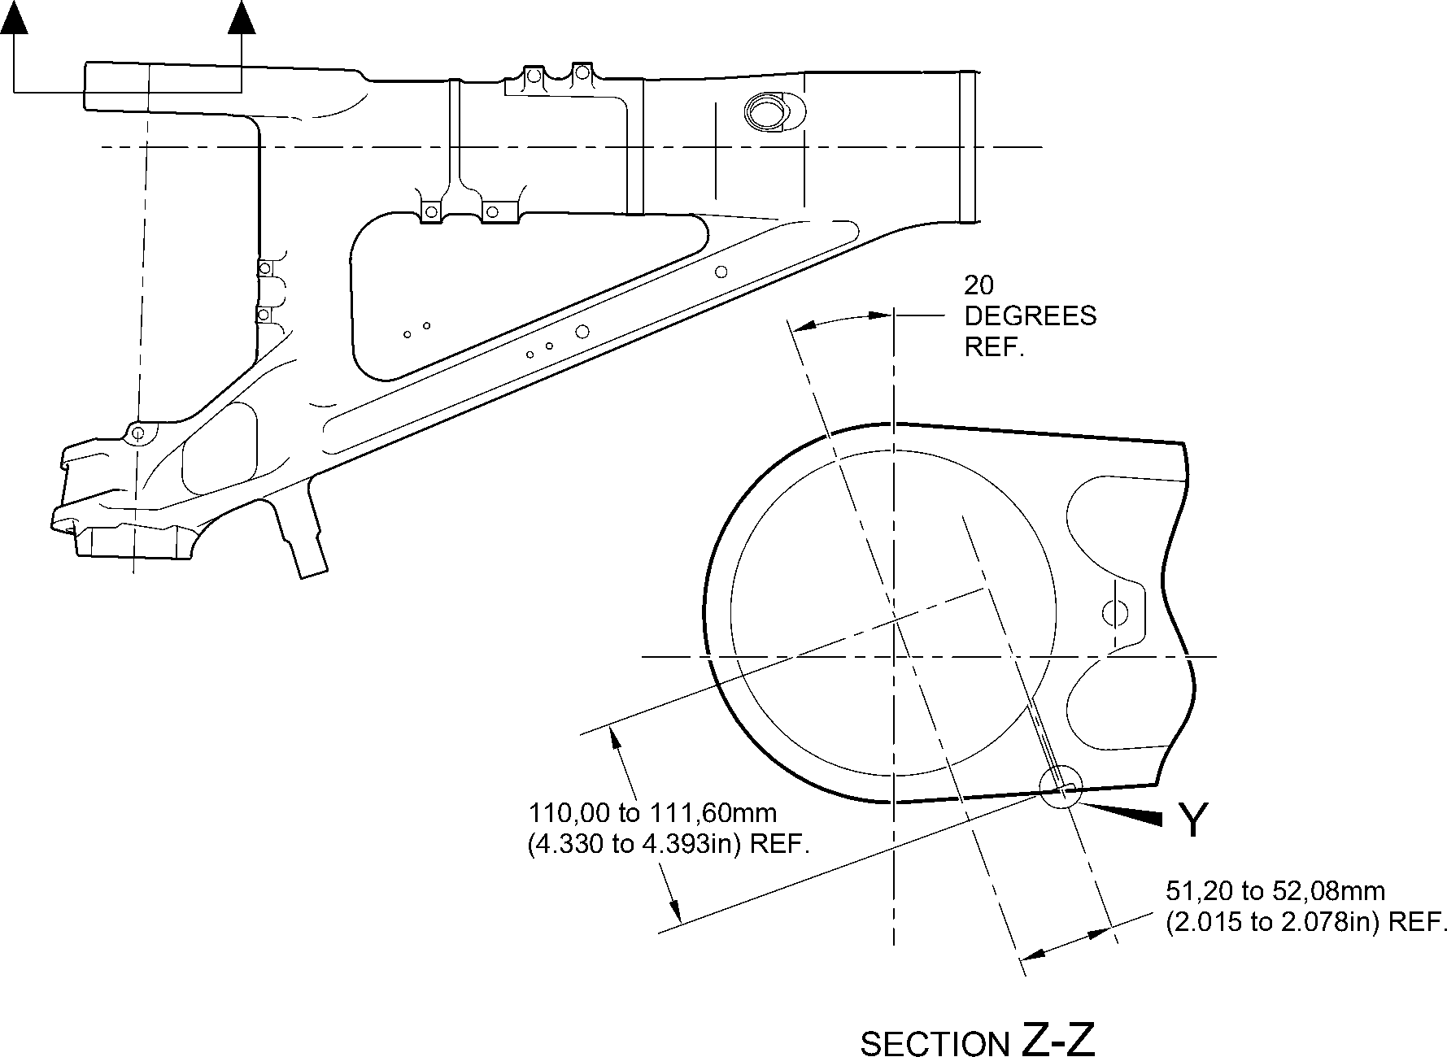

NOTE:-

DIAMETER A MUST FOLLOW REPAIR LUBRICATION

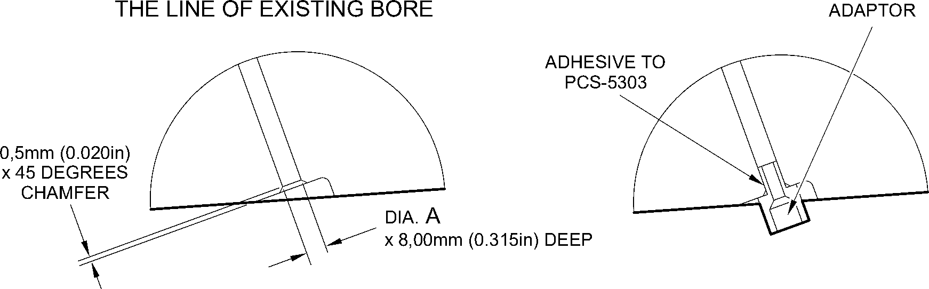

detail Y

(WITHOUT LUBRICATION ADAPTOR)

detail Y

(WITH LUBRICATION ADAPTOR)

A321A6879-1

Repair to Main Fitting  
Figure 601

Repair No. 11-25

32-12-22

Page 603

Dec 6/2019

**SAFRAN LANDING SYSTEMS UK Ltd**

CAGE: K0654



PART No. 201587001 AND 201587002 COMPONENT MAINTENANCE MANUAL  
MAIN LANDING GEAR LEG

INTENTIONALLY BLANK

Repair No. 11-25

32-12-22 Page 604

**SAFRAN LANDING SYSTEMS UK Ltd**

CAGE: K0654



PART No. 201587001 AND 201587002 COMPONENT MAINTENANCE MANUAL  
MAIN LANDING GEAR LEG

I 1. Repair No. 11-26 Main Fitting (20-410 and 20-420 Only)

1. Specified Damage and Material Specification.
2. Specified Damage

(a) Damage or wear to diameter(s) A and B.

1. Material Specification

|  |  |  |
| --- | --- | --- |
| IPL Figure and Item No. | Name | Material Specification |
| 20-410 and  20-420 Only | Main Fitting | Steel, MAT135, 35NCD16THQ |

1. Special Tools

(1) These special tools are necessary:

**NOTE: Alternative equivalents are permitted.**

|  |  |  |
| --- | --- | --- |
| Tool Part No. | Special Tool | Function |
| 460006405 | Assembly sleeve | Install the lower bearing subassembly |

1. Materials

(1) These materials are necessary:

**NOTE: Alternative equivalents are permitted.**

|  |  |
| --- | --- |
| Ref. Item | Material |
| 04-512 | Molykote 111 |

1. Repair Parts

(1) These repair parts are necessary:

**NOTE: Alternative equivalents are permitted.**

|  |  |  |
| --- | --- | --- |
| Part No. | Repair Part | Material Specification |
| 450266371 to 383 | Repair lower bearing subassembly | - |
| 201646300 | Repair inner liner | - |

Repair No. 11-26

32-12-22

Page 601

Dec 4/2020

**SAFRAN LANDING SYSTEMS UK Ltd**

CAGE: K0654

**SSAFRAN**

PART No. 201587001 AND 201587002 COMPONENT MAINTENANCE MANUAL

MAIN LANDING GEAR LEG

**CAUTION: FOR DEVIATIONS OUTSIDE THE LIMITS OF THIS REPAIR SCHEME CONTACT**

**M-DL GLOUCESTER.**

E. Procedure (Refer to Figures 601, 602 and 603)

**CAUTION: USE THIS PROCEDURE ONLY FOR POST SB 201-32-58 UNITS AND**

**REQUIREMENTS OF THESE SB MUST BE FOLLOWED FULLY. FOR PRE  
SB 201-32-58 UNITS REFER TO** **REPAIR NO. 11-10****.**

1. Machine diameters A and B to the nearest oversize dimensions shown in Table 1 to  
   remove the damage or wear: refer to M-DLPS1004-4-1 and Figure 602. Blend any sharp  
   edges smoothly into the adjacent surfaces. Make the surface finish for diameter A,  
   1,6 micrometers (63 micro-inches) and the surface finish for diameter B,  
   0,8 micrometers (32 micro-inches).
2. Measure and record the new diameters A and B for information at para (8).
3. Machine the chamfers and radii as shown: refer to Figure 602.
4. Examine the machined areas for flaws: refer to PCS-3600 and PCS-3100 inclusion  
   class 4.
5. Shot peen the machined areas in the main fitting: refer to M-DLPS123.
6. Hone the shot peened diameters A and B to the recorded diameters at para (2) +0,00 to  
   0,025 mm (0.000 to 0.001 in).

**CAUTION: DO NOT USE A MECHANICAL MOP POLISHER TO GET THE SURFACE**

**FINISH.**

1. Apply thin chromium plate to diameters A and B to the dimensions shown in Table 1:  
   refer to PCS-2110 Type C. The chromium plate thickness must be between 0,0075 and  
   0,0125 mm (0.00030 and 0.00050 in).
2. Select the applicable oversize lower bearing subassembly for diameters A and B from  
   Table 1.

**NOTE: The oversize lower bearing subassembly can be made from the related**

**PRE SB 201-32-58 lower bearing subassembly: refer to** **Table 2****.**

1. If necessary, machine the inner diameter of bronze liner: Figure 603.

**NOTE: The lower bearing 201522662 can only be machined when it is installed in**

**the lower bearing subassembly.**

1. If necessary, examine the reworked area of inner liner for flaws: refer to PCS-3200.
2. If necessary, apply Molykote 111, Material Ref. Item 04-521 to the outside diameter of  
   liner. Install the inner liner into the oversize lower bearing subassembly: refer to  
   PCS-7303. The holes in the inner liner must align with the holes in the oversize lower  
   bearing subassembly.
3. If necessary, strike through the old part number and re-identify the new lower bearing  
   subassembly with the new inner liner with part number identified in Table 2: refer to  
   PCS-6000-07.
4. Use the Assembly Sleeve 460006405 to install the oversize lower bearing subassembly  
   on the sliding tube subassembly at the applicable assembly stage: refer to ASSEMBLY.

Repair No. 11-26  
2Page 602  
Mar 15/2024

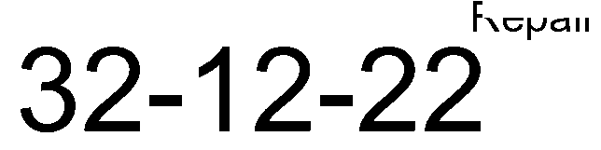

**sSAFRAN SAFRAN LANDING SYSTEMS UK Ltd**

CAGE: K0654

PART No. 201587001 AND 201587002 COMPONENT MAINTENANCE MANUAL  
MAIN LANDING GEAR LEG

1. Apply paint locally to the main fitting: refer to PCS-2500 and REPAIR.
2. Install the repaired shock absorber subassembly in the main fitting at the applicable  
   assembly stage: refer to ASSEMBL .
3. Identify the main fitting with the Messier-Dowty Limited repair number 450267370  
   adjacent to the part number: refer to PCS-6000-04.
4. Examine the part to make sure that you have obeyed all the repair instructions correctly

Lower Bearing Subassembly Details

Table 1

|  |  |  |  |  |  |
| --- | --- | --- | --- | --- | --- |
|  | Bore Diameter A | | Bore Diameter B | |  |
|  | Machined Diameter A mm (in) | After honing and chromium plating mm (in) | Machined Diameter B mm (in) | After honing and chromium plating mm (in) | Lower bearing subassembly |
| 1 | 212,138 to 212,194 (8.3519 to 8.3541) | 212,122 to 212,194 (8.3513 to 8.3541) | 209,027 to 209,088 (8.2294 to 8.2318) | 209,012 to 209,088 (8.2288 to 8.2318) | 450267371 |
| 2 | 212,288 to 212,344 (8.3578 to 8.3600) | 212,272 to 212,344 (8.3572 to 8.3600) | 209,177 to 209,238 (8.2353 to 8.2377) | 209,162 to 209,238 (8.2347 to 8.2377) | 450267373 |
| 3 | 212,438 to 212,494 (8.3637 to 8.3659) | 212,422 to 212,494 (8.3631 to 8.3659) | 209,327 to 209,388 (8.2412 to 8.2436) | 209,312 to 209,388 (8.2406 to 8.2436) | 450267375 |
| 4 | 212,588 to 212,644 (8.3696 to 8.3718) | 212,572 to 212,644 (8.3690 to 8.3718) | 209,477 to 209,538 (8.2471 to 8.2495) | 209,462 to 209,538 (8.2465 to 8.2495) | 450267377 |
| 5 | 212,738 to 212,794 (8.3755 to 8.3777) | 212,722 to 212,794 (8.3749 to 8.3777) | 209,627 to 209,688 (8.2530 to 8.2554) | 209,612 to 209,688 (8.2524 to 8.2554) | 450267379 |
| 6 | 213,129 to 213,185 (8.3909 to 8.3931) | 213,113 to 213,185 (8.3902 to 8.3931) | 209,627 to 209,688 (8.2530 to 8.2554) | 209,612 to 209,688 (8.2524 to 8.2554) | 450267381 |
| 7 | 213,429 to 213,485 (8.4027 to 8.4049) | 213,413 to 213,485 (8.4020 to 8.4049) | 209,627 to 209,688 (8.2530 to 8.2554) | 209,612 to 209,688 (8.2524 to 8.2554) | 450267383 |

Oversize Lower Bearing Subassembly  
Table 2

|  |  |
| --- | --- |
| PRE SB 200-32-58 Part Number | POST SB 200-32-58 Part Number |
| 450266261 | 450267371 |
| 450266262 | 450267373 |
| 450266263 | 450267375 |
| 450266264 | 450267377 |
| 450266265 | 450267379 |
| 450266266 | 450267381 |
| 450266267 | 450267383 |

Repair No. 11-26

32-12-22

Page 603

Mar 15/2024

**SAFRAN LANDING SYSTEMS UK Ltd**

CAGE: K0654



PART No. 201587001 AND 201587002 COMPONENT MAINTENANCE MANUAL  
MAIN LANDING GEAR LEG

Z

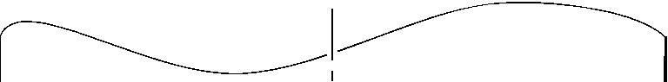

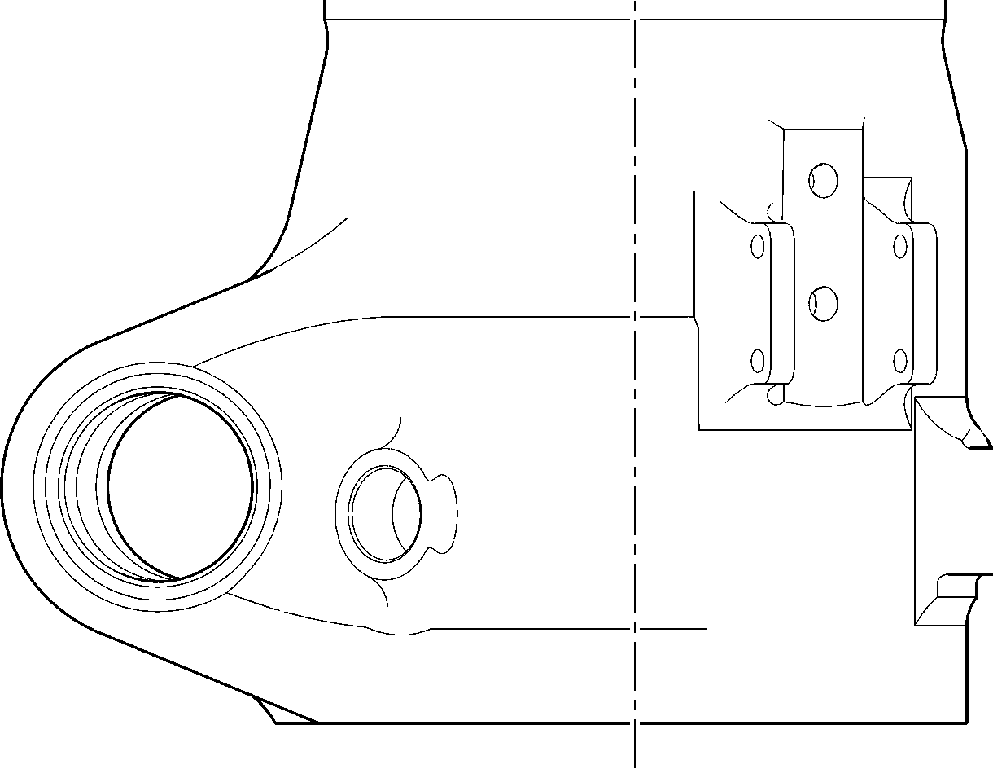

Z

A321A6881-1

Repair to Main Fitting  
Figure 601

32-12-22

Repair No. 11-26

Page 604

Dec 6/2019

**SAFRAN LANDING SYSTEMS UK Ltd**

CAGE: K0654



PART No. 201587001 AND 201587002 COMPONENT MAINTENANCE MANUAL  
MAIN LANDING GEAR LEG

19,75 to 20,25mm  
(0.778 to 0.797 in)  
RADIUS

183,00mm (7.205in)

MIN.EXTENT OF FINE LIMIT  
REMAINDER MAY BE  
dia. B -0,254mm (0.0100in)

**Y**

dia. B

55,00mm (2.165in)  
MIN. EXTENT OF

5,60mm (0.220in)  
X 15 DEGREES  
CHAMFER

15

DEGREES

99,75 to 100,50mm  
(3.927 to 3.957in)

dia. A -0,254mm (0.0100in)

FINE LIMIT 1,6

REMAINDER MAY BE H (6,3)

A -0254mm (0 0100in)

5,00 to 10,00mm  
(0.197 to 0.394in)

EXTENT OF  
CHROMIUM  
PLATE FADE OUT

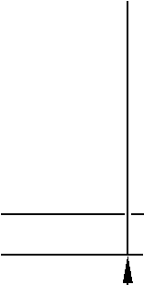

9,00 to 11,00mm

0.354 to 0.433in)  
RADIUS

198,25 to 199,00mm  
(7.805 to 7.835in)  
THIN CHROMIUM PLATE

~~dia. A~~

|  |  |  |
| --- | --- | --- |
| **©** | 0,05mm (0.002in) | **Y** |

A321A6882-2

Repair to Main Fitting - Machining  
Figure 602

Repair No. 11-26

32-12-22

Page 605

Mar 15/2024

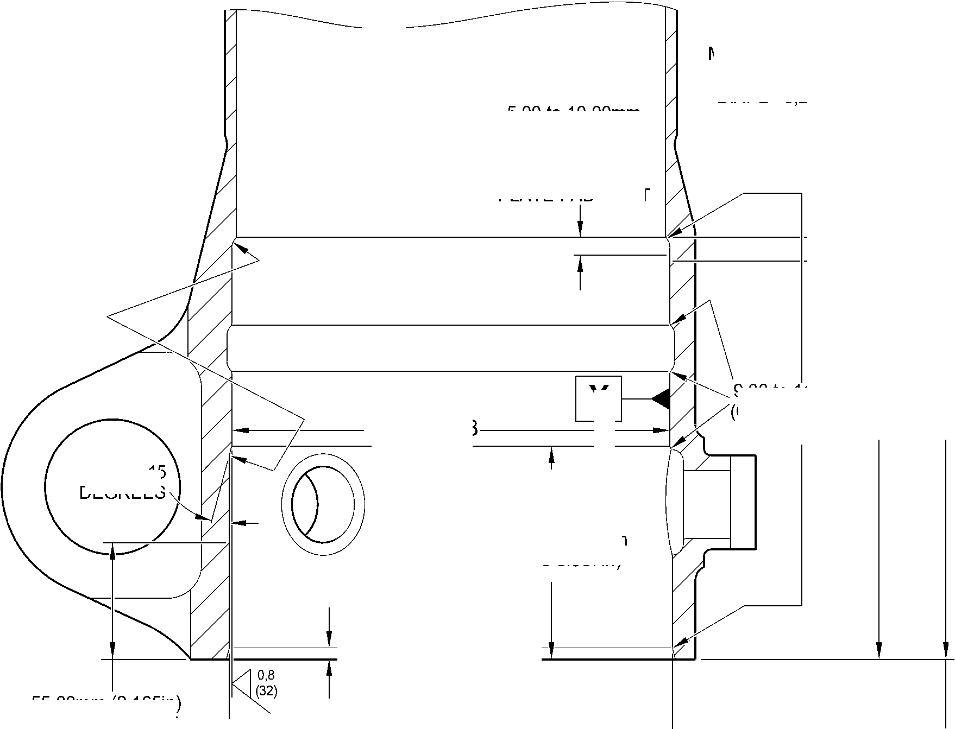

**SAFRAN LANDING SYSTEMS UK Ltd**

CAGE: K0654



PART No. 201587001 AND 201587002 COMPONENT MAINTENANCE MANUAL  
MAIN LANDING GEAR LEG

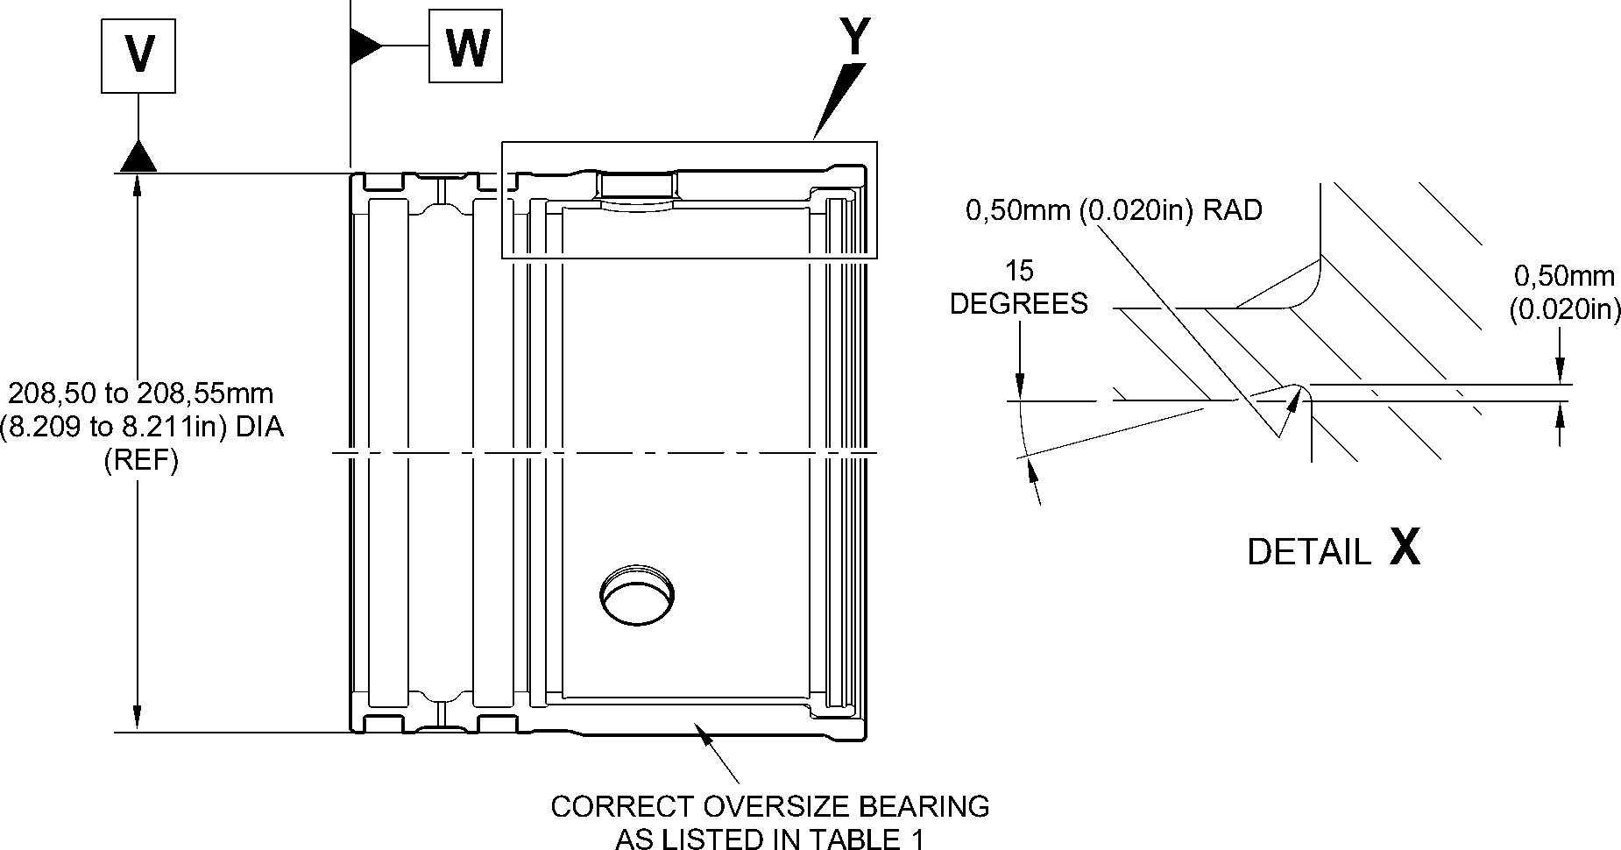

92,85 to 93,00mm

(3.656 to 3.661in)

**X**

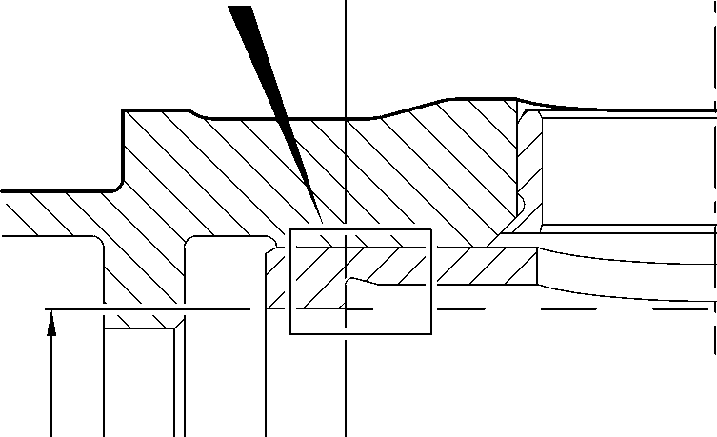

**X**

64,650 to 64,775mm

(2.5453 to 2.5502in)

178,87 to 179,07mm 182,453 to 182,516mm

(7.042 to 7.050in) DIA (7.1832 to 7.1857in) DIA

DETAIL **Y**



0,025mm  
(0.0010in)

0,040mm  
(0.0015in) DIA

**W**

0.333 to 0.867  
DEGREES

MODIFIED REPAIR LOWER  
BEARING SUBASSEMBLY

DETAIL **Y**

WITH INNER LINER

NEW INNER LINER

201646300

A321A6964-2

Lower Bearing Subassembly Machining and Liner Installation

Figure 603

32-12-22

Repair No. 11-26

Page 606

Mar 15/2024

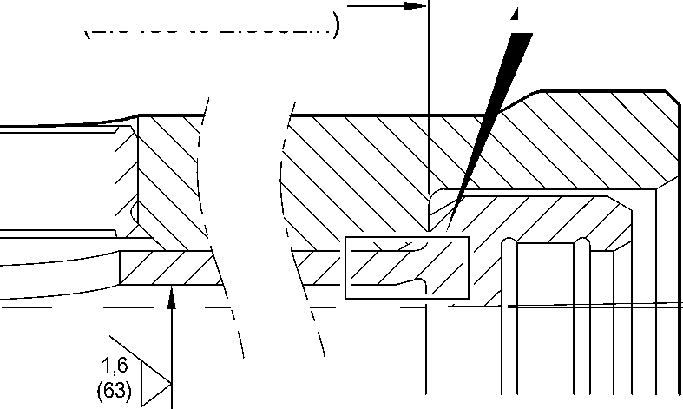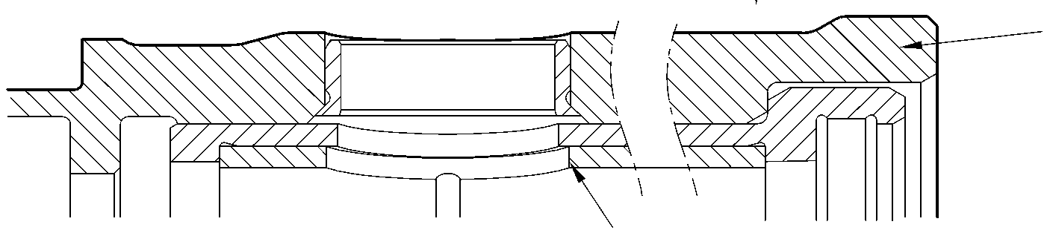

**sSAFRAN SAFRAN LANDING SYSTEMS UK Ltd**

CAGE: K0654

PART No. 201587001 AND 201587002 COMPONENT MAINTENANCE MANUAL  
MAIN LANDING GEAR LEG

I 1. Repair No. 11-27 Main Fitting (20-410, 20-410A, 20-420 and 20-420A)

1. Specified Damage and Material Specification
2. Specified Damage

(a) Damage or wear to diameter A and/or face B.

1. Material Specification

|  |  |  |
| --- | --- | --- |
| IPL Figure and Item No. | Name | Material Specification |
| 20-410, 20-410A, 20-420 and 20-420A | Main Fitting | Steel, MAT135, 35NCD16THQ |

1. Special Tools
2. These special tools are necessary:

**NOTE: Alternative equivalents are permitted.**

|  |  |  |
| --- | --- | --- |
| Tool Part No. | Special Tool | Function |
| 460006614 | Assembly tool | Install the bearing |

1. Materials
2. These materials are necessary:

**NOTE: Alternative equivalents are permitted.**

|  |  |
| --- | --- |
| Ref. Item | Material |
| TBA | Zinc |
| 05-533 | MastinoxD40 |
| 09-510A | Sealant |

1. Repair Parts

(1) These repair parts are necessary:

**NOTE: Alternative equivalents are permitted.**

|  |  |  |
| --- | --- | --- |
| Part No. | Repair Part | Material Specification |
| 450266337 | Repair Bearing | AMS 4881 or AMS 4590 |

1. Procedure (Refer to Figures 601 and 602)

**CAUTION: FOR DAMAGE MORE THAN THE LIMITS OF THIS REPAIR SCHEME, WRITE  
TO SAFRAN LANDING SYSTEMS: REFER TO GUIDE-CS-001.**

1. Machine diameter A and/or face B sufficiently to remove the damage or wear within the  
   dimensions shown: refer to M-DLPS1004-4-1 and Figure 601. Make the surface finish  
   1,6 micrometers (63 micro-inches).

Repair No. 11-27

32-12-22

Page 601

Mar 18/2025

**sSAFRAN SAFRAN LANDING SYSTEMS UK Ltd**

CAGE: K0654

PART No. 201587001 AND 201587002 COMPONENT MAINTENANCE MANUAL  
MAIN LANDING GEAR LEG

1. Machine the radii and chamfer as the dimensions shown: refer to Figure 601.
2. Measure and record the new diameter A and length C.
3. Examine the reworked area for flaws: refer to PCS-3600 and PCS-3100, inclusion  
   class 4.
4. Shot peen the machined surfaces: refer to M-DLPS123.
5. Apply cadmium plate to the machined areas: refer to PCS-2100 or PCS-2141.The  
   cadmium plate thickness must be between 0,01 and 0,02 mm (0.004 and 0.008 in).
6. Identify the part with the Safran Landing Systems repair number 450266040 adjacent to  
   the part number: refer to PCS-6000-04, an alternative reference is PCS-6000-06. If the  
   alternative reference is used, the characters must be 0,051 to 0,102 mm (0.0020 to  
   0.0040 in) deep and approximately 3,00 mm (0.118 in) high.
7. Calculate the dimensions for the repair bush, use formula:

Diameter D = Diameter A (as measured) + 0.069 to 0.126 mm (0.0027 to 0.0049 in)  
Length E = Length C (as measured) + 2,25 to 3,00 mm (0.089 to 0.118 in).

1. Machine the repair bearing to the dimensions shown and calculated: refer to Figure 602.  
   Make the surface finish 1,6 micrometers (63 micro-inches).
2. Apply cadmium plate all over the repair bearing except the bore and the internal  
   grooves: refer to PCS-2101. The cadmium plate thickness must be between 0,01 and  
   0,015 mm (0.0004 and 0.0006 in).
3. Use Assembly Tool 460006614 and install the repair bearing: refer to PCS-5100. Use  
   electrically conducting Mastinox (made from Mastinox D40, Material Ref. Item 05-533  
   and Zinc powder, Material Ref. Item TBA).
4. Check ream the repair bearing bore to the dimensions shown: refer to Figure 602.
5. Apply a bead of sealant, Material Ref. Item 09-510A to joints between the repair bearing  
   and the main fititng: refer to PCS-7200 and Figure 602.
6. Identify the part with the Safran Landing Systems repair number 450266040 adjacent to  
   the part number: refer to PCS-6000-07.
7. Examine the part to make sure that you have obeyed all the repair instructions correctly.

32-12-22

Repair No. 11-27

Page 602

Mar 18/2025

**SAFRAN LANDING SYSTEMS UK Ltd**

CAGE: K0654



PART No. 201587001 AND 201587002 COMPONENT MAINTENANCE MANUAL  
MAIN LANDING GEAR LEG

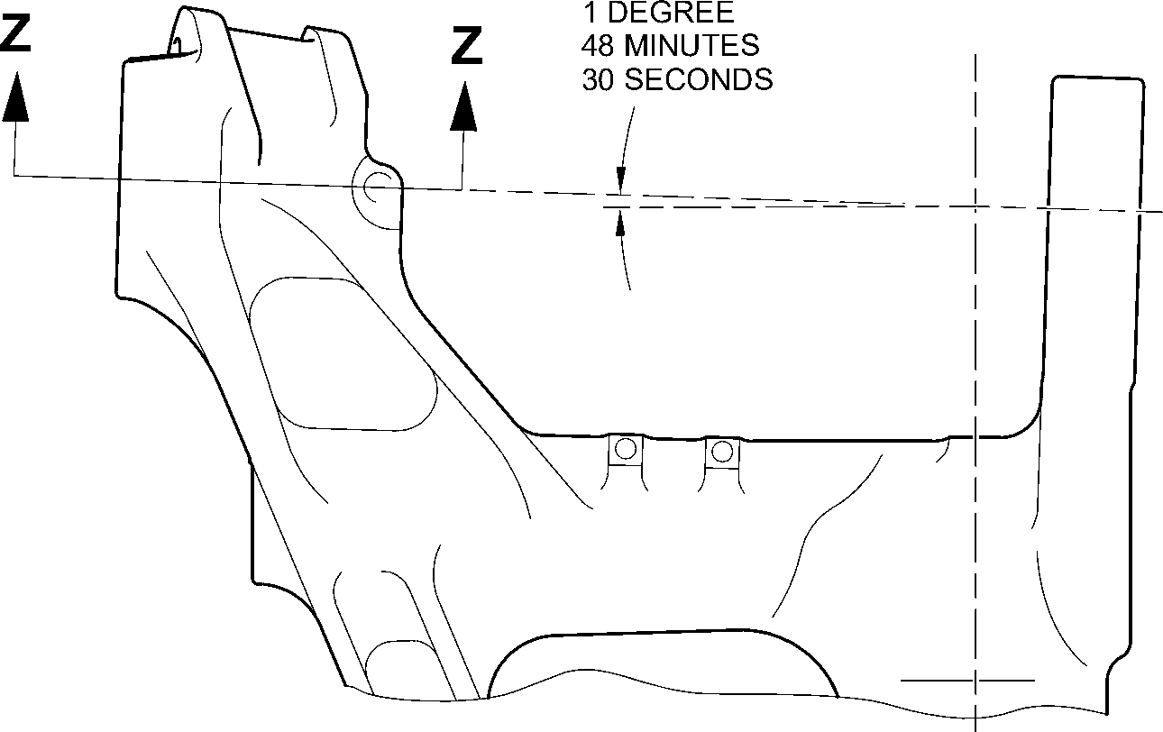

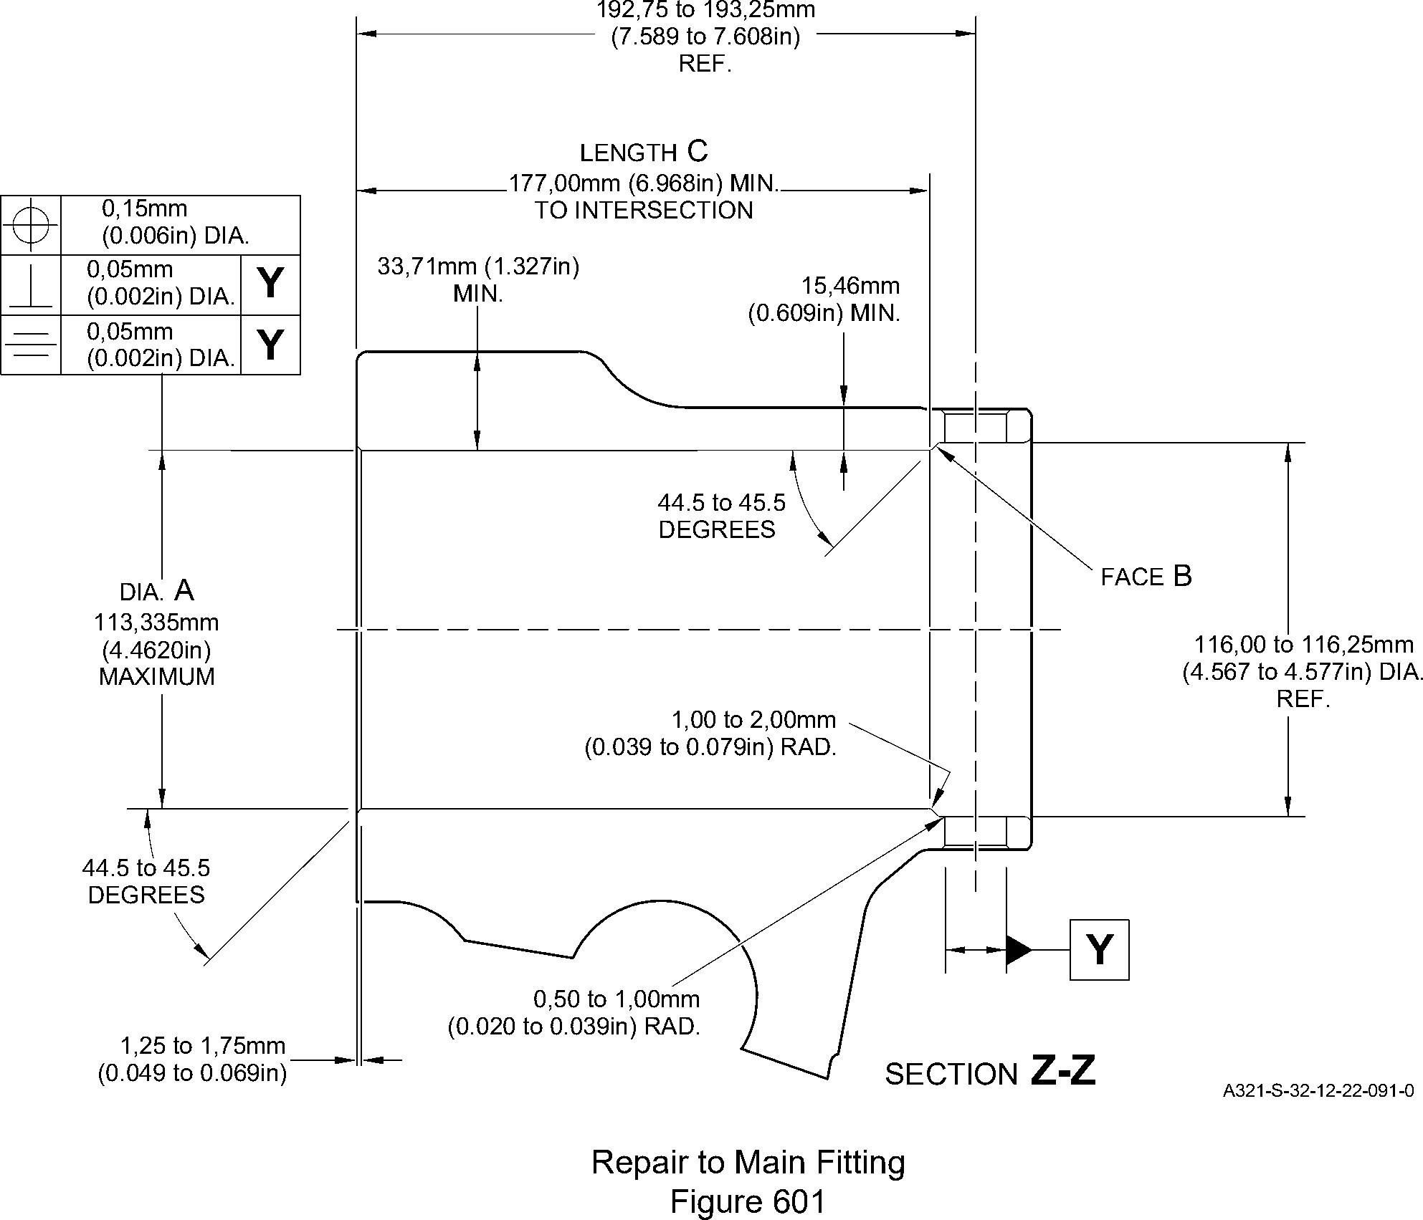

Page 603

Mar 24/2017

Repair No. 11-27

32-12-22

**SAFRAN LANDING SYSTEMS UK Ltd**

CAGE: K0654



PART No. 201587001 AND 201587002 COMPONENT MAINTENANCE MANUAL  
MAIN LANDING GEAR LEG

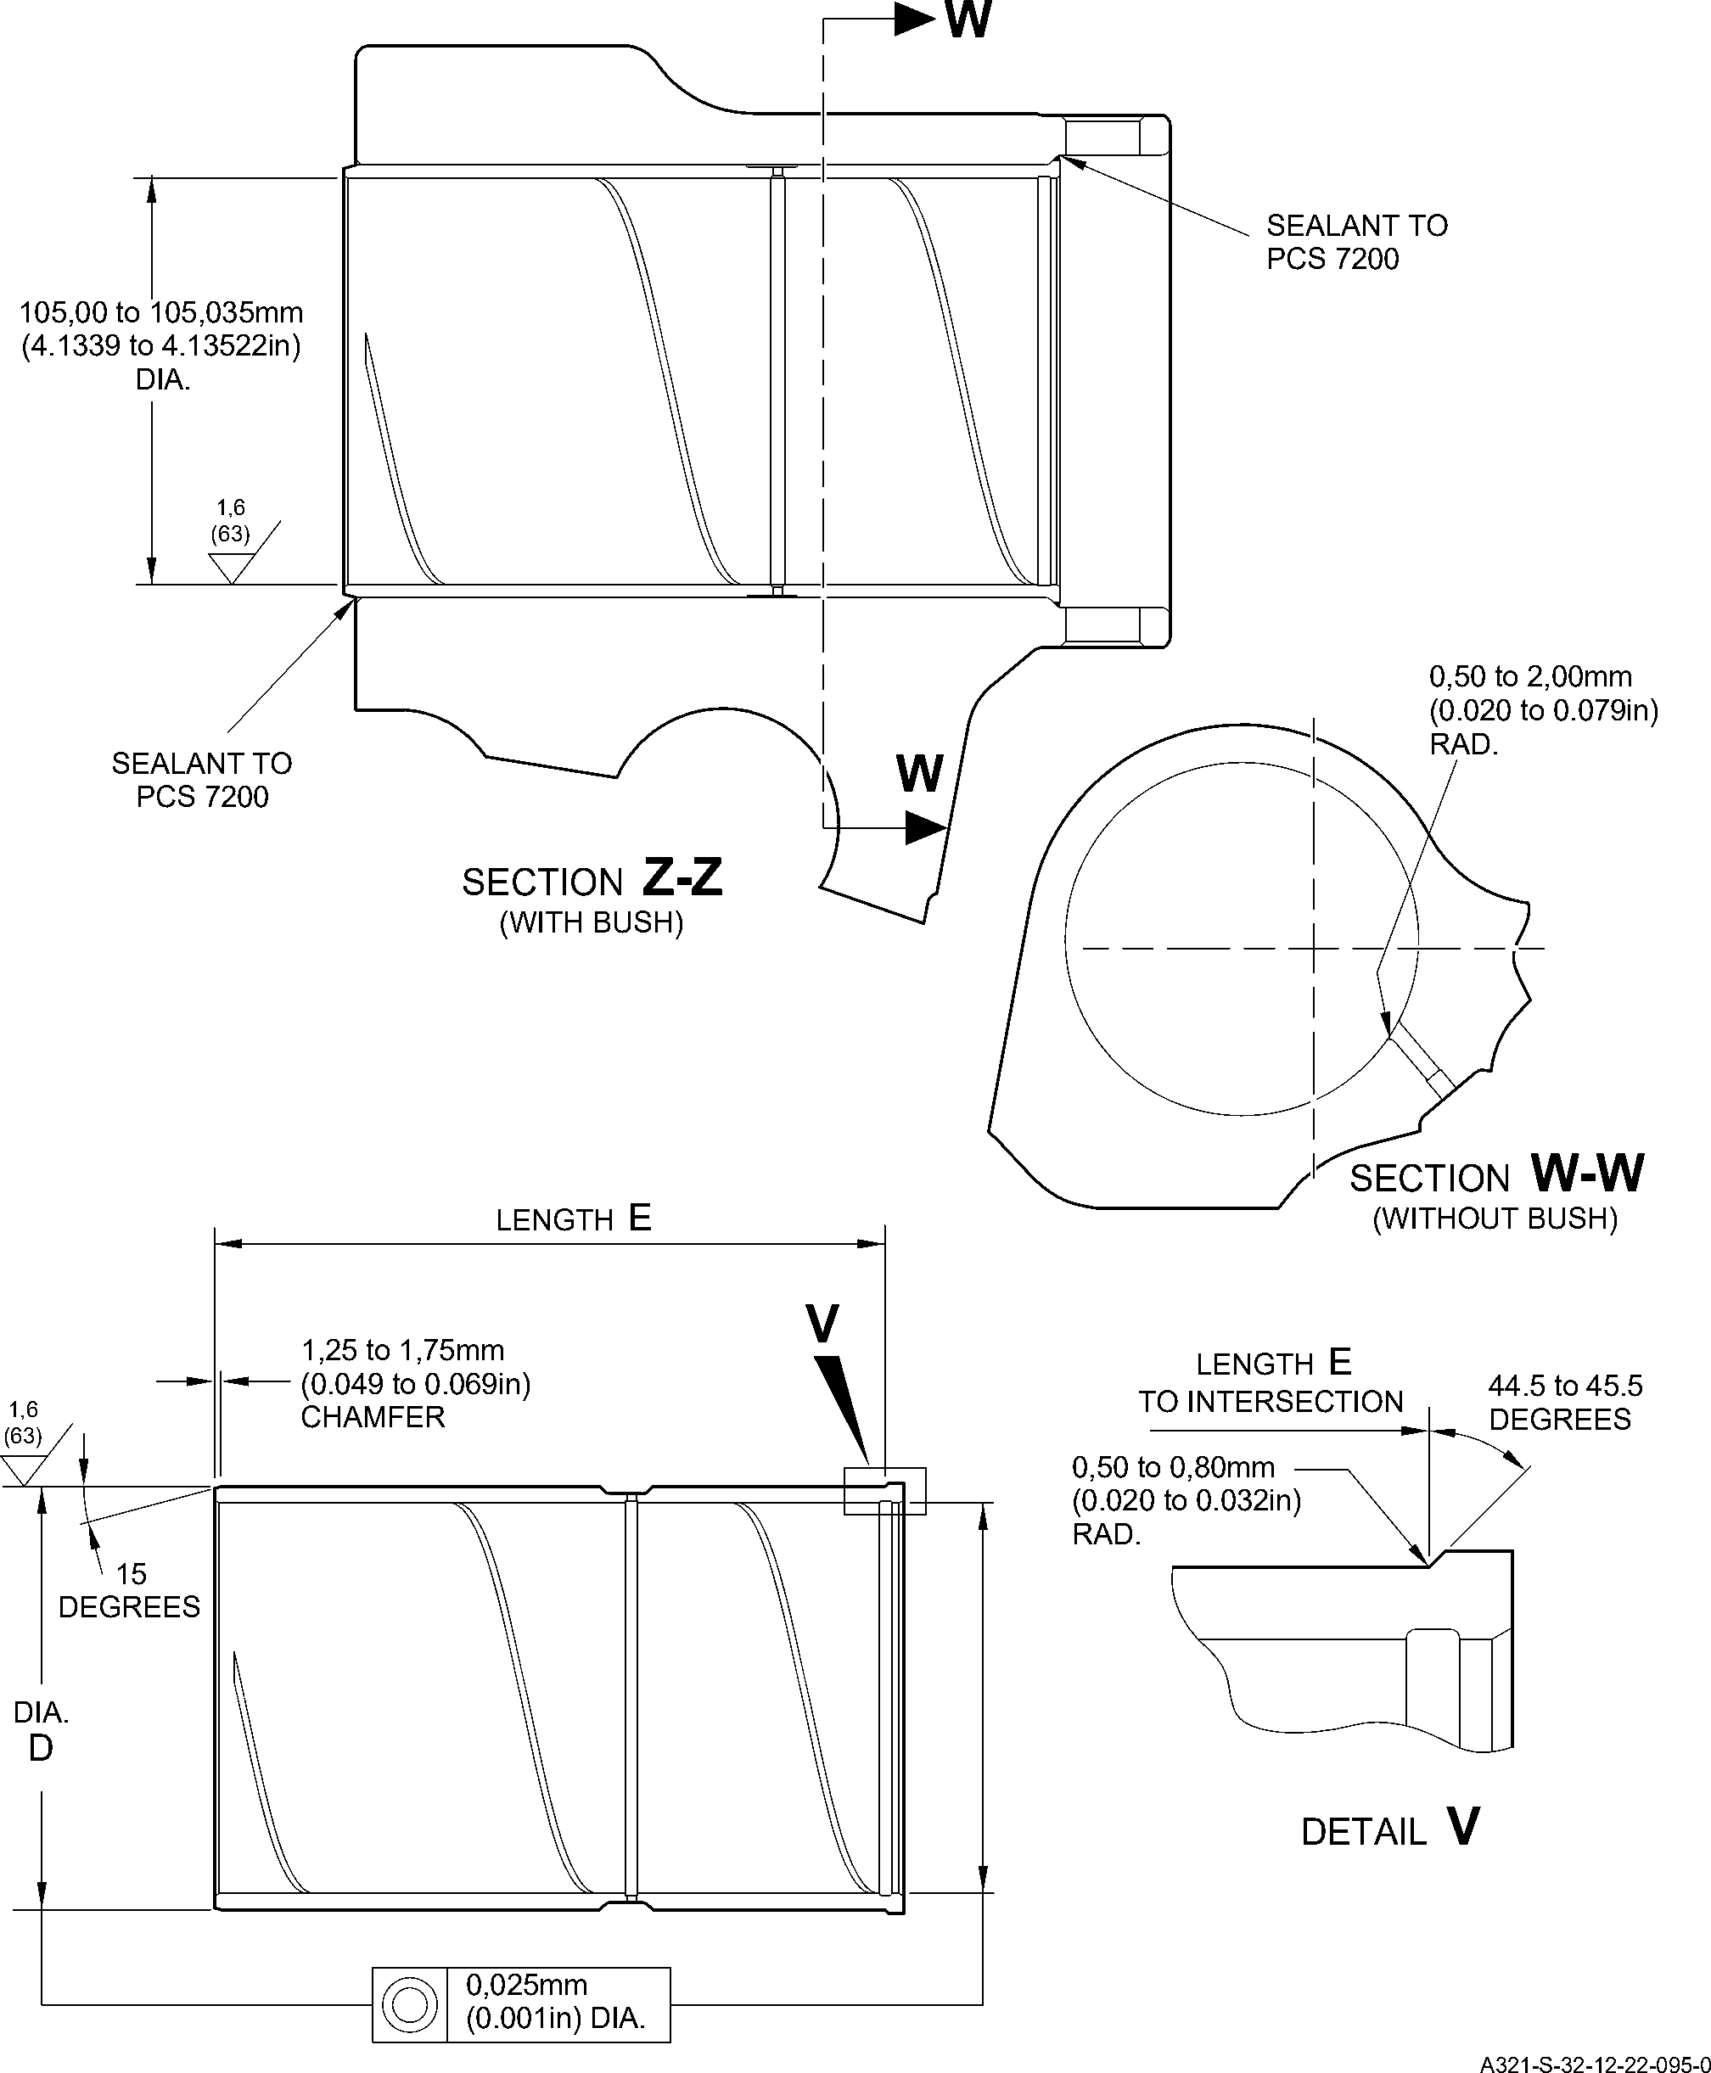

Repair Bearing - Machining and Installation

Figure 602

Repair No. 11-27

32

Page 604

-12-22 Mar 24/2017

**SAFRAN LANDING SYSTEMS UK Ltd**

CAGE: K0654



PART No. 201587001 AND 201587002 COMPONENT MAINTENANCE MANUAL  
MAIN LANDING GEAR LEG

I 1. Repair No. 11-28 Main Fitting (20-410, 20-410A, 20-420 and 20-420A)

1. Specified Damage and Material Specification
2. Specified Damage

(a) Damage or wear to diameters A and/or C.

1. Material Specification

|  |  |  |
| --- | --- | --- |
| IPL Figure and Item No. | Name | Material Specification |
| 20-410, 20-410A, 20-420 and 20-420A | Main Fitting | Steel, MAT135, 35NCD16THQ |

1. Special Tools
2. Special tools are not necessary.
3. Materials
4. Materials are not necessary.
5. Repair Parts
6. These repair parts are necessary:

**NOTE: Alternative equivalents are permitted.**

|  |  |  |
| --- | --- | --- |
| Part No. | Repair Part | Material Specification |
| MS28774-012 | 1st Oversize backing ring | - |
| MS28774-013 | 2nd Oversize backing ring | - |
| MS28775-012 | 1st Oversize O-ring | - |
| MS28775-013 | 2nd Oversize O-ring | - |
| 450239351 | 1st Oversize transfer dowel | Aluminium alloy L168-T6511 |
| 450239352 | 2nd Oversize transfer dowel | Aluminium alloy L168-T6511 |

1. Procedure (Refer to Figures 601 and 602)

**CAUTION: FOR DAMAGE MORE THAN THE LIMITS OF THIS REPAIR SCHEME, WRITE  
TO SAFRAN LANDING SYSTEMS: REFER TO GUIDE-CS-001.**

1. Do this procedure if there is damage or wear to diameter A:
2. Machine diameter A sufficiently to remove the damage or wear to the nearest  
   possible dimensions as shown in Table 601: refer to M-DLPS1004-4-1 and  
   Figure 602. Make the surface finish 1,6 micrometers (63 micro-inches).
3. Examine the reworked area for flaws: refer to PCS-3100, inclusion class 4 and  
   PCS-3600.

Repair No. 11-28

32-12-22

Page 601

Mar 18/2025

**sSAFRAN SAFRAN LANDING SYSTEMS UK Ltd**

CAGE: K0654

PART No. 201587001 AND 201587002 COMPONENT MAINTENANCE MANUAL  
MAIN LANDING GEAR LEG

1. Identify the part with Safran Landing Systems repair number 450266405A for 1stoversize or 450266405B for 2nd oversize adjacent to the part number: refer to  
   PCS-6000-04 or PCS-6000-06.
2. Select the applicable oversize transfer dowel, oversize O-ring and oversize  
   backing ring: refer to Table 601.
3. Install the selected oversize parts to the main fitting: refer to Figure 603.
4. Apply paint to external surfaces, but not to the dowel bores: refer to PCS-2500.
5. Identify the part with Safran Landing Systems repair number 450266405A for  
   1st oversize or 450266405B for 2nd oversize adjacent to the part number: refer to  
   PCS-6000-07.
6. Examine the part to make sure that you have obeyed all the repair instructions  
   correctly.

Oversize dimensions  
Table 601

|  |  |  |  |  |  |
| --- | --- | --- | --- | --- | --- |
| Oversize | Diameter A mm (in) | Diameter B mm (in) | Oversize  Transfer dowel Part No. | Oversize O-ring Part No. | Oversize Backing ring Part No. |
| 1 | 12,3190 to 12,3444 (0.4850 to 0.4860) | 13,65 (0.537) | 450239351 | MS28775-012 | MS28774-012 |
| 2 | 13,9700 to 14,0208 (0.5500 to 0.5520) | 15,37 (0.605) | 450239352 | MS28775-013 | MS28774-013 |

1. Do this procedure, if there is damage or wear to diameter C:
2. Machine diameter C sufficiently to remove the damage or wear to the nearest  
   possible dimensions as shown in Table 602: refer to M-DLPS1004-4-1 and  
   Figure 602. Make the surface finish 1,6 micrometers (63 micro-inches).
3. Examine the reworked area for flaws: refer to PCS-3100, inclusion class 4 and  
   PCS-3600.
4. Identify the part with Safran Landing Systems repair number 450266405D for  
   1st oversize or 450266405E for 2nd oversize adjacent to the part number: refer to  
   PCS-6000-04 or PCS-6000-06.
5. Select the applicable oversize transfer dowel, oversize O-ring and oversize  
   backing ring: refer to Table 602.
6. Install the selected oversize parts to the main fitting: refer to Figure 603.
7. Apply paint to external surfaces, but not to the dowel bores: refer to PCS-2500.
8. Identify the part with Safran Landing Systems repair number 450266405D for  
   1st oversize or 450266405E for 2nd oversize adjacent to the part number: refer to  
   PCS-6000-07.

32-12-22

Repair No. 11-28

Page 602

Mar 18/2025

**SAFRAN LANDING SYSTEMS UK Ltd**

CAGE: K0654



PART No. 201587001 AND 201587002 COMPONENT MAINTENANCE MANUAL  
MAIN LANDING GEAR LEG

1. Examine the part to make sure that you have obeyed all the repair instructions  
   correctly.

Oversize dimensions  
Table 602

|  |  |  |  |  |  |
| --- | --- | --- | --- | --- | --- |
| Oversize | Diameter C mm (in) | Diameter D mm (in) | Oversize Transfer dowel Part No. | Oversize O-ring Part No. | Oversize Backing ring Part No. |
| 1 | 12,3190 to 12,3444 (0.4850 to 0.4860) | 13,65 (0.537) | 450239351 | MS28775-012 | MS28774-012 |
| 2 | 13,9700 to 14,0208 (0.5500 to 0.5520) | 15,37 (0.605) | 450239352 | MS28775-013 | MS28774-013 |

Repair No. 11-28

32-12-22

Page 603

Dec 6/2019

**SAFRAN LANDING SYSTEMS UK Ltd**

CAGE: K0654

43,00mm  
(1.693in)  
CRS

Y

(REFER TO FIGURE 602)

Y

X

Z

detail Z

146,00 to 147,00mm  
(5.748 to 5.787in)

X

(REFER TO FIGURE 602)

PART No. 201587001 AND 201587002 COMPONENT MAINTENANCE MANUAL

MAIN LANDING GEAR LEG

A321A7163-1

Repair to Main Fitting  
Figure 601

32-12-22

Repair No. 11-28

Page 604

Dec 6/2019

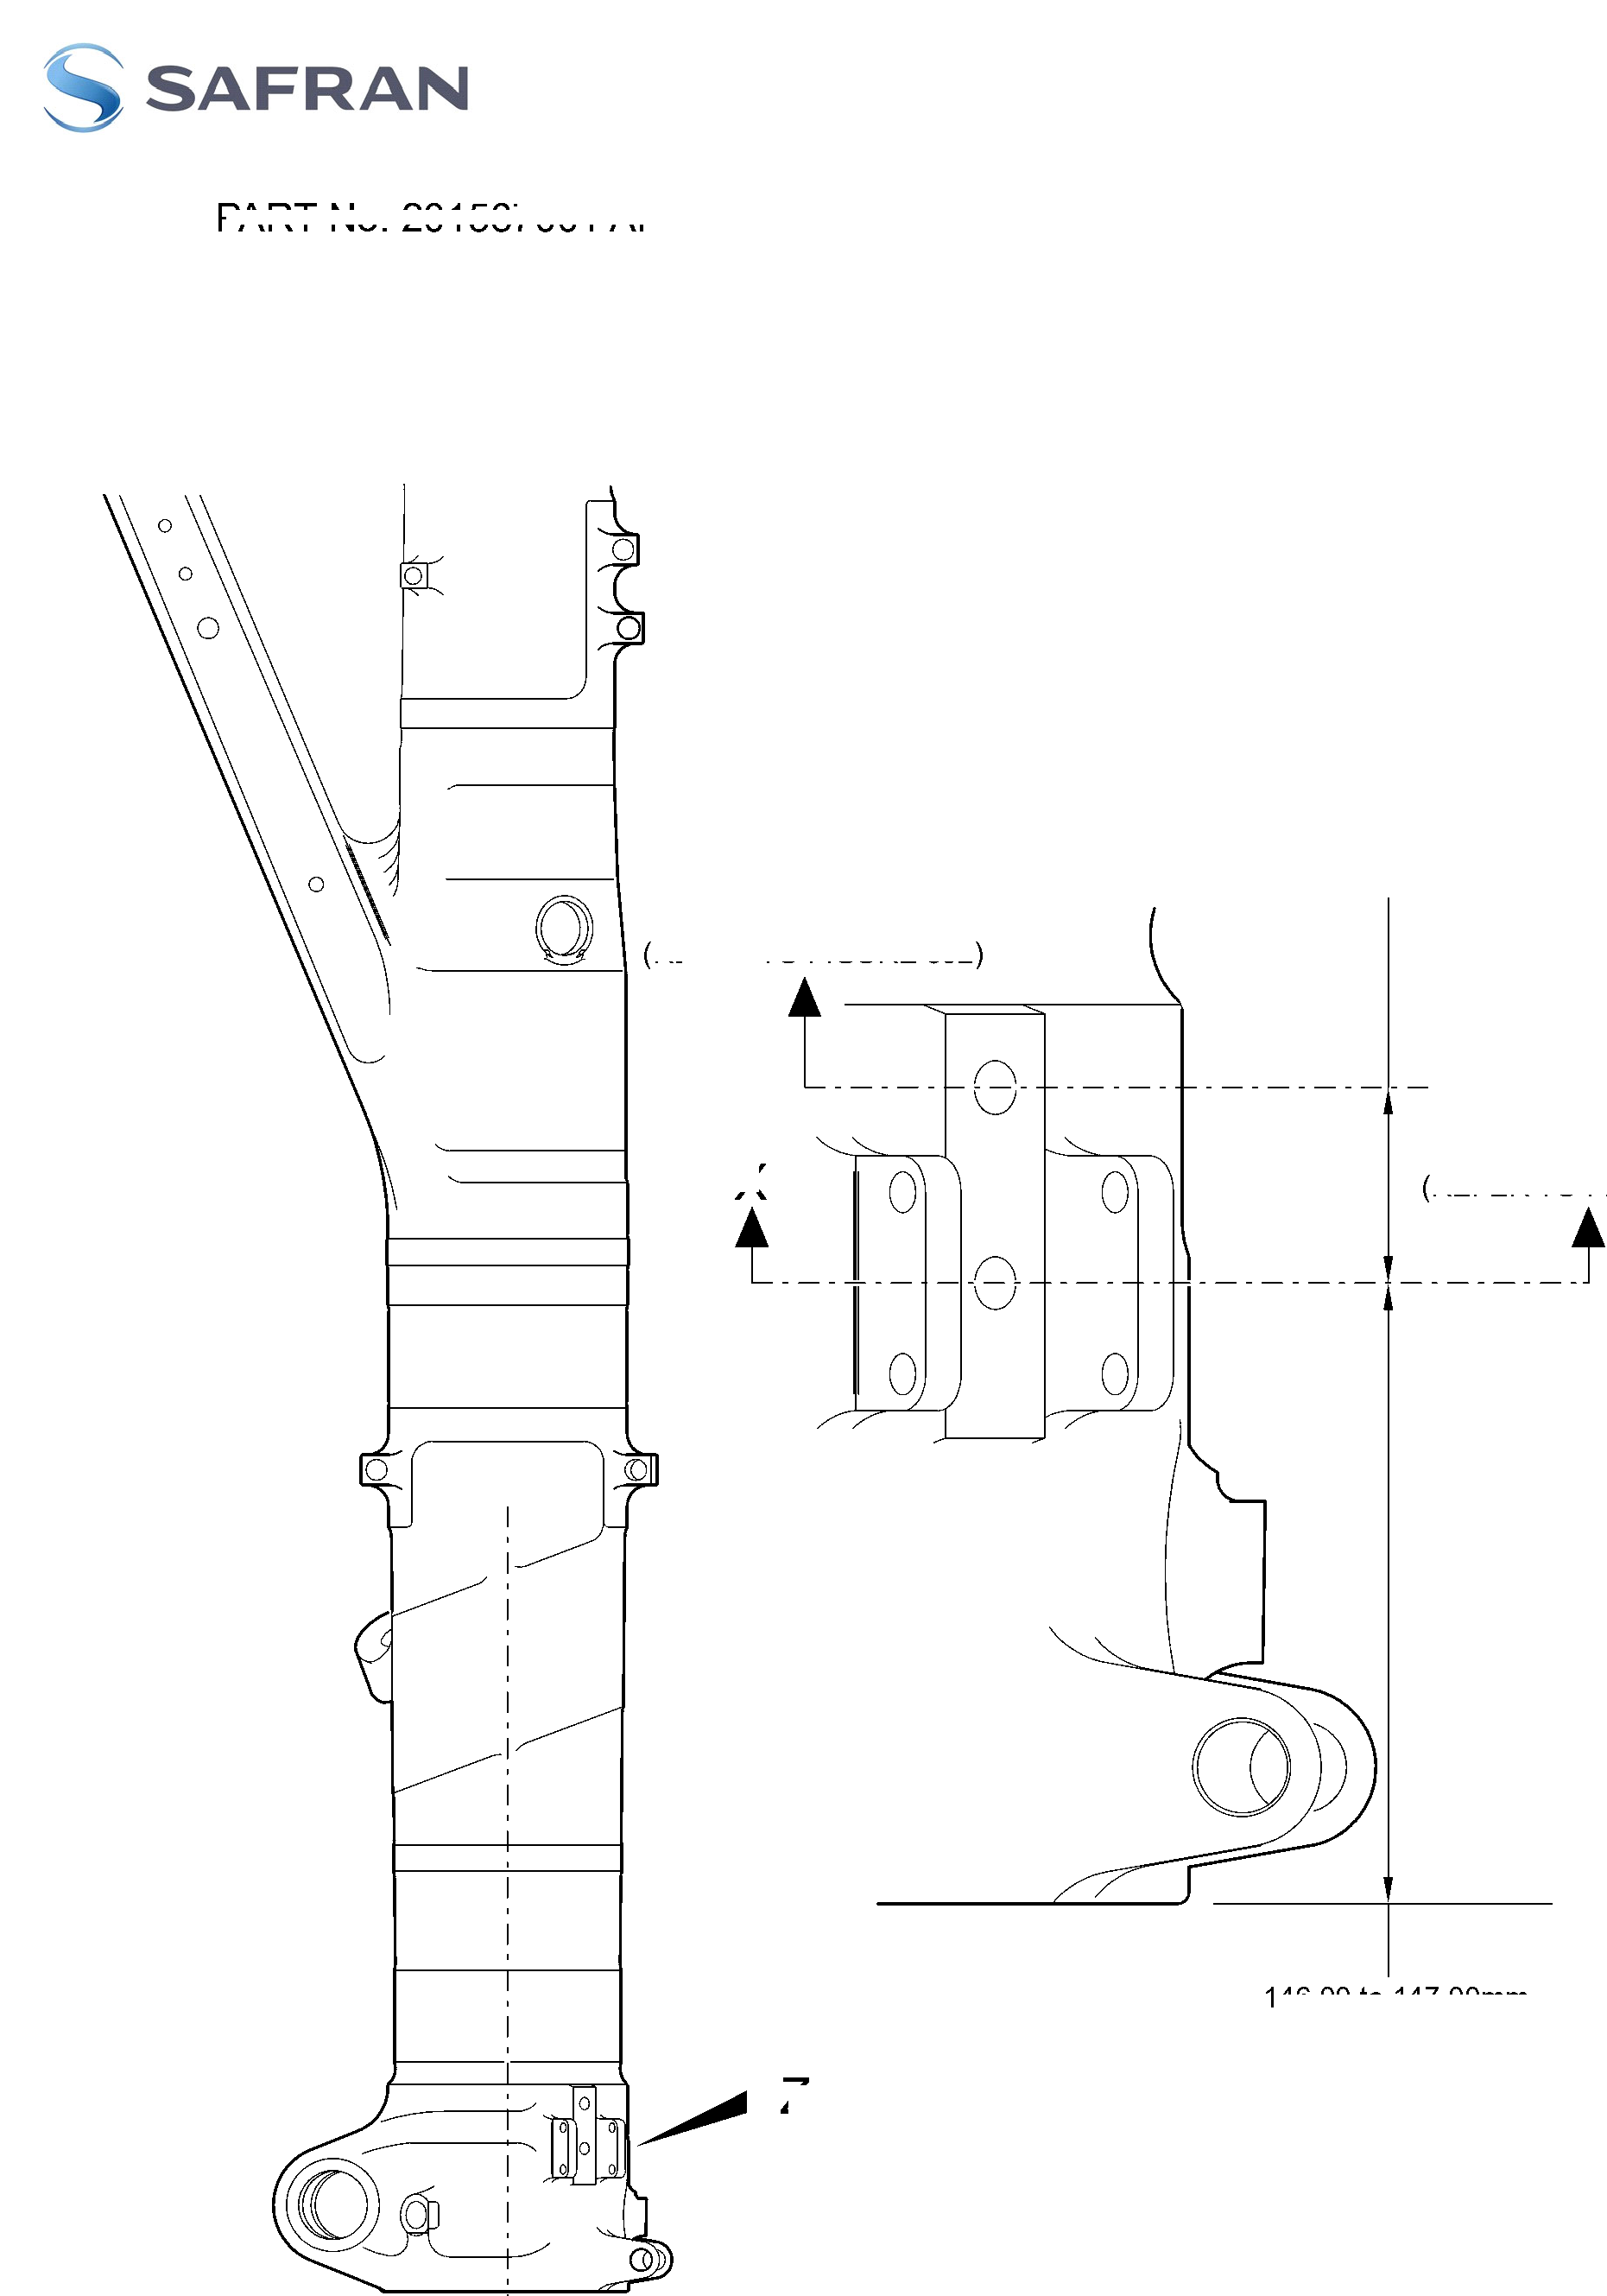

**SAFRAN LANDING SYSTEMS UK Ltd**

CAGE: K0654



PART No. 201587001 AND 201587002 COMPONENT MAINTENANCE MANUAL  
MAIN LANDING GEAR LEG

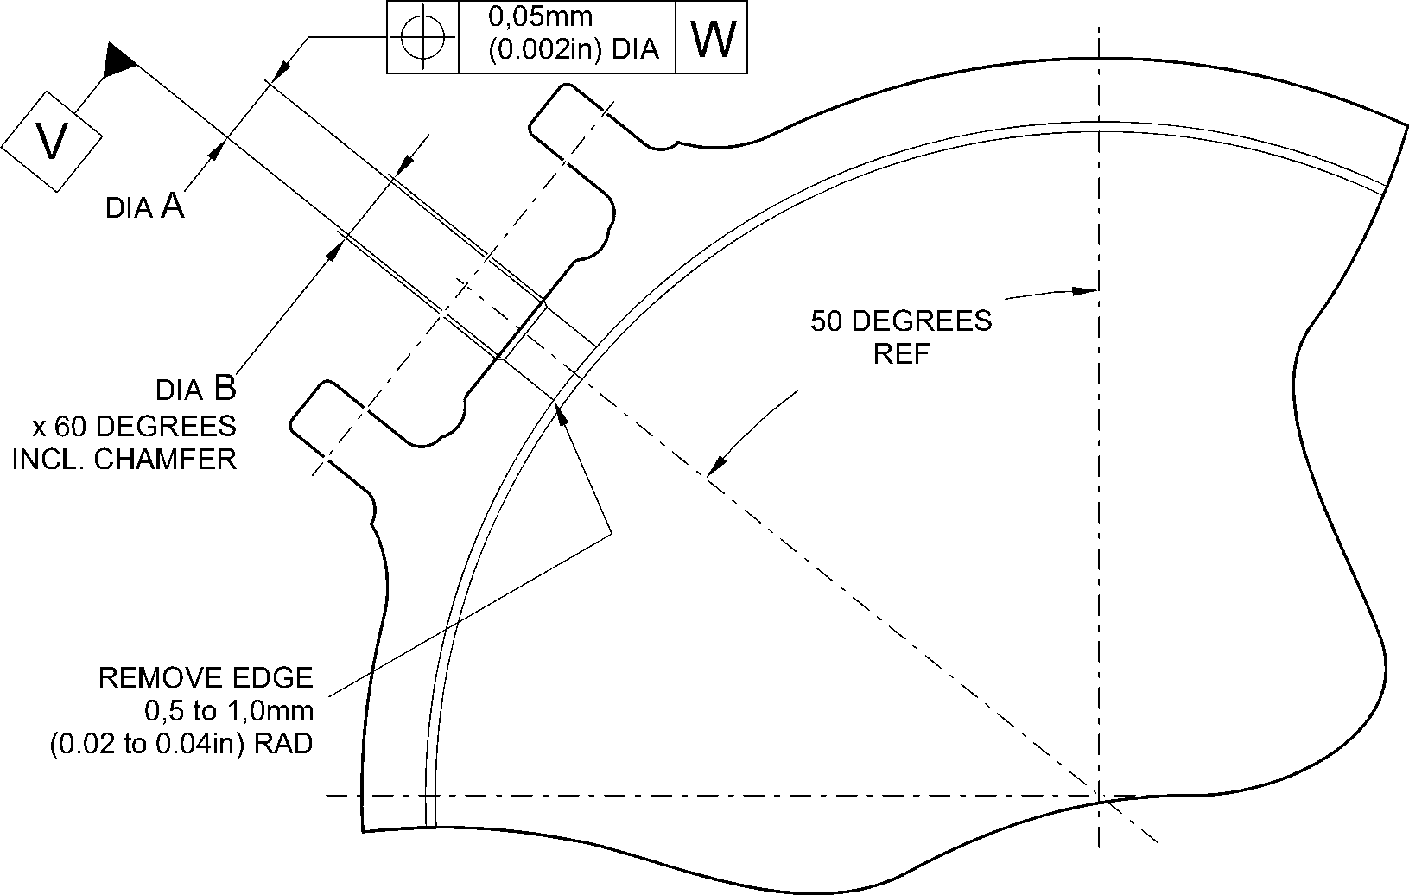

section X-X

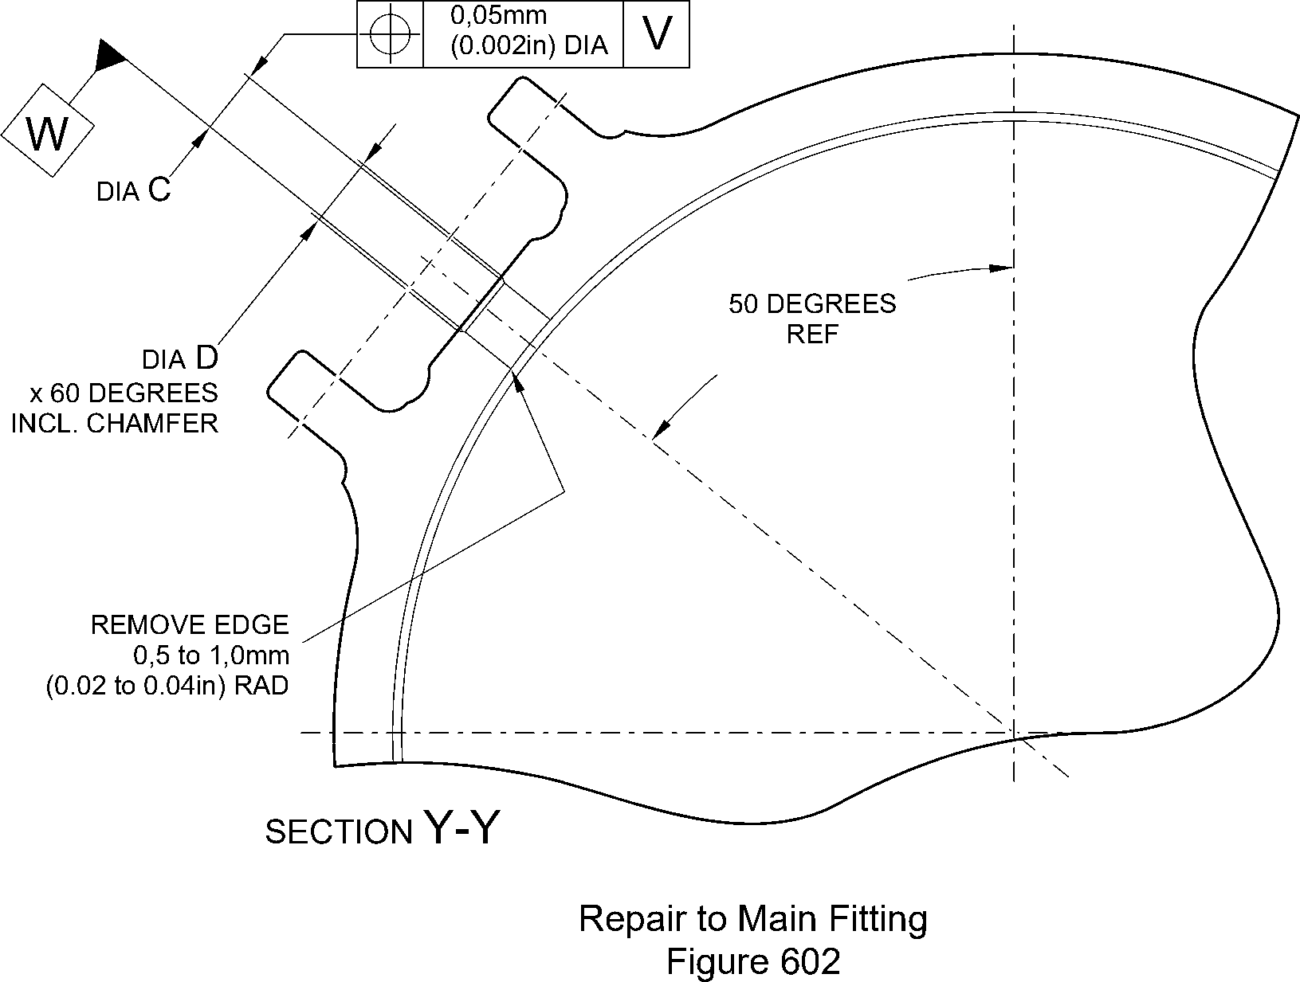

A321A7164-1

Repair No. 11-28

32-12-22

Page 605

Dec 6/2019

**SAFRAN LANDING SYSTEMS UK Ltd**

CAGE: K0654



PART No. 201587001 AND 201587002 COMPONENT MAINTENANCE MANUAL  
MAIN LANDING GEAR LEG

OVERSIZE TRANSFER DOWEL

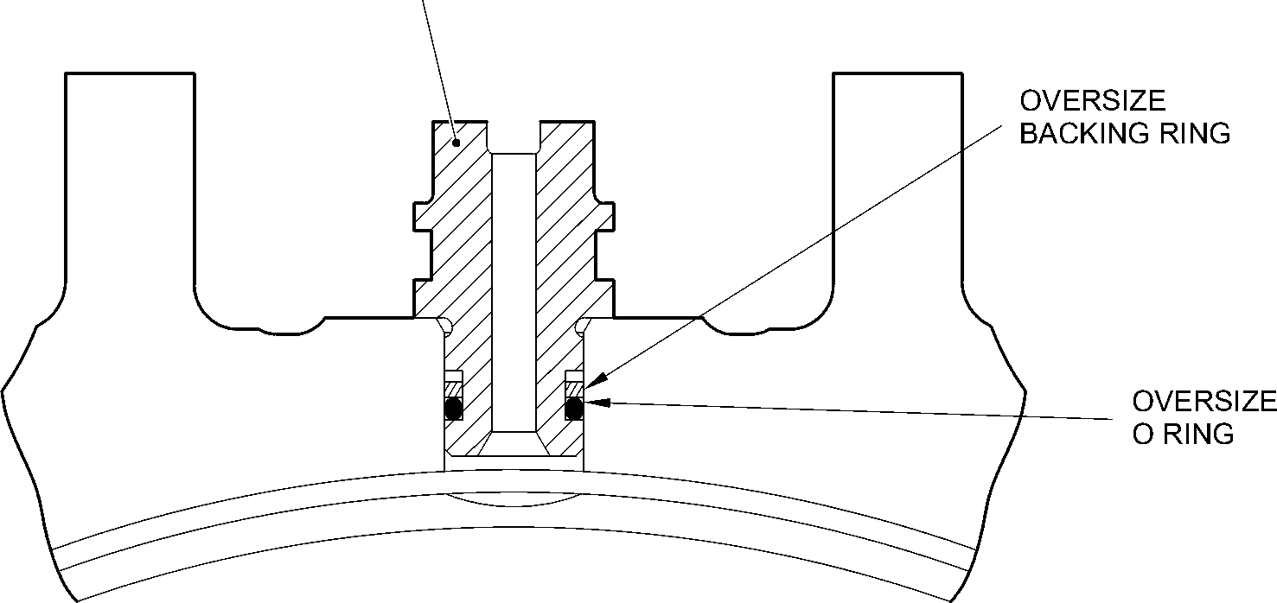

TYPICAL INSTALLATION OF

OVERSIZE COMPONENTS

A321A7181-1

Oversize Transfer Dowel - Installation  
Figure 603

32-12-22

Repair No. 11-28

Page 606

Dec 6/2019

**sSAFRAN SAFRAN LANDING SYSTEMS UK Ltd**

CAGE: K0654

PART No. 201587001 AND 201587002 COMPONENT MAINTENANCE MANUAL  
MAIN LANDING GEAR LEG

1. Repair No. 11-29 Main Fitting (20-410A and 20-420A Only)
2. Specified Damage and Material Specification.
3. Specified Damage

(a) Damage or corrosion to the diameter(s) A and/or B.

1. Material Specification

|  |  |  |
| --- | --- | --- |
| IPL Figure and Item No. | Name | Material Specification |
| 20-410A and  20-420A Only | Main fitting | Steel, MAT135, 35NCD16THQ |

1. Special Tools
2. These special tools are necessary:

**NOTE: Alternative equivalents are permitted.**

|  |  |  |
| --- | --- | --- |
| Part No. | Special Tool | Function |
| 460006405 | Assembly Sleeve | Install the lower bearing subassembly |

1. Materials
2. None.
3. Repair Parts
4. These repair parts are necessary:

|  |  |  |
| --- | --- | --- |
| Part No. | Repair Part | Material Specification |
| 450266221 to  450266225 | Lower bearing subassembly (Option 1 - Pre SB 201-32-49) | - |
| 450266261 to  450266267 | Lower bearing subassembly (Option 2 - Post SB 201-32-49) | - |

1. Procedure (Refer to Figures 601, 602 and 603)

**CAUTION: FOR DAMAGE MORE THAN THE LIMITS OF THIS REPAIR SCHEME, WRITE  
TO MESSIER-DOWTY LIMITED: REFER TO GUIDE-CS-001.**

1. Do this procedure if there is damage or corrosion to the chromium plate on  
   diameter(s) A and/or B. The bare metal must not be damaged.
2. Remove the paint from the main fitting as necessary: refer to PCS-2700  
   and REPAIR.
3. Locally remove the chromium plate from diameter(s) A and/or B: refer to  
   PCS-2110.

Repair No. 11-29

32-12-22

Page 601

Dec 23/2022

**sSAFRAN SAFRAN LANDING SYSTEMS UK Ltd**

CAGE: K0654

PART No. 201587001 AND 201587002 COMPONENT MAINTENANCE MANUAL  
MAIN LANDING GEAR LEG

1. Examine the bare metal for flaws: refer to PCS-3100, inclusion class 4 and  
   PCS-3600.

**CAUTION: DO NOT USE A MECHANICAL MOP POLISHER TO GET THE  
SURFACE FINISH. USE HONING OR LAPPING TOOLS.**

1. Apply chromium plate to diameter A to between 212,000 and 212,072 mm (8.3465  
   and 8.3493 in) with a surface finish of 1,6 micrometers (63 micro-inches) and to  
   diameter B between 208,890 and 208,966 mm (8.2240 and 8.2270 in) with a  
   surface finish of 0,8 micrometers (32 micro-inches): refer to PCS-2110  
   and Figures 601, 602 and 603. The plating thickness must be between 0,040 and  
   0,060 mm (0.0016 and 0.0024 in).
2. Examine the reworked areas for flaws: refer to PCS-3100, inclusion class 4.
3. Apply wet primer to diameters A and B: refer to PCS-2804.
4. Identify the part with the Messier-Dowty Limited repair number 450267275A  
   adjacent to the part number: refer to PCS-6000-04, maximum depth 0,13 mm  
   (0.005 in).
5. Restore all protective treatments to the main fitting: refer to REPAIR.
6. Identify the part with the Messier-Dowty Limited repair number 450267275A  
   adjacent to the part number: refer to PCS-6000-07.
7. Examine the part to make sure that you have obeyed all the repair instructions  
   correctly.
8. Do this procedure to diameter A and/or B if there is damage to the bare metal.
9. Remove the paint from the main fitting as necessary: refer to PCS-2700  
   and REPAIR.
10. Remove the chromium plate from diameter(s) A and/or B: refer to PCS-2110.
11. Machine diameters A and B, as a matched pair to remove the wear or damage.  
    Remove the minimum amount of material to get the nearest oversize pair of bores  
    given in Table 601 (Option 1 and 2). Blend any sharp edges smoothly into the  
    adjacent surfaces. The surface finish for diameter A must be 1,6 micrometers  
    (63 micro-inches) and the surface finish for diameter B must be 0,8 micrometers  
    (32 micro-inches): refer to M-DLPS1004-4-1 and Figure 601.
12. Measure and record the machined diameter(s) A and/or B.
13. Examine the bare metal for flaws: refer to PCS-3100, inclusion class 4 and  
    PCS-3600.
14. Shot peen the reworked areas of the main fitting: refer to M-DLPS123.
15. Hone diameters A and B shot peened areas to the recorded diameters +0,00 to  
    0,05 mm (0.000 to 0.002 in).

32-12-22

Repair No. 11-29

Page 602

Dec 23/2022

**sSAFRAN SAFRAN LANDING SYSTEMS UK Ltd**

CAGE: K0654

PART No. 201587001 AND 201587002 COMPONENT MAINTENANCE MANUAL  
MAIN LANDING GEAR LEG

**CAUTION: DO NOT USE A MECHANICAL MOP POLISHER TO GET THE  
SURFACE FINISH. USE HONING OR LAPPING TOOLS.**

1. Apply chromium plate to diameters A and B to the nearest dimensions shown  
   in Table 601 (Option 1 and 2): refer to PCS-2110, Figures 601, 602 and 603. The  
   plating thickness must be between 0,040 and 0,060 mm (0.0016 and 0.0024 in).  
   Refer to Figure 601 for the surface finish of diameters A and B.
2. Examine the reworked areas for flaws: refer to PCS-3100, inclusion class 4.
3. Apply wet primer to diameters A and B: refer to PCS-2804.
4. Identify the part with the Messier-Dowty Limited repair number 450267275B  
   adjacent to the part number: refer to PCS-6000-04, maximum depth 0,13 mm  
   (0.005 in).
5. Restore all protective treatments to the main fitting: refer to REPAIR.
6. Use the correct lower bearing subassembly from the Table 601 (Option 1 or 2).
7. Use the Assembly Sleeve 460006405 to install the lower bearing subassembly.

**NOTE: If you use an Option 2 Lower bearing subassembly you must use the  
sealant procedure Post SB 201-32-49 at installation of the sliding  
tube subassembly to the main fitting.**

1. Identify the part with the Messier-Dowty Limited repair number 450267275B  
   adjacent to the part number: refer to PCS-6000-07.
2. Examine the part to make sure that you have obeyed all the repair instructions  
   correctly.

Repair No. 11-29

32-12-22

Page 603

Dec 6/2019

**SAFRAN LANDING SYSTEMS UK Ltd**

CAGE: K0654



PART No. 201587001 AND 201587002 COMPONENT MAINTENANCE MANUAL  
MAIN LANDING GEAR LEG

Table 601 (Option 1 - Pre SB 201-32-49)

|  |  |  |  |  |  |
| --- | --- | --- | --- | --- | --- |
|  | Bore Diameter A | | Bore Diameter B | |  |
|  | Before chromium plate mm (in) | After chromium plate mm (in) | Before chromium plate mm (in) | After chromium plate mm (in) | Lower bearing subassembly |
| 1 | 212,242 to 212,274 (8.3560 to 8.3572) | 212,122 to 212,194 (8.3513 to 8.3541) | 209,132 to 209,168 (8.2335 to 8.2350) | 209,012 to 209,088 (8.2288 to 8.2318) | 450266221 |
| 2 | 212,392 to 212,424 (8.3619 to 8.3631) | 212,272 to 212,344 (8.3572 to 8.3600) | 209,282 to 209,318 (8.2394 to 8.2409) | 209,162 to 209,238 (8.2347 to 8.2377) | 450266222 |
| 3 | 212,542 to 212,574 (8.3678 to 8.3691) | 212,422 to 212,494 (8.3631 to 8.3659) | 209,432 to 209,468 (8.2454 to 8.2468) | 209,312 to 209,388 (8.2406 to 8.2436) | 450266223 |
| 4 | 212,692 to 212,724 (8.3737 to 8.3750) | 212,572 to 212,644 (8.3690 to 8.3718) | 209,582 to 209,618 (8.2513 to 8.2527) | 209,462 to 209,538 (8.2465 to 8.2495) | 450266224 |
| 5 | 212,842 to 212,874 (8.3796 to 8.3809) | 212,722 to 212,794 (8.3749 to 8.3777) | 209,732 to 209,768 (8.2572 to 8.2586) | 209,612 to 209,688 (8.2524 to 8.2554) | 450266225 |

Table 601 (Option 2 - Post SB 201-32-49)

|  |  |  |  |  |  |
| --- | --- | --- | --- | --- | --- |
|  | Bore Diameter A | | Bore Diameter B | | Lower bearing subassembly |
|  | Before chromium plate mm (in) | After chromium plate mm (in) | Before chromium plate mm (in) | After chromium plate mm (in) |
| 1 | 212,242 to 212,274 (8.3560 to 8.3572) | 212,122 to 212,194 (8.3513 to 8.3541) | 209,132 to 209,168 (8.2335 to 8.2350) | 209,012 to 209,088 (8.2288 to 8.2318) | 450266261 |
| 2 | 212,392 to 212,424 (8.3619 to 8.3631) | 212,272 to 212,344 (8.3572 to 8.3600) | 209,282 to 209,318 (8.2394 to 8.2409) | 209,162 to 209,238 (8.2347 to 8.2377) | 450266262 |
| 3 | 212,542 to 212,574 (8.3678 to 8.3691) | 212,422 to 212,494 (8.3631 to 8.3659) | 209,432 to 209,468 (8.2454 to 8.2468) | 209,312 to 209,388 (8.2406 to 8.2436) | 450266263 |
| 4 | 212,692 to 212,724 (8.3737 to  8.3750) | 212,572 to 212,644 (8.3690 to 8.3718) | 209,582 to 209,618 (8.2513 to 8.2527) | 209,462 to 209,538 (8.2465 to  8.2495) | 450266264 |
| 5 | 212,842 to 212,874 (8.3796 to 8.3809) | 212,722 to 212,794 (8.3749 to 8.3777) | 209,732 to 209,768 (8.2572 to 8.2586) | 209,612 to 209,688 (8.2524 to 8.2554) | 450266265 |

32-12-22

Repair No. 11-29

Page 604

Dec 23/2022

**SAFRAN LANDING SYSTEMS UK Ltd**

CAGE: K0654



PART No. 201587001 AND 201587002 COMPONENT MAINTENANCE MANUAL  
MAIN LANDING GEAR LEG

Table 601 (Option 2 - Post SB 201-32-49) (Continued)

|  |  |  |  |  |  |
| --- | --- | --- | --- | --- | --- |
|  | Bore Diameter A | | Bore Diameter B | | Lower bearing subassembly |
|  | Before chromium plate mm (in) | After chromium plate mm (in) | Before chromium plate mm (in) | After chromium plate mm (in) |
| 6 | 213,233 to 213,265 (8.3950 to 8.3963) | 213,113 to 213,185 (8.3903 to 8.3931) | 209,732 to 209,768 (8.2572 to 8.2586) | 209,612 to 209,688 (8.2524 to 8.2554) | 450266266 |
| 7 | 213,533 to 213,565 (8.4068 to 8.4081) | 213,413 to 213,485 (8.4020 to 8.4049) | 209,732 to 209,768 (8.2572 to 8.2586) | 209,612 to 209,688 (8.2524 to 8.2554) | 450266267 |

Repair No. 11-29

32-12-22

Page 605

Dec 23/2022

**SAFRAN LANDING SYSTEMS UK Ltd**

CAGE: K0654

PART No. 201587001 AND 201587002 COMPONENT MAINTENANCE MANUAL  
MAIN LANDING GEAR LEG

5,00 to 10,00mm  
(0.2 to 0.4in)  
EXTENT OF  
CHROME

FADE OUT

**X**

20,00mm (0.787in) RAD.

0,05mm

(0.002in) DIA.

20,00mm (0.787in) RAD.  
CHROMIUM PLATE MAY  
TERMINATE ANYWHERE  
ON THIS RADIUS

9,00 to 11,00mm  
(0.354 to 0.433in) RAD.

**Z**

DEGREES

**W**

99,75 to 100,5mm  
(3.927 to 3.957in)

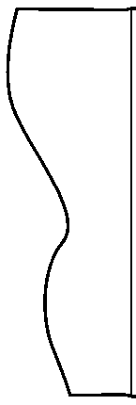

198,25 to 199,00mm

(7.805 to 7.835in)  
CHROMIUM PLATE

183,00mm (7.205in)

MINIMUM EXTENT OF FINE LIMIT DIA.

REMAINDER MAY BE

bore dia. B -0,254mm (-0.010in)

dia. B

dia. A

0,8

55,00mm (2.165in) MINIMUM EXTENT  
OF FINE LIMIT DIA.

REMAINDER MAY BE  
bOre dia. A -0,254mm (-0.010in)

215,00mm (8.465in) DIA.  
x 30 DEGREES  
CHAMFER  
INCLUSIVE

SECTION **Z-Z**

A321-S-32-12-22-060-2

Repair to Main Fitting - Machining  
Figure 601

Repair No. 11-29

32

Page 606

-12-22 Dec 23/2022

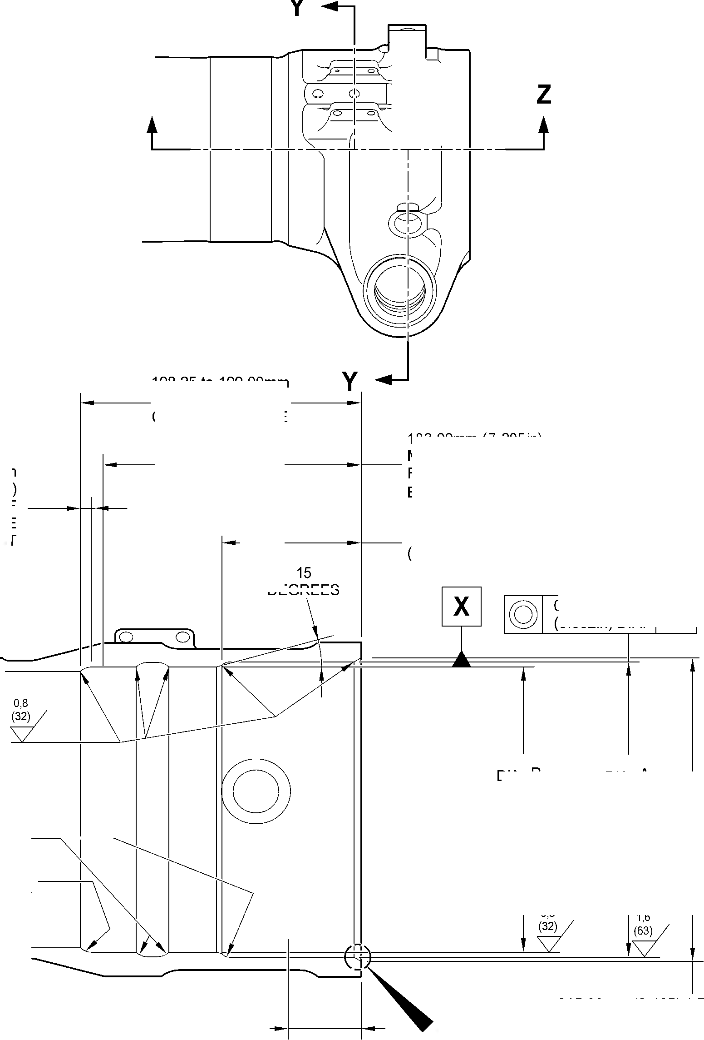

**SAFRAN LANDING SYSTEMS UK Ltd**

CAGE: K0654



PART No. 201587001 AND 201587002 COMPONENT MAINTENANCE MANUAL  
MAIN LANDING GEAR LEG

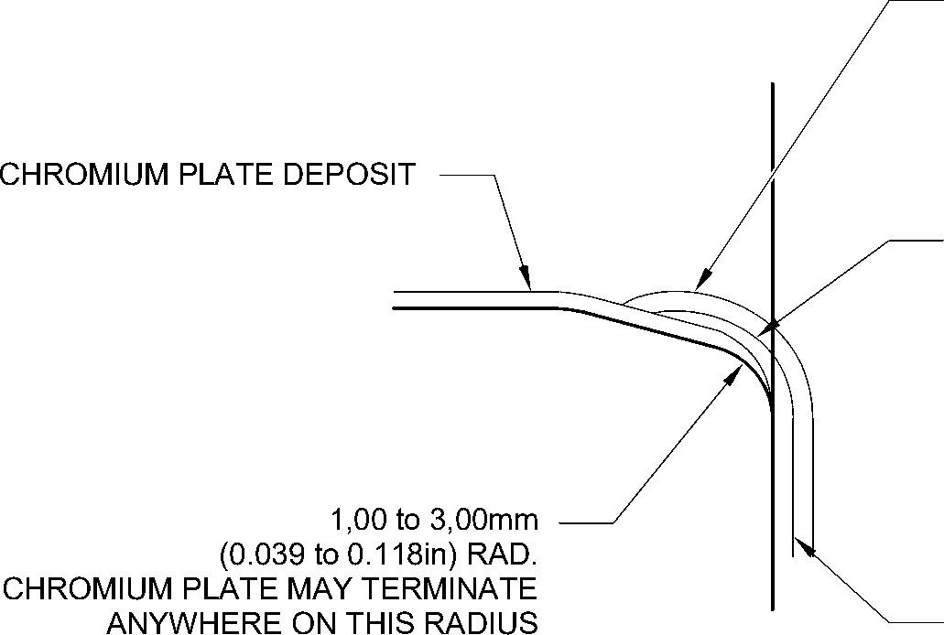

PAINT MUST OVERLAP CADMIUM PLATE

NO BARE METAL PERMISSIBLE

NO CADMIUM OR PAINT DEPOSIT TO  
ENTER OR STAND PROUD OF CHROMIUM  
PLATED BORE

CADMIUM PLATE MUST OVERLAP  
CHROMIUM PLATE

CADMIUM PLATE

detail W

CHROMIUM PLATE TERMINATION  
LOWER BARREL

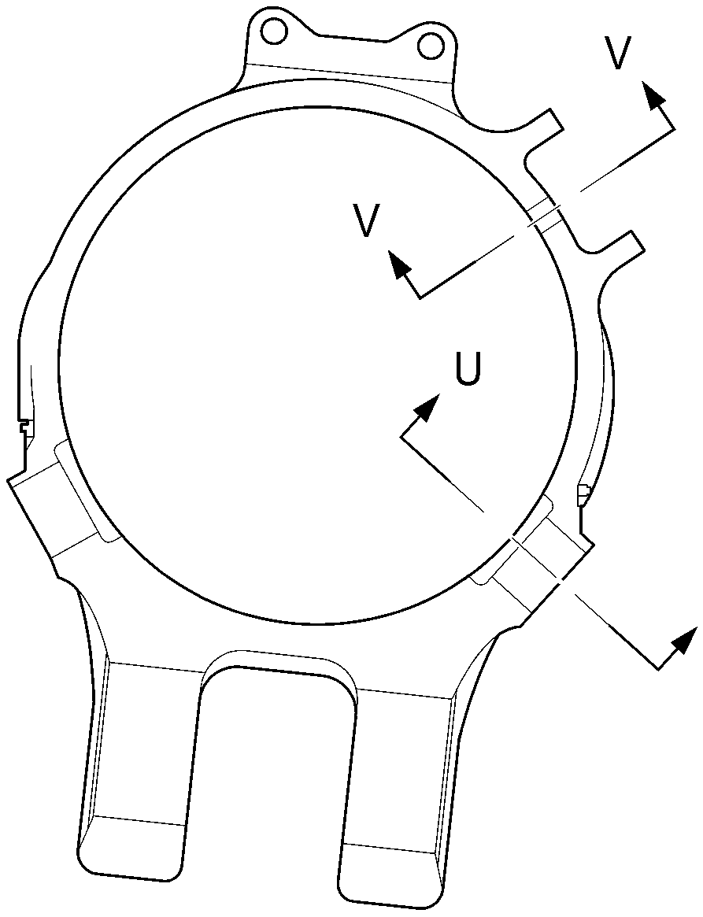

U

section Y-Y

A321-S-32-12-22-061-1

Repair to Main Fitting  
Figure 602

Repair No. 11-29

32-12-22

Page 607

Dec 23/2022

**SAFRAN LANDING SYSTEMS UK Ltd**

CAGE: K0654



PART No. 201587001 AND 201587002 COMPONENT MAINTENANCE MANUAL  
MAIN LANDING GEAR LEG

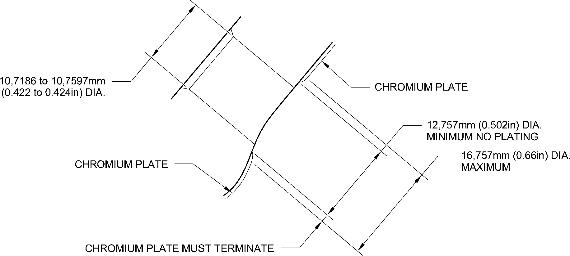

WITHIN THIS BAND. 1,00mm (0.039in) MAXIMUM RUNOUT

SECTION **V-V**

CHROMIUM PLATE TERMINATION  
AROUND CHANGEOVER VALVE HOLES  
TYPICAL 2 POSITIONS

1,00mm (0.039in) MAXIMUM

CHROMIUM PLATE

PERMISSIBLE FADE OUT

CADMIUM PLATE

CADMIUM PLATE MUST OVERLAP  
CHROMIUM PLATE  
NO BARE METAL PERMISSIBLE  
NO CADMIUM PLATE TO  
ENTER OR STAND PROUD OF CHROMIUM  
PLATED DIAMETER

1,00 to 3,00mm

(0.039 to 0.118in) RAD.

CHROMIUM PLATE MAY TERMINATE

ANYWHERE ON THIS RADIUS

CHROMIUM PLATE

50,50mm (1.988in) DIA. MAXIMUM

EXTENT OF CADMIUM FADE OUT

SECTION **U-U**

CHROMIUM PLATE TERMINATION  
AROUND DOWEL HOLES  
TYPICAL 3 POSITIONS

A321-S-32-12-22-062-1

Repair to Main Fitting - Chromium Plate Termination

Figure 603

32-12-22

Repair No. 11-29

Page 608

Dec 9/2022

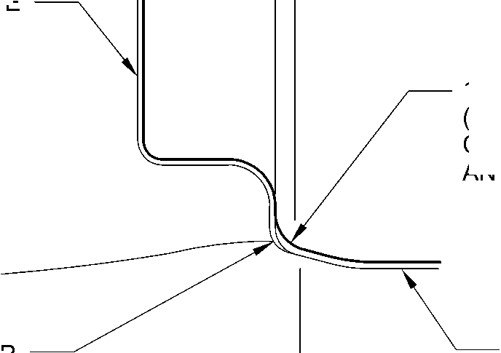

**sSAFRAN SAFRAN LANDING SYSTEMS UK Ltd**

CAGE: K0654

PART No. 201587001 AND 201587002 COMPONENT MAINTENANCE MANUAL  
MAIN LANDING GEAR LEG

I 1. Repair No. 11-30 Main Fitting (20-410A and 20-420A Only)

**CAUTION: THIS REPAIR IS FOR THE POST SB 201-32-58 UNITS ONLY. FOLLOW THE  
REQUIREMENTS OF SB 201-32-58 COMPLETELY. FOR PRE SB 201-32-58,  
REFER TO** **REPAIR NO. 11-29** **(450267275).**

1. Specified Damage and Material Specification.
2. Specified Damage

(a) Damage or corrosion to the diameter(s) A and/or B.

1. Material Specification

|  |  |  |
| --- | --- | --- |
| IPL Figure and Item No. | Name | Material Specification |
| 20-410A and  20-420A Only | Main fitting | Steel to MAT135 (35NCD16THQ) |

1. Special Tools
2. These special tools are necessary:

**NOTE: Alternative equivalents are permitted.**

|  |  |  |
| --- | --- | --- |
| Part No. | Special Tool | Function |
| 460006405 | Assembly Sleeve | Install the lower bearing subassembly |

1. Materials
2. This material is necessary:

**NOTE: Alternative equivalents are permitted.**

|  |  |
| --- | --- |
| Ref. Item | Material |
| TBA | Molykote 111, PCS-7303 |

1. Repair Parts

(1) These repair parts are necessary:

|  |  |  |
| --- | --- | --- |
| Part No. | Repair Part | Material Specification |
| 450267371 to  450267383  Refer to Table 601 | Lower bearing subassembly | - |
| 201646300 | Inner liner | - |

Repair No. 11-30

32-12-22

Page 601

Dec 4/2020

**sSAFRAN SAFRAN LANDING SYSTEMS UK Ltd**

CAGE: K0654

PART No. 201587001 AND 201587002 COMPONENT MAINTENANCE MANUAL  
MAIN LANDING GEAR LEG

1. Procedure (Refer to Figures 601, 602, 603 and 604)

**CAUTION: FOR DAMAGE MORE THAN THE LIMITS OF THIS REPAIR SCHEME, WRITE  
TO MESSIER-DOWTY LIMITED: REFER TO GUIDE-CS-001.**

1. Do this procedure if there is damage or corrosion to the chromium plate on  
   diameter(s) A and/or B. The bare metal must not be damaged.
2. Remove the paint from the main fitting as necessary: refer to PCS-2700.
3. Locally remove the chromium plate from diameter(s) A and/or B: refer to  
   PCS-2110.

**CAUTION: DO NOT USE A MECHANICAL MOP POLISHER TO GET THE  
SURFACE FINISH. USE HONING OR LAPPING TOOLS.**

1. Apply chromium plate to diameter A to between 212,000 and 212,072 mm (8.3465  
   and 8.3493 in) with a surface finish of 1,6 micrometers (63 micro-inches) and to  
   diameter B to between 208,890 and 208,966 mm (8.2240 and 8.2270 in) with a  
   surface finish of 0,8 micrometers (32 micro-inches): refer to PCS-2110 and  
   Figures 601, 602 and 603. The plating thickness must be between 0,040 and 0,060  
   mm (0.0016 and 0.0024 in).
2. Examine the reworked areas for flaws: refer to PCS-3100, inclusion class 4.
3. Apply wet primer to diameters A and B: refer to PCS-2804.
4. Identify the part with the Messier-Dowty Limited repair number 450267385A  
   adjacent to the part number: refer to PCS-6000-04, maximum depth 0,13 mm  
   (0.005 in).
5. Restore all protective treatments to the main fitting: refer to REPAIR.
6. Identify the part with the Messier-Dowty Limited repair number 450267385A  
   adjacent to the part number: refer to PCS-6000-07.
7. Examine the part to make sure that you have obeyed all the repair instructions  
   correctly.
8. Do this procedure to diameter(s) A and/or B if there is damage to the bare metal.
9. Remove the paint from the main fitting as necessary: refer to PCS-2700.
10. Locally remove the chromium plate from diameter(s) A and B: refer to PCS-2110.
11. Machine diameters A and B, as a matched pair to remove the wear or damage.  
    Remove the minimum amount of material to get the nearest oversize pair of bores  
    given in Table 601. Blend any sharp edges smoothly into the adjacent surfaces.  
    The surface finish for diameter A must be 1,6 micrometers (63 micro-inches) and  
    the surface finish for diameter B must be 0,8 micrometers (32 micro-inches): refer  
    to M-DLPS1004-4-1 and Figure 601.
12. Machine the chamfers and radii as shown: refer to Figures 601, 602 and 603.  
    Blend all sharp edges smoothly into the adjacent surface. Make the surface finish  
    for the radii 0,8 micrometers (32 micro-inches).
13. Measure and record the machined diameter(s) A and/or B.

32-12-22

Repair No. 11-30

Page 602

Dec 6/2019

**SAFRAN LANDING SYSTEMS UK Ltd**

CAGE: K0654



PART No. 201587001 AND 201587002 COMPONENT MAINTENANCE MANUAL

MAIN LANDING GEAR LEG

1. Examine the bare metal for flaws: refer to PCS-3100, inclusion class 4 and  
   PCS-3600.
2. Shot peen the reworked areas of the main fitting: refer to M-DLPS123.
3. Hone diameters A and B shot peened areas to the recorded diameters +0,00 to  
   0,025 mm (0.000 to 0.001 in).

**CAUTION: DO NOT USE A MECHANICAL MOP POLISHER TO GET THE  
SURFACE FINISH. USE HONING OR LAPPING TOOLS.**

1. Apply chromium plate to diameters A and B to the nearest dimensions shown  
   in Table 601. The plating thickness must be between 0,040 and 0,060 mm (0.0016  
   and 0.0024 in). To get the necessary surface finish hone or lap diameters A and B:  
   refer to PCS-2110 and Figures 601 to 603.
2. Examine the reworked areas for flaws: refer to PCS-3100, inclusion class 4.
3. Apply wet primer to diameters A and B: refer to PCS-2804.
4. Identify the part with the Messier-Dowty Limited repair number 450267385B  
   adjacent to the part number on the main fitting: refer to PCS-6000-04, maximum  
   depth 0,13 mm (0.005 in).
5. Restore all protective treatments to the main fitting. Make sure that the cadmium  
   plate overlaps the chromium plate terminations: refer to REPAIR, Figures 602  
   and 603.
6. Select the correct oversize lower bearing subassembly from the Table 601 for the  
   repaired diameters A and B.

**NOTE: Each POST oversize lower bearing subassembly can be made from  
the related PRE SB 201-32-58 lower bearing subassembly: refer  
to** **Table 602****.**

1. If necessary, machine the inner bore of the bronze liner: refer to Figure 604.

**NOTE: The lower bearing (16-150) bore can only be machined when it is  
installed in the lower bearing subassembly.**

1. If necessary, examine the machined area for flaws: refer to PCS-3200.
2. If necessary, apply a small quantity of Molykote 111, Material Ref. Item TBA, to the  
   outside diameter of inner liner (16A-117) and install it in the lower bearing  
   subassembly: refer to PCS-7303 and Figure 604. Make sure that the holes in the  
   new inner liner align with the holes in the lower bearing subassembly.
3. If necessary, strike through the old part number and re-identify the new lower  
   bearing subassembly with the new inner liner with a part number given  
   in Table 602: refer to PCS-6000-04 and PCS-6000-07.
4. At the applicable assembly step, use the Assembly Sleeve 460006405 and install  
   the lower bearing subassembly on the sliding tube subassembly: refer  
   to ASSEMBLY (INLUDING STORAGE).

(t)

At the applicable assembly step, install the repaired shock absorber subassembly  
in the main fitting: refer to ASSEMBLY (INLUDING STORAGE).

Repair No. 11-30

32-12-22

Page 603

Dec 6/2019

**SAFRAN LANDING SYSTEMS UK Ltd**

CAGE: K0654



PART No. 201587001 AND 201587002 COMPONENT MAINTENANCE MANUAL  
MAIN LANDING GEAR LEG

1. Identify the part with the Messier-Dowty Limited repair number 450267385B  
   adjacent to the part number: refer to PCS-6000-07.
2. Examine the part to make sure that you have obeyed all the repair instructions  
   correctly.

Oversize Lower Bearing Subassembly Dimensions (Post SB 201-32-58)

Table 601

|  |  |  |  |  |  |
| --- | --- | --- | --- | --- | --- |
|  | Bore Diameter A | | Bore Diameter B | |  |
|  | Before chromium plate mm (in) | After chromium plate mm (in) | Before chromium plate mm (in) | After chromium plate mm (in) | Lower bearing subassembly |
| 1 | 212,242 to 212,274 (8.3560 to 8.3572) | 212,122 to 212,194 (8.3513 to 8.3541) | 209,132 to 209,168 (8.2335 to 8.2350) | 209,012 to 209,088 (8.2288 to 8.2318) | 450267371 |
| 2 | 212,392 to 212,424 (8.3619 to 8.3631) | 212,272 to 212,344 (8.3572 to 8.3600) | 209,282 to 209,318 (8.2394 to 8.2409) | 209,162 to 209,238 (8.2347 to 8.2377) | 450267373 |
| 3 | 212,542 to 212,574 (8.3678 to 8.3691) | 212,422 to 212,494 (8.3631 to 8.3659) | 209,432 to 209,468 (8.2454 to 8.2468) | 209,312 to 209,388 (8.2406 to 8.2436) | 450267375 |
| 4 | 212,692 to 212,724 (8.3737 to 8.3750) | 212,572 to 212,644 (8.3690 to 8.3718) | 209,582 to 209,618 (8.2513 to 8.2527) | 209,462 to 209,538 (8.2465 to 8.2495) | 450267377 |
| 5 | 212,842 to 212,874 (8.3796 to 8.3809) | 212,722 to 212,794 (8.3749 to 8.3777) | 209,732 to 209,768 (8.2572 to 8.2586) | 209,612 to 209,688 (8.2524 to 8.2554) | 450267379 |
| 6 | 213,233 to 213,265 (8.3950 to 8.3963) | 213,113 to 213,185 (8.3903 to 8.3931) | 209,732 to 209,768 (8.2572 to 8.2586) | 209,612 to 209,688 (8.2524 to 8.2554) | 450267381 |
| 7 | 213,533 to 213,565 (8.4068 to 8.4081) | 213,413 to 213,485 (8.4020 to 8.4049) | 209,732 to 209,768 (8.2572 to 8.2586) | 209,612 to 209,688 (8.2524 to 8.2554) | 450267383 |

Oversize Lower Bearing Subassembly  
Table 602

|  |  |
| --- | --- |
| Pre SB 201-32-58 Part number | Post SB 201-32-58 Part number (fitted with inner liner 201646300) |
| 450266261 | 450267371 |
| 450266262 | 450267373 |
| 450266263 | 450267375 |
| 450266264 | 450267377 |
| 450266265 | 450267379 |
| 450266266 | 450267381 |
| 450266267 | 450267383 |

32-12-22

Repair No. 11-30

Page 604

Dec 6/2019

**SAFRAN LANDING SYSTEMS UK Ltd**

CAGE: K0654

PART No. 201587001 AND 201587002 COMPONENT MAINTENANCE MANUAL  
MAIN LANDING GEAR LEG

Y

X

dia. A

20,00mm (0.787in) RAD.

0,05mm  
(0.002in) DIA.

20,00mm (0.787in) RAD.  
CHROMIUM PLATE MAY

TERMINATE ANYWHERE  
ON THIS RADIUS

5,00 to 10,00mm  
(0.2 to 0.4in)  
EXTENT OF  
CHROMIUM  
FADE OUT

9,00 to 11,00mm  
(0.354 to 0.433in) RAD.

Z

Z

dia. B

W

99,75 to 100,5mm  
(3.927 to 3.957in)

183,00mm (7.205in)

MINIMUM EXTENT OF FINE LIMIT DIA.  
REMAINDER MAY BE

bore dia. B -0,254mm (-0.010in)

198,25 to 199,00mm

(7.805 to 7.835in)  
CHROMIUM PLATE

Y

15

DEGREES

55,00mm (2.165in) MINIMUM EXTENT  
OF FINE LIMIT DIA.

REMAINDER MAY BE  
bOre dia. A -0,254mm (-0.010in)

section Z-Z

215,00mm (8.4645in) DIA.  
x 30 DEGREES  
CHAMFER  
INCLUSIVE

A321-S-32-12-22-064-0

Repair to Main Fitting - Machining  
Figure 601

Repair No. 11-30

32-12-22

Page 605

Dec 6/2019

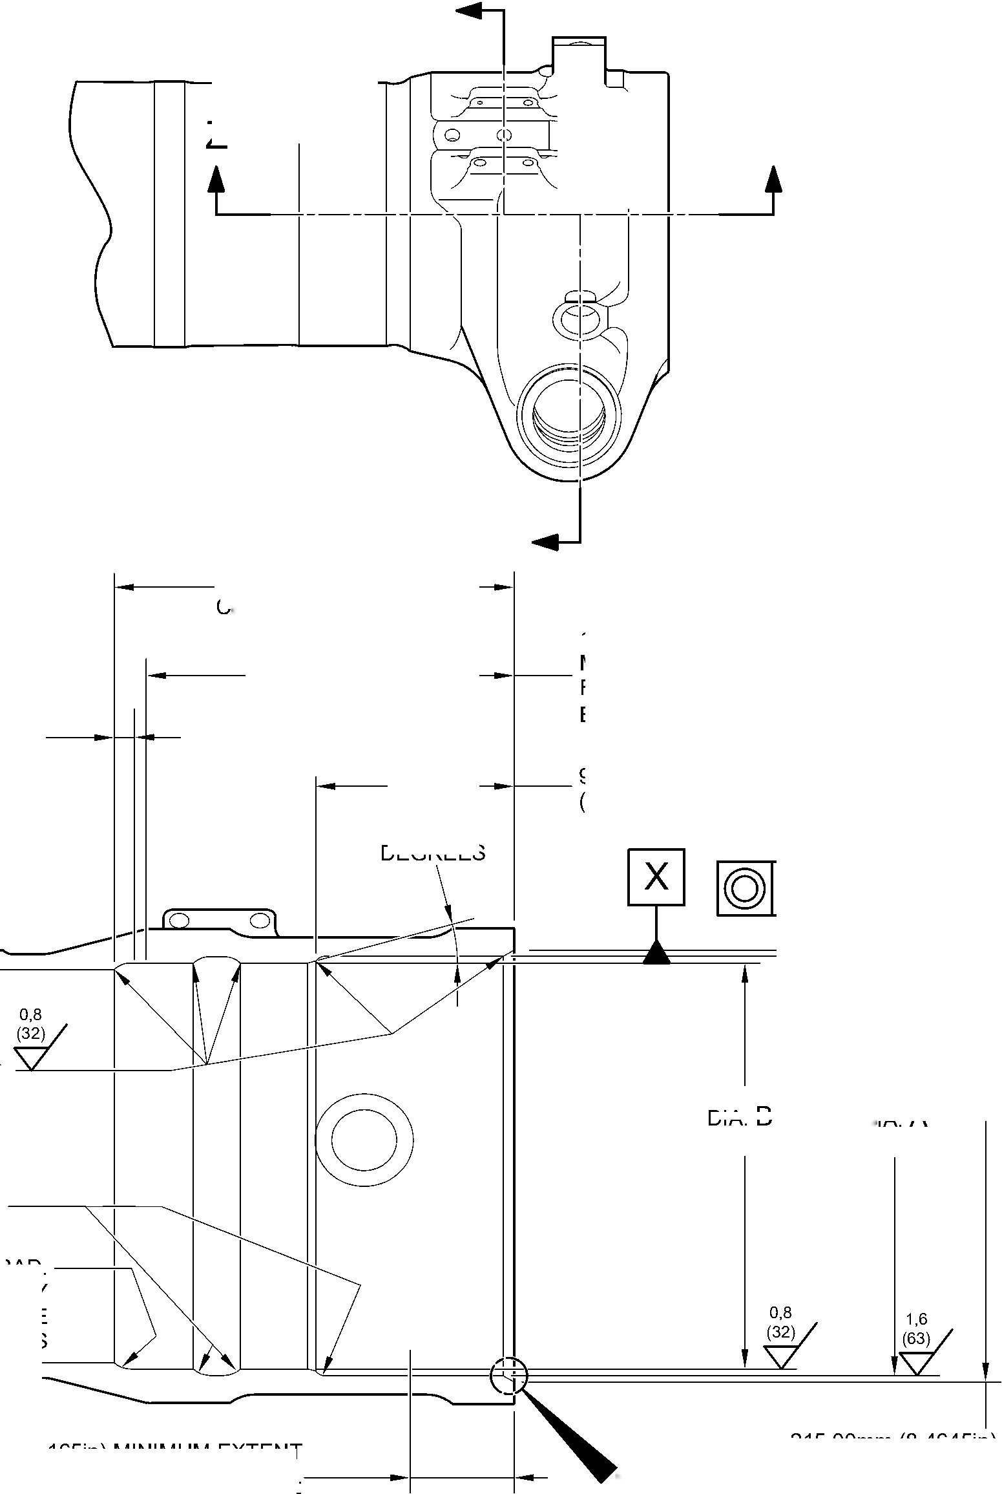

**SAFRAN LANDING SYSTEMS UK Ltd**

CAGE: K0654

PART No. 201587001 AND 201587002 COMPONENT MAINTENANCE MANUAL  
MAIN LANDING GEAR LEG

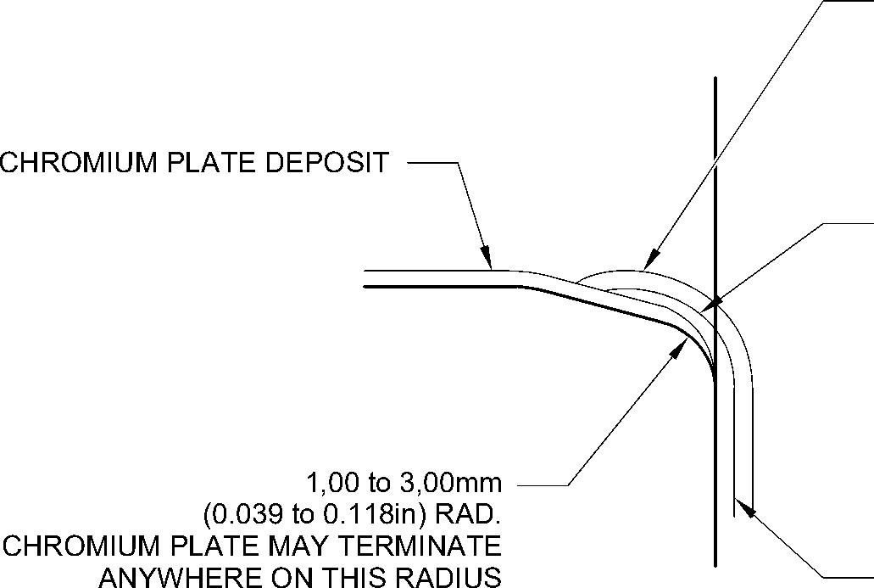

PAINT MUST OVERLAP CADMIUM PLATE

NO BARE METAL PERMISSIBLE

NO CADMIUM OR PAINT DEPOSIT TO  
ENTER OR STAND PROUD OF CHROMIUM  
PLATED BORE

CADMIUM PLATE MUST OVERLAP  
CHROMIUM PLATE

CADMIUM PLATE

detail W

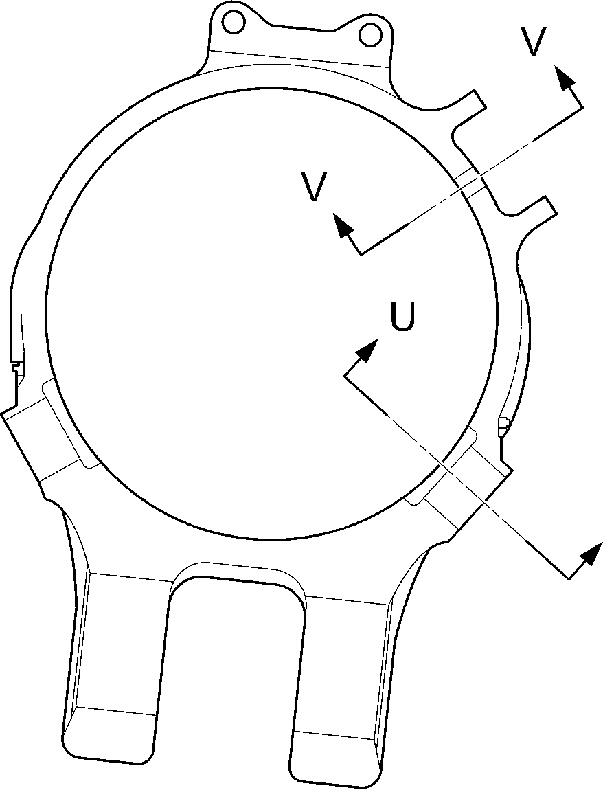

U

section Y-Y

A321-S-32-12-22-065-0

Repair to Main Fitting  
Figure 602

32-12-22

Repair No. 11-30

Page 606

Dec 6/2019

**SAFRAN LANDING SYSTEMS UK Ltd**

CAGE: K0654



PART No. 201587001 AND 201587002 COMPONENT MAINTENANCE MANUAL  
MAIN LANDING GEAR LEG

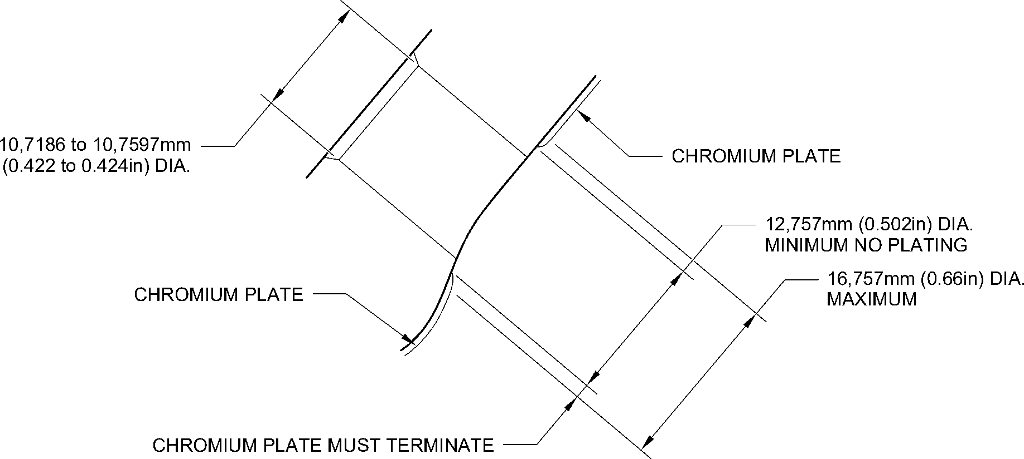

WITHIN THIS BAND. 1,00mm (0.039in) MAXIMUM RUNOUT

section V-V

CHROMIUM PLATE TERMINATION  
AROUND CHANGEOVER VALVE HOLES  
TYPICAL 2 POSITIONS

1,00mm (0.039in) MAXIMUM

CHROMIUM PLATE

PERMISSIBLE FADE OUT

CADMIUM PLATE

1,00 to 3,00mm

(0.039 to 0.118in) RAD.

CHROMIUM PLATE MAY TERMINATE

ANYWHERE ON THIS RADIUS

CADMIUM PLATE MUST OVERLAP  
CHROMIUM PLATE  
NO BARE METAL PERMISSIBLE  
NO CADMIUM PLATE TO  
ENTER OR STAND PROUD OF CHROMIUM  
PLATED DIAMETER

50,50mm (1.988in)MAXIMUM

EXTENT OF CADMIUM FADE OUT

section U-U

CHROMIUM PLATE TERMINATION  
AROUND DOWEL HOLES  
TYPICAL 3 POSITIONS

CHROMIUM PLATE

A321-S-32-12-22-066-0

Repair to Main Fitting - Chromium Plate Termination

Figure 603

Repair No. 11-30

32-12-22

Page 607

Dec 6/2019

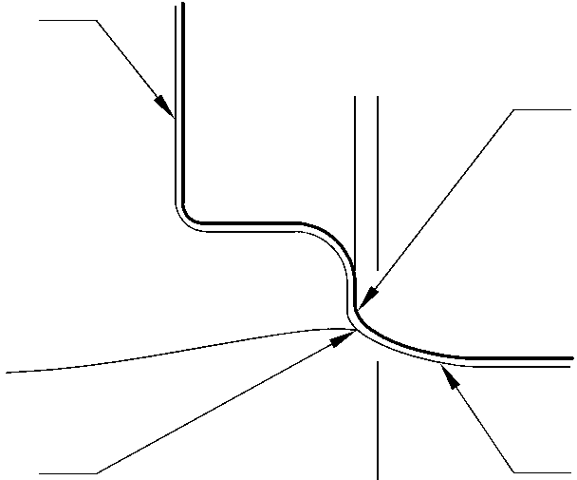

**SAFRAN LANDING SYSTEMS UK Ltd**

CAGE: K0654

PART No. 201587001 AND 201587002 COMPONENT MAINTENANCE MANUAL  
MAIN LANDING GEAR LEG

X

Z

Y

Y

X

0,5mm (0.02in)

182,453 to 182,516mm  
(7.183 to 7.186in) DIA.

CORRECT OVERSIZE  
AS IN TABLE 602

10,00mm (0.394in)

0.333 to 0.667 DEGREES

REF.

0,025mm  
(0.001in)

0,04mm  
(0.0016in) DIA.

0,5mm (0.02in)

A321-S-32-12-22-067-0

MODIFIED REPAIR LOWER BEARING  
SUBASSEMBLY

178,87 to 179,07mm  
(7.042 to 7.050in) DIA.

10,00mm (0.394in)

0,5mm (0.02in)

RAD.

15 DEGREES

0,5mm (0.02in)

RAD.

15 DEGREES

64,65 to 64,775mm  
(2.545 to 2.550in)

92,85 to 93,00mm  
(3.656 to 3.661in)

detail Z

NEW INNER LINER  
(16A-117)

Lower Bearing Subassembly - Machining and Inner Liner Installation  
Figure 604

32-12-22

Repair No. 11-30

Page 608

Dec 6/2019

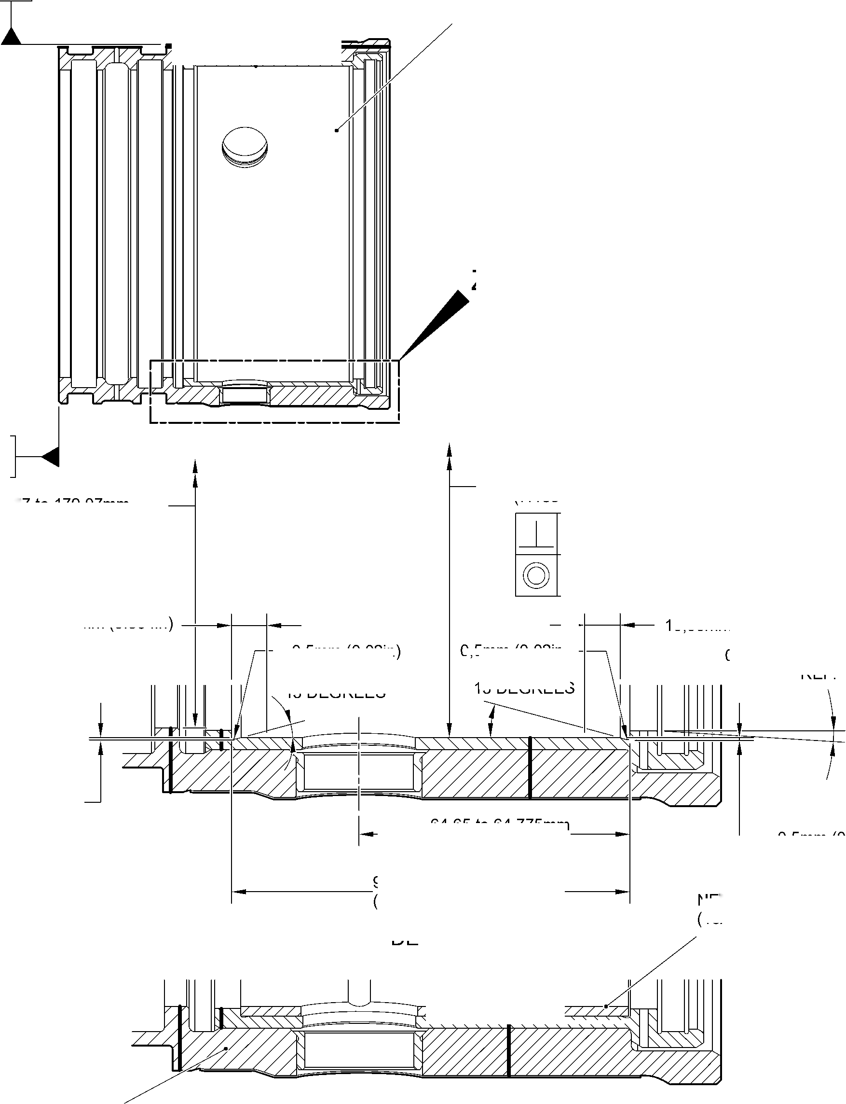

**sSAFRAN SAFRAN LANDING SYSTEMS UK Ltd**

CAGE: K0654

PART No. 201587001 AND 201587002 COMPONENT MAINTENANCE MANUAL  
MAIN LANDING GEAR LEG

1. Repair No. 11-31 Main Fitting (20-410B, 20-410C, 20-410D, 20-420B, 20-420C and 20-420D)
2. Specified Damage and Material Specification
3. Specified Damage

(a) Wear or damage or corrosion to diameter A.

1. Material Specification

|  |  |  |
| --- | --- | --- |
| IPL Figure and Item No. | Name | Material Specification |
| 20-410B and  20-420B | Main fitting | UHT Steel E35NCD16THQ to MTL-1203 with UTS 1800 MPa (261.0 ksi) |
| 20-410C,  20-410D, 20-420C and 20-420D | Main fitting | UHT Steel 300M to MTL-1201 with  UTS 1930 MPa (279.9 ksi) |

1. Special Tools
2. Special tools are not necessary.
3. Materials
4. This material is necessary:

**NOTE: Alternative equivalents are permitted.**

|  |  |
| --- | --- |
| Ref. Item | Material |
| TBA | Loctite Grade 270 |

1. Repair Parts
2. These repair parts are necessary:

|  |  |  |
| --- | --- | --- |
| Part No. | Repair Part | Material Specification |
| 450250161 to  450250166 | Oversize lubrication adaptor | Steel, S154 or 4340 to  AMS6409 and heat treated to  S154 |
| 450250241 to  450250246 | Oversize lubrication adaptor | Steel, S154 or 4340 to  AMS6409 and heat treated to  S154 |

Repair No. 11-31

32-12-22

Page 601

Mar 18/2025

**sSAFRAN SAFRAN LANDING SYSTEMS UK Ltd**

CAGE: K0654

PART No. 201587001 AND 201587002 COMPONENT MAINTENANCE MANUAL  
MAIN LANDING GEAR LEG

1. Procedure (Refer to Figure 601)

**CAUTION: FOR DAMAGE MORE THAN THE LIMITS OF THIS REPAIR SCHEME, WRITE  
TO SAFRAN LANDING SYSTEMS: REFER TO GUIDE-CS-001.**

**CAUTION: APPLY TEMPORARY CORROSION AND DAMAGE PROTECTION: REFER  
TO PCS-2800.**

1. Do this procedure if there is wear or damage or corrosion to diameter A: refer to  
   Figure 601.
2. Remove the paint from the main fitting: refer to PCS-2700.
3. Remove the cadmium plate from the main fitting: refer to PCS-2100.
4. Machine diameter A to the nearest dimensions shown in Table 601 to remove the  
   damage or wear or corrosion. Do not increase diameter A to more than 6,449 mm  
   (0.2539 in). The surface finish must be 1,6 micrometers (63 micro-inches) or better:  
   refer to PCS-4100 and Figure 601.
5. Measure and record the diameter A.
6. Machine the chamfer(s) and/or radii as shown: refer to PCS-4100 and Figure 601.
7. Examine the machined area for flaws: refer to PCS-3100, inclusion Class 4 and  
   PCS-3600.
8. Apply cadmium plate all over but not to the areas shown. The cadmium plate  
   thickness must be between 0,010 and 0,020 mm (0.0004 and 0.0008 in): refer to  
   PCS-2100 and Figure 601.
9. Select the correct oversize lubrication adaptor from Table 601 applicable for  
   diameter A.
10. Use Loctite Grade 270, Material Ref. Item TBA, to install the correct oversize  
    lubrication adaptor from Table 601: refer to PCS-5303 and Figure 601.
11. Apply primer and top coat paint all over but not to the areas shown: refer to  
    PCS-2500 and Figure 601.
12. Record the repair number onto the documentation which is attached to the part.  
    Optionally, identify the part with the Safran Landing Systems repair number  
    64-4505236-00 adjacent to the existing part number: refer to PCS-6000-07.
13. Examine the part to make sure that you have obeyed all the repair instructions  
    correctly.

32-12-22

Repair No. 11-31

Page 602

Mar 18/2025

**SAFRAN LANDING SYSTEMS UK Ltd**

CAGE: K0654

PART No. 201587001 AND 201587002 COMPONENT MAINTENANCE MANUAL  
MAIN LANDING GEAR LEG

Oversize Lubrication Adaptors  
Table 601

|  |  |  |  |
| --- | --- | --- | --- |
| Oversize | Oversize Step mm (in) | Bore Diameter A mm (in) | Oversize Lubrication Adaptor Number |
| - | Production | 4,859 to 4,925 (0.1913 to 0.1939) | 899005010 |
| 1st | 0,127 (0.0050) | 4,986 to 5,052 (0.1963 to 0.1989) | 450250161 |
| 2nd | 0,127 (0.0050) | 5,113 to 5,179 (0.2013 to 0.2039) | 450250162 |
| 3rd | 0,127 (0.0050) | 5,240 to 5,306 (0.2063 to 0.2089) | 450250163 |
| 4th | 0,127 (0.0050) | 5,367 to 5,433 (0.2113 to 0.2139) | 450250164 |
| 5th | 0,127 (0.0050) | 5,494 to 5,560 (0.2163 to 0.2189) | 450250165 |
| 6th | 0,127 (0.0050) | 5,621 to 5,687 (0.2213 to 0.2239) | 450250166 |
| 7th | 0,127 (0.0050) | 5,748 to 5,814 (0.2263 to 0.2289) | 450250241 |
| 8th | 0,127 (0.0050) | 5,875 to 5,941 (0.2313 to 0.2339) | 450250242 |
| 9th | 0,127 (0.0050) | 6,002 to 6,068 (0.2363 to 0.2389) | 450250243 |
| 10th | 0,127 (0.0050) | 6,129 to 6,195 (0.2413 to 0.2439) | 450250244 |
| 11th | 0,127 (0.0050) | 6,256 to 6,322 (0.2463 to 0.2489) | 450250245 |
| 12th | 0,127 (0.0050) | 6,383 to 6,449 (0.2513 to 0.2539) | 450250246 |

Repair No. 11-31

32-12-22

Page 603

Mar 18/2025

**SAFRAN LANDING SYSTEMS UK Ltd**

CAGE: K0654

PART No. 201587001 AND 201587002 COMPONENT MAINTENANCE MANUAL  
MAIN LANDING GEAR LEG

**Z**

dia. A

**A**

SECTION **Z-Z**(WITH LUBRICATION ADAPTOR)

SECTION **Z-Z**

(WITHOUT LUBRICATION ADAPTOR)

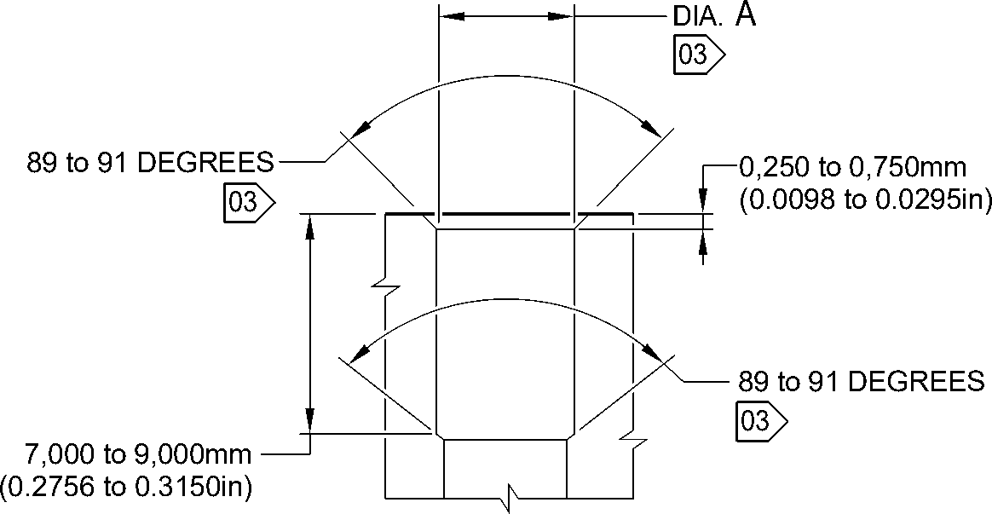

**NOTE:**

THE SURFACE FINISH MUST BE

1,6

(63)

DETAIL **A**

OR BETTER UNLESS GIVEN DIFFERENTLY.

DIAMETER A MUST BE FOLLOW THE LINE OF EXISTING BORE.

01 APPLY LOCTITE GRADE 270 TO ADAPTOR INTERFACE WITH MAIN FITTING: REFER TO PCS-5303.

02 INSTALL THE APPLICABLE LUBRICATION ADAPTOR: REFER TO TABLE 601. A321-T-32-12-22-111-0

03 CADMIUM PLATE OPTIONAL AND NO PAINT.

Repair to Main Fitting  
Figure 601

Repair No. 11-31

32

Page 604

-12-22 Mar 18/2025

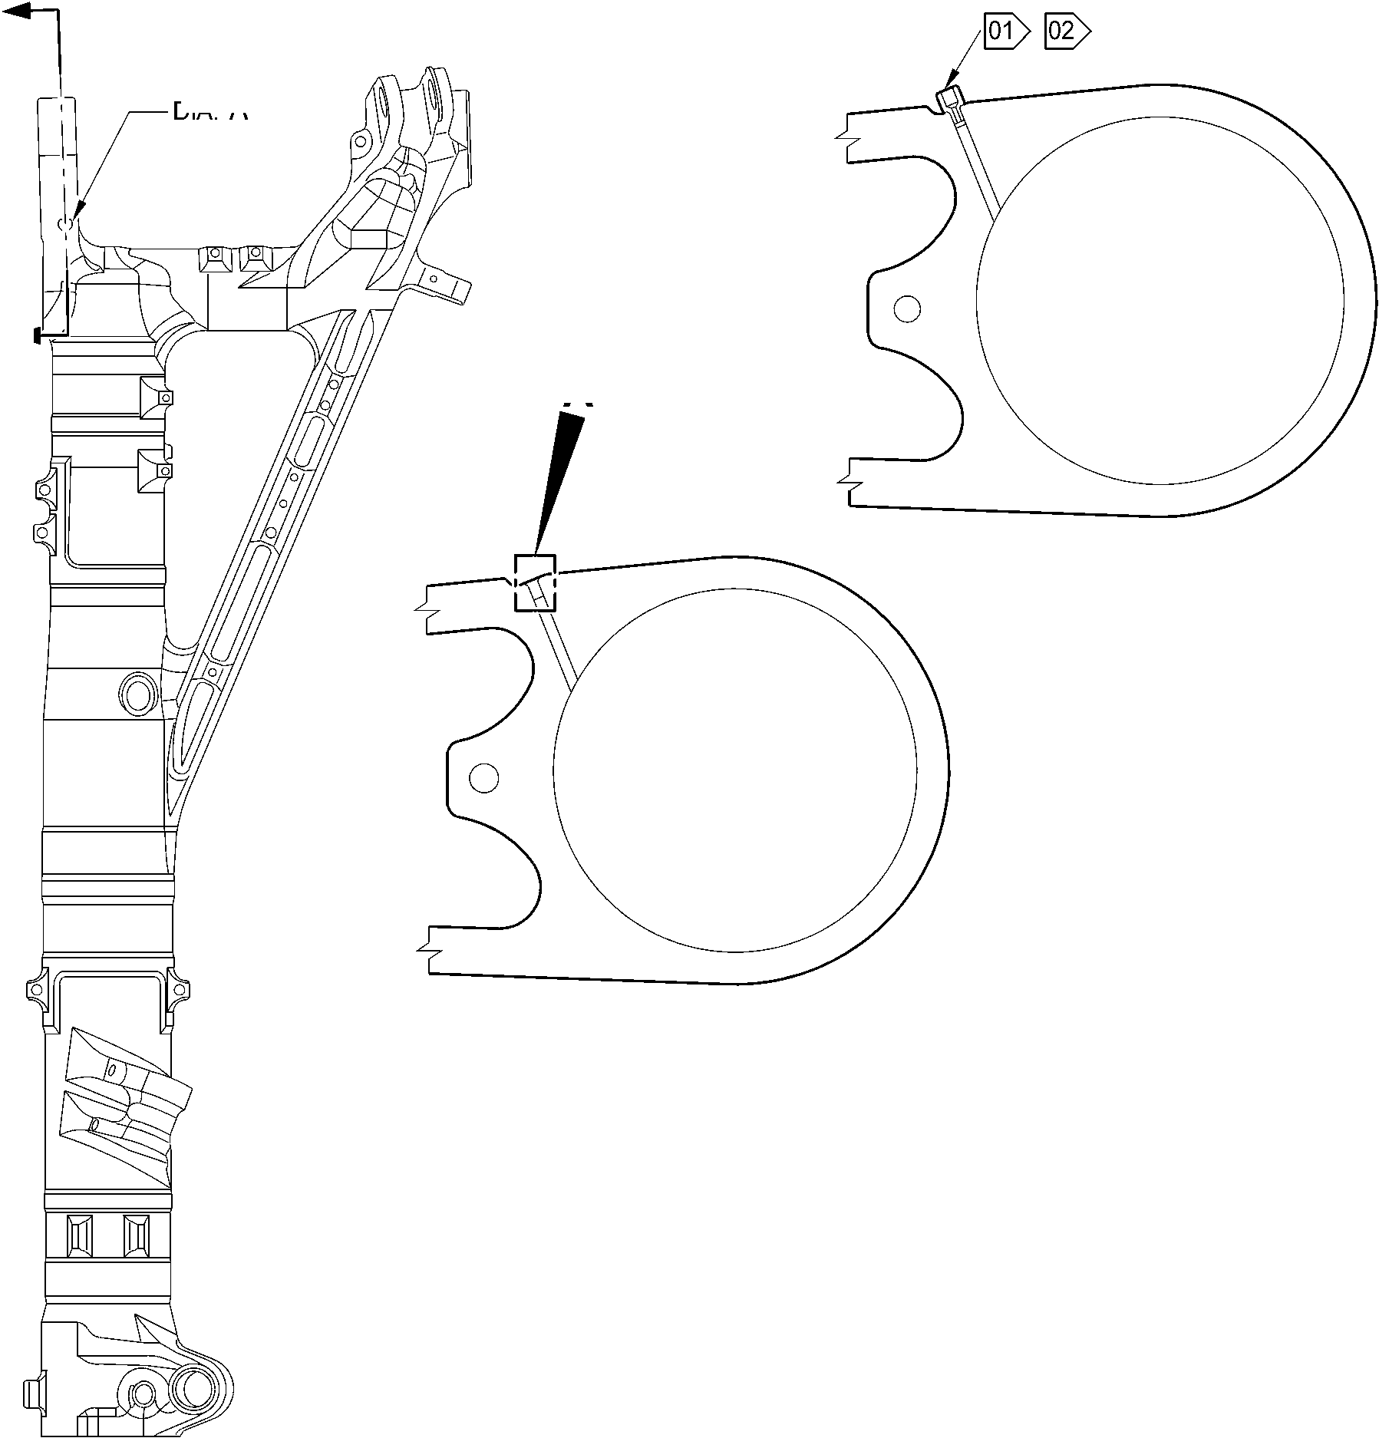

**sSAFRAN SAFRAN LANDING SYSTEMS UK Ltd**

CAGE: K0654

PART No. 201587001 AND 201587002 COMPONENT MAINTENANCE MANUAL  
MAIN LANDING GEAR LEG

1. Repair No. 11-32 Main Fitting (20-410B, 20-410C, 20-410D, 20-420B, 20-420C and 20-420D)
2. Specified Damage and Material Specification
3. Specified Damage

(a) Wear or damage or corrosion to diameter(s) A and/or B.

1. Material Specification

|  |  |  |
| --- | --- | --- |
| IPL Figure and Item No. | Name | Material Specification |
| 20-410B and  20-420B | Main fitting | UHT Steel E35NCD16THQ to MTL-1203 with UTS 1800 MPa (261.0 ksi) |
| 20-410C,  20-410D, 20-420C and 20-420D | Main fitting | UHT Steel 300M to MTL-1201 with  UTS 1930 MPa (279.9 ksi) |

1. Special Tools
2. Special tools are not necessary.
3. Materials
4. This material is necessary:

**NOTE: Alternative equivalents are permitted.**

|  |  |
| --- | --- |
| Ref. Item | Material |
| TBA | Loctite Grade 270 |

1. Repair Parts
2. These repair parts are necessary:

|  |  |  |
| --- | --- | --- |
| Part No. | Repair Part | Material Specification |
| 450250161 to  450250166 | Oversize lubrication adaptor | Steel, S154 or 4340 to  AMS6409 and heat treated to  S154 |
| 450250241 to  450250246 | Oversize lubrication adaptor | Steel, S154 or 4340 to  AMS6409 and heat treated to  S154 |

Repair No. 11-32

32-12-22

Page 601

Mar 18/2025

**sSAFRAN SAFRAN LANDING SYSTEMS UK Ltd**

CAGE: K0654

PART No. 201587001 AND 201587002 COMPONENT MAINTENANCE MANUAL  
MAIN LANDING GEAR LEG

1. Procedure (Refer to Figure 601)

**CAUTION: FOR DAMAGE MORE THAN THE LIMITS OF THIS REPAIR SCHEME, WRITE  
TO SAFRAN LANDING SYSTEMS: REFER TO GUIDE-CS-001.**

**CAUTION: APPLY TEMPORARY CORROSION AND DAMAGE PROTECTION: REFER  
TO PCS-2800.**

1. Do this procedure if there is wear or damage or corrosion to diameter(s) A and/or B:  
   refer to Figure 601.
2. Remove the paint from the main fitting: refer to PCS-2700.
3. Remove the cadmium plate from the main fitting: refer to PCS-2100.
4. Machine diameter(s) A and/or B to the nearest dimensions shown in Table 601 to  
   remove the damage or wear or corrosion. Do not increase the diameter(s) A and/or  
   B to more than 6,449 mm (0.2539 in). The surface finish must be 1,6 micrometers  
   (63 micro-inches) or better: refer to PCS-4100 and Figure 601.
5. Measure and record the diameter(s) A and/or B. Refer to Table 601 for the oversize  
   lubrication adaptor.
6. Machine the chamfer(s) and/or radii as shown: refer to PCS-4100 and Figure 601.
7. Examine the machined area(s) for flaws: refer to PCS-3100, inclusion Class 4 and  
   PCS-3600.
8. Apply cadmium plate all over but not to the areas shown. The cadmium plate  
   thickness must be between 0,010 and 0,020 mm (0.0004 and 0.0008 in): refer to  
   PCS-2100 and Figure 601.
9. Select the correct oversize lubrication adaptor from Table 601 applicable for  
   diameter(s) A and/or B.
10. Use Loctite Grade 270, Material Ref. Item TBA, to install the correct oversize  
    lubrication adaptor from Table 601 (qty 1 to 2 as necessary): refer to PCS-5303  
    and Figure 601.
11. Apply primer and top coat paint all over but not to the areas shown: refer to  
    PCS-2500 and Figure 601.
12. Record the repair number onto the documentation which is attached to the part.  
    Optionally, identify the part with the Safran Landing Systems repair number  
    64-4505233-00 adjacent to the existing part number: refer to PCS-6000-07.
13. Examine the part to make sure that you have obeyed all the repair instructions  
    correctly.

32-12-22

Repair No. 11-32

Page 602

Mar 18/2025

**SAFRAN LANDING SYSTEMS UK Ltd**

CAGE: K0654

PART No. 201587001 AND 201587002 COMPONENT MAINTENANCE MANUAL  
MAIN LANDING GEAR LEG

Oversize Lubrication Adaptors  
Table 601

|  |  |  |  |
| --- | --- | --- | --- |
| Oversize | Oversize Step mm (in) | Bore Diameter(s) A and/or B mm (in) | Oversize Lubrication Adaptor Number |
| - | Production | 4,859 to 4,925 (0.1913 to 0.1939) | 899005010 |
| 1st | 0,127 (0.0050) | 4,986 to 5,052 (0.1963 to 0.1989) | 450250161 |
| 2nd | 0,127 (0.0050) | 5,113 to 5,179 (0.2013 to 0.2039) | 450250162 |
| 3rd | 0,127 (0.0050) | 5,240 to 5,306 (0.2063 to 0.2089) | 450250163 |
| 4th | 0,127 (0.0050) | 5,367 to 5,433 (0.2113 to 0.2139) | 450250164 |
| 5th | 0,127 (0.0050) | 5,494 to 5,560 (0.2163 to 0.2189) | 450250165 |
| 6th | 0,127 (0.0050) | 5,621 to 5,687 (0.2213 to 0.2239) | 450250166 |
| 7th | 0,127 (0.0050) | 5,748 to 5,814 (0.2263 to 0.2289) | 450250241 |
| 8th | 0,127 (0.0050) | 5,875 to 5,941 (0.2313 to 0.2339) | 450250242 |
| 9th | 0,127 (0.0050) | 6,002 to 6,068 (0.2363 to 0.2389) | 450250243 |
| 10th | 0,127 (0.0050) | 6,129 to 6,195 (0.2413 to 0.2439) | 450250244 |
| 11th | 0,127 (0.0050) | 6,256 to 6,322 (0.2463 to 0.2489) | 450250245 |
| 12th | 0,127 (0.0050) | 6,383 to 6,449 (0.2513 to 0.2539) | 450250246 |

Repair No. 11-32

32-12-22

Page 603

Mar 18/2025

**SAFRAN LANDING SYSTEMS UK Ltd**

CAGE: K0654



PART No. 201587001 AND 201587002 COMPONENT MAINTENANCE MANUAL  
MAIN LANDING GEAR LEG

dia. A

**A**

VIEW **A**

dia. B

A321-T-32-12-22-112-0

Repair to Main Fitting  
Figure 601 - Sheet 1

32-12-22

Repair No. 11-32

Page 604

Mar 18/2025

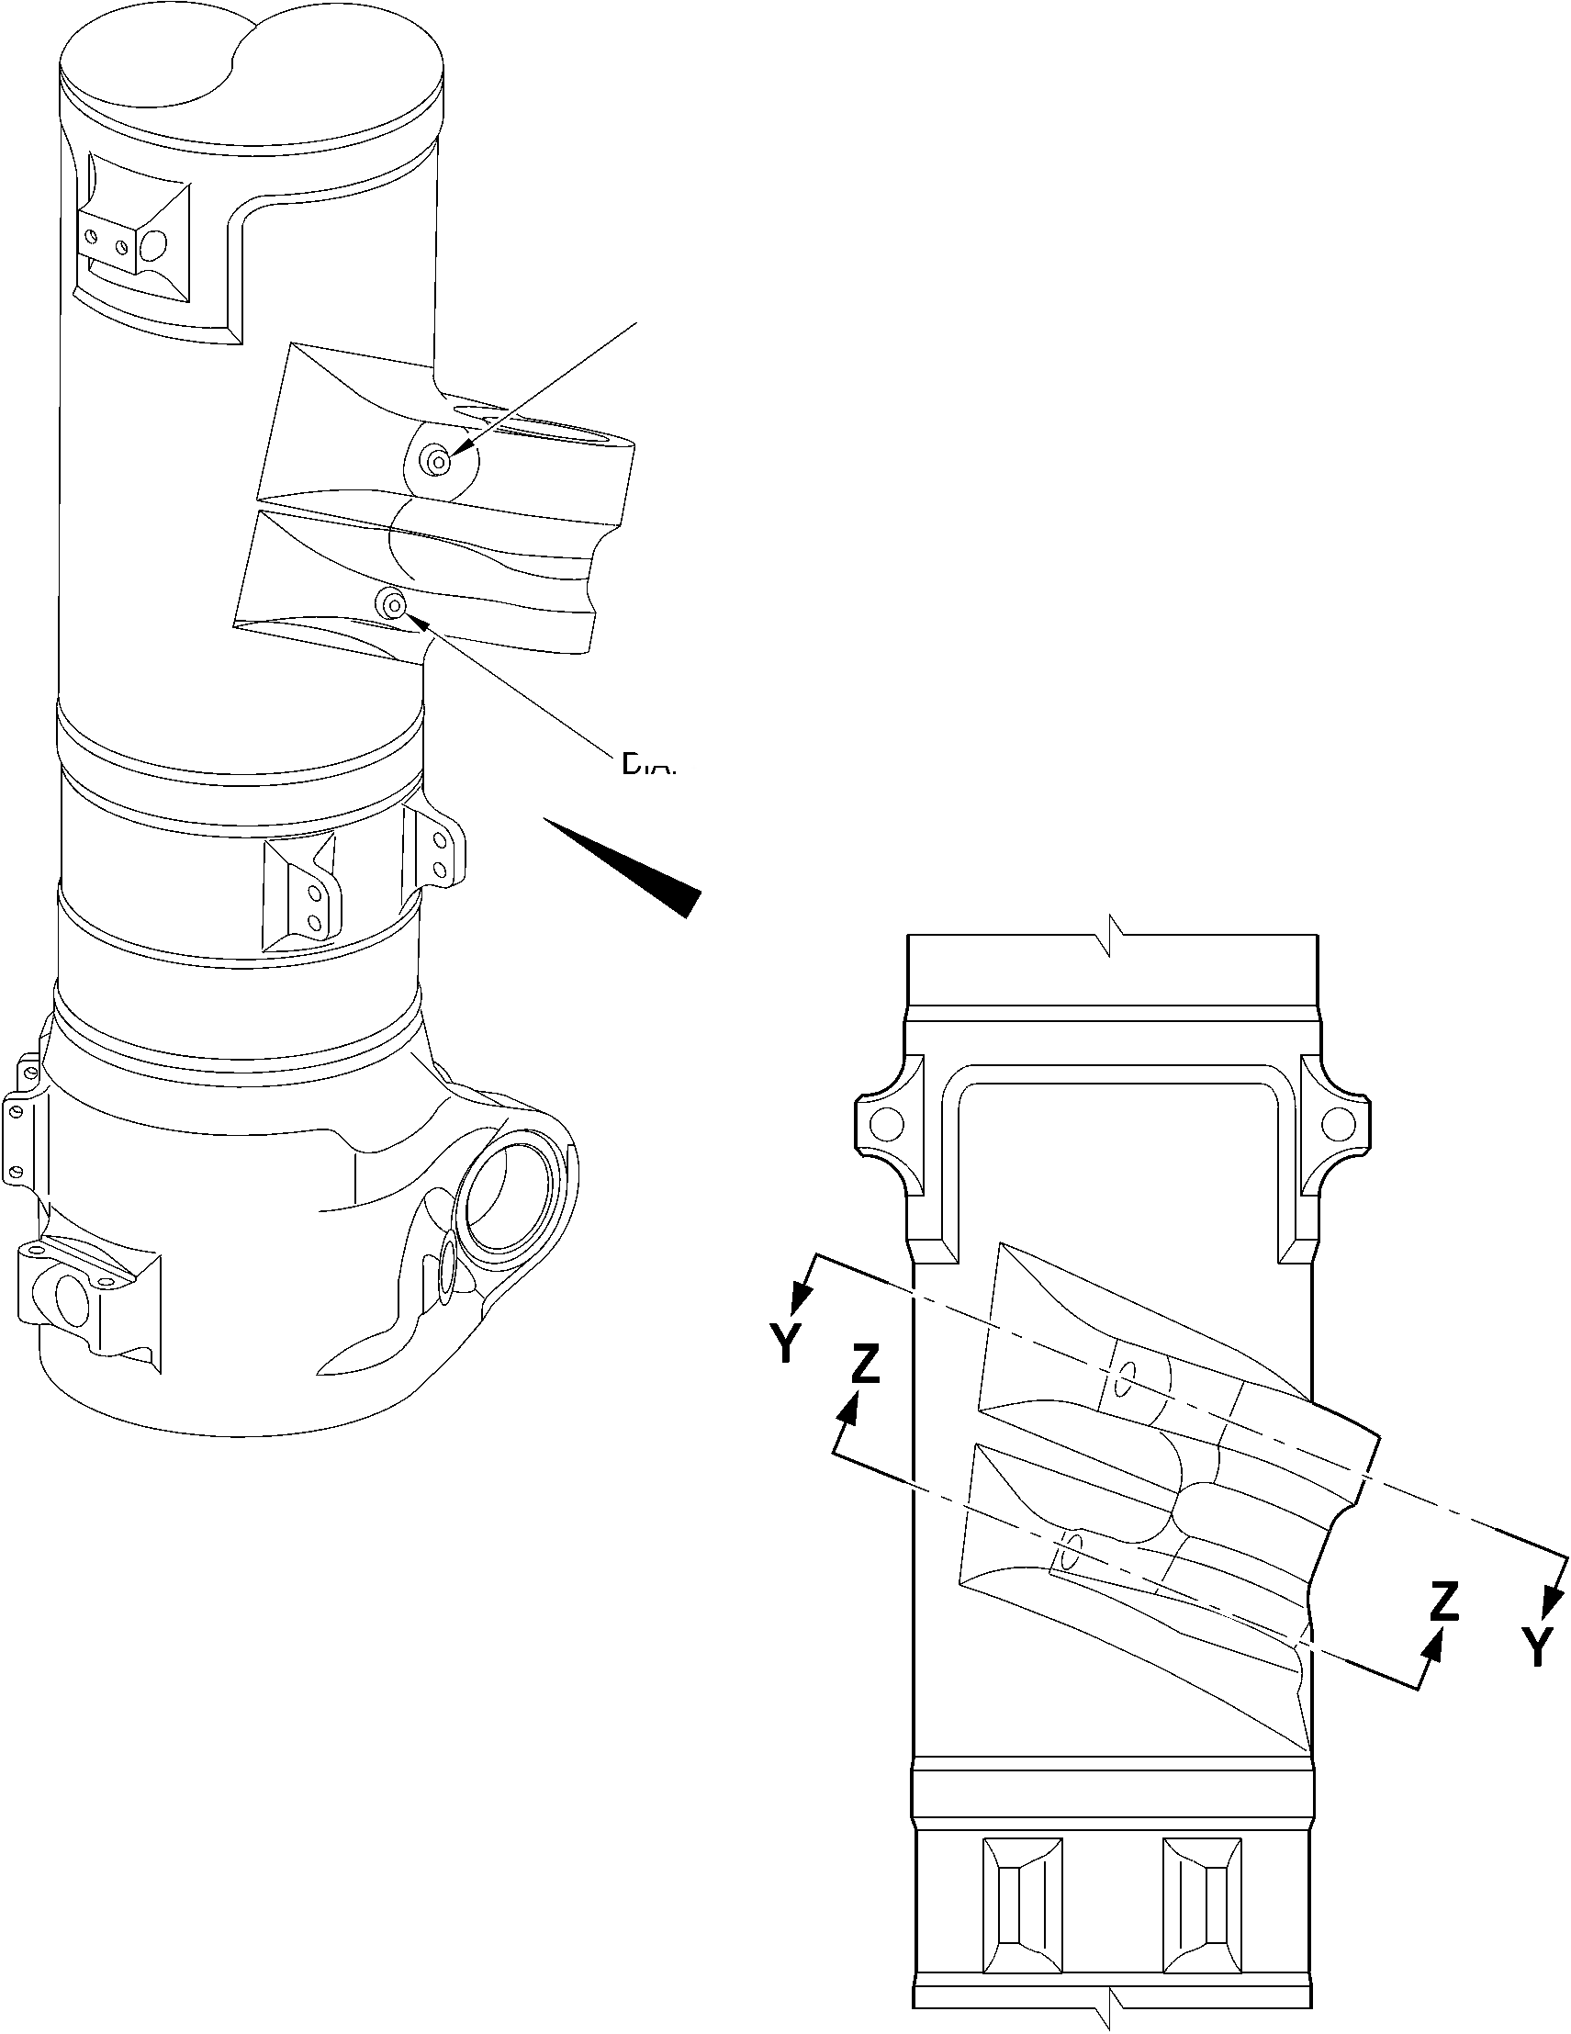

**SAFRAN LANDING SYSTEMS UK Ltd**

CAGE: K0654



PART No. 201587001 AND 201587002 COMPONENT MAINTENANCE MANUAL  
MAIN LANDING GEAR LEG

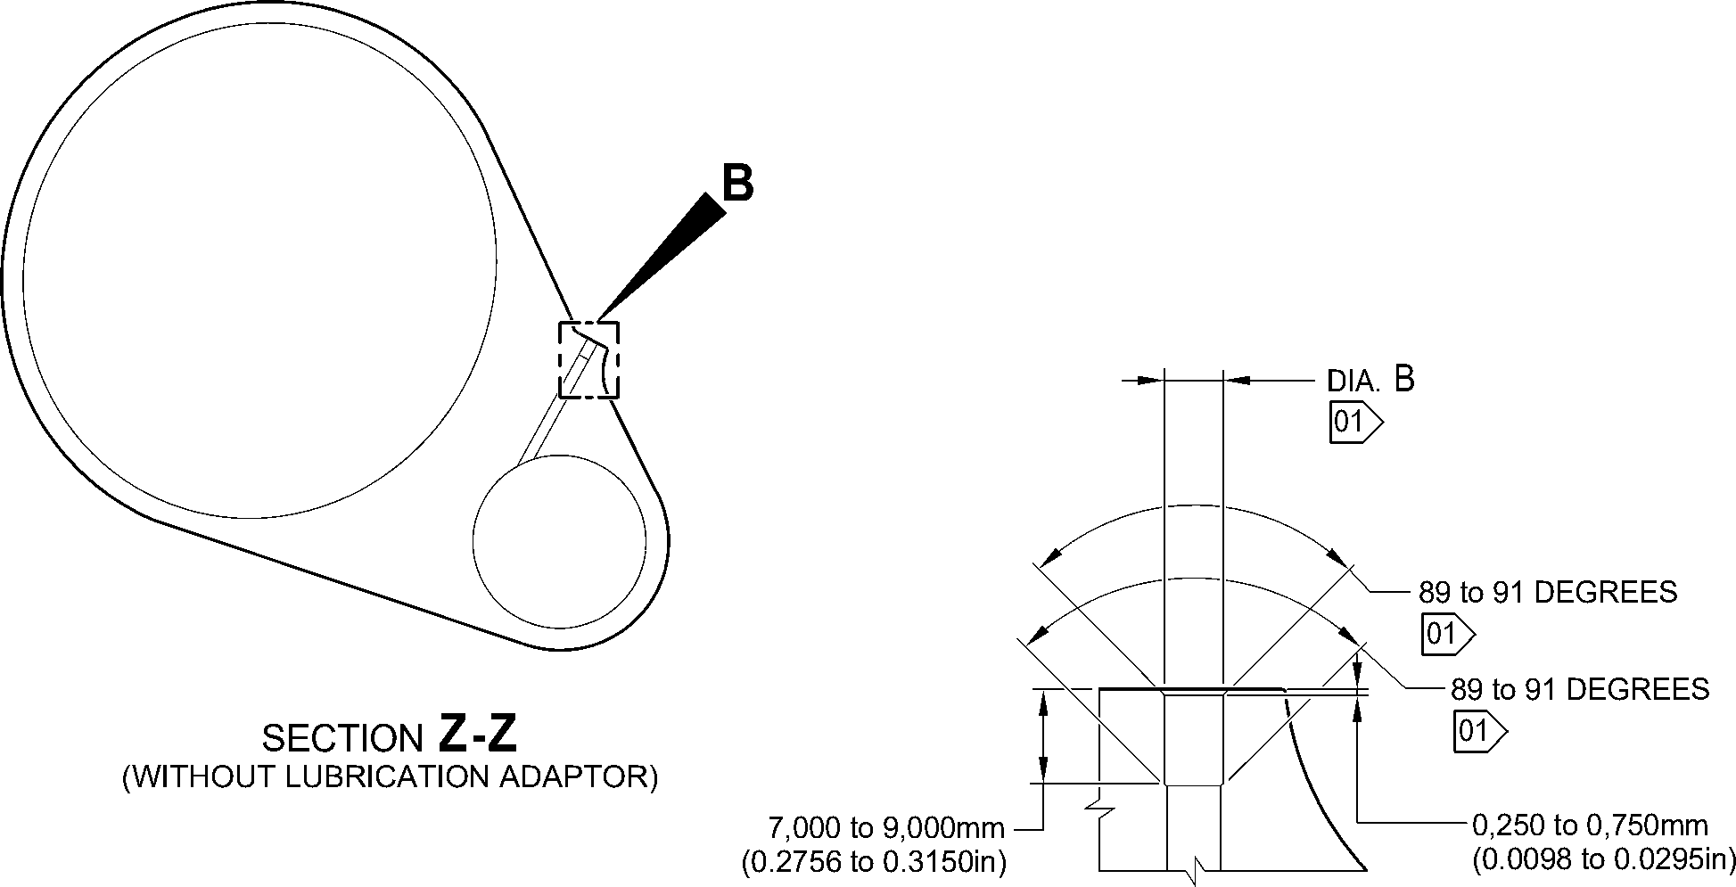

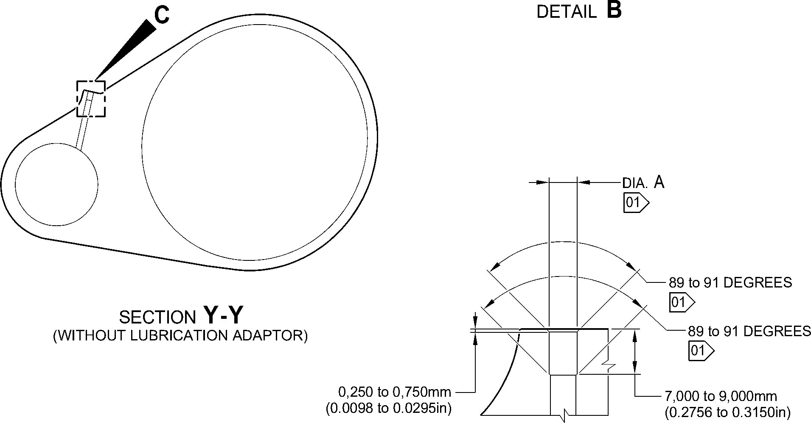

DETAIL **C**

1,6

**NOTE:** (63)

THE SURFACE FINISH MUST BE V OR BETTER UNLESS GIVEN DIFFERENTLY.

DIAMETER(S) A AND/OR B MUST FOLLOW THE LINE OF EXISTING BORES.

01 CADMIUM PLATE OPTIONAL AND NO PAINT.

A321-T-32-12-22-113-0

Repair to Main Fitting  
Figure 601 - Sheet 2

Repair No. 11-32

32-12-22

Page 605

Mar 18/2025

**SAFRAN LANDING SYSTEMS UK Ltd**

CAGE: K0654



PART No. 201587001 AND 201587002 COMPONENT MAINTENANCE MANUAL  
MAIN LANDING GEAR LEG

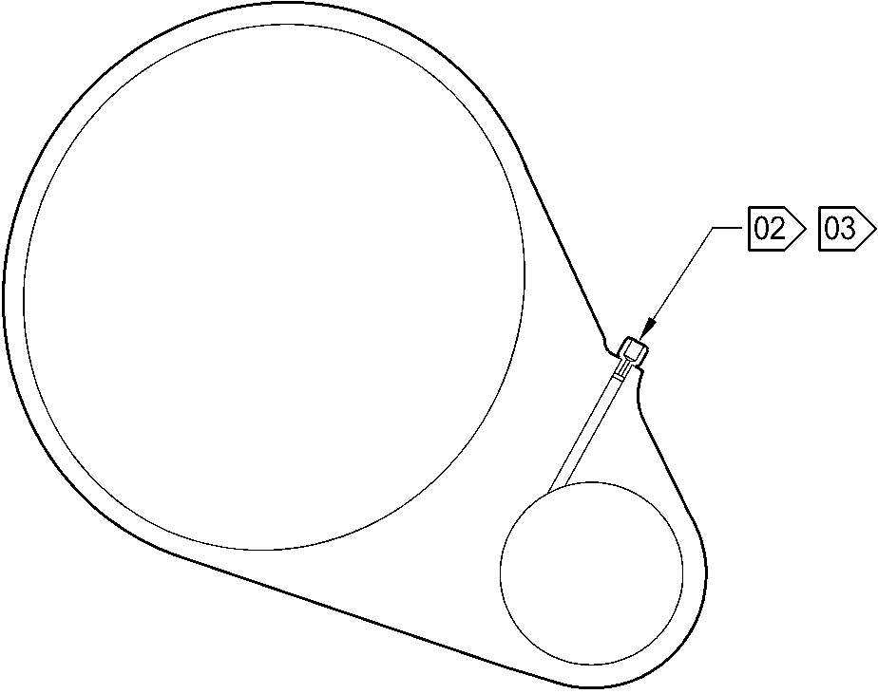

SECTION **Z-Z**

(WITH LUBRICATION ADAPTOR)

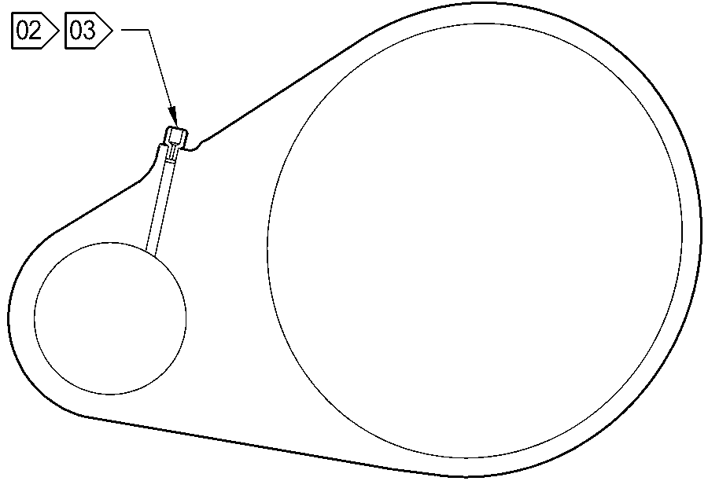

SECTION **Y-Y**

(WITH LUBRICATION ADAPTOR)

**NOTE:**

02 APPLY LOCTITE GRADE 270 TO ADAPTOR INTERFACE WITH MAIN FITTING: REFER TO PCS-5303.

03 INSTALL THE APPLICABLE LUBRICATION ADAPTOR: REFER TO TABLE 601.

A321-T-32-12-22-114-0

Repair to Main Fitting  
Figure 601 - Sheet 3

32-12-22

Repair No. 11-32

Page 606

Mar 18/2025

**sSAFRAN SAFRAN LANDING SYSTEMS UK Ltd**

CAGE: K0654

PART No. 201587001 AND 201587002 COMPONENT MAINTENANCE MANUAL  
MAIN LANDING GEAR LEG

1. Repair No. 11-33 Main Fitting (20-410B, 20-410C, 20-410D, 20-420B, 20-420C and 20-420D)
2. Specified Damage and Material Specification
3. Specified Damage

(a) Wear or damage or corrosion to diameter A.

1. Material Specification

|  |  |  |
| --- | --- | --- |
| IPL Figure and Item No. | Name | Material Specification |
| 20-410B and  20-420B | Main fitting | Steel 35NCD16THQ to MTL-1203 with  UTS 1800 MPa (261.0 ksi) |
| 20-410C,  20-410D, 20-420C and 20-420D | Main fitting | UHT steel, 300M to MTL-1201 with  UTS 1930 MPa (279.9 ksi) |

1. Special Tools
2. Special tools are not necessary.
3. Materials
4. These materials are necessary:

**NOTE: Alternative equivalents are permitted.**

|  |  |
| --- | --- |
| Ref. Item | Material |
| TBA | Zinc loaded Molykote 111 |
| TBA | Sealant |

1. Repair Parts
2. These repair parts are necessary:

|  |  |  |
| --- | --- | --- |
| Part No. | Repair Part | Material Specification |
| Refer to Table 601 for the correct oversize spherical bearing assembly | | - |

1. Procedure (Refer to Figure 601)

**CAUTION: FOR DAMAGE MORE THAN THE LIMITS OF THIS REPAIR SCHEME, WRITE  
TO SAFRAN LANDING SYSTEMS: REFER TO GUIDE-CS-001.**

1. Do this procedure if there is wear or damage to diameter A: refer to Figure 601.
2. Remove the paint from the main fitting: refer to PCS-2700.
3. Remove the cadmium plate from the main fitting: refer to PCS-2100.

Repair No. 11-33

32-12-22

Page 601

Mar 18/2025

**sSAFRAN SAFRAN LANDING SYSTEMS UK Ltd**

CAGE: K0654

PART No. 201587001 AND 201587002 COMPONENT MAINTENANCE MANUAL  
MAIN LANDING GEAR LEG

1. Machine diameter A to the nearest dimensions shown in Table 601 to remove the  
   damage or wear. Do not increase diameter A to more than 167,587 mm

(6.5979 in). The surface finish must be 1,6 micrometers (63 micro-inches) or better.  
The minimum wall thickness must not be between 15,382 mm (0.6056 in) and  
15,582 mm (0.6134 in): refer to PCS-4100 and Figure 601.

1. Measure and record diameter A. Refer to Table 601 for correct oversize spherical  
   bearing assembly.
2. Machine the chamfer(s) and/or radii as shown: refer to PCS-4100 and Figure 601.
3. Examine the machined areas for flaws: refer to PCS-3100, inclusion Class 4 and  
   PCS-3600.
4. Shot peen the reworked areas only: refer to PCS-2300.
5. Apply cadmium plate all over but not to the areas shown. The cadmium plate  
   thickness must be between 0,010 and 0,020 mm (0.0004 and 0.0008 in): refer to  
   PCS-2100. No bare metal is permitted.
6. Apply primer paint where shown: refer to PCS-2500 and Figure 601.
7. Select the correct oversize spherical bearing assembly from Table 601 applicable  
   for diameter A.
8. Install the spherical bearing assembly to the main fitting.
9. Use Zinc loaded Molykote 111, Material Ref. Item TBA, to install the oversize  
   spherical bearing assembly from Table 601 (qty 1 as necessary): refer to  
   PCS-7303 and Figure 601.
10. Apply fillet of Sealant, Material Ref. Item TBA, to the oversize spherical bearing  
    assembly: refer to PCS-7200 and Figure 601.
11. Apply top coat paint all over but not to the areas shown: refer to PCS-2500 and  
    Figure 601.
12. Record the repair number onto the documentation which is attached to the part.  
    Optionally, identify the part with the Safran Landing Systems repair number  
    64-4505109-00 adjacent to the existing part number: refer to PCS-6000-07.
13. Examine the part to make sure that you have obeyed all the repair instructions  
    correctly.

32-12-22

Repair No. 11-33

Page 602

Mar 18/2025

**SAFRAN LANDING SYSTEMS UK Ltd**

CAGE: K0654

PART No. 201587001 AND 201587002 COMPONENT MAINTENANCE MANUAL  
MAIN LANDING GEAR LEG

Oversize Lubrication Adaptors  
Table 601

|  |  |  |  |  |
| --- | --- | --- | --- | --- |
| Oversize | Oversize Step mm (in) | Inner Diameter A Before Plating mm (in) | Oversize Bearing Housing Outer Diameter Ref. mm (in) | Oversize Spherical Bearing Assembly Number |
| - | Production | 166,000 to 166,063 (6.5354 to 6.5379) | 165,934 to 165,959 (6.5328 to 6.5338) | - |
| 1st | 0,127 (0.0050) | 166,127 to 166,190 (6.5404 to 6.5429) | 166,061 to 166,086 (6.5378 to 6.5388) | 450258301 |
| 2nd | 0,254 (0.0100) | 166,254 to 166,317 (6.5454 to 6.5479) | 166,188 to 166,213 (6.5428 to 6.5438) | 450258302 |
| 3rd | 0,381 (0.0150 | 166,381 to 166,444 (6.5504 to 6.5529) | 166,315 to 166,340 (6.5478 to 6.5488) | 450258303 |
| 4th | 0,508 (0.0200) | 166,508 to 166,571 (6.5554 to 6.5579) | 166,442 to 166,467 (6.5528 to 6.5538) | 450258304 |
| 5th | 0,635 (0.0250) | 166,635 to 166,698 (6.5604 to 6.5629) | 166,569 to 166,594 (6.5578 to 6.5588) | 450258305 |
| 6th | 0,762 (0.0300) | 166,762 to 166,825 (6.5654 to 6.5679) | 166,696 to 166,721 (6.5628 to 6.5638) | 450258306 |
| 7th | 0,889 (0.0350) | 166,889 to 166,952 (6.5704 to 6.5729) | 166,823 to 166,848 (6.5678 to 6.5688) | 450258307 |
| 8th | 1,016 (0.0400) | 167,016 to 167,079 (6.5754 to 6.5779) | 166,950 to 166,975 (6.5728 to 6.5738) | 450258308 |
| 9th | 1,143 (0.0450) | 167,143 to 167,206 (6.5804 to 6.5829) | 167,077 to 167,102 (6.5778 to 6.5788) | 450258309 |
| 10th | 1,270 (0.0500) | 167,270 to 167,333 (6.5854 to 6.5879) | 167,204 to 167,229 (6.5828 to 6.5838) | 450258310 |
| 11th | 1,397 (0.0550) | 167,397 to 167,460 (6.5904 to 6.5929) | 167,331 to 167,356 (6.5878 to 6.5888) | 450258311 |
| 12th | 1,524 (0.0600) | 167,524 to 167,587 (6.5954 to 6.5979) | 167,458 to 167,483 (6.5928 to 6.5938) | 450258312 |

Repair No. 11-33

32-12-22

Page 603

Mar 18/2025

**SAFRAN LANDING SYSTEMS UK Ltd**

CAGE: K0654



PART No. 201587001 AND 201587002 COMPONENT MAINTENANCE MANUAL  
MAIN LANDING GEAR LEG

**A**

**B**

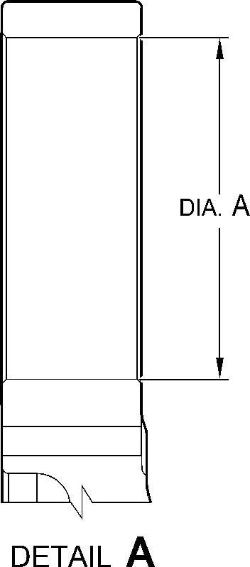

**Z**

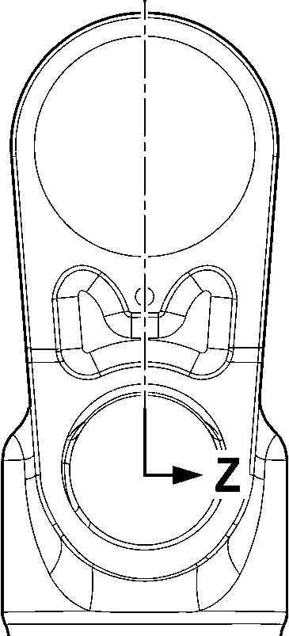

—F-

VIEW **B**

A321-T-32-12-22-146-0

Repair to Main Fitting  
Figure 601 - Sheet 1

32-12-22

Repair No. 11-33

Page 604

Mar 18/2025

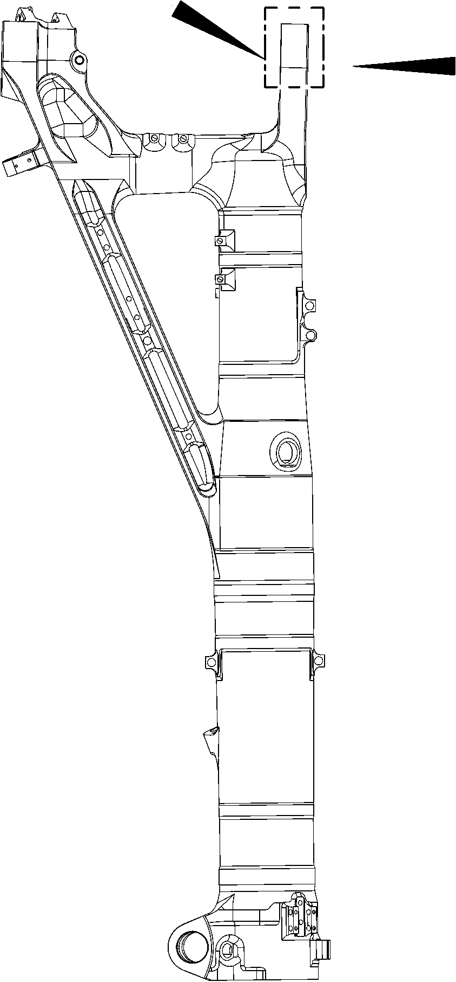

**SAFRAN LANDING SYSTEMS UK Ltd**

CAGE: K0654

PART No. 201587001 AND 201587002 COMPONENT MAINTENANCE MANUAL  
MAIN LANDING GEAR LEG

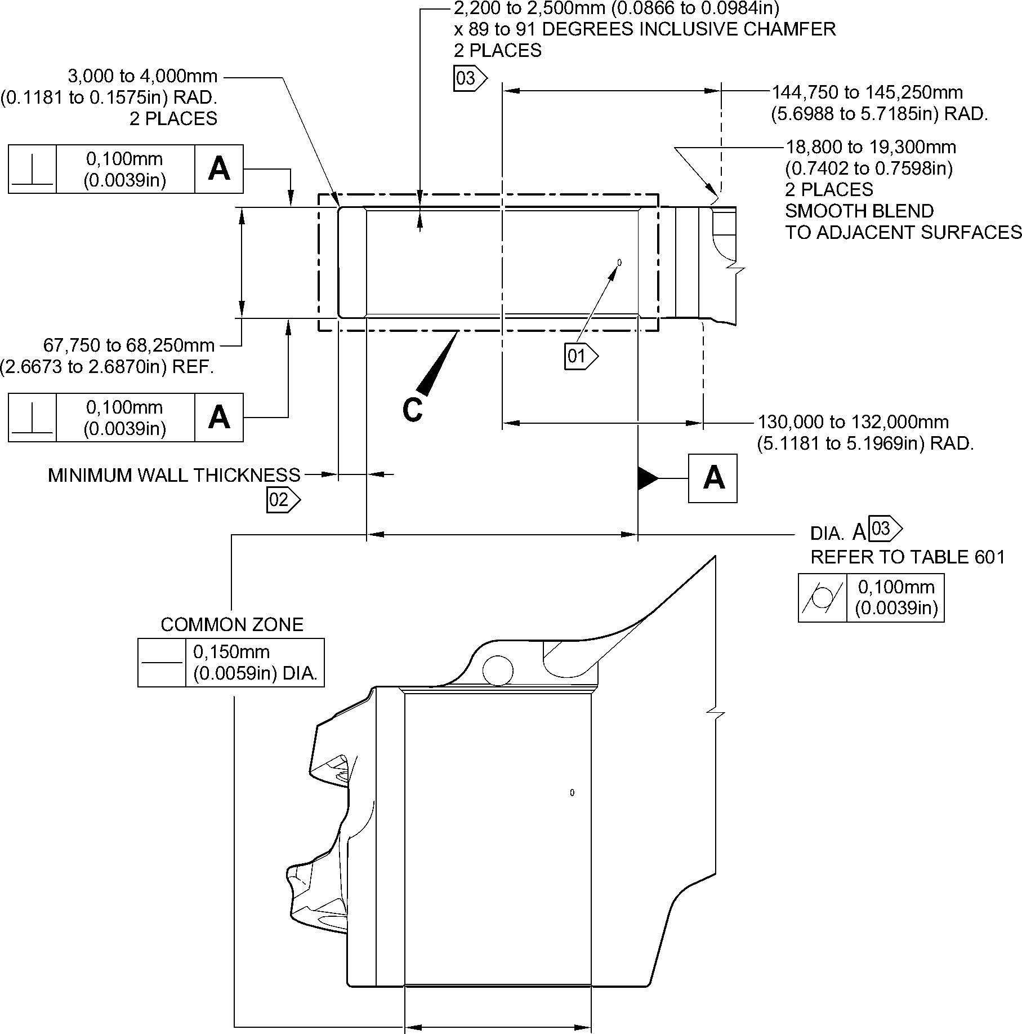

SECTION **Z-Z**

(WITHOUT OVERSIZE REAR SPHERICAL BEARING)  
90 DEGREES ROTATED

1,6

**NOTE:** (63)

THE SURFACE FINISH MUST BE V OR BETTER UNLESS GIVEN DIFFERENTLY.

DIAMETER A MUST FOLLOW THE AXIS OF EXISTING BORE.

01 REMOVE THE BREAK EDGES WITHIN 0,500 to 2,000mm (0.0197 to 0.0787in) RAD.

02 FOR THE MAIN FITTING (20-410B), (20-410C), (20-420B) and (20-420C):

THE MINIMUM WALL THICKNESS IS 15,382mm (0.6056in).

FOR THE MAIN FITTING (20-410D) and (20-420D):

THE MINIMUM WALL THICKNESS IS 15,582mm (0.6134in).

03 PRIMER PAINT ONLY: REFER TO PCS-2500. NO WITNESS OF TOP COAT PAINT PERMITTED  
ON THESE SURFACES.

A321-T-32-12-22-147-0

Repair to Main Fitting  
Figure 601- Sheet 2

Repair No. 11-33

32

Page 605

-12-22 Mar 18/2025

**SAFRAN LANDING SYSTEMS UK Ltd**

CAGE: K0654



PART No. 201587001 AND 201587002 COMPONENT MAINTENANCE MANUAL  
MAIN LANDING GEAR LEG

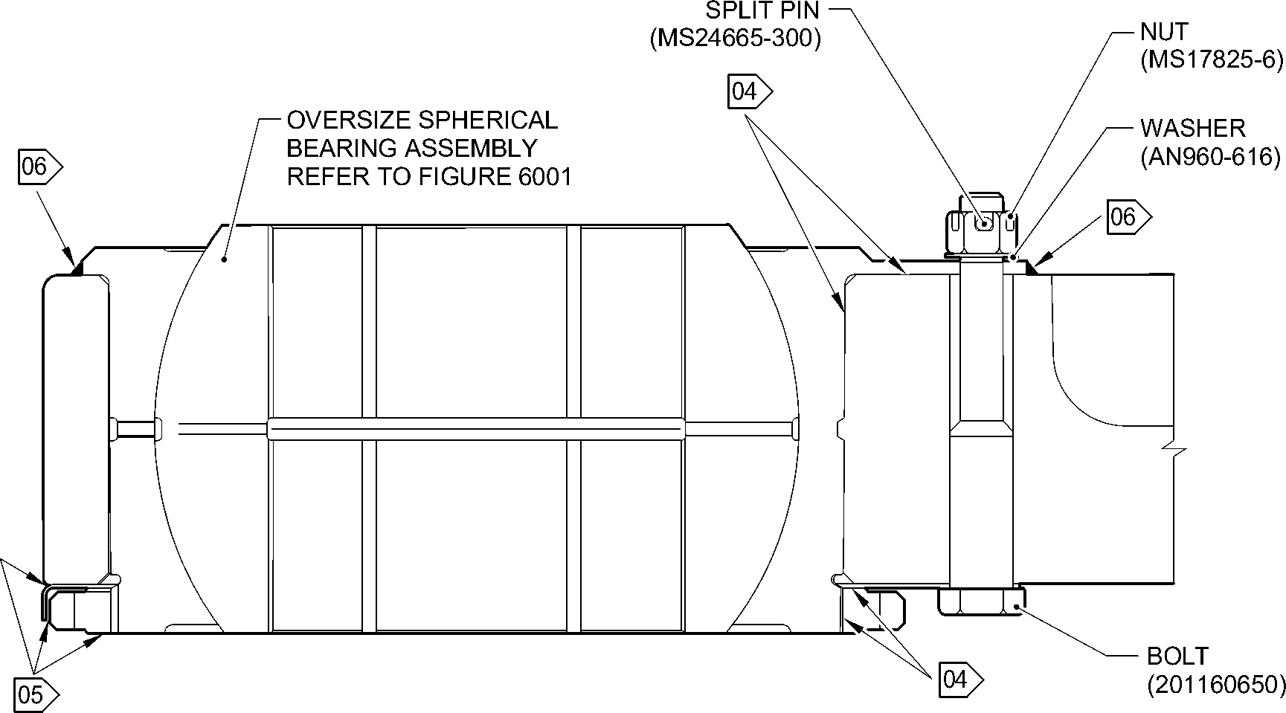

SECTION **Z-Z**

(WITH OVERSIZE REAR SPHERICAL BEARING)  
90 DEGREES ROTATED

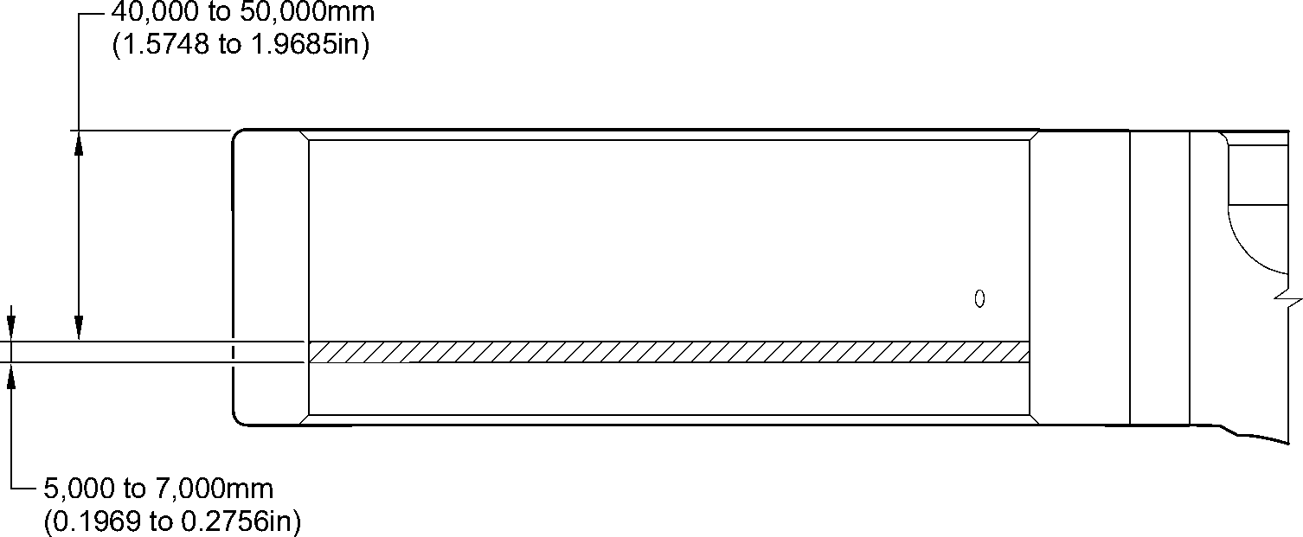

NO PAINT DETAIL **C**

**NOTE:**

04 APPLY MOLYKOTE 111 TO THE BOLT SHANKS, THREADS, UNDERCUTS AND ALL INTERFACES  
BETWEEN MATING PARTS MUST BE COATED BEFORE ASSEMBLY: REFER TO PCS-7303.

ALL CAVITIES AND VOIDS MUST BE FILLED TO PREVENT MOISTURE INGRESS.

05 APPLY A FULL BEAD OF SEALANT, PR340-2 WITH A MAXIMUM HEIGHT OF

1,000mm (0.0394in) ABOVE ADJOINING SURFACES: REFER TO PCS-7200.

06 APPLY SEALANT: REFER TO PCS-7200 TYPE 2.

A321-T-32-12-22-148-0

Repair to Main Fitting  
Figure 601 - Sheet 3

32-12-22

Repair No. 11-33

Page 606

Mar 18/2025

**sSAFRAN SAFRAN LANDING SYSTEMS UK Ltd**

CAGE: K0654

PART No. 201587001 AND 201587002 COMPONENT MAINTENANCE MANUAL  
MAIN LANDING GEAR LEG

1. Repair No. 11-34 Main Fitting (20-410B, 20-410C, 20-410D, 20-420B, 20-420C and 20-420D)
2. Specified Damage and Material Specification
3. Specified Damage

(a) Wear or damage or corrosion to diameter(s) A and/or B.

1. Material Specification

|  |  |  |
| --- | --- | --- |
| IPL Figure and Item No. | Name | Material Specification |
| 20-410B and  20-420B | Main fitting | UHT Steel E35NCD16THQ to MTL-1203 with UTS 1800 MPa (261.0 ksi) |
| 20-410C,  20-410D, 20-420C and 20-420D | Main fitting | UHT Steel 300M to MTL-1201 with  UTS 1930 MPa (279.9 ksi) |

1. Special Tools
2. Special tools are not necessary.
3. Materials
4. These materials are necessary:

**NOTE: Alternative equivalents are permitted.**

|  |  |
| --- | --- |
| Ref. Item | Material |
| TBA | Zinc loaded Molykote 111 |
| TBA | Sealant |

1. Repair Parts
2. These repair parts are necessary:

|  |  |  |
| --- | --- | --- |
| Part No. | Repair Part | Material Specification |
| 61-4533019-00 | Repair blank bush | Aluminium Bronze to AMS-4640 Ftu ≥ 758 MPa (109.9 ksi) |

Repair No. 11-34

32-12-22

Page 601

Mar 18/2025

**SAFRAN LANDING SYSTEMS UK Ltd**

CAGE: K0654

**SSAFRAN**

PART No. 201587001 AND 201587002 COMPONENT MAINTENANCE MANUAL  
MAIN LANDING GEAR LEG

1. Procedure (Refer to Figure 601 and Figure 602)

**CAUTION: FOR DAMAGE MORE THAN THE LIMITS OF THIS REPAIR SCHEME, WRITE  
TO SAFRAN LANDING SYSTEMS: REFER TO GUIDE-CS-001.**

**CAUTION: APPLY TEMPORARY CORROSION AND DAMAGE PROTECTION: REFER  
TO PCS-2800**

1. Do this procedure if there is wear or damage or corrosion to diameter(s) A and/or B:  
   refer to Figure 601 and Figure 602.
2. Remove the paint from the main fitting: refer to PCS-2700.
3. Remove the cadmium plate from the main fitting: refer to PCS-2100.
4. Machine diameter(s) A and/or B to remove the minimum amount of material to  
   remove the wear or damage or corrosion. Do not increase diameter(s) A and/or B  
   to more than 13,727 mm (0.5404 in). The surface finish must be 1,6 micrometers  
   (63 micro-inches) or better: refer to PCS-4100 and Figure 601.
5. Measure and record the diameter(s) A and/or B.
6. Machine the chamfer(s) and/or radii as shown: refer to PCS-4100 and Figure 601.
7. Examine the machined areas for flaws: refer to PCS-3100, inclusion Class 4 and  
   PCS-3600.
8. Shot peen the machined areas only: refer to PCS-2300.
9. Apply cadmium plate all over but not to the areas shown. The cadmium plate  
   thickness must be between 0,010 and 0,020 mm (0.0004 and 0.0008 in): refer to  
   PCS-2100. No bare metal is permitted.
10. Apply primer paint to the main fitting where shown: refer to PCS-2500.
11. Prepare the repair bush from the blank bush 61-4533019-00 with these dimensions  
    for installation (qty 1 to 2 as necessary): refer to Figure 601 and Figure 602.
12. Machine diameter Z, use the formula:

Dia. Z = Diameter A and/or B (as measured) + 0,018 to + 0,029 mm  
(+ 0.0007 to + 0.0011 in).

1. Apply cadmium plate all over. The cadmium plate thickness must be between  
   0,010 and 0,015 mm (0.0004 and 0.0006 in): refer to PCS-2101 and

Figure 602.

1. Use Zinc loaded Molykote 111, Material Ref. Item TBA, to install the repair bush.  
   Apply heat to the housing to 100°C and then cool the repair bushes: refer to  
   PCS-5105-2, PCS-7304 and Figure 601 and Figure 602.
2. Apply fillet of Sealant, Material Ref. Item TBA, to the bush flange and bush tail end:  
   refer to PCS-7200 and Figure 601.
3. Apply top coat paint all over but not to the areas where shown: refer to PCS-2500.
4. Record the repair number onto the documentation which is attached to the part.  
   Optionally, identify the part with the Safran Landing Systems repair number  
   64-4505112-00 adjacent to the existing part number: refer to PCS-6000-07.
5. Examine the part to make sure that you have obeyed all the repair instructions  
   correctly.

Repair No. 11-34

Page 602

Mar 18/2025

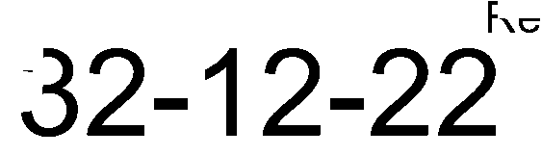

**SAFRAN LANDING SYSTEMS UK Ltd**

CAGE: K0654

PART No. 201587001 AND 201587002 COMPONENT MAINTENANCE MANUAL  
MAIN LANDING GEAR LEG

dia. B

**Y**

**Y**

COMMON ZONE

**Y**

**Y**

SECTION **Z-Z**

A321-T-32-12-22-134-0

0.150mm

(0.0059in) DIA.

0,100mm  
(0.0039in) DIA.

50,000mm (1.9685in)

**YY**

dia. A

Repair to Main Fitting  
Figure 601 - Sheet 1

Repair No. 11-34

32

Page 603

-12-22 Mar 18/2025

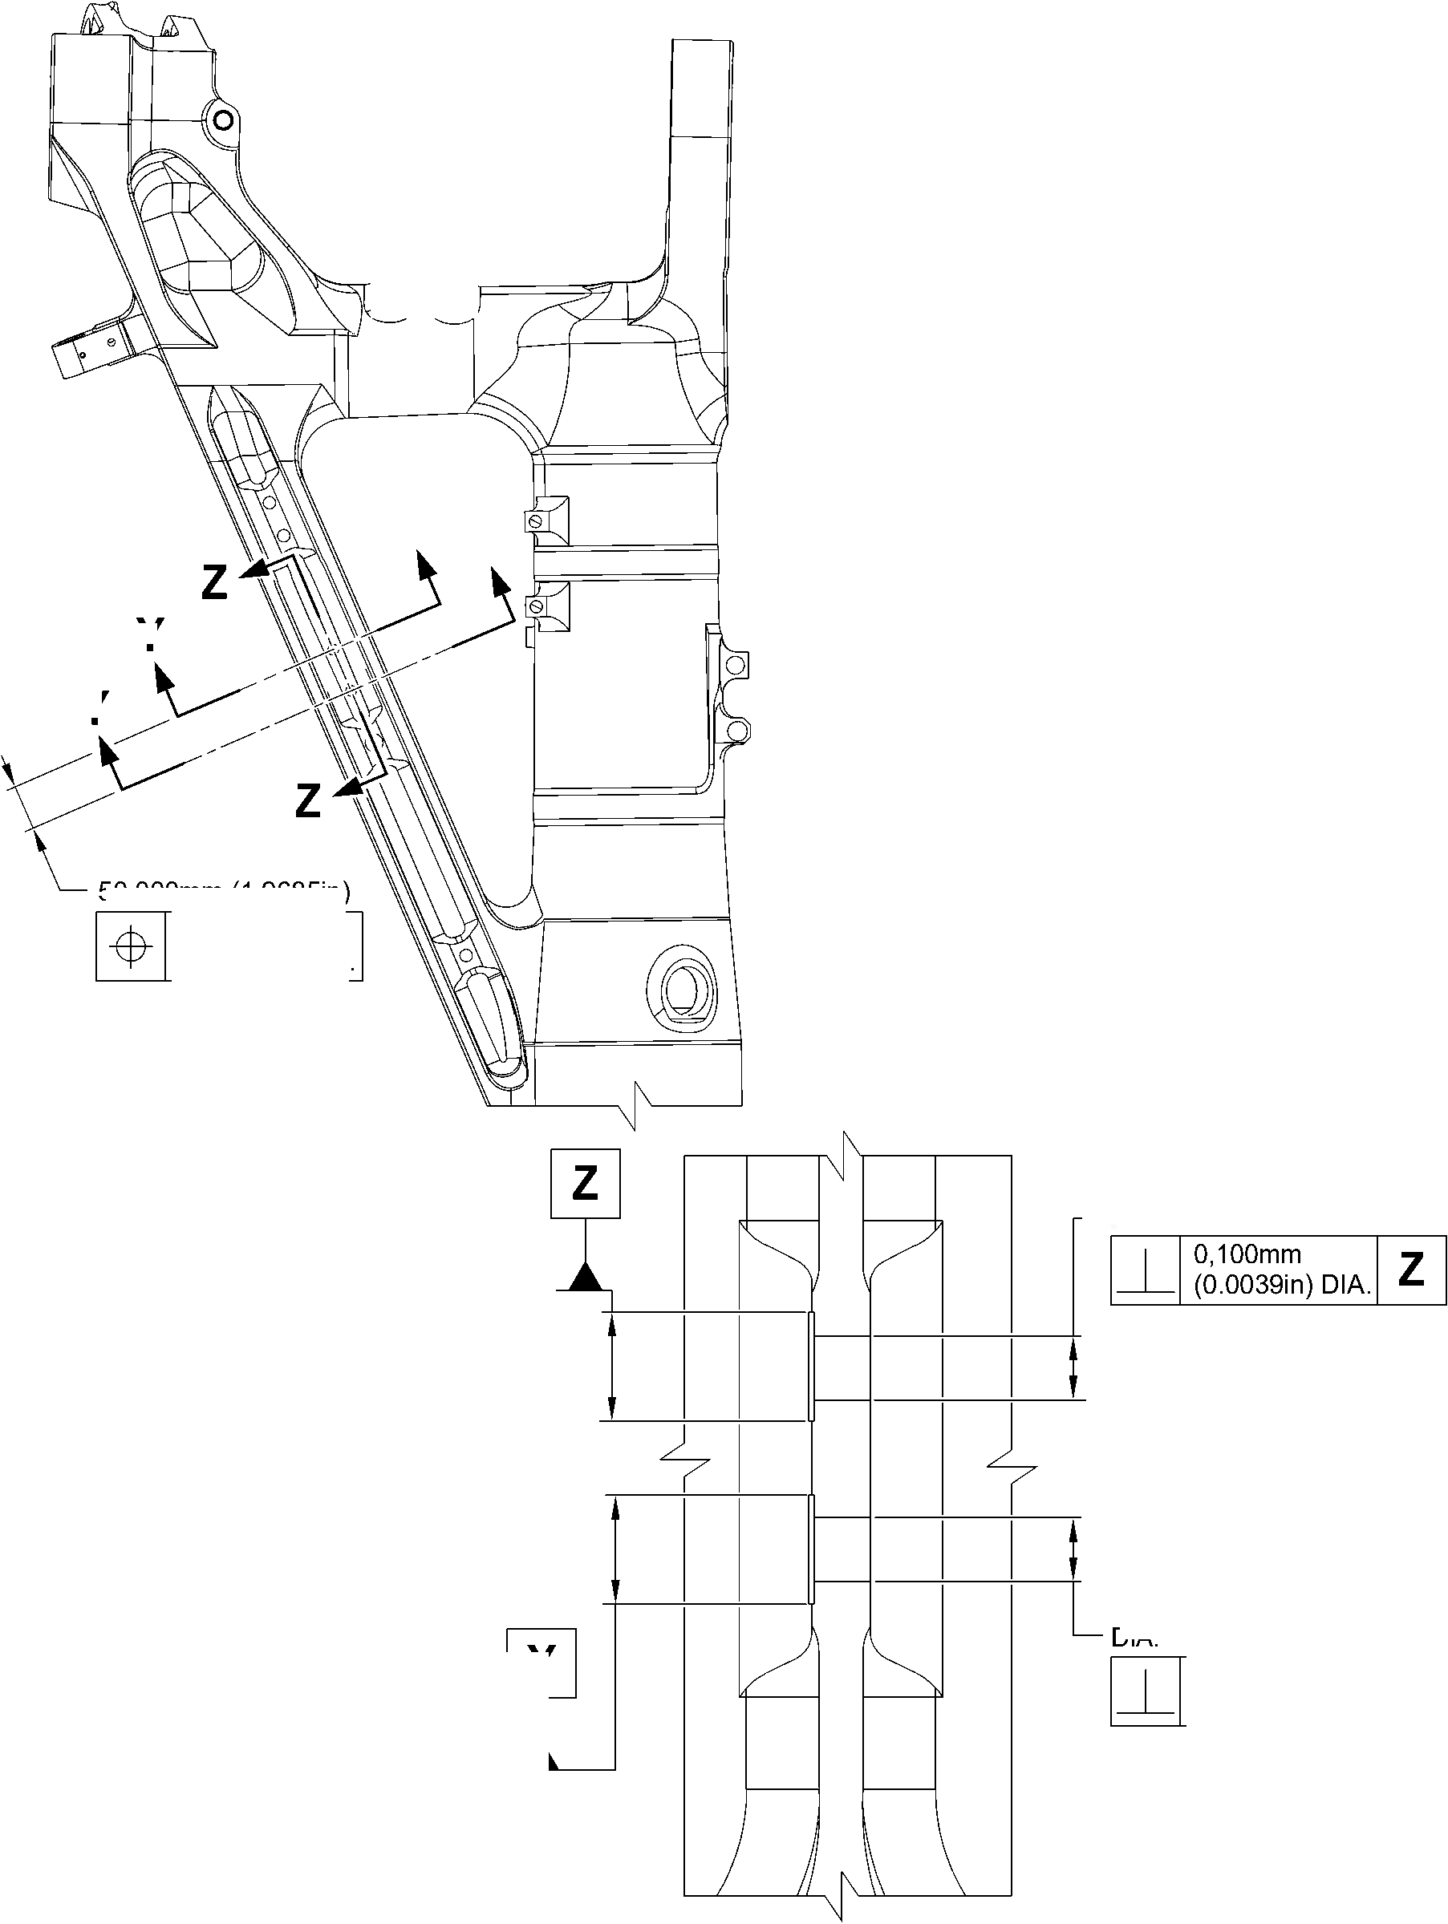

**SAFRAN LANDING SYSTEMS UK Ltd**

CAGE: K0654

PART No. 201587001 AND 201587002 COMPONENT MAINTENANCE MANUAL  
MAIN LANDING GEAR LEG

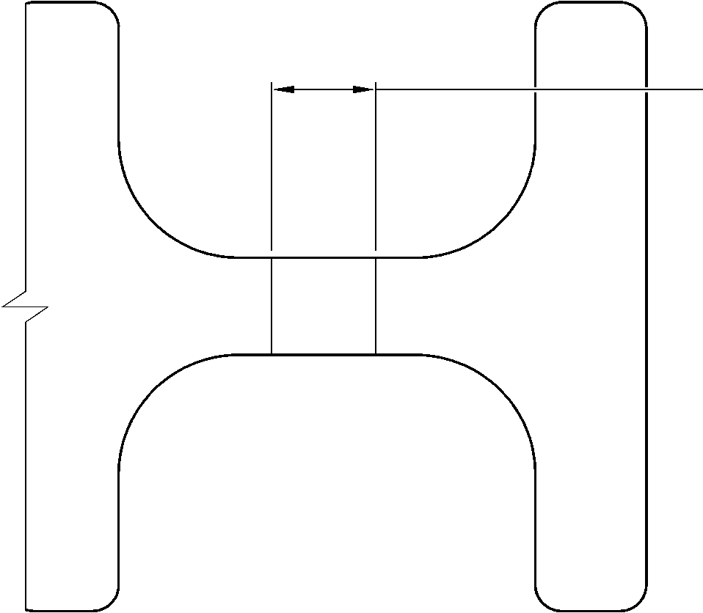

dia. A and B

13,727mm (0.5404in) DIA.

MAX.

SECTION **Y-Y**

(WITHOUT BUSHES)

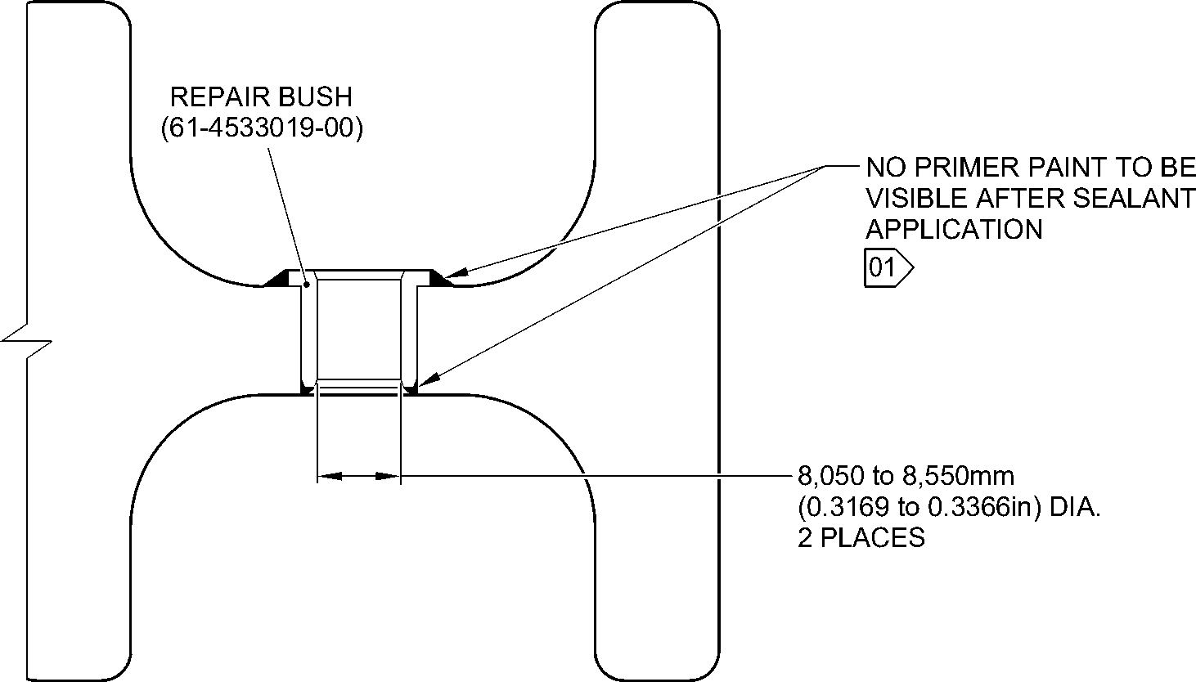

SECTION **Y-Y**(WITH BUSHES)

1,6

**NOTE:** (63)

THE SURFACE FINISH MUST BE V OR BETTER UNLESS GIVEN DIFFERENTLY.

DIAMETERS A AND B MUST FOLLOW THE AXIS OF EXISTING BORE.

DEBURR THE SHARP EDGES WITH 0,500 to 1,000mm (0.0197 to 0.0394in) RAD.

UNLESS GIVEN DIFFERENTLY.

01 APPLY FILLET SEALANT: REFER TO PCS-7200. MAKE SURE THAT THE SEALANT  
COMPLETELY COVERS EXPOSED PRIMER PAINT.

A321-T-32-12-22-135-0

Repair to Main Fitting  
Figure 601 - Sheet 2

32-12-22

Repair No. 11-34

Page 604

Mar 18/2025

**SAFRAN LANDING SYSTEMS UK Ltd**

CAGE: K0654

PART No. 201587001 AND 201587002 COMPONENT MAINTENANCE MANUAL  
MAIN LANDING GEAR LEG

2,900 to 3,150mm  
(0.1142 to 0.1240in)

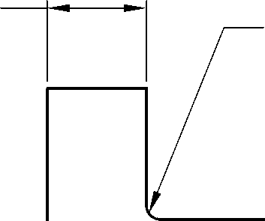

0,300 to 0,500mm

(0.0118 to 0.0196in) RAD.

—► 0,750 to 1,250mm

(0.0295 to 0.0492in)  
x 14,5 to 15,5 DEGREES  
CHAMFER

dia. Z

1,6

(63)

8,050 to 8,550mm  
(0.3169 to 0.3366in) DIA. REF.

0,750 to 1,250mm  
(0.0295 to 0.0492in)

x 14,5 to 15,5 DEGREES  
CHAMFER

11,500 to 12,000mm  
(0.4528 to 0.4724in)

3,2

**NOTE:** (125)

THE SURFACE FINISH MUST BE OR BETTER UNLESS GIVEN DIFFERENTLY.

DEBURR THE SHARP EDGES WITH 0,130 to 0,380mm (0.0051 to 0.0150in) RAD.  
UNLESS GIVEN DIFFERENTLY.

APPLY CADMIUM PLATE ALL OVER: REFER TO PCS-2101. THE CADMIUM PLATE  
THICKNESS MUST BE BETWEEN 0,010 to 0,015mm (0.0004 to 0.0006in).

A321-T-32-12-22-136-0

Repair to Main Fitting - Bush

Figure 602

Repair No. 11-34

32-12-22

Page 605

Mar 18/2025

**SAFRAN LANDING SYSTEMS UK Ltd**

CAGE: K0654



PART No. 201587001 AND 201587002 COMPONENT MAINTENANCE MANUAL  
MAIN LANDING GEAR LEG

INTENTIONALLY BLANK

Repair No. 11-34

32-12-22 Page 606

**sSAFRAN SAFRAN LANDING SYSTEMS UK Ltd**

CAGE: K0654

PART No. 201587001 AND 201587002 COMPONENT MAINTENANCE MANUAL  
MAIN LANDING GEAR LEG

1. Repair No. 11-35 Main Fitting (20-410B, 20-410C, 20-410D, 20-420B, 20-420C and 20-420D)
2. Specified Damage and Material Specification
3. Specified Damage

(a) Wear or damage or corrosion to diameter(s) A and B.

1. Material Specification

|  |  |  |
| --- | --- | --- |
| IPL Figure and Item No. | Name | Material Specification |
| 20-410B and  20-420B | Main fitting | UHT Steel E35NCD16THQ to MTL-1203 with UTS 1800 MPa (261.0 ksi) |
| 20-410C,  20-410D, 20-420C and 20-420D | Main fitting | UHT Steel 300M to MTL-1201 with  UTS 1930 MPa (279.9 ksi) |

1. Special Tools
2. Special tools are not necessary.
3. Materials
4. These materials are necessary:

**NOTE: Alternative equivalents are permitted.**

|  |  |
| --- | --- |
| Ref. Item | Material |
| TBA | Zinc loaded Molykote 111 |
| TBA | Sealant |

1. Repair Parts
2. These repair parts are necessary:

|  |  |  |
| --- | --- | --- |
| Part No. | Repair Part | Material Specification |
| 61-4533018-00 | Repair blank bush | Aluminium Bronze to AMS-4640 Ftu ≥ 758 MPa (109.9 ksi) |

Repair No. 11-35

32-12-22

Page 601

Mar 18/2025

**SAFRAN LANDING SYSTEMS UK Ltd**

CAGE: K0654

**SSAFRAN**

PART No. 201587001 AND 201587002 COMPONENT MAINTENANCE MANUAL  
MAIN LANDING GEAR LEG

1. Procedure (Refer to Figure 601 and Figure 602)

**CAUTION: FOR DAMAGE MORE THAN THE LIMITS OF THIS REPAIR SCHEME, WRITE**

**TO SAFRAN LANDING SYSTEMS: REFER TO GUIDE-CS-001.**

**CAUTION: APPLY TEMPORARY CORROSION AND DAMAGE PROTECTION: REFER**

**TO PCS-2800**

1. Do this procedure if there is wear or damage or corrosion to diameter(s) A and B: refer  
   to Figure 601 and Figure 602.
2. Remove the paint from the main fitting: refer to PCS-2700.
3. Remove the cadmium plate from the main fitting: refer to PCS-2100.
4. Machine diameter(s) A and B to remove the minimum amount of material to  
   remove the wear or damage or corrosion. Do not increase diameter(s) A and B to  
   more than 15,727 mm (0.6192 in). The surface finish must be 1,6 micrometers  
   (63 micro-inches) or better: refer to PCS-4100 and Figure 601.
5. Measure and record the diameter(s) A and B.
6. Machine the chamfer(s) and/or radii as shown: refer to PCS-4100 and Figure 601.
7. Examine the machined areas for flaws: refer to PCS-3100 inclusion, Class 4 and  
   PCS-3600.
8. Shot peen the machined areas only: refer to PCS-2300.
9. Apply cadmium plate all over but not to the areas shown. The plating thickness  
   must be between 0,010 and 0,020 mm (0.0004 and 0.0008 in): refer to PCS-2100.  
   No bare metal is permitted.
10. Apply primer paint to the main fitting where shown: refer to PCS-2500.
11. Prepare the repair bushes from the blank bush 61-4533018-00 with these

dimensions for installation (qty 1 to 2 as necessary): refer to Figure 602.

1. Machine diameter Z, use the formula:

Dia. Z = Dia. A (as measured) + 0,018 to + 0,029 mm  
(+ 0.0007 to + 0.0011 in).

1. Apply cadmium plate all over. The plating thickness must be between 0,010  
   and 0,015 mm (0.0004 and 0.0006 in): refer to PCS-2101 and Figure 602.
2. Use Zinc loaded Molykote 111, Material Ref. Item TBA, and install the repair  
   bushes. Apply heat to the housing to 100°C and then cool the repair bushes: refer  
   to PCS-5105-2, PCS-7304 and Figure 601 and Figure 602.
3. Apply fillet of Sealant, Material Ref. Item TBA, to the bush flange and bush tail end:  
   refer to PCS-7200 and Figure 601.
4. Apply top coat paint all over but not to the areas shown: refer to PCS-2500.
5. Record the repair number onto the documentation which is attached to the part.  
   Optionally, identify the part with the Safran Landing Systems repair number  
   64-4505111-00 adjacent to the existing part number: refer to PCS-6000-07.
6. Examine the part to make sure that you have obeyed all the repair instructions

correctly.

Repair No. 11-35

Page 602

Mar 18/2025

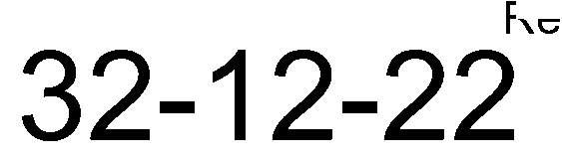

**SAFRAN LANDING SYSTEMS UK Ltd**

CAGE: K0654



PART No. 201587001 AND 201587002 COMPONENT MAINTENANCE MANUAL  
MAIN LANDING GEAR LEG

40,000mm (1.5478in)

COMMON ZONE

**Y**

**Y**

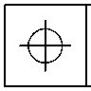

0.150mm

(0.0059in) DIA.

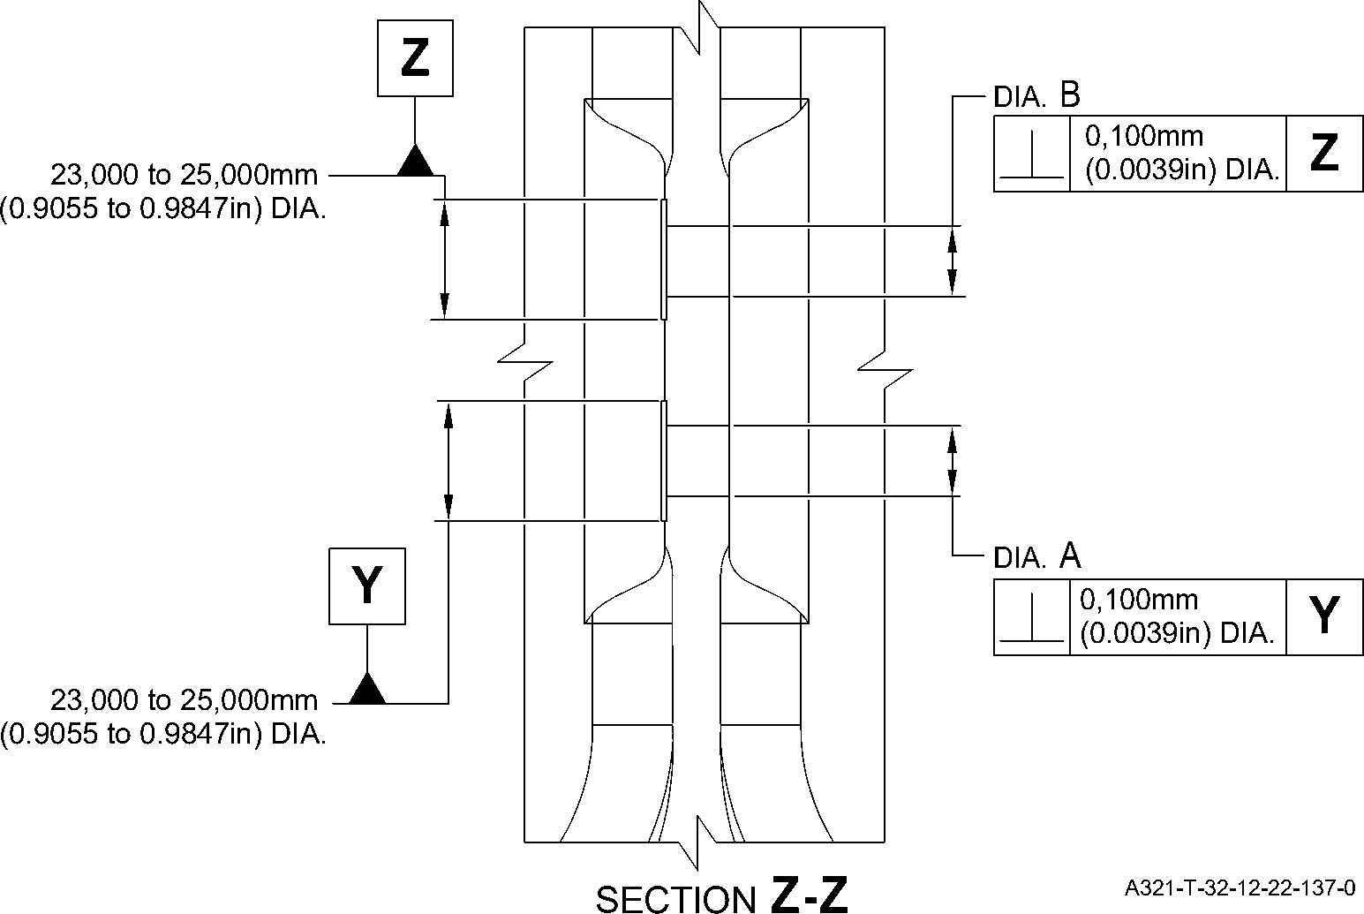

Repair to Main Fitting  
Figure 601 - Sheet 1

Repair No. 11-35

32-12-22

Page 603

Mar 18/2025

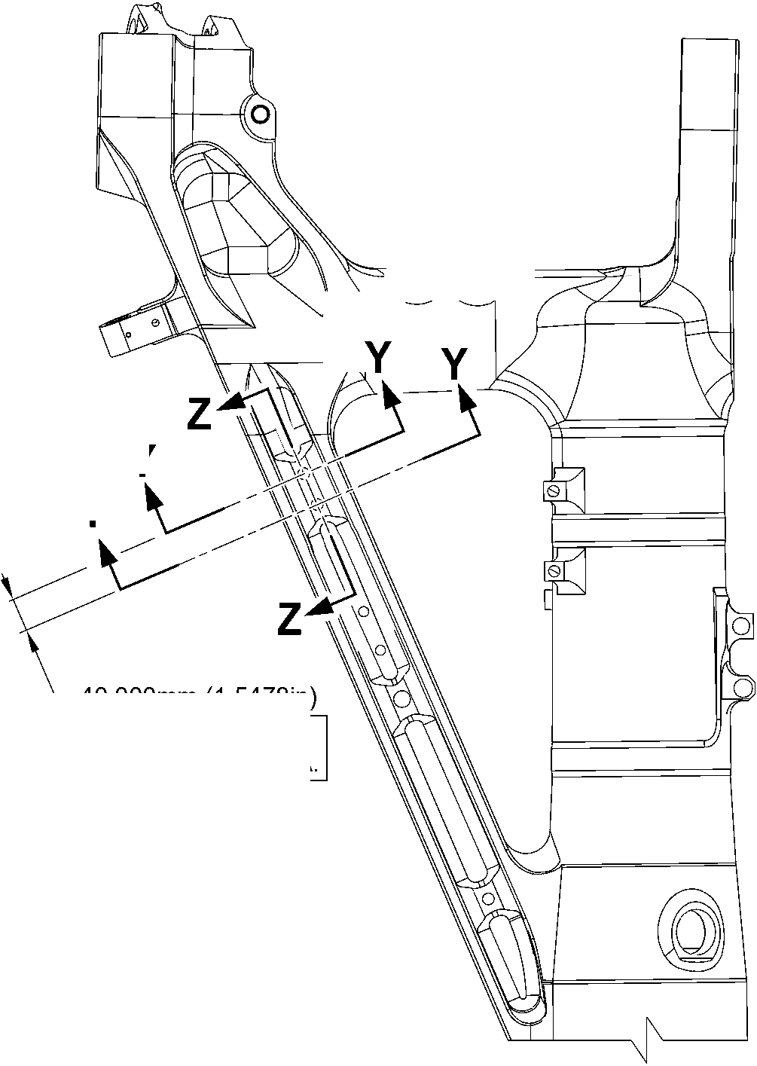

**SAFRAN LANDING SYSTEMS UK Ltd**

CAGE: K0654

PART No. 201587001 AND 201587002 COMPONENT MAINTENANCE MANUAL  
MAIN LANDING GEAR LEG

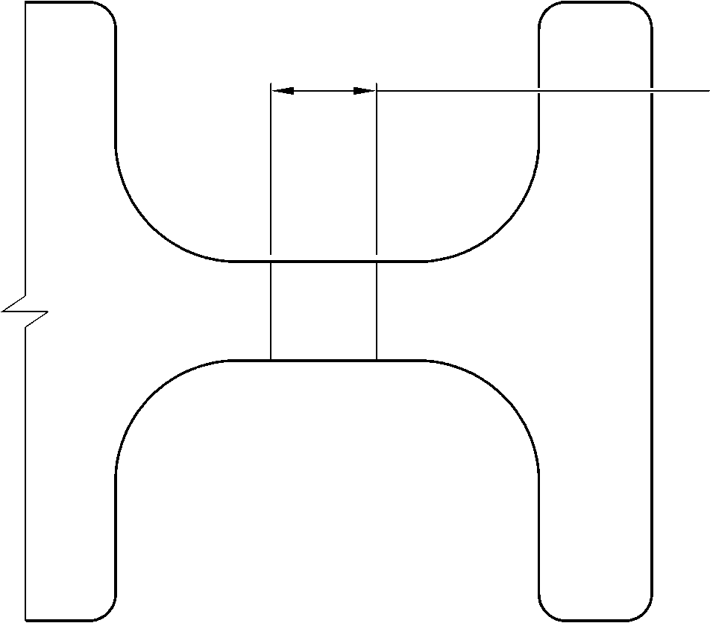

dia. A and B

15,727mm (0.6192in) DIA.

MAX.

**A**

SECTION **Y-Y**(WITHOUT BUSHES)

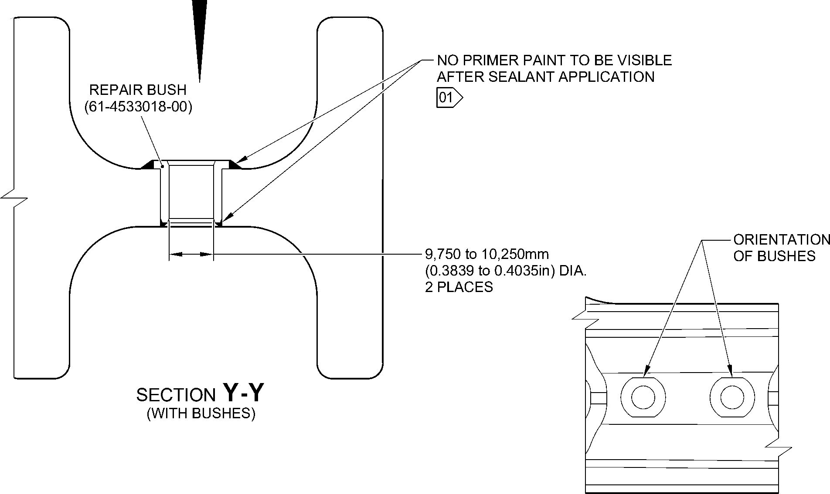

1,6

**NOTE:** (63) VIEW

THE SURFACE FINISH MUST BE V OR BETTER UNLESS GIVEN DIFFERENTLY.

DIAMETERS A AND B MUST FOLLOW THE AXIS OF EXISTING BORE.

DEBURR THE SHARP EDGES WITH 0,500 to 1,000mm (0.0197 to 0.0394in) RAD.

UNLESS GIVEN DIFFERENTLY.

01 APPLY FILLET SEALANT: REFER TO PCS-7200. MAKE SURE THAT THE SEALANT COMPLETELY  
COVERS EXPOSED PRIMER PAINT.

A321-T-32-12-22-138-0

Repair to Main Fitting  
Figure 601 - Sheet 2

32-12-22

Repair No. 11-35

Page 604

Mar 18/2025

**SAFRAN LANDING SYSTEMS UK Ltd**

CAGE: K0654

PART No. 201587001 AND 201587002 COMPONENT MAINTENANCE MANUAL  
MAIN LANDING GEAR LEG

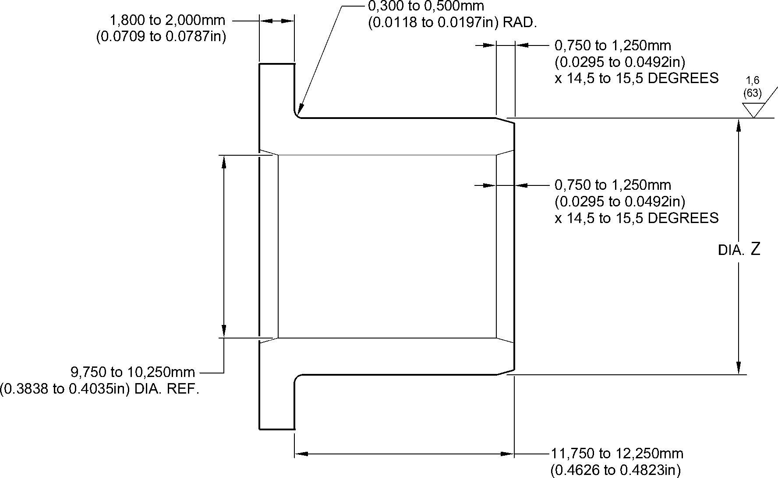

3,2

**NOTE:** (125)

THE SURFACE FINISH MUST BE V OR BETTER UNLESS GIVEN DIFFERENTLY.

APPLY CADMIUM PLATE ALL OVER: REFER TO PCS-2101. THE PLATING THICKNESS

MUST BE BETWEEN 0,010 to 0,015mm (0.0004 to 0.0006in).

DEBURR THE SHARP EDGES WITH 0,130 to 0,380mm (0.0051 to 0.0150in) RAD.

UNLESS GIVEN DIFFERENTLY.

A321-T-32-12-22-139-0

Repair to Main Fitting - Bush

Figure 602

Repair No. 11-35

32-12-22

Page 605

Mar 18/2025

**SAFRAN LANDING SYSTEMS UK Ltd**

CAGE: K0654



PART No. 201587001 AND 201587002 COMPONENT MAINTENANCE MANUAL  
MAIN LANDING GEAR LEG

INTENTIONALLY BLANK

Repair No. 11-35

32-12-22 Page 606

**sSAFRAN SAFRAN LANDING SYSTEMS UK Ltd**

CAGE: K0654

PART No. 201587001 AND 201587002 COMPONENT MAINTENANCE MANUAL  
MAIN LANDING GEAR LEG

1. Repair No. 11-36 Main Fitting (20-410B, 20-410C, 20-410D, 20-420B, 20-420C and 20-420D)
2. Specified Damage and Material Specification
3. Specified Damage

(a) Wear or damage or corrosion to diameter(s) A and/or B and/or C and/or D.

1. Material Specification

|  |  |  |
| --- | --- | --- |
| IPL Figure and Item No. | Name | Material Specification |
| 20-410B and  20-420B | Main fitting | UHT Steel E35NCD16THQ to MTL-1203 with UTS 1800 MPa (261.0 ksi) |
| 20-410C,  20-410D, 20-420C and 20-420D | Main fitting | UHT Steel 300M to MTL-1201 with  UTS 1930 MPa (279.9 ksi) |

1. Special Tools
2. Special tools are not necessary.
3. Materials
4. Materials are not necessary.
5. Repair Parts
6. Repair parts are not necessary.
7. Procedure (Refer to Figure 601)

**CAUTION: FOR DAMAGE MORE THAN THE LIMITS OF THIS REPAIR SCHEME, WRITE  
TO SAFRAN LANDING SYSTEMS: REFER TO GUIDE-CS-001.**

**CAUTION: APPLY TEMPORARY CORROSION AND DAMAGE PROTECTION: REFER  
TO PCS-2800**

1. Do this procedure if there is wear or damage or corrosion to diameter(s) A and/or B  
   and/or C and/or D: refer to Figure 601.
2. Remove the paint from the main fitting: refer to PCS-2700.
3. Remove the cadmium plate from the main fitting: refer to PCS-2100.
4. Machine diameter(s) A and/or B and/or C and/or D to remove the minimum amount  
   of material to remove wear or damage. Do not increase diameter(s) A and/or B  
   and/or C and/or D to more than 16,170 mm (0.6366 in). The surface finish must  
   be 1,6 micrometers (63 micro-inches) or better: refer to PCS-4100 and  
   Figure 601. The minimum wall thickness must not be less than 1,915 mm  
   (0.0754 in): refer to Figure 601.
5. Machine the chamfer(s) and/or radii as shown: refer to PCS-4100 and Figure 601.
6. Examine the machined areas for flaws: refer to PCS-3100, inclusion Class 4 and  
   refer to PCS-3600.

Repair No. 11-36

32-12-22

Page 601

Mar 18/2025

**sSAFRAN SAFRAN LANDING SYSTEMS UK Ltd**

CAGE: K0654

PART No. 201587001 AND 201587002 COMPONENT MAINTENANCE MANUAL  
MAIN LANDING GEAR LEG

1. Shot peen the machined areas only: refer to PCS-2300.
2. Apply cadmium plate all over. The plating thickness must be between 0,010  
   and 0,020 mm (0.0004 and 0.0008 in): refer to PCS-2100 or PCS-2141. No bare  
   metal is permitted.
3. Apply primer and paint finish all over but not to the areas shown. No bare cadmium  
   is permitted but not to the areas where there is no paint: refer to PCS-2500 and  
   Figure 601.
4. Record the repair number onto the documentation which is attached to the part.  
   Optionally, identify the part with the Safran Landing Systems repair number  
   64-4505234-00 adjacent to the existing part number: refer to PCS-6000-07.
5. Examine the part to make sure that you have obeyed all the repair instructions  
   correctly.

32-12-22

Repair No. 11-36

Page 602

Mar 18/2025

**SAFRAN LANDING SYSTEMS UK Ltd**

CAGE: K0654

PART No. 201587001 AND 201587002 COMPONENT MAINTENANCE MANUAL  
MAIN LANDING GEAR LEG

dia. D

dia. C

dia. B

DIA. A

**A**

VIEW **A**

A321-T-32-12-22-140-0

Repair to Main Fitting  
Figure 601 - Sheet 1

Repair No. 11-36

32

Page 603

-12-22 Mar 18/2025

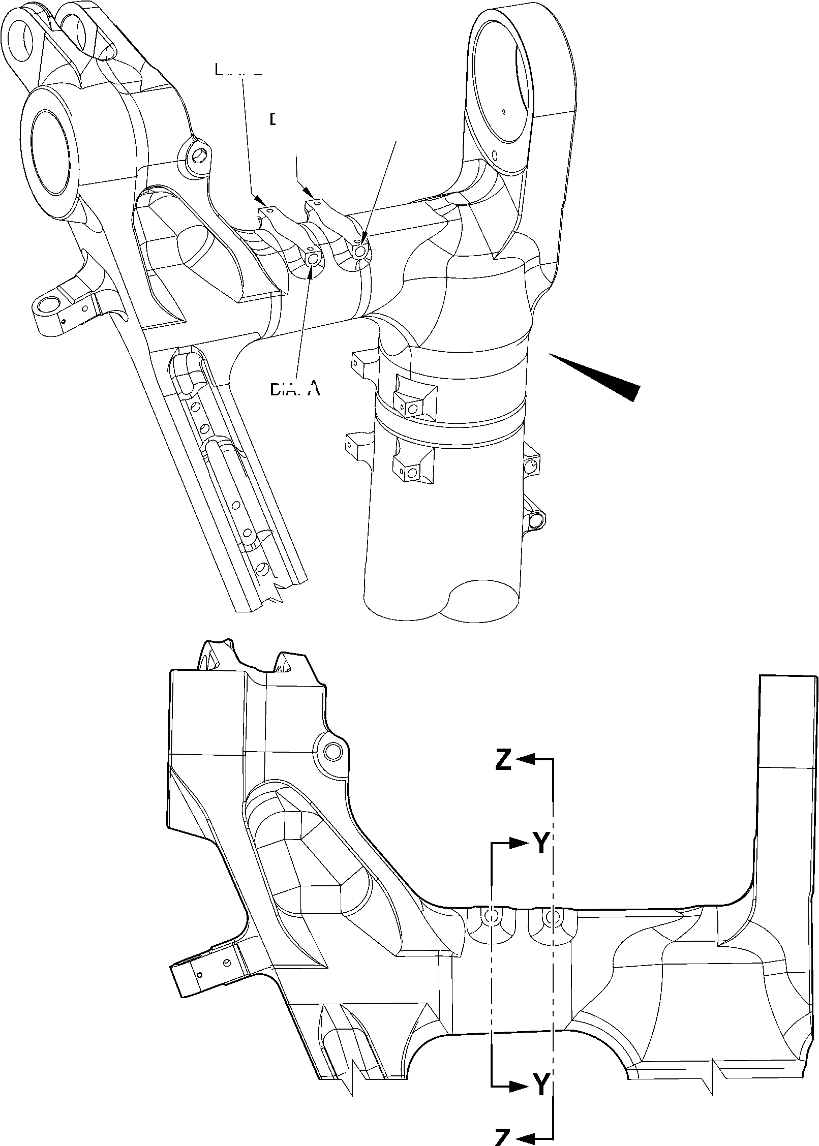

**SAFRAN LANDING SYSTEMS UK Ltd**

CAGE: K0654



PART No. 201587001 AND 201587002 COMPONENT MAINTENANCE MANUAL  
MAIN LANDING GEAR LEG

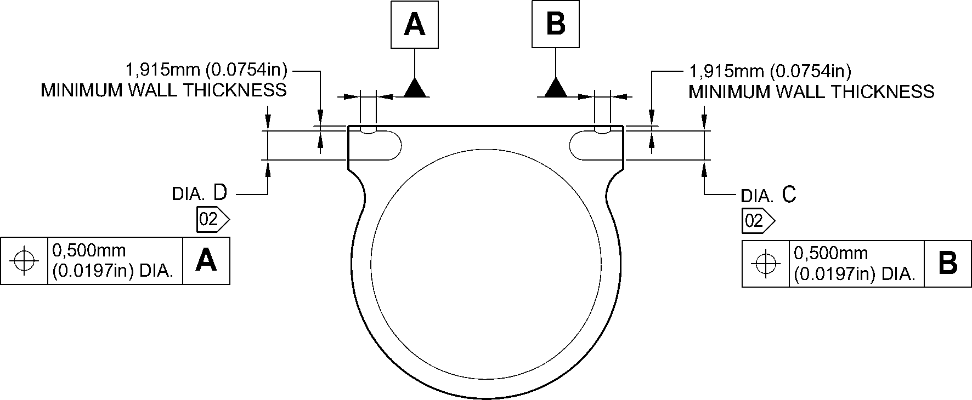

SECTION **Z-Z**

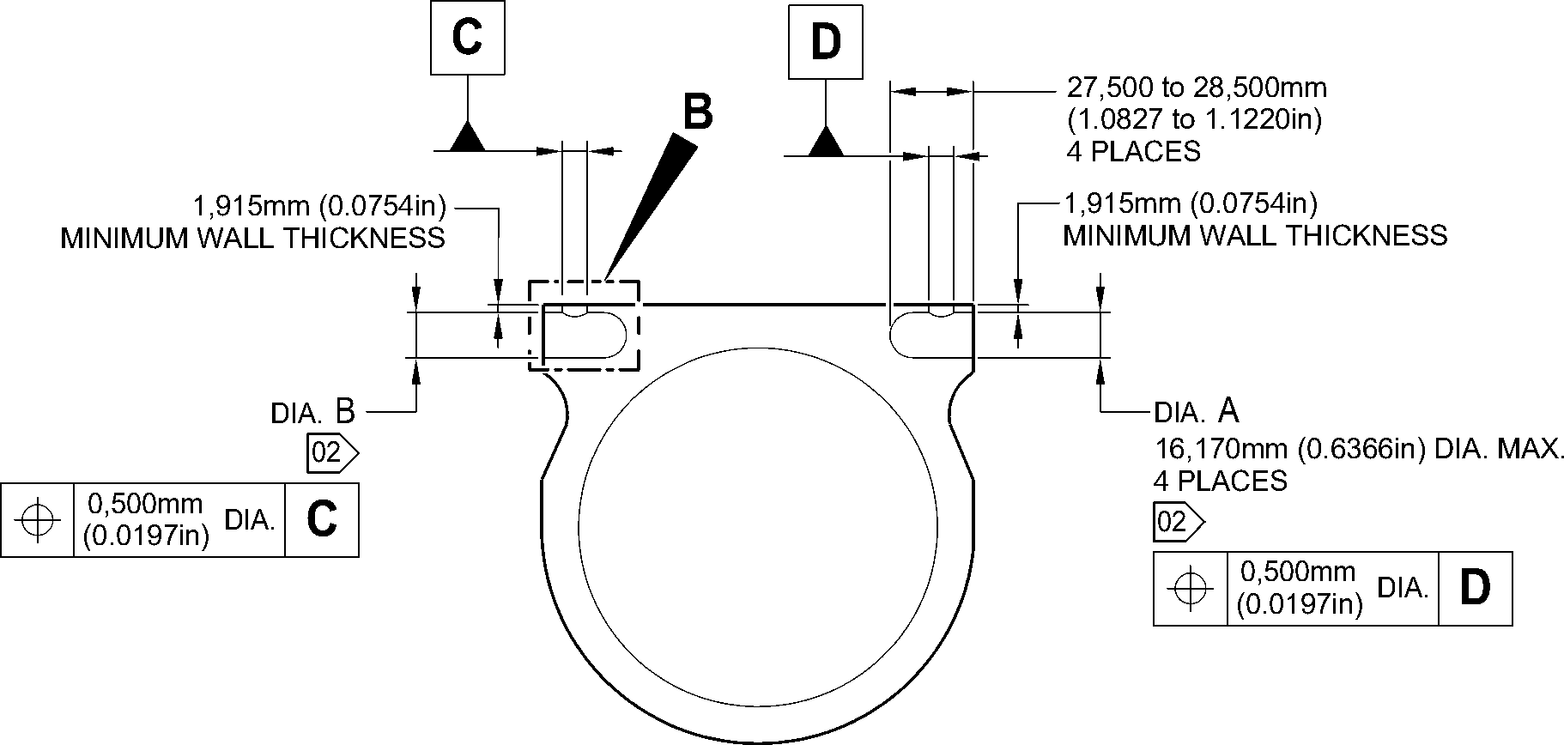

SECTION **Y-Y**

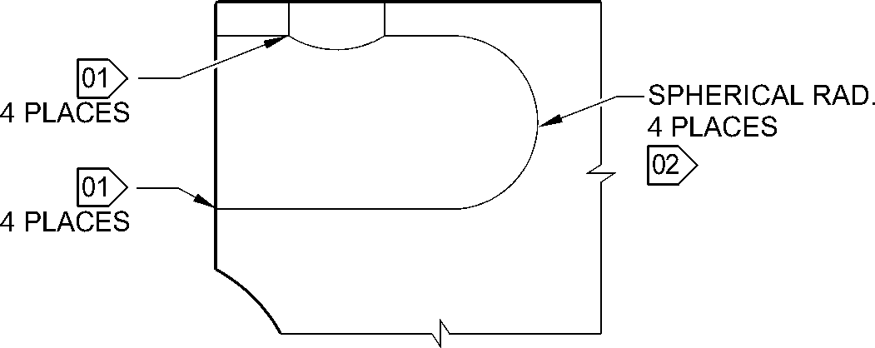

**NOTE:** (16,36) DETAIL **B**

THE SURFACE FINISH MUST BE OR BETTER UNLESS GIVEN DIFFERENTLY.

DIAMETERS A, B, C AND D MUST FOLLOW THE AXIS OF EXISTING BORES.

01 REMOVE THE SHARP EDGES OF 0,250 to 1,000mm (0.0098 to 0.0394in) RAD.

02 NO PAINT.

A321-T-32-12-22-141-0

Repair to Main Fitting  
Figure 601 - Sheet 2

32-12-22

Repair No. 11-36

Page 604

Mar 18/2025

**sSAFRAN SAFRAN LANDING SYSTEMS UK Ltd**

CAGE: K0654

PART No. 201587001 AND 201587002 COMPONENT MAINTENANCE MANUAL  
MAIN LANDING GEAR LEG

1. Repair No. 11-37 Main Fitting (20-410B, 20-410C, 20-410D, 20-420B, 20-420C and 20-420D)
2. Specified Damage and Material Specification
3. Specified Damage

(a) Wear or damage or corrosion to diameter(s) A.

1. Material Specification

|  |  |  |
| --- | --- | --- |
| IPL Figure and Item No. | Name | Material Specification |
| 20-410B and  20-420B | Main fitting | UHT Steel E35NCD16THQ to MTL-1203 with UTS 1800 MPa (261.0 ksi) |
| 20-410C,  20-410D, 20-420C and 20-420D | Main fitting | UHT Steel 300M to MTL-1201 with  UTS 1930 MPa (279.9 ksi) |

1. Special Tools
2. Special tools are not necessary.
3. Materials
4. These materials are necessary:

**NOTE: Alternative equivalents are permitted.**

|  |  |
| --- | --- |
| Ref. Item | Material |
| TBA | Loctite Grade 601 |
| TBA | Molykote 111 |

1. Repair Parts
2. These repair parts are necessary:

|  |  |  |
| --- | --- | --- |
| Part No. | Repair Part | Material Specification |
| 62-4505252-00 | Repair sleeve | Stainless Steel -17-4PH to AMS5643 H1025 |

1. Procedure (Refer to Figure 601 and Figure 602)

**CAUTION: FOR DAMAGE MORE THAN THE LIMITS OF THIS REPAIR SCHEME, WRITE  
TO SAFRAN LANDING SYSTEMS: REFER TO GUIDE-CS-001.**

1. Do this procedure if there is wear or damage or corrosion to one or more holes  
   diameter A: refer to Figure 601 and Figure 602.
2. Remove the paint from the main fitting: refer to PCS-2700.
3. Remove the cadmium plate from the main fitting: refer to PCS-2100.

Repair No. 11-37

32-12-22

Page 601

Mar 18/2025